
Managing Projects in the Organization
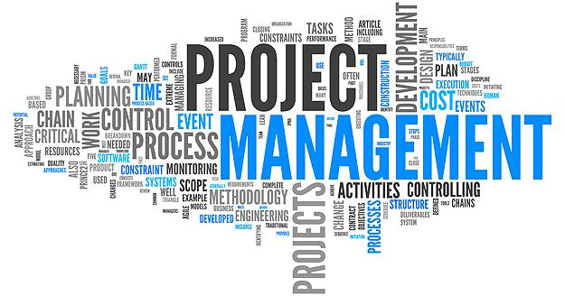
BMSW5104

Name: Daicylen Antolin
Student #: 1818171
Lecturer: Paul Jenkins
Date: 24th August
Table of Contents
- Introduction
- Background of the Chosen Organization
- Project Tools
3.1 First Tool Libre Project
3.2 Estimating Algorithms
3.2 Summary on Tools
4.) Project and Plans
4.1 Plan
4.2 Project Breakdown (WBS)
4.3 Timing Estimates
4.4 Cost and Resource Breakdown Schedule
4.5 Network Diagram
5.) Critical Analysis of the Ability to Manage a Project
6.) Conclusions and Recommendation
7.) References

1.Introduction
Queuing and waiting in a food chain restaurant before being served is exhausting, especially on peak hours when you are too hungry and all you want is to quickly grab some warm foods to eat. But in this food chain, you cannot do anything but just patiently wait, and on the temperature soaring during the summer, all you want is a quick service, get the foods and go. Managing a self-ordering system will be discussed in this report,
The aim of this report is to be able to develop the understanding and capability of project management within the workplace and to enhance and optimize the knowledge and understanding of tools and techniques used in managing a project. The success of the project depends on how it is carried out and performed. It is important to choose the right path, determined by the techniques and tools.
Project management composes of duties and processes focusing on creating a product or giving a service (Abramova et al., 2016). This report is to critically assess the functionality to ability to plan the implementation of the project with the purpose of understanding the different factors and to evaluate and assess the skills in project management within the organization. It contains the tasks and procedure based on producing a product or providing a service.
Different tools and techniques will be discussed in this report to complete a project, A successful management project is a result of a good development of a future work plan, analyzing the different jobs to be performed, giving feedback to staff and the quality and deadline management.
The essential details shall be considered as well as the plan that incorporates the techniques and methods can help implement the project successfully in Jollibee. The entire methods and techniques are based on the system adopted for the project (Eriksson et al., 2017).

2.Background of the Chosen Organization
Jollibee London is a Filipino multinational chain of fast food restaurants owned by Jollibee Foods Corporation (JFC). It has a total of 1200 outlets worldwide. The company started as an ice cream parlor but due to the request of the customers to serve hot meals and sandwiches, the owner and founder decided to convert the ice cream parlor into a fast food restaurant. The very first Jollibee outlet was constructed in Manila, Philippines. They opened for franchise since then, and the latest to open is in London. The food chain is best known for its burgers, fried chicken, spaghetti pasta and now some Filipino dishes which are usually served during breakfast. Since Jollibee is being new in the area, and with its growing customers, hundreds are queuing daily. Kiosk or the self-ordering system is the most appropriate project to manage in this expanding food chain to help reduce the queue and to make it easier for the customers to order their chosen foods.
This self-ordering system project or the kiosk, will make the life easier for both the customers and the employees and would be the best way to improve the productivity of the employees and the company would be more competitive as most of food chains have this system used in their restaurant.

3. Project tools
Project, according to the “Guide to Project Management”, is an extraordinary set of harmonized actions with concrete start and finish points launched by an individual or organization to meet a particular goal within a specified schedule, cost and completion while tool is an instrument used to change something or to accomplish a goal using different methods. Project management is an organization based on a centralised global industry.
Project management tools are tools designed that help the individual or a group to organize their work effectively and manage projects and tasks for implementation. The term generally refers to project management software that can be purchased online or even used for free (Kezner, 2019). It is an act of planning, organizing, leading, reporting and an execution of a certain project using different tools and technique to meet the deadlines and target implementation, causing a plan to happen through the people involved in the project (Narvaev & Marco De, 2014). Dividing work into smaller tasks is a common productivity technique that makes work manageable and achievable.
WBS (Work Breakdown Structure) is a tool and technique which is one of the most important documents for project management (Harris, et al., 2018). The work is divided in smaller tasks as a common technique to enhance productivity to manage and the project properly and achieve the goal and expectation of the management and finish it on time It combines scope, cost and schedule constraints and can customize project plans. The Project Management Institute (PMI) defines the division of labor as a hierarchical unit that focuses on the execution of the work of the project team. There are two types of WBS, firstly hard- based and secondly, soft-based, with the help of WBS, the project manager can plan the whole task of implementing self-ordering systems in Jollibee. The tool will help in laying out the entire plan from broad project to the processes that may come under the comprehensive plans.
Gantt chart is another tool often used to help carry out the project and to track progress in closed stages as they offer a clear visual view of stages and dependencies. Application technique is used in traditional and complex projects, where a detailed step is required, and successful delivery depends on a rigid structure (Eriksson, 2017). It started in the early 20th century which was used with very limited adaptation covering a wide range of project types, in which the questions of the authors were universal. Through the use of Gantt chart, the manager of the project can have a quick loo of the period of the project and the resources that are required and the tasks that are needed to be carried out which is useful to help with complicated projects that embraces the relevance of timing based on projects that are not useful to all projects. The Gantt chart is a widely used and popular project management tool that provides a visual view of what features to perform and when. Gantt maps are great for tracking project plans because they help a person see the interdependence of tasks, especially when one task is the result of completing another task (Lientz & Rea, 2017). They can also be used to view progress, resources, constraints, and other relevant planning information.
PERT (Project Evaluation Review Technique) is a project management tool used which is useful to manage the project and to estimate the time it takes to complete a project realistically, and it represents the technique of program evaluation. PERT charts are tools used in project planning in a project, making it easier for team members to plan and coordinate the execution of work (Pellerin, 2019). PERT maps were created in the 1950s to support the creation of weapons and defense projects for the UK Navy. At the same time, as the introduction of PERT in the fleet, the private sector also critically provided a similar method. PERT is a critical way, and both are used to illustrate the scheme and work on the project (Karabulut, 2017). However, with PERT, a person does three different time calculations for a project, firstly a person estimates the shortest time each task can have, secondly the most convenient time, and lastly the longest duration of tasks when things are not planned. A fixed end date is computed again for PERT due to possible change of the hours of the contractors as it is normally happening. According to Berg (2020), was developed by the Polaris submarine research team in 1959 when a nuclear weapon program was trying to be created. This will plan the whole project from beginning to end to reach your objective.
PRINCE2 (Projects IN Controlled Environment) is a short project in a controlled environment, and it is a method based on project management (Pellerin & Perrier, 2018). The UK government mainly uses it, but it is also common in the private sector in England and around the world. The technique further divided the controllable phases depending on demand of the project. It makes sure that the business risks are minimized, and the management of their project is done incredibly (Grogan et al., 2017).
The main functions of PRINCE2 focus on business motivation, determine the organizational structure of the project management team and use a product-based strategy (Hinde, 2018). It is a structured project management method and practitioner certification program which approach is to keep the project in place with its methodology.
Critical Path Method (CPM), according to Bhasin (2020), it is considered as network analysis design which is used to control the procedure of the project. This is a technique for a complicated piece of work, which has the duration and needed to be completed on time. CPM is a valuable technique to plan a project to avoid or keep away from any time-frame issues which are most suited for projects with multiple activities of complicated type. It minimizes delays, organizes projects, predicts time, improve project organization, visualize dependencies, maximizes efficiency, calculates float, view graphics, plan s and controls project and organizes and maintains contingency planning.
Functions of CPM:
- To identify the activities to be completed on time.
- To calculate the shortest time needed in completion of a project
- To identify the step that can be delayed without any impact on the whole project.
- It helps to link the dates the task can the earliest and end the latest to keep the project schedule.
Elements of CPM:
- Critical path analysis- one with the lengthy time span which will cause delay in the project
- Critical float determination- time that a task can slip before it begins a delay
- Early start and finish calculation- a task can start and finish with the help of forwarding a press technique
- Late start and finish calculation-an activity can start and the latest date finish before it begins to delay the project by using backward press technique.

3.1 First Tool Libre Project
ProjectLibre is another tool for planning a self-ordering system or kiosk, it is considered as one of the best tools for an open-source project. It was created by the founders of OpenProj and continues to grow. This is a software to design the procedure of the self-ordering system which has a variety of features in it (Guerra et al.,2019). It is a free and available software for practical project management which comprises range and useful features. Its goal is to explain how a person can easily use this program; this is not an explanation for the method of project management but to assign resources to a piece of work and calculates the project costs. A task assigning approach can be used to breakdown the entire structure of the self-ordering system. The software also uses a multiple number of functions which are helpful to the plan, including histograms, structure breakdown and earned-value costing (Whyte et al., 2016). It is compatible with Microsoft, which makes it easier to insert file related to it. It has a mass information of the self-ordering system that includes the task procedure, resources and its details, workings that are needed to be done and the non-working days.
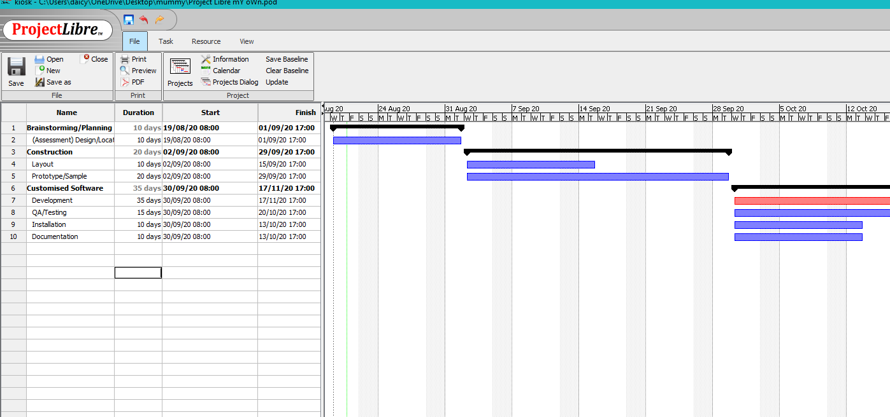

3.2 Estimating algorithms
The design process itself requires not only professionalism but also knowledge and experience in many cases, creativity and intuition of the developers (Guerra et al., 2019). Figure shows a working algorithm for using a software product to support accounting and decision-making processes in a project management team.
Advantage and courage in the design project must be explained. The tasks of the project and its execution should be separated, priorities must be set and the expectations against the data should be known. Every team’s expertise and job responsibility must be known, and the project management process should be understood. To create a better estimate of a project, studying the team’s history is important, WBS is essential to apply, before starting to plan and estimate the project.
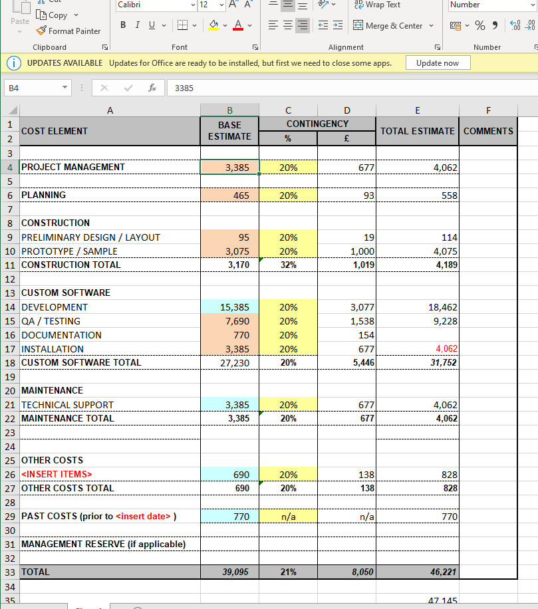

3.3 Summary on Tools:
Software management tool helps project managers and teams meet customer requirements and meet time, budget and scope concepts (Anantatmula & Rad, 2018). However, with so many options available, choosing the right project management tool can be confusing, and people may not know where to start. Many small and medium-sized businesses in every industry now use online project software. These types of software use cloud-based technology and are provided by application companies such as Software and Service (SaaS) (Guerra et al.,2019).
Tools usefulness For Kiosk
The tools that are discussed help the project managers to manage the entire projects efficiently. These tools and techniques are very useful for the projects and the management that is required to carry out them. Their presence is essential for the self -ordering system as they minimize the hassle of going through the heavy and detailed form of information while working on the projects (Drury -Grogan,2017). It also plays a key role in assigning of the tasks which do not create any sort of miscommunication. For the implementation of the kiosks, these techniques shall be valuable as the self-ordering system is a technology-related and requires assistance from various people. It is filled with technicalities that can make or break the project. The implementation of self-ordering system is based on the possibility of providing ease to the customers of the food chain, so the plan is of high importance (Guerra et al.,2019).
Jollibee is a global brand which is known for its remarkable fast food and service it provides to the customers. The chain is reasonable for many outstanding projects and done with the help of certain management and expertise that are opted by the multinational brand. Before the implementation or design of a project, Jollibee makes sure that a systematic method is followed. The self-ordering system must go through several approvals and research before it is considered for implementation. The possibility of the success of the self-ordering system, the cost was also considered, and then the environment that the kiosk would be most profitable (Leng, et al., 2018). Jollibee has different customers in each region and not everyone can be satisfied with the implementation of the chosen project, however, the research showed that this could be a step up for its London branch.
Project management criteria:
There are numerous approaches used by any project management head after the approval of the self-ordering system. These approaches taken are essential to carry out the project efficiently with the most accuracy and while considering all the necessary outcomes and parameters. This will help the project manager in implementing the plan smoothly and make the procedure easy to carry out and understood by the employees.
The first criteria of the self-ordering system that is considered, is the ease of understanding which helps in catering the knowledge of the project and its related technicality if any. When implementing this approach, the understanding of the stakeholders regarding the project will be considered for them to be familiar with the concept because it could be risky to implement the kiosk without a clear concept of its technical understanding.
4. Project and Plan:
The chosen project which is the self-ordering system/ kiosk needs to be pre-planned and well administered. The necessary tools and techniques will be applied and will come up with a more enhanced and fully planned project breakdown scheme to apply it to the plan. It will help to demonstrate the whole plan to the team and to aid in the entire time while carrying out the project.
Team members include:
  - Project manager
  - Software developers/ programmers
  - QA/ qa analysts
  - Technical author
  - Engineers
Project details
The reports of self-ordering system are filled with details, but the unnecessary details can create distractions and cause problems in the implementation of the project. The details provided with the reports of the project must be to the point without any irrelevant details present. Gantt chart and work breakdown structure will be used which are effective and efficient to avoid the unnecessary details that may flood the project with insufficient information. The WBS, Gantt chart and tables for the assigned tasks will be applied to get a better understanding of the project.

4.1 Plan:
Self-ordering system simplifies and improves the efficiency of the ordering process for both customers and restaurants. It minimizes manual entry which also ensures data accuracy and
security during order placement. Customers can view product menus and a confirmation will be displayed for a correctly placed order. The entire technique and methods depend on the systematic approach adopted for a project, which includes developing a plan accessing the task
that is needed to be performed allocating the resources required and giving feedback.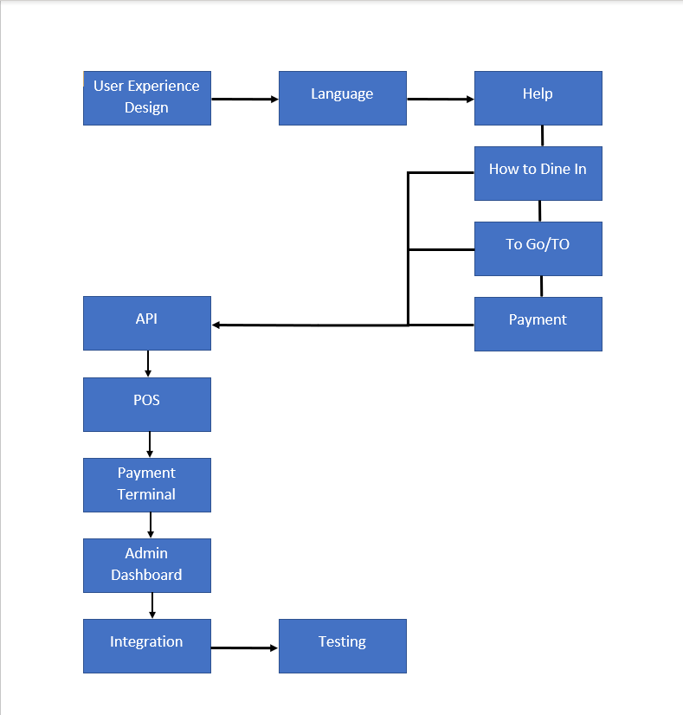
FLOW:
Select a language> tap to begin> choose to dine in/ take out< select items> customize>Confirm order> select payment method> get the receipt> claim items
4.2 Project Breakdown- WBS:
The WBS is designed to provide a common understanding of the scope of the project. This is a hierarchical description of the work that needs to be done to complete the commitment to the project (Greer et al., 2018). Through planning, managing a project becomes successful with the support of effective management. WBS is the organization’s tool to identify employees that are responsible to complete a certain task relating to a project.
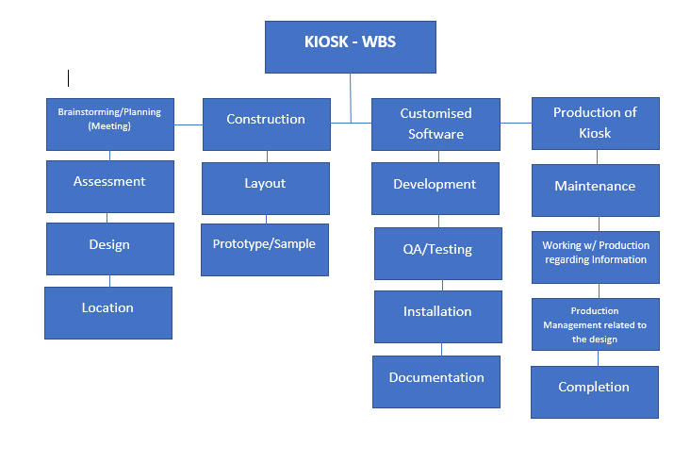4.3 Timing estimates
Gantt chart visually represent each task of developing the kiosks. The chart presents the entire task and operations with the relative date that project shall commence along the duration that it will take. This is helpful for a project manager to administer each of the function and combine its alignment with the actual operations. The different team working on the project can take assistance from the chart (Sutrisna et al., 2018). It is essential that each team coordinate effectively to reach the promising results. The aim with the pre-planned schedule is to align each of the task within the mentioned time frame and achieve the desired results without affecting the productivity.
WBS greatly simplifies the project evaluation process. It offers the following advantages over other rating techniques. WBS identifies all the work that needs to be done on the project. Therefore, freeing up less work is necessary to deliver the requested results of the project by reviewing the WBS with project owners (Kerzner, 2018). WBS leads to more accurate cost and schedule calculations. The project manager agreed to participate in the WBS end of the study team. The team representation creates enthusiasm and responsibility for the project. WBS provides the basis for the mission (Chong, 2017). The exact task is assigned to a specific team member who is responsible for performing it. WBS enables work-based control and monitoring. This way, one measure the progress and make sure the project is delivered on time. 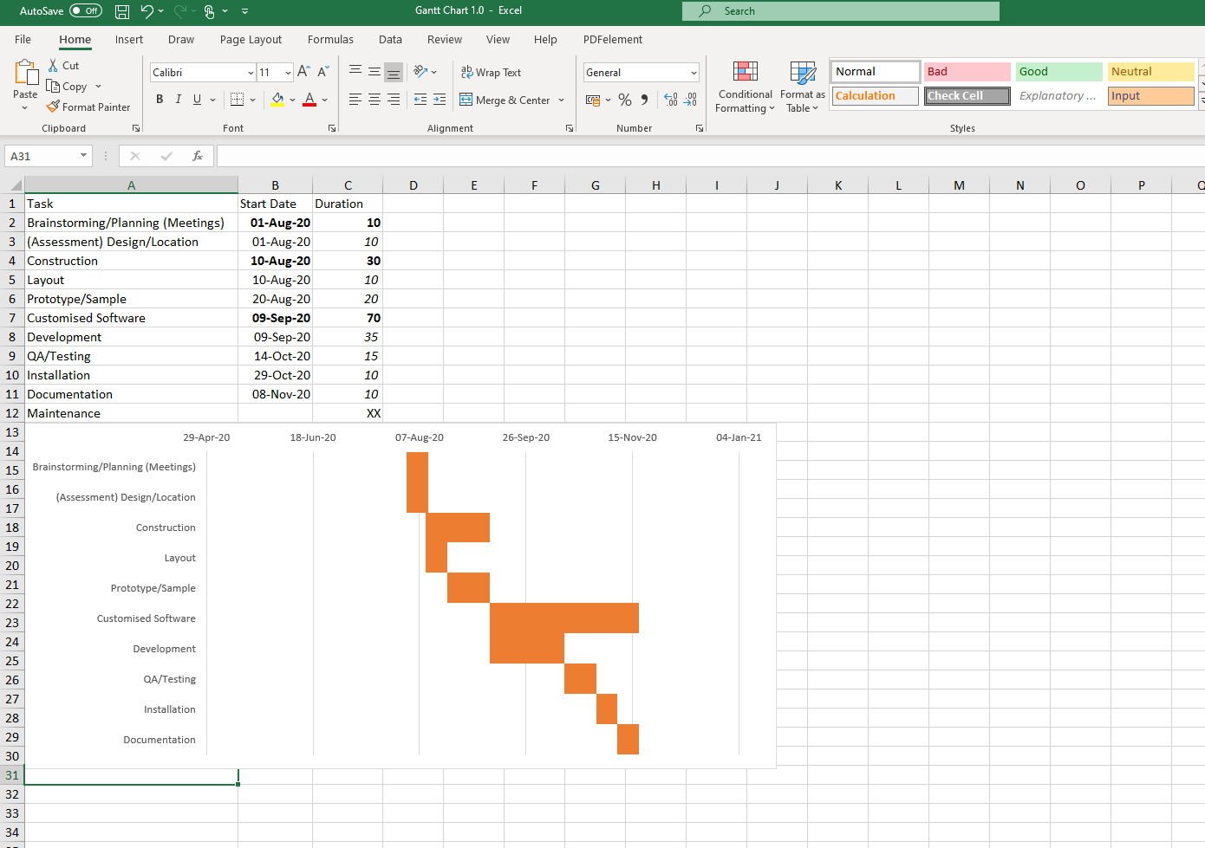
4.4 Costs and Resource Breakdown Structure
A cost-breakdown structure is a hierarchical classification that represents the various costs of a project. The cost-sharing structure represents the cost of the components of the collaboration structure, such as WBS (Steenkamp, et al., 2019). Statistics are an essential tool for the management and financial aspects of all projects and provide a framework for the implementation of cost management measures. It is involved in dealing with the financial aspects of all projects. This is the planning structure used by the financial controller to prepare budgets and perform various financial calculations, like, final estimate, execution costs, variances and value of benefits (Chong et al., 2017). Most project tools, including project management, planning, and ERP, are missing in the cost-sharing structure. The resource allocation structure is a list of resources needed to manage a project. The list is divided by role and type and includes at least the people needed to complete the project (Wilson et al., 2017). However, that covers everything a person spend on the project, including people, project management tools, equipment, materials, and even fees and licenses. However, the structure of the resource allocation is more impressive as it is a hierarchical diagram that allows the project manager to organize the resources and see their consistency. RBS is a list of the functions and resource type used in planning and controlling the project, including the personnel and equipment that will cost money. RBS reports on the budget because a complete list of resources makes it easy to estimate the cost of the project. It is a way to keep a personal budget intact instead of spending it independently (Kezner, 2018).
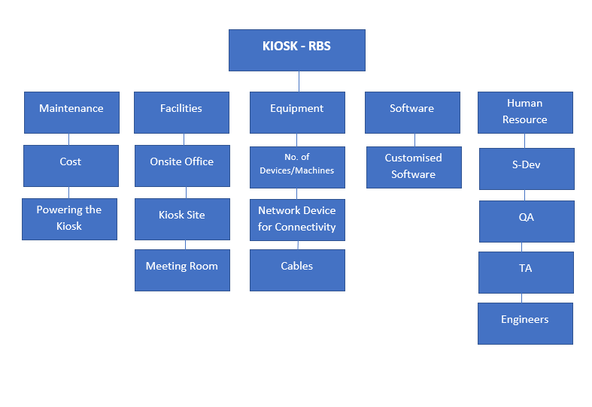

4.5 Network Diagram
A project diagram is a visual representation of the workflow of the project. A raster diagram that shows roles and responsibilities, and then arrows that describe the time frame and the order in which the work is done so that a raster plan is a way to visualize progress and to track every phase of a project until it is finished (Wilson, et al., 2017). Project managers use an online map to track the project to see the progress of each object. They can then share the space with the rest of the project team (Guinan et al., 2019). This is especially useful for those who have a better understanding of the visually delivered information. For these team members, network diagrams improve performance and increase project productivity. Another aspect of the network plan is that it describes the scope of the project. The network map collects all projects and activities.
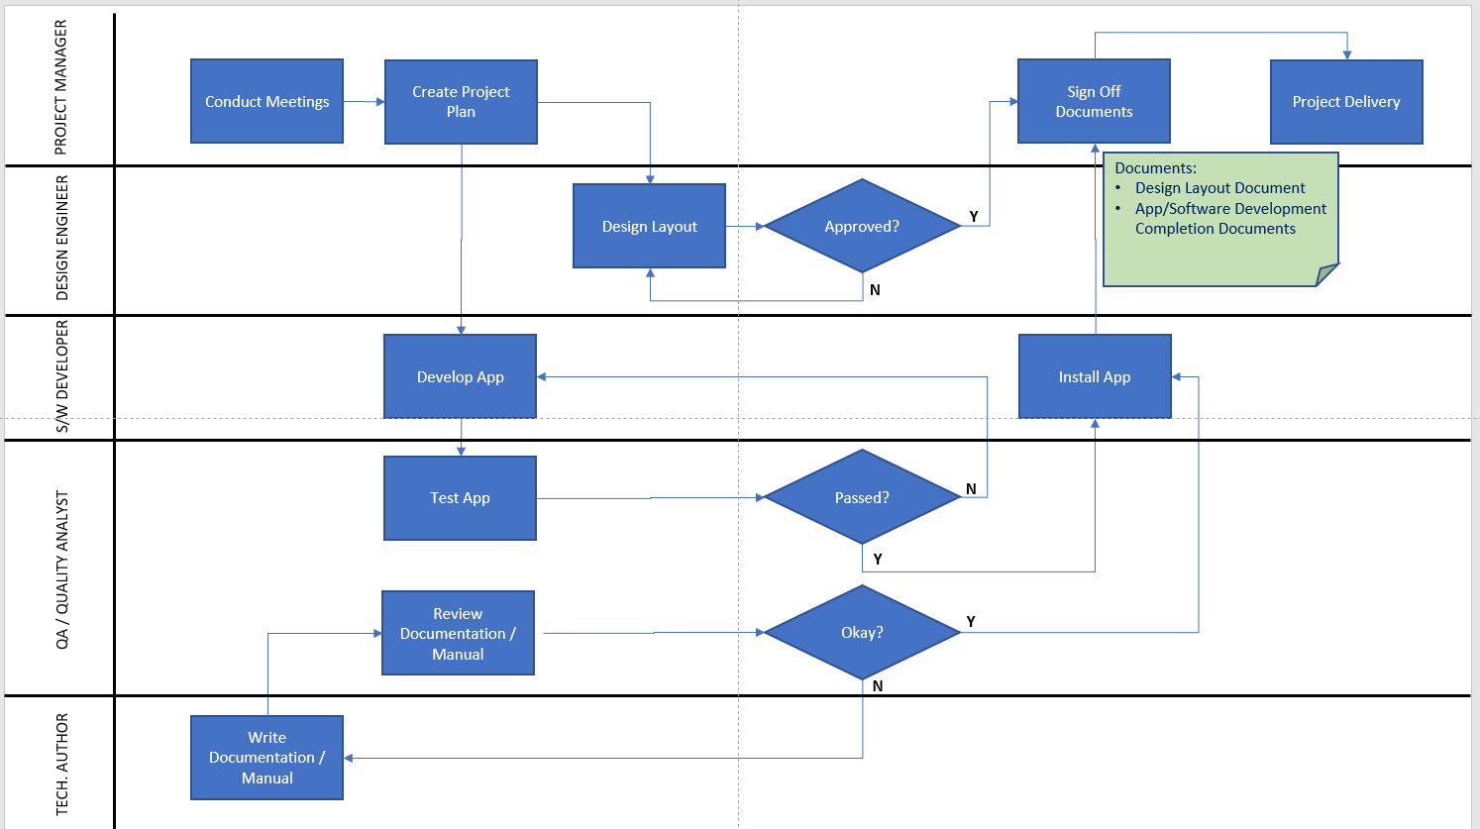

5. Critical Analysis of the Ability to Manage a Project:
As my ability to analyze my work as a project manager is a concern, I tried to make a critical evaluation of my strengths and weaknesses. The revelation that I came up will help me in my assessment and shall help me improve my skills and learning of project management.
Management objectives and priorities
The objective is to deliver the project in time and of high quality. The whole project team works together to achieve this by respectively checking that progress is made as planned and monitoring the quality of the product at various stages. Every project manager must have the ability to make the relevant decision that is necessary for the project and its implementation. Prioritizing each task and procedure according to the time limit or the mandatory. I learned that I can prioritize the necessary task and the procedure that are necessary. The project design helped me focus on the function of each stage of the structure.
Assumptions, dependencies and constraints
In this project plan, several factors are considered. The following list shows the way milestones on various project phases that have scheduled:
- Team budget
- Project deadline
- Final presentation
- Holidays
Risk management is a simple step to improve and lessen the uncertainty that can affect the outcome of the project by understanding what potential event might enhance a project. Identifying the risk will reduce the negative impact that will cause problems. The risk should also be analyzed, so that the results could be high or very high. Planning for the risk is also needed, to remove, reduce or transfer the risk. Accepting the risk means something must be done. Action must be done, or further review is best to understand the outcome of what ever risk is affecting the process of the project.
The importance of risk management is that the project objective can be met through analyzing and responding to the risk accordingly. It is often overlooked but can help to minimize the negative outcome and increase the positive outcome of managing a project.
Some potential risks for the project include:
- Technology
- People
- Financial
- Structure
- Market
Monitoring
The monitoring progress is done by the following:
- Project status meeting
- Shared document repository
- Project tracing with respect to the project plan and WBS
It is understandable that the skills of project management are all about competence. Project management skills backup my technical skills and the knowledge of the digital tools is inevitable to succeed at different tasks of the projects. Difficult skills about project management can be compared with professional knowledge of machine maintenance as well as with technical functionality (Ardolino et al., 2017). I understand to make sure that I am trained to develop the essential project management skills before moving on to the other skills such as technical and communicational skills.
Effective communication skills
The continuous communication with the team needs to be on the track so as the project will go on smoothly. The effectiveness of the team to reach a common goal is highly important and as a project manager, this was my weakness. The gap that I encountered in my ability to communicate the deadline and task needed to be done efficiently, but I learned that it could be done by a more effective emotional intelligence skills and to listen to the team member for a better result.
One key to good communication is set and encourage a face to face communication, like a short but frequent meeting so that people will be forced to focus during stand-up meetings.
Ability to strategy
The project manager needs to have a deep knowledge of the strategy that is needed to complete the project, and at times each aspect of the project requires different strategies that must be implemented with effectiveness. I also learned that my ability to strategies is not as good as my experience of planning the project, however, I can work much more on the strategic planning to further implement the project on a more professional level.

6. Conclusion and Recommendations
Project management is a critical process and important for any organization as it is carried on a broad scale by a small or large organization. The tools and techniques used helped managers in achieving the project-related goals on a wider level. These techniques are essential to carry out the projects.
The self-ordering system for Jollibee helped develop the understanding of the project management procedure, strategies and skills that are required to work on a project. The critical evaluation of project management helped me gain the perspective on the pros and cons of managing project and to work on myself to become a better project manager.
The understanding and ability to manage within the workplace has developed throughout the process and by using management tools and techniques, the knowledge as a project manager has enhanced.

7.References
Abramova, V., Pires, F., & Bernardino, J. (2016, March 02). Open Source vs. Proprietary Management Tools. In New Advances in Information Systems and Technologies. 331-340.
Anantatmula, V., & Rad, P. (2018, July 24). Role of Organizational Project Management Maturity Factors on Project Process. Engineering Management Journal, 30(3), 165-178.
Ardolino, M., Rapaccini, M., Saccani, N. G., Crespi, G., & Ruggeri, C. (2017, May 0). The Role of Digital Technologies for the Service Transformation of Industrial Companies. International Journal of Production Resources, 56(6), 2116-2132.
Berg, B. (2020, July 20). The Benefits of Using a PERT Chart for Project Planning.
Bhasin, H. (2020, July 21). Critical Path Method: Meaning, Steps, Benefits and Disadvantages.
Chong, A., Ch'ng, E., Liu, M., & Li, B. (2017, July 1-15). Predicting Consumer Products Demands via Big Data: The Roles of Online Promotional Marketing and Online Reviews. 55(17), 5142-5146.
Eriksson, P., Laarson, J., & Pessamaa. (2017, November). Managing Complex Projects in the Infrastructural Equation Model for Flexibility-Focused Management. International Journal of Project Management, 35(8), 1512-1523.
Greer, L., Jong, B. A., Schouten, M., & Dannals, J. E. (2018). When and Why Hierarchy Impacts Team Effectiveness: A Meta: Analytic Integration. Journal of Applied Psychology, 103(6), 591-613.
Grogan, D., Convoy, K., & Acton, T. (2017, September). Examining Decision Characteristics and Challenges for Agile Software Development. Journal of Systems and Software, 131.
Guerra, B. C., Bakchan, A., Leite, F., & Faust, K. (2019, March 15). BIM- Based Automated Construction Waste Estimation Algorithm: The Case of Concrete Drywall Waste Stream. Waste Management, 825-832.
Guinan, P., Parise, S., & Langowitz, N. (2019, September). Creating an Innovative Digital Project Team: Levers to Enable Digital Transformation. Business Horizon, 62(6), 717-727.
Harris, C., Garruba, M., Melder, A., Voutier, C., Waller, C., Ramsey, W., & King, R. (2018). Sustainability in Healthcare by Allocating Resources Effectively (SHARE) 8:Developing Implementing and Evaluating an EvidenceDissemination Service in a Local Healthcare Setting. BMC Health Services Research, 18(1), 1-26.
Hinde, D. (2018, June 22). PRINCE2 Study Guide: 2017 Update.
Karabulut, M. (2017, December). Application of Monte Carlo Simulation and PERT/ CPM Teachniques in Planning of Construction Project: A Case Study. Periodicals of Engineering and Natural Sciences, 5(3).
Kezner, H. (2018, May 15). Project Management Best Practices: Achieving Global Excellence. John Wiley & Sons.
Kezner, H. (2019, February 22). Strategic Planning for Project Management Using The Project Management Maturity Models.
Leng, H., Li, X., Zhu, j., Tang, H., Zhang, Z., & Ghadimi, N. (2018, April 18). A New Power Prediction Method based on Ridgelet Transforms, Hybrid Feature Selection and Closed-Loop Forecasting. Advanced Engineering Informatics, 36, 20-30. Retrieved February 28, 2018, from https://www.sciencedirect.com/science/article/abs/pii/S1474034617303154
Lientz, B., & Rea, K. (2017, September 17). Breakthrough Technology Project Management. Routeledge.
Narvaev, T., & Marco De, A. (2014, January 23). International Journal of Project Management.
Pellerin, R., & Perrier, N. (2018, September 24). A Review of Methods, Techniques and Tools for Project Planning and Control. International Journal Of Production Research, 57(7), 2160-2178.
Steenkamp, A., Alawdah, A., Almasri, O., Gai, K., Khattab, N., Swaby, C., & Abaas, R. (2019, October 31). Enterprise Architecture Case Study. Journal of Information Systems Education, 24(2), 3.
Sutrisna, M., Ramanayaka, C., & Goulding, J. S. (2018, May 29). Developing Work Breakdown Structure Matrix for Managing Offsite Construction Project. Architectural Engineering and Design Management, 14(5), 381-397.
Whyte, J., Stasis, A., & Lindkvist, C. (2016, February). Managing Change in the Delivery of Complex Projects:Configuration Management Asset, Information and "big data". International Journal of Project Management, 34(2), 339-351.
Wilson, G., Bryan, J., Cranston, K., Kitzes, J., Nederbragt, L., & Teal, T. (2017). Good Enough Practices in Scientific Computing PLoS Computational Biology. 13(6).

