Reflective Practice In Counselling (ECS6002)
Stephen A. Harris
Essay Assignment
07-12-2020

Why Procrastinate?: Using Argyris’ Ladder of Inference to Decode A Universe of One.

‘How do we exorcise the haunting of our separate histories?’ (Hollis, 2016).

The Ladder

Business theorist Professor Chris Argyris’ Ladder of Inference is a staged model designed to test ones own assumptions and beliefs regarding a given set of information prior to taking action based on those assumptions and beliefs. Argyris posits that our own (often unconscious) assumptions influence the conclusions we draw and thus affect the beliefs upon which we base our subsequent actions - sometimes with less than optimal results.
The key to this applying this model effectively is to recognize the existence of a reflexive loop that exists between our beliefs and the data we select to support our assumptions. By practicing the habitual questioning of the validity of our assumptions and beliefs we grant ourselves the opportunity to pursue alternative courses of action, which may lead to more favorable outcomes. This examination of how we problem-solve is termed double loop learning. Agyris describes the fruits of his work with co-author social scientist Donald Schön as such: ‘Double loop learning occurs when the error is detected and corrected in ways that involve the modification of an organization (or individual’s) underlying norms, policies and objectives’ (Agyris and Schön, 1978).

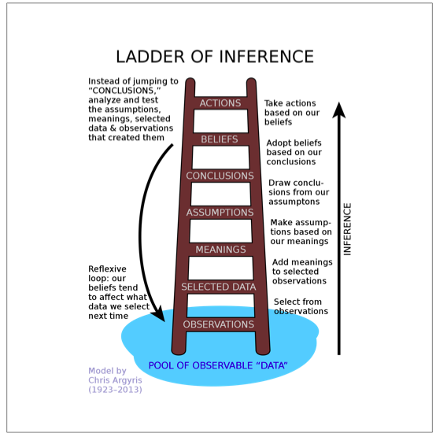

Argyris’ Ladder of Inference

Applied Reflection-On-Action
In order to conduct an analysis and critique of Argyris’ model I needed to examine it within the context of a problem or error within a system. Regarding Therapeutic Reflective Practice that system is often a behavioral pattern that has resulted in a critical incident - as experienced by either the practitioner or a client subject. (Boud and Fales, 1983) relate: ‘The impetus (to reflect) could be provoked by an external event, or could develop… (via) a series of occurrences over time, causing a dissatisfaction that leads to a reconsideration of them’.
To these ends I selected a learning issue, procrastination, and the case notes from a subject I helped to oversee as part of a healthcare team circa. 2012. The subject was a chronic procrastinator whose pattern of behavior - along with a phalanx of other psychological comorbidities - first appeared during his time in high school. I subsequently observed Argyris’ model in relation to his case history.

A Universe of One

In his seminal work on reflective practice The Reflective Practitioner social scientist Donald Schön makes reference to developmental psychologist Erik Erikson. ‘In the hopes of avoiding imposing our own unconscious assumptions upon the patient’s’ Erikson urges the practitioner to ‘listen in a special way’. He goes on to advise us to view the patient as “’a series on one’ who must be understood in terms of the unique experiences of his life” (Schön, D. 1983). Thus, by examining the specific details of a single subject’s internal narrative vs. attempting to categorize their difficulties via a generalized list of symptoms, Argyris’ Ladder seeks to avoid the unconscious assumptions that Erikson warns us of.

Jason
I first met Jason during my time as part of his healthcare team at Harvard’s McLean Psychiatric hospital in Boston. Jason - a 40-year-old man initially diagnosed with intractable depression - had suffered a series of ever worsening ‘down times’ over the previous few years. The worsening of his condition had culminating in his current hospitalization following a particularly dark period. Now, a year after his admission, he was struggling with plans to re-integrate himself back into the world. As he considered returning to college - something he had failed at as a younger man - the subject of procrastination arose as a serious historical issue. During his adolescent years in high school, and then in college, Jason had tried numerous methods to combat a preliminary diagnosis of Dyslexia. These methods included private tutors, custom-designed academic programs, and a small fortune spent on self-help literature: all to no avail. Picking up his discomfort when discussing his school years, his psychotherapist - my supervisor - made the decision to include his history of procrastination as an ongoing subject of discussion during his weekly therapy sessions. Thus, I have considered the contents of the case notes from these sessions as the ‘Pool of Observable Data’ when applying Argyris’ model.

Procrastination and its Categorization

‘The voluntary delaying of behavior despite knowing it is
not necessarily in one’s interest to do so’ (Steel 2007).

The phenomenon of procrastination has long plagued the world of education. In an environment where high scores on exams and papers are the currency of academic upward mobility this putting off of the inevitable with no apparent positive gains is surprisingly common. A 2007 report observed ‘almost 50% procrastinating consistently and problematically’ (Terada, 2020). Subsequently, a great deal of research has been carried out in an attempt to understand the reasons behind this self-defeating behavior, with various models being proposed.
When categorizing procrastinators, professor of psychology Josef Ferrari suggests a tripartite model comprising of Arousal, Decisional and Avoidant types (Ferrari, 2000). Simply put, the arousal-based procrastinator will delay commencement of their work until the last possible moment so as to experience the thrill of completing their task with little room to spare. The Decisional procrastinator is beset with the dilemma of endless possibilities and finds it almost impossible to make the decisions necessary to complete their task. The motive of the avoidant type is the protection of one’s work from the potential of negative evaluation by having an external reason on which to blame their poor grades (Deemer et al, 2018). At first glance, this last category, a form of self-handicapping (Beck et al, 2000) seemed the most likely culprit as far as Jason was concerned. According to Argyris’ model, assumptions regarding Jason’s behavior surrounding academia are not an acceptable path to diagnosis.

Step 1 – The Pool of Observable Data/Observations

Observable Data can be described as everything we ‘see’: everything that is made available to us through our senses. The contents of the Internet; the conversations we have; our observations of the people, places and things we come into contact with on a daily basis form just part of this enormous reservoir. This pool of information does not remain with us in its initial form for very long. From a physiological perspective, the human brain has adapted itself in order to be able to process and accommodate the innumerable pieces of data it receives on a moment-to-moment basis. Editing and pruning as it goes, the brain retains the necessary and discards the unnecessary. Research shows that many details are soon lost as the mind packages what it has ‘seen’ into more manageable, and storable, pieces. Sigmund Freud described this process of functional forgetting thus: ‘Normal forgetting takes place by way of condensation. In this way it becomes the basis for concepts’ (Squire, 2011). Thus, as we consider the first step up Agryis’ ladder, the concept of objectivity already begins to blur.

The pool of observable data that confronted Jason over the years revealed a history of late assignments, poor exam results, and constant academic setbacks. In addition to this, Jason’s cycles of depression grew deeper and more frequent as his school performance plummeted. Multiple interventions on behalf of his family and local teaching staff appeared to have little effect on his problem. By the time I met Jason he was convinced that he was, in his words: ‘Stupid and broken’.

Upon further discussion, Jason revealed that his relationship with his mother had fueled this ever-increasing sense of low self-esteem from an early age. From a functional perspective, Jason’s interpersonal relationship with his mother displayed extreme polarities between ‘Dominance’ and ‘Affiliation’ on his mother’s behalf - Dominance denoting ‘power and control’ and Affiliation denoting ‘nurturance and warmth’ (Leising, 2011). As a child he would often come home from school early and tell his mother that he had been bullied by classmates for his poor performance, and by teachers for his attitude and apparent lack of effort. He recalled an occasion when his mother dismissing his teary-eyed explanations and promptly drove him back to the school. Upon their arrival his mother had tea with the headmaster, oblivious to the fact that a faculty member was caning Jason in the adjoining room. It was under the influence of this matriarchal regime - a place where his mother’s controlling demeanor was combined with an apparent lack of caring - that Jason’s journey up the Ladder Of Inference began.

Step 2 – Selected Data

Our Selected Data is the information that we have chosen to include from our available pool. Our unconscious mind will already have sifted through all the available information, but as our conscious mind becomes involved in the decision-making process, we tend to bend the picture towards a view that suits our current agenda. From a conscious perspective, this tendency towards ‘seeing what we want to see’ is often referred to as Confirmation Bias. By example, during a controlled social experiment, a group of law enforcement officers in Stockholm, Sweden who prided themselves on their neutrality regarding the potential guilt of arrestees, ‘… displayed a more guilt-confirming mindset after pressing charges’ (Lidén, 2019). Consciously or not, as humans we have a tendency ignore what doesn’t fit with the way we want to see things.

In Jason’s case, when quizzed as to his school experience, his responses were uniformly negative. From his reports of being bullied by his peers and staff to his mother’s unsupportiveness regarding the situation, he could not recall an occasion where school had yielded anything positive in his life.

Step 3 – Meanings

The attachment of meaning to an event, relationship or piece of information, has been shown to be something that humans are want to do. In fact, many social scientists have argued that the importance of this process is integral to happiness and contentment with one’s lot, especially when one feels that they have no control over the external circumstances of their life. Psychiatrist Steven M. Southwick encapsulates the essence of this process: ‘Even though we as human beings cannot often control the circumstances of our lives, we can control our attitudes and responses to those circumstances (Southwick et al, 2006, p. 162).
Thus, it appears that by actively shaping our conscious narrative of past events, we feel we gain some control over the world around us. According to Agryis’ model, this process of pairing past events with current meaning has future consequences. American philosophy professor Anthony Rudd describes this process in the following fashion: ‘As self-conscious temporal agents we are aware of the pasts that we have … we consciously attempt to build our futures on the basis of those pasts as we understand them (this is true even when what we are trying to do is to break with them)’ (Rudd, 2012).

When Jason’s mother reacted as she did, with apparent disinterest towards his feelings as they related to his schooling, Jason needed to make sense of his mother’s behavior - especially as her actions did not appear (to him) to adhere to social norms concerning the mother-child protective relationship. Child psychologist Grazyna Kochanska warns of such behavior between children and their caregivers: ‘When exposed to negative, rejecting, unresponsive… parenting, difficult children are at considerable risk for a broad range of behavior problems.’ (Kochanska et al, 2013).

Left with no other visible options, Jason took what he had experienced and made his own assumptions.

Step 4 – Assumptions

As the subject arrives at the mid-point of Argyris’ ladder, they convert the meaning they have attached to their prior experience into assumptions. One of the disadvantages of making assumptions is that they are generally accepted (by the assumer) to be true. They also do not require the presence of any discernable objective proof in order to take shape. As we have seen during the transition from ‘all available’ to ‘selective’ data, the mind tends to favor information that supports its developing belief(s). Psychologist Edmond J.S. Sonuga-Barke points out: ‘Our assumptions do more than just dictate the question as they also dictate the answer’ (Sonuga-Barke, 2011). As mentioned earlier by Rudd, one consequence of self-shaping our past narratives is that these amended versions of ourselves are carried forwards into the future - albeit armed with an arsenal of newly developing beliefs: ‘ … evidence of a certain dysfunction gets over-interpretted and evidence against gets ignored’ (Sonuga-Barke, 2011).

Fast sinking into a swamp of academic hot water at school, Jason’s negative experiences began to pile up. Further poor exam results led to extended disciplinary protocols on behalf of the school. Summoned before committees of senior staff to explain himself, Jason began to feel trapped and without support. Spanish professor of psychology Eva Garossa discusses how students’ emotional states are connected to their search for meaning within the academic sphere, that universities: ‘also can … encourage students to conceptualize failure as a valuable part of the learning process’ (Garossa, 2016). Unfortunately for Jason this more enlightened approach was not part of the system he found himself in. Feeling helpless and at the mercy of the institution he turned his attention to a more manageable target; Someone vs. something to which he could assign his feelings in an attempt to bring order to his increasingly chaotic inner life.

Step 5 – Conclusions

One way of describing the process of drawing conclusion(s) would be to state that one reaches a decision through reasoning. In his book The Importance Of Being Rational Professor of Philosophy Errol Lord states: ‘We devote a good portion of our lives trying to figure out what it makes sense to do, believe, intend, desire, and hope for given our often limited information and abilities’ (Lord, 2018). Faced with few visible options, and unable to establish a functional line of communication with his teachers, Jason considered his experiences and what they meant to him. He subsequently stitched together an emotionally charged narrative that supported his need to make sense of an ongoing situation: a situation that was routinely exacerbated by some of the less well-recognized components of his dyslexia diagnosis. These symptoms included: ‘Persistent difficulties (with) organization of work and concentration… (and) producing disjointed written work due to losing track of sequential information’ (Mortimore et al, 2006). If anything, Jason’s cognitive deficits hindered his ability to apply reason to his situation, and thus the reflexive mechanisms that Argyris’ Ladder seeks to uncover began to take full effect.

Psychologist Jenel Taylor Cavazos has written about how the degree of emotional sensitivity an individual possesses has a significant effect on the development of their worldview. In her work, RLS score denotes an individual’s sensitivity to absence of structure. In an experiment where participants were asked to complete a story ‘high RLS individuals’ stories were considerably more negative’ (Jenel Taylor Cavazos et al, 2011). When viewed in the light of Cavazos’ research, Jason’s persistently negative internal narrative suggests a sensitivity to lack of structure. It is possible that Jason, in an unconscious attempt to enforce order upon his situation, allowed his assumptions to pour fuel on the fire of a long-gestating belief.

Step 6 – Beliefs

Belief: Any proposition that is accepted as true on the basis of inconclusive evidence. A belief is stronger than a baseless opinion but not as strong as an item of knowledge – (Heery, 2007)

The belief that Jason had developed was that to risk exposing his thoughts and opinions on paper in the form of schoolwork was to risk failure and subsequently put himself at risk for further ridicule from his peers, teachers and family. This fear of ridicule manifested itself as academic procrastination. Furthermore, over time this singular response gave way to a wider pattern of risk aversion. Unfortunately, beyond his generalized anxiety regarding his school life, Jason remained oblivious to the future consequences of his actions. His situation is aptly described by professor of psychology Crystal Park in her paper on meaning making and stressful life events: ‘For example life goals may shift though processes beyond intentionality’ (Park, 2010).

Step 7 – Actions

Jason’s pattern of aversive behavior began with his schoolwork, but over time expanded to include anything he considered as a first-person expression of himself. He developed a complex private language involving metaphor and symbolism to protect himself from a world where anything or anyone in this context was perceived as a threat. He started to speak backwards, reading road signs and magazines aloud in public as if to assure himself that his ‘secret’ language was impenetrable to others. Then, as his condition worsened, he began to withdraw from the world altogether.

Initially the emergence of the Internet as a socially acceptable form of communication allowed him to distance himself from any meaningful human contact unnoticed, but eventually his friends drifted away as he continued to develop a complex narrative that offered justification for the defenses he had erected against the world outside. As his consciousness became mired in a Gordian Knot of recursive thinking he flitted from misguided action (backed by familiar assumptions) to further misadventure and back again. With each repetition of the cycle he concretized his belief that there was no course of action other than continued avoidance available to him.

To appreciate the mechanism behind the action(s) that Jason took as a result of his long-developing beliefs is to comprehend the deductive and potentially healing power of Argyris’ model. The key to this understanding is recognizing the presence of a reflexive loop that runs between the subject’s beliefs and the data that he repeatedly chose to select from the world around him in order to support those beliefs - This systematic reflexive phenomenon is best described by Argyris’ models of single and double loop learning (Argyris and Schön, 1978).

The Loop

Single loop learning is a problem solving technique during which the subject reflects directly on an action, often in relation to an undesired outcome. If the outcome did not meet with the subject’s expectations then changes in action are implemented. Conversely, double loop learning involves the examination of the factors that drove an action, as well as the action itself - the idea being that if one reviews the assumptions and beliefs that drove the action, flaws in the system may be discovered and addressed so leading to alternative action and thus alternative outcome(s). As per Erikson’s plea for practitioners to treat each patient as a ‘universe of one’ (Schön, 1983) the individual nature of each person’s value system and their specific way of doing things is a complex combination of experience and acquired meaning, thus setting up a unique chain of events as they make their way up Argyris’ Ladder (from initial data selection all the way to action). As such, any prescribed modifications to the component events that form the ladder should also be tailored to suit this unique and individual system.

In Jason’s Case, his consultant psychotherapist honed in on the data that Jason chose to recognize (selected data). Jason carried this selected information forwards with him, subsequently adding meaning and then drawing the assumption that no one cared that he was struggling at school and felt alienated. Once Jason had set up this initial narrative (based entirely on his recollection of a single defining incident) it reflexively looped back on itself ad infinitum: each consecutive perceived slight adding fuel to the fire - ‘When… experience is ambiguous, it is assimilated consistent with expectations set up by prior advertising’ (Bagchi, 2020).

Upon repeated revisiting of these adolescent interactions with his mother during therapy a revised version of events emerged.

Originally perceived content of interaction(s) -

Jason: I hate school and I am being bullied. I am deeply unhappy.

Mother: Don’t be ridiculous.

Initially revisited content of interaction(s) -

Jason: I hate school and I am being bullied. I am deeply unhappy.

Mother: You’ll get over it. It’s all part of the experience.

Revised content of interaction(s) -

Jason: I hate school and I am being bullied. I am deeply unhappy.

Mother: I don’t understand. I didn’t hear you. Would you like a nice cup of tea?

In the original version of the story, the one that Jason carried with him and used as fuel for his long-standing assumptions and beliefs, his mother ridiculed and dismissed his experience and feelings. Later in the reflective process Jason reconsidered his mother’s response as one of disinterest and dismissal. Following repeated reflection Jason settled on a revised version of events: that of an immature and emotionally inexperienced woman who’s own childhood with post-Victorian parents had left her ill-equipped for motherhood. Thus, Jason concluded, his mother’s response was not driven by any motive or cruelty, but merely demonstrated an aversion to the emotionally charged content of Jason’s plea for help. Ironically, his mother’s defenses (action based on her own unique set of assumptions and beliefs) had unwittingly initiated a defensive mechanism of his own.

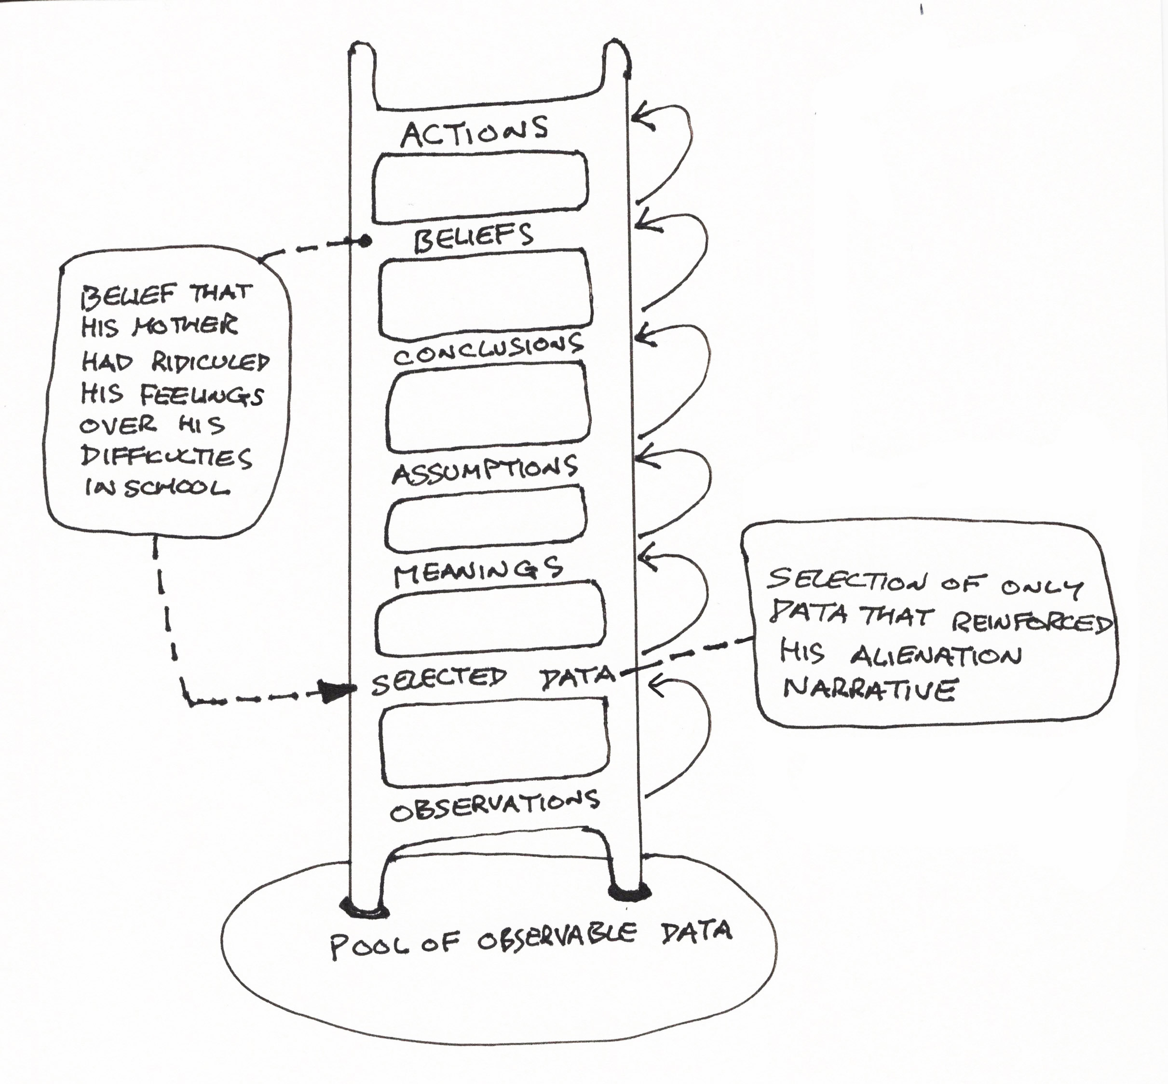

Jason’s reflexive loop

Is it really that simple?

There are a number of voices that have expressed concern that the journey up Argyris’ Ladder is hardly as direct as a first glance at the model may suggest. The aforementioned revisiting of Jason’s interactions with his mother by his therapist is clear demonstration that repetitive and varied applications of Argyris’ model are often necessary in the pursuit of meaningful results. Professor of Psychology at Haifa University, Raanan Lipschitz writes in a paper examining the ‘Chic and Mystique’ of Argyris and Schön’s work: ‘Double loop learning typically appears as a thorough enquiry employing multiple perspectives, which persists until the problem is clearly understood’ (Lipschitz, 2000). Whereas Lipschitz’s observations highlight a more nuanced use of Argyris’ model in the therapeutic setting, Professor of Nursing, Jennifer Greenwood observes that the model is ‘essentially flawed’ (Greenwood, 1993) due to it’s failure to take into account intention (reflection-before-action). However, this approach may have served little purpose in Jason’s case as his assumptions and subsequent beliefs were predominantly reactionary in nature.

In conclusion

Through the practice of reflection-on-action (via the application Argyris’ Ladder of Inference Model to our subject’s case history) we observed the ever-widening rift between the subject’s espoused theories and his theories-in-use.

We observed how the subject selected only data that would support a developing internal narrative from the available pool of information (as informed by his ongoing daily life). Once selected, the subject attached meaning to this information – in the subject’s case, labeling the selected data as the details of an ongoing struggle between himself and his school and family. Supported by this emotionally charged, meaningful information the subject assumed that he was the victim of a campaign of institutional (school) and familial (matriarchal) alienation. Having suffered repeated instances of perceived alienation at the hands of both school and family the subject concluded he was trapped in a situation over which he had no overt control. The subject’s subsequent sense of helplessness led him to develop a belief that any further efforts towards proving his worth to school and family were not only futile, but also carried an unacceptable risk of exposure to further and continued humiliation.

These fears led directly to a pattern of action: that of chronic procrastination in the academic setting. Furthermore, over time, this pattern of became reflexive in nature thus creating a paradigm that was to have long and far-reaching consequences. The subject’s belief that honest self-expression represented a risk to his emotional safety perpetually informed the information he chose to consider when making decisions regarding his future actions. Unrecognized, the psychological real estate this reflexive loop encompassed, and the subsequent scope of actions it informed grew greatly over a period of years.

By the time the subject put himself in the hands of highly qualified psychological care his habit of chronic procrastination had expanded to a global strategy of emotional withholding and patterns of avoidance that involved most areas of his life.

Specific discoveries regarding the reflexive nature of his behavior made during focused, supervised reflection-on-action altered the subject’s perception of his adolescent school experience and concurrent interactions with his mother. These changes in perception and resultant changes in belief led to a profound revision of the subject’s personal narrative regarding self-expression and risk. Which, in turn, led to the subject gradually introducing non-defensive behavior into his daily interaction with the world - to great positive ends.

In effect, the subject was introduced to the idea of double loop learning and thus sought to question his assumptions and beliefs on a global level. This new reflective mode of thinking provided a positive alternative to his previous patterns of behavior. (Greenwood, 1998).

“Reference List”

Argyris, C. and Schön, D. (1978). Organizational Learning: A theory of action perspective. Reading, MA: Addison Wesley. Pp. 2-3.

Bagchi, R., Ham, S. and He, C. (2020). Strategic Implications of Confirmation Bias-Inducing Advertising. Production and operations management, Vol.29 (6), pp. 1573-1596.

Beck, B., Koons, S. and Milgrim, D. (2001). Correlates and Consequences of Behavioral Procrastination: The Effects of Academic Procrastination, Self-Consciousness, Self-Esteem and Self-Handicapping. Journal of social behavior and personality, Vol.15 (5), pp. 3.

Boud, E. and Fales, A. (1983). Reflective learning: key to leaning from experience. Journal Of Humanistic Psychology, Vol. 23 (2), pp. 99-117.

Cavazos, J., Judice-Campbell, N. and Ditzfeld, C. (2012). Differing emotional sensitivities in the two factors of personal need for structure. Journal of research in personality, Vol.46 (1), pp. 49-54.

Deemer, E., Yough, M., and Morel, S. (2018). Performance-approach goals, science task preference, and academic procrastination: Exploring the moderating role of competence perceptions. Motivation and emotion, Vol.42 (2), pp. 200-213.

Ferrari, J. (2000). Psychometric validation of two procrastination inventories for adults: Arousal and avoidance measures. Journal of Psychopathology and Behavioural Assessment, Vol. 14, pp. 97-110.

Garrosa, E., Blanco-Donoso, L., Carmona-Cobo, I. and Moreno-Jiménez, B. (2017). How do Curiosity, Meaning in Life, and Search for Meaning Predict College Student’ Daily Emotional Exhaustion and Engagement? Journal of happiness studies, Vol.18 (1), pp. 17-40.

Greenwood, J. (1993). Reflective practice: a critique of the work of Argyris and Schön. Journal of Advanced Nursing, Vol. 19, pp. 1183-1187.

Greenwood, J. (1998). The role of reflection in single and double loop learning. Journal of Advanced Nursing, Vol. 27, pp. 1048-1053.

Heery, E. and Noon, M. (2017). A Dictionary of Human Resource Management. 3rd ed. Pp. 1. [ebook] Oxford: Oxford University Press. Available at: https://www-oxfordreferencecom.ezproxy.uwtsd.ac.uk/view/10.1093/acref/9780191827822.001.0001/acref-9780191827822 [Accessed 3rd Dec. 2020].

Hollis, J. (2016). Hauntings: Dispelling The Ghosts Who Run Our Lives. New York: Chiron Publications. Pp.

Kaurin, A., Egloff, B., Stringaris, Argyris, Wessa, M., Christine, M., Reif, A. (2016). Only complementary voices tell the truth: a reevaluation of validity in multi-informant approaches of child and adolescent clinical assessments. Vienna Journal of Neural Transmission, Vol.123 (8), pp. 981-990.

Kochanska, G. and Kim, S. (2013). Difficult temperament moderates links between maternal responsiveness and children’s compliance and behavior problems in low-income families. Journal of child psychology and psychiatry, Vol.54 (3), pp. 323-332.

Leising, D. and Bleidorn, W. (2012). Which are the basic meaning dimensions of observable intrapersonal behavior? Personality and individual differences, Vol.51 (8), pp. 986-990.

Lidén, M., Gräns, M. and Juslin, P. (2019). From devil’s advocate to crime fighter: confirmation bias and debiasing techniques in prosecutorial decision-making. Psychology, crime & law, Vol.25 (5), pp. 494.

Lipshitz, R. (2000). Chic, Mystique, and Misconception. The Journal of Applied Behavioral Science, Vol.36 (4), pp. 456-473.

Lord, E. (2018). The Importance of Being Rational. Oxford: Oxford University Press 2018. Pp. 1.

Mortimore, T. and Crozier, W. (2006). Dyslexia and difficulties with study skills in higher education. Studies in higher education, Vol.31 (2), pp. 235-251.

Oxfordreference.com, (2020). Confirmation Bias. [online] Available at: https://www.oxfordreference.com/view/10.1093/oi/authority.20110810104644335 [Accessed 28 Nov. 2020].

Park, C. (2010). Making Sense of the Meaning Literature: An Integrative View of Meaning Making and Its Effects on Adjustment to Stressful Life Events. Psychological Bulletin, Vol. 136 (2), pp. 257-301.

Rudd, A. (2012). Self, Value, and Narrative: A Kierkegaardian Approach. Oxford: Oxford University Press. Pp. 187.

Schön, D. (1983). The Reflective Practitioner. New York: Basic Books. Pp. 117.

Sonuga‐Barke, E. (2011). Editorial: The elephant in the laboratory – on the influence of non-scientific assumptions on research in child psychology and psychiatry. Journal of child psychology and psychiatry, Vol.52 (1), pp. 1-2.

Southwick, S., Gilmartin, R., McDonough, P. and Morrisey, P. (2006). Logotherapy as an adjunctive treatment for chronic combat-related PTSD: A meaning-based intervention. American Journal Of Pyschotherapy, 60(2), pp. 161-174.

Squire, L. (2011). The art of remembering: Larry R. Squire enjoys an engaging account of how memory works and how to win in memory competitions. Nature, Vol. 472 (7341), pp. 33.

Steel, P. (2007). The nature of procrastination: A meta-analytic and theoretical view of quintessential self-regulatory failure. Psychological Bulletin, 133, pp. 65-94.

Terada, Y. (2020). 3 reasons students procrastinate and how to help them stop. [online] Available at: https://www.edutopia.org/article/3-reasons-students-procrastinate-and-how-help-them-stop [Accessed 3rd Nov. 2020].

The tendency to test one's beliefs or conjectures by seeking evidence that might confirm or verify them and to ignore evidence that might disconfirm or refute them – (oxfordreference.com, 2020).

