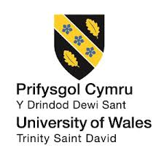

Marketing Management
LCMB7001
MBA – Masters of Business Administration

- NAME OF STUDENT – KESHAV PANESAR

- STUDENT ID – 2229241

- NAME OF LECTURER – DR.TUSHARA BALENDRAN

- ASSIGNMENT TITLE – ASSESSMENT 2

- SUBMISSION DATE – 05/MAY/2023

Table of Content

Introduction………………………………………………………………………………………………..4
External Analysis……………………………………………………………….…………………….…..4
Pestle Analysis……………………………………………………………………………………………4
Porters 5 Forces………………………………………………………………………………………..…6
Internal Analysis……………………………………………………………………………………….….7
Advanatages & Disadvanatages of SWOT Analysis…………………………………………….……7
SWOT Analysis of the Company………………………………………………………………..………8
STP Strategy……………………………….…………………..……………………………………...….9
Marketing Mix Strategy…………………………………………...………………………………….…10
Recommdations for Future Marketing Strategies……………………………………………………11
Conclusion…………………………………………………………………………………………….....12
Refrences……………………………………………………………………………………………..….13

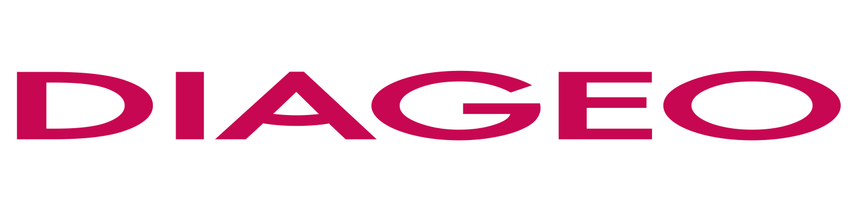

Introduction
The world's largest producer and distributor of alcoholic drinks, DIAGEO, is the focus of this project. PESTLE, Porter's Five Forces, SWOT, segmentation, targeting, positioning, and a study of the marketing mix are just few of the tools used to analyze the company's strategic marketing approaches from every conceivable viewpoint. This project identifies DIAGEO's SWOT, including the company's strengths, weaknesses, opportunities, and threats, in relation to its target market and positioning strategy.

External Analysis

PESTLE ANAYLSIS

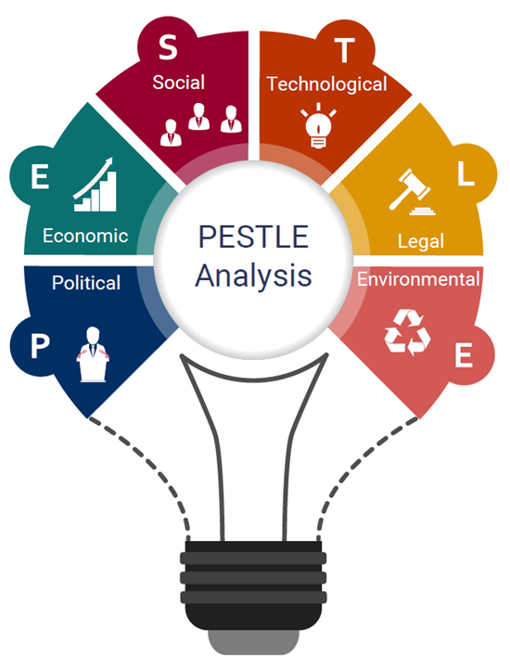

Figure 1: PESTLE ANAYLSIS
(Source : pestle anayalsis 2020)
- Political: Since it is in a highly regulated industry, the company may benefit from political stability and uniformity in policymaking. However, its profitability can be greatly impacted by shifts in government regulations, taxes, or tariffs. The company must monitor political developments in all areas where it does business (Moore, 2023).
- Economic: Consumers' tendency to reduce discretionary spending during challenging economic circumstances might hurt the company's sales and profitability. However, a rise in product demand is possible if economies in countries where DIAGEO does business improve.
- Sociocultural: The company's brand portfolio includes products that appeal to consumers of different cultural backgrounds and lifestyles. But shifts in consumer tastes and priorities can also affect DIAGEO's bottom line. For instance, less alcohol consumption may result from a general trend towards better lives.
- Technological: The business has embraced technology, which has allowed it to enhance its supply chain and streamline its operations. However, problems with technology can have serious consequences for its operations and brand credibility. The loss of confidence and credibility among consumers, for instance, might be devastating in the event of a data breach.
- Legal: The firm's strong legal department helps it stay in line with rules and defends its interests. However, its reputation and bottom line can take a hit from legal obstacles like lawsuits or regulatory fines. The firm has an obligation to follow local laws wherever it does business.
- Environmental: The corporation has implemented a sustainability plan to decrease water consumption, carbon emissions, and trash production (White, 2023). It is still possible for climate change to have an adverse effect on the company's supply chain and operations, resulting in increased costs and reduced profitability. It is imperative that DIAGEO maintain an aggressive stance toward environmental issues.

Porters 5 Forces
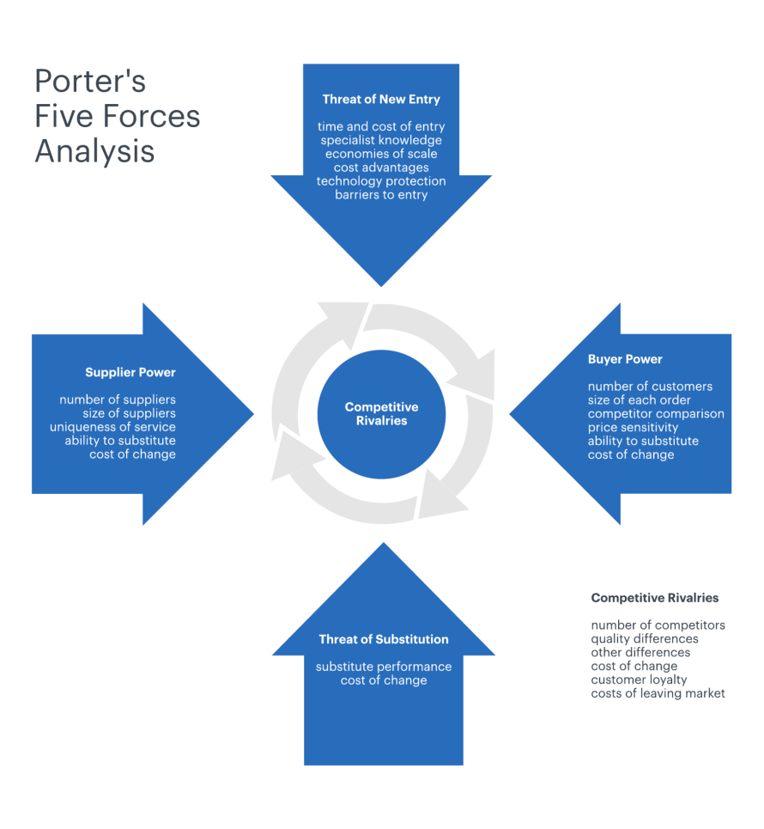
Figure 2: Porter’s five forces model
(Source: Porterfiveforces,2023)
- Threat of new entrants: The first factor is the potential for new competitors to enter the market, which is relatively low for DIAGEO. The high expense of complying with laws in the alcoholic beverage business is a barrier to entry for new companies (Edwards, 2021). It is difficult for new competitors to obtain market share due to DIAGEO's strong brand presence and varied line of products.
- Bargaining power of suppliers: The bargaining power of suppliers is a medium third force affecting DIAGEO. Despite its size and scope, the industry still relies on a small number of suppliers for essential ingredients like grains and hops. DIAGEO's bottom line could be negatively affected if its suppliers' prices or availability fluctuated significantly.
- Bargaining power of buyers: As for the third factor, DIAGEO benefits from strong buyer bargaining power. The alcoholic beverage market is very competitive, and consumers have many options from which to choose (Staples et al., 2020). That's why it's so important for DIAGEO to develop new ways to set its products apart from the competition.
- Threat of substitutes: Substitute product threat, the fourth factor, is moderate for DIAGEO. Although there are non-alcoholic alternatives to alcoholic drinks, the social experience of drinking with others is unlike anything else.
- Intensity of competitive rivalry: Lastly, DIAGEO's intense competitive rivalry. Large alcoholic beverage producers like AB InBev and Pernod Ricard present stiff rivalry for the business. There is ongoing pressure for DIAGEO to innovate and release new goods in response to the competition from these firms.

Internal Analysis

Advantages & Disadvantages of SWOT Analysis
The SWOT Analysis is a technique used in company strategy development. Some benefits and drawbacks of conducting a SWOT analysis are outlined below.
- Advantages
The simple yet insightful nature of the SWOT analysis makes it a useful tool for assessing the state of any given business. A company's strengths, like its brand name or client base, might be highlighted by the tool, while its weaknesses, such as inefficient procedures or obsolete equipment, can be exposed. As an additional perk, SWOT analysis may guide companies' future strategic decisions. Businesses can improve their chances of success by anticipating and adapting to external possibilities and dangers like new technologies and shifting consumer preferences. The cost of conducting a SWOT analysis is low; it just takes a small group of people to perform the analysis. Companies of all sizes, from startups to multinational conglomerates, can benefit from the technology.
- Disadvantages
There are several drawbacks to using SWOT analysis, though. One major drawback is that it often lacks nuance and complexity (Stacchiniet al., 2022). The programme could miss the finer points of complex business environments and fail to account for important variables affecting a company's bottom line. The fact that it may not lead to any concrete next steps is yet another drawback of SWOT analysis. The tool can be useful for assessing a company's strengths and shortcomings, but it may lack specific instructions for improving areas of weakness or capitalising on openings. It's possible that the results of a SWOT analysis will not amount to much if no concrete steps are taken to implement them. Bias is another potential issue with SWOT analysis. The analysis outcomes are sensitive to the biases and assumptions of the individuals who contributed to the instrument. The best way for businesses to prevent bias is to use various perspectives and objective facts.

SWOT Analysis of the Company
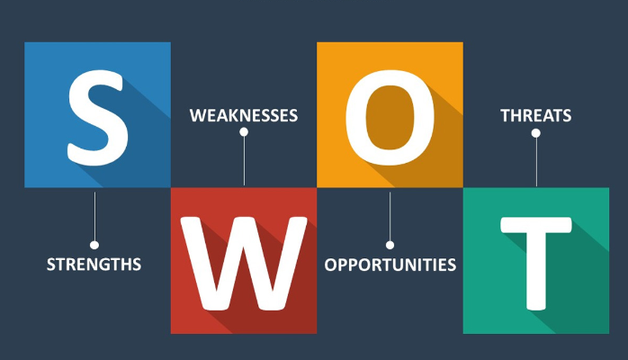

Figure 3: SWOT Analysis
(Source: Shaw, 2017)
- Strengths: DIAGEO is one of the largest beverage firms in the world, selling its products in more than 180 countries under a wide variety of brand names. Several of the company's strengths highlighted by the SWOT analysis contribute to its dominant position in the market. DIAGEO has many advantages due to its many products, global reach, and well-known brands. The corporation has also been making efforts to become more sustainable by minimising its negative effects on the environment. In addition, DIAGEO has continuously demonstrated solid financial performance, marked by increased revenues and profits (Atiaseet al., 2022).
- Weaknesses: However, the company also has some holes in its armour. The majority of the company's income comes from its most important markets, which are North America and Europe. Another potential threat to the company's market share and bottom line is the intense competition in the sector. As a result, DIAGEO may be unable to expand as rapidly as it could if it focused more on developing economies in places like Asia and Africa.
- Opportunities: Several doors of opportunity exist for DIAGEO to seize. Consumers in emerging nations may show more interest in the company's alcoholic beverages as their disposable incomes rise and their preferences evolve (Alam and Parveen, 2022). DIAGEO might attract a wider audience by offering non-alcoholic and low-alcoholic options. Earnings might benefit from the growing demand for premium alcoholic beverages. DIAGEO may capitalize on rising public interest in health and wellness by introducing new, more beneficial goods.
- Threats: DIAGEO faces a variety of possible threats. Increasing government oversight of the sale of alcoholic drinks may have a detrimental impact on the company's financial line and ability to function. During economic downturns or recessions, people's discretionary expenditure, which includes alcohol purchases, may decrease. The impacts of climate change on the supply chain and operations may lead to higher costs and lower profits. The company's market share and profits might be impacted by the increase in competition from both new and established competitors.
STP Strategy
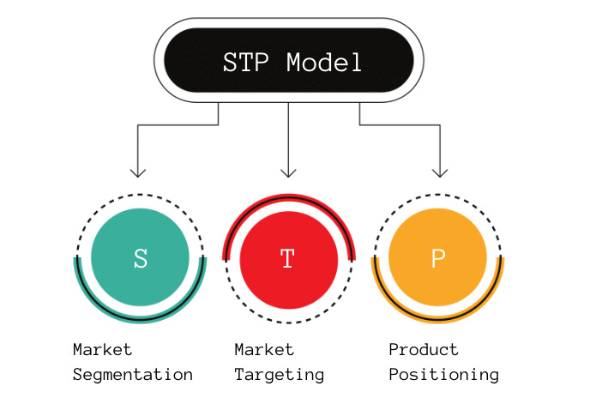
- Segmentation: DIAGEO's collection of alcoholic beverages spans the gamut from beer to spirits, allowing the company to appeal to a wide spectrum of consumers. The business divides its target audience into distinct subsets according to demographic, psychological, and behavioural characteristics. For instance, it markets its Smirnoff brand as a hip and fashionable choice to a younger audience. Its Johnnie Walker brand aims for the same class of wealthy people who appreciate finer things in life. DIAGEO also divides its market by region, aiming its wares at specific countries and regions based on consumer needs.
- Targeting: DIAGEO aims for a wide range of consumers, from young adults to well-off executives. Customers that are picky about what they buy and are prepared to spend more for it are the company's main focus (Helmold, 2022). Consumers that place a premium on getting together with friends over a drink are another focus for DIAGEO, and the company markets its products with this idea in mind. The company plans to focus on lucrative niches and offerings, and it routinely examines its product line to ensure it's on track.
- Positioning: DIAGEO markets itself as the world's preeminent producer and distributor of premium alcoholic beverages. The company's advertising stresses the superiority of its products by emphasising their history and handcrafted nature. In addition to marketing itself as a responsible business, DIAGEO highlights its dedication to sustainability and efforts to lessen the company's environmental effects. The company's products are marketed to those who aspire to project an image of wealth and refinement by associating themselves with the brands. DIAGEO also uses celebrity and influencer endorsements to portray their products as cutting-edge and modern.

Marketing Mix Strategy
The marketing mix, or the "4Ps" (product, pricing, promotion, and place), is a set of guidelines for developing an all-encompassing plan for promoting a product or service. The marketing strategy of DIAGEO is broken down as follows:
- Product: Besides beer and wine, DIAGEO also produces various distilled spirits. Johnnie Walker, Smirnoff, Captain Morgan, and Guinness are just a few of the well-known brands owned by the firm. DIAGEO's products' premium and high-quality positioning attract customers willing to spend more for a superior brand.
- Price: Value perception has a large role in how DIAGEO sets prices. The company's premium items are priced above average because they are aimed at customers willing to pay more for superior quality and opulence. In order to appeal to a wide range of customers, DIAGEO implements a number of pricing differentiation tactics.
- Promotion: Advertising DIAGEO use a wide variety of advertising channels to build consumer interest in its products and sustain its customer base (Seifu, 2022). The corporation spends substantially on marketing to establish a reputation for its products as being on-trend and fashionable. DIAGEO also uses its marketing budget to support major events like music festivals and sporting competitions.
- Place: DIAGEO's products can be found in a wide variety of retail outlets, as well as in bars and restaurants. Products manufactured by the company are exported to over 180 different countries. Distributors and wholesalers are important allies for DIAGEO in getting its wares into the hands of consumers worldwide.

Recommendations for future marketing strategies
With a wide variety of alcoholic beverages, a solid global foothold, and widely recognised brands, DIAGEO has risen to the top of the alcoholic beverage business. The company faces stiff competition, so it must constantly develop new products and adjust its marketing to reflect shifting consumer tastes and new developments in the marketplace. Some suggestions for DIAGEO's future advertising campaigns:
- Expand in Emerging Markets: DIAGEO should look to strengthen its foothold in fast-growing regions like Asia and Africa. As a result of rising living standards and shifting consumer choices, these regions offer promising expansion potential. DIAGEO can capitalise on the opportunities in these markets by increasing its product lines and advertising campaigns there.
- Diversify Product Offerings: Products should be diversified to include low-alcohol and non-alcoholic options as consumers become more health conscious and demand them. The business might build on its existing brand portfolio to meet the needs of this expanding market.
- Increase Sustainability Efforts:DIAGEO has to maintain its commitment to sustainability and cutting its carbon footprint. The business could attract eco-conscious customers by emphasising its commitment to sustainability.
- Leverage Technology: The utilisation of technology could help DIAGEO's marketing efforts. The company could expand its customer base through targeted digital marketing and social media efforts. Virtual tours of distilleries and augmented reality advertising campaigns are just two examples of how DIAGEO could leverage technology to give customers a more engaging and personal experience.

Conclusion
DIAGEO's smart marketing tactics are a major reason for the company's success in the cutthroat alcoholic beverage market. The high competitiveness and dependency on important markets are possible limitations that could limit development potential, while the diversified portfolio, global presence, and excellent brand awareness are significant assets. Opportunities for DIAGEO to innovate and stand out include entering new markets and broadening the range of products it offers. To stay competitive, the organisation must continuously adjust its approach to meet the shifting tastes of its target market. Overall, DIAGEO's continuous focus on innovation and sustainability will help the firm remain competitive in the future, and the company's smart marketing techniques have allowed it to remain a major player in the alcoholic beverage industry.

References
Alam, Q. and Parveen, R., 2022. BUNDABERG BREWED DRINKS. Regional Businesses in a Changing Global Economy: The Australian Experience.
Atiase, V.Y., Agbanyo, S., Ameh, J.K., Sambian, R.M. and Ganza, P., 2022. Creating value for whom? Digitization and governance practices of nontraditional export firms in Africa. Strategic Change, 31(1), pp.31-44.
Edwards, C., 2021. Entrepreneurs and regulations: Removing state and local barriers to new businesses. Cato Institute, Policy Analysis, (916).
Helmold, M., 2022. Market Segmentation, Targeting, Differentiation and Positioning. In Performance Excellence in Marketing, Sales and Pricing: Leveraging Change, Lean and Innovation Management (pp. 105-116). Cham: Springer International Publishing.
Lucid Content Team (2018). How to Define Strategy Using Porter’s Five Forces. [online] Lucidchart.com. Available at: https://www.lucidchart.com/blog/what-is-strategy.
Moore AM, M., 2020. Exposing the tactics of alcohol companies. European Journal of Public Health, 30(Supplement_5), pp.ckaa165-216.
Seifu, M., 2022. The Effect of Promotional Tools on Brand Image: The case of Diageo, Meta Abo Breweries SC (Doctoral dissertation, St. Mary’s University).
Shaw, J. (2017). How to Complete a Personal SWOT Analysis. [online] Medium. Available at: https://medium.com/thrive-global/how-to-complete-a-personal-swot-analysis-2f8769aebd5e.
Stacchini, A., Guizzardi, A. and Mariotti, A., 2022. Smoothing down arbitrariness in planning: From SWOT to participatory decision making. Land Use Policy, 119, p.106213.
Staples, A.J., Reeling, C.J., Widmar, N.J.O. and Lusk, J.L., 2020. Consumer willingness to pay for sustainability attributes in beer: A choice experiment using eco‐labels. Agribusiness, 36(4), pp.591-612.
White, J.S., 2023. Sustainable distilling: CO2 emissions, energy decarbonization, and by-products. In Distilled Spirits (pp. 299-332). Academic Press.

