

Contemporary Theme of Technology in the Hotel and Hospitality Industry

Student Name : Filis Laris Osman
Student ID : 2025564
Module Name : Contemporary Themes in the Hotel and Hospitality Sector
Module Code: BMIH6001
Lecturer’s Name : Giulia Chifari

Table of Contents
Introduction 4
About the Company 5
Overview of Literature- SWOT Analysis 6
Artificial Intelligence and the UK Hotel Sector 11
Technological Advancements: Artificial Intelligence 11
Intercontinental Hotels Group and Artificial Intelligence (AI Solutions) 12
Future Policy and Management Options 16
Signals Intelligence (SIGINT) 16
State from Artificial Governance 17
Competitive Strategies 17
Conclusion 19
References 20

Table of Figures
Figure 1: Intercontinental Hotels Group (IHG) 5
Figure 2: Market Size of UK Hospitality Industry 6
Figure 3: UK Hospitality Industry Leaders 7
Figure 4: AI usage throughout the Nation 10
Figure 5: Share of businesses using Artificial Intelligence (AI) 12
Figure 6: Model of Using the Artificial Intelligence 13
Figure 7: UK Hospitality Industry theoretical framework 14
Figure 8: Contemporary Issues faced by UK Hospitality due to Artificial Intelligence 15
Figure 9: Cyber Security measures for preventing data infringements 17
Figure 10: Factors which affect Artificial Governance 18

Introduction
In the hospitality and Hotel sector, technology stances as a metamorphic power, determining visitor experiences and working productivity. From unified online reservations and mobile registrations to custom-made room commands and AI-oriented caretaker facilities, technology improves expediency and raises client happiness (Bulchand-Gidumal et al, 2023). In corporation innovative analytics also permits data-oriented policy-making, enhancing resource distribution and advertising approaches. Additionally, in a post-epidemic epoch, technology helps in executing well-being and security procedures, nurturing a sense of faith amongst visitors. Accepting technology not merely rationalises procedures but is important for continuing rivalry and linking the developing hopes of contemporary tourists to the energetic scenery of hospitality. The selected corporation for the report is the InterContinental Hotels Group and the technology theme is artificial intelligence and its AI-based solutions. The report has emphasised the usage of the technology by the company along with the issues which are being faced by them at present. It further includes the SWOT Analysis and the recommendatory measures like Signal intelligence, state of artificial governance etc. with the main aim to deal with these issues.

About the Company
InterContinental Hotels and Resorts, an internationally well-known lavish hospitality brand, exemplifies elegance and fineness in commerce. With an affluent inheritance ranging over seven eras, InterContinental has constantly set the quality for luxurious housing and unequalled facilities. Acknowledged for its legendary properties in main places globally, the brand provides to discriminating tourists looking for a mixture of cultural legitimacy and modern richness (InterContinental Hotels and Resorts, 2023). Accepting leading-edge technology and supportable performance, InterContinental Hotels and Resorts endures reconsidering the artwork of hospitality, generating mesmerising experiences that resound with the contemporary worldwide tourist even though maintaining the brand's promise to untiring quality and matchless grace.

Figure 1: Intercontinental Hotels Group (IHG)
[Source: Intercontinental Hotels Group, 2023].
InterContinental Hotels and Resorts, a leader in splendour hospitality, circumnavigates the growing scenery by perfectly incorporating technology and remarkably AI-based solutions. Artificial Intelligence enhances guest exposure with modified facilities, from computer-generated caretaker assistance to prophetical room personalisation. The business's enfold of Artificial Intelligence as well as its subsidiary technology-based solutions increases working proficiency, rationalisation booking procedures, and strengthens data-oriented policy-making (Gupta et al, 2022). Among worldwide connectivity requests, InterContinental deliberately accepts Artificial Intelligence to modify amenities, confirming a pleasant-sounding mixture of tradition and novelty. This planned tech incorporation not only makes a parallel with the brand's assurance of brilliance but also places InterContinental as a forward-looking front-runner in the self-motivated monarchy of hospitality and hotel.
Overview of Literature- SWOT Analysis
SWOT Analysis through System Theory-Effect of AI on InterContinental Hotels and Resorts in the Hospitality Commerce
Strengths:
Enhanced Visitor Exposures through Personalisation:
System Theory- InterContinental's integration of AI generates an energetic system where visitor information is unceasingly input, administered, and used to personalise facilities.
Impact- The organised system allows the hotel to familiarise facilities in actual time, providing personalised recommendations, room predilections, and modified connections (Ioannou Katidou and Sakalidou, 2020). This increases visitor happiness, nurturing an optimistic feedback loop as gratified visitors are probably to be involved more with the B & B.
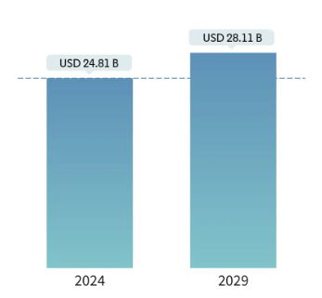
Figure 2: Market Size of UK Hospitality Industry
[Source: Mondor Intelligence, 2024].

Enhanced Operational Productivity:
System Theory- AI-oriented technologies shape unified classification that systematises working duties, making a rationalised and organised working model.
Impact- The consistent classification confirms all-in-one communication between numerous divisions, improving resource distribution and refining total productivity (Ioannou Katidou and Sakalidou, 2020). For example, AI-generated chatterbots could manage routine visitor enquiries, permitting workers to concentrate on more multifaceted responsibilities, thereby increasing output.
Weaknesses:
Initial ExecutionPrices and Staff Training:
System Theory- The outline of Artificial Intelligence necessitates an orderly service, together with economic funds in technology and complete worker training agendas(Margas, 2023).
Impact- The primary transition phase might witness short-term disturbances as the system familiarises itself with new-fangled technologies. The interrelation of several hotel tasks suggests that worker training is important for the whole system to work coherently.
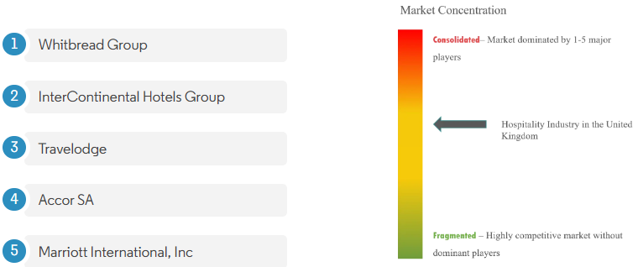
Figure 3: UK Hospitality Industry Leaders
[Source: Mondor Intelligence, 2024].
Dependence on Technological Substructure:
System Theory- The hotel's dependency on consistent Artificial Intelligence systems suggests susceptibility to disturbances in the high-tech substructure.
Impact- A let-down in any element of the system, whether due to practical problems or cyber intimidations, possibly will disturb the whole working movement (Margas, 2023). This highlights the significance of strong cybersecurity procedures and contingency strategies to uphold system flexibility.
Opportunities:
Data-OrientedDecision-Making and IncessantDevelopment:
System Theory- Artificial Intelligence systems generate a control-loop arrangement where information is unceasingly composed, examined, and exploited for policy-making(Bie, 2023).
Impact- The hotel possibly will harness actual-time information to make well-versed conclusions, acclimatising facilities built on altering visitor likings and marketplace tendencies. This iterative aspect procedure confirms incessant development inside the system, positioning facilities with self-motivatedclienthopes.
Customisation and Targeted Advertising:
System Theory- The consistent Artificial Intelligence system permits for the formation of targeted promotion approaches built on individual visitor silhouettes and activities(Bie, 2023).
Impact- The classification modifies elevations, faithfulness programs, and advertising crusades to definite visitor sectors, increasing the efficiency of advertising hard work. This modified method subsidises enlarged visitor involvement and trustworthiness.
Threats:
Cybersecurity Dangers and Information Confidentiality Concerns:
System Theory- The interrelated artificial Intelligence system includes the unceasing movement of delicate visitor information, making it vulnerable to cybersecurity intimidations(Alizadeh and Foroughi, 2023).
Impact- A break in the arrangement may well negotiate legitimate secrecy, giving rise to lawful difficulties and destroying the hotel's status. The consistent flora of the system intensifies the requirement for strong cybersecurity procedures to protect the honesty of the complete classification.
Adaptation to Growing Technology:
System Theory- The hotel's dependency on Artificial intelligence suggests a necessity for
incessant adaptation to developing machinery.
Impact- The affiliated system needs sporadic information and improvement to stay up-to-date with industrial progressions (Alizadeh and Foroughi, 2023). Let-down to acclimate might outcome in system inadequacies or a competitive shortcoming as the business grows.
InterContinental Hotels Groups amalgamation of Artificial intelligence technologies demonstrates a multifaceted and mutually dependent system. System theory supports what means numerous elements inside the hotel, from visitor facilities to working purposes, shapeaco-dependent systems that trust the unified addition of Artificial Intelligence (Doborjeh et al, 2022). Even though strong points influence the helpful feedback loops inside this classification, feebleness underlines the necessity for full preparation and adaptation. Chancesdisplayin what way the system possibly will incessantly progress and recover, even thoughintimidationshighlight the significance of protecting the whole interdependent edifice contrary to possible hazards. The theoretical amalgamation of technology, chiefly Artificial Intelligence, inside InterContinental Hotels and Resorts, has reappraised hospitality by inspiring visitor practices, confirming working productivity, and talking about current dares (Kong et al, 2023). The planned acceptance of technology lines up with growing visitor hopes and places the brand as an innovator in employing novelty for a unified and custom-made hospitality exposure.

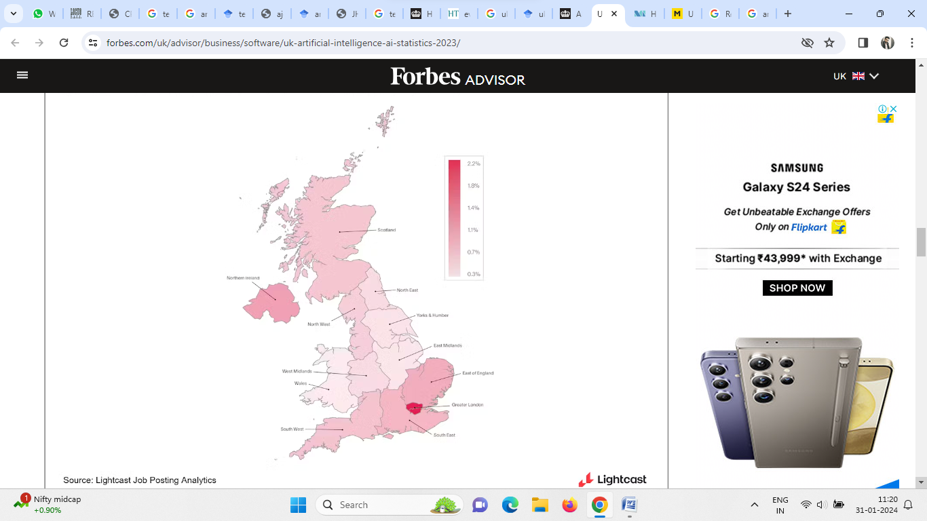
Figure 4: AI usage throughout the Nation
[Source: Forbes, 2023].

Artificial Intelligence and the UK Hotel Sector

Technological Advancements: Artificial Intelligence
The advent of the Industry 4.0 revolution has been recognised as the catalyst which has impetus the pace of technological advancements in the UK Tourism as well as the Hospitality Industry. There are different types of technologies which are being firmly utilised by business firms in the terre operational activities on a consecutive basis. These technologies may include Robotics, a wide variety of mobile apps, the Internet of Things (IoT), virtual reality, contactless solutions etc. The Central administration of the country is also been supporting the business firms who are being engaged in the UK Tourism and hospitality segment to adopt as well as implement these innovative technologies in a strategic manner. For instance, the UK Government has promoted the Help to Grow Programme to increase the pace of innovation in the SMEs who are being engaged in the hospitality industry under the main head of the Hospitality Strategy: Reopening, Recovering and Resilience (GOV.UK, 2023).
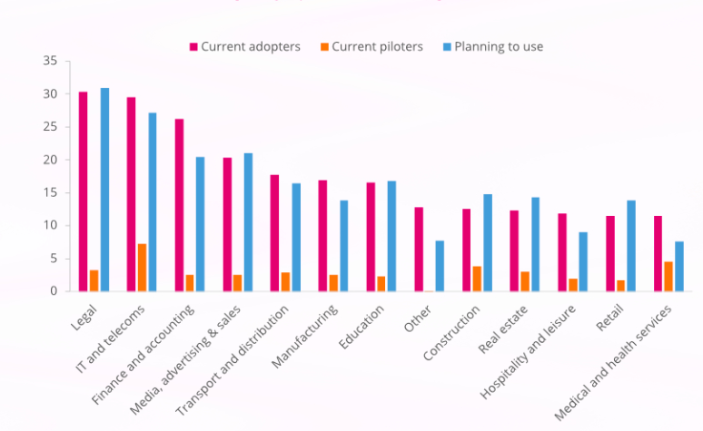
Figure 5: Share of businesses in using Artificial Intelligence (AI)
[Source: Forbes, 2023].
One of the most common technologies which have been widely adopted as well as utilised by the business users of this industry is Artificial Intelligence (AI). The UK AI market has been valued at around £16.9 billion in the year 2023 (Forbes, 2023). The term artificial intelligence refers to the development of computer systems which perform tasks with human intellect like reasoning, problem-solving etc (GOV.UK, 2022). The UK has been considered the hub for artificial technologies throughout Europe. Artificial intelligence, as well as its subsidiary technologies, are being broadly utilised by the business organisations of the national hospitality industry. This has been because they firmly assist them in their business operations which has led to the expansion of this market ambit into the industry. For instance, around 12% of the UK Hospitality businesses have adopted as well as implemented the use of these technologies with a growth rate of around 6.5% (Huang et al., 2022).

Intercontinental Hotels Group and Artificial Intelligence (AI Solutions)
Business firms like the Intercontinental Hotels Group (IHG) are being recognised for their usage of a wide variety of technologies to attain their desired business goals. The company has firmly utilised artificial intelligence as well as its subsidiary technologies to accomplish its ultimate organisational objectives. The usage of these innovative technologies has firmly assisted the company in coping with contemporary market adversities like stakeholder issues etc (Buhalis and Moldavska, 2022). The stakeholder issues are considered the foremost problematic situations which have been faced by business firms at the contemporary time. Business firms in the hospitality sector are using these technologies with the main aim of redressing the issues which have been raised due to the operational activities of the company with their customers. For instance, the Intercontinental Hotels Group (IHG) has raised the usage of artificial intelligence as well as its subsidiary technologies in booking as well as customer care centres (Intercontinental Hotels Group, 2022).

Figure 6: Model of Using the Artificial Intelligence
[Source: Ruel and Njoku, 2020].
This has firmly assisted the company to handle these operations in a more effective as well as efficient manner. These have further led to a rise in the satisfaction levels of their customers (Drexler and Lapré, 2019). These ahs further led to the attainment of a wide variety of organisational objectives like the rise into organisational goodwill as well as the mature customer bank of the company. Business firms like the Intercontinental Hotels Group (IHG) are being recognised for their communal effort through the optimum utilisation of artificial intelligence technologies. The organisational initiatives of the company in the context of artificial intelligence technologies can be firmly understood under the main head of the collaboration with the other business firms. For instance, the company has firmly prioritised their efforts to collaborate with Winnow with the main aim to assist their hotels to minimise food wastage as well as the upraise the sustainability approaches in the company. This has resulted in a 30% reduction in food wastage in the hotels of the company due to the adoption as well as the implementation of the Winnow Vision AI Enable Technology (Intercontinental Hotels Group, 2019).
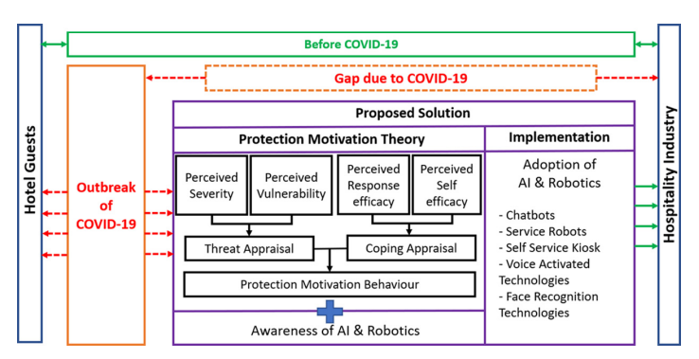
Figure 7: UK Hospitality Industry theoretical framework
[Source: Gaur et al., 2021].
This has been further recognised as one of the most prominent Artificial Intelligence-based solutions which has been adopted as well as utilised by the business firm. These technological advancements envisage the usage of high-tech cameras, smart scales as well as AI-based smart metre technology. This has firmly assisted the business organisation at present, where more than the 5,600 hotels of the company are firmly utilising these technologies throughout the world. There are various types of issues which arise in the course of the business operations of the company in the context of the usage of artificial intelligence as well as its subsidiary technologies. These issues can be firmly recognised under the following heads-
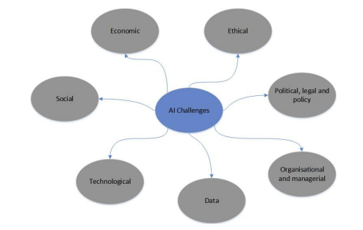
Figure 8: Contemporary Issues faced by UK Hospitality due to Artificial Intelligence
[Source: Dwivedi et al., 2021].
Data Security
Data security has been recognised as the foremost issue which has been faced by the company at the contemporary time. This is because artificial technologies are being used by the company in the context of their consecutive business operations (Chi et al., 2020). This further signifies that the data which have been used by the company must be stored securely. These can further lead to the adoption of a wide variety of these technological measures to attain a secure environment where the integral information of the organisation's customers can be kept securely. The Intercontinental Hotels Group has been adopting as well as implementing various measures to secure their integral information from cyber infringements.
Changing perspectives of technologies
The artificial technologies which are being used by the business firs can be firmly recognised under the main head of machine learning, robotics etc. These technologies are being used by customers to book their rooms in hotels etc. For instance, there are around 44% of customers book their rooms online manner along with their payment and the locality (MINTEL, 2023). These new advancements in artificial intelligence and its subsidiary technologies may lead to the backwardness of the company in terms of the competitive edge over its rival firms.
Artificial Intelligence Governance
The main issue which has been faced by contemporary business organisations is the rapid advancements as well as the upgradations into AI-based solutions and technologies. The advent of new technologies leads to the rise of various responsibilities (Conrady and Buck, 2012). These further lead to the formulation of numerous types of policies as well as ethical standards to mitigate the risks of violation of any of these standards.

Future Policy and Management Options
The recommendatory measures for the participants of the national hospitality industry country to cope with the issues which have arisen due to the usage of artificial intelligence are as follows-

Signals Intelligence (SIGINT)
The Signals can be recognised as the foremost preventive measure which must be adopted as well as implemented by the business first to prevent their integral information from the various types of cyber attacks. This makes the integral customer-centric data of the company secure from the infringements of cyber-attackers (WINDER and LEVINE, 2019). This is because this system prevents unwanted accesses who do not have the authority to approach the informative data. These systems must be adopted as well as utilised by the management of the Intercontinental Hotels Group (IHG) as these will lead to the diminishment of the number of cases of data violation from unauthorised users. These will further assist the other business organisations that are being engaged in the wide variety of business operations of the hospitality segment.
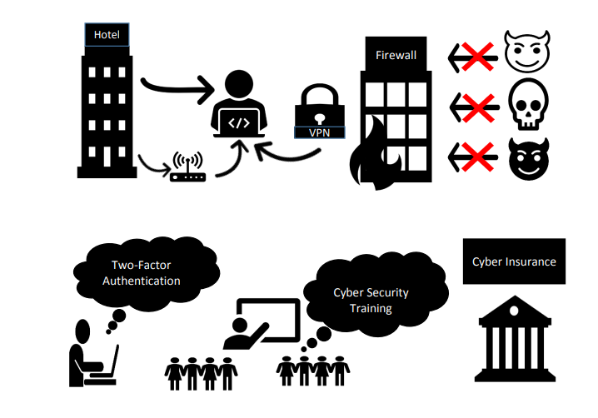
Figure 9: Cyber Security measures for preventing data infringements
[Source: Shabani and Munir, 2020]

State from Artificial Governance
The term artificial governance connotes a wide variety of factors including the tools, solutions etc which may lay down the dualistic impact of the subsidiary applications as well as the development of artificial intelligence (Butcher and Beridze, 2019). These can firmly assist the business firms under the UK Hospitality segment to adversities which may arise under the main head of the roles as well as the responsibilities into these technologies. For instance, the Ethically Aligned Design can be recognised as another example which symbolises the ethical initiative which is being taken by corporations using artificial intelligence.
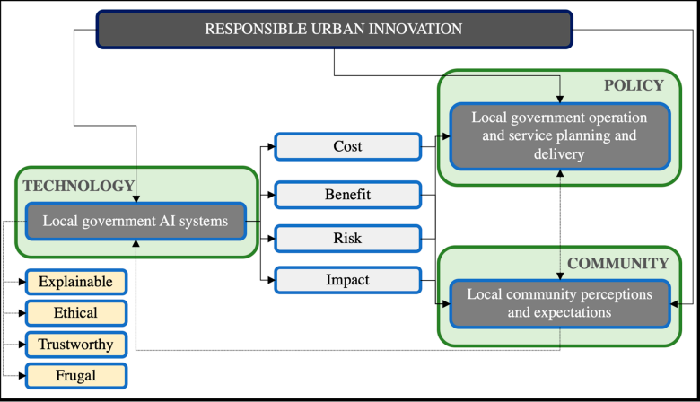
Figure 10: Factors which affect Artificial Governance
[Source: Yigitcanlar et al., 2021]

Competitive Strategies
The rise of various types of innovations as well as the alterations to the prevailing technologies has firmly assisted business firms to cope with the contemporary issues in the context of artificial intelligence. The adoption, as well as formulation of the different types of competitive strategies, will firmly assist the business corporations to maintain their competitiveness in the hospitality industry. Intercontinental Hotels Group (IHG) has adopted as well as executed their competitive strategy by increasing its additional investments to upgrade its technological capabilities (Intercontinental Hotels Group, 2020).

Conclusion
Lastly, it can be said that numerous business firms are being engaged in the hospitality segment of the country and are being adopted as well as implementing numerous types of artificial intelligence as well as its subsidiary technologies which have firmly assisted them in raising their business growth. The InterContinental Hotels Group has been optimally utilising a wide variety of artificial intelligence-based technologies in their consecutive business operations. These all business operations have firmly assisted them in attaining their desired business growth. The company has been adopting as well as executing numerous types of recommendatory measures to cope with contemporary issues like data privacy information through Signals Intelligence etc.

References
Alizadeh, H. and Foroughi, M. (2023) A Strategic SWOT Analysis of Leading Electronics Companies based on Artificial intelligence. International Journal of Business Management and Entrepreneurship, 2(5), pp.59-74.
Bie, X. (2023) Suggestions for Applying Digital Technology to Improve Service Quality in Mid to High-end Hotels. Journal of Innovation and Development, 5(2), pp.42-44.
Buhalis, D. and Moldavska, I. (2022) Voice assistants in hospitality: using artificial intelligence for customer service. Journal of Hospitality and Tourism Technology, 13(3), pp.386-403.
Bulchand-Gidumal, J., William Secin, E., O’Connor, P. and Buhalis, D. (2023) Artificial intelligence’s impact on hospitality and tourism marketing: exploring key themes and addressing challenges. Current Issues in Tourism, pp.1-18.
Butcher, J. and Beridze, I. (2019) What is the state of artificial intelligence governance globally? The RUSI Journal, 164(5-6), pp.88-96.
Chi, O.H., Denton, G. and Gursoy, D. (2020) Artificially intelligent device use in service delivery: A systematic review, synthesis, and research agenda. Journal of Hospitality Marketing & Management, 29(7), pp.757-786.
Conrady, R. and Buck, M. eds. (2012) Trends and issues in global tourism 2012. Springer Science & Business Media.
Doborjeh, Z., Hemmington, N., Doborjeh, M. and Kasabov, N. (2022) Artificial intelligence: a systematic review of methods and applications in hospitality and tourism. International Journal of Contemporary Hospitality Management, 34(3), pp.1154-1176.
Drexler, N. and Lapré, V.B. (2019) For better or for worse: Shaping the hospitality industry through robotics and artificial intelligence. Research in Hospitality Management, 9(2), pp.117-120.
Dwivedi, Y.K., Hughes, L., Ismagilova, E., Aarts, G., Coombs, C., Crick, T., Duan, Y., Dwivedi, R., Edwards, J., Eirug, A. and Galanos, V. (2021) Artificial Intelligence (AI): Multidisciplinary perspectives on emerging challenges, opportunities, and agenda for research, practice and policy. International Journal of Information Management, 57, p.101994.
Forbes (2023) UK Artificial Intelligence (AI) Statistics And Trends In 2024. Forbes [online]. Available from: https://www.forbes.com/uk/advisor/business/software/uk-artificial-intelligence-ai-statistics-2023/ [Accessed 25/01/2024].
Gaur, L., Afaq, A., Singh, G. and Dwivedi, Y.K. (2021) Role of artificial intelligence and robotics to foster the touchless travel during a pandemic: a review and research agenda. International Journal of Contemporary Hospitality Management, 33(11), pp.4079-4098.
GOV.UK (2023) Hospitality Strategy: Reopening, Recovery, Resilience. GOV.UK [online]. Available from: https://assets.publishing.service.gov.uk/media/63ff288b8fa8f527fac3da8d/hospitality_strategy_update_on_delivery_report.pdf [Accessed 25/01/2024].
Gupta, S., Modgil, S., Lee, C.K., Cho, M. and Park, Y. (2022) Artificial intelligence enabled robots for stay experience in the hospitality industry in a smart city. Industrial Management & Data Systems, 122(10), pp.2331-2350.
Huang, A., Chao, Y., de la Mora Velasco, E., Bilgihan, A. and Wei, W. (2022) When artificial intelligence meets the hospitality and tourism industry: an assessment framework to inform theory and management. Journal of Hospitality and Tourism Insights, 5(5), pp.1080-1100.
InterContinental Hotels Group (2019) Award-winning AI technology helps IHG hotels track, measure and reduce food waste. InterContinental Hotels Group [online]. Available from: https://www.ihgplc.com/en/news-and-media/news-releases/2019/award-winning-ai-technology-helps-ihg-hotels-track-measure-and-reduce-food-waste [Accessed 25/01/2024].
InterContinental Hotels Group (2021) Annual Report and Form 20-F 2021. InterContinental Hotels Group [online]. Available from: https://www.ihgplc.com/~/media/Files/I/Ihg-Plc/investors/annual-report-2021/ihg-2021-annual-report.pdf [Accessed 25/01/2024].
InterContinental Hotels Group (2022) Annual Report and Form 20-F 2022. InterContinental Hotels Group [online]. Available from: https://www.ihgplc.com/~/media/Files/I/Ihg-Plc/investors/annual-report/annual-report-2022.pdf [Accessed 25/01/2024].
InterContinental Hotels Group (2023) About Us. InterContinental Hotels Group [online]. Available from: https://www.ihgplc.com/en/our-brands/intercontinental. [Accessed: 31/01/2024].
Ioannou Katidou, A. and Sakalidou, M.C. (2020) The impact of Self-Service Technologies in the Hotel Industry on Employee's Job and Customer Satisfaction.
Kong, H., Wang, K., Qiu, X., Cheung, C. and Bu, N. (2023) 30 years of artificial intelligence (AI) research relating to the hospitality and tourism industry. International Journal of Contemporary Hospitality Management, 35(6), pp.2157-2177.
Margas, S. (2023) Artificial intelligence and the industry of hospitality and tourism threats and opportunities.
MINTEL (2023) AI ACTIVITY IN UK BUSINESSES. MINTEL [online]. Available from: https://store.mintel.com/report/uk-hotels-market-report [Accessed 25/01/2024].
Mondor Intelligence (2024) Hospitality Industry in UK Size & Share Analysis - Growth Trends & Forecasts (2024-2029). Mondor Intelligence [online]. Available from: https://www.mordorintelligence.com/industry-reports/hospitality-industry-in-the-united-kingdom [Accessed 25/01/2024].
Ruel, H. and Njoku, E. (2020) AI redefining the hospitality industry. Journal of Tourism Futures, 7(1), pp.53-66.
Shabani, N. and Munir, A. (2020) A review of cyber security issues in hospitality industry. In Intelligent Computing: Proceedings of the 2020 Computing Conference, Volume 3 (pp. 482-493). Springer International Publishing.
WINDER, P.B.J. and LEVINE, G. (2019) HOSPITALITY INDUSTRY PRIVACY WHITEPAPER.
Yigitcanlar, T., Corchado, J.M., Mehmood, R., Li, R.Y.M., Mossberger, K. and Desouza, K. (2021) Responsible urban innovation with local government artificial intelligence (AI): A conceptual framework and research agenda. Journal of Open Innovation: Technology, Market, and Complexity, 7(1), p.71.

