Entrepreneurship
BMIH5001
Individual Business Model Canvas with entrepreneurial reflection

Lecturer: Ka Po Chong
Student id: 2213957
Student name: Georgiana Cucu
Word count: 2063

Part 1.
The proposed enterprise is an organic dining establishment that prioritizes procuring locally and sustainably. Its objective is to accommodate the growing need for dining options that are both healthful and environmentally sustainable. By utilizing organic, locally sourced ingredients, the restaurant intends to create a menu that is both delectable and environmentally friendly. This strategy reduces the carbon footprint associated with food transportation while supporting local producers (Stein and Santini, 2021). A custom that values health and sustainability is intended to be drawn to the restaurant by its dedication to eco-friendly practices and nutritious, high-quality fare. The restaurant aims to establish a novel benchmark for sustainable cuisine and distinguish itself in the highly competitive hospitality industry by giving precedence to these components (Barringer and Ireland, 2018).

The value proposition of the restaurant is predicated on its dedication to providing a culinary experience that prioritizes health, all the while featuring a meticulously curated menu of organic foods. The restaurant upholds sustainability, supports the local ecosystem, and guarantees the availability of fresh ingredients through its emphasis on local procurement (Osterwalder et al., 2015). Situated in prime urban areas, it ensures convenient accessibility for clientele. Additionally, in order to elevate the dining experience, the establishment places an emphasis on contemporary amenities and meticulous sanitation. Furthermore, it exhibits an inclusive stance by providing area for children's entertainment, in this manner accommodating families. Satisfying the demands of health-conscious and environmentally conscientious consumers, this model exemplifies corporate responsibility and sustainable practices (Williams, 2021).

Collaboration with local organic farms and co-ops is an integral component of the business strategy as it guarantees a consistent provision of fresh ingredients, which is a critical component in upholding the restaurant's dedication to serving organic and nourishing meals (Rae, 2008). By forming alliances with organizations such as the Soil Association, one can guarantee that the organic produce utilized is genuine (Soil Association, 2020). Specialized logistics companies are critical in ensuring the safe transportation of perishable products while preserving their organic integrity. In the same way, manufacturers of eco-friendly packaging adhere to the brand's environmental principles (Blackwell, 2011). Renewable energy providers are essential for the sustainable operation of businesses. At the core of this approach lie several activities such as stimulating robust supplier relationships to guarantee product quality, adhering to rigorous organic certification criteria, consistently introducing novel dishes to accommodate diverse dietary requirements, and capitalizing on conventional and digital marketing channels to expand market penetration. The primary objectives of distinctive culinary events and exceptional customer service are to foster brand loyalty and increase brand exposure. For in-person and online transactions, streamlining the ordering and payment procedures is essential for increasing revenue and improving the customer experience (Zimmerer and Scarborough,2011).

The organic restaurant's focus on customer segments that correspond to market segmentation and consumer behavior theories underscores the significance of accommodating particular groups characterized by unique preferences (Minaee et al., 2021). Health-conscious consumers are in search of nourishing, high-quality cuisine that complements their way of life. Encouraging sustainable agricultural practices, proponents of organic farming exhibit a predilection for establishments that procure ingredients in an ethical manner. Environmentalists are drawn to companies that strive to reduce their ecological impact. Menus that accommodate the dietary requirements of individuals with allergies or food sensitivities are crucial, with a particular emphasis on safety and inclusivity. Individuals in search of novel and exceptional dining experiences seek out distinctive culinary options. Finally, clientele with an interest in a "organic lifestyle" are attracted to companies that exemplify their individual values and inclinations, thus showcasing how their product offerings correspond with their personal values and way of life.

The restaurant implements a personalized strategy when cultivating client relationships by customizing the culinary experience to accommodate specific dietary restrictions and personal preferences. By ethics-compliantly utilizing consumer data, this customization is enhanced, as it facilitates the recollection of preferred dishes or allergies of returning customers, consequently cultivating loyalty and a feeling of inclusion (Mariotti and Glackin, 2012). A rewards program that directly links customer engagement with tangible benefits, such as seasonal meals or attendance at wellness events, encourages repeat visits and healthy eating habits by awarding points for such actions. Promoting feedback channels, both physical and virtual, fosters a reciprocal flow of communication that guarantees consumers feel acknowledged and appreciated. The restaurant's proactive participation in community health-related activities serves to strengthen its reputation as a brand that prioritizes the welfare of the local community. Moreover, by utilizing email newsletters, social media, and other digital platforms, the restaurant can inform customers about upcoming events, health advice, and new menu items, in that way maintaining a dialogue outside the establishment (Helmold, 2012). In addition to sustaining participation, this approach fosters a sense of community centered on the mutual appreciation for health and sustainability. Conceptual frameworks such as Relationship Marketing emphasize the significance of implementing these tactics when establishing enduring consumer connections. Relationship marketing, according to Huggins et al., (2020), is preoccupied with consumer satisfaction and retention as opposed to short-term transactions. In light of this theoretical framework, the restaurant's endeavors to tailor experiences to individual preferences, incentivize customer loyalty, elicit feedback, foster community involvement, and uphold transparent communication are all pivotal in fostering long-lasting relationships and guaranteeing customer perseverance. By adopting this strategy, the restaurant not only establishes a unique position for itself in a highly competitive industry but also satisfies modern consumers' demands for customized and significant brand engagements.

The restaurant's ability to deliver on its value proposition of providing nutritious and environmentally favorable food relies heavily on critical resources. Organically certified ingredients are indispensable for guaranteeing the quality and sustainability of the food, thereby adhering to the environmental philosophy of the restaurant. An adequately furnished culinary area facilitates the creation of organic and allergen-free dishes, thereby enriching the gastronomic encounter for patrons who prioritize their health. Efficient point-of-sale (POS) systems and resilient IT infrastructure facilitate seamless in-store transactions as well as online interactions, encompassing order processing and reservation management (Timmons and Spinelli,2008). The criticality of the culinary staff's ability to craft health-conscious dishes demonstrates the significance of human resources in fulfilling the restaurant's commitment. The strategic implementation of marketing tools such as pay-per-click, social media, email marketing, and search engine optimization is crucial for optimizing distribution channels and increasing the restaurant's visibility and interaction with prospective clients. Implementing a customer relationship management (CRM) system is critical for sustaining long-term customer relationships, managing loyalty programs, and monitoring customer feedback. Physical resources, including a hospitable dining area that embodies the brand's principles and caters to the varied requirements of patrons, are crucial in establishing a favorable ambiance. The availability of financial resources facilitates the execution of premium pricing tactics and the administration of cash flow across diverse revenue streams, such as delivery, in-house dining, and event coordination. In accordance with theoretical frameworks such as the Resource-Based View (RBV), these resources emphasized the significance of both tangible and intangible assets in attaining strategic objectives and obtaining a competitive edge. According to Barney (1991), the RBV posits that distinctive capabilities and resources are essential to an organization's strategy and performance. This emphasizes the criticality of these essential resources to the achievement of the restaurant.

The organic restaurant's cost structure shows the substantial investments necessary to sustain its value proposition. As a result of their sustainable agricultural methods and reduced economies of scale, organic ingredients are more expensive than their non-organic counterparts (Fernandes et al., 2020). An additional crucial cost is the remuneration of proficient chefs and staff who possess expertise in organic products and dietary restrictions. This expenditure underscores the significance of human capital in the provision of high-quality service. Ongoing financial commitments are required for marketing and advertising, specifically in the digital domain, in order to efficiently engage the intended audience and establish brand recognition (Burns, 2022). Obtaining and sustaining organic certification, as well as adhering to health and safety protocols, are additional expenditures that the restaurant must bear in order to comply with regulatory mandates. The most expensive operational resources include investments in specialized kitchen equipment designed for the preparation of allergen-free and organic food, as well as advanced information technology systems utilized for reservation and customer relationship management. Menu development, which necessitates investigation and ingenuity to satisfy the demands of health-conscious consumers, and quality control and compliance, which guarantee adherence to organic and dietary principles, are exceptionally costly endeavors. These expenditures are critical for the restaurant to sustain its competitive advantage and are consistent with the value chain analysis theory, which stresses the significance of maximizing consumer value-creating activities (Dubey et al., 2020).

The establishment utilizes a combination of conventional and digital platforms in order to efficiently engage with its clientele. Conventional media such as leaflets, billboards, and television advertisements target a wide-ranging demographic, which promotes consciousness within the immediate vicinity. By targeting specific demographics and interests, online channels such as email marketing, Pay Per Click, social media, and LinkedIn, increase engagement and improve the precision of marketing efforts. The revenue streams are diversified, with a substantial portion of revenue coming from premium pricing that signifies the health benefits, quality, and origin of the food, as well as the overall culinary experience (Roysko, 2023). Further streams encompass take-away provisions and event coordination, with an emphasis on the significance attributed to the ambiance, caliber of service, and distinctive attributes such as environments suitable for families. The versatility of payment methods to accommodate both in-store and online transactions enhances consumer convenience.

Part 2.

Graham Gibbs introduced the Gibbs reflective cycle in 1988 as a framework for systematic reflection on the phases of an activity or experience. It has since found extensive application in the fields of education and professional development (Adeani, Febriani and Syafryadin, 2020). In order to delve into this model, I commence by recounting my GET2 test experience, an assessment that gauges an individual's inclination towards initiating and overseeing projects. The assessment outcomes categorised me as "Occasional Enterprising," a label that implies a moderate level of involvement in entrepreneurial endeavours. The results elicited a combination of surprise and introspection within me, as they appeared to contradict my preconceived notions regarding my potential as an entrepreneur. As I assessed this result, I pondered the ramifications of adopting a risk-averse approach in specific circumstances, which might restrict certain prospects but could also mitigate the likelihood of failure in high-stakes endeavors. To conduct a more comprehensive analysis, I utilized McClelland's Theory of Needs as a framework. According to Osemeke and Adegboyega (2017) individuals are driven by a distinct combination of needs for power, affiliation, and accomplishment. The outcomes I obtained are consistent with an entrepreneurial profile that prioritizes calculated risks and sustainable growth over high-risk endeavors, which is consistent with a moderate need for achievement. Upon careful reflection of these observations, I have reached the conclusion that my enterprising inclinations, although not overly assertive, may be well-suited for structured environments that value innovative yet prudent strategies, qualities similar to those of an intrapreneur as defined by Pinchot cited in Orchard (2015). However, the moderate inclination towards enterprise indicated here may indicate a well-balanced approach, potentially reflecting a strategic risk orientation that is consistent with the calculated conservatism observed in corporate environments. Adopting this mindset allows for the recognition and capitalization on opportunities that fall within specific risk thresholds; this could prove to be an especially advantageous outlook in fast-paced and competitive business landscapes. In pursuit of professional opportunities that foster innovation and calculated risk-taking, I aim to develop these skills through focused educational initiatives, including Massive Open Online Courses provided by FutureLearn and OpenLearn. The objective of this methodical strategy for cultivating my entrepreneurial aptitudes is to maximize my capacity for business ventures in environments that strike a balance between risk reduction and innovation. Furthermore, the strategy entails utilizing business simulation tools and case studies to refine market analysis and strategic thinking abilities, as suggested by Rae (2008) in its investigation of the entrepreneurial process. Through the incorporation of these components into my personal growth and progress, my objective is to augment my entrepreneurial material, consequently empowering myself to make substantial contributions to enterprises that prioritize both ingenuity and judicious administration. By undertaking this introspective task and utilising the Gibbs model as a structure, I have discerned a means to efficiently exploit my enterprising qualities and devised a plan for my professional growth that is congruent with my individual attributes and the ever-changing nature of the modern business environment.
References:

Adeani, I.S., Febriani, R.B. and Syafryadin, S. (2020). Using Gibbs’ Reflective Cycle In Making Reflections Of Literary Analysis. Indonesian EFL Journal, [online] 6(2). Available at: https://journal.uniku.ac.id/index.php/IEFLJ/article/view/3382.
‌Barringer, B. R. & Ireland, R.D. (2018) Entrepreneurship: Successfully Launching New Ventures, 4thEd., Prentice Hall: New Jersey

Blackwell, E. (2011), How to Prepare a Business Plan: Planning for Successful Start-up and
Expansion, (5th Ed) Sunday Times Business Enterprise Series, Kogan Page

Burns, P. (2022) Entrepreneurship and Small Business, 5th Ed., Palgrave Macmillan: Basingstoke

Dubey, S., Singh, R., Singh, S.P., Mishra, A. and Singh, N.V., 2020. A brief study of value chain and supply chain. Agriculture Development and Economic Transformation in Global Scenario, pp.177-183.

Fernandes, S. da C., Pigosso, D.C.A., McAloone, T.C. and Rozenfeld, H. (2020). Towards product-service system oriented to circular economy: A systematic review of value proposition design approaches. Journal of Cleaner Production, 257, p.120507. doi:https://doi.org/10.1016/j.jclepro.2020.120507.

Helmold, M. (2022). Supply Chain Management and Distribution Channels. pp.185–198. doi:https://doi.org/10.1007/978-3-031-10097-0_18.

Huggins, K.A., White, D.W., Holloway, B.B. and Hansen, J.D., 2020. Customer gratitude in relationship marketing strategies: A cross-cultural e-tailing perspective. Journal of Consumer Marketing, 37(4), pp.445-455.

Mariotti, S. and Glackin, C. (2012) Entrepreneurship: Starting and Operating a Small Business (3rd
Ed), London: Prentice-Hall.

Minaee, S., Boykov, Y.Y., Porikli, F., Plaza, A.J., Kehtarnavaz, N. and Terzopoulos, D. (2021). Image Segmentation Using Deep Learning: A Survey. IEEE Transactions on Pattern Analysis and Machine Intelligence, [online] 44(7), pp.1–1. doi:https://doi.org/10.1109/tpami.2021.3059968.

Orchard, S. (2015). Entrepreneurship and the Human Capital of Organizational Innovation: The Intrapreneur. The Entrepreneurial Rise in Southeast Asia, pp.111–138. doi:https://doi.org/10.1057/9781137373809_6.

Osemeke, M. and Adegboyega, S. (2017). Critical review and comparism between maslow, herzberg and mcclelland’s theory of needs. Funai Journal of Accounting, [online] 1(1), pp.161–173. Available at: https://www.fujabf.org/wp-content/uploads/2018/01/Critical-Review-and-Comparism-between-Maslow-Herzberg-and-McClellands-Theory-of-Needs.pdf.

Osterwalder, A., Pigneur, Y., Bernarda, G. and Smith, A. (2015). Value Proposition Design: How to Create Products and Services Customers Want. [online] Google Books. John Wiley & Sons. Available at: https://www.google.co.uk/books/edition/Value_Proposition_Design/jgu5BAAAQBAJ?hl=en&gbpv=1&dq=value+proposition&pg=PA8&printsec=frontcover

Rae, D. (2008) Entrepreneurship: from opportunity to action, 2nd Ed., Basingstoke: Palgrave
Macmillan

Röyskö, M., 2023. Utilizing pay-per-click search engine marketing for an SME’s B2B marketing mix.

Soil Association (2020). Soil Association. [online] Soilassociation.org. Available at: https://www.soilassociation.org/.

Stein, A.J. and Santini, F. (2021). The sustainability of ‘local’ food: a review for policy-makers. Review of Agricultural, Food and Environmental Studies, [online] 103. doi:https://doi.org/10.1007/s41130-021-00148-w.

Timmons, J. & Spinelli, S. (2008) New Venture Creation: Entrepreneurship for the 21st Century,
McGraw Hill: Boston

Williams, S. (2021) FT Guide to Business Start Up: The most comprehensive guide for
entrepreneurs, 32nd Ed., Financial Times Press: Harlow.

Zimmerer, T.W. & Scarborough, N.M. (2011) Essentials of Entrepreneurship, 6th Ed., Prentice Hall:
New Jersey

‌

Appendix:

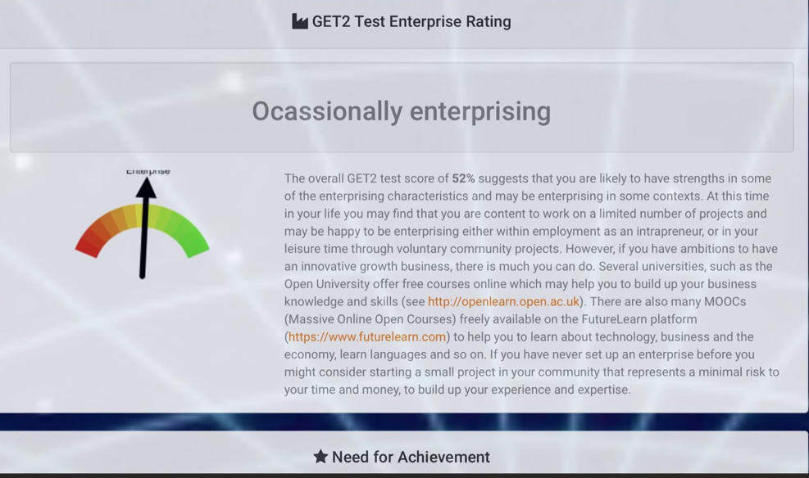
Fig 1. GET2 Test

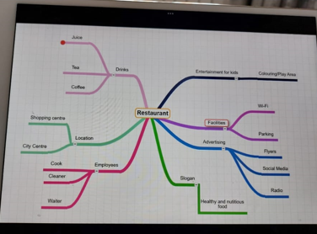
Fig 2. Concept map.

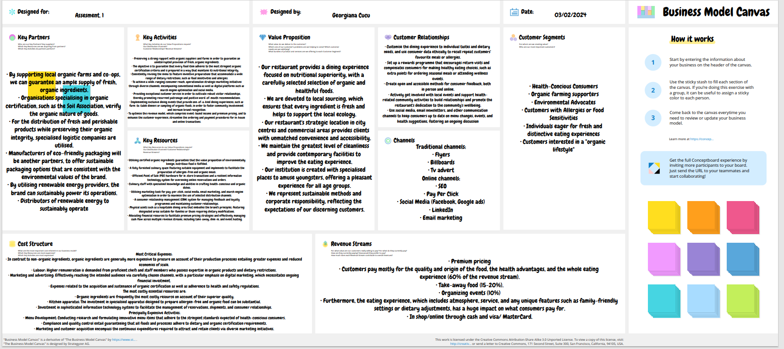
Fig 3. BMC

