

Student name: Tania Begum
Student ID:2441716

Module name: Introduction to health and social care
Module code: LCHS4003
Lecturer name : Mohammad Aliyu
Content page

Element 1 …………………………………………………………….. page
Current functioning: 1. This service covers the whole of London — about 620 square miles and nearly 9 million people.
2. ⁠It answers around 2 million 999 calls a year and attends more than 3,000 emergencies every day.
3. ⁠Its role includes not just responding, but also working on less-serious calls, helping find hospital beds, and working in major incident planning.

Challenges: Two Current Challenges Facing UK Ambulance Services
1. Increased Demand and Response Time Delays. The number of 999 calls has risen sharply — over 10 million calls were made in England in 2023 alone.
2. Recruitment, Retention, and Staff Wellbeing. Ambulance staff face long shifts, emotional stress, and increasing violence and abuse from the public.
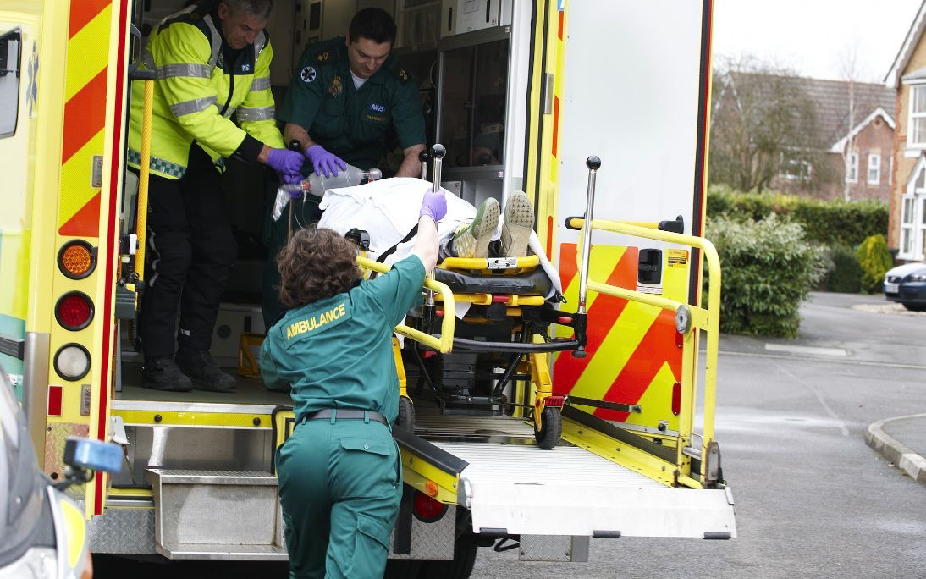
Introduction: Ambulance service is a very important part of UK healthcare system, supplying emergency and non-emergency services care to the vulnerable people every year. They are responsible to responding to 999 calls and give primary treatment until transporting them to the hospitals. Ambulance services also support urgent community care and major incident response. Ambulance crews include paramedics, emergency medical technicians, and call handlers, all working together to deliver urgent care. They use advanced equipment to treat patients at the scene, meaning many people can be helped without going to hospital. Overall, ambulance services are essential for providing immediate care, preventing further harm, and making sure patients reach the right medical support as quickly as possible.

Brief history of Ambulance service: The idea of Ambulance Service care start in the 19th century inspired by battlefield medicine.
The horse- drawn ambulance were invented and introduced metropolitan asylum board, mainly to transport infectious patients to hospital.
By the 1920-1930s motorised ambulance replaced horse - drawn ambulances. When the National Health Service (NHS) was founded in 1948, ambulance services were brought under local health authorities.
AMBULANCE SERVICES

Task 2: The Origin of the National Health Service (NHS)

The National Health Service (NHS) was created in 1948, but the ideas behind it developed over many years. Before the NHS existed, healthcare in Britain was uneven and often based on whether people could afford to pay. Many families relied on charity hospitals, private doctors, or had no care at all. Illness could easily lead to poverty.

During the Industrial Revolution, crowded cities and dangerous factories caused more accidents and disease. This made it clear that the country needed a better way to care for its workers. In 1911, the government introduced the National Insurance Act, which helped some workers pay for a doctor. However, this scheme did not cover everyone—especially women, children, and the unemployed.

A major push for change came during World War II. The war required organised medical services, and emergency healthcare was provided to everyone who needed it. This showed that a national system could work effectively. In 1942, Sir William Beveridge published the famous Beveridge Report, which suggested a welfare system to support people from “cradle to grave.” He argued that everyone should have access to health services, and that poverty should not prevent people from getting treatment.

After the war, the Labour government, led by Minister of Health Aneurin Bevan, acted. Bevan believed that the government should guarantee healthcare for all citizens. Despite disagreements with doctors and hospitals about how the system should be run, Bevan successfully launched the NHS on 5 July 1948. It was the world’s first system to offer free, universal healthcare, funded by taxes.

Key Principles of the NHS

Three main principles shaped the NHS:
1. Universal Access – Everyone living in the UK should be able to use the NHS.
2. Free at the Point of Use – People do not pay when they receive treatment.
3. Funded Through Taxation – The cost is shared fairly across society through taxes.

Current Structure of the NHS

Today, the NHS is large and complex. It includes:
• Department of Health and Social Care (DHSC) – sets overall policy and direction.
• NHS England – manages the national budget and the delivery of services.
• Integrated Care Systems (ICSs) – regional groups that coordinate hospitals, GPs, mental health services, and community care.
• NHS Trusts – organisations that run hospitals and specialist services.
• Primary Care Services – such as GPs, pharmacists, dentists, and opticians.

Critical Examination of the NHS Today

The NHS is still valued as one of the UK’s most important public services. It offers fair access to care and remains less expensive than many international healthcare systems.

Strengths:
• Free and fair access for everyone.
• Strong public support and trust.
• Cost-effective compared to private insurance-based systems.

Challenges:
• Long waiting times for operations and emergency care.
• Staff shortages, especially nurses and GPs.
• Growing demand from an ageing population and more long-term conditions.
• Financial pressure, leading to stretched resources.

References

Beveridge, W. (1942). Social Insurance and Allied Services.
Webster, C. (2002). The National Health Service: A Political History.
Gorsky, M. (2008). “The British National Health Service 1948–2008.” Health Economics, Policy and Law.
The King’s Fund (2021). The NHS at 75: Lessons for the Future.
References for task 1: NHS Digital. (2024). NHS Workforce Statistics: Ambulance Staff Overview. Retrieved from https://digital.nhs.uk/
BBC News. (2023). Ambulance delays: Why are response times getting worse? Retrieved from https://www.bbc.co.uk/news/health-64216424.

