Field Journal
INTRO
The surveying performed in Strata Florida ranged across a large part of the land originally owned by the monastery, which was founded in 1184, including the abbey woods, and the field next to the abbey ruins, referred to in this journal as ‘the bumpy fields’. The general area surrounding the abbey has strong evidence of human interaction for an extended period of time, ranging from iron-age hillforts on hills not far from the abbey, the Cistercian monastery, further farming around the 16th century, and used in RAF training during WWII. There has been a range of archaeological interaction with the landscapes surrounding and including the ones which we surveyed.

ABBEY WOODS
The second and third days of our module were spent in the Abbey woods. During this time, we went on a walk around the area, identifying different earthenworks and considering different ways in which the landscape has been interacted with. This included mainly a range of roads that signified the monastery's boundaries, walls, and leats carrying water across the landscape, to help with farming and mining.
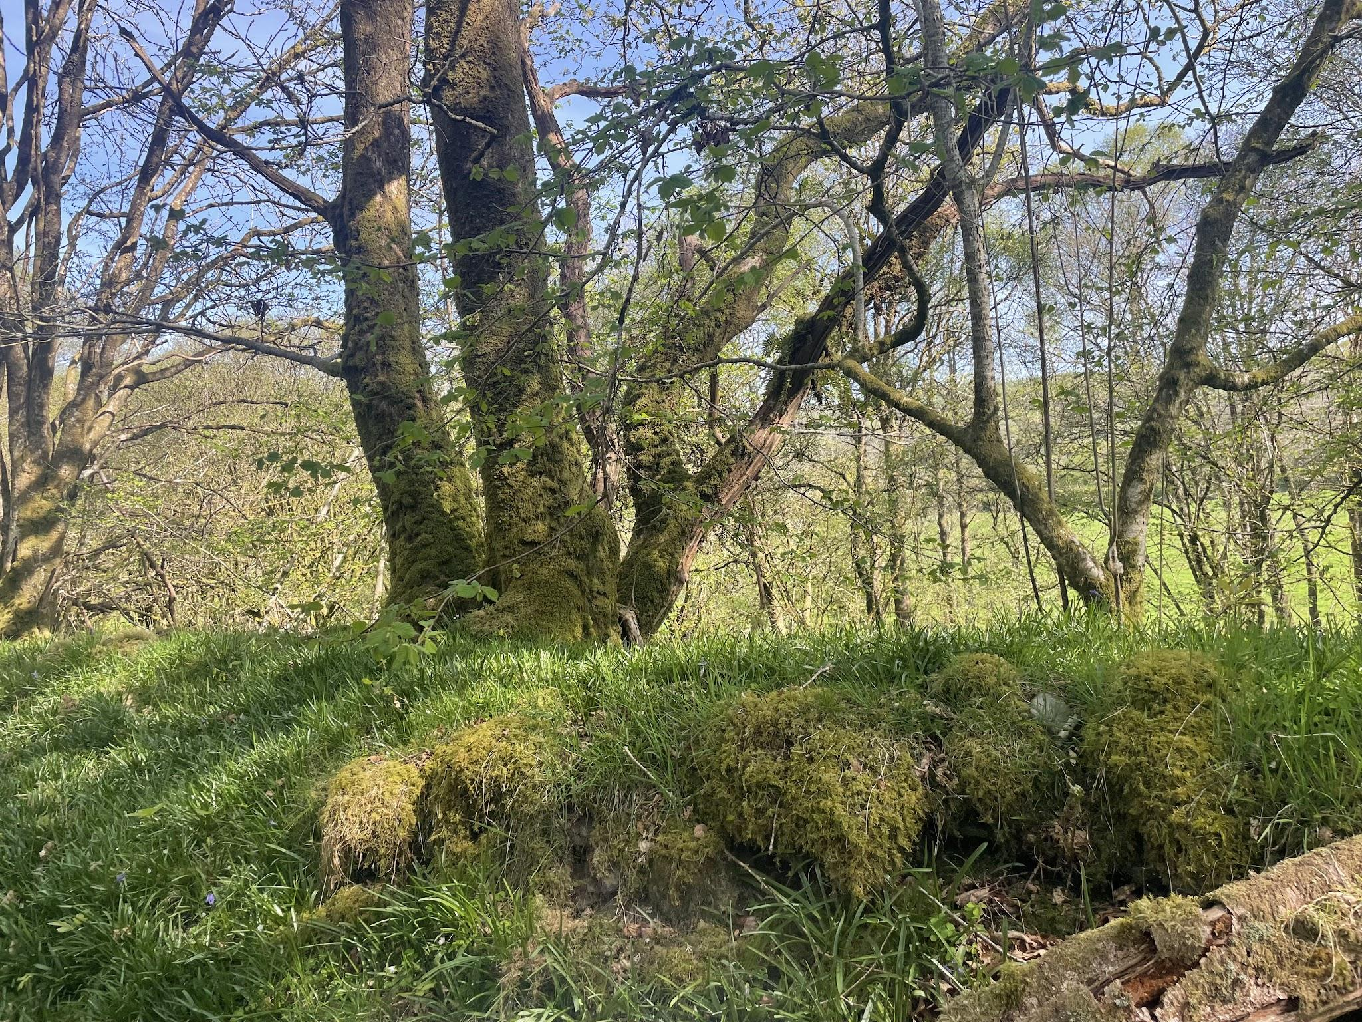
left: bank of one of the roads across the woods
We also considered the potential of a kiln in the area, due to the likelihood of the monastery producing pottery, and the prevalence of clay in the area. However, excavations where the kiln was suspected to be revealed nothing. There were also considerations of how this space was changed through the different managements of the land. Many of the trees in the woods were identified to likely be quite modern (70-80 years old).However, there ois evidence of other interaction with the area, including parts of planes from the RAF training during the second world war, and a tree that was likely from at least the 17th century. There is also some speculation of interaction in these woods before the medieval and monastic period: with a stone formation which looks similar to Neolithic burial mounds. However, there is also a likelihood that this could be a dump site from all of the walls built around this area in the medieval and post-medieval period.
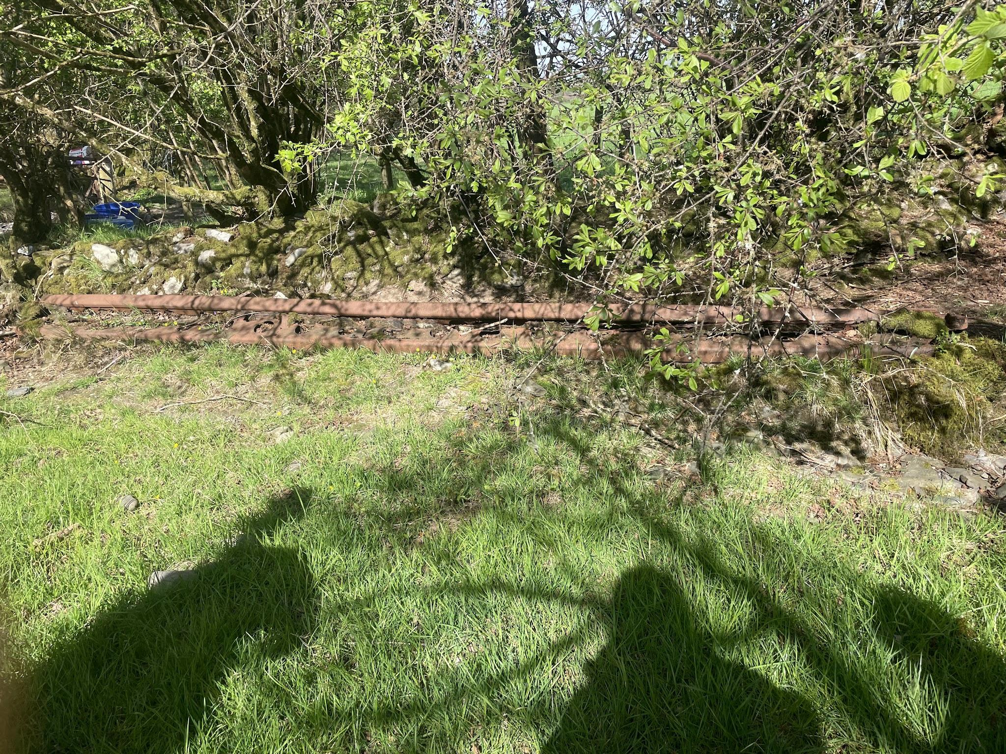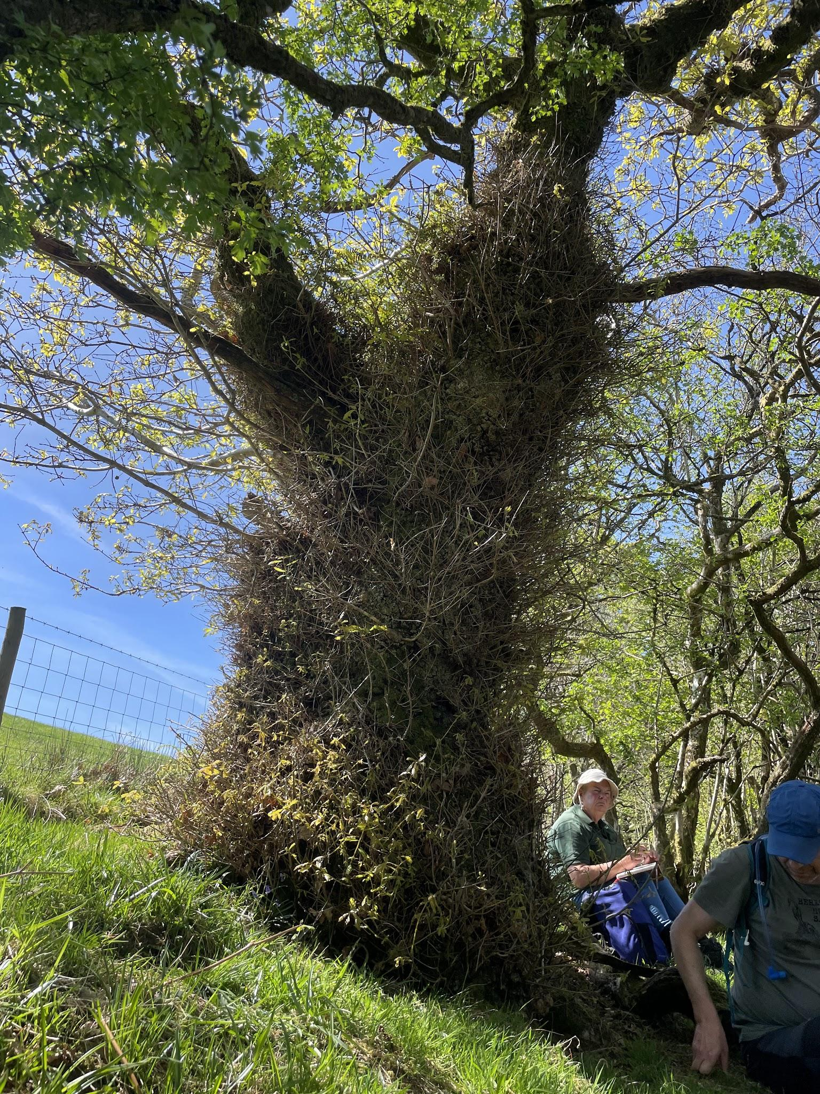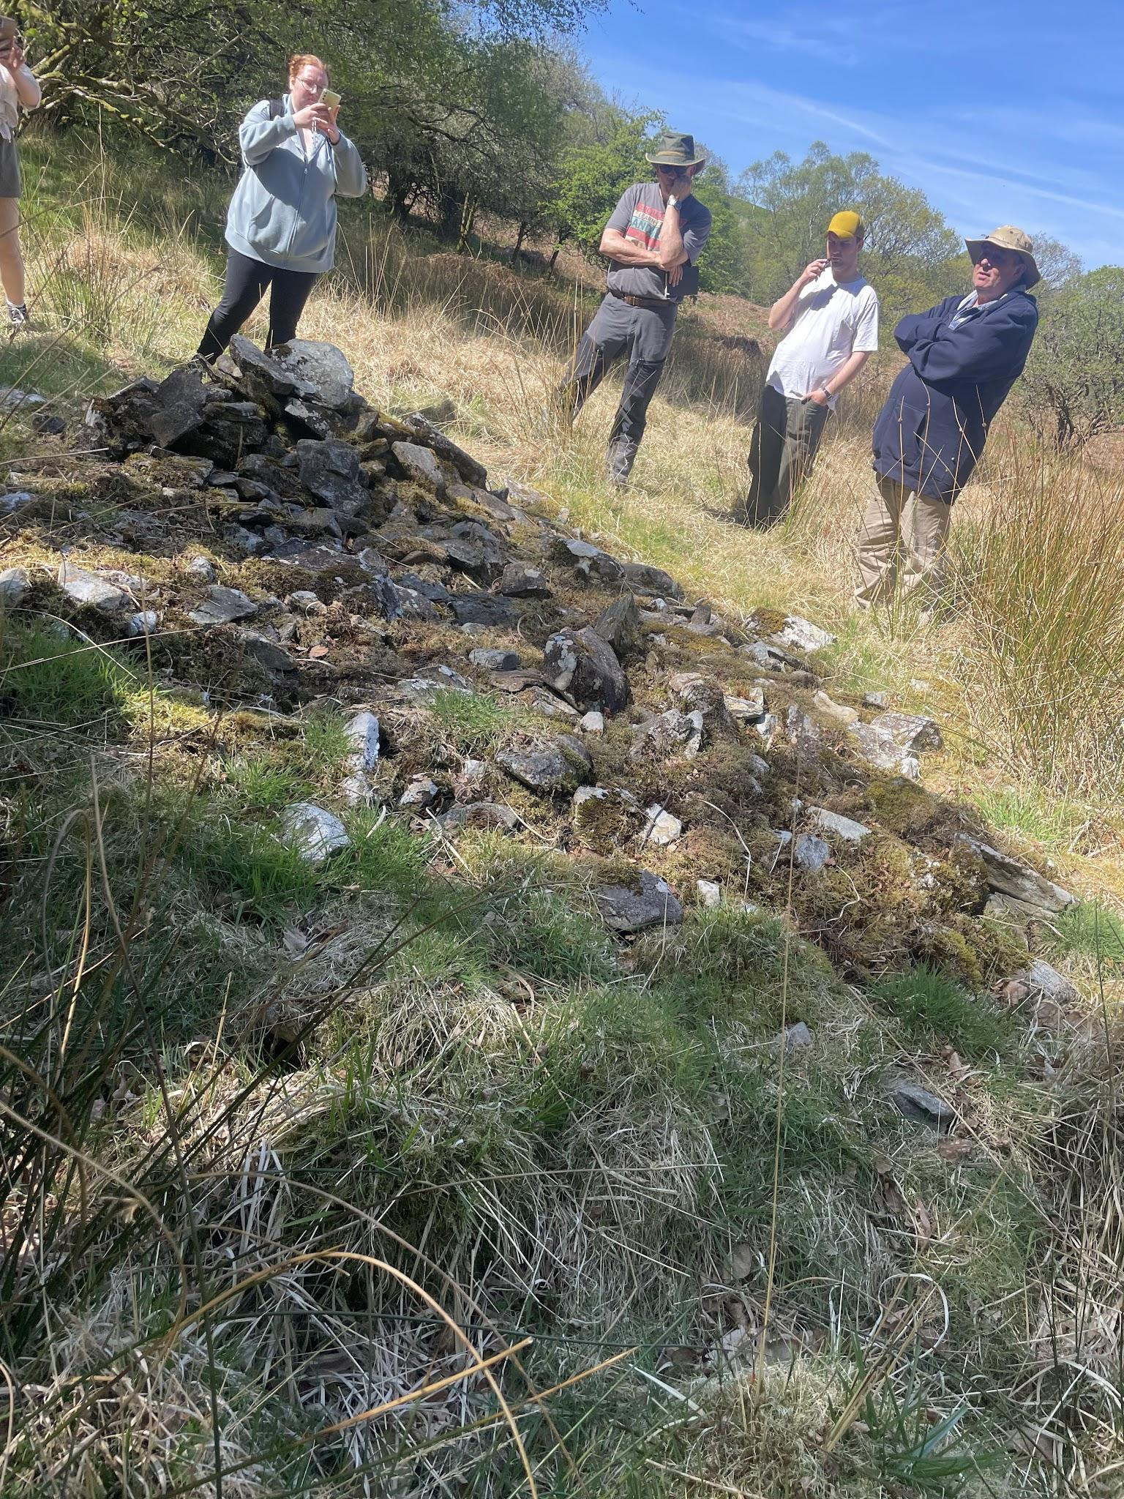
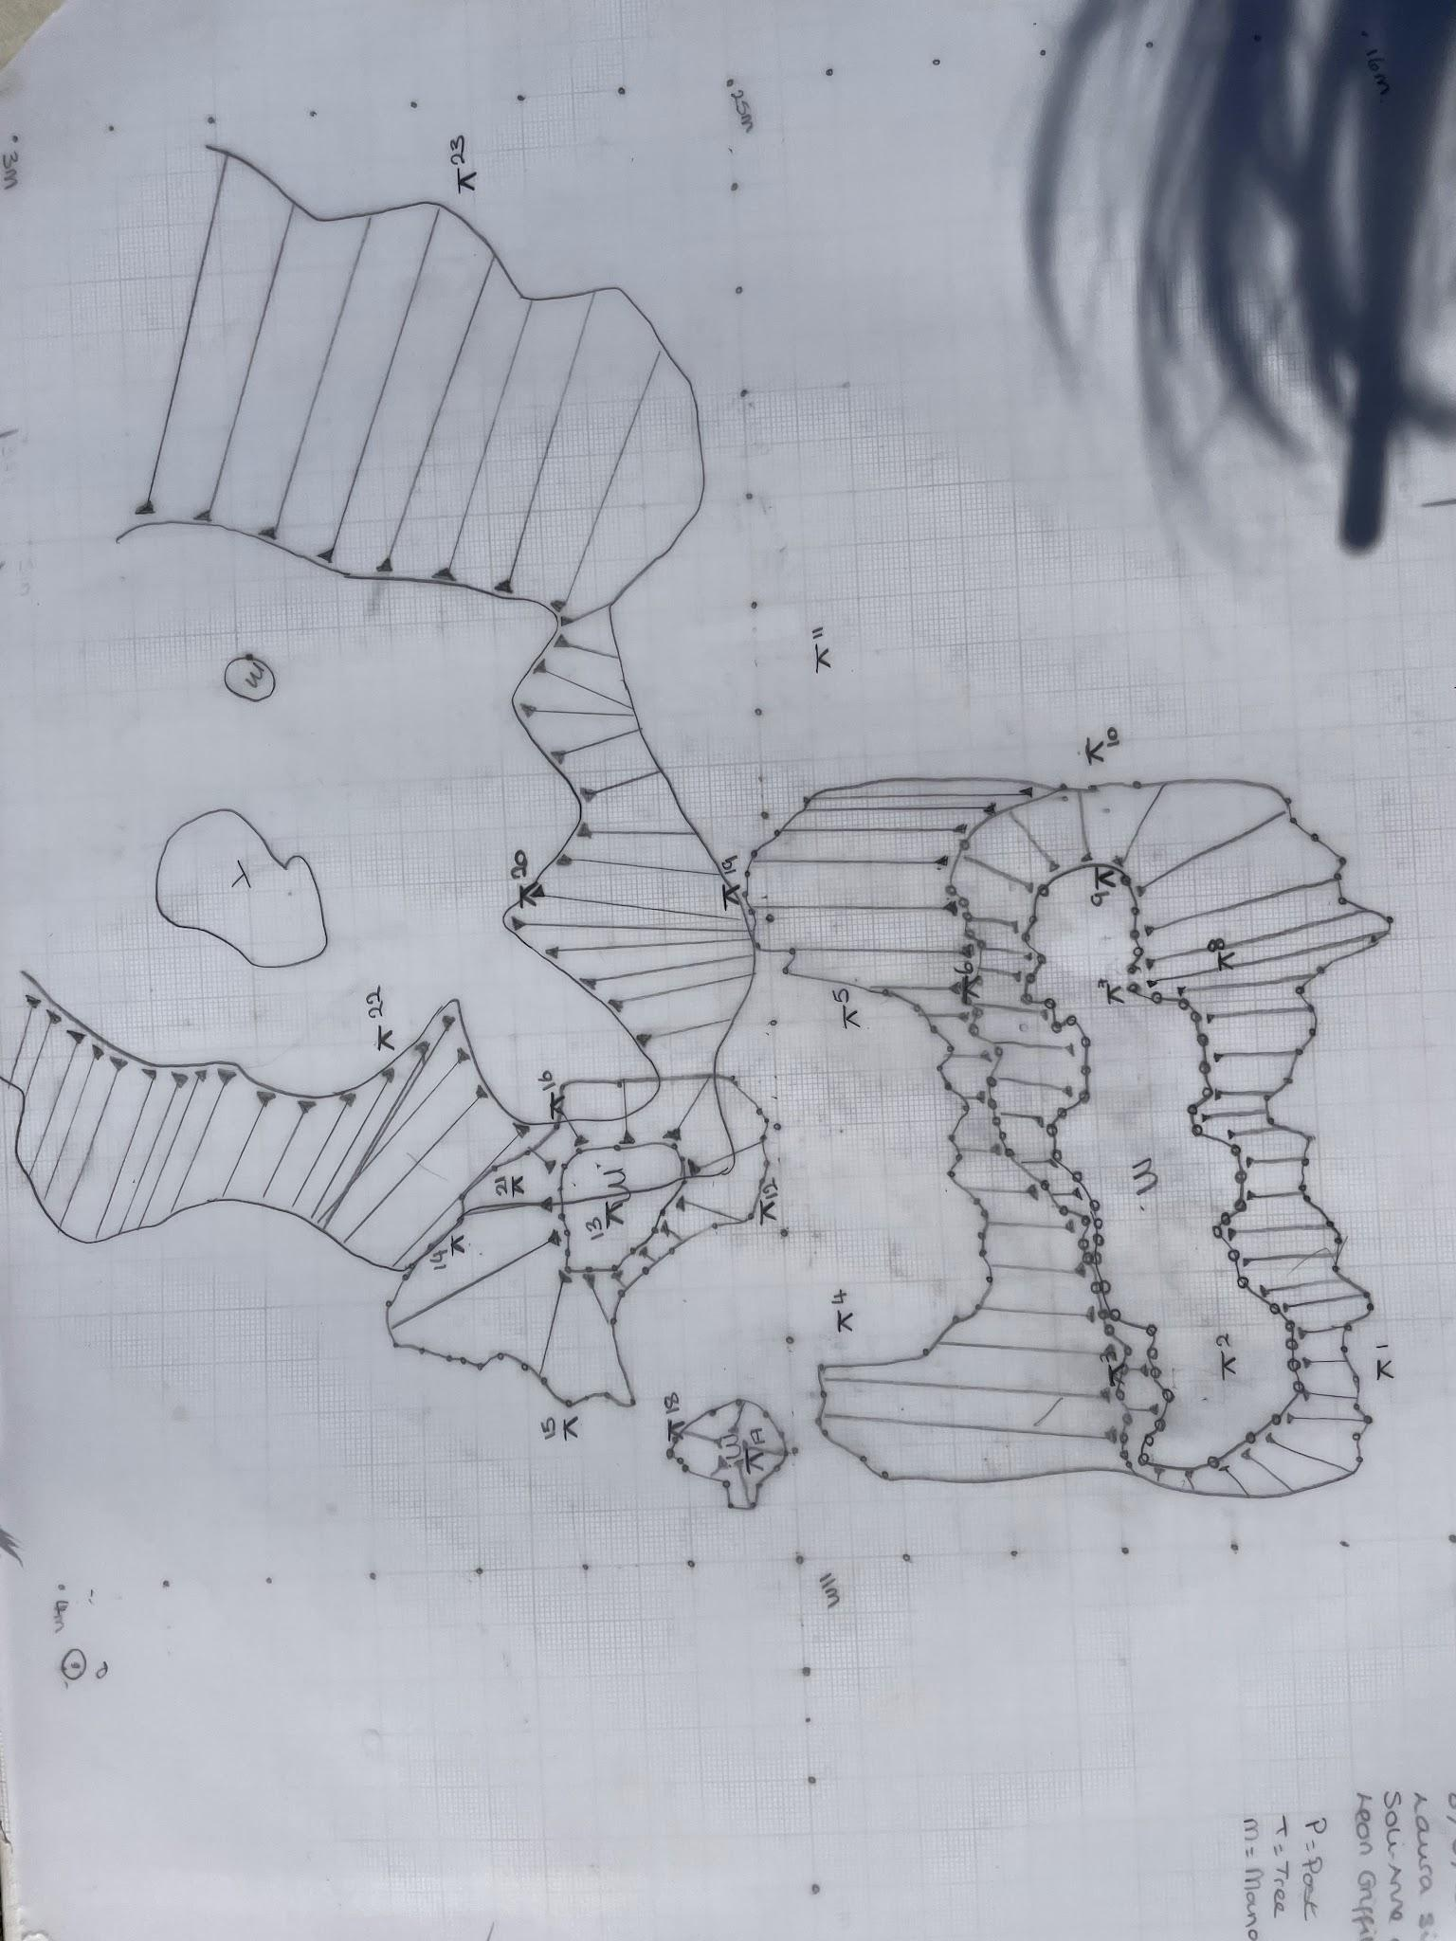
Above left: a piece of RAF aircraft. Middle: the tree rumoured to be at least 500 years old, Above right: collection of stones
The landscape of the woods was where we began to develop the skills necessary for ra[id site surveying. We did this initially on a small cross-section of road by the edge of the woods towards the abbey. The main aim at this time was to begin to understand the use of hachures as a sign of sloping and include approximate measurements that could be converted into metric measurements if necessary. For this, I used my steps. I found this space a useful place to begin understanding rapid site surveying, as the enclosed space helped me focus on one thing at a time.
BELOW: initial hachure survey of a section of the road, notes on how to perform a rapid site survey.
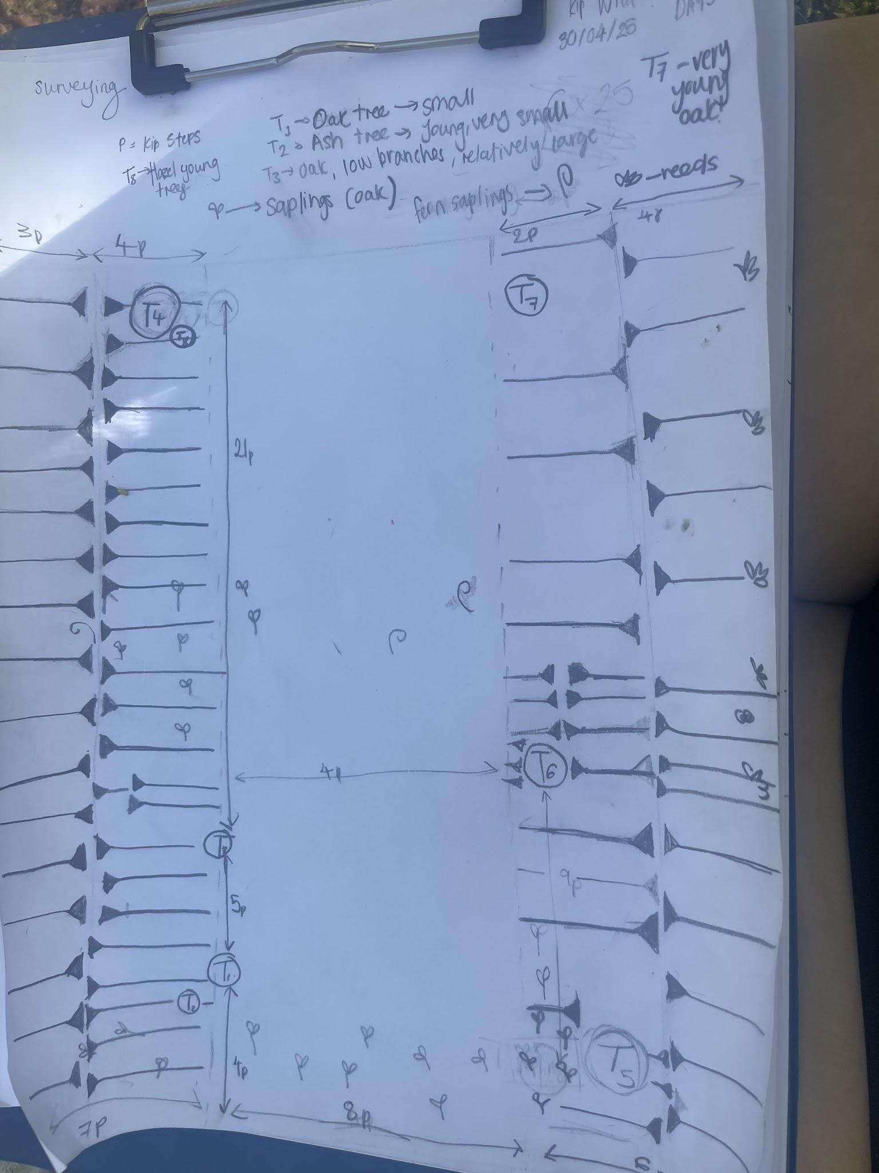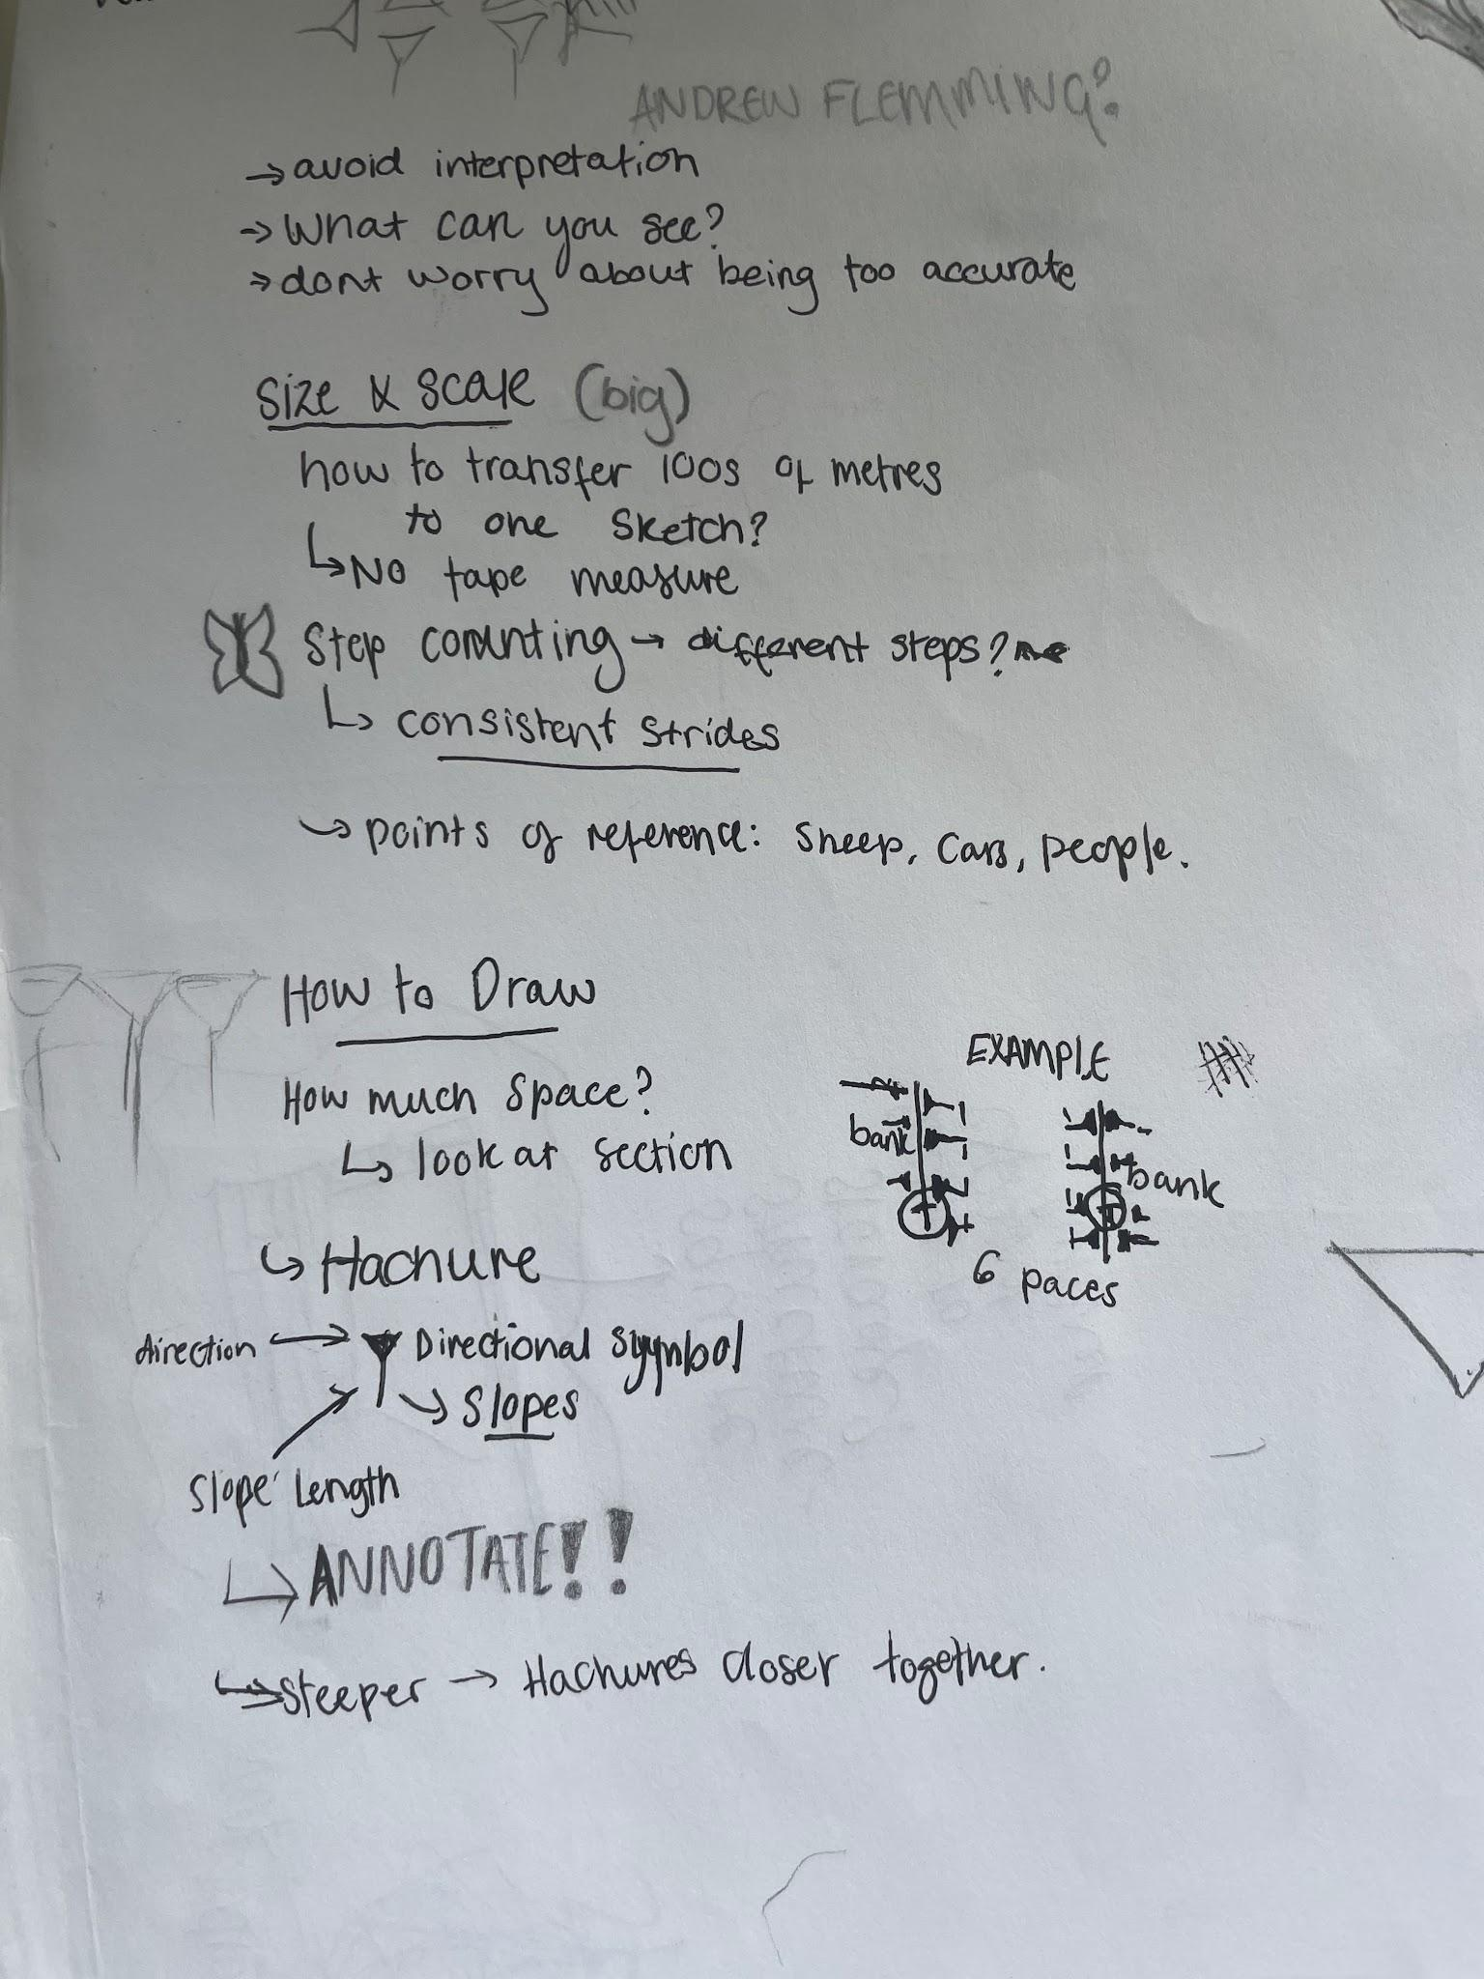

BUMPY FIELDS
After attempting our first rapid site surveys in the woods, we moved to attempting to create surveys for the bumpy fields. I found this a lot harder, as it was a larger space to work with, so it felt more difficult to focus. This field also included a range of features, extending up a hill, having a space with reeds, (indicating a change in soil), large lumps which were likely spoil heaps from the original excavations of the monastery to one side, and an ash tree in the centre with obvious lumps in the ground surrounding it. After, we began experimenting with the dumpy levels, to gain a form of understanding before using them fully.
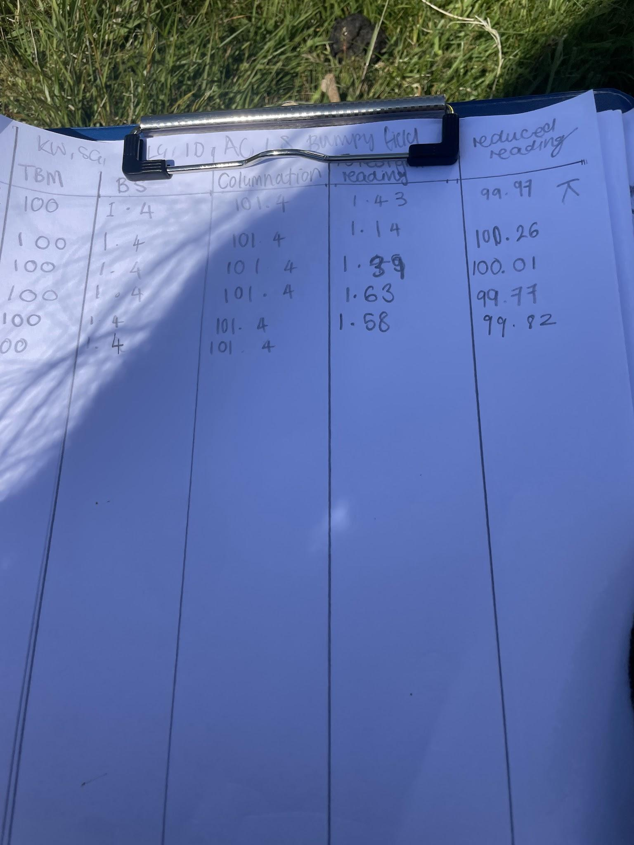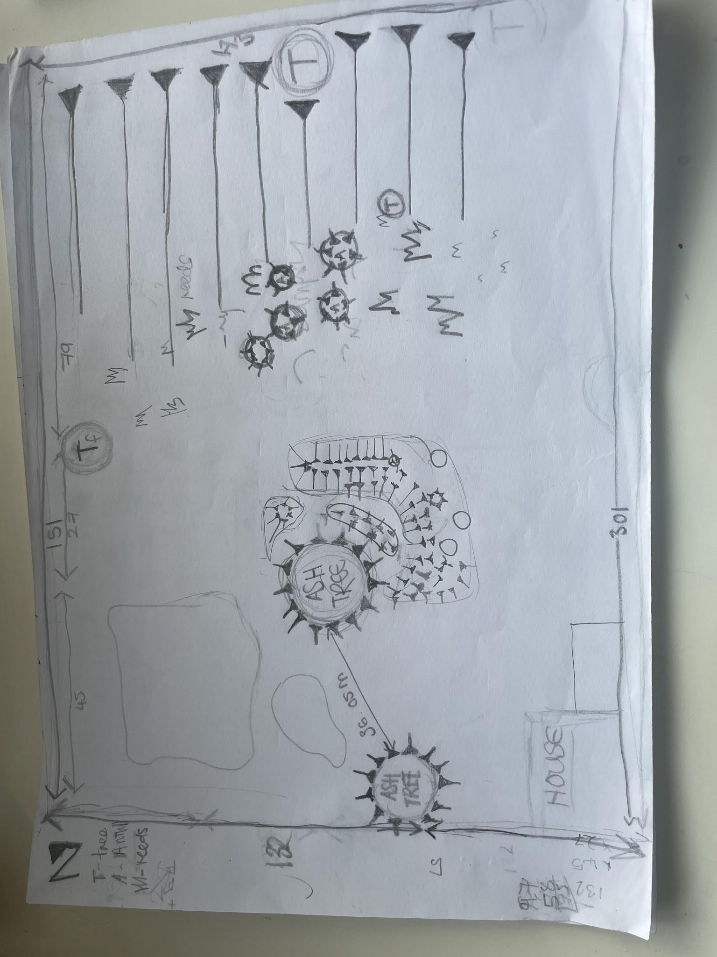left: initial dumpy level recordings, right: rapid site survey of bumpy field
At this point, I understood how to do the calculations from the temporary benchmark and why these calculations were being made, however, I didn't understand how to connect them to the measured surveying or to plot them on my map. The next time we were in the bumpy fields, we began creating a measured survey of the area surrounding the tree with large lumps in groups of two and three. I worked with just Iwa on the first day, then Apollo joined on the second day of this process.
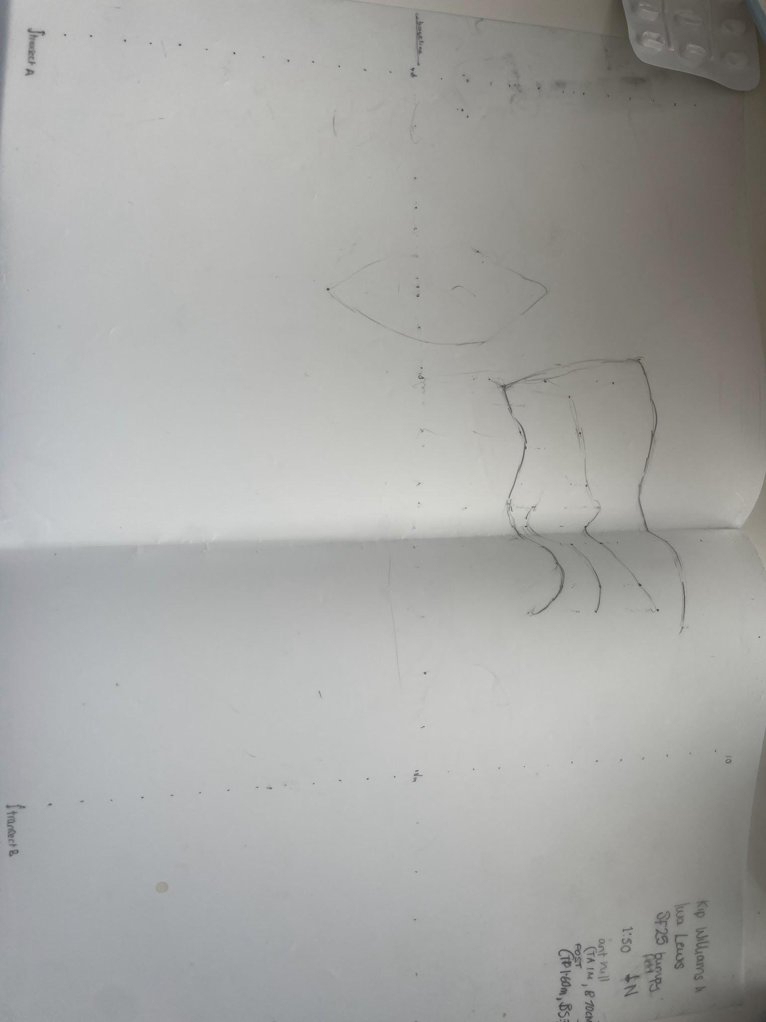
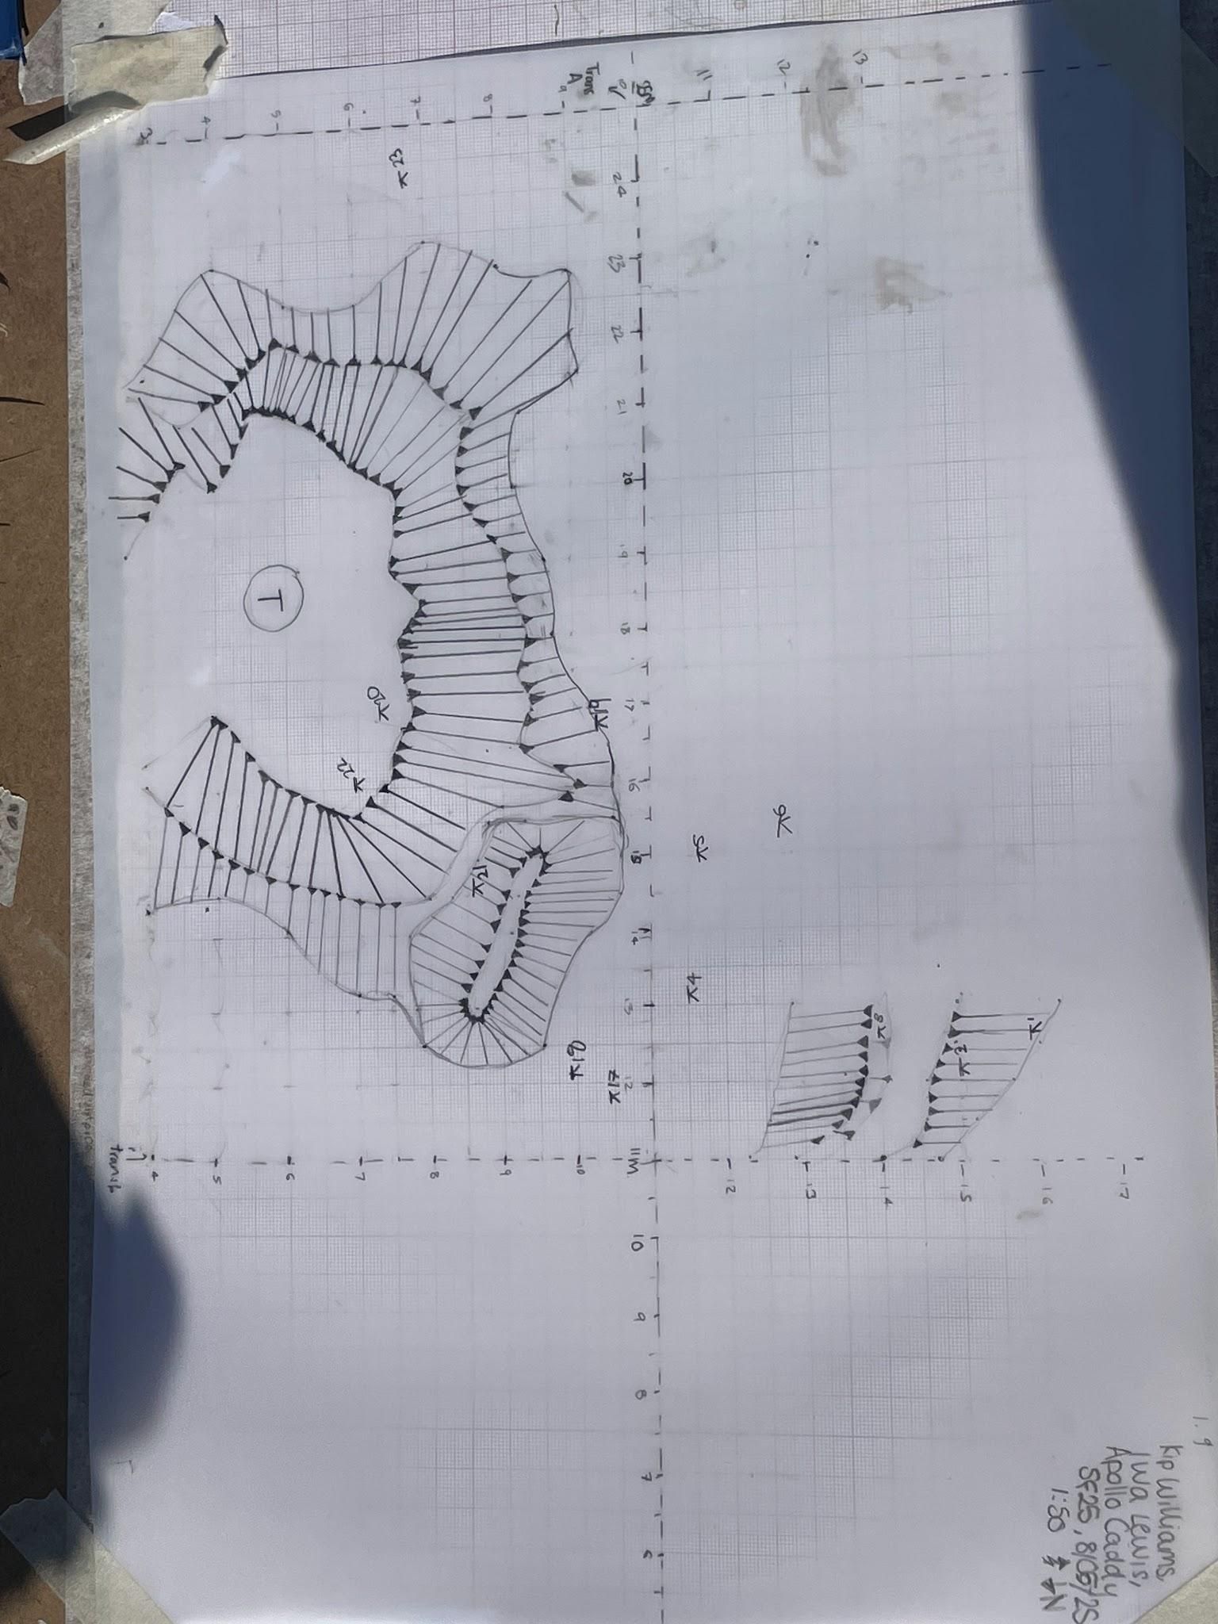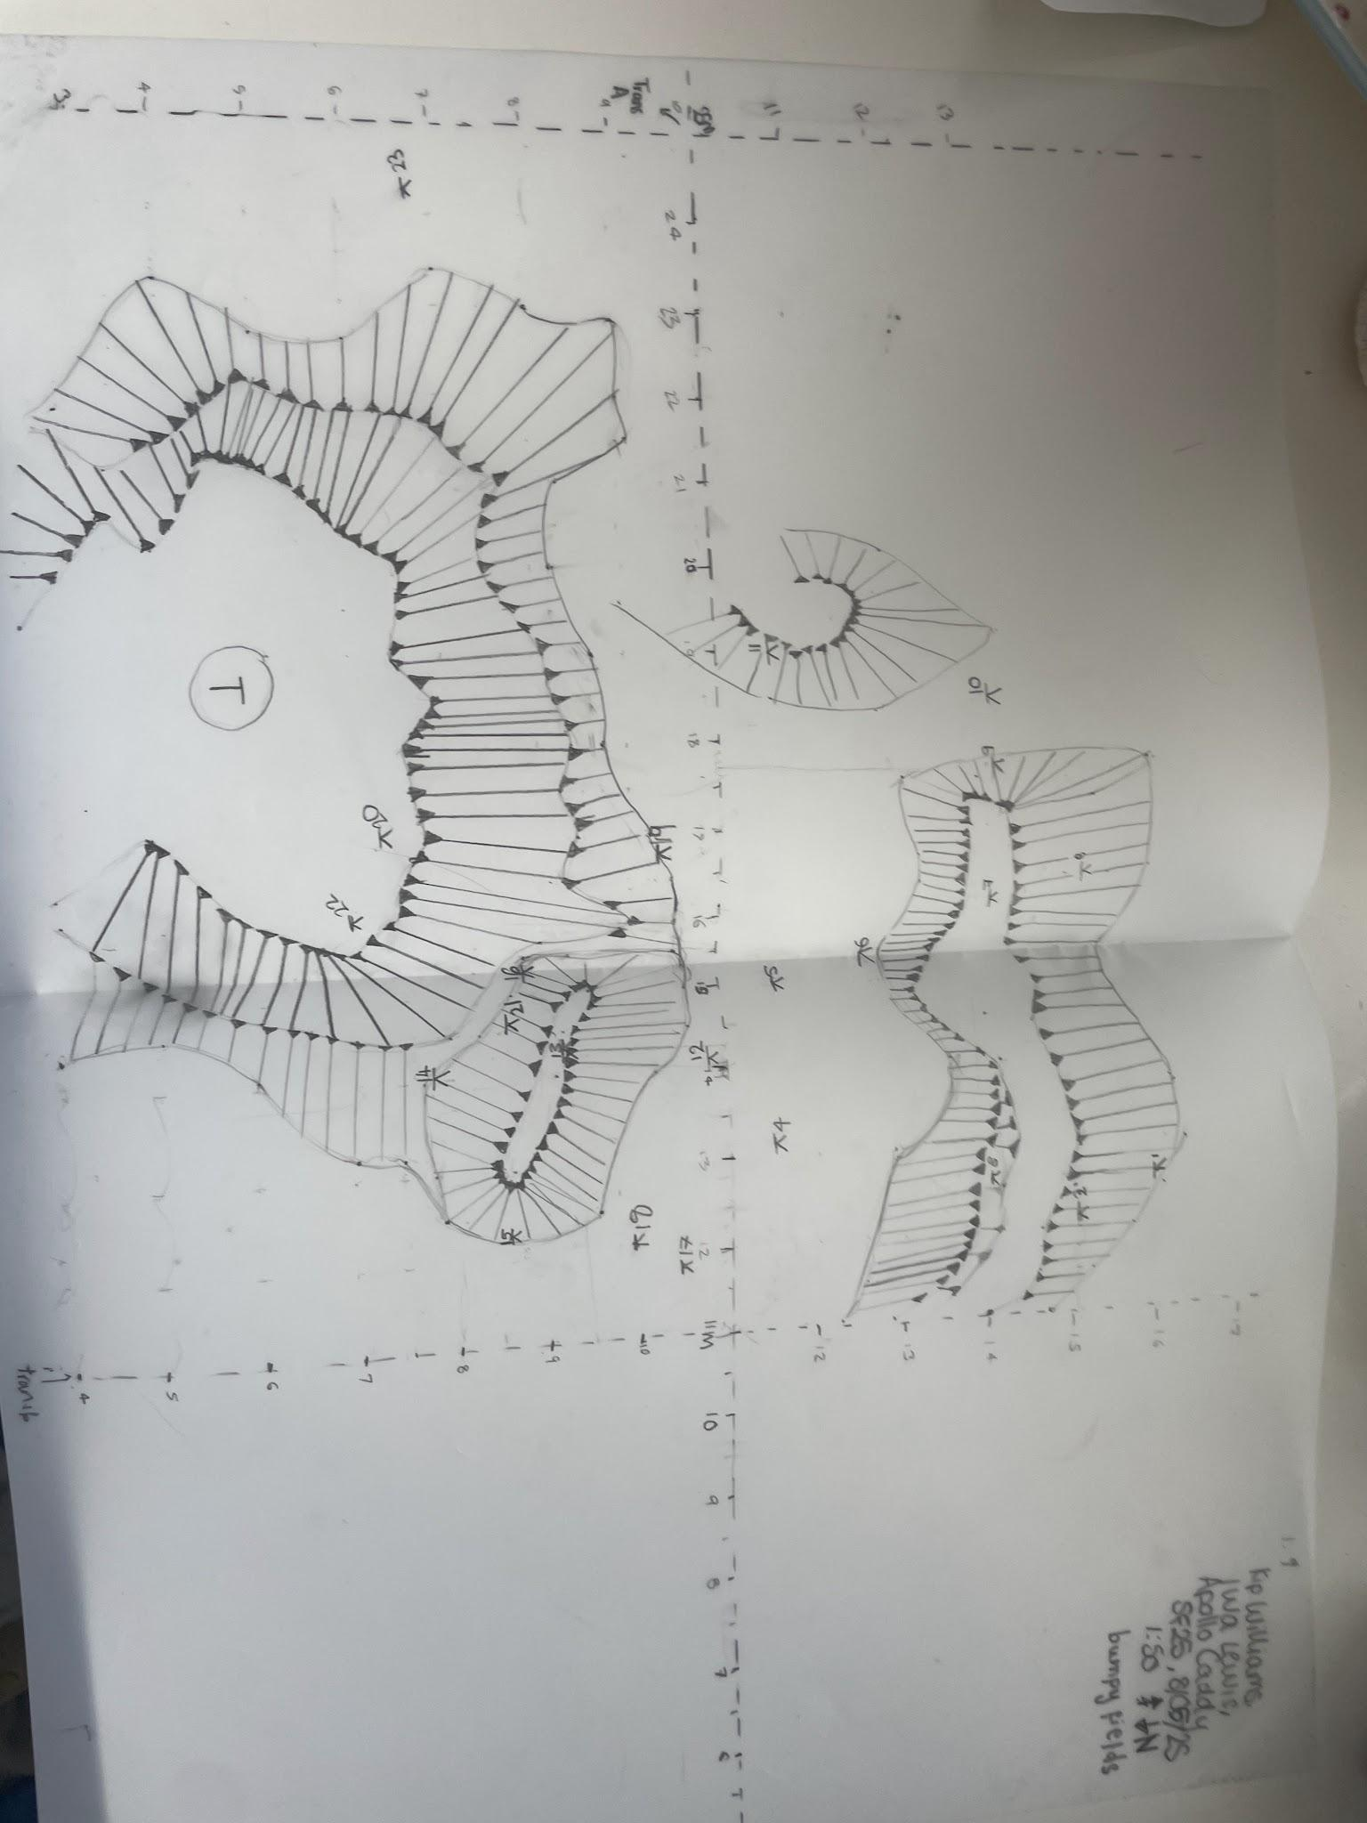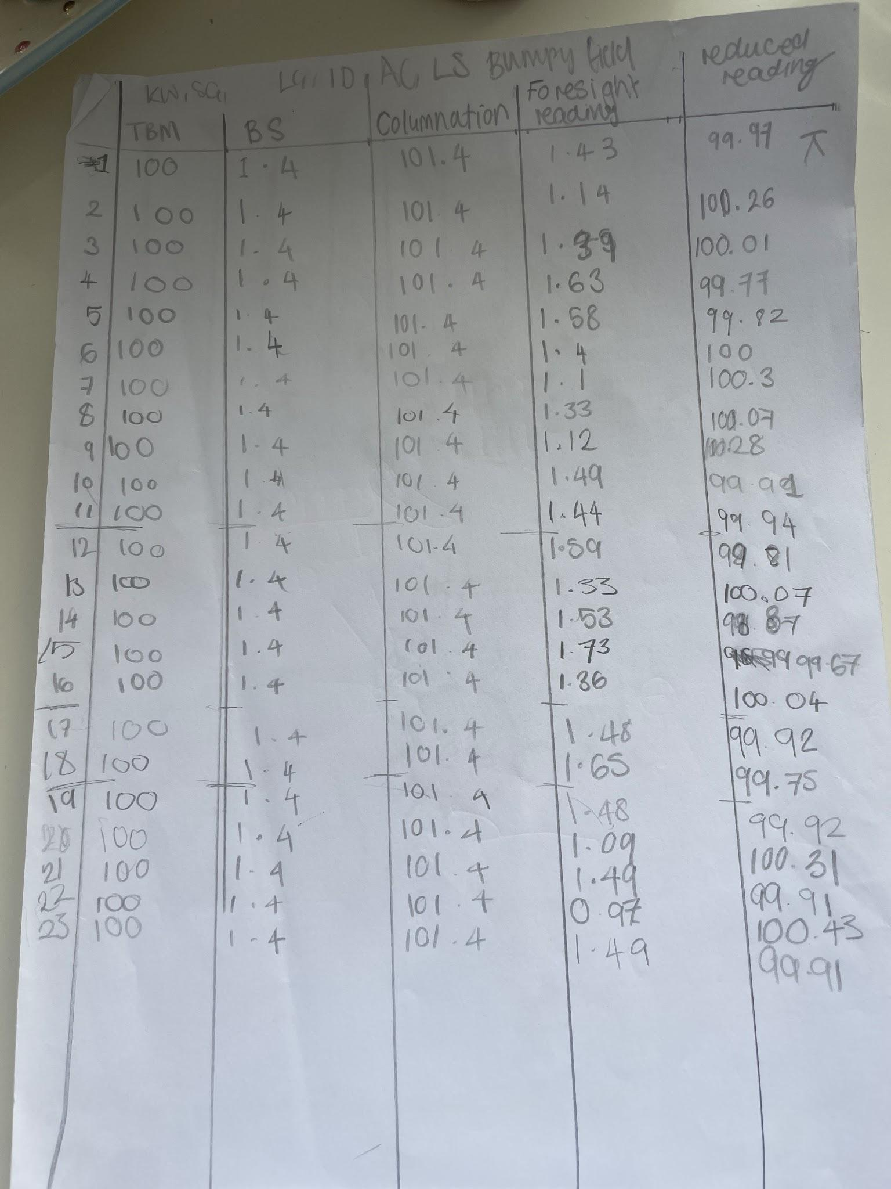
Above left: initial survey, above middle left: survey from the second day, above middle right: collated final survey, above right: dumpy level recordings and calculations
In the process of measuring surveying, I took on a leadership role, deciding where to measure, etc. One of the main barriers I encountered with this is cooperating with others who understand the material less, but this was resolved easily. We managed to create two different measured survey sketches, which we then collated into one using reference points. We then continued to do dumpy level measurements and plotted them onto our maps. During this process, I recorded the measurements and calculated the reduced readings, then later plotted them onto our maps. I then collated all of the measurements from the two days of surveying on the final day and traced them onto the same map to create a full map of all our measured surveying.

ABBEY MINES
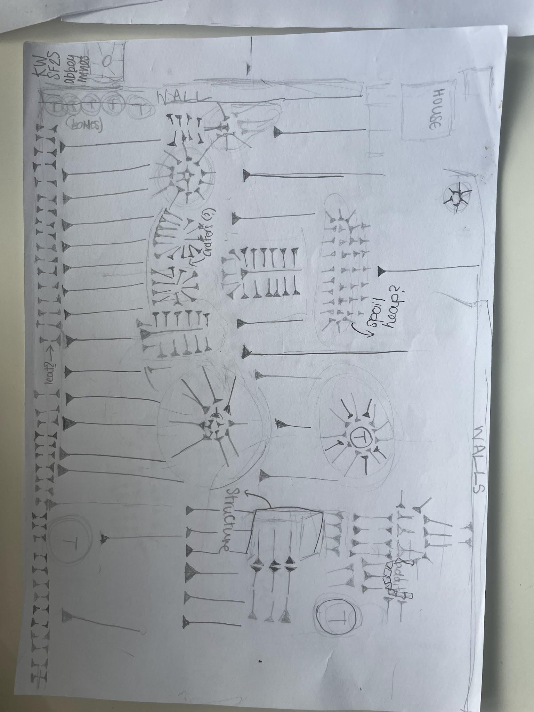
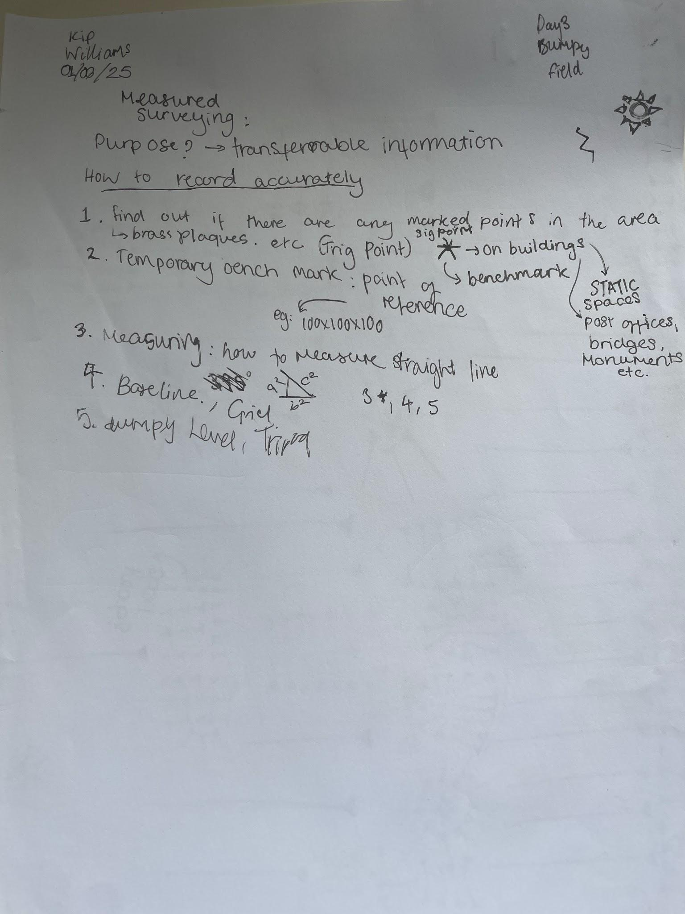
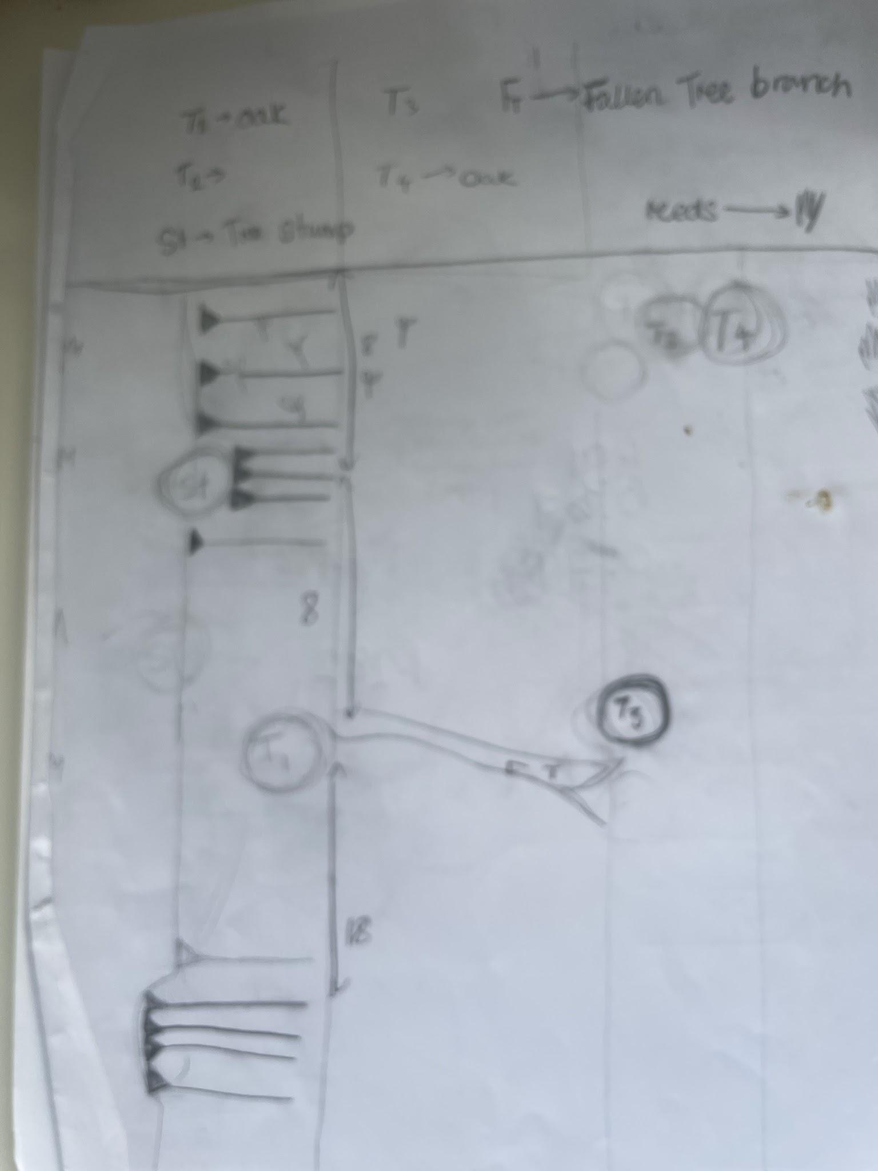
The Abbey mines were another site which we used to help our understanding of rapid site surveying. This was a large space with a range of very specific features that only occurred once or twice. Examples of these include addicts, ruins of structures, fully abandoned structures, spoil heaps, and craters. These mines raised questions about how long there has been activity occurring in the area: with definitive evidence of mining from the Victorian era and slightly earlier, but less definitive evidence of earlier interaction. There has been geophysical surveying of this area from previous archaeologists, including David Sables, who attempts to answer some of the questions raised about the history of the mining, especially surrounding the concept of the cistercian monks using the mines, especially due to the commonality oa Cistercian orders mining in the 13th century, and some debate as to whether there was mining in this location during the bronze and iron age. . There were parts of the landscape that were visible whilst doing a rapid site survey, which could have been created before the Victorian structures, namely, the adit and a completely covered structure. The adit uses stone which is a different colour to the stone used for the houses and walls, which could indicate that it was made at a different time. It is also likely that on this location, I had to create two hachure surveys because my initial survey did not have the correct scale for where the structure and adit were on the map. This was an issue for me multiple times, as I have found creating accurate scale difficult, but it was something that I believe I became better at with practice.
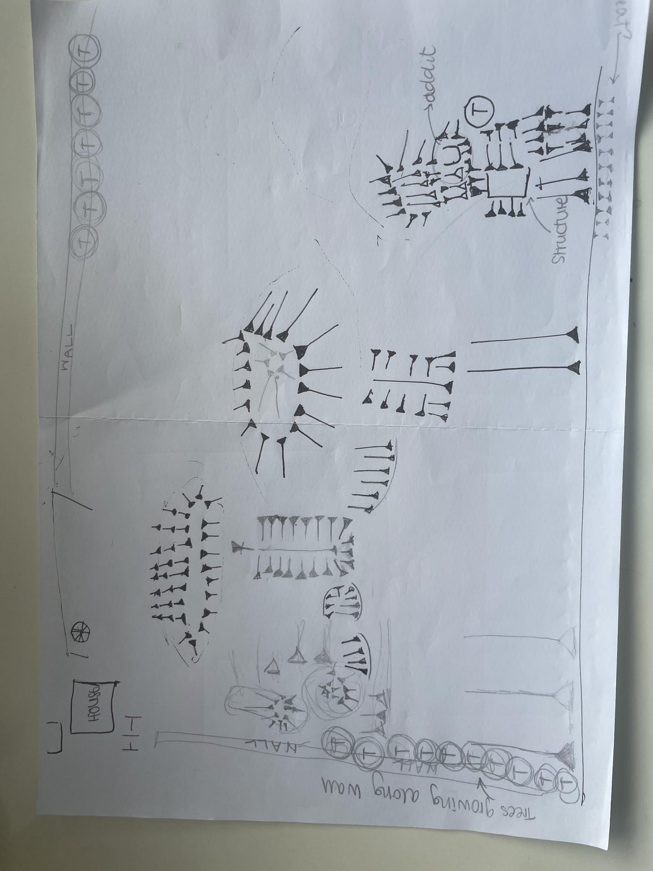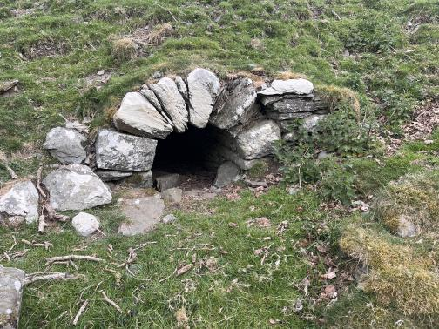
Left: initial rapid sight survey, middle: second rapid site survey, right: adit.
Conclusion
Overall, this period of fieldwork was useful for developing my skills and understanding of how to identify areas of potential archaeological interest, along with how to effectively record them, depending on the time and resources available.
Bibliography
“About” <https://www.strataflorida.org.uk/about.html>
Sables, David, The Monks Who Mined?, Mining History: The Bulletin of the Peak District Mines Historical Society, season-02 2015, xix <https://moodle.uwtsd.ac.uk/pluginfile.php/1051141/mod_resource/content/1/the%20monks%20who%20mined%20artical.pdf>
Williams, Kip, taken 29/04/2025
Williams, Kip, taken 29/04/2025
Williams, Kip, taken 29/04/2025
Williams, Kip, taken 29/04/2025
Williams, Kip, taken 30/04/2025
Williams, Kip, taken 30/04/2025
Williams, Kip, taken 01/05/2025
Williams, Kip, taken 02/05/2025
Williams, Kip, taken 02/05/2025
Williams, Kip, taken 05/05/2025
Williams, Kip, taken 05/05/2025
Williams, Kip, taken 05/05/2025
Williams, Kip, taken 08/05/2025
Williams, Kip, taken 08/05/2025
Williams, Kip, taken 08/05/2025
Williams, Kip, taken 08/05/2025

“About” <https://www.strataflorida.org.uk/about.html>.
David Sables, The Monks Who Mined?, Mining History: The Bulletin of the Peak District Mines Historical Society, season-02 2015, xix <https://moodle.uwtsd.ac.uk/pluginfile.php/1051141/mod_resource/content/1/the%20monks%20who%20mined%20artical.pdf>.
Kip Williams, 2025
Kip Williams, 2025
Kip Williams, 2025
Kip WIlliams, 2025
Kip Williams, 2025
Kip Williams, 2025
Kip Williams, 2025
Kip Williams, 2025
Kip Williams, 2025
Kip Williams, 2025
Kip Williams, 2025
Kip Williams, 2025
Kip Williams, 2025
Kip Williams, 2025
Kip Williams, 2025

