

Assignment Title – Report on Communication Skills and Technology.
Student Name - Olufemi Ademokoya.
Student number – 2125012.
Course Name: Effective Team Working and Communication.
Course Code: BMSW4002_LON.
Lecturer’s Name – Lloyd Beharry.

Table of Contents
1. Introduction 3
2. Models of Communication 4
2.1. Shannon and Weaver 4
2.2. Schramm 5
2.3. Berlo 6
3. Communication Skills 8
3.1. Verbal Skills 8
3.2. Non-Verbal Skills 8
3.3. Active Listening 9
4. Communication Technology 10
4.1. Advantages 10
4.2. Disadvantages 10
5. Conclusion 11
References 12

- Introduction
Every communication has at least one sender, one piece of information, and one recipient. Although it may look simple. Communication is a complex subject. The transmission of messages from senders to recipients can be affected by various events. This includes our emotions, the cultural context around us, and the communication methods we choose, and even our geographic location. Companies around the world place great value on good communication skills because communicating effectively and unambiguously is very difficult. Speaking, writing, listening and reading are all forms of communication. People listen carefully, speak and write clearly, and show admiration for opposing ideas. Organizational management must include effective communication. Effective management depends on effective communication. Educate employees about new laws, prepare for climate disasters, ensure workplace safety across the company, and respect employee attitudes. Successful organizations need comprehensive policies and procedures for communicating with stakeholders, employees, voters, and the general public. Improved employee satisfaction, engagement and morale. Communication that enables employees to understand their working conditions motivates employee engagement and loyalty. Through communication, employees can learn the benefits of not joining a union when joining a union is the goal of the organization. In addition, employees have access to key factors that improve employer satisfaction.

2. Models of Communication
2.1. Shannon and Weaver
The design of this paradigm was intended to facilitate good communication between senders and receivers. We also discussed the properties of "noise" that affect how people communicate. This strategy was originally developed to improve technical communication. It then spread rapidly throughout the telecommunications industry. The Shannon model of information theory was a groundbreaking comprehensive explanation of the concept of "noise." According to the María and Pedro case study, the sound made a clear difference in the message. Because of the noise at Pedro's workplace, he thought the opposite of what Maria told him. Instead of cooking, he interpreted it as chicken. Describing how information gets mixed up helps people identify areas for improvement in communication (Davenport Sypher et al., 1989). This model allows us to analyze the important steps of information transfer from start to finish. A communication model was developed to define communication with technical tools. However, it has been used to characterize almost every conceivable type of communication. Considered the "mother of all models" of human communication is thought to be the Shannon Weaver communication model. It is frequently called the "information theory." It is a mathematical theory that is viewed as a "linear" paradigm for communication (Irgens, 1995).
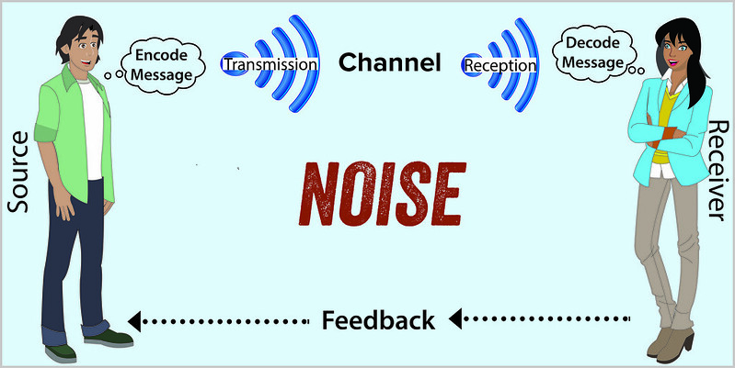
Figure 1 Shannon Weaver model of communication

2.2. Schramm
This assumption has been criticized because the Shannon-Weaver model assumes that communication is always linear. Schram argued that we need to understand how messaging affects people (McBride et al., 2018). In Schram's view, communication is understood as a method between encoders and decoders. Most importantly, the model takes into account how recipients interpret messages (Cairns et al., 1998). According to Schramm, interpreting is influenced by a person's background, experience, and area of ​​expertise. Schramm also believed that mediums were used to convey messages. Decoders can also pass acknowledgments about messages to confirm receipt. He argued that communication without response from listeners is ineffective (Manusov et al., 2020).
According to Schram's theory, coding and decoding are his two fundamental components of effective communication. He also emphasizes that communication is not complete until both sides respond. Regarding the professor and villager case study, the professor is facing a coding problem. As Schramm mentioned, decoding is not done correctly until the actual message is received. When the professor screamed and told the villagers about the fire, the villagers were unable to decipher his words correctly. In short, this indicates that coding and decoding are the most important factors in communication (Bonebright, 2010).
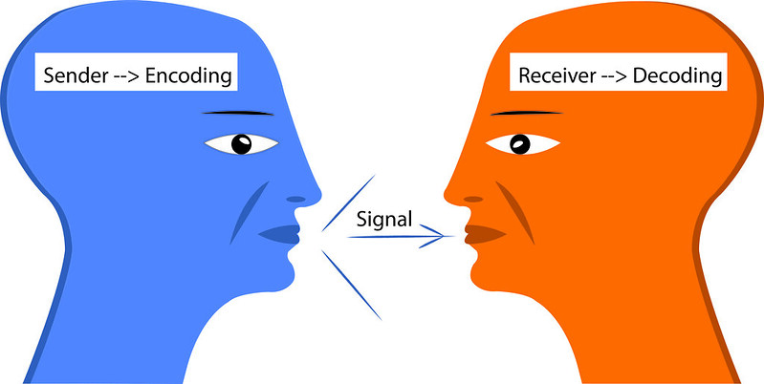
Figure 2 Schramm Communication Model

2.3. Berlo
Regarding message origin, Berlo has discovered variables that affect the sender or source of a communication. The ability to speak and write is the first component of communication skills (Jonsdottir and Kristinsson, 2020). Second, attitude is a person's point of view that the listener can influence. A third factor is whether the source has the necessary expertise to be effective on a particular topic. Fourth, communication can be influenced by the social system of the source, such as beliefs, values, and opinions. The next item on the agenda is the model's message (Adair, 2005). Text, video, and voice are just some of the media that can convey your message. There may be factors that affect the message at the same time, such as: B. Content that is submitted data. Verbal and non-verbal actions used to convey messages are called elements. The delivery of messages is called processing. Frames were used to organize messages. Coded forms of communication such as letters, gestures, and music were used to convey messages.
Her five primary senses - hearing, perception, touch, smell and taste - serve as channels for messages. Think about how your mother shows you love. Either she hugs you and says "I love you" or she prepares your favorite meal. These are all ways of expressing affection. The recipient is the person who decrypts the communication (Najafi et al., 2018). As with the previous generation, the receiver is at the end. In contrast, Berlo argued that conditions similar to those of the sender must exist for the recipient to understand and interpret the message. As a result, the source and receiver components are similar. The message must then be decrypted and its meaning determined by the recipient. Berlo presents the communication paradigm as simply as possible. Bello’s model shows a photograph of a professor and a case study of a villager. Berlo said that sometimes senders use harsh language that recipients don't understand. Like the case study, it is clearly stated that the villagers were poorly educated and could not understand the professor's words.
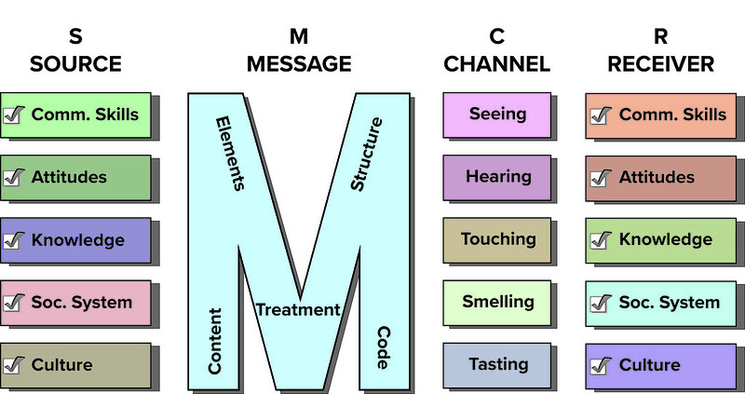
Figure 3 Berlo Communication Model

Communication Skills

3.1. Verbal Skills
Verbal communication is the process of exchanging information with others through words. It might therefore include both spoken and written communication as a result (Hagiu and Bortoș, 2021). However, the term is commonly used to describe only oral communication. It comprises of the words which are used, as well as how they are heard and understood, when it comes to verbal communication. The three situations in which verbal communication skills are most frequently employed are interpersonal conversation, group discussions, and public speaking. Interpersonal communication is one individual speaking directly to another (Schramm et al., 2021). Small-group conversations are known as group discussions, whereas large-scale presentations of knowledge are known as public speaking (Duck and McMahan, 2016).

3.2. Non-Verbal Skills
The facial expressions of happiness, sadness, rage and worry are all of the same, despite the reality that nonverbal communique and conduct range extensively throughout nations (Li and Xu, 2020). Given how persuasive and influential nonverbal gestures might also additionally be, a few courts restrict which of them are allowed in courtroom docket settings in which they may impact juror verdicts. A lot of facts can also be discovered through motion and posture. The examination of frame language has grown appreciably for the reason that 1970s, famous media specialised in how defensive postures like arm and leg crossing may be misinterpreted. Nonverbal communique is aided through the eyes, which additionally carry crucial symptoms such as glancing, staring, and blinking (John et al., 2019). For instance, your blink fee and student length growth whilst you view people or belongings you like. Nonverbal communique additionally consists of bodily cues like clothing, hairstyles, and different bodily traits (Muksin et al., 2021). Different sun sunglasses can evoke numerous moods, consistent with a colour psychology examination. Appearance can affect a person's bodily responses, perceptions, and interpretations (Lee and Kim, 2018).

3.3. Active Listening
Effective communication requires both speaking and listening. A technique for listening to and responding to the other that facilitates understanding between two people is Active Her Listening. Another way to describe it is by activating all your senses and listening. This is an important first step to defuse the situation and solve the problem (Foran and Lee, 2022). Along the Max-The Multi Tasker case study, it becomes clear that active listening plays an important role in communication. As Max was busy with multiple calls at the same time, his interests spread to different customers. Had Tamara proactively asked when the event would be held, there would have been no confusion. Several studies have shown that active listening is impaired when people paint their fingernails, read books, and sometimes use mobile phones (Kubota, 2019). The same thing happens to Max because he made multiple calls when Tamara called him.
On the other hand, emphatic listening is all about listening individuals with patience. By using a methodical listening and questioning approach called "empathic listening," you can build and strengthen connections by better understanding what is being said from both an academic and emotional standpoint (AL-Shafeay et al., 2020). As a result, it raises the bar for active listening abilities considerably. The goal of an empathic listener is to keep the speaker from losing control and going on the defensive (Griffith and Dunham, 2014). The speaker should refrain from asking direct questions, disagreeing with what is said, or refuting facts in order to achieve this. Later, the evidence will be reviewed. But for now, pay attention only to what is being said and the speaker's emotions. In context to the case study of Max the multi tasker the need of emphatic listening arises when Max told Tamara about the illness of her mother. At that point Tamara can give her time whilst listening to the Max. The illness of mother creates a psychological impact on anyone’s mind. Same reason was with Max; he was willing to pay full attention to his business but due to the stress he messed up all. Although Tamara should have understood the situation of Max but she gave her an aggressive response in terms of the miss-commitment.

Communication Technology
In the modern world, communication has changed and technology-mediated communication has replaced face-to-face contact. Modern communication tools such as email, mobile phones, and social media sites such as Facebook and Twitter all fall under the category of communication technologies (Cozzolino et al., 2019).

4.1. Advantages
The speed at which communication technology works (messages are sent quickly and responses are received instantly) is one of its advantages. As a result, communication has become more effective and trustworthy in both social and professional contexts. Face-to-face conversations are now possible from different locations (Quintanilla and Wahl, 2018). Additionally, these skills make communication more economical compared to other forms of communication such as long distance. Globalization is another advantage of communication technology. The global economy has become interdependent as communications technology connects people and nations, facilitating trade and business. Language and regional barriers are removed, enabling quick and easy information exchange.

4.2. Disadvantages
The main drawback is that verbal communication does not involve physical contact. Inability to read facial expressions, gestures, and verbal cues. As a result, the message or its seriousness can be misunderstood. Another drawback is the security risk of having your information stolen by fraudsters. This can lead to loss of assets, money, and reputational damage (Feng et al., 2020). Additionally, social networks can lead to addiction and low levels of education due to the communication codes and phrases used in these media.

Conclusion
To connect with others and share our experiences and needs, we need to communicate and build relationships. It gives us the ability to communicate information, express opinions, and express emotions. It is the essence of life. We all need to communicate. Day-to-day communication allows us to carry out our tasks discreetly, ultimately improving our and our company's professionalism. Effective communication skills are highly valued in business. Executives with poor communication skills are usually the biggest culprits behind productivity problems.

References
Adair, J.E., 2005. How to grow leaders: The seven key principles of effective leadership development. Kogan Page Publishers.
AL-Shafeay, K.M., Al_Dujaili, M.J. and Al-Wattar, Y.M.A., 2020. THE IMPACT OF INFORMATION AND COMMUNICATION TECHNOLOGY (ICT) IN THE ACCOUNTING SYSTEM: ADVANTAGES, APPLICATIONS, AND CHALLENGES. PalArch's Journal of Archaeology of Egypt/Egyptology, 17(6), pp.15814-15825.
Bonebright, D.A., 2010. 40 years of storming: a historical review of Tuckman's model of small group development. Human Resource Development International, 13(1), pp.111-120.
Cairns, T.D., Hollenback, J., Preziosi, R.C. and Snow, W.A., 1998. A study of Hersey and Blanchard’s situational leadership theory. Leadership & Organization Development Journal.
Cozzolino, D., Da Lio, B., Bacco, D. and Oxenløwe, L.K., 2019. High‐dimensional quantum communication: benefits, progress, and future challenges. Advanced Quantum Technologies, 2(12), p.1900038.
Davenport Sypher, B., Bostrom, R.N. and Hart Seibert, J., 1989. Listening, communication abilities, and success at work. The Journal of Business Communication (1973), 26(4), pp.293-303.
Duck, S. and McMahan, D.T., 2016. Communication in everyday life: A survey of communication. SAGE Publications.
Feng, Z., Fang, Z., Wei, Z., Chen, X., Quan, Z. and Ji, D., 2020. Joint radar and communication: A survey. China Communications, 17(1), pp.1-27.
Foran, K. and Lee, D., 2022. Developing effective communications (2022).
Griffith, B.A. and Dunham, E.B., 2014. Working in teams: Moving from high potential to high performance. Sage Publications.
Hagiu, A. and Bortoș, S., 2021. Towards an Applied Ethics in Digital Communication: A Transdisciplinary Perspective on Responsibility. Analele Universității din Craiova, Seria Filosofie/Annals of the University of Craiova, Series: Philosophy, 48(2), pp.110-123.
Irgens, O.M., 1995. Situational leadership: A modification Hersey and Blanchard. Leadership & Organization Development Journal, 16(2), p.36.
John, P., Brooks, B. and Schriever, U., 2019. Speech acts in professional maritime discourse: A pragmatic risk analysis of bridge team communication directives and commissives in full-mission simulation. Journal of Pragmatics, 140, pp.12-21.
Jonsdottir, I.J. and Kristinsson, K., 2020. Supervisors’ active-empathetic listening as an important antecedent of work engagement. International Journal of Environmental Research and Public Health, 17(21), p.7976.
Kubota, M., 2019. What is “Communication”?―Beyond the Shannon & Weaver’s Model―. International Journal, 13(1), pp.54-65.
Lee, N. and Kim, Y., 2018. A conceptual framework for effective communication in construction management: Information processing and visual communication. In Construction Research Congress 2018 (pp. 531-541).
Li, Z. and Xu, J., 2020. Medicine together with humanities and media: An MHM model to move forward for health communication studies. International Journal of Nursing Sciences, 7(Suppl 1), p.S1.
Manusov, V., Stofleth, D., Harvey, J.A. and Crowley, J.P., 2020. Conditions and consequences of listening well for interpersonal relationships: Modeling active-empathic listening, social-emotional skills, trait mindfulness, and relational quality. International Journal of Listening, 34(2), pp.110-126.
McBride, M., Edwards, B., Kutner, S. and Thoms, A., 2018. Responding to the whole person: Using empathic listening and responding in the writing center. The Peer Review, 2(2).
Muksin, N.N., Shabana, A. and Tohari, M.A., 2021, June. Online Based Communication Model for Indonesian Migrant Workers in Hong Kong On Financial Management. In Journal Universitas Muhammadiyah Gresik Engineering, Social Science, and Health International Conference (UMGESHIC) (Vol. 1, No. 1, pp. 138-146).
Najafi, M., Yazdāni, H., Mirbāgherifard, S.A. and Koupā, F., 2018. Verbal Communication between Man and God Based on the Theory of Jakobson and David Berlo’s Communication Model (in Prose Mystical Texts till 7th AH Century). journal of mytho-mystic literature, 14(50), pp.267-293.
Quintanilla, K.M. and Wahl, S.T., 2018. Business and professional communication: Keys for workplace excellence. Sage Publications.
Schramm, M., Pebesma, E., Milenković, M., Foresta, L., Dries, J., Jacob, A., Wagner, W., Mohr, M., Neteler, M., Kadunc, M. and Miksa, T., 2021. The openeo api–harmonising the use of earth observation cloud services using virtual data cube functionalities. Remote Sensing, 13(6), p.1125.

