Principles of Teaching, Learning and Emergent Technologies.

Reflections on a
30-minute micro-teach.

Edward Jones
In this assignment I will draw on Gibbs (1988) Reflective Cycle (see Appendix 1) and Johns (2004) Model for Structured Reflection in order to evaluate and analyse my micro-teaching session and academically critique the emergent technology used. I will describe the session and reflect on the experience and what I learnt from both the successes and failures.

Although I’ve been in a teaching post for almost a year, I have felt aware of my lack of formal teacher training. I felt certain that there were better and worse ways to share knowledge and inspire people and I wanted to know the better ones! The micro-teaching felt like a safe environment in which to experiment and learn.

As a lecturer in the architectural glass department, I decided to teach about the use of scale drawings in architectural projects. The guidance that we had received in lesson planning helped me organise my thoughts and clearly outline my intentions for the lesson. I drew upon Bloom’s (1956) Taxonomy of Educational Objectives to help breakdown the learning into individual objectives and outcomes.

Due to limited time I felt that it would be difficult to go beyond Blooms (1956) ‘application stage’ so I decided to focus on imparting a practical skill that could then be practiced in class and reviewed in a ‘summative assessment’ (Jarvis, 2010, p217). I felt this would allow for some broader theoretical learning about site and context in Architectural and Stained Glass and then also a specific skill.

Following Bloom’s Taxonomy (see Appendix 2), I wanted to introduced the subject and described broadly what Scale was and how and why it was used. I wanted to give my students an understanding of the topic so that they would be able to demonstrate it in my quiz before being able to apply what they had learnt in an exercise.

I intended to use my PowerPoint presentation to deliver visual examples of scale drawings to help explain what they are and when they are used. Although PowerPoint isn’t technically “emergent” technology, it is still an invaluable way of delivering visual information in a concise and organised manner. It gives the teacher the opportunity to construct a learning aid prior to the class that breaks down the subject and offers prompts for wider discussion.
Reflecting on my use of PowerPoint, I feel that I could have spoken more freely around the slides. Despite feedback that I expanded well on the slides, I was aware that I had been reading the text from them rather than putting the information in my own words and reiterating the important points.

As Pacansky-Brock (2013) puts it In Best Practices for Teaching with Emerging Technologies, ‘rather than using PowerPoint to craft a dynamic visual backdrop to a verbal presentation, most of us fill our slides with text’ (Pacansky-Brock, 2013, p9) I fear I also made this mistake, and reflecting on it now is useful for future presentations. PowerPoint should be used, I see now, to ‘craft a dynamic visual backdrop to a verbal presentation’ (ibid). The important word for me there is ‘backdrop’; it should add value to what is primarily an animated verbal presentation. I think this will help me to address one of the points raised in my observation feedback regarding presence and voice projection.

It was half way through the PowerPoint that I was planning to use the quiz with the intention to ‘formatively assess’ (Jarvis, 2010, p217) whether students had understood the principle of scaling measurements. By giving them various dimensions along with a scale ratio such as 1:5, I planned to use the answers to address any difficulties students may be having, before I asked them to apply the principle to a real life situation.

In Best Practices for Teaching with Emerging Technologies, Pacansky-Brock (2013) argues that current problems with student engagement and motivation may be resolved by embracing, rather than resisting deep-rooted generational preferences. She uses the example of the use of mobile devices in the classroom as a point of friction between teacher and student, where the teacher tends to banish them. I was excited and inspired by the idea of incorporating these sorts of technologies rather than just removing them from the learning environment.

So I proceeded to log into my Socrative Online Quiz (see Appendix 3 for screen shots of the quiz).

“Password not recognised”

Sure that I had entered the correct password, I tried to enter it again… and again… Realising that I had all eyes on me with the minutes ticking away, I hurriedly decided to press on ahead and adapted that part of the lesson.

“Well you may be in luck!” I joked,
“You might have just escaped an exam!”

I felt a little embarrassed and wanted to move on quickly. However, in hindsight, I don’t think it would have been unreasonable to pause a moment longer whilst I resolved the issue. Perhaps I could have asking the class a question such as “when have you encountered scale drawings in your lives, turn to your neighbour and discuss”.

I learnt some valuable lessons about using new or emerging technology in the classroom. Firstly, wherever possible, trial the technology in the place that you are going to use it, before the start of the lesson. Secondly, always have a plan B. In this instance, having my quiz questions in another format, either in the PowerPoint presentation or noted down on paper would have given me the opportunity to deliver the quiz verbally to the students.

Without these options available, my first thought had been to make up some numbers and scales and ask the class to work the answers out on paper. However, in the next moment, I had the idea that this could be a good opportunity to demonstrate the process in action by bringing in an element of experiential learning.

I asked for a volunteer and gave them a tape measure, asking them to measure something and read out the dimensions. I wrote these on the board and gave each set of measurements a ratio to scale it with. The volunteer provided three sets of measurements and the rest of the class converted them. I asked the class for their answers and as they called them out it provided an opportunity for us to discuss how we had arrived at the answers and to iron out any issues there might have been.

On reflection, this slight change of course was useful for the lesson. Although the quiz would have shown me how well the students had grasped a concept, it wouldn’t necessarily have enhanced the learning experience for the students. In my opinion, seeing the process of scaling, in the context in which it would be used, deepened the understanding of the process.

Having ascertained that all the students were comfortable with the calculations the final part of the lesson was designed to allow the students to produce a scale drawing of the door, window and fixtures at the entrance to the classroom.

Minton (2005, p6) argues ‘Learning is growth through experience’. It feels important to bring what is being talked about abstractly into the real world, with experiential learning we make an ‘attempt to provide primary experiences, a sense of reality, to counterbalance the secondary experiences of the lecture theatre” Jarvis (2010, p174)

I tried to simulate a real life situation in which the student would measure a set of windows and then calculate the measurements and draw it to scale in order to produce a template to use in your stained glass designs.

My initial intention was to get the students to work in pairs. Having given them a tape measure, I would send them out to measure up and produce a drawing between them.
However, due to time constraints, I decided to take another volunteer and work with them at the front of the class to measure the doorway, whilst I transcribed the measurements onto the whiteboard. The class could then convert the measurements and draw the doorway at a scale of 1:5.

My first mistake was placing the pressure of measuring up the doorway onto a student that may or may not have had any experience in doing such a task. As a regular part of my job, I took for granted the difficulty of the task. In normal circumstances I’m sure that the student would have been capable of taking the measurements confidently but the pressure of being in front of the class made them nervous and doubt their ability. In addition, my directions about which parts of the door to measure were hard to follow and the exercise started to struggle.

Again, as with the password issue, I felt the need to hurry things along to get past the difficult situation and keep the lesson on schedule. I felt a bit embarrassed that the exercise was unravelling and wanted to take control of the situation and steer us back on course. So I offered to take over the measuring whilst the student noted the measurements down on the diagram. They stated that they didn’t think they could do the noting down so I thanked them and finished off the exercise alone, measuring and noting down the measurements until the class had all the info they needed to start work on their drawing.

As all this was happening, a sense of unease was beginning to build in the back of my mind. I didn’t like the uncomfortable situation that I had put the student in and I could sense that they might be feeling a little embarrassed. In a clumsy attempt to try to end the difficult situation for the student I feel that I actually made the experience worse. I disempowered the student by not giving them the opportunity to complete the task with guidance and prove their competence. Rather than taking over from them I could have seen it as a good opportunity for learning – not just for the volunteer but the whole class. I could have encouraged them and confirmed the measurements as we went, ensuring they were correct and ultimately leaving the student with a sense of satisfaction. As it was, by taking over from the student and ultimately ending their participation, it could have led to a sense of shame that might become a future barrier to learning for the student.

Later, when reflecting on this experience I came upon this in Minton’s Teaching Skills (2005, p174) “Handling a practical is handling frustration for both teacher and student. Oh! The temptation to be able to take it out of their hands and just show them again how easy it is! Why is it they can’t understand?’ He invites us to consider the level of difficulty the task requires and ask questions such as ‘what level of skill do they need before they can even attempt it?’ and to consider our student’s ‘readiness’ which we can do by imagining the experience of each individual student and how it will be for them. In order to learn, he argues, ‘we have to deal with confidence, success breeds success, repeated failure demotivates’ (ibid).

Within the context of the micro-teach, a safe environment to learn and fail, I think it would have helped me to ask the students how they felt about that part of the lesson. To either confirm or discredit my interpretation, and to offer feedback as to how I might have dealt with the situation differently.

Having completed the measurements we moved on to the final part of the lesson. In order to consolidate my student’s learning, and demonstrate to them that they had indeed acquired a skill and some knowledge, I invited them to produce a scale drawing themselves. As Minton (2005, p23) says ‘ How do I get the belief of the knowledge unless I actually do it?’

I had prepared a drawing sheet for each of the students and sent out an equipment list before the lesson, so having made sure everybody had what they needed we began.
As it turned out, the layout of the desks - in a U with the open end facing the front – made it really easy to assess the student’s progress, entering into the U and addressing the students in the round. From here I could easily see who was struggling and go to assist them. Students were able to ask me questions easily as they only needed to glance up and I was there. This made it easy to keep everyone on track and make sure that people weren’t dropping far behind. I would certainly consider arranging desks like this in my future lessons.

To my surprise, with the lesson coming to an end nearly all the students’ drawings were complete! So in the last minute or two, I asked everyone to turn their drawings around so that we could look at each other’s work and have a brief discussion about how everybody felt they had done.

The drawings showed me whether enough has been learnt and assimilated in order to apply the knowledge to a practical task. This doesn’t take into account, however, the individual student’s knowledge prior to starting the class. For this reason, I feel that the success of the class can’t just be measured by those that mastered the exercise with ease. In hindsight, it is clear that some of the students had done similar things before; we had artists and engineers in the class. During the drawing exercise I noticed some of these students working with less experienced students, demonstrating and explaining as they went along. As I observed this I thought about my initial intention to pair or group the students for the exercise and wondered if I could have purposefully put more experienced students with less experienced ones to facilitate peer assisted learning.

The feedback I received for my micro-teach suggested that the area I needed to work on most was ‘Class management and control’, particularly ‘presence and voice projection’ and ‘transitions’. I recognised this at the time, and I hope that with practice I’ll develop more confidence and so my delivery will become more fluid and self-assured. I take inspiration from Jarvis’ (2010) reflections on Parker Palmer in which he states “fear leads to loss of relationship and a form of didacticism that ‘protects’ us from the students” (Jarvis, 2010, p194). By working on relationships with the individual students in the classroom I hope to counterbalance feelings of apprehension that may be negatively impact my presence in the classroom.

Instinctively I’m drawn to more hands on styles of learning, where you learn through doing, engaging in experiential exercises. This is unsurprising, perhaps, given my own education has largely been in applied arts and design. Having a chance to explore some of the theory behind learning, I’m pleased to find that contemporary teaching practice and neuroscience supports this sort of applied learning. John Medina, the director of the Brain Centre for Applied Learning Research, believes that more traditional formal approaches to education are no longer optimal given what we now know about the brain, and that a large group of students listening passively for long periods is an ‘almost perfect anti-brain learning environment’ (Medina, 2018).

With regard to emergent technology more broadly, I feel with Howard Rheingold, professor at Stanford and Berkley. He describes the benefits that the use of technology can bring to the classroom by “flipping” it from a “passive to an active experience” (Pacansky-Brock, 2013 p6). He advocates quite an extreme shift away from traditional pedagogies of didactic classroom based teaching to one were, through the use of technology, students can undertake the lower orders of Bloom’s Taxonomy outside the classroom using devices by watching pre-prepared lectures and taking online quizzes. This then leaves the classroom-based time free to engage with the higher order of Bloom’s Taxonomy such as analysing and evaluating. I’m certainly going to think about ways to extend my teaching beyond the classroom in future.

I feel I learnt a lot from this exercise and hope to put that learning into good use as I progress on my teaching journey.
References

Bloom et al., 1956. Taxonomy of educational objectives : the classification of educational goals. Handbook 1, Cognitive domain, London: Longman Group Ltd.

Gibbs, G. & Great Britain. Further Education Unit, 1988. Learning by doing : a guide to teaching and learning methods, London: FEU.

Jarvis, P., 2010. Adult education and lifelong learning : theory and practice 4th ed., London: Routledge.

Johns, C., 2009. Becoming a reflective practitioner 3rd ed., Oxford: Wiley-Blackwell.

Medina, J. 2018 Brain Rules. Available at http://brainrules.net/ (Accessed 20th January 2019)

Minton, D. & City Guilds of London Institute, 2005. Teaching skills in further and adult education 3rd ed., Australia ; United Kingdom: Thomson Learning.

Pacansky-Brock, M. & Ko, S.S., 2013. Best practices for teaching with emerging technologies, New York, NY: Routledge.

Appendix

(1) Gibbs Reflective Cycle
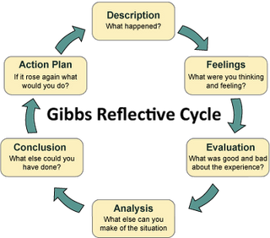

(2) Bloom's Taxonomy
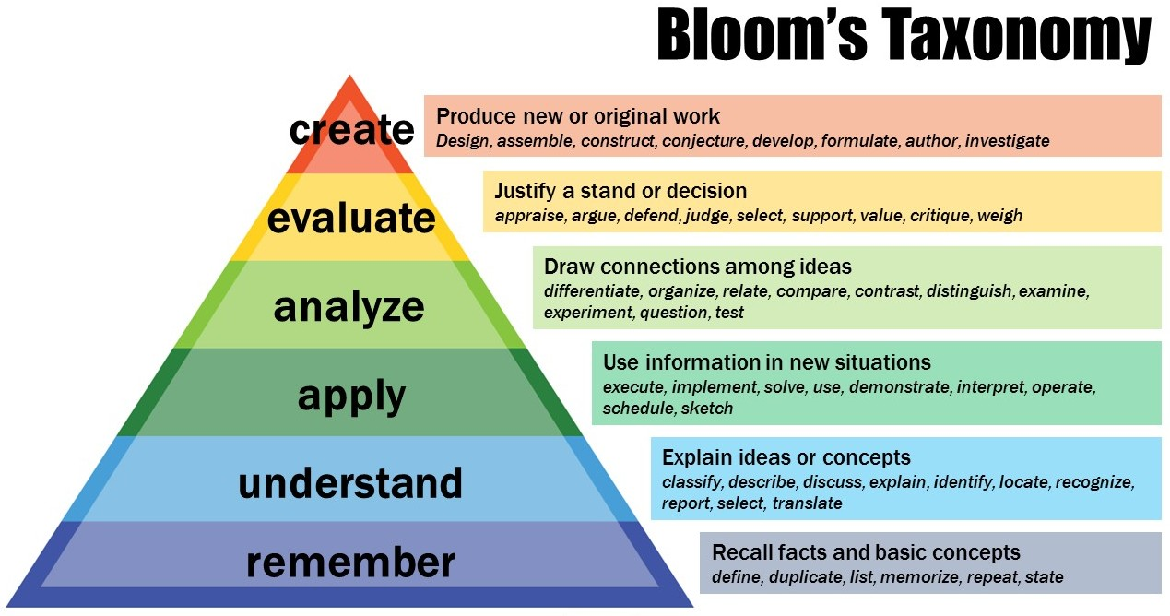

(3) My unused Socrative Quiz questions
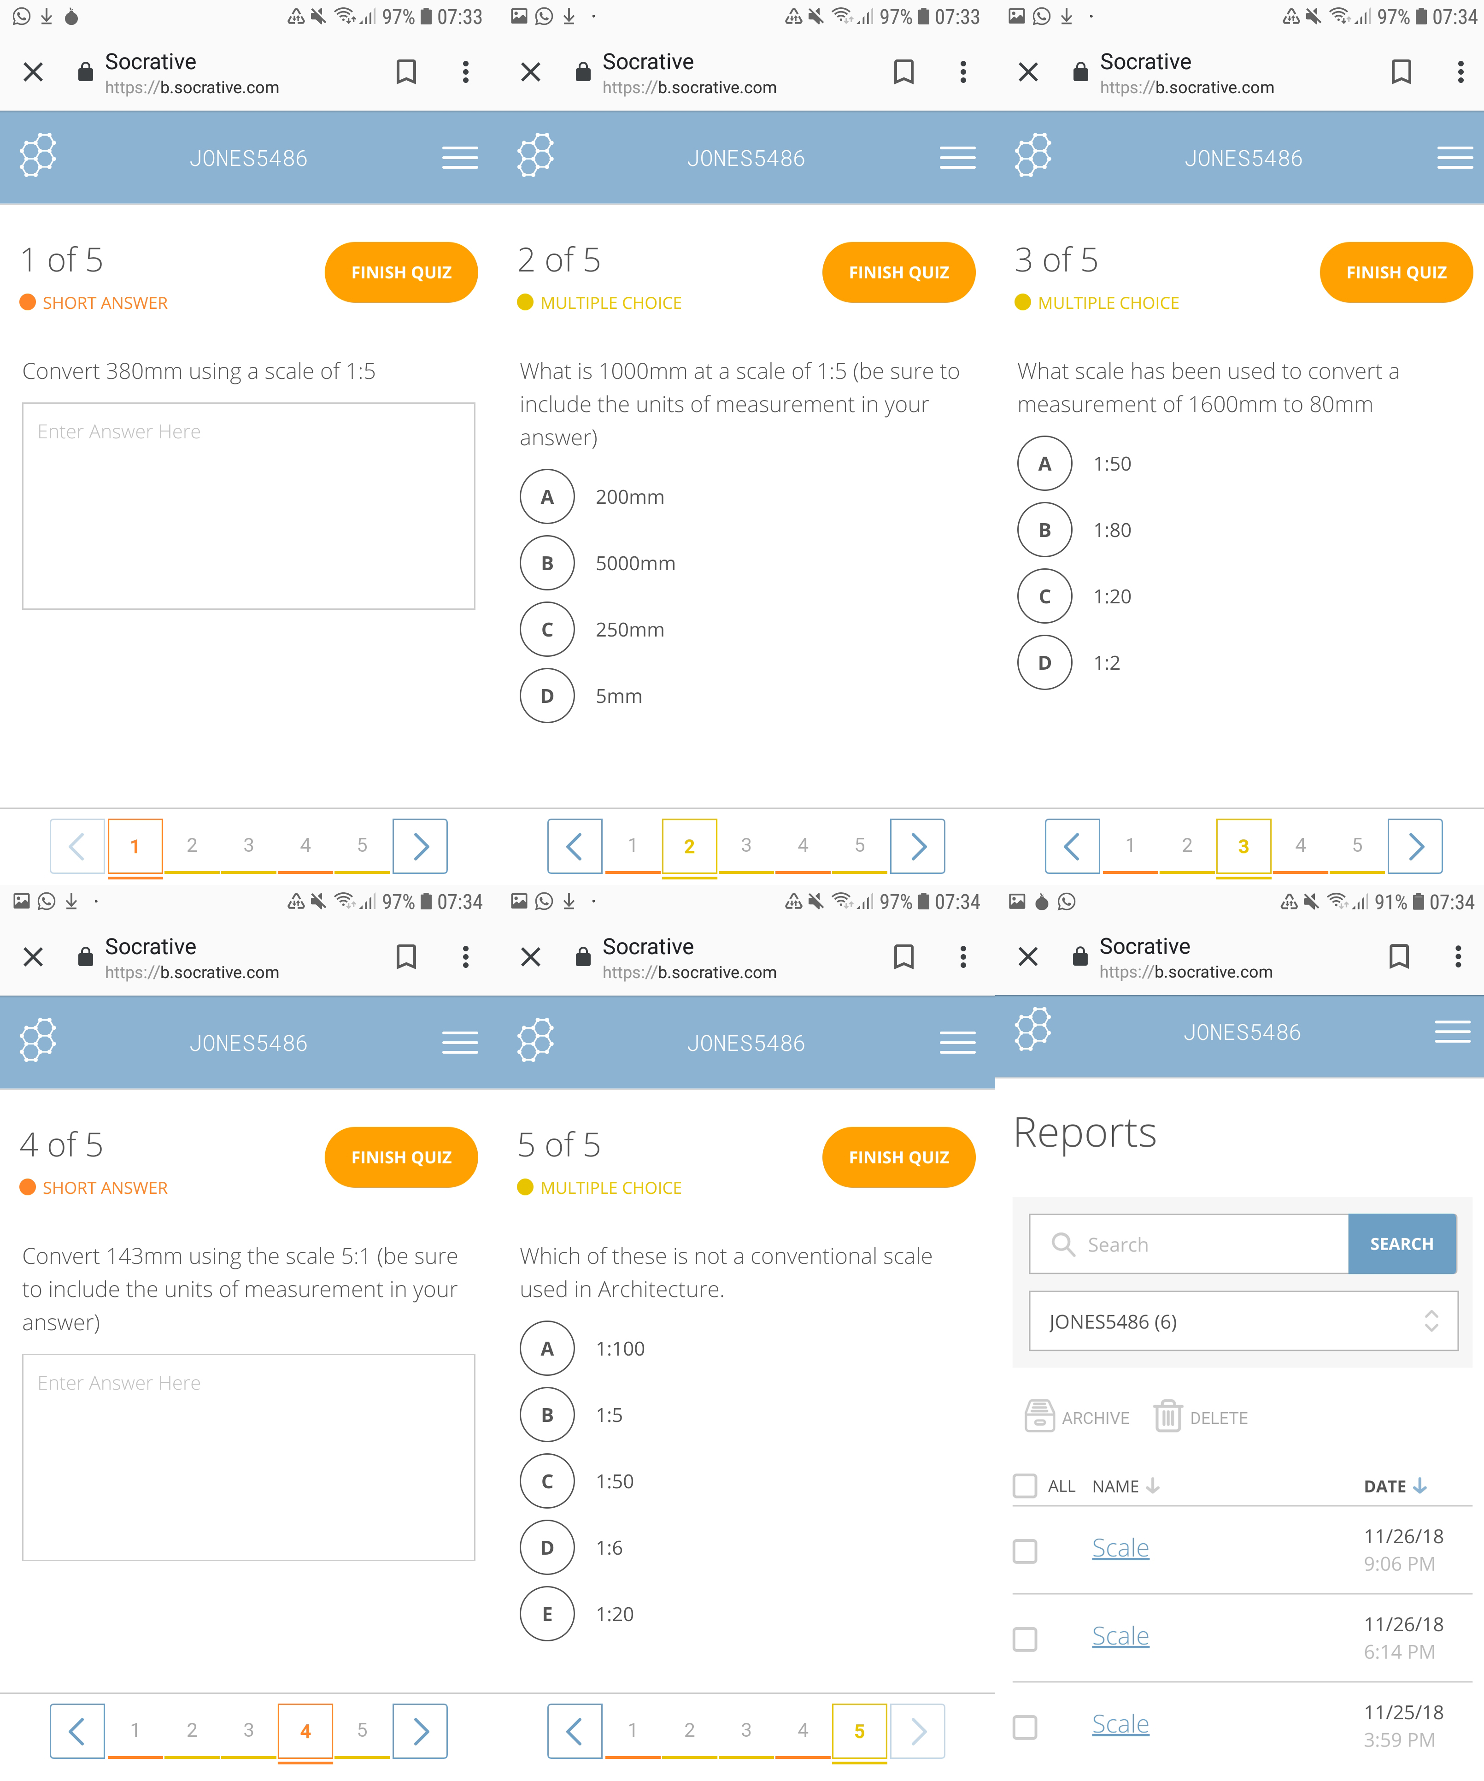

(4) One students completed scale drawing of the doorway.
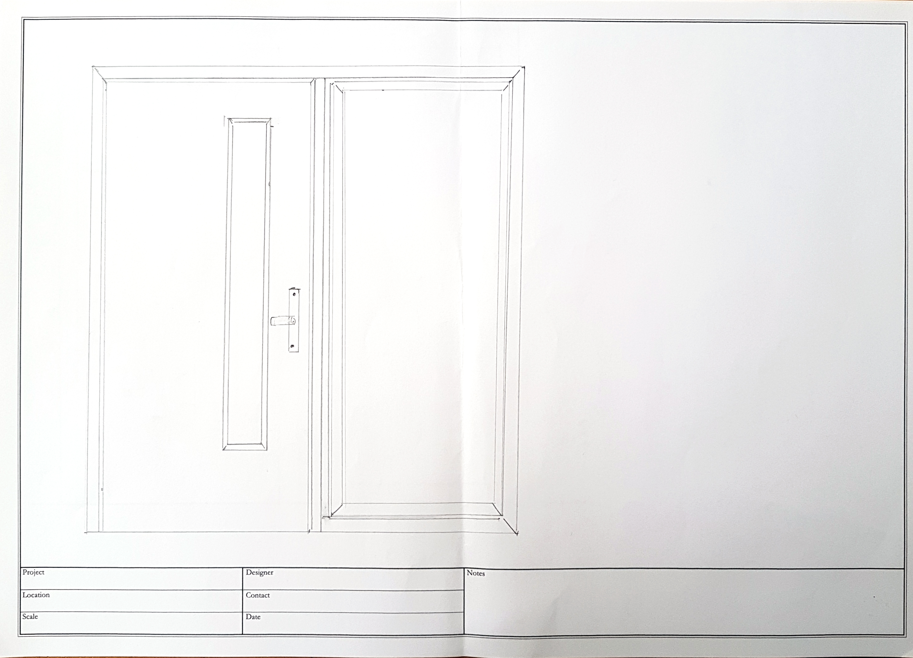

Since returning to Socrative after the lesson, I discovered that it is possible to export your quiz as a .pdf document for use outside of Socrative.

