University of Wales Trinity of Saint David
Energy in a flywheel
Engineering science M4X00385
Laith Alkadhim
1802039
13/12/19

Contents

Introduction 1
Experimental Procedure 2
Results 3
Analysis 4
Conclusion 5
Evaluation 6
Further Work 7
Bibliography 8

Introduction
For this science experiment the aim was to see how energy is stored into a flywheel and how different potential energy affects the overall result. The aim of this report was to gather evidence and use this to prove the theory and effect of energy on a flywheel. With the results gathered, calculations would be made to show the effects the different weights had on both potential energy and kinetic energy.
The experiment was set up so that different masses would be placed on to a hanger, the time taken for the hanger to fall and rise was recorded as was the final height that it reached. The mass was the only variable. All other factors were kept the same. An average for the results was taken from the data that was measured by hand.
The two values were recorded and using the equation PE+PE loss=KE the overall energy which was transferred into the flywheel and also how much was lost during the motion was found.
The equation a=h1/tf^2 to work out the acceleration of the flywheel and showing how the difference in potential energy will affect this.
The general accepted theory is that the more potential energy the greater kinetic energy will be transferred through the flywheel. There should also see a point where the flywheel will reach the maximum amount of energy that can be stored down to its weight and inertia.

1

Experimental Procedure
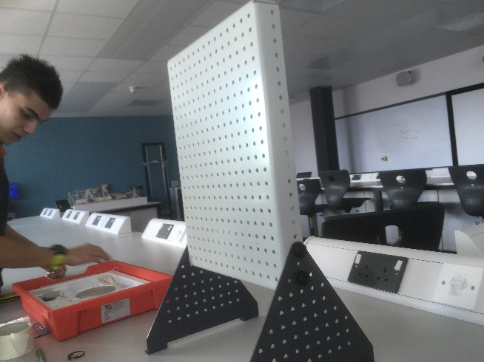

Figure 1: a picture of the work panel
For the experiment procedure the kit was opened (TecQuipment,2019), the work panel and the bearing block was assembled. It was made sure that the number of holes from the right-hand side of the panel were counted following the guidance booklet. Once the bearing block was set up the string was attached to the weight hanger. A magnetic ruler was then placed to the work panel and the height of 280mm was measured from the bottom of the hanger. A mark on the string was then placed so that it would be quicker to return to that specific height for each of the tests.
Throughout the whole experiment, each test with the various weights was repeated three times. The average was then calculated and used for the data. It was made sure that the string was coiled the same way for each run. A mass of 10g was added for the first test. Once let go the time taken for the weight to fall and then return to its maximum height was recorded, along with the maximum height that it reached. A stopwatch on a phone was used to record the time taken for the weight to make its travel. Another person looked at the maximum height that was reached on the return. Video footage was taken of the whole experiment so that it was possible to go back over and look at the footage to more accurately get the time taken to fall and the video could be paused by frame so the overall height could be seen.
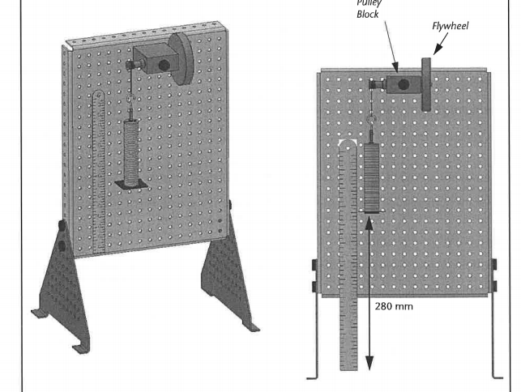

Figure 2: an example of how the experiment should be set up (TecQuipment,2019)
2

Results
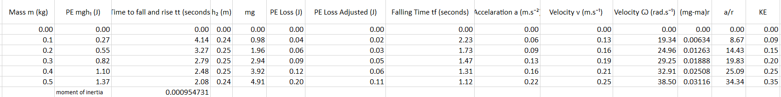
Figure 3: The table of results that was produced
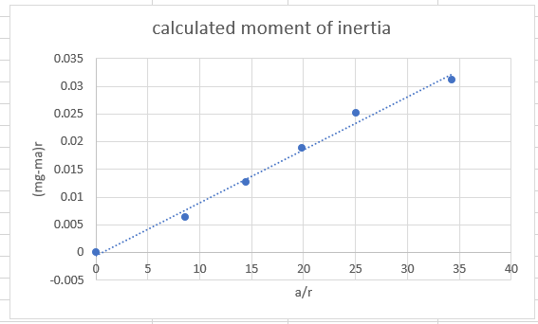
3
Figure 4: graph made to calculate the moment of inertia

Analysis
From figure 3 above looking at the data collected we can see that as the mass increases this has the effect of increasing the potential energy, we can see that this has a direct correlation on the kinetic energy that is transferred into the flywheel.
Looking at the values for both the acceleration and the angular velocity of the flywheel as more mass is applied these figures are increasing. This is expected as the gravity values are constant so only the mass is a variable.
If we look at the values on the graph for each of the masses and the potential energy loss, we can see that as the mass increases so does the pe loss. This can be put down to the amount of force that is put onto string and the bearing block. The greater amount of force placed vertically down, the more friction this causes in the bearing slowing down the rate that the flywheel can accelerate. Although the energy lost is greater the increase in potential energy out ways the additional frictional forces that are created.
To calculate the value for moment of inertia the gradient of the graph is taken. The calculated moment of inertia was 0.000954731 looking at the value given in the book was 0.0004696 there is obviously some discrepancy in the data here. This may be down to the slight inaccuracy’s in the way that the data was collected and how the experiment was carried out. Although they differ, they are still within the scale of each other.
From looking at the data collected we can see that as PE is increased the more energy is stored into the flywheel and then released back as kinetic energy. Confirming the relationship between the two and how a flywheel will store the energy and what percentage of that is transferred back into the h2 and how much is lost on this process.

4

Conclusion
Looking at another very similar experiment where they have used different masses and have measure the effect this has by using a sensor.
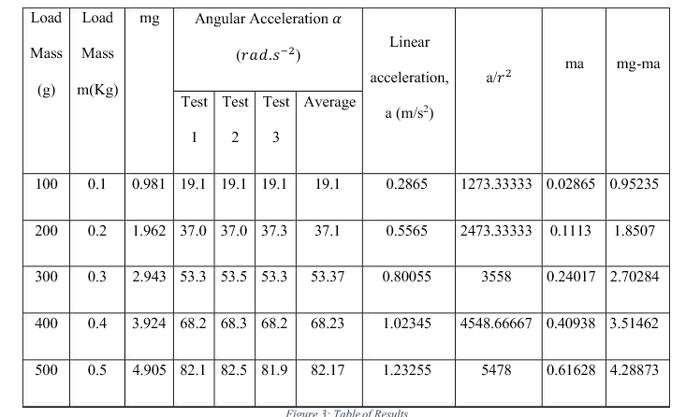
  - figure 5: showing a similar experiment conducted (macharia, 2019)
The table above was constructed using data from a similar experiment, this experiment used increasing masses and a sensor to look at how acceleration and the moment of inertia was affected. The setup and the exact dimensions of the flywheel may differ slightly however the principles and the trend of the results follow the experiment that was carried out in this assignment. For example, looking at the angular acceleration in figure 5 above the first weight of 0.1kg its average was 19. 1rad.s-2 and the second weight, giving and average of 37. 7rad.s-2. From looking at these two results we can see the trend of the increase in angular acceleration as the weight increases. Looking At the experiment that was conducted in this report the first was 19. 34rad.s-2 and the second being 24.96 rad. s-2. The exact figures are slightly different, but this is most likely down to the differences in set up. However they do both show a similar size of scale between the two points.
From this report here the moment of inertia was calculated to be 0.80176x10-4. The weights used on the experiment was the same as the experiment conducted in this report. Looking at the dimensions of the flywheel listed it is fairly similar to what was used on this experiment. By having a moment of inertia calculated which is similar and on the same scale as the one on the above experiment helps confirm and backs up the results found here and shows that the experiment can be repeated.

5

Evaluation
From the results that the experiment produced we can see that the data supports the theory for energy conservation within a flywheel. However, looking at the same results we can see some discrepancies within the data, looking at figure 3 again the results for the test at 0.4kg we can see that while it does follow the general pattern for the data, the results are roughly where they would be expected to be from figure 4. Looking at the graph it is clear that the chosen point deviates from the line of best fit. Having this result differ from the rest is generally down to the human error within the experiment that was conducted. Looking at the experiment in detail there was many variables that would explain the slight error is results that was found. The first being the time it took for the flywheel to be released and when the stopwatch was started. When the experiment was conducted it was made sure that the same people were doing the same job each time to try and keep it as repeatable as possible. Doing it by eye will always cause some variation in the data. Being human it is impossible to be able to start the stopwatch exactly at the right time consistently, this also applies to stopping it once it has reached its final height. During the experiment there were occasions where the results had to be retaken either down to lack of communication to when the flywheel was being dropped or even mishaps with pressing the start on the timer consistently. Down to these errors some tests had to be redone and get the timings of each action as close as possible.
Another area where variations could occur was the resetting of the weight hanger. Firstly, this was being done by eye so there was a possibility for the weight hanger to start at slightly different heights each time effecting the results. For the experiment there was a pen mark placed on the string which when lined up with a corresponding edge on the bearing block gave the correct height for the hanger. However, looking back at this it was possible as the weight was increased the string could have changed length and stretched taking up the tension. This would have changed the height slightly with each different test. There were also chances that the ruler could have been moved. The ruler is magnetic and is free to move and slide on the work panel, again it could have been possible that the ruler moved slightly half way through the tests thus causing in inaccuracies within the work.
It is not possible to know exactly what type of variation was present or to what extent these errors effect the data when conducting the experiment so, these results have to be taken with some consideration when viewed and plotted on the graph.

6

Further Work
If the experiment was able to be carried out again with an unlimited budget, more equipment available then changes could be made for the results to be more accurate and to get rid of the human error and the anomalies that occurred.
For example, the human error inbetween letting the flywheel drop and the other person starting the timer can vary massively. Using something like a timing gate so that the exact time when the flywheel is dropped the timer is started. Having this equipment would eliminate that variable and make the experiment more accurate. (eisco labratory timer, 2019)
Another way that the experiment could be improved is to use a high-quality slow-motion camera so that the exact height of the weight hanger on its return could be determined. By videoing the test with such a camera, the footage could then be played back at precise frames so that the exact height for h2 could be found. Using something like this would eliminate the parallax and the inaccuracy of having someone look by eye as the test is going on to see what height it reached. From my research a device like this can also be used to calculate the velocity of the hanger in motion. By setting up a known measurement scale behind the hanger then using how many frames per second the video is shooting in and corresponding that to the distance it has moved the speed can be worked out on both the downward and upwards travel.
Looking at the frictional losses throughout the experiment if it would to be conducted again then it would be beneficial to try and cut down on the frictional losses as much as possible. One way that this could be achieved is to change the bearings in the flywheel. looking at this article (popular mecchanics , 2019) where they have come up with a bearing without using a cage for the rollers this dramatically reduces the rolling friction of the bearing. This could be used in this experiment to reduce on the potential energy loss and could provide better results that could show how much energy the flywheel is capable of storing and where it reaches it limit.

7

Bibliography
(2019, 12 11). Retrieved from https://www.rapidonline.com/Eisco-Laboratory-Timer-and-Timing-Gate-52-3434?IncVat=1&pdg=pla-294357559827:kwd-294357559827:cmp-757438067:adg-44804851896:crv-207912323492:pid-52-3434:dev-c&gclid=EAIaIQobChMI7PW23OWt5gIVibHtCh2AMA3oEAQYASABEgJQmfD_BwE
(2019, 12 11). Retrieved from eisco labratory timer: https://www.rapidonline.com/Eisco-Laboratory-Timer-and-Timing-Gate-52-3434?IncVat=1&pdg=pla-294357559827:kwd-294357559827:cmp-757438067:adg-44804851896:crv-207912323492:pid-52-3434:dev-c&gclid=EAIaIQobChMI7PW23OWt5gIVibHtCh2AMA3oEAQYASABEgJQmfD_BwE
(2019, 12 11). Retrieved from popular mecchanics : https://www.popularmechanics.com/technology/gear/a15603/super-efficient-greaseless-bearings/
https://www.rapidonline.com/Eisco-Laboratory-Timer-and-Timing-Gate-52-3434?IncVat=1&pdg=pla-294357559827:kwd-294357559827:cmp-757438067:adg-44804851896:crv-207912323492:pid-52-3434:dev-c&gclid=EAIaIQobChMI7PW23OWt5gIVibHtCh2AMA3oEAQYASABEgJQmfD_BwE. (2019, 12 11). Retrieved from https://www.rapidonline.com/Eisco-Laboratory-Timer-and-Timing-Gate-52-3434?IncVat=1&pdg=pla-294357559827:kwd-294357559827:cmp-757438067:adg-44804851896:crv-207912323492:pid-52-3434:dev-c&gclid=EAIaIQobChMI7PW23OWt5gIVibHtCh2AMA3oEAQYASABEgJQmfD_BwE
macharia, D. (2019, 12 13). academia.edu. Retrieved from Flywheel lab Report: https://www.academia.edu/36510440/Title_Flywheel_Lab_Report

8

