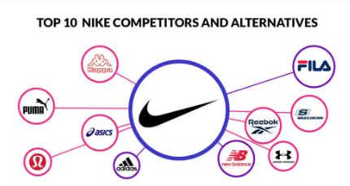
Targeting of Nike
This marketing strategy phase involves selecting the most effective customer segments to meet the firm's goals. Nike targets three main groups, like, men, women, and kids. For men, it offers shoes for various sports and activities, including running, training, football, basketball, and more. Women’s offerings include yoga shoes, while the kids' line focuses on young athletes. Nike emphasizes both comfort and design, providing products in various colours to enhance customer satisfaction and enjoyment.
Positioning of Nike
Positioning places a brand among competitors, and Nike has established itself as a leader in innovative, high-quality sports equipment. Through its iconic swoosh, "Just Do It" slogan, and association with top athletes, Nike connects emotionally with customers, portraying a victorious and ambitious image. It also influences fashion trends, aligning its products with active lifestyles. Nike has successfully built a strong belief that its products are the top choice for sport’s needs.
Table Market Segmentation
- Demographic - Ages 15–55, men, women, kids, high-income, sports lovers
- Geographic- Urban areas, global reach
- Psychographic - Active lifestyle, interests,
- Behavioural - Frequent buyers, loyal customers

