Matthew James (1809299)
1809299@student.uwtsd.ac.uk
Networking operating systems and services
ACCA5023 – Worksheet 1

Contents
1. Introduction 2
2. Assumptions 2
3. Creating a working Virtual LAN environment 2
3.1 Installation of Oracle Virtual Box 2
3.2 Creation of Server & Client Environment 3
3.3 Installation of Windows Server 2019 & Windows 10 Pro 7
4 Configuring Virtual Network 12
4.1 Server1 Network Configurations 12
4.2 Testing Virtual Environment network connections 16
4.3 Testing Server1 & Client1 19
4.4 Testing Server2 & Client2 21
5 Troubleshooting steps 22
5.1 32-bit Operating systems 22
5.2 Re-occurring installation process. 24
6 Observational Notes 24
6.1 Type 1 Hypervisor 24
6.1.1 Benefits: 24
6.1.2 Drawbacks: 25
6.1.3 Vendors: 25
6.2 Type 2 Hypervisor 25
6.2.1 Benefits: 25
6.2.2 Drawbacks: 25
6.2.3 Vendors: 25
6.3 What are Subnet masks within an IPv4 address? 25
6.4 Cloud Computing 26
6.4.1 What is Cloud computing 26
6.4.2 What is Infrastructure as a Service: 26
6.4.3 What is Platform as a Service 26
6.4.4 What is Software as a Service 26
6.4.5 Cloud computing benefits 26
6.4.6 Drawbacks 27
6.4.7 Vendors 27
6.5 Terminologies used and compared with another network operating systems 27
6.5.1 Internet Control Message Protocol 27
6.5.2 Server Management 27
Bibliography 30

Introduction
The purpose of the following report will showcase the various actions that the author took in order to create a virtualised Server to Client environment using Window based operating systems.

Assumptions
It is assumed that the read has adequate knowledge of information technology and can understand a variety of common terms within the field.

Creating a working Virtual LAN environment
Within the following section the author will undertake the steps to install and set up two Server and two Client environments.

Installation of Oracle Virtual Box
Installing Oracle Virtual box with the following settings.

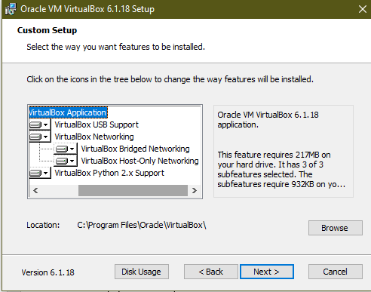
Figure 1 - Installation of VirtualBox & Settings

Creation of Server & Client Environment

The server and client environment have similar steps in order to create as such the author has decide to only report on the creation of a server VM.
Selecting Name and Operating System for the Virtual Machine
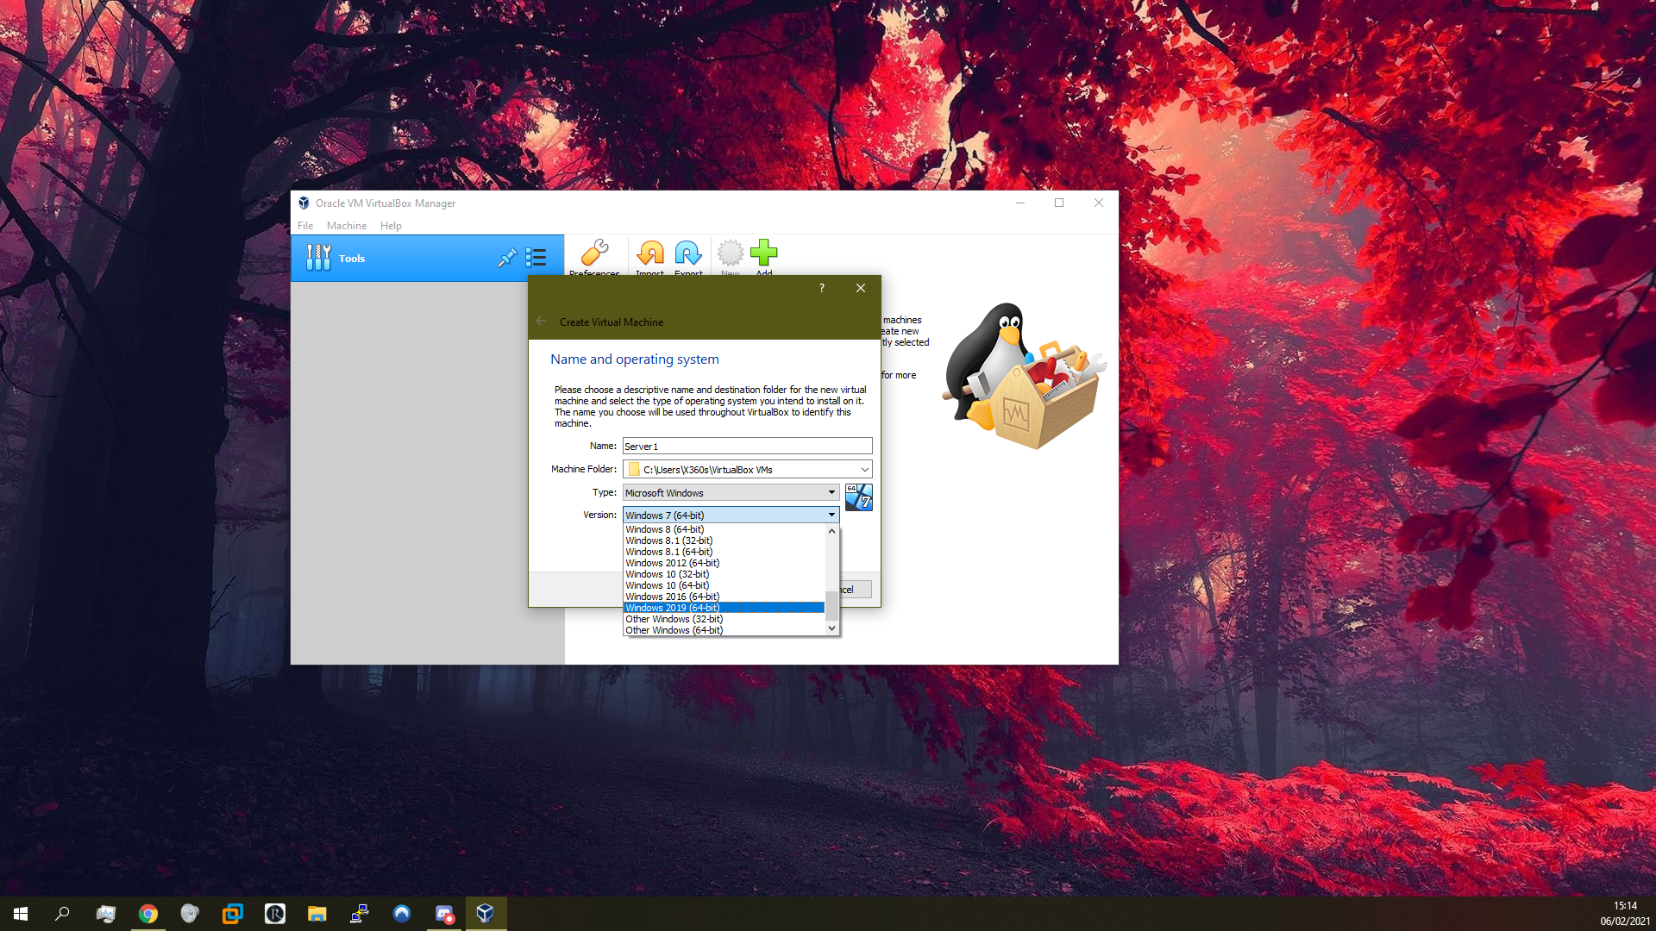
Figure 2 - Adding Windows Server 2019
Selecting the amount of Random-Access Memory (RAM) to ensure that the virtual machine functions correctly and efficiently for the desired purpose.
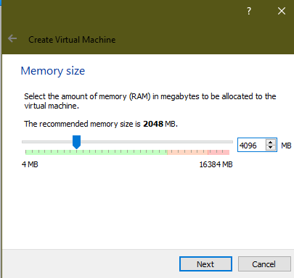
Figure 3 - Selecting 4GB as the Memory size for the Servers.
Selecting the hard disk file type:
VDI was selected as this ensures that all information is saved to a single file for easy transfer.
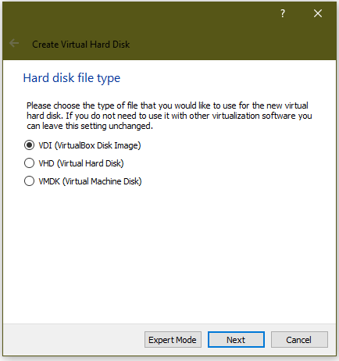
Figure 4 - Selecting Hard Disk File Type
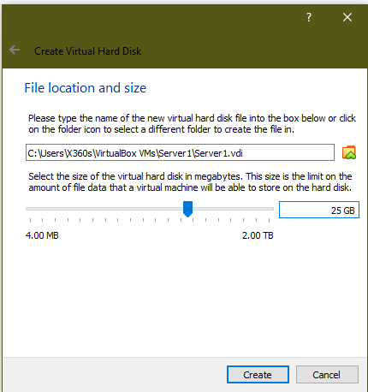
Figure 5 - Selecting File Location and Size

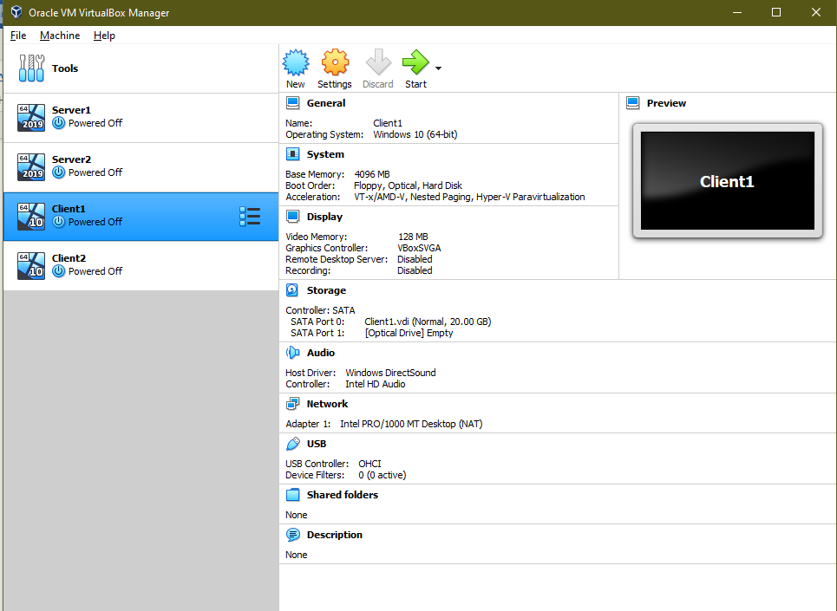
Figure 6 - Creation of 2 Servers & 2 Client Virtual Machines

Installation of Windows Server 2019 & Windows 10 Pro
The windows version that the author has decided to install are the following:
- Microsoft Windows Pro 2021
- Microsoft Windows Server 2019
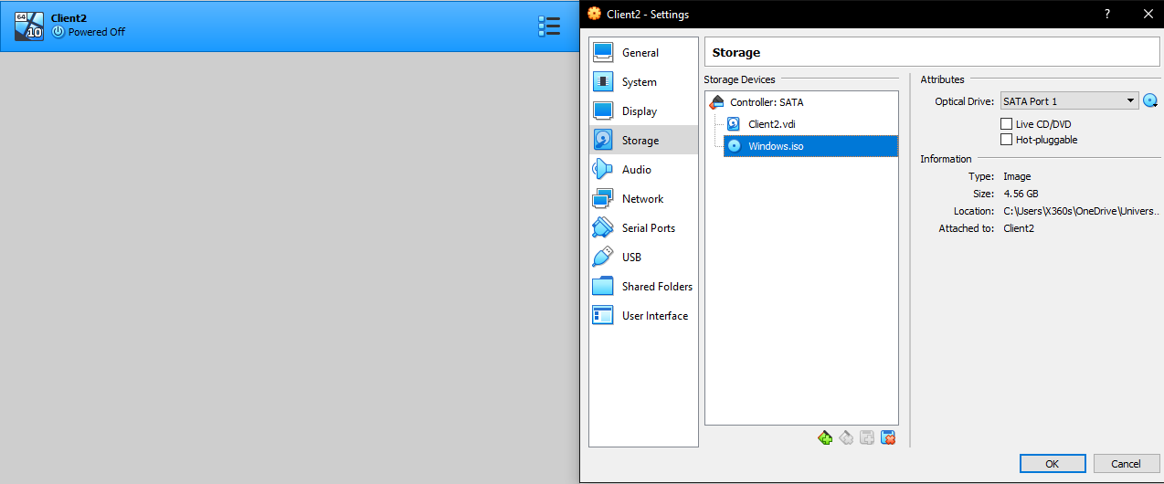
Figure 7 - Selecting Windows ISO for Client 2
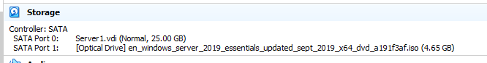
Figure 8 - Selecting Windows Server 2019 ISO for Server1
Before the installation process is started, the author has taken time to research the following optimization techniques when using Oracles VM VirtualBox, the optimizations have been applied to all of the create VMs.
Only one method was select to be implemented.
- Enable PAE/NX – this feature determines whether a host’s CPU will be exposed to the virtual machine. Once enabled the OS can utilise the CPU to access more than 4gb of RAM thus allowing the author to allocate more.
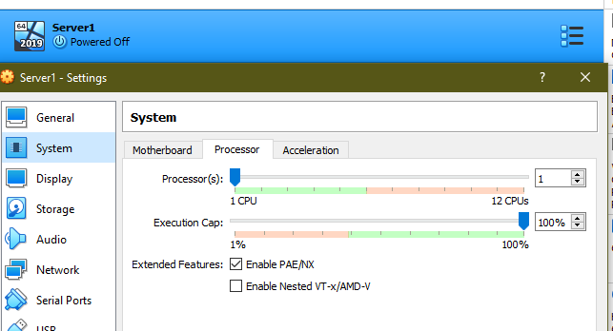

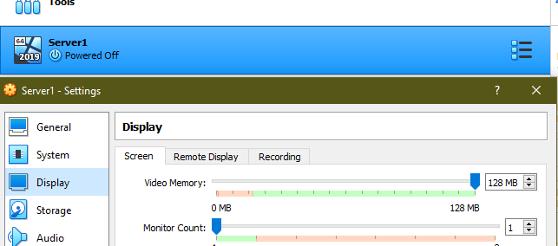
Figure 9 - Selecting Video Memory
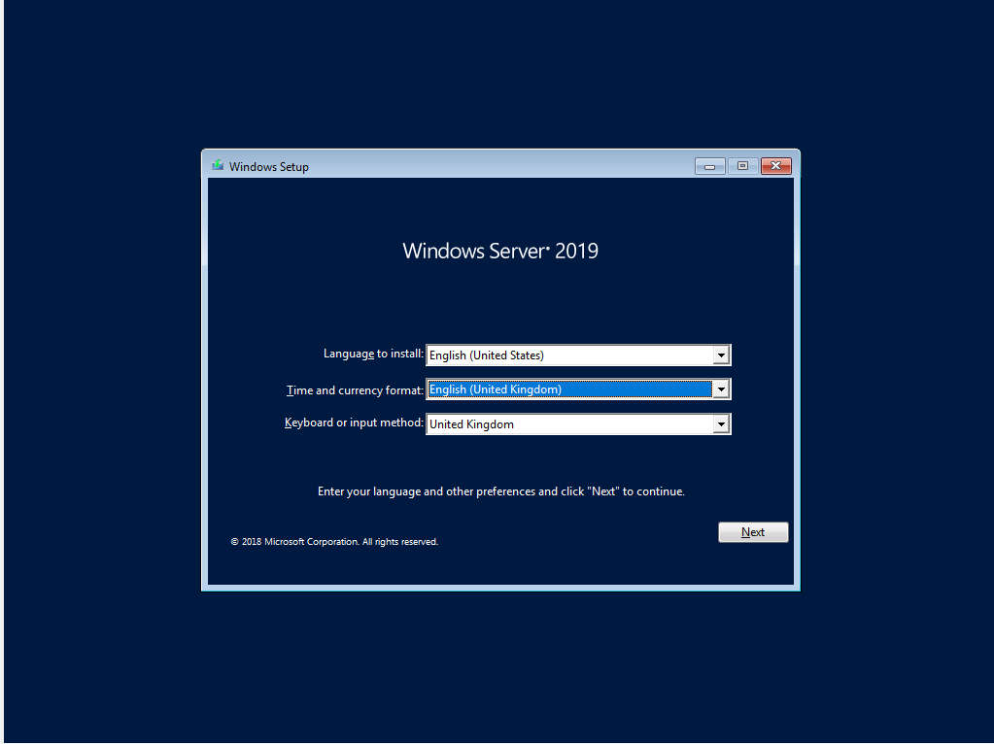
Figure 10 - Windows Server 2019 installation
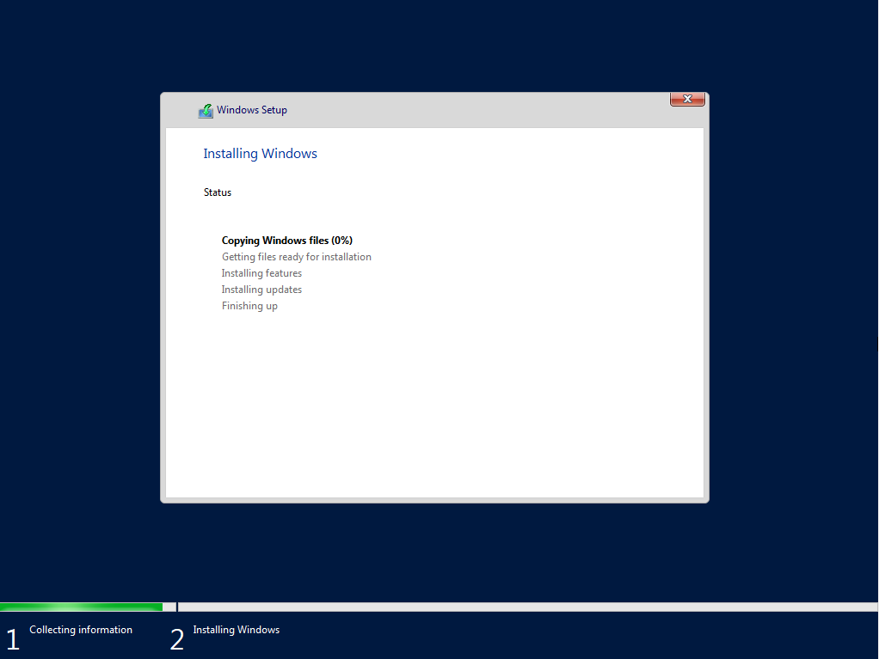
Figure 11 - Installing Windows to selected Partition.
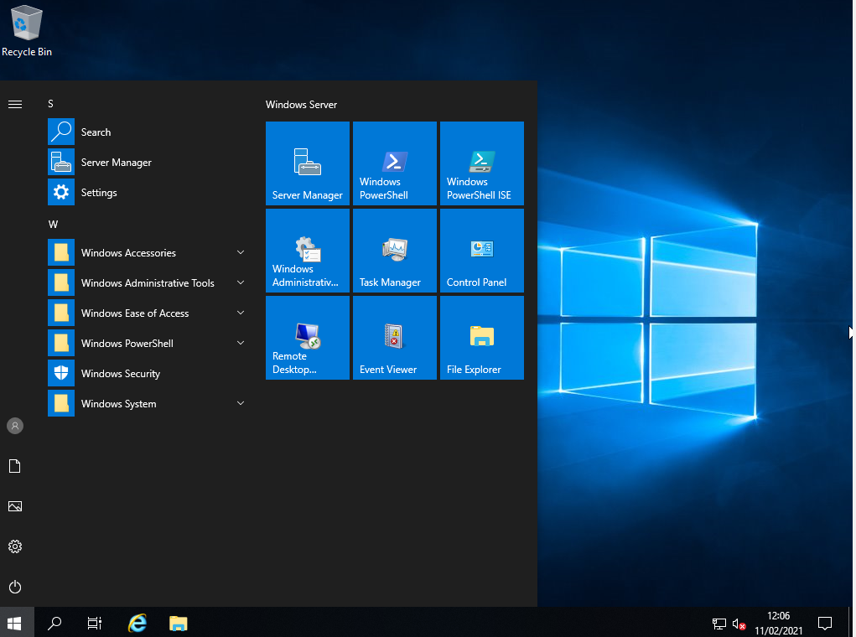
Figure 12 - Windows Server 2019 installed

The process for installing Windows 10 Pro has very similar steps. Therefore, the author did not present the read with similar process images.
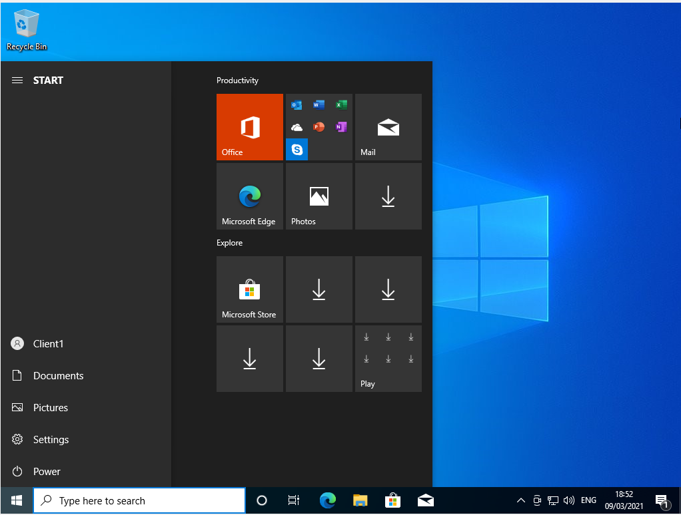
Figure 13 - Windows 10 Pro installed

Configuring Virtual Network

The following section will demonstrate the steps required to configure a Virtual Network.

Server1 Network Configurations
Within Figure 14, the following steps have been implemented:
- Ethernet Adapter 1 has been renamed to PublicNet.
- IP Configuration of PublicNet
  - IP Address
  - Subnet
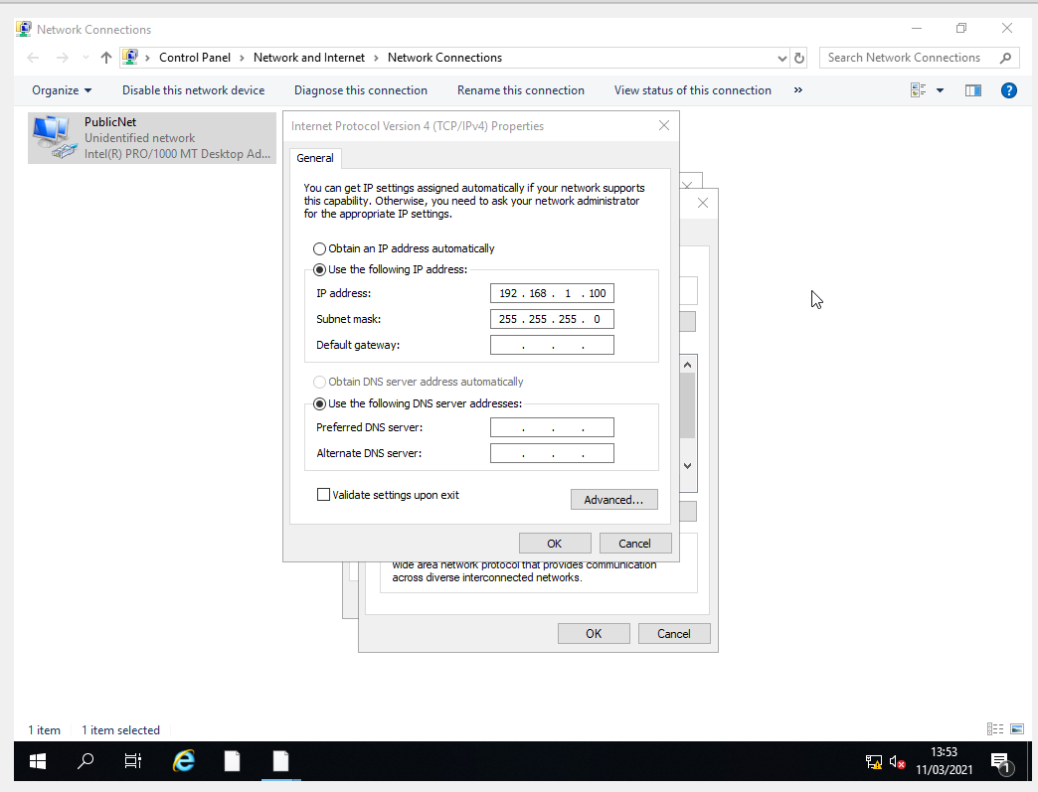
Figure 14 - IP Configuration of Server1
- Ethernet Adapter 1 has been renamed to PrivateNet1.
- IP Configuration of PublicNet
  - IP Address
  - Subnet Mask

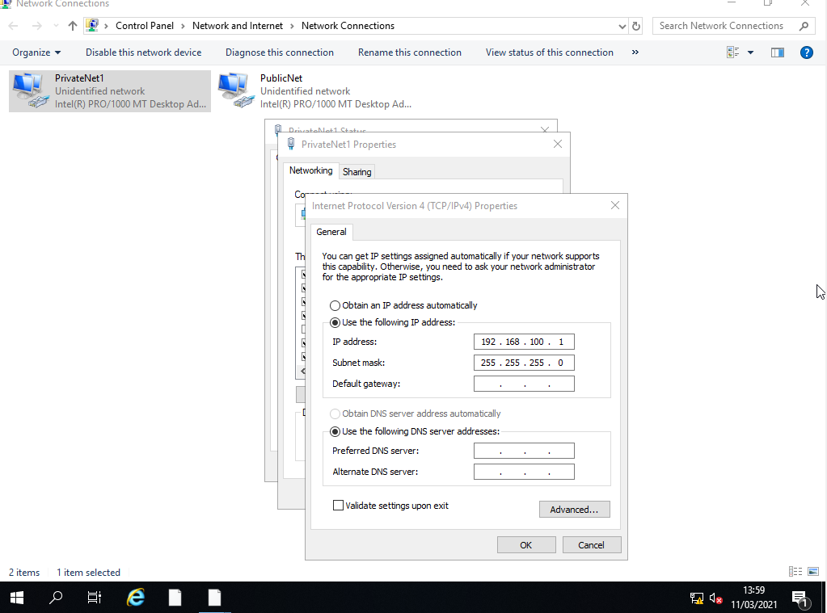
Figure 15 - PrivateNet1 Creation on Server1

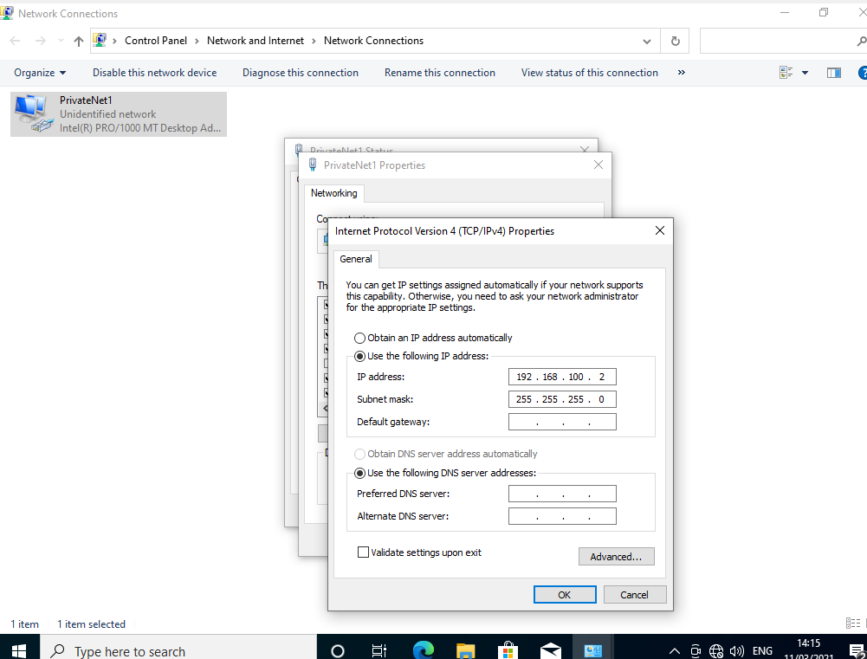
Figure 16 - Configuring PrivateNet1 on Client 1

Get Client 2 image of private next.
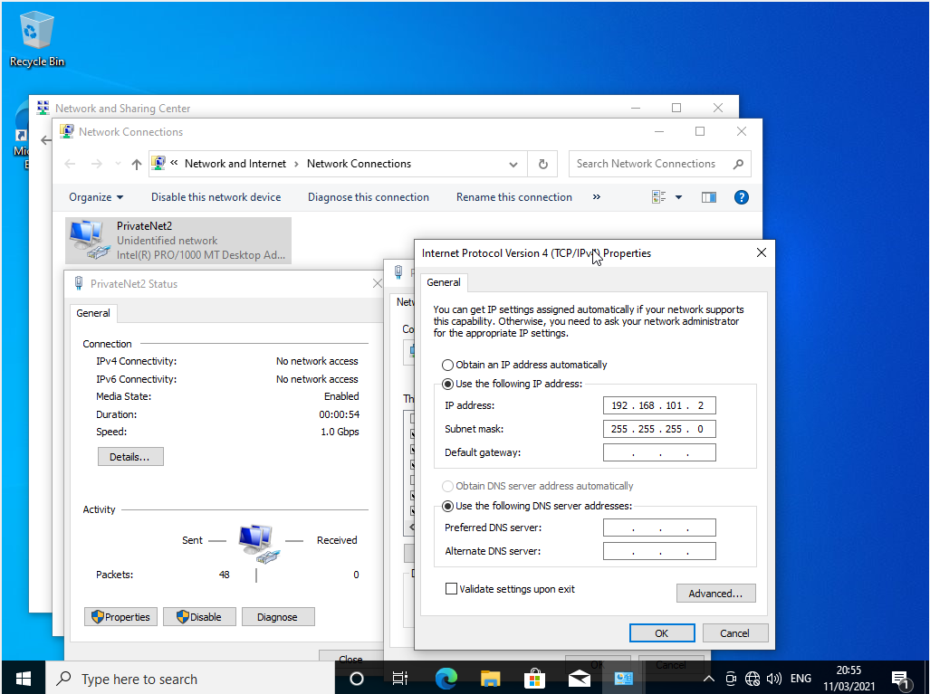
Figure 17 - Configuring PrivateNet2 on Client 2

Testing Virtual Environment network connections

Server1 & Client1
The author has disabled Firewall protection for both Public and Private for Server1 & Client1. This is done due to the testing method being ICMP (pinging). In Out-of-box-experience (OOBE) environments this will be denied.

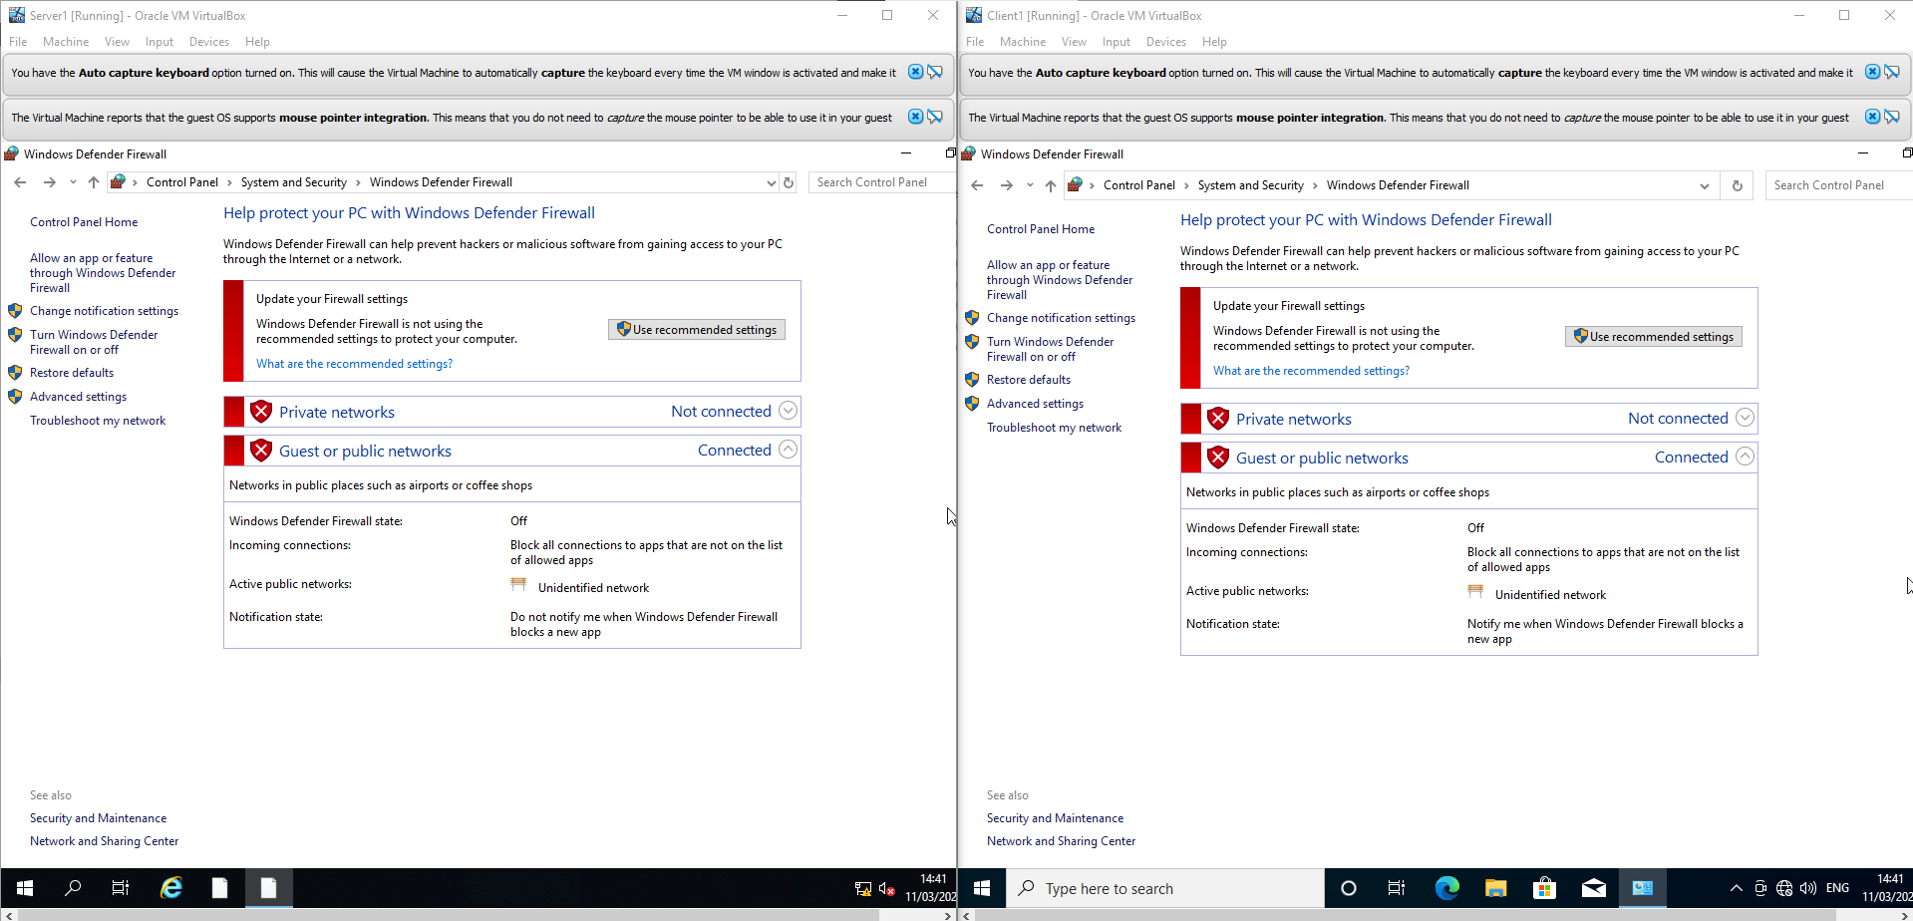
Figure 18 - Server1 Firewall being disabled.
Then go on to the firewall part and testing the IPs
Figure 19 - Client1 Firewall being disabled.

Testing Server1 & Client1
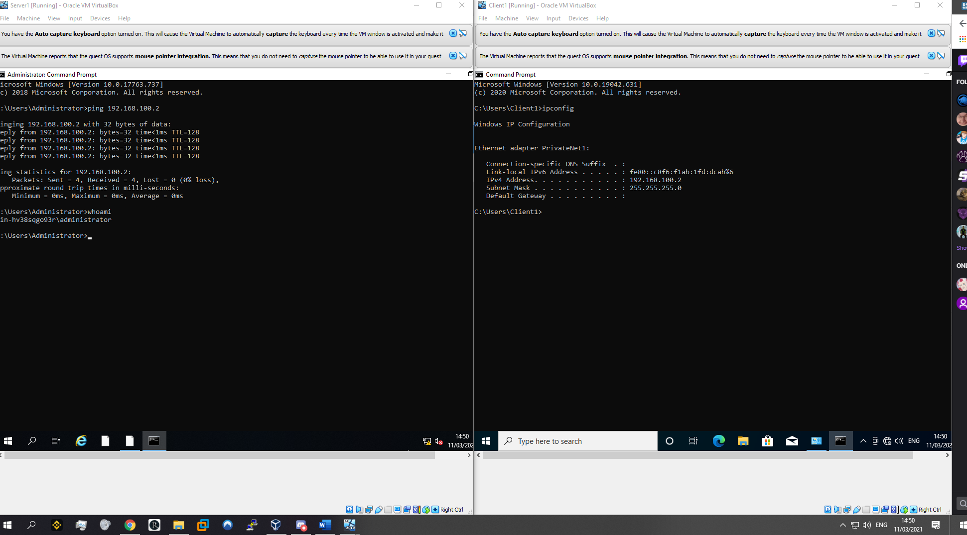
Figure 20 - Server1 Pinging Client1
Figure 21 - Client1 IPConfig

Testing Server2 & Client2
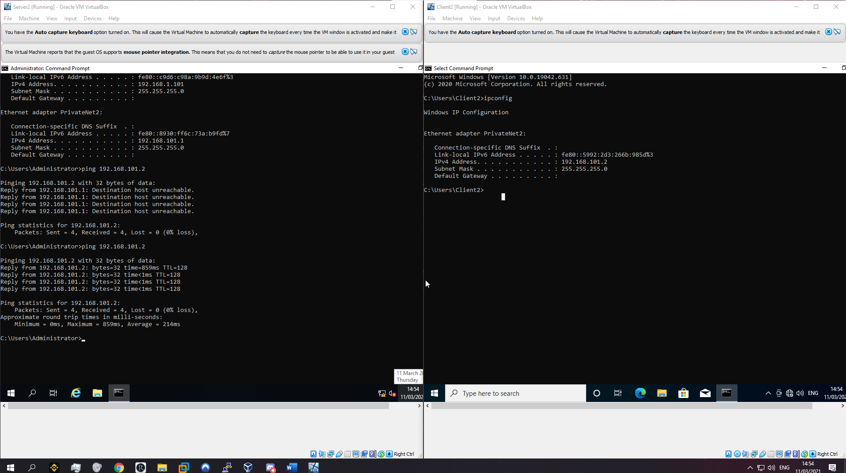
Figure 22 - Server2 Pinging Client2

Figure 23 - Client 2 IPConfig

Troubleshooting steps
There were some occurrences where’s errors occurred within the author’s work. The following is demonstrating the errors and what actions were used to fix them.

32-bit Operating systems
The author had been instructed to implement a 64-bit windows server 2019 and Windows 10 environment. In the initial installation process, the author was uinable to produce 64-bit but was only given 32-bit system. It was later found by conducting further research that virtualisation was not turned on. The author began to research how to enable this feature and was able to successfully turn on virtualisation and begin the installation processes. [1]
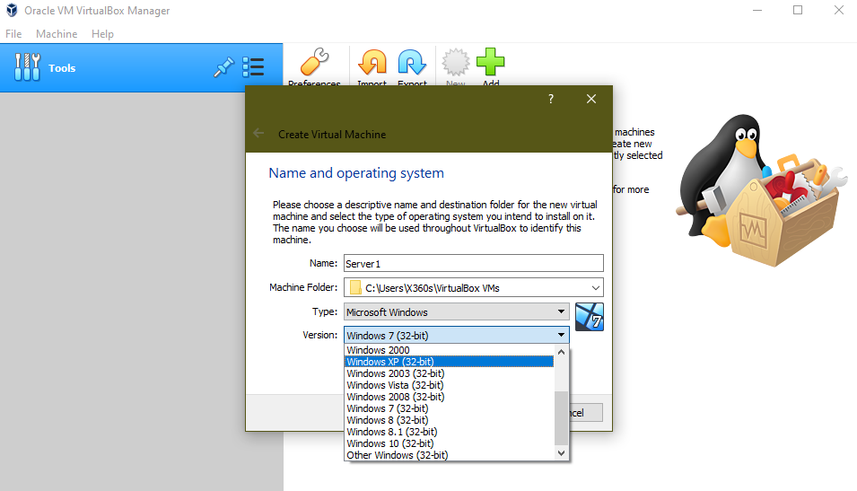
Figure 24 - 32-bit Operating System
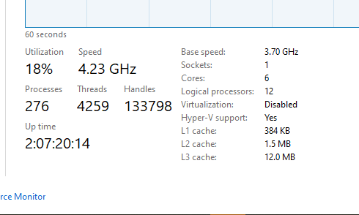
Figure 25 - Virtualisation disabled

Figure 26 - 64-bit available for use

Re-occurring installation process.
The author encountered their Virtual machines re-booting into the Windows installation process. The author conducted research and found that even though the installation had been completed, the Virtual machine (VM) was still calling on the installation disc as it had not been removed from the storage of the VM. Once removed, the VM posted into Windows Server 2019.
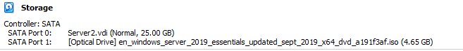
Figure 27 - Installation of Windows Server

Observational Notes
The differences between Type1 and Type 2 Hypervisors

Type 1 Hypervisor
Type1 Hypervisor [2] also known as ‘bare-metal hypervisor’ runs directly on the host machines physical hardware, this allows a Virtual machine (VM) to run without the need of an underlying operating System (OS) and other contents such as drivers. Type 1 hypervisor are regarded as the most efficient and best performing hypervisors within an enterprise environment.

Benefits:
- Performance - As Type 1 hypervisors are not constrained by inherent limitations that come with OSes, this allows for greater performance.
- Highly secure – Type 1 hypervisors run directly on the physical hardware without any underlying OS, they are secure from flaws and vulnerabilities which are usually found overtime often endemic to OSes, this ensures that every VM is isolated from any malicious software activity. [3]

Drawbacks:
- Additional Software – in most cases type 1 hypervisors require additional external management with interfaces such as Microsoft Centre Virtual Machine Manager or VMware vCentre, these are required to access the full functionality of a hypervisor’s abilities.
- High initial costs – type 1 has great benefits for enterprise environments, but this does not come without its higher initial costs and great support from external contract requirements.

Vendors:
- Microsoft’s Hyper-V.
- Citrix Hypervisor also known as Xen Server.
- Oracle VM Virtual Box

Type 2 Hypervisor
Type 2 Hypervisors [4] run on the hosts operating system; therefore type 2 hypervisors are also known as hosted hypervisors. These types of hypervisors are hosted on the OS and the hypervisor itself runs on that layer as another piece of software to enable virtualizations. This in turns relies on the hosts resources such as OS, memory, storage, and network.

Benefits:
- Simple management – the hypervisor has all the required management capabilities to fully utilise the software packages installed.
- Testing – Type 2 hypervisors are used for testing due to the user being able to run multiple instances with different OSes to test how the software reacts and works within each environment, these hypervisors are very easy to set up.

Drawbacks:
- Unlike type 1 hypervisors, type 2 relies on the Hosts resources and can introduce latency issues on which will affect performance of the host machine.
- Security risks – type 2 hypervisors are prone to malicious software attacks as they utilise the OS on the host. If the host OS is compromised so is all type 2 VMs. [5]

Vendors:
- VMware Workstation/Fusion
- Microsoft Virtual PC
- Red Hat Enterprise Virtualisation

What are Subnet masks within an IPv4 address?
A Subnet mask is an essential item that is required for internet protocol suite (TCP/IP) to function. [6] the subnet mask is used to determine whether a host is on the local subnet or on a remote network. In TCP/IP, the various parts of an IP address that are used are never fixed. Information is supplied in a 32-bit number called a subnet mask. An example of a subnet mask is 255.255.255.0 which is used for a class C address [7]. All host bits within a subnet mask are 0’s and all network bits are set to 1’s. this way the subnet mask separate the IIP address into network and host addresses.
Two numbers within an address is always assigned and can be considered reserved, these numbers are ‘255’ which is allocated to be the broadcast address and the ‘0’ which is assigned to the network address. These two numbers cannot be assigned to any hosts as they are solely reserved for that purpose. [8]

Cloud Computing

What is Cloud computing
Cloud computing is the delivery of on-demand computing services, from applications, storage, and processing powers. This is separated into a variety of different service types:
Software as a Service (SaaS), Platform as a Service (PaaS), Infrastructure as a Service (IaaS).
The principle of cloud computing is removing the costs of hosting a computer infrastructure or data centres this removing the initial up-front costs and complexity of owning and maintaining their own IT infrastructure and simply pay for what the organisations requires at the given time.
The variety of different cloud computing services range from the afore mentioned SaaS, PaaS, IaaS.
These methods are bought either on a pay as you go basis or on a contractual agreements and requirements basis.

What is Infrastructure as a Service:
This section relates to an organisation purchasing fundamental building blocks of computing that can be rented: physical or virtual servers, storage, and networking. [9]

What is Platform as a Service
This section includes all areas of infrastructure as a service as well as an additional layer such as tools and software that developers need to build applications, this also includes middleware, database management, operating systems, and development tools. [9]

What is Software as a Service
This section is the delivery of application, this is the version of cloud computing that most people use on a day-to-day basis. The underlying hardware and operating systems are not used by the end user and they will only have access to the service via a web browser or app. This section is often bought on a per-set or per-user basis. [9]

Cloud computing benefits

The benefits of cloud computing will vary on the organisation or person utilising the service. Fundamentally, the following points are considered to be the main benefits when purchasing a cloud computing solution.
- Saving on physical space – an organisation no longer needs to purchase physical space for housing various infrastructure items such as servers and maintaining said servers which includes and not limited to updating applications, operating systems, and decommissioning/disposing of hardware and software when no longer in use. A company can completely remove the physical infrastructure aspect. [10]
- Faster start – utilising cloud services can allow an organisation to move faster with certain projects and test out concepts without lengthy procurement and upfront time and costs. The concept is that an organisation can often purchase an IaaS or PaaS environment and begin to utilise these services as cloud providers will already have ready to use servers and networks. The ability to spin up new services without the time and effort associated with traditional IT would allow these projects to be implemented and tested faster. [11]

Drawbacks
- Long term – Cloud services are very beneficial to organisations in the short term as they can be purchased to produce test environment. However, this is not always the case when considering long term use of cloud computing. With the initial up-front costs of purchasing physical storage space for your IT infrastructure, some organisations defer to the cloud computing option for a cheaper price. If an application is required for regular use by an organisation it may be cheaper in the long term by purchasing the physical space.
- Migration – if an organisation decides mid-way through that they wish to incorporate or move to a new cloud computing infrastructure, it may not be easy to do this as migrating existing data or apps to the cloud may be much more complicated and requires additional resources and contractor assistance.

Vendors
- Amazon Web Services (AWS)
- Microsoft Azure
- Google Cloud Platform

Terminologies used and compared with another network operating systems

Internet Control Message Protocol
Internet Control Message Protocol (ICMP) also known as Ping is a transport level protocol within the internet protocol suite (TCP/IP) that is used to communicate information about network connectivity issues back to the source of compromised transmission. It sends control messages such as destination network unreachable, source route failures and source quench. ICMP sends data packet structure with an 8-byte header and variable sized data section. [12] ICMP command has very little to no alterations from a Windows device to a Linux device, both re-repeat the same process of collecting information on the network and reporting it back within a data packet structure.

Server Management
Windows and Linux are both market leaders in the web-hosting space and provide servers for a variety of functions such as webhosting. A Server is a computer program or device that provide specific services to another computer program and its user.
Linux provide an open-source software operating system that is built around the Linux kernel. Linux uses distributions for both desktop and server use. The main function of a Linux OS is to manage software resources and its artifacts while Microsoft Windows Server is strictly for Microsoft branded products and trusted third party applications.
Linux excels in its security, multitasking functionality and provides administrative from the systems admin support perspective while Microsoft excels within the user-friendly graphical interface as with all their products. Microsoft also supports a large variety of third-party applications with long term and extended support for their servers.
Both Servers have their Pros and cons within the Server space. The feature of each varies per the use case. It would be recommended when going to implement a server that the developer of the server should research and analyse difference aspect of both systems and find the correct need for the project taking into consideration the costs, time and need of the system.
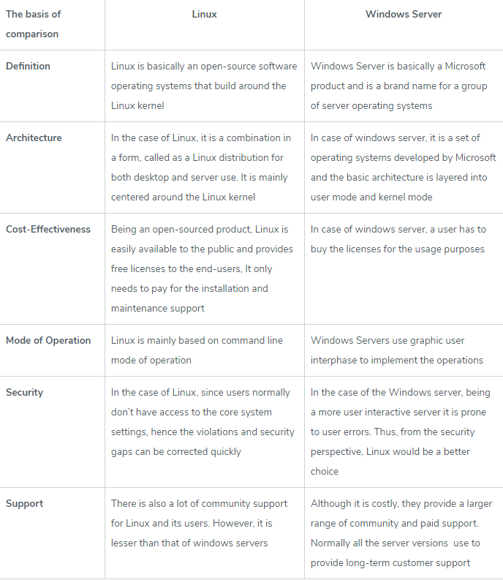
Figure 28 - Comparison Table [13]

Bibliography

[1] | Berkeley, “Enabling Virtualization in your PC BIOS,” Berkeley, [Online]. Available: https://bce.berkeley.edu/enabling-virtualization-in-your-pc-bios.html. [Accessed 06 February 2021].
[2] | VapourApps, “What is a hypervisor,” VapourApps, 13 May 2016. [Online]. Available: https://vapour-apps.com/what-is-hypervisor/. [Accessed 2021 March 11].
[3] | techtarget, “What's the difference between Type 1 vs. Type 2 hypervisor?,” techtarget, 13 January 2021. [Online]. Available: https://searchservervirtualization.techtarget.com/feature/Whats-the-difference-between-Type-1-and-Type-2-hypervisors. [Accessed 2021 March 11].
[4] | medium, “Type 1 and Type 2 Hypervisors: What Makes Them Different,” medium, 24 May 2019. [Online]. Available: https://medium.com/teamresellerclub/type-1-and-type-2-hypervisors-what-makes-them-different-6a1755d6ae2c. [Accessed 11 March 2021].
[5] | IBM Cloud Education, “Hypervisors,” IBM, 8 May 2019. [Online]. Available: https://www.ibm.com/cloud/learn/hypervisors#:~:text=Cons%3A%20A%20Type%202%20hypervisor,introduces%20latency%20issues%2C%20affecting%20performance.. [Accessed 11 MArch 2021].
[6] | Microsoft, “Understand TCP/IP addressing and subnetting basics,” Microsoft, 21 Septemnber 2020. [Online]. Available: https://docs.microsoft.com/en-us/troubleshoot/windows-client/networking/tcpip-addressing-and-subnetting. [Accessed 11 March 2021].
[7] | Paessler, “IT Explained: IP Address,” Paessler, [Online]. Available: https://www.paessler.com/it-explained/ip-address. [Accessed 11 March 2021].
[8] | avinetworks, “Subnet Mask,” avinetworks, [Online]. Available: https://avinetworks.com/glossary/subnet-mask/. [Accessed 11 March 2021].
[9] | S. Watts, “SaaS vs PaaS vs IaaS: What’s The Difference & How To Choose,” BMC Blogs, 15 June 2019. [Online]. Available: https://www.bmc.com/blogs/saas-vs-paas-vs-iaas-whats-the-difference-and-how-to-choose/. [Accessed 12 March 2021].
[10] | SalesForce, “12 Benefits of Cloud Computing,” SalesForce, [Online]. Available: https://www.salesforce.com/products/platform/best-practices/benefits-of-cloud-computing/. [Accessed 12 March 2021].
[11] | ZDNet, “What is cloud computing? Everything you need to know about the cloud explained,” ZDNet, 13 December 2018. [Online]. Available: https://www.zdnet.com/article/what-is-cloud-computing-everything-you-need-to-know-about-the-cloud/. [Accessed 12 March 2021].
[12] | Extrahop, “Internet Control Message Protocol (ICMP),” Extrahop, [Online]. Available: https://www.extrahop.co.uk/resources/protocols/icmp/. [Accessed 12 March 2021].
[13] | P. Pedamkar, “Difference Between Linux and Windows Server,” Educba, [Online]. Available: https://www.educba.com/linux-vs-windows-server/. [Accessed 12 March 2021].

