
Project Planning Assignment
Module: Management Innovation&Sustainability
Module Number: M5X01176
Category: School of Engineering:
Name: Zhendu Fang
Student Number: 1904716
Supervisor: Mark Sandford

Content
Abstract 1
General Team roles 1
Team roles 1
Self-perception 2
Overall Group Plan 3
Personal plan 5
Cost 7
Milestones 8
Gateway 8
Risk management 10
Gantt chart 11
Bibliography 14

Abstract
The aim of the project is to design an electric hillclimb/sprint car based on a monocoque donated by Tom’s to compete in the British Hillclimb&Sprint Championship under strict regulations. The monocoque is from Tom’s 032F raced by Jacques Villeneuve, which got one win and five second prizes in 1992 Japanese F3 championship. The whole group is made up of 18 members and divided into four parties including chassis, electric powertrain, aerodynamics and simulation. The aero group, which I belong to, is responsible for designing kinds of aero devices to keep the car racing with satisfied aerodynamic performance. A typical aerodynamic package of an openwheel race car consists of rear wings, front wings and an undertray diffuser. With these aero devices functioning well, the car is expected to generate as much downforce as possible while with a small penalty of drag. The main avenues for aerodynamics research in the motorsport industry are wind tunnel testing and Computational Fluid Dynamics(CFD(Kevin M. Peddie, 2009). Considering the high cost associated with creating a model and running wind tunnel, we adopt CFD as the primary tool to test our design and a small wind tunnel may be used to verify separate aero device performance but not the complete car.

General Team roles

Team roles
The aero group is made of 4 members. Table 1 below shows each one’s roles and responsibilities.
Team Member | Roles | Responsibilities
Alex Baldwin | - Group leader  - Shaper / Complete Finisher | - Design front wing
Duke Asamoah | - Team worker | - Design rear wing
Zhendu Fang | - Shaper/Complete finisher | - Design floor
Dion Billing | - implementer | - Design Side pods and engine cover
Table 1

Self-perception
It is imperative for me to possess some particular kinds of skills or personalities to process the group work well.
As a designer, I need to have a basic understanding of the aerodynamics and partial differential equation to design an undertray diffuser effectively. The former one contributes to gaining specific diffuser geometry design, and the latter one is conducive to understanding how CFD works deeply. Furthermore, CAD and CFD software is a dispensable part of the design process. Accordingly, I am supposed to train myself to be proficient in using Solidworks(CAD software) and AnsysFluent(CFD software).
As a team member, I also need to develop some appropriate personality traits to collaborate well with my teammates.A team role is someone who tends to behave, contribute and interrelate with others in a particular way(Belbin, 2010). Belbin and his colleagues found nine kinds of different roles which can be divided into three groups:
- action-oriented roles: Shaper, Complete Finisher and Implementer
- people-oriented roles: Co-ordinator, team worker and Resource Investigator
- cerebra roles: Plant, Monitor Evaluator, Specialist.
A healthy and robust team should have a balanced combination of the nine roles. However, it does not mean that our team requires nine people to work well. Everyone can have more than one position in the group, and their roles may change as time goes by. Besides how many roles are needed depends on the structure and objective of the team. From my perspective, it is reasonable for us to have one or two positions in each oriented group for our four-member squad. I am a complete finisher and shaper according to the self-assessment designed by Belbin.
Consequently, I am an action-oriented role. Generally, a shaper is appropriate to lead the team. And someone in my team is undoubtedly more qualified than me to be the leader. Incidentally, there are no cerebra roles in our group, and I am eager to become that kind of role. The function of cerebra roles is to produce new ideas, solve problems technically and evaluate and judge ideas and suggestions, etc. It is obvious that this kind of role requires versed technical skills and specialized knowledge. The group supervisor takes a proportion of responsibilities of this kind of role at present though he explicitly is not a member of the team. As a result, I need to spend more time on accumulating professional knowledge and training skills on concerning software to be competent to take the role. Now I am still acting as a finisher to ensure the team meets our obligations and delivers on time.

Overall Group Plan
The table 2 below shows the plan of the work of the whole group
Task Name | Duration | Start | Finish | Description
Aero research | 126 days | Mon 30/09/19 | Mon 23/03/20 | All the research including regulations, aerodynamics, knowledge about software and specific design.
CAD concept 1 | 17 days | Fri 11/10/19 | Sat 02/11/19 | Raise the initial idea and transfer it to a well-build CAD model. It is a bit of time-consuming due to unfamiliarity
CFD Concept 1 | 4 days | Sun 03/11/19 | Wed 06/11/19 | Test the model in CFD software and gain its simulated aero performance
CAD concept 2 | 8 days | Thu 07/11/19 | Sun 17/11/19 | Second idea
CFD concept 2 | 2 days | Mon 18/11/19 | Tue 19/11/19 | -
CAD concept 3 | 4 days | Wed 20/11/19 | Mon 25/11/19 | Third idea
CFD concept 3 | 2 days | Tue 26/11/19 | Wed 27/11/19 | -
Find best concept combination using CFD | 12 days | Thu 28/11/19 | Fri 13/12/19 | Now every single aero device has three design. Then we combine the different designs to get different aero package models and test them in CFD software. According to the result we determine which design to adopt.
Refine parameters using CFD | 5 days | Mon 06/01/20 | Fri 10/01/20 | Try different parameters during a reasonable range such as length, degree with CFD software to gain best aero performance
Prepare presentation | 18 days | Thu 07/11/19 | Sun 01/12/19 | -
Present presentation | 1 day | Mon 02/12/19 | Mon 02/12/19 | -
Manufacture scale model prototype | 10 days | Mon 06/01/20 | Fri 17/01/20 | Build prototypes for every aero device according to the final design
Test prototype scale model in wind tunnel | 3 days | Mon 20/01/20 | Wed 22/01/20 | Test design physically
Analyse data and compare with CFD | 1 day | Thu 23/01/20 | Thu 23/01/20 | Analyse data
Small improvements to the design | 10 days | Fri 24/01/20 | Thu 06/02/20 | -
Prepare the second presentation | 32 days | Fri 07/02/20 | Sun 22/03/20 | -
Viva 2 - Present presentation | 1 day | Mon 23/03/20 | Mon 23/03/20 | -
Write final report | 80 days | Tue 03/12/19 | Mon 23/03/20 | -
Table 2

Personal plan
Table 3 below shows my personal plan.
Task Name | Duration | Start | Finish | Actual Work | Description
Specify regulations about aero devices | 2 days | Mon 30/09/19 | Tue 01/10/19 | 3 hrs
have a basic understanding of aerodynamic | 51 days | Mon 30/09/19 | Mon 09/12/19 | 20 hrs | Though we will learn it in Vehicle Dynamics, we still need to spend much time on its application
research then determine aero target | 6 days | Mon 30/09/19 | Mon 07/10/19 | 3 hrs | The goal includes lift and drag coefficient, downforce, central of pressure.
Discuss and determine each member's division | 1 day | Mon 07/10/19 | Mon 07/10/19 | 1 hr | The divisions include front wing design, rear wing design, underbody design and sidepod design
Specific research on diffuser design | 121 days | Tue 08/10/19 | Tue 24/03/20 | 25 hrs | I am responsible for underbody design
group meetings | 126 days | Mon 30/09/19 | Mon 23/03/20 | 40 hrs | Whole group meetings and aero group meetings
CFD tutorials | 6 days | Mon 07/10/19 | Mon 14/10/19 | 4 hrs | I never use CFD software before so I need to do tutorials to help me get familiar with it as soon as possible
CAD model of concept1 diffuser | 17 days | Fri 11/10/19 | Sat 02/11/19 | 10 hrs
CFD analysis of concept1 | 4 days | Mon 04/11/19 | Thu 07/11/19 | 8 hrs
possible improvements of concept1 | 3 days | Fri 08/11/19 | Tue 12/11/19 | 3 hrs | Do some possible modification according to the CFD result
CAD model of concept2 diffuser | 8 days | Mon 04/11/19 | Wed 13/11/19 | 8 hrs
CFD analysis of concept2 | 2 days | Thu 14/11/19 | Fri 15/11/19 | 5 hrs
possible improvements of concept2 | 3 days | Mon 18/11/19 | Wed 20/11/19 | 3 hrs
CAD model of concept3 diffuser | 4 days | Mon 18/11/19 | Thu 21/11/19 | 6 hrs
CFD analysis of concept3 | 2 days | Fri 22/11/19 | Mon 25/11/19 | 4 hrs
possible improvements of concept3 | 3 days | Tue 26/11/19 | Thu 28/11/19 | 3 hrs
combine different aerodevices concepts and analyze in CFD | 12 days | Thu 28/11/19 | Fri 13/12/19 | 15 hrs
Refine the final diffuser's parameters using CFD | 5 days | Mon 06/01/20 | Fri 10/01/20 | 10 hrs
Prepare presentation | 19 days | Thu 07/11/19 | Tue 03/12/19 | 5 hrs
Present presentation | 1 day | Wed 04/12/19 | Wed 04/12/19 | 1 hr
Manufacture scale model prototype | 10 days | Sat 11/01/20 | Thu 23/01/20 | 10 hrs
Test prototype scale model in wind tunnel | 5 days | Fri 24/01/20 | Thu 30/01/20 | 5 hrs
Analyze data and compare with CFD | 5 days | Sat 01/02/20 | Thu 06/02/20 | 5 hrs
Small improvements to design | 15 days | Fri 07/02/20 | Thu 27/02/20 | 15 hrs
Prepare second presentation | 17 days | Fri  28/02/20 | Mon  23/03/20 | 5 hrs
Viva 2- present presentation | 1 day | Mon  23/03/20 | Mon  23/03/20 | 1 hr
Write final report | 80 days | Tue 03/12/19 | Mon 23/03/20 | 10 hrs
Total |  |  |  | 238 hrs
Table 3

Cost
In general, our primary work is to build CAD models and test them in the CFD software. Therefore, the prime cost comes from specialist software. After that, it is ideal for us to build a full car model and test its aero performance in a wind tunnel. Considering the reality what we can do is to construct a scale single aero device model and test it in the available small wind tunnel.
As a consequence, another cost comes from the manufacturing of the model. According to D.Ngo and Kashani(2018,p.173), 3D printing has been extensively used by architects and designers to produce aesthetic and functional prototypes due to its rapid and cost-effective prototyping capability. The use of 3D printing has minimised the additional expenses that are incurred in the process of developing a product. There are various methods and techniques in 3D printing. We choose to use FDM(Fused Deposition Modelling), which is the most popular and economic one at present.

Table 4 below shows the specific cost of each item.
Material | Cost | Purchase leading time
3D printer | ₤2,808 | 1 day
3D printer filament | ₤28.88 | 1 day
Carbon fibre sheets | ₤5,000 | 1 day
Resin | ₤161.63 | 1 day
Solidworks2019 | ₤3,100 | 2 days
Ansys | ₤4,600 | 2 days
Total | ₤15698.51
Table 4

Milestones
To ensure our work is on track, we set several milestones for the whole group as showed below in Table 5.
Milestone | Due Date | Comments
First Concept Design | Wed 06/11/2019 | This will motivate members to continue making designs
Presentation | Mon 02/12/2019 | Present presentation with the entire group
Best design combination | Fri 13/12/2019 | Leading CAD and CFD work finished
Wind tunnel testing | Wed 22/01/2020 | Analyse real values and compare with CFD
Final report submission | Mon 23/03/2020 | Finish the whole group
Table 5

Gateway
Every member of the team is responsible for the design of some individual aero device. And we have different ideas. Finally, we need to combine the deferent ideas as a whole aero package and test them to find the best one. Then we can identify which approach is most conducive for the overall aerodynamic performance. At this moment, we need to refine the selected design. In aerodynamics, the drag coefficient, lift coefficient and generated downforce are the most representative parameters to reveal an aero device’s performance. When it comes to the diffuser, it is convinced that the diffuser can generate massive downforce with a small penalty of drag. Therefore, what is worthy of considering are only lift coefficient and generated downforce. In the beginning, we determined the aim of the whole car, in which the lift coefficient should not be less than -1.92(minus indicates direction and does not affect magnitude), and the downforce should not be less than 6,000N. As a result, the lift coefficient of the diffuser is supposed to be at least -1.9. As for downforce, according to Vyssion and jjn9128(2018), the undertray and rear diffuser produce between 60%-65% of F1 car’s downforce. My goal is to reach 60% of the overall downforce. In other words, the downforce generated by diffuser should be more than 3600N.
The performance of the diffuser is dominated by its geometry properties which include inlet angle, outlet angle, ground clearance, the length of the flat area and rear diffuser and the position relative to the rear wing. Let us look at these properties separately. McBeath(2011,p.151)indicated that to maximize underbody downforce run the shortest steepest inlet possible, but only up to a point. In other words, the inlet angle should be as large as possible but not more significant than some certain degree and so does outlet angle. The difference is that the maximum degree of outlet angle is more significant than the inlet angle. Hence McBeath(2011,p.148) concluded that the trick to maximizing the downforce is to have the longest throat section(the flat area of underbody) with the shortest and therefore steepest possible diffuser that maintains attached flow. According to Ehirim’s(2012) work, I choose to do my test with the inlet angle ranging from 3 to 10 degree and outlet angle ranging from 9 to 20 degree. As for ground clearance, the regulation has restricted a minimum of 40mm. What is difficult to test is the relative position to the rear wing. In general, proximity of rear wing and the end of the diffuser helps it generate more downforce. However, how close it should be is a hard question. Because it will affect the whole car’s aero balance and the rear wing’s efficiency. We need to spare more effort and work together to figure it out in the future.

Risk management
Risk— an uncertain event or set of circumstances that, should it occur, will affect the achievement of the project's objectives(Project risk analysis and management guide, 1997 p.5). Therefore, we can conclude that the risk comes from uncertainty. As for me, the most significant uncertainty comes from the use of specialized software. As a designer of the diffuser, most of my work is finished in the CAD and CFD software. However, the reality is I begun to learn these two kinds of software when the project began. When I try to transfer my idea into the Cad model in software, a simple geometry may cost me a long time to finish. It may induce a delay in the overall group work. When it comes to the CFD software, it is not hard to get familiar with the basic operation but challenging to be proficient in it. Because the software is packaged so well that you feel it formidable to understand the complex theory behind those operations or parameter setting clearly. Then when the CFD result does not meet your prediction, it will be strenuous to distinguish whether it is wrong with your design or with your operation of the software.
With regard to the unfamiliarity of the CAD software, it is useful to do training tasks by building some models of the objects which I am interested in. The disadvantage is that I have to spend much extra time. Another way is trying to make the model with someone skilled first and imitate him. Though it is the same software, there are multiple ways to build one model. Once get used to one building style, it will be much easier to continue a more complex model.
As for the complex theory of CFD software, a possible method is to spend time understanding concerning mathematics knowledge and try to program some basic algorithms about CFD on my own. This requires programming skills. One more way is to run CFD with different conditions and compare the results to help understand the function of specific parameters. This requires a considerable amount of time or several computers running simultaneously.
The other uncertainty comes from my emotion. Because it takes quite a long time for me to get the result of the design due to the complexity of the calculation. The cycle to get one full design is time-consuming, which includes proposing a conception, building up the CAD model then testing it with CFD software. You can not know if your idea works until a long time after you raised it, and you are even not sure what leads to your failure. It is prone to feel negative emotions when you find most of your time is spent on failure. As a result, it will have a bad influence on my work efficiency and may even affect my teammates.
The influence of emotion is hard to avoid but can be mitigated by sharing. Try to spend as much time as possible working with others. Then both the frustration and happiness can be shared. A secondary method is that once getting a new idea, do not build a model and run CFD immediately. Turn to someone more specialized for suggestions, rethink the approach then process it.

Gantt chart
Group Gantt chart
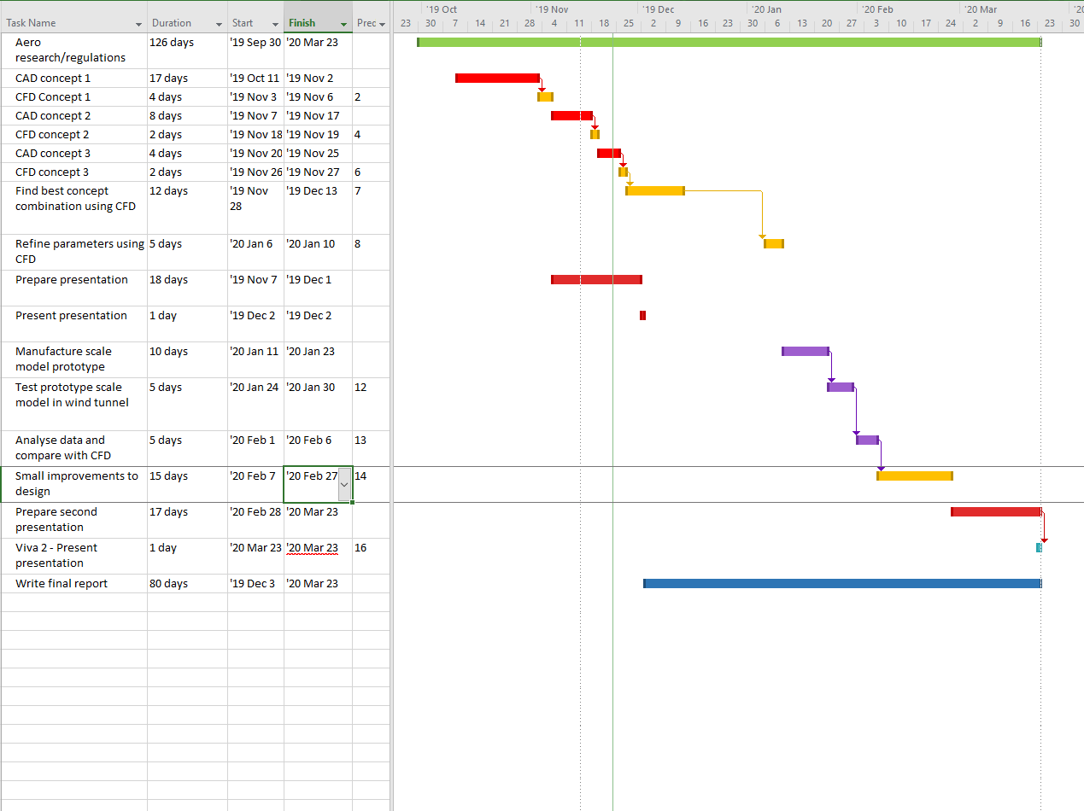

Personal Gantt Chart

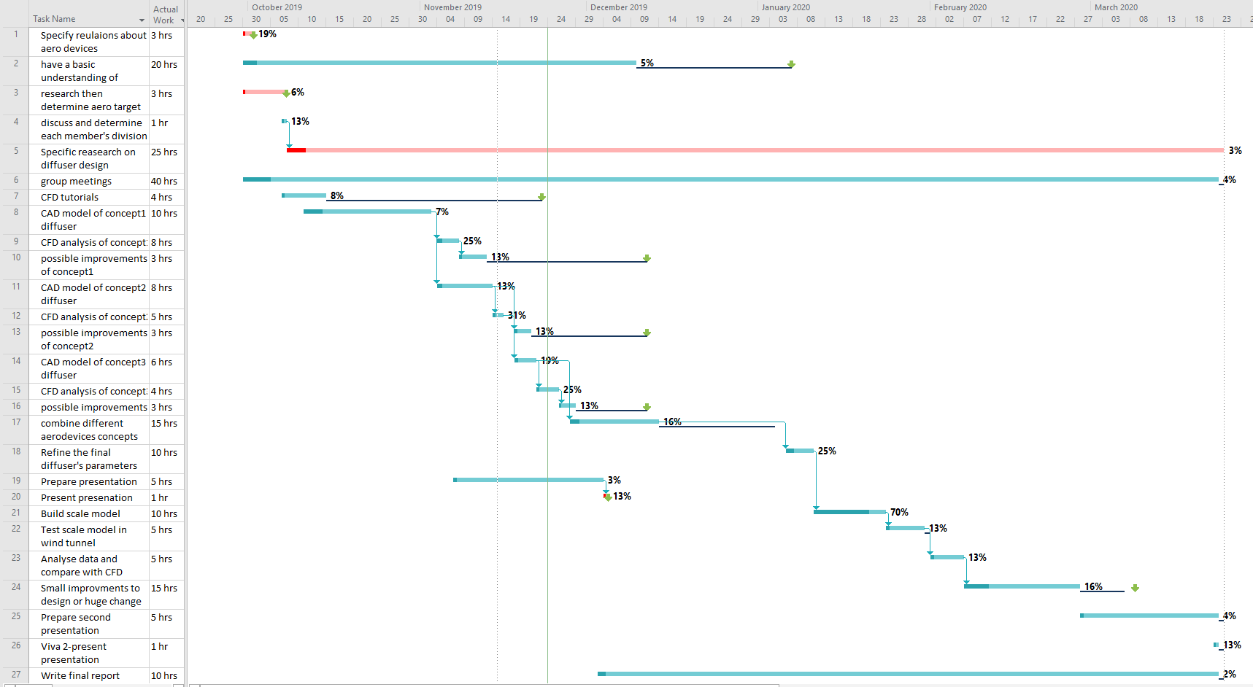

Bibliography
BELBIN, R. M. 2010. Management teams, Routledge.
EHIRIM, O. 2012. Optimal Diffuser Design for Formula SAE Race Car Using an Innovative Geometry Buildup and CFD Simulation Setup with On-Track Testing Correlation. SAE Technical Paper.
KEVIN M. PEDDIE, L. F. G. 2009. CFD Study on the Diffuser
of a Formula 3 Racecar.
MCBEATH, S. 2015. Competition Car Aerodynamics: A Practical Handbook, Veloce.
NGO, T. D., KASHANI, A., IMBALZANO, G., NGUYEN, K. T. Q. & HUI, D. 2018. Additive manufacturing (3D printing): A review of materials, methods, applications and challenges. Composites Part B: Engineering, 143, 172-196.
Simon P, Hillson D, Newland K. editors.1997, Project risk analysis and management (PRAM) guide. UK: The Association for Project Management,
Vyssion and jjn9128 .2018. The Ground Effect
Available at: https://www.f1technical.net/features/21667
(Accessed: 20 Nov 2019).

