Module: Digital Skills and Research Methods
BMSW4003

Lecturer: Koushik Modak
  The impacts of virtual learning environment (Moodle) on students of university of wales trinity saint David | UNIVERSITY OF WALES TRINITY SAINT DAVID LONDON  Student: Petrina Marian (2123530)

Executive summary

This study embarks on the importance of a virtual learning environment (Moodle) and changing aspects from the student's point of view. Also, various steps help create the environment in institutions and universities to establish this setting. There is a detailed exploration of important aspects and the impact on students' life with the primary and secondary data analysis.

Table of Contents
Introduction 3
Rationale 4
Aims and objectives 4
Literature 5
Virtual learning environment 5
Practical implication 5
Theories of VLE (Moodle) 6
How can a virtual learning environment be accomplished in the University of Wales Trinity Saint David London Campus? 7
Methodology 9
Primary data analysis 10
Secondary data analysis 14
Recommendations and conclusion 16
Referencing 17

Introduction
Virtual learning pertains to an understanding with the assistance of computers and the internet, internal as adequately as external the installations furnished by the academic organization, in this case, the University of Wales Trinity Saint David London Campus. The teachings are furnished by the educators in a digital atmosphere for the learners. Virtual learning assists in developing the imaginative reasoning of pupils. This eventually enables them to increase their enthusiasm too. Virtual learning is an extraordinary means approved by numerous universities and colleges to impart schooling to scholars effectively. A virtual learning setting intends for efficient interchanges and effective understanding settings, as adequately as strategy lessons.

Rationale
There are many ways to educate students and assist in their development, but the virtual learning environment allows a unique path to walk and increases the power of imagination in the students. The explanation to enforce any modern technology is earning something satisfactorily, reasonably, quickly. The VLE enactment renders no irregularity, which allows students to get used to technology and the positive aspects of digital learning. VLE (Moodle) is an interaction of students with digital environmental learning in which the students will interact with technology and modern ways of learning. In today's era, this VLE is a very common and effective direction in the way of learning and education; this environment of digital technology and modern equipment is now an essential part of modern learning. Nowadays, almost every student is very comfortable with the use of technology, and also learning is also a crucial part of it.

Aims and objectives
To understand the impact of the Virtual Learning Environment on student
Therefore, the major objectives will be,
- To identify the different ways to improve digital skills to suit the new system of learning.
- To create an awareness of the importance of effective analysis of information and transition into a knowledge

Literature

Virtual learning environment
A virtual learning environment is an online working medium that provides learners and lecturers with an online solution that increases their understanding skills. E- Classroom, which takes place or replaces the physical classroom atmosphere for those applying to learn from a distance. A Virtual learning environment tackles technology to supplement in-class knowledge (Yang et al., 2018). A virtual learning environment guides to a method that presents teachers' online solutions aspired to create interactively (Chui et al., 2020). The learning environments are active. A virtual learning environment also helps to create professors, store and publish scope, plan lessons and courses and interact between scholar and lecturer, even in real-time. Virtual learning environments are usually elements of a higher education institution’s vaster learning management system.

Practical implication
Most of the education of virtual learning systems have taken some practical methods which involve an independent variable then analyzing and calculating its effect on types that belong to practical implications. This states that the analysis of education may give an outcome in a finite knowledge of the virtual learning systems (McMurtry-Chubb, 2019). This indicates that virtual learning systems education may require to extend to retain techniques that endeavor to grasp the fundamental methods and strategies amid other essential factors, studies of the modifications and events as Interaction of a learner with the technology interventions in specific forms under situational conditions.
Social constructivism and VLE
Learning applies to switching knowledge and relation between individuals and their circumstances. The changes show themselves in academic skills. Mental ability, learning strategies, physical skills, and attitudes all alter as a result of these changes. Some people believe that education is a visible change in conduct (Lombardo and Kantola, 2021). Others feel that learning is an inadvertently visible internal factor in which pupils arrive at fresh reports to life to grasp and then either construct new or adjust old. Any effort was taken by professors, online facilities, etc., to form the online learning environment to form an effective online learning environment has been a way for participants to consider part of society and be able to construct the knowledge.
Cognitive Scaffolding and Virtual learning environment
Cognition exists in education; it elaborates that cognitive scaffolding is a transient work that allows the apprentice to get the steps in understanding situations. Cognitive scaffolding also elaborates as a stimulus or to the learner's potential level knowingly giving help to perform some task for the student (Doo et al., 2020). The meaning of cognitive scaffolding is that knowledge is helped initially as a learning work of cognition. A virtual learning atmosphere such as secondary life delivers a valuable chance to boost cognitive scaffolding.

Theories of VLE
Cognitivism Theory
In the Distinction to behaviorism, societies belong to preparing links that are based on constitute between understanding and previous knowledge. Cognitivism with behaviorism by revealing that learner's procedure and encode understanding in particular ways. According to Social Cognitive Theory, which is a branch of cognitivism, observing different counterparts, notably one peer, is by far the most effective kind of learning asset (Scarantino et al., 2020). Cooperative problem-solving and discussion-based interests, as well as peer-to-peer education, are optimal actions. Problem-solving, discussion-based activities, and peer-to-peer teaching are ideal activities because they enable social interactions that increase comprehension. To support the development of mental health facilities, it is critical that conveyance is done in teams and that distinct parts of learning be connected simultaneously.
Importance of VLE
The profits of virtual education contain the flexible approach to completing tasks at a time which provides the most suitable to the student required to operate there to manage time to ensure to end their work earlier before the deadline fixed by the lecturer (Becerra-Romero et al., 2019). Virtual courses, which give knowledge to students on how to set their routine better, bear the accountability of engaging the suitable approach to showing among the whole class on a day and time. As an overcome students gain professions from work but also they set and enhance their skills.

How can a virtual learning environment be accomplished in the University of Wales Trinity Saint David London Campus?
Selecting the good technology
Numerous outstanding software applications are available in today's era with decent features to assist the invitation in the university the virtual understanding excursion. Nonetheless, the University requirements to prepare a system for selecting the good one for the institute.
Opting for creative content-upload alternatives
Institutes desire to prioritize improving learner attention as their primary key deliberations when establishing a strong virtual understanding setting. This implies retaining the alternative to upload a broad collection of multimedia subjects, encompassing pictures, tapes, interactive examinations, and online demonstrations.
Constructing committing training
Modifying the in-class education equipment to the virtual learning environment names for a tremendous bargain of aptitude and awareness of the technologies existing wielded. A spectrum of implied devices is living utilized today with purposes that enable educators to establish a sharp survey and create organizations.

Methodology
In terms of methodology, the study has been conducted following positivist thinking to identify the effectiveness of online learning in the current situation. However, the study has not only focused on a secondary data collection approach but also has conducted a direct survey through Online surveys. In this survey process, participants have provided their opinions in multiple-choice answers to questions and their responses have been critically analyzed with a quantitative data analysis approach.

Primary data analysis
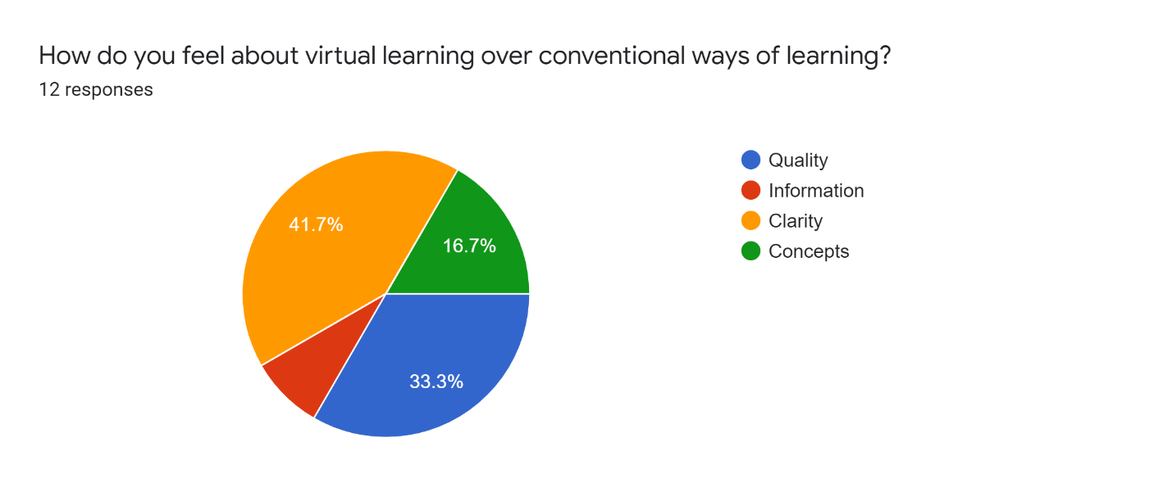
(Source: Google Forms, 2022)
Based on the above chart, it can clearly be observed that the majority of the participants including 41.7% have voted to experience more clarity in the online learning and education system. However, there are also some other participants holding another huge portion of participants of 33.3% have stated that they have experienced more clarity.

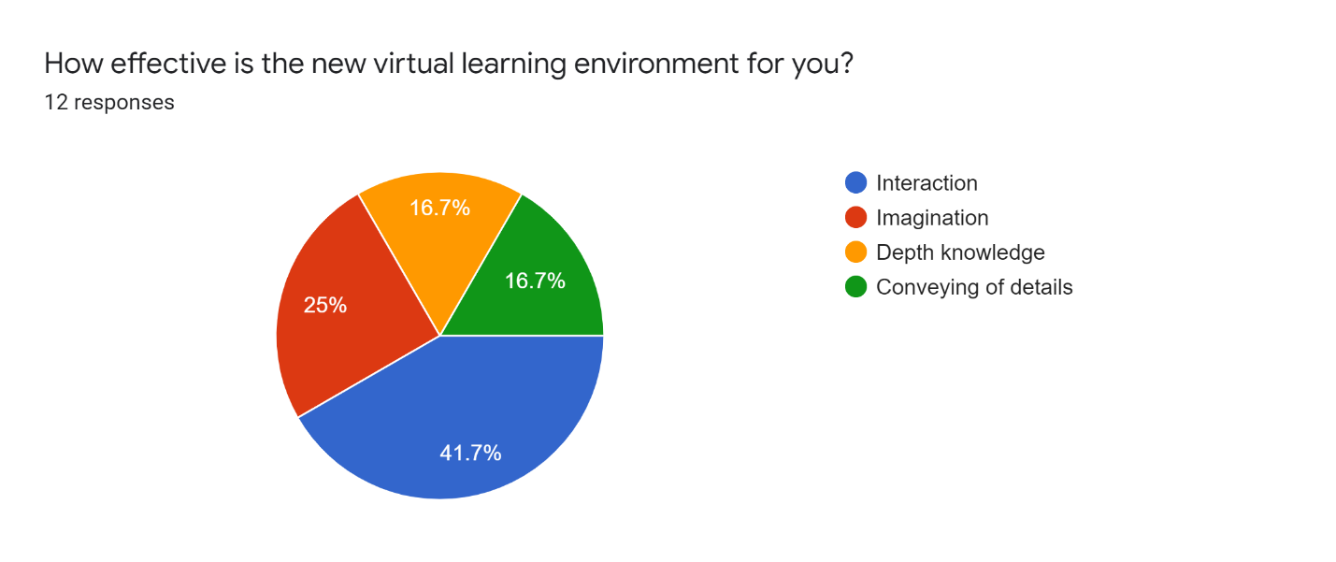
(Source: Google Forms, 2022)
Based on the above figure, it can be seen that the majority of the participants, consisting of 41.7% State that the online learning facilities are very effective and enhance their interaction capabilities. However, 25% of them stated that it sharpens their imagination power. Lastly, two small equal equal-sized of respondents stated that this provides deep knowledge and conveys details.
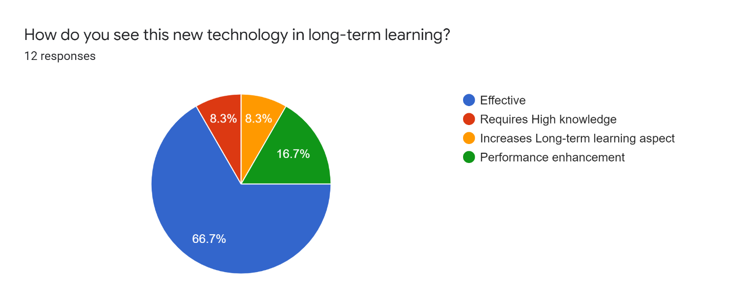
(Source: Google Forms, 2022)
The majority of the individuals participating in the online survey holding 66.7% stated that it is an effective strategy for the future. However, there are still some people who believe that it requires a high amount of knowledge. Some other respondents acknowledged that the Moodle system and the virtual classroom facilities offer students to enhance their performance.

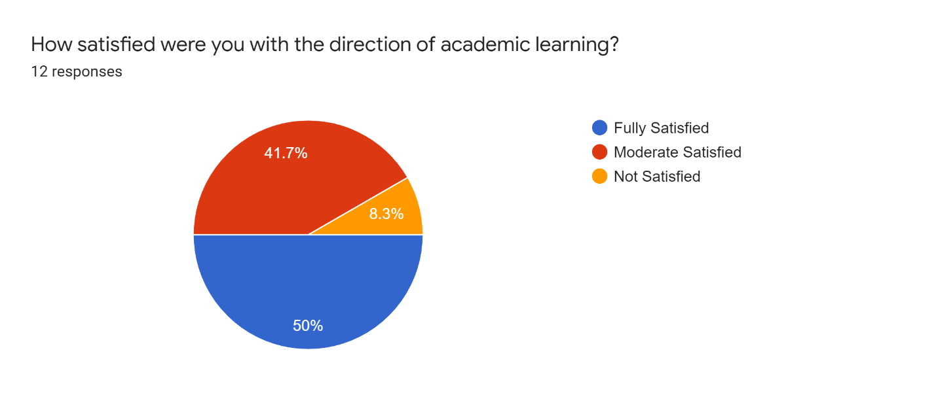
(Source: Google Forms, 2022)
In dorms of academic writing, almost half of the respondents stated that they are fully satisfied with the academic writing procedure. However, the second-largest percentage of the service includes 41.7% of total respondents. Apart from that, there are also a few people who are not satisfied with online coaching.
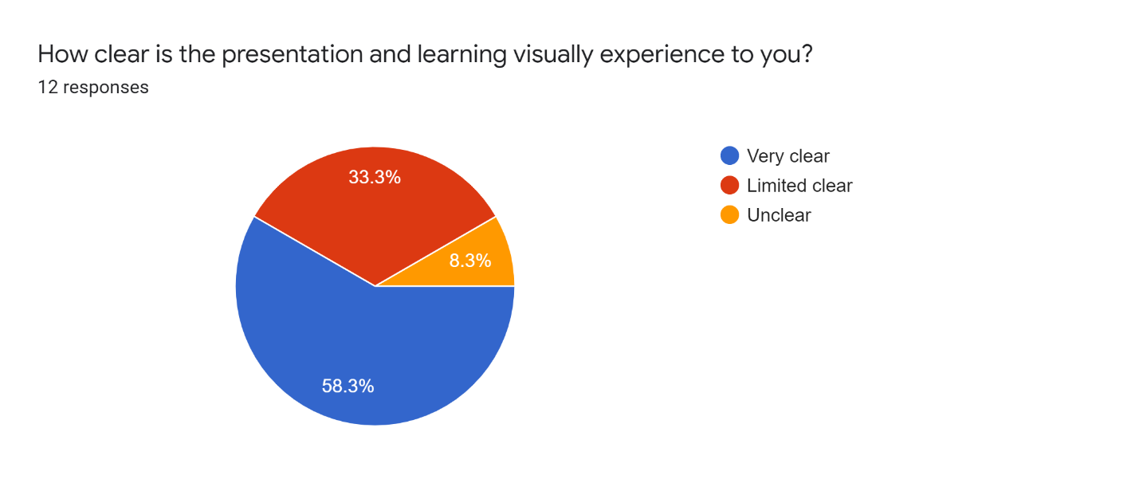
In terms of the clarity of the presentation, most of the respondents stated that it was very clear for them. However, 33% of the respondents stated that it was limited and clear for them and the rest said it was completely unclear for them. The above chart shows that almost 33.3 percent of Google did not learn or understand anything.

Secondary data analysis
A virtual learning environment proposes not just an elegantly constructed room for education and knowledge, but a spot where students, educators, and learners realize comfort (Open LMS, 2022). A decent VLE enables users to establish their understanding of settings concurrently over the period. With all that takes off into a real classroom – the assignment proposals, the lesson, the discussions.


Figure 1: Virtual learning environment
(Source: Open LMS, 2022)
There are several platforms and software which are utilized to run these VLE programs also, 55% of the students engage in digital activities in their free time as they are very used to the technology (Spurlock, 2020). Digital support enables students to accumulate data from all over the internet. In other words, there is an unlimited source of knowledge on digital platforms.
The students which are new to this environment are also liking this structure and feel that it is an effective way of learning. According to the study, 69% of new students are actively utilizing these platforms to learn new concepts and master them (Jakosalem and Jakosalem, 2022).

Figure 2: Distance learning through virtual classroom
( Source: Jakosalem and Jakosalem, 2022)

Recommendations and conclusion
The outcomes of the recent explore taking demonstrated a complicated picture of learners’ communities of design of the VLE but existed restricted by the tiny hierarchy of the study. The survey of writings illustrated before furthermore indicated that previous methods of learning have been curbed in their transferability by the priority on case research of e-learning within personal discussions. Moreover, universities should adopt these approaches for the sake of better learning and great experience of knowledge with deep knowledge. Also, these methods allow detailed study and visual experience.

Referencing
Becerra-Romero, A., Díaz-Rodríguez, M. and González-Estrada, O.A., (2019). Development of a virtual learning environment for the subject Numerical Methods under Moodle. In Journal of Physics: Conference Series (Vol. 1161, No. 1, p. 012010). IOP Publishing.
Chui, K.T., Fung, D.C.L., Lytras, M.D. and Lam, T.M., (2020). Predicting at-risk university students in a virtual learning environment via a machine learning algorithm. Computers in Human Behavior, 107, p.105584.
Disrupting Flawed Legal Arguments to Advance the Cause of Justice. Washburn LJ, 58, p.531.
Dodel, M. and Mesch, G., (2018). Inequality in digital skills and the adoption of online safety behaviors. Information, Communication & Society, 21(5), pp.712-728.
Doo, M.Y., Bonk, C. and Heo, H., (2020). A meta-analysis of scaffolding effects in online learning in higher education. International Review of Research in Open and Distributed Learning, 21(3), pp.60-80.
Google forms, 2022. Update your browser to use Google Drive, Docs, Sheets, Sites, Slides, and Forms - Google Drive Help. [online] Docs.google.com. (2022) Available at: <https://docs.google.com/forms/d/1GAbSHw50u4ClHAywu4q2bUecyjdaO_RVe914VcHl5z8/edit#responses> [Accessed 8 April 2022].
Jakosalem, F. and Jakosalem, F., (2022). Distance Learning & Virtual Classrooms: Where Learning Never Stops - myViewBoard Blog. [online] myViewBoard Blog. Available at: <https://myviewboard.com/blog/education/distance-learning-virtual-classrooms-where-learning-never-stops/> [Accessed 8 April 2022].
Lombardo, E. and Kantola, J., (2021). Social constructivism. In The Routledge Handbook of Gender and EU Politics (pp. 43-55). Routledge.
Mach, K.J., Lemos, M.C., Meadow, A.M., Wyborn, C., Klenk, N., Arnott, J.C., Ardoin, N.M., Fieseler, C., Moss, R.H., Nichols, L. and Stults, M., (2020). Actionable knowledge and the art of engagement. Current Opinion in Environmental Sustainability, 42, pp.30-37.
McMurtry-Chubb, T.A., (2019). The Practical Implication of Unexamined Assumptions:
Open LMS, (2022). [online] Openlms.net. Available at: <https://www.openlms.net/blog/products/building-a-modern-virtual-learning-environment-vle/> [Accessed 8 April 2022].
Scarantino, A., (2020). Insights and blindspots of the cognitivist theory of emotions. The British Journal for the Philosophy of Science.
Spurlock Jr, D., (2020). Scholarship during a pandemic: Secondary data analysis. Journal of Nursing Education, 59(5), pp.245-247.
Yang, D., Alsadoon, A., Prasad, P.C., Singh, A.K. and Elchouemi, A., (2018). An emotion recognition model based on facial recognition in virtual learning environment. Procedia Computer Science, 125, pp.2-10.

