Blog Submission

Student Name Navid Reaz
Student ID 2322819

Name of Students in Group: N/A

Link to Individual Blog:

Words included in Individual’s Blog (including reference list): - Copy and paste the words from your blog.

THE SAMRITANS 24/7 SUICIDE HELPLINE:
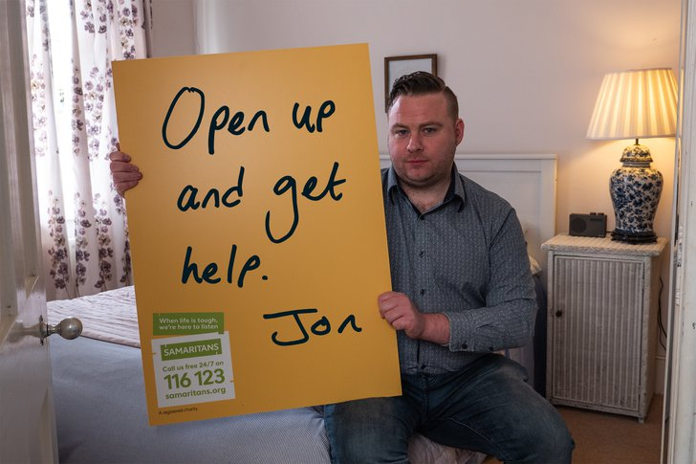
Suicide is tragic. Every year people in the UK will take their own life. For most cases, it could be prevented with support and mental health resources at a timely intervention. In England and Wales, 5,642 suicides were registered in 2022, Office for National Statistics. (n.d.). The number of registered suicides in 2012 was 4887, Statista. (n.d.). These statistics may suggest an increase in suicide rate, which is a public health concern. However, the UK government does suggest a decrease in suicide rate within the 45- 64 age group in England, UK Government. (n.d.). As mental health support improves in the UK, charities such as The Samaritans, are supporting individuals in crisis to help reduce suicide numbers in the UK.

The Samaritans are a UK based charity that provides listening and support for people that are at risk of suicide, Samaritans (n.a.). The charity is open and can be contacted 24/7 on their suicide helpline; ‘166 123’, Samaritans (n.b.).

The Samaritans 24/7 helpline gives any individual contemplating suicide direct access to support at any time of the day. If someone needed urgent support, the helpline will be available.
Trained volunteers operate calls on the helpline. The volunteers provide a safe environment where individuals are allowed to express their concerns without feeling judged. The British Association for Counselling and Psychotherapy believes this too as suicidal thoughts have emotional pain which can be better resolved without individuals being judged as they are less likely to open up and receive the support they need,
Samaritan volunteers can provide people with direct help by guiding people to local mental health centres or local support groups, so individuals receive specialised direct care while also having the option to call the helpline. Other charities such as Mind UK encourage conversations with professionals such as doctors as openly talking about suicidal thoughts can decrease the chance of a people acting on their feelings, Mind. (n.d.). Being able to directly talk to someone may help people have a more level head and therefore less likely to commit suicide.
In conclusion, the 24/7 helpline provided by The Samaritans, is an operation that emulates what the company stand for; compassionate listening to prevent individuals from taking in their own life. Its longevity ensures that it can play a vital role to helping anyone’s well-being journey.
References:
Office for National Statistics. (n.d.). Suicides in United Kingdom: 2022 registrations. Available at : https://www.ons.gov.uk/peoplepopulationandcommunity/birthsdeathsandmarriages/deaths/bulletins/suicidesintheunitedkingdom/2022registrations (Accessed 16/04/2024)
Statista. (n.d.). Suicide figures in the United Kingdom (UK) since 2000. Statista. Available at : https://www.statista.com/statistics/282226/suicide-figures-in-the-united-kingdom-uk-since-2000/ (Accessed : 16/04/2024)
UK Government. (n.d.). Statistical report: Near to real-time suspected suicide surveillance (NRTSSS) for England for the 15months to August 2023. GOVUK. Available at: https://www.gov.uk/government/statistics/near-to-real-time-suspected-suicide-surveillance-nrtsss-for-england/statistical-report-near-to-real-time-suspected-suicide-surveillance-nrtsss-for-england-for-the-15-months-to-august-2023 (Accessed : 16/04/2024)
Samaritans (n.a.). What we do. Available at: https://www.samaritans.org/wales/about-samaritans/our-organisation/what-we-do/ (Accessed: 16/04/2024)
Samaritans (n.b.). Contact Samaritans. Available at: https://www.samaritans.org/wales/how-we-can-help/contact-samaritan/ (Accessed: 16/04/2024)
British Association for Counselling & Psychotherapy (BACP). (2021) The importance of listening to people experiencing suicidal thoughts. BACP. Available: https://www.bacp.co.uk/news/news-from-bacp/2021/10-march-the-importance-of-listening-to-people-experiencing-suicidal-thoughts/ (Accessed : 16/04/2024)
Mind. (n.d.). Talking about suicidal feelings. Mind. Available at https://www.mind.org.uk/information-support/helping-someone-else/supporting-someone-who-feels-suicidal/talking-about-suicidal-feelings/ (Accessed : 16/04/2024)

TRAINING AND EDUCATION AT THE SAMARITANS:
Are you an individual or an organisation that wants to support suicidal people?
The Samaritans are providing comprehensive training aiming to educate people with skills to prevent suicides in the UK.

Educating individuals is important in preventing suicides, as it provides people somewhere to turn so they are less likely of suicide, Healthwise. (n.d.). The Samaritans aim to help prevent suicide rates in the long-term by educating people.
Can you identify risk factors of suicide?
Such as Stress, anxiety, post-traumatic stress disorder, depression, phobias, SOS Silence of Suicide. (n.d.). Common risk factors can be seen as mental disorders. Studies in New Zealand and Australia, during the 1980’s show this. International literature showed the strongest risk factors are mental disorders and they would require more attention to reduce youths’ suicidal behaviours, Beautrais AL. (2000). The Samaritans teach risk factors and other useful information in the training programme.
Training and development can also be accessed by professionals in healthcare, education, or any other sector, that would like to improve their suicide prevention initiatives. Work place factors may have a relationship with suicide, K.Folmer M.C.Howard. (2022). Having managers and HR professionals that can recognise employees at risk maybe more favourable for the organisation as it will reduce the chance of suicides in the organisation due to resources and education being available.
The Samaritans are not the only organisation that provides suicide prevention, zero suicide London have had a campaign where, more than 350,000 Londoners have accessed suicide prevention training, NHS Northwest London Clinical Commissioning Group. (n.d.). This campaign is however done online only. The Samaritans aims to provide suicide prevention training online and in real life courses. Many companies such as Mind UK and the NHS emphasise the importance of reaching out in real life to someone or a professional to tackle mental health and suicide effectively.
Suicide is a major cause of premature death in the UK, Health and Safety Executive (HSE). (n.d.). The Samaritans provide a range of skills in these training programmes to be learnt while advocating mental health in the hope to reduce the suicide rate in the UK. The Samaritans will work on their mission by compassionately listening and providing support such as training programmes.

References:
SOS Silence of Suicide. (n.d.). SOS Silence of Suicide. Available at: https://sossilenceofsuicide.org/
(Accessed: 16/04/2024).
Beautrais AL. (2000).Risk Factors for Suicide and Attempted Suicide among Young People. Australian & New Zealand Journal of Psychiatry. Available at: https://journals.sagepub.com/doi/abs/10.1080/j.1440-1614.2000.00691.x Accessed: 16/04/2024).
Healthwise. (n.d.). How Education Helps Suicide Prevention. Healthwise. Available at: https://www.healthwise.org/blog/how-education-helps-suicide-prevention.aspx Accessed: 16/04/2024) .
K.Folmer M.C.Howard. (2022). What Employers Need to Know About suicide Prevention. Harvard Business Review. Available at: https://hbr.org/2022/01/what-employers-need-to-know-about-suicide-prevention Accessed: 16/04/2024).
NHS North West London Clinical Commissioning Group. (n.d.). More than 350,000 Londoners Have Accessed Suicide Prevention Training as Part of the ZeroSuicideLDN Campaign. NHS North West London Clinical Commissioning Group. Available at: https://www.nwlondonicb.nhs.uk/news/news/more-350000-londoners-have-accessed-suicide-prevention-training-part-zerosuicideldn-campaign Accessed: 16/04/2024).
Health and Safety Executive (HSE). (n.d.). Suicide and work-related stress. Health and Safety Executive (HSE). Available at: https://www.hse.gov.uk/stress/suicide.htm Accessed: 16/04/2024).

Evaluation of marketing theory that underpins your blog: e.g. how your blog helps to market your charity, the target audience, the objective of each blog, how you engage the target audience, the marketing metrics to evaluate each blog.
The two blogs; ‘THE SAMRITANS 24/7 SUICIDE HELPLINE’ and TRAINING AND EDUCATION AT THE SAMARITANS above effectively highlight the good work being done by the Samaritans. The blogs take into account specific target audience’s and market their work in the hopes of growing.
The target audience for the first blog is seen to be anyone experiencing suicide.
The first blog uses many social factors to influence their marketing. Suicide Prevention is a social issue. Encouraging people to seek help, raises awareness on the issue and can be seen as a positive social change which can resonate with

