Academic & Employability skills
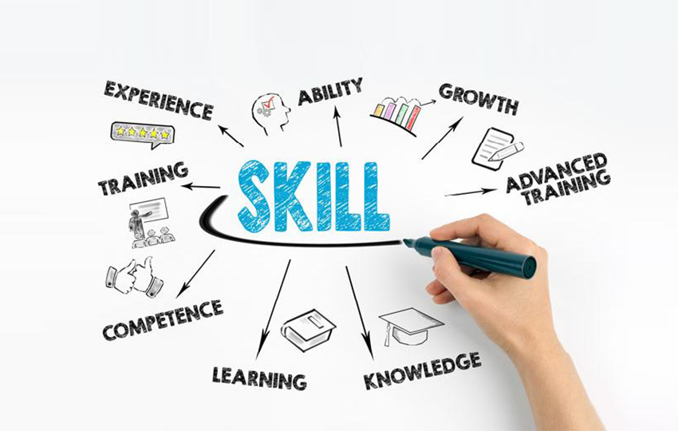

Name -Hamed Miah
Student number – 1826424
Assignment title - Academic and Employability Skills
Module code - BMSW4001
Lecturer name – Sylvia Hoffmann
Context
Introduction 3
Cover Letter 3
Presentation 3
Job searching 4
CV 4
Paraphrasing 4
Summarising 5
Skills 6
Conclusion 6
Reference 7
Appendix 8

Introduction
In this report I will be reflecting on my learning and explaining what I have learnt and how it has benefited me. I will talk about both term 1 and term 2 and the in-class activities.
Cover letter
In class we learnt about cover letter and how to write a cover letter. I learnt that creating a cover letter for your job puts you up there as a top contender for the job. If you do not bother to write a cover letter your CV might not even be read.
Before we wrote the cover letter, we had to do an exercise where we got given a template and was to fill in the missing information. This has helped me as it showed me where and when you should write something like if you don’t know the person you will start the cover letter with dear sir/madame and end the cover letter with yours faithfully whereas if you know the person you will start the cover letter their name and you will end it with yours faithfully.
When I went to do the cover letter for the in class exercise I did it for a head chef position. Overall, I did good but had a few changes to do to make the cover letter even better. What I should have included on my cover letter is where I found the job advertised. Also, I will need to talk about what they will gain from hiring me and not as much of what I will gain.
Also, I learnt from a recruiting site that cover letters are very underrated this is because most people are not 100% sure on what a cover letter is. Also, with a cover letter you set yourself apart and help sell your application. REED (2019)
Presentation
In class we had to do a presentation in front of the class and we each got different topics to talk about. The topic I had was academic vocabulary. I had to talk about what it is and where and when it can be used and how we will benefit from it.
Before the presentation we did a few mock presentations. I feel like this really helped as it helped boost my confidence and it also helped me learn how to talk clearly in a presentation. One of our mock presentation was about reflection model.
When I did my presentation on academic vocabulary, I had three people access my presentation. The feedback really helped me for my future presentations even for different modules. The feedback I got was positive but have improvements to do. The positives I will keep doing like being well prepared and making it simple for my audience to understand. What I can work on is keeping presentations a bit longer to cover the time I have, also not to be nervous and talk clear and loud so people in the back of the room can hear me because at times when I got nervous my voice goes low and makes it hard to understand.
I have also learnt from online you should make presentation fun, enjoyable and interesting, so your audience stays engage. Not too long with lots of writing making the presentation boring making the audience lose interest on the presentation. Envatos tut (2019)

Job searching
We also learnt how to search for the right job, this is important because many people search for jobs but don’t know what there really searching for, they just want a job. But by looking for a job that interests you can make it easier to get the job. Also, you will realise many recruitment websites have filter searches, this had helped me to find jobs which I didn’t think was out there.
CV
I also learnt about writing a cv and how important it is. I leant that a cv is meant to sell yourself to the employers hiring me. Also, I learnt that a cv Is not to get you a job its yourself that get you the job but the cv is what gives you the opportunity to get an interview. So I learnt I will need to put everything about myself which is relevant to land e a chance of getting the job.
I have also learnt from online that there are six main things to include in a CV which are:
Name and contact detail – this should stay at the top and should have all the details for the company to contact you.
Profile/personal statement – This you need to keep sharp, as this is your quick sale pitch, you need to hook the employer.
Core skills sections – this you will need to create a snapshot of your abilities to give the employer an understanding of your skills.
Work experience – this is Important as you must show your employer you can work and if your work experience is like the job your applying for you will stand out more as your more experienced.
Education and qualification – this show you have the right knowledge for the job as the job description might have what qualifications you will need.
Hobbies and interest – this is not as important but recommended because it shows your employer the character you are. StandoutCV (2019)
Paraphrasing
Paraphrasing is when you get an information which is written on spoken and put it in your own words, keeping the same meaning. Your dictionary (2018)
This I have learnt in term 1 and it has helped me with all my classes. At first it was hard to do as it wasn’t making sense when I was changing the words around with other words. As I kept doing it, I was getting better and my paraphrasing was making more sense. I have also found out if you are not sure of what word to change you can use a thesaurus, but you must be careful as the sentence still needs to make sense. Once you have paraphrased something you will still need reference where you got it from. This gives credit to the person which made it. I have improved my paraphrasing by putting what I learnt in class in practise in term 2. What I learnt was I got given in class exercise to work on paraphrasing. What we did was we got given a piece or writing and we had to paraphrase the writing. Then we got feedback to see how we can improve on it.
I also went online for help and I came across a method which has helped me. It’s a 5-step method to paraphrase. These 5 steps are:
- Make sure you read the document many times to fully understand the meaning
- Write down the key parts of the documents
- Write your part of the document without looking at the original copy, using the key parts to help you.
- Then compare your document with the original one and see if it matches and if there is changes to be made make sure they get done.
- Most importantly reference the source where you got the information from. Scribbr (2019)
Summarising
Summarising is when you get a piece of information and get the key parts of that information. You can also summarise when giving information to someone by just telling them the key points. Cambridge dictionary (2019)
This has helped me so far throughout university as I have been having to do a lot of research in my classes. IT is extremely time consuming and hard to read through every document to get research I’m looking for. So, by summarising I can pick out the key parts and see what is relevant to me. If I see the passage is not relevant for me to read, I will look for another passage.
I have also done an in-class exercise on summarising where we was given a piece of document and we had to summarise it and answer some questions. By doing this practise it has helped because we learnt to read the questions first so when we summarise, we know what we should be looking for. By doing this exercise it has helped me do online research much faster and more efficient.
I looked online and I got some tips on how to summarise. These tips helped me summarise more better. The key tips are to look at:
- Look for the key information
- Look at each paragraph, look at the key parts on the paragraph
- List the key parts on another piece of paper so you don’t forget it
- Look for the main idea of the text
- Always think of the question you are trying to answer
By going through these steps, it has made me be able summarise documents much easier.
Skills
In term 1 I investigated my skills I have, and I looked into how I can improve my skills. By doing that in term 1 it gave me a chance to work on these skills so I can improve it. The skills I believe I have improved is time management. I am good at time management on the things I enjoy but when it comes to other stuff, I don’t enjoy I can be poor in managing my time. So, what I do is I use the 80/20 rule a lot now in my everyday life. This has helped me to at least make sure I get my main two tasks of the day. This has really helped me because sometimes I do small tasks and at the end of the day, I have a big task to do then I leave it as my body just shuts down. I have also improved in leadership and management skills as I looked into what it takes to do that skill and in my workplace I have been trusted to give the chefs holidays which is a big step for me as this gives me the opportunity to become the leader of the kitchen and manage it.
Conclusion
Overall, Academic and employability skill class has helped me a lot in university and everyday life. I realised what you learn is not just for the lessons and work life it also helps with everyday lifestyle. Also, this lesson has made me understand how small something might seem it does need to be given thought, for example I spoke about job search, people might think this is easy and how hard can searching for a job be. But there Is many steps towards job search. As some jobs are not even targeted at you like security as you would need a SIA licence. Also, this lesson has improved me for my workplace as it has taught me what skills I should be aware off and it has also made me more confidence in front of customers. I do see a difference in me before I started this class to now, and how my academic side has improved. It has also given me confidence and knowledge for the future as I plan to give few presentations.

Reference
REED (2019) [Online] Available from: https://www.reed.co.uk/career-advice/what-is-a-cover-letter/ (Accessed: 26 December 2019)
Envatos tut (2019) [Online] Available from: https://business.tutsplus.com/tutorials/creative-presentation-ideas--cms-27281 (Accessed: 26 December 2019)
StandoutCV (2019) [Online] Available from: https://standout-cv.com/pages/what-to-include-in-a-cv (Accessed: 30 December 2019)
Yours dictionary (2018) [Online] Available from: https://examples.yourdictionary.com/examples-of-paraphrasing.html (Accessed: : 30 December 2019)
Scribbr (2019) [Online}: https://www.scribbr.com/citing-sources/how-to-paraphrase/ (Accessed: : 30 December 2019)
Cambridge dictionary (2017) [Online] Available from: https://dictionary.cambridge.org/dictionary/english/summarize (Accessed: 30 December 2019)

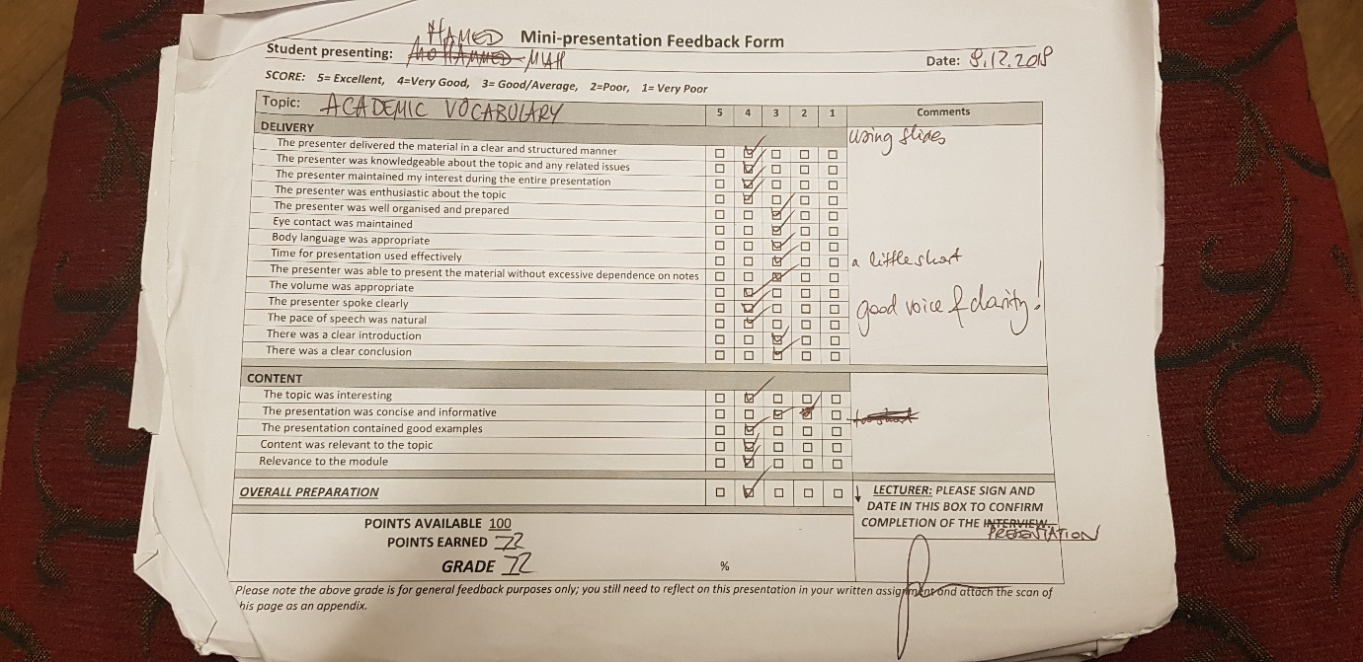
Appendix


