

ASSIGNMENT 2020
Effective Team Working and Communication

Lecturer Submitted by
Afzal Sayed MUNNA Mihail Daniel GUSA - 1916898

Introduction

In this assignment, I would like to talk about all the methods and steps of communication and teamwork. I will go through definitions, the importance of communication, theories, types of communication, and how communication can improve the efficiency at your workplace. On a daily basis, the way we interact on the street, at work or home, conversation makes our life easy as long as we communicate with each other through the same channel.

1. Communication

- "Communication is a transfer of information from one person to another, whether or not it elicits confidence. But the information transferred must be understandable to the receiver."
- G.G. Brown

- "Communication is an exchange of facts, ideas, opinions or emotions by two or more persons."
- W.H. Newman and C.F. Sumer Jr

- "Communication is the process by which information is transmitted between individuals or organizations so that an understanding response results."
- Peter Little

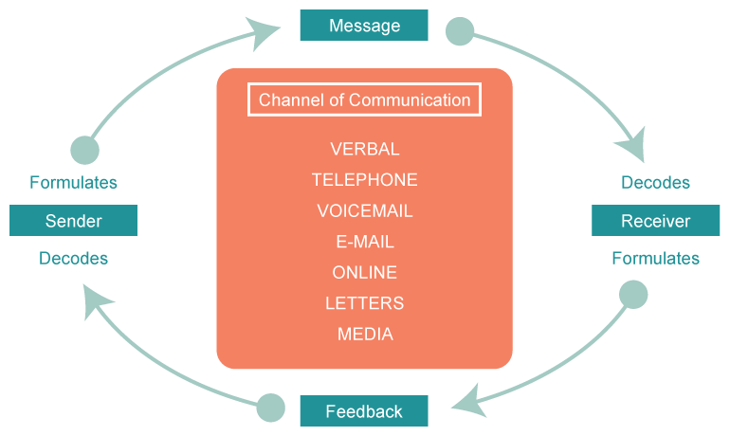

2. Importance of communication

Definitions:

- “Communication forms a part of your self-concept, and it helps you understand yourself and others, solve problems and learn new things, and build your career.”

- "We all share a fundamental drive to communicate. Communication can be defined as the process of understanding and sharing meaning." - Pearson, J., & Nelson, P.

- "A crucial, but often overlooked function of leadership is creating a culture in which effective communication can flourish". - Greg Satell

- "People unable to express themselves clearly in writing limit their opportunities for professional, salaried employment." – The College Board, 2004

We are going through a day we are using the communication in any forms using different channels. Communication is the exchange of data between two, three or more people. Sending the message is defined as sender and the one receiving the information is defined as a receiver.

Our data can include ideas, instructions, facts, opinions or emotions.

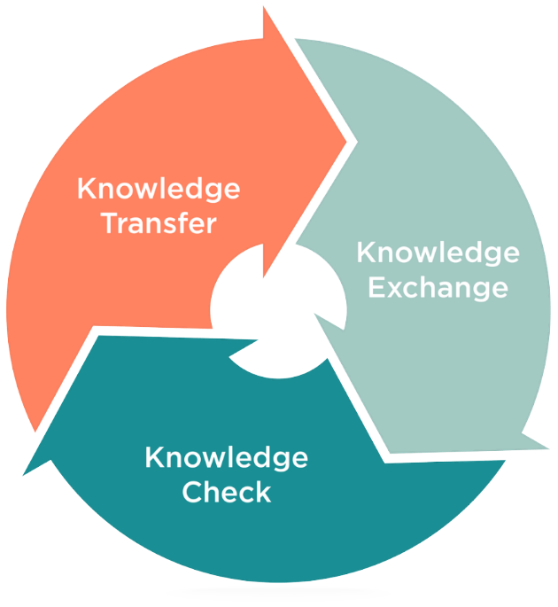
3. Importance of Effective Communication

Definitions:

- "Communication leads to community, that is, to understanding, intimacy and mutual valuing." - Rollo May

- "I know that you believe that you understood what you think I said, but I am not sure you realize that what you heard is not what I meant." - Robert J. McCloskey

- "To effectively communicate, we must realize that we are all different in the way we perceive the world and use this understanding as a guide to our communication with others." - Anthony Robbins

Effective communication is more than exchanging information and has a deeper meaning. To communicate effectively, you have to understand the emotion and intentions behind the information. Make sure you completely understood the message and meaning of what is being said by entirely focusing on your sender. Businesses who communicate effectively are 50% more likely to have low turnover rates. So what's stopping you for communicating effectively? Well, lack of focus, for instance. You can't communicate effectively when you are multitasking. If you are thinking of what to say next or checking your phone, you are not focused enough, and you may lose nonverbal communication.

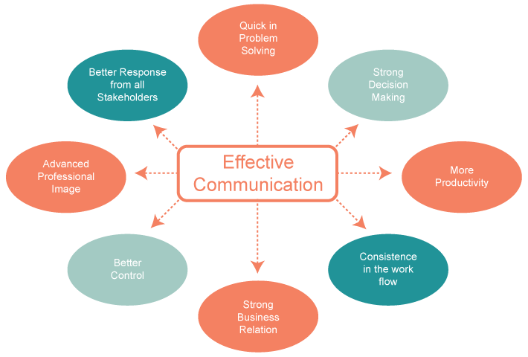
4. Methods of Communication

There are two main ways of sharing information between sender and receiver: Verbal and Non-verbal communication. No matter what form of communication we choose, it is essential to have the right intention to connect with the other person. In a face-to-face conversation, for instance, we have to pay attention to both verbal and non-verbal communication.

a. Verbal Communication

Verbal communication is a linguistic form of interaction — the use of words or messages between two or more people. A speech is a part of everyday usage; oral communication mainly face-to-face, academic usage involves more aspects like written an email or sign language. Non-verbal communication is a complementary mode differentiated from verbal communication.

We use everyday verbal communication through our emails, messages, phone calls, meetings or letters. Verbal communication is about the way we communicate, both spoken and written. Verbal communication is a reference to our use of words.

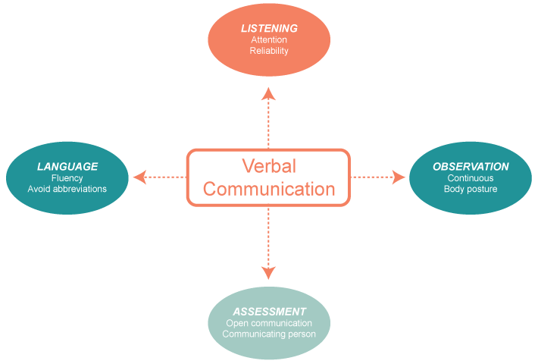

b. Non-verbal Communication (body language)

When we are communicating effectively and accurately, we have to be aware of our nonverbal signals and emotions that we send to others. Our body language, part of our nonverbal communication, like physical appearance, gesture or facial expression, can transmit valuable messages to our receiver.

We can send a mixed message to a person with or without our will. This will make our receiver confused. You can say something verbally but your body or facial expression can suggest something else.

For instance, If someone stops you on the street and is asking you for directions and you show them to the right, but you say to the left, your receiver will be confused. Non-verbal communication and verbal communication are equally essential.

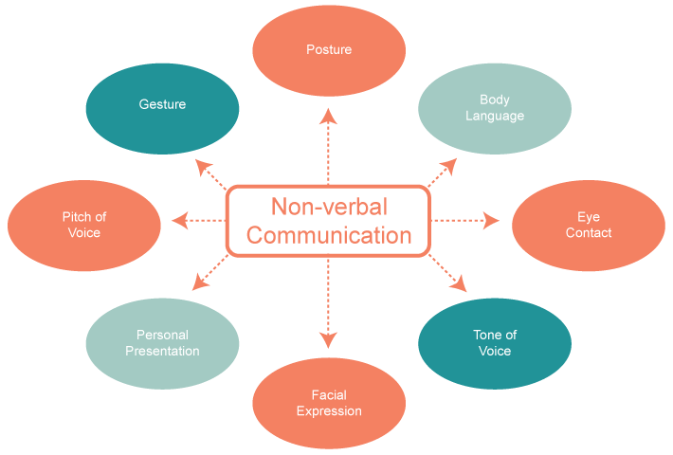

5. Theories of Communication

Communication theory is the method of sending and receiving data.
A message can be affected by many principles, components or methods, communication theory will explain every single aspect. It is crucial to use the same channel when communicating. For instance, if you don't speak the same language with your receiver, Your receiver will find it difficult to understand completely what are you trying to convey. Below I will explain three communication types: Shannon-Weaver, Berlo and Schramm.

5.1 Shannon-Weaver Models of communication

In 1948 Shannon Weaver model was created as a result of an article wrote in Bell Systems Technical Journal with Warren Weaver and Claude Elwood Shannon

Shannon and Weaver Model of Communication describes that the communication is divided in six linear steps: sender, encoder, channel, noise, decoder, and receiver. A 7th concept ('feedback') was later on introduced by Warren Weaver and modified the model from a linear to cyclic model.

“The fundamental problem of communication is that of reproducing a message sent from one point, either exactly or approximately, to another point” (Shannon, 1948, p. 379).

The following design will show you the linear concept of communication designed by Shannon-Weaver:

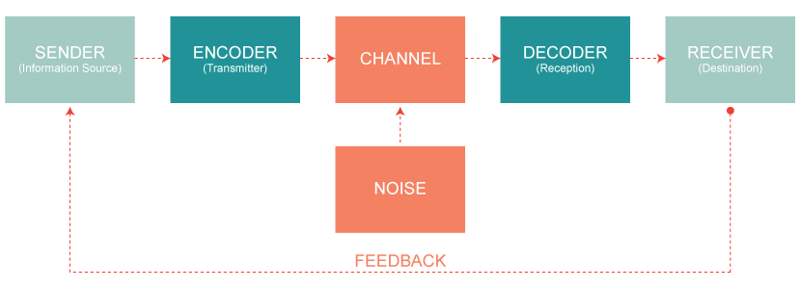

The Shannon-Weaver model let us understand how information is transferred and how a message is sent and received. Shannon-Weaver model has some limitations like nonverbal communication. Feedback was another limitation of this model but added later.

The Shannon-Weaver model of communication was radical because it explains in details the idea of ‘noise’. It may show how the information is disturbed and helps us to identify areas where we can improve communication. As a disadvantage, we can add that this is a linear model, it does not have power relationships, and it does not address one-to-many communication.

Exemple: A phone discussion

Sender: The sender is the one who initiated the phone call and aimed to deliver an important message

Encoder: The device turns his voice in binary data which can be sent through the line.
Channel: The channel is the device which is wired to a server
Noise: It can be affected by malfunctions of encoders/decoders.
Decoder: The device used by the receiver will convert back from binary data to sound.
Receiver: Interpreting the message is done by the receiver when hearing the sounds.
Feedback: The receiver will talk to respond and let the sender know that he understood.

5.2 Berlo Model of communication

David Berlo, in 1960, developed Shannon and Weaver linear model of communication and invented SMCR which stand for Sender-Message-Channel-Receiver. David Berlo added some factors that affect the communication process between two people which includes communication source, encoder, message, channel, decoder, and communication receiver. Berlo included: communication skills, social system, awareness level, cultural system, and attitude. The model also aims on encoding and decoding, which occurs before the sender conveys the message, and before the receiver gets the message correspondingly.

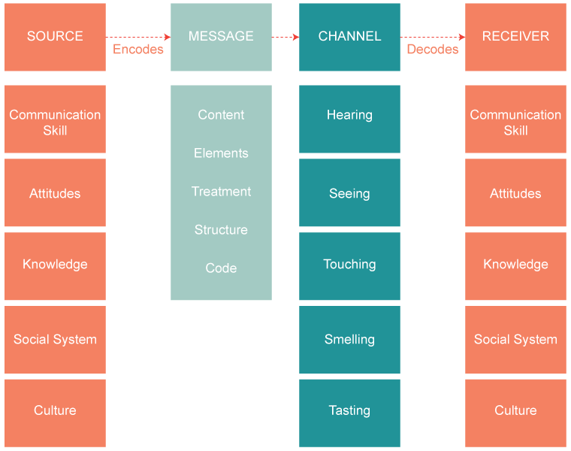

Although Berlo improved the linear model of communication, his model of communication has limitations. The main problem of the model is that the model ignores the usage of sixth sense as a channel which is a contribution to humanity (thinking, analyzing, understanding, etc.). Unlike Shannon and Weaver's linear model of communication who added later 'feedback.' Berlo's model does not have 'feedback' or 'noise'. Lack of mention of barriers to communications also shows that this model is not a full circle of communication.
5.3 Schramm Model of communication

In 1954, Wilber Schramm proposed a different type of model which is circular, and the sender and the recipient of the message can be the same person.
A message is encrypted and can be send to the same receiver or to a different receiver. It comes down to the recipient to decrypt the message and then encode it again before sending the message to a new receiver (circular). Schramm thought that the communication is incomplete unless and until the sender receives feedback from his recipient. He believed that communication is a two-way process, and you have to have a sender and a receiver.

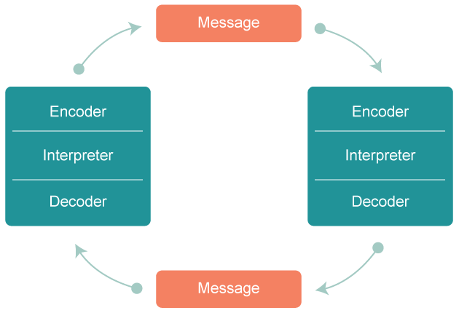

The negative point is that the communication model is occasionally compromised by semantic noise, variations, and misinterpretation that can produce a message to be decoded differently by the receiver. This can be an explanation for any cases when you send the same message to two different receivers, and they understand your message completely different.

6. Effective communication at your workplace

At my workplace, we use different types of communication from face-to-face to emails, Skype or Teams. We receive email and phone calls from customers with orders. After a stock check, we send the order, printed, in the warehouse. I am working as a Marketing Graphic Designer, and my job is to design everything from packagings to flyers or business cards which allows me to communicate through multiple channels with different suppliers. For instance, if we need packaging, I will use skype to communicate this to the factory in China. Luckily, our suppliers from China speak English which allows me to have accessible communication. Although in this company we have people from all over the world we all communicate in English and everything goes smooth as we are using the same channel. Most of the time, I'm on the phone with different people discussing different matters or solving problems. We have effective communication as all employees know how and when to listen or when to speak. Our H.R. department had a meeting with every single one of us where they explain to us the importance of effective communication and hand us an Employee handbook with all this information.

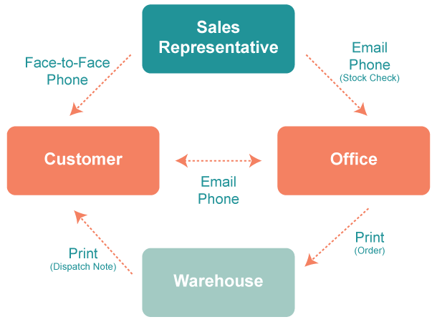

Conclusion

In conclusion, communication is a full circle with words, body language, gesture, eye contact, etc. All of these are making communication possible. You can successfully utilize your voice and body language to transmit your message across or if possible, eye contact instead of other forms of indirect communication. Sometimes you can send the wrong message with your body language, or just only one word will make you lose money or hurt people in the business. Be careful what you answer and make sure you are fully aware and you completely understood the message before replay. You can say "yes" to something having no clue, and yet you already accepted.

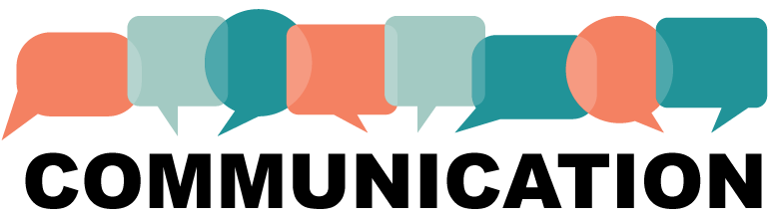

All these methods of communications helped us to have a better understanding of how communication works and how communication is applied every single day. It is essential to use the same channel of communication to make ourself clearly understood and to understand clearly the message from our sender.

References and Bibliography

Communication

1. “Action + reaction + interaction, A.J. (2013). Articles Junction. Retrieved 9 April, 2020, from http://articles-junction.blogspot.com/2013/07/meaning-of-communication-definition-of.html”

Importance of communication

1. “Harvard business review, G.S. (2014). The Google Way of Attacking Problems. Retrieved 9 April, 2020, from https://hbr.org/2014/12/the-google-way-of-attacking-problems”

2. “Pearson, J., & Nelson, P. (2000). An introduction to human communication: understanding and sharing (p. 6). Boston, MA: McGraw-Hill.”

Importance of Effective Communication
1. “Libraries - University of Minnesota. (2018). Effective Business Communication. Retrieved 9 April, 2020, from https://open.lib.umn.edu/businesscommunication/part/chapter-1-effective-business-communication/”

Methods of Communication

1. “Oxford reference. (2011). Verbal communication. Retrieved 9 April, 2020, from https://www.oxfordreference.com/view/10.1093/oi/authority.20110803115457102”

Theories of Communication

1. “Helpfulprofessor, C.D. (2020). Shannon-Weaver Model of Communication | 7 Key Concepts (2020). Retrieved 10 April, 2020, from https://helpfulprofessor.com/shannon-weaver-model/”

2. “Wikipedia. (2020). Models of communication. Retrieved 10 April, 2020, from https://en.wikipedia.org/wiki/Models_of_communication”

