

ACBA6002 WORD COUNT: 9132

Architecture, Built and Natural Environments,
University of Wales Trinity Saint David, Swansea
For BSc of
Civil Engineering
Written under the Supervision of
Juan Ferriz-Papi
Peter Charlton

Evaluation of the use of piezoelectric transducers in determining the strength of concrete

By

Shahram Sharifi

Abstract

Nowadays, concrete is the second most consuming material in construction structures. Due to the use of this product in the construction industry, concrete testing is a critical issue. By examining the patterns and behaviours of the waves, it is possible to find the degree of homogeneity and the strength of structures. Piezoelectric transducers can demonstrate the hardness and uniformity of the sample by measuring how waves propagate. In this study, using the piezoelectric transducers as a cheaper and faster way to test the strength of concrete is evaluated. Transducers are shown as a better method to evaluate some concrete properties. In this case, porosity and curing, by measuring the velocity of energy waves. Twenty-four samples were tested with two ratios of water to cement (0.55 and 0.65(.In this study, two transducers were attached to the samples with a certain distance from together, and then the sample was hit with a hammer at a specific point. The velocity of the generated wave was calculated, and the strength of the samples predicted accordingly. This result was compared with the results obtained from the strength of the compressive machine. The regression analysis has shown a strong, positive association between two wave velocity test and concrete strength tests in any stages. These results are confirmed a direct relationship between them, and both have the same direction. The F Statistic is shown there is a substantial relation between predicted the strengths by transducers and the recorded strength by the compressive machine. Based on the results obtained, it can be claimed that the PZT proved their efficiency in measuring strength at different age and porosity.

Keywords: Piezoelectric transducers, wave propagation, concrete strength, compressive machine



Author’s Declaration
I declare that the work in this dissertation was carried out in accordance with the regulations of the University of Wales, Trinity Saint David. The work is original except where indicated by special references in the text and no part of the dissertation has been submitted for any other degree.
Any views expressed in the dissertation are those of the author and in no way represent those of the University of Wales, Trinity Saint David.
The dissertation has not been presented to any other University for examination either in the United Kingdom or overseas.
I hereby give permission for my work, if accepted, to be available for photocopying and inter-library loan, and for the title and summary to be made available to outside organisations.

Signed
Shahram Sharifi
Date ……………………………………………………………………………………………………………..

Copyright statement

The copyright of this dissertation rests with the University of Wales, Trinity Saint David. No information derived from this dissertation shall be published without the prior written consent of the University.

Signature
Shahram Sharifi

Date ………………………………………………………………………………………………………..

ACKNOWLEDGEMENT

I praise God for his greatness and his mercy. My lord, you are faithful to me. Praise Lord.
I would like to express my sincere gratitude to my advisors, Juan Ferriz-Papi and
Peter Charlton for their continuous guidance, support, encouragement. His wisdom, knowledge, high standards and commitment inspired and motivated me.

I would like to extend thanks to Sergio Garate contributed to the work presented in this dissertation and also to Alan Nantel for the feedback and advice.
A special thanks also go to Keerthi Kumara Ranasinghe. I appreciate all your help.

My deepest appreciation goes to my dear family. Nothing can express how thankful I am to them.

.

TABLE OF CONTENTS

A
TABLE OF TABLES VIII
TABLE OF EQUATIONS IX
1 Introduction 1
1.1 Motivation 1
1.2 Problem statement and main purpose 1
1.3 Research aims 2
1.4 Objectives 2
1.5 Scope and limitations. 2
1.6 Outline of the thesis 2
2 Literature review 3
2.1 Introduction 3
2.2 Concrete 3
2.3 Ultrasonic techniques 3
2.4 Piezoelectricity 4
2.5 Piezoelectric transducers (PZT) 4
2.6 Impact-echo method 4
2.7 Wave propagation technique: 5
2.8 Curing 5
2.9 Porosity 5
2.10 Compressive strength test 6
3 Methodology and Experimental set up 8
3.1 Introductions 8
3.2 Sample preparation 10
3.2.1 Sieve Analysis 10
3.2.2 Batching (calculate the quantities of materials for concrete) 13
3.2.3 Determine the ratio of fine aggregate (6mm) to coarse aggregate 20mm 15
3.2.4 Mixing 19
3.2.5 Slump test 20
3.2.6 Filed sampling and Compaction of the concrete 21
3.2.7 Curing regimes (BS EN 12390‑2:2019) 22
3.3 Experimental setup 23
3.3.1 Wave propagation test (impact hammer) 23
3.3.2 Compressive strength test 28
4 Result 30
5 Discussion 36
6 Conclusion and recommendation 41
6.1 Recommendation nad further research 41
7 References 42
8 Appendices 46

TABLE OF FIGURES
Figure ‎2-1: relationship between the w/c ratio and strength of concrete (Neville & Brooks, 2010) 6
Figure ‎2-2: relationship between the w/c ratio and strength of concrete (Neville & Brooks, 2010) 7
Figure ‎2-3: effect of load applied on specimens (Elwell & Fu, 1995) 8
Figure ‎3-1: Diagram of amount and ratio of specimens (Author) 9
Figure ‎3-2 : Plan and stages of tests (Author) 9
Figure ‎3-3: Details of process (Author) 10
Figure ‎3-4: steps of making samples (Author) 11
Figure ‎3-5: the equipment were used in sieves experiment (Author) 12
Figure ‎3-6: Order and size of sieves ((Author) 13
Figure ‎3-7: diagram of fineness modulus of sand (Ramchandra, V. Gehlot, 2012) 16
Figure ‎3-8: the mixer has used for mixing the materials (Author) 19
Figure ‎3-9: the materials was prepared for mixing (Author) 19
Figure ‎3-10: Types of equipment that were used for slump test (Author) 20
Figure ‎3-11: the vibration machine MATEST C278 used in this experiment (Author) 21
Figure ‎3-12: Surface of concrete has made it level (Author) 21
Figure ‎3-13: Covering samples by thick plastic for protection from dehydration (Arthur) 22
Figure ‎3-14: specimens kept in curing tank till the experiment (Arthur) 22
Figure ‎3-15: the hammer that used in experiment (Author) 23
Figure ‎3-16 : PZT that used in the experiment(Author) 24
Figure ‎3-17: the oscilloscope that was used (Author) 25
Figure ‎3-18 : handmade template that designed for the wave propagation experiment (Author) 25
Figure ‎3-19: setting up of software for experiment (Author) 26
Figure ‎3-20: Foam (Half egg shell tray) that used in this experiment ((Author) 26
Figure ‎3-21: process of experiment (made in sketch up by Author) 27
Figure ‎3-22: Compression machine which used in this experiment (Author) 28
Figure ‎3-23 : sample of specimen before and after the compressive strength test (Author) 29
Figure ‎3-24: set up of compressive machine for test ((Author) 29
Figure ‎4-1: result of Wave propagation and compressive machine (Author) 31
Figure ‎5-1: analyse the gradient of regression lines 38
Figure ‎5-2: recorded strength by compressive machine for any ratio at any stage 39
Figure ‎5-3: the velocity of the waves has recorded by PZT for any ratio at any stage 39
Figure ‎8-1: diagram for results of wave propagation test for sample M11 43
Figure ‎8-2: diagram for results of wave propagation test for sample M21 44
Figure ‎8-3: diagram for results of wave propagation test for sample M31 45
Figure ‎8-4: diagram for results of wave propagation test for sample M12 46
Figure ‎8-5: diagram for results of wave propagation test for sample M22 47
Figure ‎8-6: diagram for results of wave propagation test for sample M32 48
Figure ‎8-7: diagram for results of wave propagation test for sample M13 49
Figure ‎8-8: diagram for results of wave propagation test for sample M23 50
Figure ‎8-9: diagram for results of wave propagation test for sample M33 51
Figure ‎8-10: diagram for results of wave propagation test for sample M14 52
Figure ‎8-11: diagram for results of wave propagation test for sample M24 53
Figure ‎8-12: diagram for results of wave propagation test for sample M34 54
Figure ‎8-13: diagram for results of wave propagation test for sample M41 55
Figure ‎8-14: diagram for results of wave propagation test for sample M51 56
Figure ‎8-15: diagram for results of wave propagation test for sample M61 57
Figure ‎8-16: diagram for results of wave propagation test for sample M42 58
Figure ‎8-17: diagram for results of wave propagation test for sample M52 59
Figure ‎8-18: diagram for results of wave propagation test for sample M62 60
Figure ‎8-19: diagram for results of wave propagation test for sample M43 61
Figure ‎8-20: diagram for results of wave propagation test for sample M53 62
Figure ‎8-21: diagram for results of wave propagation test for sample M63 63
Figure ‎8-22: diagram for results of wave propagation test for sample M44 64
Figure ‎8-23: diagram for results of wave propagation test for sample M54 65
Figure ‎8-24: diagram for results of wave propagation test for sample M64 66

TABLE OF TABLES
Table ‎3-1: fineness modulus obtained by sieves analysis 13
Table ‎3-2: amount of materials on base of ratio for RC 20 (Author) 15
Table ‎3-3: cumulative retained for sand (Author) 17
Table ‎3-4: fineness modulus result (Author) 17
Table ‎3-5: Amount of particles (sand and aggregates) (Author) 18
Table ‎3-6: Result of slump tests (Author) 20
Table ‎3-7 : The hammer specifications 23
Table ‎3-8 : Technical Details of transducers (TIMESETL, 2019) 24
Table ‎3-9: details of oscilloscope (picotech, 2019) 25
Table ‎4-1: result of Wave propagation and compressive machine (Author) 30
Table ‎4-2: regression lines foe mixes in each stage 34
Table ‎4-3: strength of concrete that has predicted by transducers (MPa) 34
Table ‎4-4: sum of squares (total, regression, residual) and the coefficient of determination 35
Table ‎5-1: result of the test statistic F∗ 36
Table ‎5-2: regression line for mix with ratio 0.65 at the 7-day stage 37
Table ‎5-3: regression line for mix with ratio 0.55 at the 7-day stage 37
Table ‎5-4: regression line for mix with ratio 0.65 at the 28-day stage 38
Table ‎5-5: regression line for mix with ratio 0.55 at the 28-day stage 38
Table ‎5-6: the velocity of the waves has recorded by PZT for any mixes at any stage 39
Table ‎8-1: results of wave propagation test for sample M11 43
Table ‎8-2: results of wave propagation test for sample M21 44
Table ‎8-3: results of wave propagation test for sample M31 45
Table ‎8-4: result of wave propagation test for first mix (ratio 0.55 water to cement) in 7 days 46
Table ‎8-5: results of wave propagation test for sample M12 46
Table ‎8-6: results of wave propagation test for sample M22 47
Table ‎8-7: results of wave propagation test for sample M32 48
Table ‎8-8: result of wave propagation test for second mix (ratio 0.55 water to cement) in 7 days 48
Table ‎8-9: results of wave propagation test for sample M13 49
Table ‎8-10: results of wave propagation test for sample M23 50
Table ‎8-11: results of wave propagation test for sample M33 51
Table ‎8-12: result of wave propagation test for third mix (ratio 0.65 water to cement) in 7 days 51
Table ‎8-13: results of wave propagation test for sample M14 52
Table ‎8-14: results of wave propagation test for sample M24 53
Table ‎8-15: results of wave propagation test for sample M34 54
Table ‎8-16: result of wave propagation test for fourth mix (ratio 0.65 water to cement) in 7 days 54
Table ‎8-17: results of wave propagation test for sample M41 55
Table ‎8-18: results of wave propagation test for sample M51 56
Table ‎8-19: results of wave propagation test for sample M61 57
Table ‎8-20: result of wave propagation test for first mix (ratio 0.55 water to cement) in 28 days 57
Table ‎8-21: results of wave propagation test for sample M42 58
Table ‎8-22: results of wave propagation test for sample M52 59
Table ‎8-23: results of wave propagation test for sample M62 60
Table ‎8-24: result of wave propagation test for second mix (ratio 0.55 water to cement) in 28 days 60
Table ‎8-25: results of wave propagation test for sample M43 61
Table ‎8-26: results of wave propagation test for sample M53 62
Table ‎8-27: results of wave propagation test for sample M63 63
Table ‎8-28: result of wave propagation test for third mix (ratio 0.65 water to cement) in 28 days 63
Table ‎8-29: results of wave propagation test for sample M44 64
Table ‎8-30: results of wave propagation test for sample M54 65
Table ‎8-31: results of wave propagation test for sample M64 66
Table ‎8-32: result of wave propagation test for fourth mix (ratio 0.65 water to cement) in 28 days 66
Table ‎8-33: The F-distribution table for the alpha level 0.05 67

TABLE OF EQUATIONS
Equation ‎3-1: absolute volume method formula (Mishra, 2019) 14
Equation ‎3-2: fuller formula (Ramchandra, V. Gehlot, 2012) 16
Equation ‎3-3: parabola fuller formula (Popovics, 1992) 17
Equation ‎3-4 : strength of concrete formula Invalid source specified. 29
Equation ‎4-1 : velocity of wave formula 30
Equation ‎4-2: formula for regression straight line (Cook and Wheater, 2000) 32
​​ Equation ‎4-3: total sum of square formula (Cook and Wheater, 2000) 32
Equation ‎4-4: regression sum of square formula (Cook and Wheater, 2000) 32
Equation ‎4-5: residual sum of square formula(Cook and Wheater, 2000) 33
Equation ‎4-6: the coefficient of determination formula (Cook and Wheater, 2000) 33
Equation ‎4-7: Adjusted R-squared formula (Cook and Wheater, 2000) 33
Equation ‎4-8: mean square error (MSE) formula (Cook and Wheater, 2000) 33
Equation ‎4-9: regression mean square (MSR) formula (Cook and Wheater, 2000) 33
Equation ‎5-1: The test statistic formula (Cook and Wheater, 2000) 36

Nomenclature
V_{c} …………………………………………………………………..… Absolute volume of fully compacted fresh concrete
C …………………………….………………………………………………………………………………………………. Mass of cement
W ……………………………………………………………………………………….……………………………………….Mass of water
C_{a} ……………………………………………………………………………………………………………. Mass of coarse aggregates
F_{a} ………………………………………………………..……………………….…………………………….. Mass of fine aggregates
S_{ca}………………………………………………………..………………………………the specific gravity of coarse aggregates
S_{fa}………………………..……………………………………….……………………….the specific gravities of fine aggregates
d………………………………………………………………………………………………………….max size of the fine aggregate
D…………………………………………………………………….……………………..……….max size of the coarse aggregate
P_{d}………………………………………..……………………………………….…….……………….……percentage of particle size
F………………………………………………………………………………..……….……………………….. Fuller for large particles
F₁…………………………………………………………………………….………………………..Real modulus for small particles
F₂…………………………………..………………………………………….………..…………… Real modulus for large particles
S………………………………………………………………………..……..……..………………….. Percentage of small particles
CV.…………………………………………………………………………………...…………………………….Coefficient of variation
SD……………………………………………………………………………………………………………………….. Standard Deviation
NDE..............................................................................................................Non-destructive evaluation
BS ………………………………………………………………………………………………………………………….....British standard
WP……………………………………………………………………………………………………..……..…………. Wave propagation
MPa……………………………………………………………………………………………….…………….………………… Mega Pascal
Km/s……………………………………………………………………………………….……………………. Kilometre per Second
Kg/m3………………………………………………………………………………..………………………. Kilogram per cubic metre
MM……………………………………………………………………………………….…………………………………………. millimetre
Kg…………………………………………………………………………………………………..……………………………………. Kilogram
MIC……………………………………………………………………………………………..………………………….………. micrometre
°C…………………………………………………………………………………………………..…………………………………………Celsius
W/C…………………………………………………………………………………..……………..……………….. Water–cement ratio
SS _{total}………………………………………………………………………………………….………….…………… total sum of square
SS _{residual}………………………………………………………………………….…………….………………… residual sum of square
r²……………………………………………………………………………….………..……………the coefficient of determination
MSE…………………………………………………………………………………….……………………….regression sum of square
MSR…………………………………………………………………………………………………….………..regression mean square
M³…………………………………………………………………………………………….…………………..……………….. Cubic metre
RC……………………………………..……………………………………………………………………………….. Reinforced concrete
PZT……………………………….……………………………………………….……………………….…… Piezoelectric transducers
S²……………………………………………………………………………………………………………………….…………………. Variance

Introduction
Nowadays, concrete is the second most consuming material in construction structures. Sustainability at high pressures and easy formability caused three tonnes of concrete consumed per person per year. Concrete becomes complete and sturdier over time. These specifications have made it an important part of the construction. (R.Gagg, 2014).
Due to the use of this product in the construction industry, concrete testing is a critical issue. Testing examines the quality and utility of all the materials that make up the structure. In other words, these specific tests help to control and check the quality of hardened concrete. This method ensures that the quality of concrete is suitable for different types of operations. Concrete testing on hardened concrete addresses the different aspects such as how to build high-quality concrete, how to achieve the required resistance, combat all corrosive factors, durable concrete formation and many more.
Besides all the rules and regulations, concrete testing is part of the technical specifications of the contract, and all contractors and engineers require it...
Numerous destructive and non-destructive methods have developed have been to estimate the strength of concrete in the structure. Recently, the destructive testing methods of concrete, which are generally associated with the destruction and damage of structures, are avoided as far as possible. Non-destructive evaluation (NDE) methods are many different technological solutions for solving the problems with maintenance and monitoring of the structures without causing significant damage to the structure (Hammarström, 2018). Also, it is possible to do the experiments on a particular concrete sample for multiple times. NDE, by measuring concrete’s response to some exciters can evaluate the properties of concrete. (Yee Yan Lim, Kok Zee Kwong, Willey Yun Hsien Liew and Chee Kiong Soh, 2016)

Motivation
In all stages of examining concrete, non-destructive tests are a priority. Non-destructive tests divide into several categories. Each has positive and negative characteristics. Therefore, many parameters should be considered when choosing the right method such as type of the method, accuracy, cost and time of testing. In other words, these specific tests help to control and check the quality of hardened concrete. At present, the construction industry is looking for inexpensive and better ways to conduct these tests. In response to this demand, this study can show it. Piezoelectric transducers are available at a very affordable price, and NDE can be the solution that many companies and organisations are looking for in response to this demand.

Problem statement and main purpose
It is possible to come up with precise solutions by combining different branches of science. In the field of non-destructive testing of concrete, scientists have found methods to measure the strength of materials, including concrete, by combining wave science and materials engineering. One of these methods is to study the propagation of waves in the samples tested.

By examining the patterns and behaviours of the waves, it is possible to find the degree of homogeneity and the strength of structures. Such studies on structures require using devices with high precision. Piezoelectric transducers can demonstrate the hardness and uniformity of the sample by measuring how waves propagate. In this study, transducers are shown as a better method to evaluate some concrete properties. In this case, porosity and curing, by measuring the velocity of energy waves.

Research aims
- Evaluate the use of piezoelectric transducers as a cheaper and faster way to test compression strength of concrete.

Objectives
- changing the velocity of the waves in different curing and porosity
- Finding the relation between concrete’s strength and how the energy is delivered.
- Analysis using the direct effect of piezoelectric.

Scope and limitations.
The general scope of work is limited to analyse the function of piezoelectric transducers to determine the strength of concrete. Next, the results will be compared to the results of an acceptable test (in this case is the compressive strength test). The work is not focused on the quality of concrete or efficiency different ratio of water to cement. Also, this study is not focused on how the types of curing can impact on the strength of concrete. This study has tried to prove the thesis by reasonable and experimental method. However, there is some limitation, such as:

  - Lack of access to more accurate devices for measuring the velocity of energy.
  - The limited number of samples due to the lack of concrete moulds in the laboratory.
  - Limited time due to the academic year, and difficulties to test the samples at 60 days due to the Coronavirus pandemic.
  - It was considered the 24-hours limit maximum difference between measuring energy wave and testing to compression strength.

Outline of the thesis
Introduction and motivation of this study with the aims and objectives of the study are in chapter 1. Also, the scope and limitations of the study concluded in this chapter. Chapter 2 is a literature review. Methodology and experiments set up are in chapter 3. The result of the experiments is presented in chapter 4 in a clear and academic format. Discussions are content in chapter 5. Conclusions and the scope of future research and recommendations are placed in chapter 6. Finally, the bibliography containing the references and appendices has brought.

Literature review

Introduction
The literature review is about the evaluation of the non-destructive tests on the base of the wave propagation. The presentation focused on the function of piezoelectric transducers in the evaluation of the velocity of wave propagation. Piezoelectric transducers have different applications, and analysing the velocity of the propagation waves can also be used for other fields. However, the focus here is on the study of the velocity of waves in concrete by piezoelectric transducers. For proving, the results by piezoelectric transducers should be compared to the results of the compressive strength test. So, the literature review also includes aspects of compression strength testing in concrete. However, the strength of concrete by itself is not under discussion. It has attempted to provide this literature review on based the date of the research and the study process.

Concrete
As definition of British Standard concrete is “material formed by mixing cement, coarse and fine aggregate and water, with or without the incorporation of admixtures, additions or fibres, which develops its properties by hydration.” (BS Institution, 2003)

Ultrasonic techniques
Ultrasonic tests, which are classified as non-destructive tests, have been used since 1940. In these techniques, hidden cracks and cavities and material homogeneity can be identified considering the laws governing the propagation of high-frequency sound waves. Significant progress in ultrasonic techniques started in the 1980s. Simultaneous ultrasonic devices rely on digital signal processing became a precision instruments for industrial inspections. (olympus, 2019).
Base on the improvements of the science, ultrasonic techniques have divided two significant types:
- Linear ultrasonic testing: According to Bungey’s study, these types of tests are ideal for quick comparison but have many difficulties in calculating absolute strength (Bungey, 1980). However, it is more accurate in determining the depth of internal defects because it has high sensitivity and greater power (tojić, D. & Nestorović, T. & Marković, Nemanja, 2012).
- Non-linear ultrasonic testing: This method is affected by detect or slight changes because it is based on concrete properties (Shah Et.al., 2013).
Now, many great pieces of research have started in many countries, such as:
- USA: the Electric Power Research Institute in Charlotte (nde-ed.org, 2020)
- Germany: the Fraunhofer Institute for non-destructive Testing in Saarbrucken (nde-ed.org, 2020)
- England: the non-destructive Testing Centre in Harwell (nde-ed.org, 2020)

Piezoelectricity
Electrical energy can be obtained from other types of energy like vibration, wind and heat. Some materials give rise to an electric polarization when strained under applied stress. In other words, the pressure is converted into electricity. These materials are called piezoelectric. (Xiaochen Xu, Dongwei Cao, Hailu Yang, Ming He, 2018)
In 1880, Pierre and Curie were the first researches that worked on piezoelectricity. They could find the phenomenon of piezoelectricity. Other researchers have developed their findings over time. For these finding new applications have been found. However, piezoelectricity was first used by W. Hankel as a term, but it was Paul Langevin and his colleagues who first used this property in a submarine detector in 1917. They were able to use the piezoelectric properties in a hydrophone to detect back waves (Deivasigamani, 2014). Finally, in the 1950s, it was found how the piezoelectric effects could be used by creating the piezoelectric transducers. Since then, they have been used in various fields. (Zhu, 2010)

Piezoelectric transducers (PZT)
For converting mechanical energy to electrical energy, piezoelectric transducers are playing a vital role. Generally, there are two types of PZT: ceramics and single-crystal materials. (Quartz, gallium-phosphate, tourmaline, etc.). (A.G S. Barreto Neto , A.M.N. Lima, Francisco Tejo, Christian Precker, C.S. Moreira, 2012)
Professor Dr Dragoslav Stojic and colleagues in their research on a full-size reinforced concrete bent-cap have shown for extensive inspection infrastructure, using the piezo-ceramic material can be trustable. They demonstrated that when there is a crack in a sample, a sensitive drop of transmissions energy will be between the actuator and transducers. In this research, it has been demonstrated that the health monitoring of concrete from an early age until lifetime can use the piezoelectric transducers. (tojić, D. & Nestorović, T. & Marković, Nemanja, 2012)
In other research done by Dixit and Bhalla, piezoelectric transducers are embedded in a specimen of plain cement concrete. Next, they tried to impact the specimen by a falling an iron-ball from different heights. Researchers have shown there is a direct relationship between the damages and damping by analysing the voltages and frequencies. (Anjaneya Dixit, Suresh Bhalla, 2018)

Impact-echo method
In the initial, testing the strength of concrete was through the impact which called sounding. In this method, just by using a hammer, it is possible to find out the qualitative evaluation of the concrete. The sound of striking the hammer is the key. When the sound is similar to ringing, it shows that the concrete has good quality, and when the sound is similar to a drum, it means there are cracks or delamination. The result is the only perception of the person testing. (Mishra, 2020)
Saafi and Sayyah attached an array of piezoelectric transducers to a structure. They used amplitude and phase information from transducers to detect and estimate the extent of the excitations. (M.Saafia,T.Sayyah, 2001)

Wave propagation technique:
The wave propagation (WP) technique is a test that uses PZT as an actuator and some sensors. This test has tried to show any difference in waves as electrical signatures through the concrete. Travel time is the key to this method (Yee YanLim,Scott T.Smith,Chee KiongSoh, 2018).
Research into measurement wave propagation techniques using transducers began about 20 years ago. Initial research conducted on steel structures. Firstly, Keilers and Chang (Keilers et al, 1995) attempted to quantify the damage by using piezoelectric materials. Secondly, research conducted to determine the cracks by using the wave propagation technique (Ihn J-B, Chang F-K, 2004) (Giurgiutiu V, 2003). After 2007, research on the strength of concrete by using the wave propagation technique began widely ( Divsholi BS, Yang Y,2014)( Song G, Gu H, Mo Y, Hsu T, Dhonde H,2007).

Curing
As definition of curing by BS EN 13670 “curing is the process of preventing the loss of moisture from the concrete whilst maintain a satisfactory temperature regime. The curing regime should prevent the development of high temperature gradients within the concrete”. (National Structural Concrete Specification, 2010)
A study in Korea has used an algorithm relation between concrete curing and wave propagation. In this study, some piezoelectric transducers embedded in spacemen as sensors for acquisition data. They attempted to compare the strength results with the penetration resistance test by a universal testing machine (UTM) to verify the results. This study has shown while the concrete mix paste changes from a liquid paste to a semi-solid form, the wave propagation is changed as well. The analysed data has proved that the velocity of wave propagation has a higher value in the boundary of the higher rigidity in the concrete (Tareen et al, 2019).
In 2015, in a study regards cure monitoring by using piezoelectric in concrete, researchers proved a relation between the concrete curing and slope. They used a new method based on the admittance-based sensor by using multiple PZT transducers. They simultaneously monitored the curing status after embedding the piezoelectric transducers in the samples. In this research investigated the effect of piezoelectric transducers via admittance measurements on concrete. The results showed that these could be efficiently used to monitor concrete curing. (Kim et al, 2015).

Porosity
Porosity is the number of pores in a material for instance pores in certain concrete. It is common detention of porosity. Porosity can effect on hardening, composition of concrete, cement reactions and hardening. Normally it is called by volume percent (Tepfers, 2012).
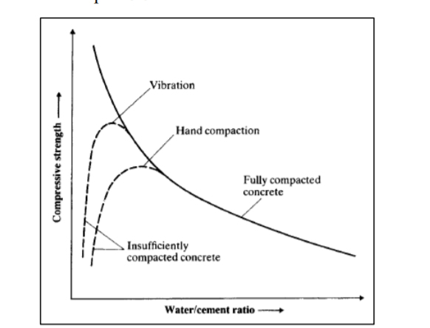
The pores in the concrete (called porosity) caused by the extra water. This water remand after the hydration. While the concrete is making, it should be ensured that all particles are adequately hydrated and no excess water should remain. In this scenario, concrete still contains approximately 18.5% extra space (Neville & Brooks, 2010). So the higher the w/c ratio causes the higher porosity. Also, there is a relationship between the w/c ratio (main factor of porosity) and the strength of concrete (Figure ‎2-1).
Figure ‎2-1: relationship between the w/c ratio and strength of concrete (Neville & Brooks, 2010)

According to a study in 2018, the stress wave transferring is impacted by the porosity. Variation of porosity can determine the amount of impact. This study has proved a relationship between stress wave parameters and porosity in cement paste by using the piezoelectric transducers. The researchers made a 3D model of specimens with X-ray computed tomography (CT) scanning method. Then the results were compared with the wave propagation test. They have proved if amplitude and velocity decreased, porosity will be increment (Du et al, 2018).
In another research at Loughborough University, the researchers used three different frequencies corresponding to the resonance of the transducers were introduced into the mortar and concrete samples. The main result was about the behaviour of the dispersion of cementitious materials. They predicted the dispersion of the wave from the heterogeneity of the material (Dona et al, 2015).

Compressive strength test
For proving, the results by piezoelectric transducers should be compared to the results of the compressive strength test. So, the literature review also includes aspects of compression strength testing in concrete. The resistance to failure under the action of compressive forces defines the compressive strength of any material (civildigital, 2020). There are two shapes of the standard for measuring the compressive strength of concrete (Addis, 1998):
- cube
- cylinder
One of the earlier experiments about the compressive strength was in 1989 by Goldman and Bentur. They tried to develop a high strength concrete. In 1998, a new model suggested (Kim et al, 1998). This model was based on the constant rate model for prediction the strength. They are shown in their experiment if concrete at an early age has cured in high temperature, it can achieve a higher strength, but in the next step, the strength will be lower. On the other side, if concrete at an early age has cured at a low temperature, its strength will be low, but in the next step, the strength will be higher. Finally, both can achieve the same strength.
How concrete fails in compressive test
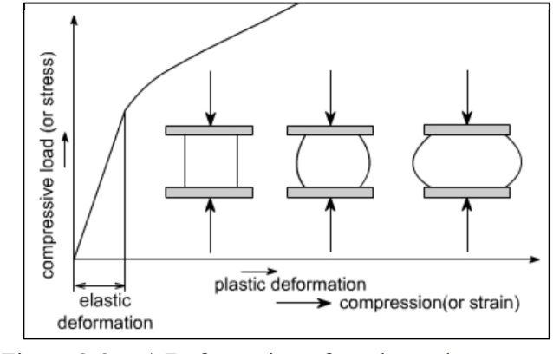
Throughout the specimen, stress can never be right uniaxial. The load applied on specimen which coming from frictional between machine platen and samples can affect deformations on the specimen as shown at the Figure ‎2-2 (Elwell & Fu, 1995).
Figure ‎2-2: relationship between the w/c ratio and strength of concrete (Neville & Brooks, 2010)

When the load applied, the specimen desire to deformation outward, as Elwell & Fu (1995) explained, stress will affect on the specimen in a triangular manner. So there will be approximately 20° to 30° deviation from the main direction of the load (Figure ‎2-3).
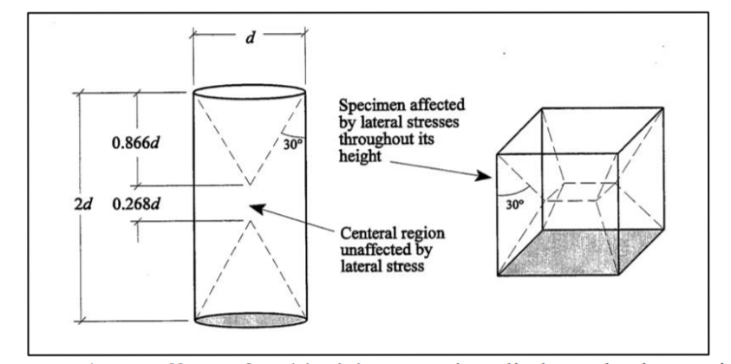
Figure ‎2-3: effect of load applied on specimens (Elwell & Fu, 1995)

Methodology and Experimental set up

Introductions
Combining wave propagation and material engineering knowledge to investigate the role of transducers to measure wave propagation velocity provides an opportunity to perform inexpensive and reliable tests on concrete. Evaluation of transducer performance in measuring wave propagation rate and its relation with curing and porosity, which is one of the objectives of this study, can be a step forward for non-destructive testing of concrete with low accuracy and cost. Confirming this test could lead to a reduction in the cost of non-destructive testing, something the construction industry has always demanded.
According to the aims and objectives of this study, the methodology is experimental. Because only the laboratory system can demonstrate the physical properties of the concrete, therefore, an experiment used to verify this relationship. Experimental methods require a higher cost and accuracy, but the results will be more reliable. Matching the type of methodology with the research methodology reviewed in the research background is another confirmation for it.
This project has attempted to make the specimens based on BS for strength testing. Because firstly, this standard can be applied to similar tests. Secondly, these samples will be used to test the strength in the next stage. The results of this test (that are acceptable by the BS) will be used to check the results of the wave propagation test to confirming the theory of this study.
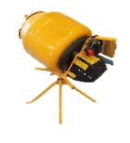
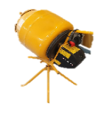
Since the purpose of this study is to investigate using piezoelectric transducers in different porosities and curing of concrete, two types of concrete with different water/cement ratio were investigated. Two mixes were prepared from each type of concrete, and six samples were made from each mix. A total number of 24 samples were collected. Because the materials were dehydrated for 24 hours in the oven, the water-to-cement ratio was 0.55 for the first type and 0.65 for the second type see (Figure ‎3‑1). Samples were made in size (100mm *100mm*100mm).
Figure ‎3-1: Diagram of amount and ratio of specimens (Author)
The samples were demoulded 24 hours after moulding and transferred to the water tank immediately.
Samples were tested in two stages, seven days and 28 days. At each stage, three samples from each mix were tested for wave propagation and then broken by strength testing (Figure ‎3-2).

Figure ‎3-2 : Plan and stages of tests (Author)

The process has divided into five parts. Each part has several sections that shown in Figure ‎3-3.
Figure ‎3-3: Details of process (Author)

Sample preparation
Preparing the samples for testing is one of the most critical parts. Four sections have been followed for making samples. As Figure ‎3-4 has shown, each section has been done based on the BS.
If the standards are not following correctly, the test results will be invalid. This standard should be the same for all samples. The results can be compared with this method. Adherence to the standards allows the results to be compared with previous research and can be relied upon for further experiments in the future.
Figure ‎3-4: steps of making samples (Author)

(BS EN 17892-4:2016)

Sieve Analysis

The purpose of this part of the experiment is to find out the particles’ size of the aggregates that used for making the samples. It is essential to know these sizes because of aggregates in concrete usually make up about 70% of the volume of concrete, and many of the physical, chemical and mechanical properties of concrete are related to aggregates. Therefore, the role of aggregates in concrete is essential for mixing design and economic issues. Also, another major cause is the chemical reaction with cement and the highly resistant material.

Sieve experiment process

In this sieve experiment, the following equipment has used Figure ‎3-5

- Metal tray
- Bowl
- Brush
- Vibration machine
- Scope
- Oven
- Weighting scale
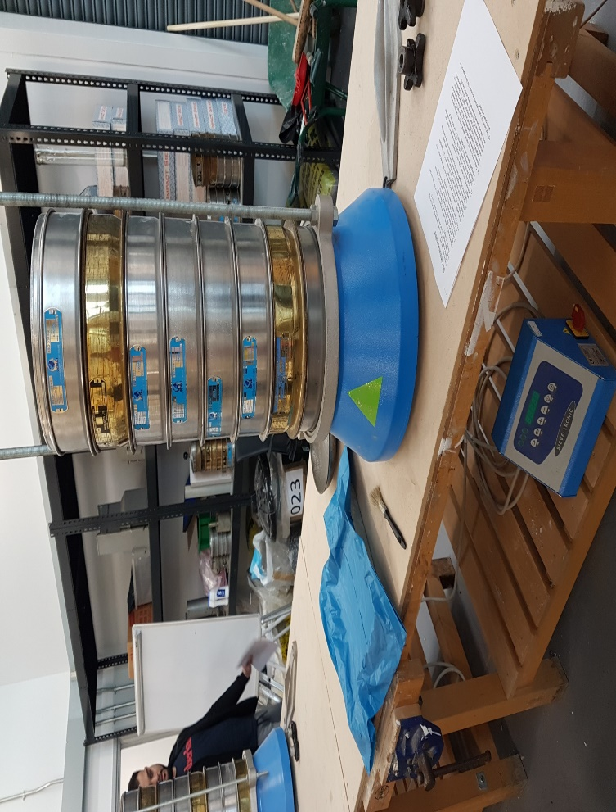
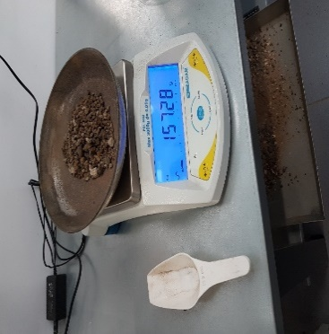
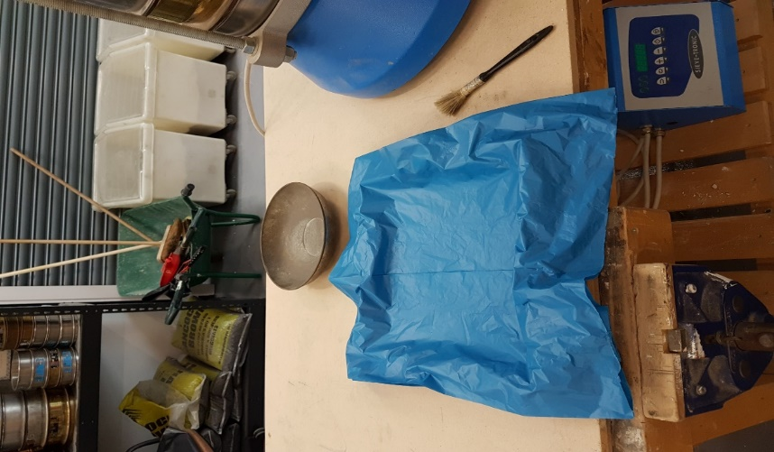
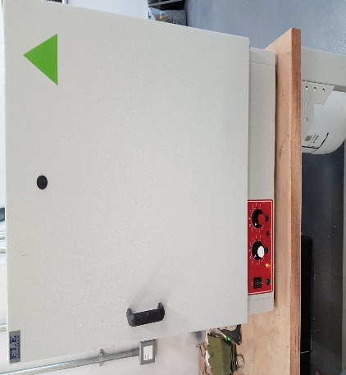
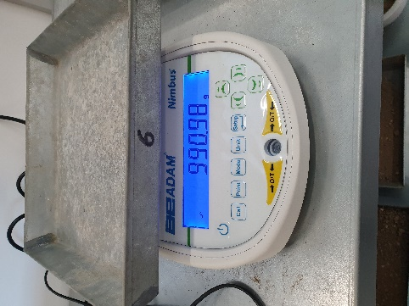
Figure ‎3-5: the equipment were used in sieves experiment (Author)
4
7
6
1
5
2
3

In the first step, the special sieve for this test was inserted based on numerical order. The number and size of these sieves are given in Figure ‎3-6.
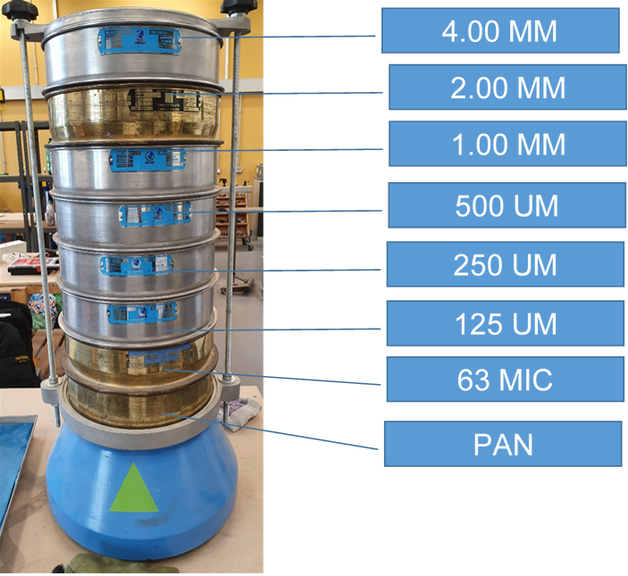
Figure ‎3-6: Order and size of sieves ((Author)

Based BS EN 13670, all equipment was checked for cleanliness and correctness before starting the test. The materials were placed on the highest sieve, and then the vibration machine was turned on for two minutes. Finally, the material in each sieve has been weighted with high accuracy. In this case, the results are shown in Table ‎3-1: fineness modulus obtained by sieves analysis
Table ‎3-1: fineness modulus obtained by sieves analysis
 | Fineness modulus
sand | 8.34
6mm Aggregate | 5.90
20mm Aggregate | 3.36

Batching (calculate the quantities of materials for concrete)
In this experiment concrete, RC 15 is used which has the ratio of 1:1.5:3 (cement: sand: aggregates) that to be calculated by absolute volume method where the volume of fully compacted concrete is equal to the absolute volume of cement, sand, coarse aggregates and water. (Mishra, 2019)
According to the absolute volume method, the formula for calculating the quantities of materials is:
Equation ‎3-1: absolute volume method formula (Mishra, 2019)
$$V\text{c}=\frac{W}{1000}+\frac{C}{1000Sc}+\frac{F\text{a}}{1000SFa}+\frac{C\text{a}}{1000SCa}$$
Where:
V_{c} = Absolute volume of fully compacted fresh concrete
C = Mass of cement
W =Mass of water
Ca = Mass of coarse aggregates
Fa = Mass of fine aggregates
S_{ca} = the specific gravity of coarse aggregates on base BS 8500-2:2015 ≈ 2.6
S_{fa}= the specific gravities of fine aggregates on base BS 8500-2:2015 ≈ 2.6
S_{c}= the specific gravities of cement on base BS 8500-2:2015 ≈ 3.15
In this calculation based on of the method the air content has been ignored.
And per cubic meters the bulk densities of materials based on BS 812-2:1995 was assumed as below:
Coarse aggregates = 1650 kg/m3
Fine aggregates (sand) = 1700 kg/m3
Cement = 1500 kg/m3
Considering the mix proportion (1:1.5:3), the ratio of masses of material to cement should be:
$$\frac{1500}{1500}:\frac{1.5×1700}{1500}:\frac{3×1650}{1500}$$

$$1:1.7:3.3$$
Because the aggregate is very dry (these were in the oven for more than 24 hours), the ratio of water to cement is concentrated 0.55 for first and second mixes and 0.65 for third and fourth mixes. If the calculation has been done for 100 kg of cement for first and other mixes, the formula should be:
$$vc=\frac{0.55×100}{1000}+\frac{1×100}{1000×3.15}+\frac{1.7×100}{1000×2.6}+\frac{3.3×100}{1000×2.6}=0.279m^{3}$$

So 0.279 m³ concrete can be made by 100 kilograms of cement.
Due to the size of any sample (100mm*100mm*100mm), the volume of any sample should be approximately 1000000mm³ 0r 0.001m³. Also, 2% of air has been considered.
So the real volume of compacted concrete for any mix (six samples) should be: 0.001m³×6=0.006m³ → 0.006 m³ - 2 % (air) =0.00588m³
So cement for any mix should be:
$\frac{0.279m^3}{100kg}=\frac{0.00588m3 }{x}≫x=2.11 kg$

Other ingredients can be calculated by using the amount of cement and the result from section 3.2.2 (Cement: sand: aggregates = 1:1.7:3.3):
Cement = 2.11 kg
Sand: 1.7 × 2.11 kg = 3.58 kg
Aggregates (6mm + 20mm): 3.3 × 2.11 kg = 6.96 kg
Water: 0.55 × 2.11 kg = 1.16 kg

Table ‎3-2: amount of materials on base of ratio for RC 20 (Author)
material | Amount (kg)
cement | 2.11
sand | 3.16
aggregates | 6.33
water | 1.16

However, since there are two types of aggregates (6mm and 20mm) used in this experiment and given the sieve test result, it is necessary to calculate the quantity of each type of aggregates and sand. For this calculation, the Maximum of density method has been used.

Determine the ratio of fine aggregate (6mm) to coarse aggregate 20mm
For determining the ratio of fine aggregate (6mm) to coarse aggregate 20mm, the size of any types of aggregates should be calculated. This calculation should be done by analysing the results in sieves analysis experiment, which has been done in this research in section ‎3.2.1.
This method is coming from Fuller and Thompson’s idea that was based on the ideal curve. (Ramchandra, V. Gehlot, 2012).They presented the below formula:
Equation ‎3-2: fuller formula (Ramchandra, V. Gehlot, 2012)
$P_{d}=100×√(\frac{d}{D})$/D)
Where:
d=max size of the fine aggregate
D=max size of the coarse aggregate
P_{d}=percentage of particle size by weight smaller than the size, d
Based on the size of sieves in sieves analysis for sand (4mm, 2mm, 1mm, 500um, 250um, 125um, 63mic) and max size of the sand (2mm), the Fuller fine modulus is as below.

Figure ‎3-7: diagram of fineness modulus of sand (Ramchandra, V. Gehlot, 2012)

2mm → $\sqrt[2]{\frac{2}{2}} ×100=100\%$
1mm → $\sqrt[2]{\frac{1}{2}} ×100=70.71\%$
500um → $\sqrt[2]{\frac{0.5}{2}} ×100=50\%$

250um → $\sqrt[2]{\frac{0.25}{2}} ×100=35.35\%$
125um → $\sqrt[2]{\frac{0.125}{2}} ×100=25\%$
63mic →$\sqrt[2]{\frac{0.063}{2}} ×100=17.68\%$.

Based on the Equation ‎3-3 to calculation the amount of any aggregates and sand, Fuller is needed. Fuller will be obtained by the cumulative retain. So the cumulative retained for sand and aggregates should be calculated. Cumulative retained for sand has brought in Table ‎3-3 and in the same way that has been done for aggregates 6mm and 20 mm.
Table ‎3-3: cumulative retained for sand (Author)
Sieves size (mm) | %Pass | % retained
4 | 100 | 0
2 | 100 | 0
1 | 70.71 | 29.29
0.5 | 50 | 50
0.25 | 35.35 | 64.65
0.125 | 25 | 75
0.063 | 17.68 | 82.32
cumulative |  | 301.26

Fineness modulus for fuller is= cumulative retained/100 = 301.26/100=3.01

This process has been done in the same way for 6mm and 20 mm. The result was 3.89 for 6mm and 5.73 for 20 mm (see Table ‎3-4). In other hand, the real amount was calculated in Table ‎3-1(see Table ‎3-4).

Table ‎3-4: fineness modulus result (Author)
type | real | fuller
sand | 3.36 | 3.01
6mm | 5.90 | 4.80
20mm | 8.34 | 5.73

As parabola Fuller formula (Popovics, 1992) the amount of any aggregates and sand was calculated:
Equation ‎3-3: parabola fuller formula (Popovics, 1992)
$$F = \left(F1×\frac{X}{100}\right)+ \left(F2 × \left(1-\frac{XS}{100}\right)\right)$$
Where:
F= Fuller for large particles (2)
F1= Real modulus for small particles (1)
F2= Real modulus for large particles (2)
S= Percentage of small particles (1)

4.80= (3.36×$\frac{X}{100}$) + (5.90 × (1-$\frac{X}{100}$) → 4.80= 3.36$\frac{X}{100}$ + 5.90-5.90 $\frac{X}{100}$→ 5.90 $\frac{X}{100}$ – 3.36 $\frac{X}{100}$ = 5.90 – 4.80 →2.54 $\frac{X}{100}$ = 1.10 →$\frac{X}{100}$=$\frac{1.10}{2.54}$ →X_{SAND}= 0.4330×100→ S=43.30%
G₁₌ 100%-43.30% = 56.70%
5.73 = (4.80×$\frac{X \left(\text{S+G1}\right)}{100}$) + (8.34×(1-$\frac{X \left(\text{S+G1}\right)}{100}$))→X_{(S+G1})=74.57%
G₂= 100%- 74.57% = 25.43%
As pervious calculation (see Table ‎3-2) amount of sand plus aggregates is 9.49 kg.
So #20mm aggregate or G₂ is: $\frac{25.43}{100}=\frac{G2}{9.49}$→ G2=2.413
(G1+S) + G2 = 9.49→G1 + S = 9.49 –G2→G1+ S = 9.49-2.413→ G1+S = 7.077
$\frac{S}{S+G1}$=$\frac{43.30}{100}$ → $\frac{S}{7.077}$=$\frac{43.30}{100}$ →S=3.064
$\frac{G1}{S+G1}$=$\frac{56.70}{100}$ → $\frac{G1}{7.077}$=$\frac{56.70}{100}$ →G1=4.012

Table ‎3-5: Amount of particles (sand and aggregates) (Author)
type | AMOUNT (kg)
sand | 3.064
G1 (6mm) | 4.012
G2 (20mm) | 2.413

There is a possibility of wasting some concrete in the process. Therefore for any mix, 10% extra of concrete has been considered.

Mixing
(BS 8500-1:2015+A2:2019)

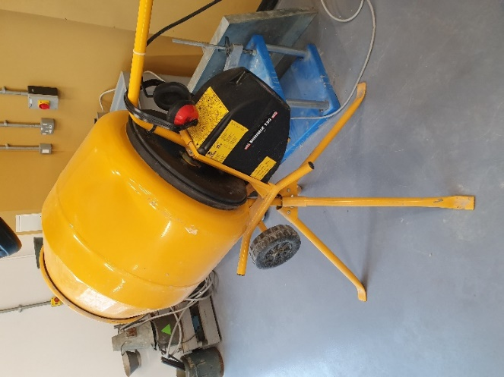
The concrete needs to be thorough to ensure that the mass becomes homogeneous and gets uniform colour and consistency, which is essential for the production of consistent quality concrete. The size of the mixer should accommodate the ingredients of one batch. In this experiment, Minimix 130 Manufactured by Belle with 130 litres capacity been used. (Figure ‎3-8)
Figure ‎3-8: the mixer has used for mixing the materials (Author)
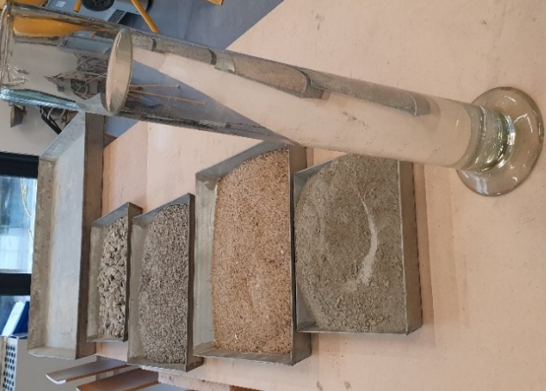
After assuring the mixer was clean and free of dust on the inner side and blade was aligned correctly, the materials were measured accurately and were ready for mixing. (Figure ‎3-9)
Figure ‎3-9: the materials was prepared for mixing (Author)
To start the mixing, 1/4 of water was poured into the drum. Next, half of aggregates, sand and all of the cement has been added. The remaining of aggregates, sand and water has been added as well. Ingredients have mixed for at least 2 minutes before discharging. This has been timed from the moment all the water added into the drum.

Slump test
(On base of BS EN 12350-2:2019)

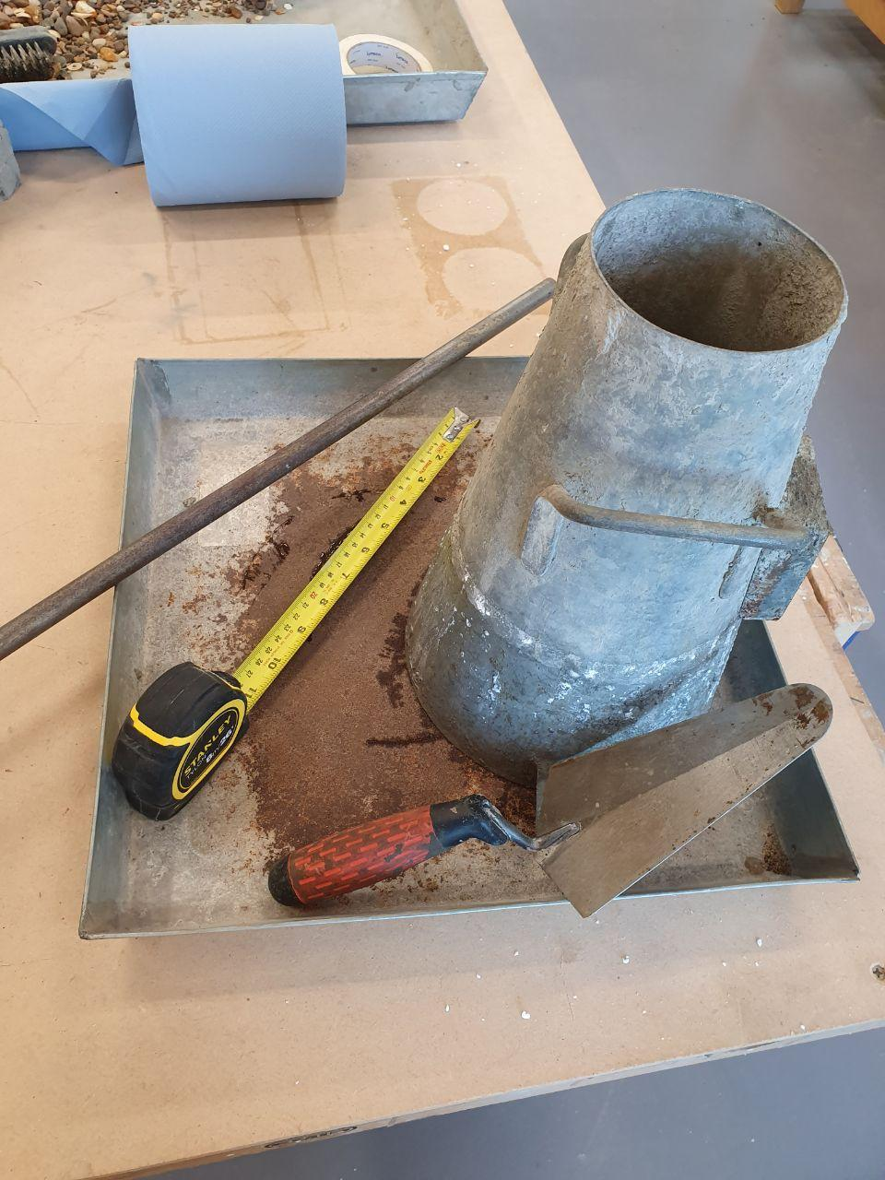
Workability is working with a concrete easily for which one wants to use it. Workability would be measured by Slump test. It can indicate the impact of the increase in water content and, therefore, the increase of porosity. Slump cone test has been used in this study, which is a simple and accessible test that can be used at sites to distinguish the workability of the concrete mix. Slump test has to do at the beginning of the concreting operation. The apparatus for conducting the slump test mainly is a metallic mould in the form of a frustum of a cone. A steel tamping rod of 16mm diameter and 60 cm height has been used for compacting (Figure ‎3-10). The internal surface of the mould has been thoroughly cleaned of moisture and any hardened concrete before doing the test.
Slump test cone
Tamping rod
Measure tape
Trowel
Figure ‎3-10: Types of equipment that were used for slump test (Author)

The cone has been placed on a non-absorbent horizontal, rigid and horizontal surface. Then it was filled in 3 layers (the thickness of each layer was approximately 1/3 of the height of the mould). Each layer has been tamped 25 times a rod. After the top layer had stamped, the concrete had levelled with a trowel. So the mould was filled precisely to the top. The mould was removed. The concrete subsided that known as a slump. This operation has been carried out without any vibration and within 150 seconds after the starting point. The difference in level between the highest point of the sample and the height of the mould has been measured. This measure is the slump of concrete. The results are brought in the Table ‎3-6.

Table ‎3-6: Result of slump tests (Author)
TYPE OF MIX | RESULT OF SLUMP TEST
First mix ratio 0.55 c/w (M1) | 710 mm
Second mix ratio 0.55 c/w (M2) | 620 mm
First mix ratio 0.65 c/w (M3) | 1210mm
Second mix ratio 0.65 c/w (M4) | 1200mm

Filed sampling and Compaction of the concrete

Based on BS EN 12390‑2:2019, instructions for avoiding the adhering the concrete to the mould, non-reactive release liquid applied to the inner surface of the moulds. For filling the moulds a tray and shovel been used. The Moulds has been filled in two layers.
The compacting has been done immediately after the placing concrete in the moulds. To achieve proper compaction after many layers, the vibration table been used for 1 minute after that as BS recommendation states: “there is no further appearance of large air bubbles on the surface of the concrete and the surface becomes relatively smooth with a glazed appearance, without excessive segregation” (British Standards Institution, 2019).
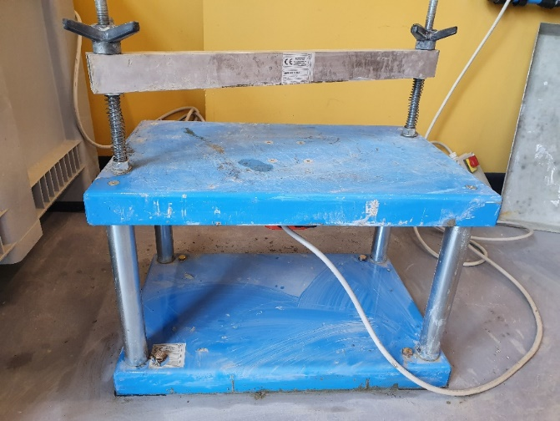
In this experiment, the vibration machine was MATEST C278 (Figure ‎3-11). It has been designed on BS EN 12390-2 by manufacture. (MATETS, 2017)
Figure ‎3-11: the vibration machine MATEST C278 used in this experiment (Author)

Based on the observation during the vibration, 30 seconds was a necessary duration for any layers, to avoid over-vibration and to achieve full compaction. After the compacting, the excess concrete have removed by the trowel for making level the concrete surface and upper edge of the mould as shown in Figure ‎3-12.
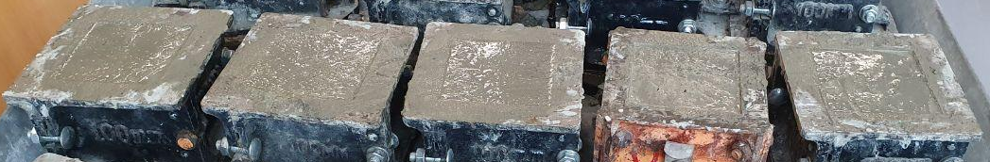
Figure ‎3-12: Surface of concrete has made it level (Author)

Curing regimes (BS EN 12390‑2:2019)
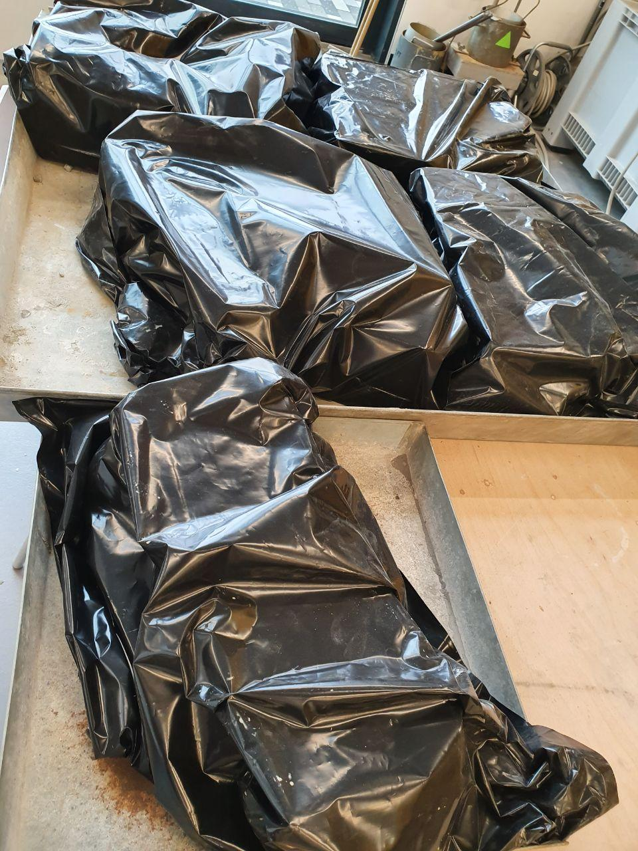
After 24 hours, the cubes were demoulded. In this period the temperature was about (20 ± 5) °C and the specimens were protected against vibration, shock and dehydration by covering with thick black plastic (Figure ‎3-13).
Figure ‎3-13: Covering samples by thick plastic for protection from dehydration (Arthur)

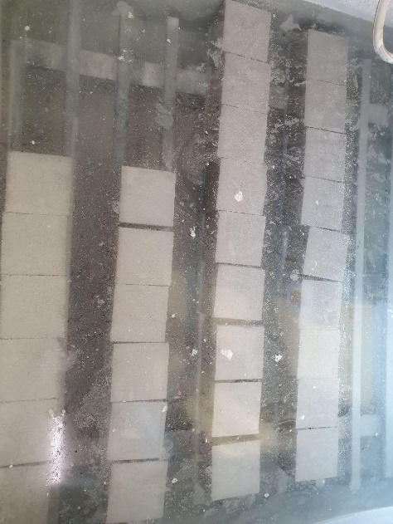
The specimens after demoulding were placed straight away in curing tank which was filled by tap water with a temperature of (20 ± 2) °C which is the BS suggestion (Figure ‎3-14) (BS EN 12390‑2:2019).
Figure ‎3-14: specimens kept in curing tank till the experiment (Arthur)
About 4 hours before the testing, the cubes were brought out for achieving the room temperature. During the gap between the wave propagation test and compressive test, the specimens were protected from moisture loss by covering as BS suggested.

Experimental setup

For accurate results, experiments should be designed properly. By choosing these experiments, it has been tried to establish a relationship between wave velocity and concrete strength. In designing these experiments, it has been attempted to avoid errors and raise the number of each test to improve its accuracy. For this purpose, two types of experiments have been considered:
- The first experiment (the wave propagation test) has been designed to determine the velocity of the waves.
- The second test is for concrete’s strength performed by the compressive machine.
The results of these two experiments will be correlated using the wave velocity formula in concrete to analyse the performance of the piezoelectric transducers to measure the strength of the concrete.

Wave propagation test (impact hammer)
This experiment is based on impact hammer that uses an impact modal hammer and a response accelerometer. This type of test is using for calculating: damping ratios, shapes of a test structure and the natural frequencies (Crystalinstruments, 2019).
There is not an exact standard for this unique design of the experiment. So it was tried to act on the base of the standard of the closest test. Which is EN 12504-4:2004.
In this experiment the following equipment were used:

- Hammer: For the Wave propagation test, an impact hammer has been used instead of the simple hammer because the accuracy specifications of the impact hammer were available.

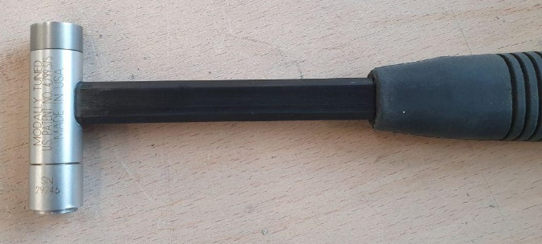
Table ‎3-7 : The hammer specifications
(johnmorrisgroup, 2020)
Hammer Mass | 0.16 kg
Hammer Length | 21.6 cm
Head Diameter | 1.57 cm

Figure ‎3-15: the hammer that used in experiment (Author)

- Piezoelectric transducer
According to many studies, the PZT or lead zirconate titanate was chosen. Because PZT is one of the most popular transducers in the world, these are less sensitive but have higher stability which is suitable for concrete tests. Usually, PZT consists of a brass disk glued with a piezo-ceramic layer (A.G S. Barreto Neto , A.M.N. Lima, Francisco Tejo, Christian Precker, C.S. Moreira, 2012).

Table ‎3-8 : Technical Details of transducers (TIMESETL, 2019)
Item Weight | 40.8 g
Product Dimensions | 18 x 5 x 1.5 cm
Item model number | TXJ-055-EU
Colour | Brass
Size | φ27mm, wire length 33mm

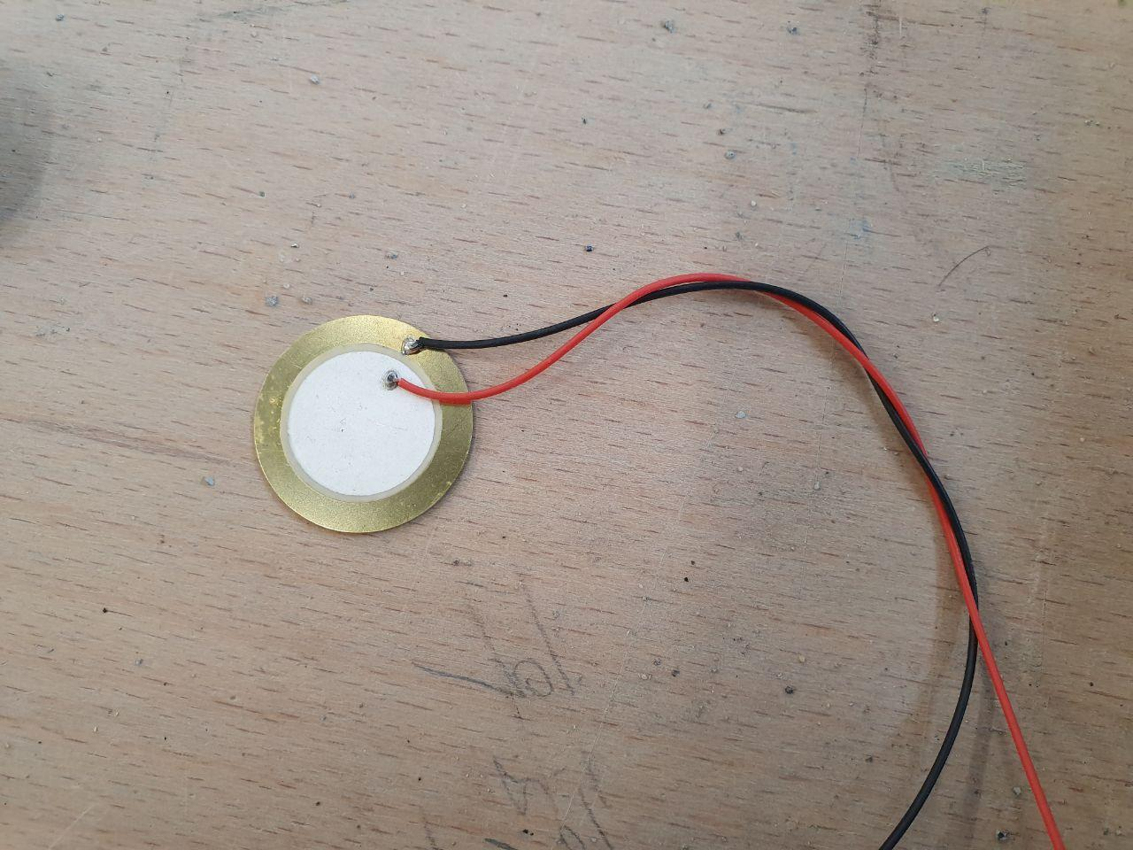
Brass disk
Piezo ceramic layer
Wires
Figure ‎3-16 : PZT that used in the experiment (Author)

- Oscilloscope:
A laboratory device is needed to represent and analysing the waveforms of electronic signals. An oscilloscope will graphically display the wave’s behaviour based on time. Furthermore, this is what is needed in the experiment to calculate the velocity. In this case, Picoscope made by Picotech factory was used that can be seen the details below:

Table ‎3-9: details of oscilloscope (picotech, 2019)
Bandwidth | (10 MHz on ±50 mV range)
Rise time (10% to 90%, calculated) | 17.5 ns (35 ns on ±50 mV range)
Input sensitivity | 10 mV/div to 20 V/div
DC accuracy | ±1%
Maximum sampling rate (single shot) | 80 MS/s
Time base accuracy | 50 ppm with ≤10 PS jitter
Frequency range | DC to 20 MHz
Temperature range (stated accuracy) | 20 °C to 30 °C
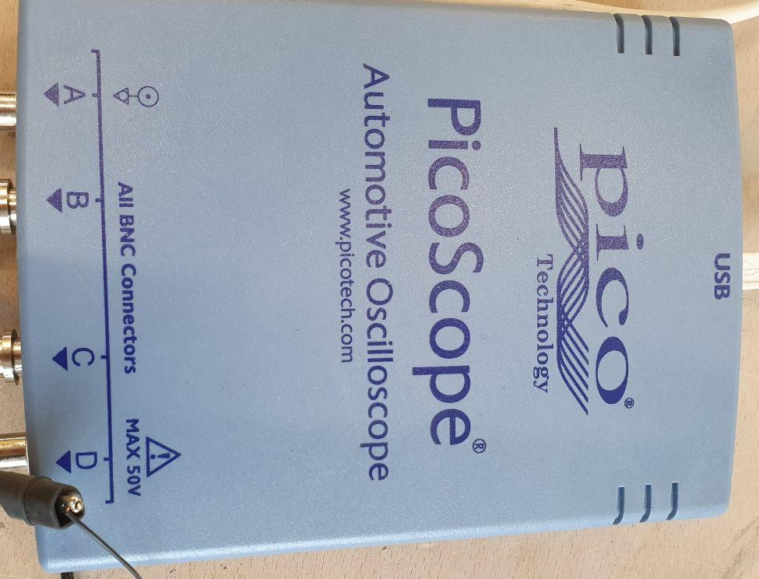
Figure ‎3-17: the oscilloscope that was used (Author)

- Handmade template to specify the exact location of transducers and impact location: for determining the accurate distance between the transducers and the hit point on all of the samples a template has been designed (Figure 3-18).
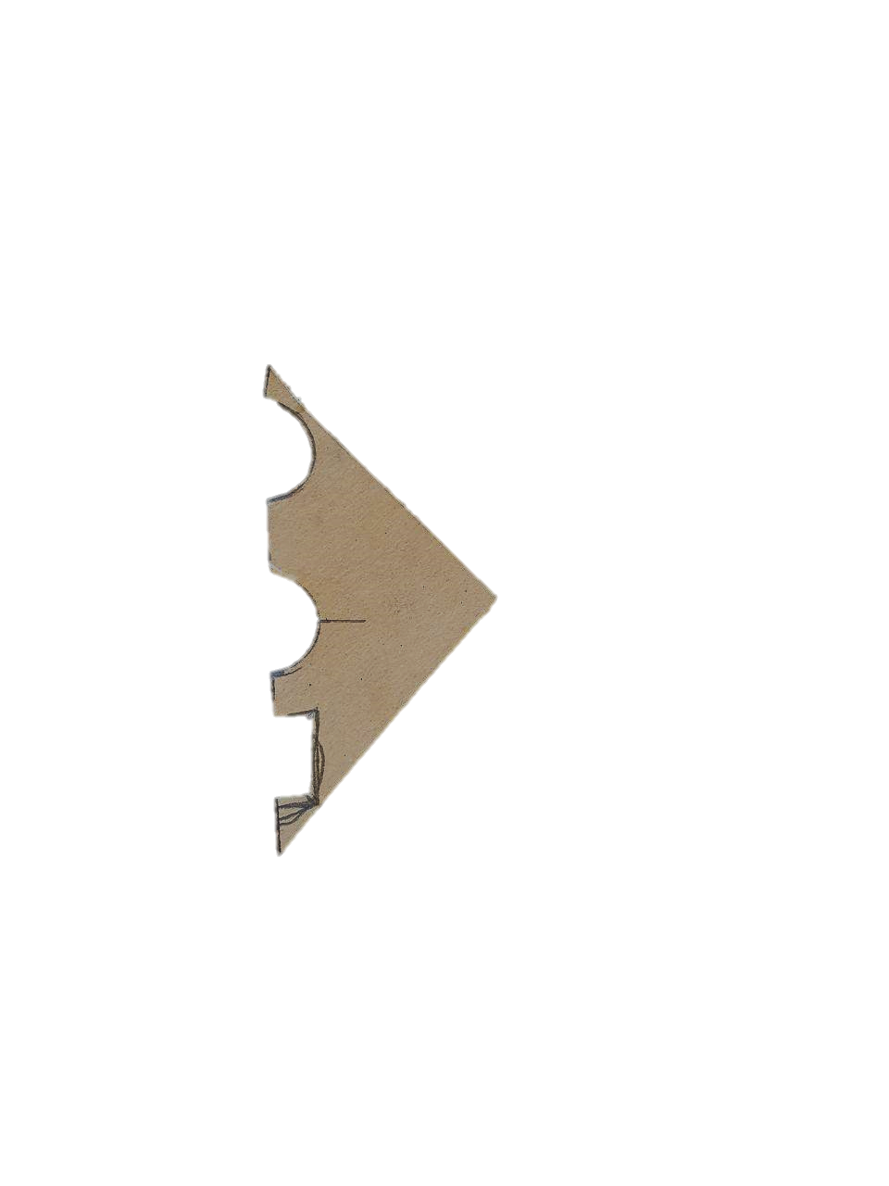
From middle to middle the two transducers was 5 cm
From middle of hit point to middle the first transducer was 3 cm
Figure ‎3-18 : handmade template that designed for the wave propagation experiment (Author)

- The software: as suggested by the manufacturer of the oscilloscope (which used in test), the PICOSOPE 6 should be used. It is available on the site of the manufacturer. The setting up of software has shown below. Figure ‎3-19

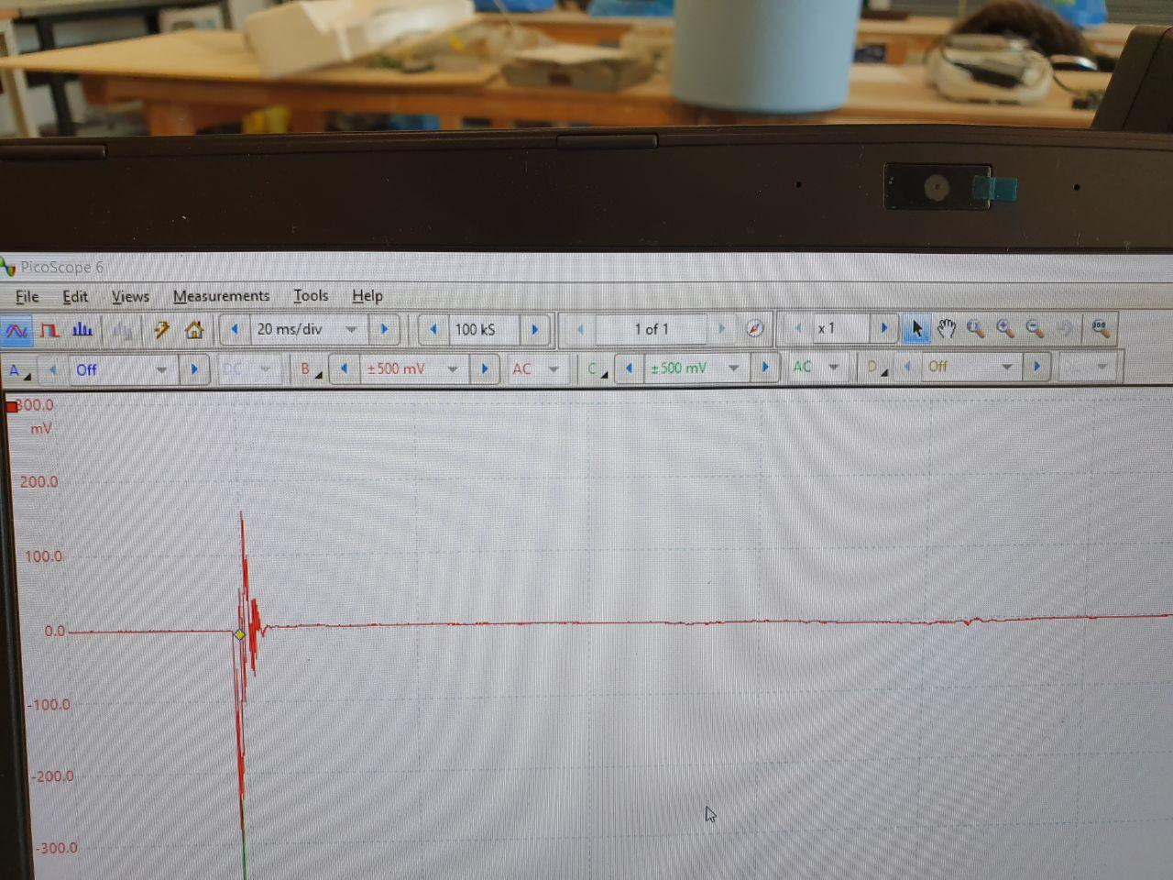
Figure ‎3-19: setting up of software for experiment (Author)

- Foam (Half egg shell tray): for avoiding any external forces and any effect by vibration after the hit, the foam has been used in the test. It has been placed under the samples. Foam by the shape of half eggshell tray was chosen (Figure ‎3-20). This type of foam has double efficiency for weight-bearing and reaction against forces. Because it has the airflow in it and it prevents warming the side which is on the face of foam and helps to stay at the same temperature.
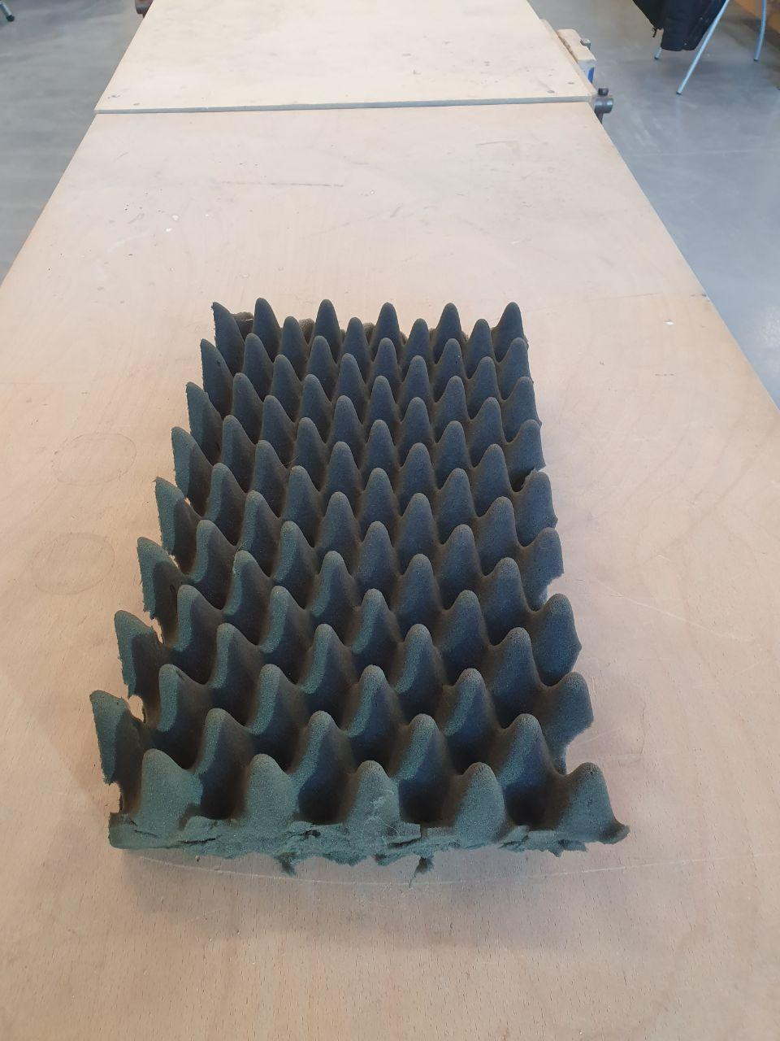
Figure ‎3-20: Foam (Half egg shell tray) that used in this experiment ((Author)

Process of experiment

The test specimens were removed from the water tank one hour before the test, to get to the room temperature (the water tank was placed in the same room). They were covered with plastic to prevent dehydration until testing. Then, by considering the choice of indirect contact for the transducers, the exact locations of the transducers and the location of impact on one of the surfaces were determined by using a template. The transducers were then attached to the sample by adhesive. The transducers and the impact spot, all had been located on a direct line which was helpful to calculate the velocity of the waves.
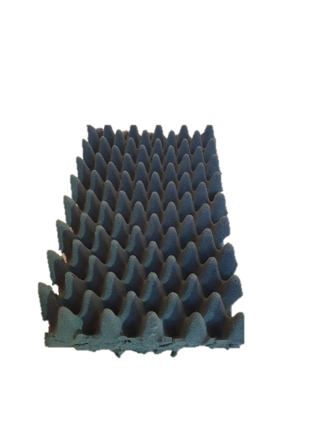
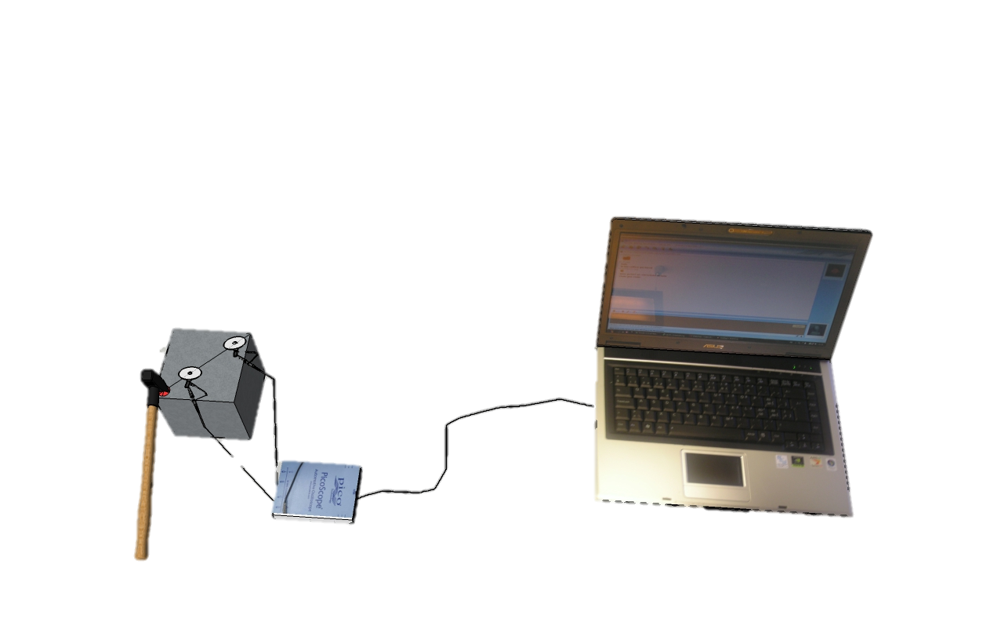
The distance between the two sensors was 5cm, and the closest sensor to the location of impact considered 3cm (see Figure ‎3-18). Then the sample was put on the foam to avoid the impact of any external factors. Then, the specified point was hit by a hammer. The whole process of the experiment is coming in Figure ‎3-21.
Figure ‎3-21: process of experiment (made in sketch up by Author)

If the two signals displayed in the software were similar, the time interval between the two sensors would be measured. If the signals were not similar, the test should be ignored because it indicates a defect during the test. One minute later, the experiment should be repeated. The experiment was performed ten times. The mean of these numbers was considered as acceptable velocity for the sample. The specimen was again coated with plastic after testing, to be used later for strength testing.

Compressive strength test
Laptop
Assessing the Compressive strength of concrete is important because it is a parameter linked with strength and durability.
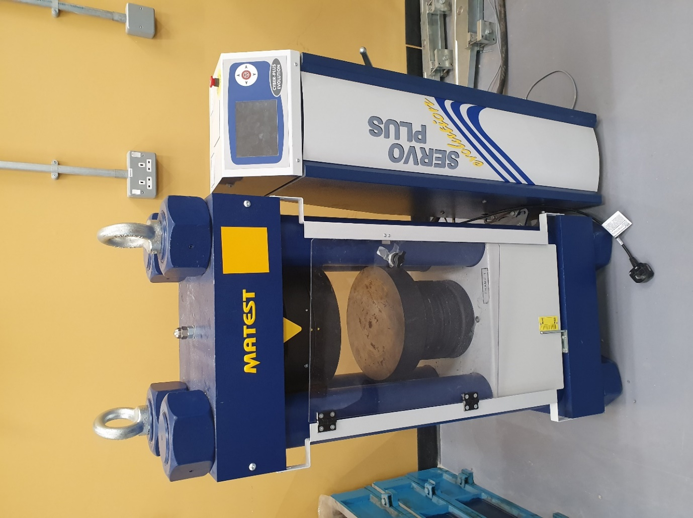
Specimens are tested by compressive machine after 7 and 28 days of casting. In this case, the compression machine is MATEST C089-10N. After checking the dimensions of the cubes, the load applying on plates is called platens of testing machines, were wiped clean.
Platen
Where the specimens have to place
Control screen
Figure ‎3-22: Compression machine which used in this experiment (Author)
As BS EN 12390‑3:2019 says “After removal of the specimen from curing, the specimens were tested for strength as soon as practicable (within 10 hours). The test facility was at a temperature of (20 ± 5) °C”.
After placing the cube in the machine, the load without any shock were applied. Than load increased continuously at a specific rate, which is shown in Figure ‎3-24 until the specimen broke, and no further load could be sustained (Figure ‎3-23). The maximum load applied to specimens is recorded.

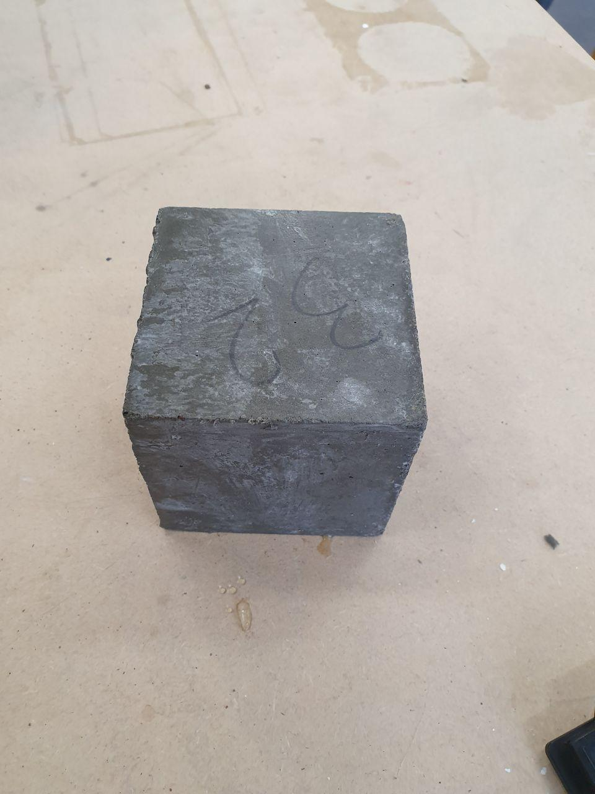
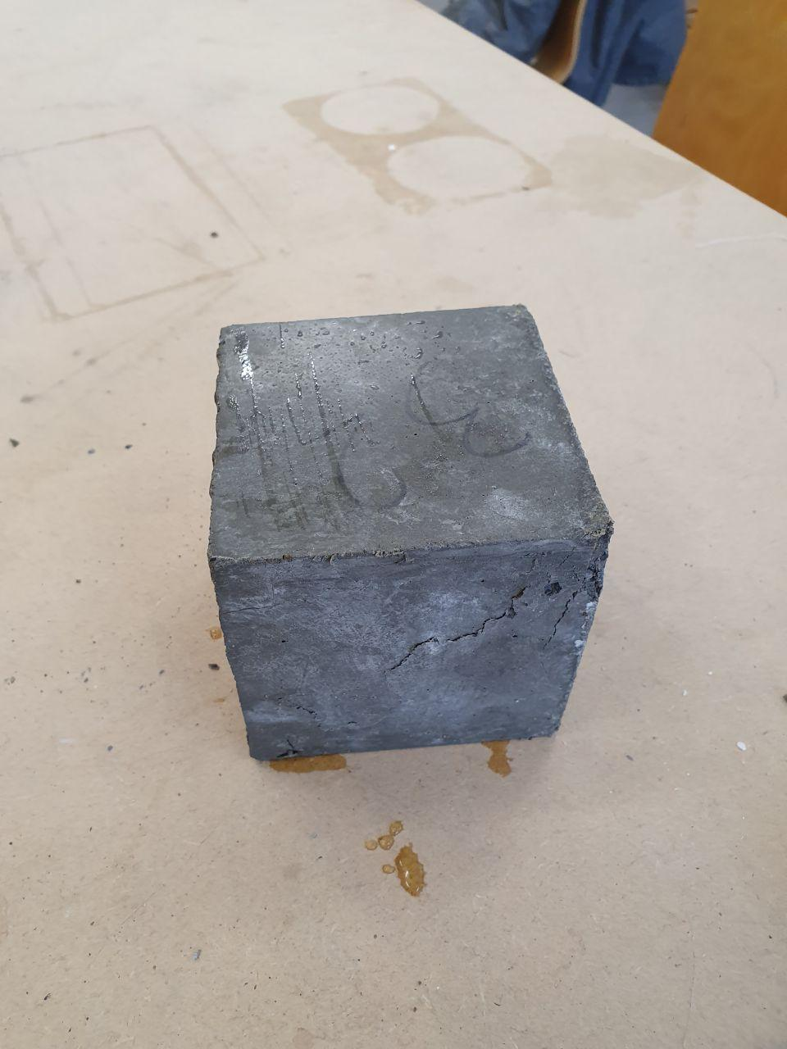
Figure ‎3-23 : sample of specimen before and after the compressive strength test (Author)
The strength should be calculated by dividing the load on the cube at the failure by the cross-sectional area:

Equation ‎3-4 : strength of concrete formula (civildigital,2020)

$$\frac{load on the cube at failure }{the cross-sectional area}=strength$$

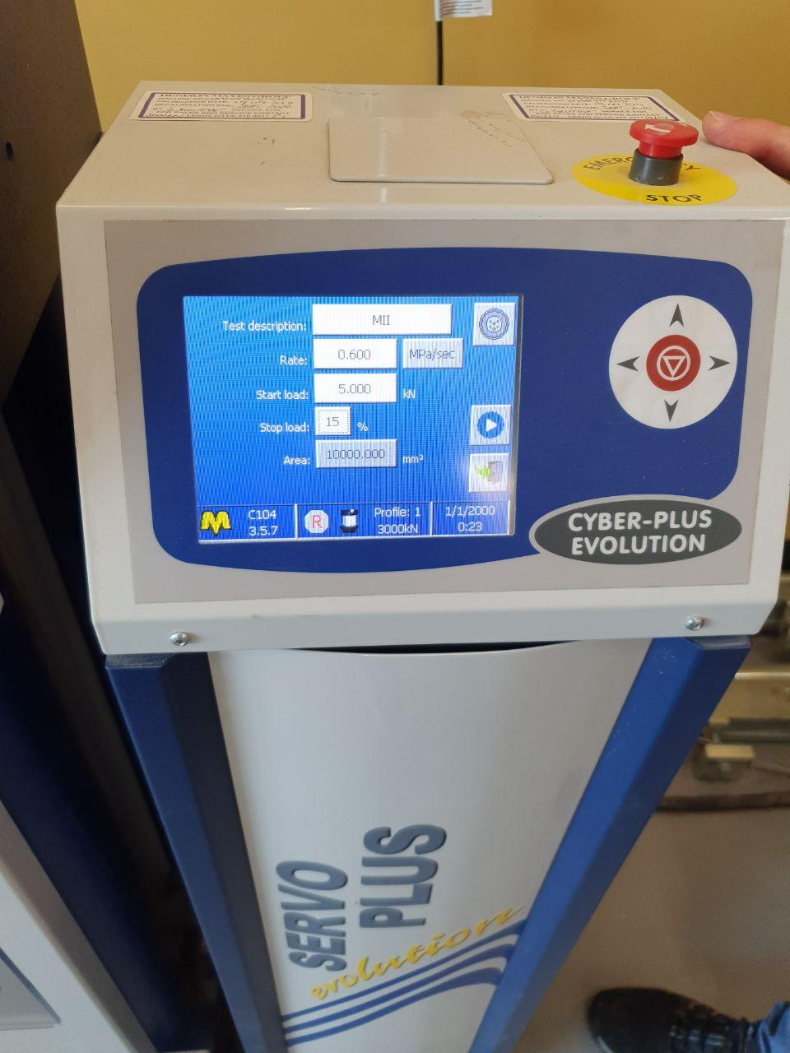
The compressive machine was set up as Figure ‎3-24
Figure ‎3-24: set up of compressive machine for test ((Author)

Result
Two different experiments have been done on each sample. So there are two results tables for each sample. The first test is related to testing the velocity of the waves in the sample, and the second test is the compressive machine. As mention in the previous sections, three samples from each mix have been tested at each stage. The results of each mix have been obtained from these results at each stage. Therefore, the average of the results for three samples made in a mix has been calculated and is ​​considered as acceptable velocity for that mix. Based on this, the result of each mix has been ​​calculated in each step.
The result for the first experiment (wave propagation) is the time that the waves travel between two sensors so the unit should be seconds(s), but because the distance between the two transducers is short, the results were microseconds (µs). Since the purpose of this experiment is to obtain the wave velocity, the distance between the two transducers must be divided into time obtained in the experiment according to Equation 4-1.
Equation ‎4-1 : velocity of wave formula
$\frac{distance between the two transducers (KM)}{time of traveling of wave between twotransducers(s)}=$Velocity of wave (km/s)

Before using the formula, the units of the test results must be converted to the appropriate unit for Equation 4-1. Therefore, the time must be divided into 1000,000 and the distance between the two transducers, which is 5cm has to be divided into 100000, which means the distance is 0.00005 km.
The result of the compressive machine, which is called the maximum strength is shown below, and its unit is MPa.

Table ‎4-1: result of Wave propagation and compressive machine (Author)
sample | Average of Velocities for any sample  (km/s) | Maximum strength (MPa) | sample | Average of Velocities for any sample  (km/s) | Maximum strength (MPa)
M11 | 2.05094 | 28.697 | M41 | 2.18505 | 37.632
M21 | 2.06576 | 29.542 | M51 | 2.16874 | 37.2028
M31 | 2.01686 | 27.057 | M61 | 2.10203 | 35.8079
M12 | 2.08608 | 35.2571 | M42 | 2.26134 | 48.569
M22 | 2.11525 | 35.8437 | M52 | 2.51560 | 53.8695
M32 | 2.22521 | 37.8179 | M62 | 2.48132 | 50.7149
M13 | 1.83178 | 18.5943 | M43 | 1.94279 | 24.4797
M23 | 1.80997 | 18.4726 | M53 | 1.98843 | 24.9236
M33 | 1.89840 | 19.2243 | M63 | 2.00439 | 25.969
M14 | 1.93150 | 20.4272 | M44 | 2.01096 | 26.3413
M24 | 1.93750 | 21.1718 | M54 | 2.02975 | 27.6444
M34 | 1.92998 | 20.2411 | M64 | 2.02406 | 27.4224

Figure ‎4-1: result of Wave propagation and compressive machine (Author)

For establishing a relation between the UPV and the strength of concrete, from any mix, 6 data points (samples) at any stage have been plotted. Form Table ‎4-1, it has been observed that for the mix with ratio 0.55 at the 7-day stage, the pulse velocity ranges were from 2.016 to 2.225 km/sec for which the values of compressive strength ranges from 27.057 to 37.818 MPa, also for the mix with ratio 0.65 at the 7-day stage, the velocity ranges were from 1.81 to 1.937 km/sec which the values of compressive strength ranges were from 18.472 to 21.171 MPa. Mix with ratio 0.55 at the 28-day stages, has a range from 2.102 to 2.516 km/sec for velocity and the values of compressive strength range from 35.807 to 53.87 MPa, ratio 0.65 has had the pulse velocity ranges from 1.942 to 2.03 km/sec for which the values of compressive strength ranges from 24.479 to 27.645 MPa at the 28-day stages.

For analysing the results, a liner regression should be applied to establish a relation between the results. Therefore some measures should be calculated, such as the gradient and intercept of the regression line and etc. Their formula and the results have been brought in below.

Equation ‎4-2: formula for regression straight line (Cook and Wheater, 2000)
$$ӯ=a+b\overline{x}$$

$$b=\frac{\sum{xy-\frac{\sum{x}\sum{y}}{n}}}{\sum{x^{2}}-\frac{{\left(\sum{x}\right)}^{2}}{n}}$$
Where n = number of sample
x= data point (in this case velocity of waves)
y= data point (in this case is results from compressive machine)
a=intercept of the regression line
b= gradient of the regression line

​​ Equation ‎4-3: total sum of square formula (Cook and Wheater, 2000)

$$SS_{total}=\sum{y^{2}-\frac{{\left(\sum{y}\right)}^{2}}{n}}$$
Where n = number of samples
x= data point (in this case velocity of waves)
y= data point (in this case is results from compressive machine)

Equation ‎4-4: regression sum of square formula (Cook and Wheater, 2000)
$$SS_{regression}=\frac{{(\sum{xy-\frac{\sum{x}\sum{y}}{n})}}^{2}}{\sum{x^{2}}-\frac{{\left(\sum{x}\right)}^{2}}{n}}$$
Where n = number of sample
x= data point (in this case velocity of waves)
y= data point (in this case is results from compressive machine)

Equation ‎4-5: residual sum of square formula(Cook and Wheater, 2000)
$$SS_{residual }=SS_{total}-SS_{regression}$$
Where
SS_{total} = total sum of square
SS _{regression} = regression sum of square

Equation ‎4-6: the coefficient of determination formula (Cook and Wheater, 2000)
$$r^{2}=\frac{SS_{ regression }}{SS_{ total}}$$

Equation ‎4-7: Adjusted R-squared formula (Cook and Wheater, 2000)
$$r_{adjusted}^{2}=1-\frac{(1-r^{2})(n-1)}{(n-p-1)}$$
Where n = number of sample
P= number of predictors
r²= the coefficient of determination

Equation ‎4-8: mean square error (MSE) formula (Cook and Wheater, 2000)
$$MSE=\frac{SS_{residual }}{n-2}$$
Where n = number of sample

Equation ‎4-9: regression mean square (MSR) formula (Cook and Wheater, 2000)
$$MSR=\frac{SS regression}{1}$$
The Equation ‎4-2 has been done for the mixes in each stage, and the results have been brought in the table below.
Table ‎4-2: regression lines foe mixes in each stage (Author)
MIX | a  (intercept of the regression line) | b  (gradient of the regression line) | Equation for regression line
mix with ratio 0.55 at the 7-day stage | -80.021 | 53.689 | y ̅=-80.021+53.689x ̅
mix with ratio 0.65 at the 7-day stage | -14.619 | 18.153 | y ̅=-14.619+18.153x ̅
mix with ratio 0.55 at the 28-day stage | -54.222 | 42.958 | y ̅=-54.222+42.958x ̅
mix with ratio 0.65 at the 28-day stage | -48.173 | 37.150 | y ̅=-48.173+37.150x ̅

By placing the recorded velocity by PZT in equations for regression lines, the strength of each sample can be predicted. Results have brought in the Table ‎4-3.

Table ‎4-3: strength of concrete that has predicted by transducers (MPa) (Author)
sample | strength of concrete that has predicted by transducers (MPa) | Maximum strength by compressive machine(MPa) | sample | strength of concrete that has predicted by transducers (MPa) | Maximum strength by compressive machine(MPa)
M11 | 30.09 | 28.697 | M41 | 39.64 | 37.632
M21 | 30.89 | 29.542 | M51 | 38.94 | 37.2028
M31 | 28.26 | 27.057 | M61 | 36.08 | 35.8079
M12 | 31.98 | 35.2571 | M42 | 42.92 | 48.569
M22 | 33.54 | 35.8437 | M52 | 53.84 | 53.8695
M32 | 39.45 | 37.8179 | M62 | 52.37 | 50.7149
M13 | 18.63 | 18.5943 | M43 | 24.00 | 24.4797
M23 | 18.24 | 18.4726 | M53 | 25.70 | 24.9236
M33 | 19.84 | 19.2243 | M63 | 26.29 | 25.969
M14 | 20.44 | 20.4272 | M44 | 26.53 | 26.3413
M24 | 20.55 | 21.1718 | M54 | 27.23 | 27.6444
M34 | 20.42 | 20.2411 | M64 | 27.02 | 27.4224

Also, ​​ Equation ‎4-3, Equation ‎4-4, Equation ‎4-5, Equation ‎4-6 and Equation ‎4-7 have been done for the mixes in each stage, and the results have been brought in below tables.

Table ‎4-4: sum of squares (total, regression, residual) and the coefficient of determination (Author)
MIX | SS_{total} | SS _{regression} | SS_{residual} | r2 | Adjusted r² | MSE | MSR
mix with ratio 0.55 at the 7-day stage | 99.798 | 75.896 | 23.902 | 0.761 | 0.701 | 5.975 | 75.896
mix with ratio 0.65 at the 7-day stage | 5.942 | 5.089 | 0.854 | 0.856 | 0.820 | 0.213 | 5.088
mix with ratio 0.55 at the 28-day stage | 317.230 | 275.438 | 41.791 | 0.868 | 0.835 | 10.447 | 275.438
mix with ratio 0.65 at the 28-day stage | 8.213 | 6.915 | 1.298 | 0.842 | 0.802 | 0.325 | 6.914

Discussion

The F Statistic has been used to prove that linear regression is appropriate which its formula is as below:
Equation ‎5-1: The test statistic formula (Cook and Wheater, 2000)
$$F^{*}=\frac{MSR}{MSE}$$
Hypothesis = the linear regression is appropriate
The null hypothesis is H₀: β₁=0.
The alternative hypothesis is H_{A}: β1≠0. (F∗> critical value)

According to the table critical value for alfa=0.05 (Table ‎8-33 in the appendices) is 7.7086 and as Table ‎4-4 for mix with ratio 0.55 at the 7-day stage, the test statistic will be 12.70.
(F∗=75.896/5.975=12.70→ (F∗=12.70) > 7.7086
Because F∗ is bigger than the critical value, the linear regression was a good idea for analysing the result for the mix with ratio 0.55 at the 7-day stage. Respectively, this calculation has been done for others mixes, and the results are shown that the linear regression is a good idea for analysing (see Table ‎5-1).

Table ‎5-1: result of the test statistic F∗ (Author)
MIX | F* | critical value | Is the linear regression a good idea?( hypothesis)
mix with ratio 0.55 at the 7-day stage | 12.70 | 7.7086 | YES
mix with ratio 0.65 at the 7-day stage | 23.84 | 7.7086 | YES
mix with ratio 0.55 at the 28-day stage | 26.36 | 7.7086 | YES
mix with ratio 0.65 at the 28-day stage | 21.30 | 7.7086 | YES

In Figure ‎4-1, the results of both experiments have been given for the whole samples. These results are confirmed a direct relationship between wave velocity and concrete’s strength. The results for the coefficient of determination in Table ‎4-4 are positive, these are shown to both have the same direction. It indicates the transducers recorded less time (higher velocity of waves) for more strength of concrete. Therefore, just like the compressive machine that records the higher number for the higher strength of the concrete, the transducers record a higher velocity for the higher strength of the concrete as well.
As Table ‎4-4, the adjusted r² are 0.701, 0.835 for mixes with ratio 0.55 in 7days and 28 days. Respectively this amount for mixes with ratio 0.65 are 0.820 and 0.80. These amounts are shown significant positive linear association. It means the points are close to the linear trend line (regression line). So, as it has been suggested, there is a strong, positive association between two wave velocity and concrete strength in any stages (Hokimoto, 2017).
The correlation equations for the regression line for mixes as Table ‎4-2 are given below:
Mix with ratio 0.55 at the 7-day stage → y ̅=-80.021+53.689x ̅ (Table ‎5-3)
Mix with ratio 0.65 at the 7-day stage → y ̅=-14.619+18.153x ̅ (Table ‎5-2)
Mix with ratio 0.55 at the 28-day stage → y ̅=-54.222+42.958x ̅ (Table ‎5-4)
Mix with ratio 0.65 at the 28-day stage → y ̅=-48.173+37.150x ̅ (Table ‎5-5)
Table ‎5-2: regression line for mix with ratio 0.65 at the 7-day stage (Author)
Regression line
Table ‎5-3: regression line for mix with ratio 0.55 at the 7-day stage (Author)
Regression line

Regression line
Regression line
Table ‎5-4: regression line for mix with ratio 0.65 at the 28-day stage (Author)
Table ‎5-5: regression line for mix with ratio 0.55 at the 28-day stage (Author)

The gradient of the regression lines is the slope of the line. It is as soul and heart of the equation. It is shown that each unit of velocity indicates how much of the strength of the concrete will be increased. So the maximum strength for the mix with ratio 0.55 at the 7-day stage is expected to increase by 53.689 (MPa) on average if the velocity is increased 1 (km/s). In other words, for any unite (1 km/s) of velocity, the strength in the mixes will be increase as below:

Figure ‎5-1: analyse the gradient of regression lines (Author)
Also by comparing the gradient of the regression lines of any mix based on the ratio of water to cement (Table ‎4-2), clearly can understand the low-porosity mix (ratio 0.55) has a higher velocity because its gradient of the regression line (53.689 for seven days stage and 42.958 for 28 days stage) is steeper than the other mixes (ratio 0.65). It means that transducers show more strength in the low-porosity mix and results from compressive machine test has confirmed this.
Table ‎5-6: the velocity of the waves has recorded by PZT for any mixes at any stage (Author)

According to Figure ‎5-3, the velocity has increased by increasing the age of the samples. This rate of increase was higher for the first mix (ratio 0.55). By comparing Figure ‎5-2 and Figure ‎5-3, it has been shown the recorded velocity and the recorded strength of the mixes by the machine, has a similar slope.
Figure ‎5-2: recorded strength by compressive machine for any ratio at any stage (Author)
Figure ‎5-3: the velocity of the waves has recorded by PZT for any ratio at any stage (Author)
In other words, the rate of change for the recorded velocity in both stages is consistent with the rate of change for the recorded strength by the compressive machine. So, the transducers have shown a higher velocity by increasing the age of the samples as accurate as of the compressive machine. It indicates the efficiency of transducers.

The F Statistic (Equation ‎5-1) can be used to prove the accuracy of the predicted strength by transducers. So, the hypothesis has changed.
Hypothesis= the predicted strength by PZT are close to the recorded strength by the compressive machine
The null hypothesis is H₀: β₁=0.
The alternative hypothesis is H_{A}: β1≠0. (F∗> critical value)

MSR= 2288.169
MSE= 3.083857

According to Table ‎8-33 in the appendices, the critical value for alpha = 0.05 is 4.009, and as MSR is calculated 2288.169 and MSE is calculated 3.083857, the result will be 741.98.
F∗=2288.169/3.083857)= 741.98→ (F∗=741.98) > 4.009

Because F∗ is bigger than the critical value, the predicted strength by PZT is close to the recorded strength by the compressive machine. Also, by using Equation ‎4-7, the Adjusted R2 is 0.969895. As Henseler (Henseler et al., 2009) proposed a rule of thumb for acceptable R2, there is a substantial relation between predicted the strengths by transducers and the recorded strength by the compressive machine. In this case, the Standard Error is 1.756091, which is perfectly acceptable.

Conclusion and recommendation

The F Statistic is shown the linear regression is a good idea for analysing the results of tests. Also, regression analysis has shown a strong, positive association between two wave velocity test and concrete strength tests in any stages. These results are confirmed a direct relationship between them, and both have the same direction.
The results have been analysed at different stages for the analysis of the curing. The transducers have shown a higher velocity by increasing the age of the samples as accurate as of the compressive machine. It indicates the efficiency of transducers.
Regression analyse are shown that the low-porosity mix (ratio 0.55) has a higher velocity because its gradient of the regression line (53.689 for seven days stage and 42.958 for 28 days stage) is steeper than the other mixes (ratio 0.65). It indicates the transducers recorded less time (higher velocity of waves) for more strength of concrete.
The F Statistic is shown there is a substantial relation between predicted the strengths by transducers and the recorded strength by the compressive machine.
Based on the results obtained, it can be claimed that the PZT proved their efficiency in measuring strength at different age and porosity.

Recommendation nad further research

Because of limitations in during the experiment (the epidemic of COVID-19), the 60-day stage of the samples was not investigated. Therefore, it has suggested the test have should repeat in the 60-day stage.
Creating a wave with a simple hammer was approximate. It is better to use a precision instrument to create an accurate force to apply to all samples in the next experiment.
It is also possible to use three or four sensors instead of two sensors. In this case, it is helpful the measuring the wave velocity between the first sensor with the rest of the sensors. Their average can be as the sample velocity. Thus, the exact amount that this study did not reach it. Maybe it will obtain.

References

- A technical committee of CONSTRUCT, the concrete Structures Group. (2010) ‘National Structural Concrete Specification.’ National Structural Concrete Specification for Building Construction. Fourth edition complying with BS EN. https://construct.org.uk. [Online]
    - Available at: https://construct.org.uk/wp-content/uploads/2017/01/NSCS-Edition-4.pdf (Accessed 18 December 2019).

- British Standards Institution. (2003) ‘Terms, definitions, symbols and abbreviations. In: BS EN 206, Concrete — Specification, performance, production and conformity. London: BSI Standards Publication, p. 16.

- British Standards Institution. (2009). BS EN 13670, ‘Execution of concrete structures (incorporating corrigenda October 2015 and November 2015)’ London: British Standards Institution.

- British Standards Institution. (2016). BS EN 17892-4, ‘Geotechnical investigation and testing - laboratory testing of soil. Determination of particle size distribution.’ London: British Standards Institution.

- British Standards Institution. (2016). BS EN 17892-4, ‘Geotechnical investigation and testing - laboratory testing of soil. Determination of particle size distribution.’ London: British Standards Institution.

- British Standards Institution. (2019). BS 8500-1:2015+A2, ‘Concrete - complementary British Standard to BS EN 206. Method of specifying and guidance for the specifier’ London: British Standards Institution

- British Standards Institution. (2019). BS EN 12390-2, ‘Testing hardened concrete. Making and curing specimens for strength tests.’ London: British Standards Institution.

- British Standards Institution. (2019). BS EN 12390-3, ‘Testing hardened concrete. Compressive strength of test specimens.’ London: British Standards Institution.

- Civil Digital. (2020) civildigital.com. [Online] Available at: https://civildigital.com/compressive-strength-concrete-concrete-cubes/
    - [Accessed 25 January 2020].

- Cook, P. Wheater, C. Wright, J (2000) Using statistics to understand the environment. London: Routledge. Series: Routledge introductions to environment series. pp 10-50

- Deivasigamani, A. (2014) ‘PIEZOELECTRIC ENERGY HARVESTING FROM WIND-INDUCED FLUTTER.’ Melbourne, Australia: RMIT University. [Online]. Available at: https://pdfs.semanticscholar.org/f6f3/d20e670048230cedbc59ab82d2ac1a184f86.pdf

- Dixit, A. Bhalla, S. (2018) ‘Prognosis of fatigue and impact induced damage in concrete using.’ Sensors and Actuators A: Physical, Volume 274, pp. 116-131.

- Dona, M. Lombardo, M. Barone, G. (2015) ‘Experimental study of wave propagation in heterogeneous materials, Available at: https://www.researchgate.net/publication/318990780_Experimental_study_of_wave_propagation_in_heterogeneous_materials. (Accessed: 11 November 2019).

- Du, C. Zou, D. Liu, T. Lv, H. (2018) ‘An exploratory experimental and 3D numerical investigation on the effect of porosity on wave propagation in cement paste
    - Measurement.’ Measurement. Vol.122, pp.611-619.
- Gehlot, V and Ramchandra (2012) Design of Concrete Structures. 3rd Edition. Jodhpur. Published by Scientific Publishers.

- Henseler, J. Ringle, C and Sinkovics, R. (2009). The use of partial least squares path modeling in international marketing. Advances in International Marketing (AIM) Emerald Group Publishing. Vol. 20, 277-320.

- Hokimoto, T. (2017) Advances in Statistical Methodologies and Their Application to Real Problems. University of Tokyo, Japan.

- John Morris Group. (2020) General purpose Modal Analysis impact hammer. 8 kHz frequency range 500 lb amplitude range 10 mV/lb sensitivity, 0.3 lb hammer mass, 0.6 inch head diameter. Available at: https://www.johnmorrisgroup.com/AU/Product/7701/General-purpose-Modal-Analysis-impact-hammer-8-kHz-frequency-range-500-lb-amplitude-range-10-mVlb-sensitivity,-03-lb-hammer-mass,-06-inch-head-diameter [Accessed 24 January 2020].

- Kim, W. Jo, H. Park, G. (2015) ‘Concrete cure monitoring using piezoelectric admittance.’ Advanced in Structural Engineering and Mechanics (ASEM), Volume 15, pp. 25-29.

- Lim, Y. Smith, S. Kiong Soh, C. (2018) ‘Wave propagation based monitoring of concrete curing using piezoelectric materials: Review and path forward’. NDT & E International, Volume 99, Pages 50-63

- MATEST. (2017) Concrete compression machine 3000 kN automatic, Servo-plus evolution. [Online] Available at: http://www.matest.com/en/product/c089-10n-concrete-compression-machine-automatic [Accessed 16 December 2019].

- MATEST. (2017) Vibrating tables. [Online] Available at: http://www.matest.com/en/product/c278-vibrating-tables [Accessed 21 December 2019].

- Mishra, G. (2019) Theconstructor.org. Calculate Quantities of Materials for Concrete -Cement, Sand and Aggregates. [Online] Available at: https://theconstructor.org/concrete/calculate-quantities-of-materials-for-concrete/10700/ [Accessed 10 December 2019].

- Mishra, G. (2020) The Constructor. [Online]. Available at: https://theconstructor.org/practical-guide/destructive-non-destructive-field-test-of-concrete/7147/. (Accessed 2nd February 2020).

- Neto, A. Lima, A. Tejo, F. Precker, C. Moreira, C. (2012) ‘Piezoelectric Buzzer Optimization for Micropumps’ Boston, COMSOL.

- NDT RESOURCE CENTRE. nde-ed.org. (2020) History of Ultrasonic [Online] Available at: https://www.nde-ed.org/EducationResources/CommunityCollege/Ultrasonics/Introduction/history.htm
    - [Accessed 22 January 2020].

- OLYMPUS. (2019) www.olympus-ims.com. [Online] Available at: https://www.olympus-ims.com/en/ndt-tutorials/flaw-detection/tip-diffraction/
    - [Accessed 27 December 2019].

- Pico Technology. (2019) www.picotech.com. [Online] Available at: https://www.picotech.com/oscilloscope/4224-4424/picoscope-4224-4424-specifications [Accessed 16 December 2019].

- Popovics, S. (1992) Concrete Materials: Properties, Specifications, and Testing. Second Edition. New Jersey: Noyes publications. Page 452.

- Saafia, M. Sayyah, T. (2001) ‘Health monitoring of concrete structures strengthened with advanced composite materials using piezoelectric transducers.’ Composites Part B: Engineering, Volume 32, Issue 4, Pages 333-342.

- Stogic, D. Nestorovic, T. Markovic, N (2012) ‘The application of piezoelectric transducers in the structural health monitoring of reinforce concrete structures.’ International Multidisciplinary Scientific Geo Conference : SGEM; Sofia. Volume 2, pp. 641-647.

- Tareen, N. Kim, J. Kim, W. Park, S. (2019), Comparative Analysis and Strength Estimation of Fresh Concrete Based on Ultrasonic Wave Propagation and Maturity Using Smart Temperature and PZT Sensors.’ Micromachines. Vol.10 (9), p.559-576.

- Tepfers, R. (2012) ‘Concrete technology – porosity is decisive.’ [Online]. Available at: https://www.researchgate.net/publication/275350234_Concrete_technology_-_porosity_is_decisive. (Accessed 18 December 2019).

- Xu, X. Cao, D. Yang, H. Ming, H. (2018) ‘Application of piezoelectric transducer in energy harvesting in pavement.’ International Journal of Pavement Research and Technology, 11(4), pp. 321-416.

- Zhu, X. (2010) ‘Piezoelectric ceramic materials: Processing, properties, characterization, and applications.’ Piezoelectric Materials: Structure, Properties and Applications. Nova Science Publishers. New York, pp. 1-34.

Appendices

Mix with ratio 0.55 (water to cement) in 7day’s stage (wave propagation)
In this stage, the samples M11, M21, M31 have tested, and the results have shown below:
M11: the first sample of the first mix (ratio 0.55 water to cement)

Table ‎7-1: results of wave propagation test for sample M11
Experiment NO | 1 | 2 | 3 | 4 | 5 | 6 | 7 | 8 | 9 | 10
Original Results (µs) | 27.49 | 21.41 | 29.52 | 24.68 | 20.25 | 23.46 | 29.57 | 24.2 | 21.88 | 25.09
Convert result to seconds(s) | 0.00002749 | 0.00002141 | 0.00002952 | 0.00002468 | 0.00002025 | 0.00002346 | 0.00002957 | 0.0000242 | 0.00002188 | 0.00002509
Velocity (m/s) | 1818.84 | 2335.36 | 1693.77 | 2025.93 | 2469.14 | 2131.29 | 1690.90 | 2066.12 | 2285.19 | 1992.83
Average of Velocities (m/s) | 2050.94

Figure ‎7-1: diagram for results of wave propagation test for sample M11

M21: the second sample of the first mix (ratio 0.55 water to cement)

Table ‎7-2: results of wave propagation test for sample M21
Experiment NO | 1 | 2 | 3 | 4 | 5 | 6 | 7 | 8 | 9 | 10
Original Results (µs) | 21.24 | 26.03 | 24.67 | 24.68 | 25.28 | 23.73 | 25.82 | 23.62 | 21.45 | 26.87
Convert result to seconds(s) | 0.00002124 | 0.00002603 | 0.00002467 | 0.00002468 | 0.00002528 | 0.00002373 | 0.00002582 | 0.00002362 | 0.00002145 | 0.00002687
Velocity (m/s) | 2354.05 | 1920.86 | 2026.75 | 2025.93 | 1977.85 | 2107.04 | 1936.48 | 2116.85 | 2331.00 | 1860.81
Average of Velocities (m/s) | 2065.76

Figure ‎7-2: diagram for results of wave propagation test for sample M21

M31: the third sample of the first mix (ratio 0.55 water to cement)

Experiment NO | 1 | 2 | 3 | 4 | 5 | 6 | 7 | 8 | 9 | 10
Original Results (µs) | 30.44 | 27.75 | 23.67 | 26.39 | 17.65 | 26.71 | 23.72 | 25.1 | 23.61 | 27.86
Convert result to seconds(s) | 0.00003044 | 0.00002775 | 0.00002367 | 0.00002639 | 0.00001765 | 0.00002671 | 0.00002372 | 0.0000251 | 0.00002361 | 0.00002786
Velocity (m/s) | 1642.58 | 1801.80 | 2112.38 | 1894.66 | 2832.86 | 1871.96 | 2107.93 | 1992.03 | 2117.75 | 1794.69
Average of Velocities (m/s) | 2016.86
Table ‎7-3: results of wave propagation test for sample M31

Figure ‎7-3: diagram for results of wave propagation test for sample M31

Sample name | Average
M11 | 2050.94(m/s)
M21 | 2065.76(m/s)
M31 | 2016.86(m/s)
TOTAL FOR M1 IN STAGE 7 DAYES | 2044.52 (m/s)
Table ‎7-4: result of wave propagation test for first mix (ratio 0.55 water to cement) in 7 days

Also In this stage, the samples M12, M22, M32 (made from the second mix) were tested that the results have shown below:
M12: the first sample of the second mix (ratio 0.55 water to cement)

Experiment NO | 1 | 2 | 3 | 4 | 5 | 6 | 7 | 8 | 9 | 10
Original Results (µs) | 19.71 | 25.11 | 22.04 | 26.34 | 25.74 | 26.54 | 24.95 | 23.34 | 26.38 | 21.76
Convert result to seconds(s) | 0.00001971 | 0.00002511 | 0.00002204 | 0.00002634 | 0.00002574 | 0.00002654 | 0.00002495 | 0.00002334 | 0.00002638 | 0.00002176
Velocity (m/s) | 2536.78 | 1991.24 | 2268.60 | 1898.25 | 1942.50 | 1883.95 | 2004.01 | 2142.25 | 1895.38 | 2297.79
Average of Velocities (m/s) | 2086.08
Table ‎7-5: results of wave propagation test for sample M12

Figure ‎7-4: diagram for results of wave propagation test for sample M12

M22: the second sample of the second mix (ratio 0.55 water to cement)

Table ‎7-6: results of wave propagation test for sample M22
Experiment NO | 1 | 2 | 3 | 4 | 5 | 6 | 7 | 8 | 9 | 10
Original Results (µs) | 28.05 | 22.29 | 22.57 | 22.39 | 22.85 | 25.47 | 23.43 | 23.07 | 21.39 | 26.48
Convert result to seconds(s) | 0.00002805 | 0.00002229 | 0.00002257 | 0.00002239 | 0.00002285 | 0.00002547 | 0.00002343 | 0.00002307 | 0.00002139 | 0.00002648
Velocity (m/s) | 1782.53 | 2243.16 | 2215.33 | 2233.14 | 2188.18 | 1963.09 | 2134.02 | 2167.32 | 2337.54 | 1888.22
Average of Velocities (m/s) | 2115.25

Figure ‎7-5: diagram for results of wave propagation test for sample M22

M32: the third sample of the second mix (ratio 0.55 water to cement)

Experiment NO | 1 | 2 | 3 | 4 | 5 | 6 | 7 | 8 | 9 | 10
Original Results (µs) | 21.38 | 21.1 | 24.06 | 21.46 | 20.61 | 20.58 | 25.81 | 22.27 | 24.59 | 24.22
Convert result to seconds(s) | 0.00002138 | 0.0000211 | 0.00002406 | 0.00002146 | 0.00002061 | 0.00002058 | 0.00002581 | 0.00002227 | 0.00002459 | 0.00002422
Velocity (m/s) | 2338.63 | 2369.67 | 2078.14 | 2329.92 | 2426.01 | 2429.54 | 1937.23 | 2245.17 | 2033.35 | 2064.41
Average of Velocities (m/s) | 2225.21
Table ‎7-7: results of wave propagation test for sample M32

Figure ‎7-6: diagram for results of wave propagation test for sample M32
Sample name | Average
M12 | 2086.08(m/s)
M22 | 2115.25(m/s)
M32 | 2225.21(m/s)
TOTAL FOR M2 IN STAGE 7 DAYES | 2142.18(m/s)
Table ‎7-8: result of wave propagation test for second mix (ratio 0.55 water to cement) in 7 days

Mix with ratio 0.65 (water to cement) in 7day’s stage (wave propagation)
In this stage, the samples M13, M23, M33 have tested, and the results have shown below:

M13: the first sample of the first mix (ratio 0.65 water to cement)

Table ‎7-9: results of wave propagation test for sample M13
Experiment NO | 1 | 2 | 3 | 4 | 5 | 6 | 7 | 8 | 9 | 10
Original Results (µs) | 25.29 | 28.4 | 25.46 | 23.46 | 29.16 | 27.82 | 28.71 | 31.19 | 26.93 | 28.22
Convert result to seconds(s) | 0.00002529 | 0.0000284 | 0.00002546 | 0.00002346 | 0.00002916 | 0.00002782 | 0.00002871 | 0.00003119 | 0.00002693 | 0.00002822
Velocity (m/s) | 1977.07 | 1760.56 | 1963.86 | 2131.29 | 1714.68 | 1797.27 | 1741.55 | 1603.08 | 1856.67 | 1771.79
Average of Velocities (m/s) | 1831.78

Figure ‎7-7: diagram for results of wave propagation test for sample M13

M23: the second sample of the third mix (ratio 0.65 water to cement)

Table ‎7-10: results of wave propagation test for sample M23
Experiment NO | 1 | 2 | 3 | 4 | 5 | 6 | 7 | 8 | 9 | 10
Original Results (µs) | 28.11 | 21.63 | 22.71 | 35.6 | 34.27 | 24.73 | 29.79 | 30.9 | 27.54 | 27.62
Convert result to seconds(s) | 0.00002811 | 0.00002163 | 0.00002271 | 0.0000356 | 0.00003427 | 0.00002473 | 0.00002979 | 0.0000309 | 0.00002754 | 0.00002762
Velocity (m/s) | 1778.73 | 2311.60 | 2201.67 | 1404.49 | 1459.00 | 2021.84 | 1678.42 | 1618.12 | 1815.54 | 1810.28
Average of Velocities (m/s) | 1809.97

Figure ‎7-8: diagram for results of wave propagation test for sample M23

M33: the third sample of the first mix (ratio 0.65 water to cement)

Table ‎7-11: results of wave propagation test for sample M33
Experiment NO | 1 | 2 | 3 | 4 | 5 | 6 | 7 | 8 | 9 | 10
Original Results (µs) | 28.42 | 25.02 | 27.79 | 28.02 | 29.65 | 27.01 | 25.47 | 23.82 | 24.61 | 24.86
Convert result to seconds(s) | 0.00002842 | 0.00002502 | 0.00002779 | 0.00002802 | 0.00002965 | 0.00002701 | 0.00002547 | 0.00002382 | 0.00002461 | 0.00002486
Velocity (m/s) | 1759.32 | 1998.40 | 1799.21 | 1784.44 | 1686.34 | 1851.17 | 1963.09 | 2099.08 | 2031.69 | 2011.26
Average of Velocities (m/s) | 1898.40

Figure ‎7-9: diagram for results of wave propagation test for sample M33

Table ‎7-12: result of wave propagation test for third mix (ratio 0.65 water to cement) in 7 days
Sample name | Average
M13 | 1831.78 (m/s)
M23 | 1809.97 (m/s)
M33 | 1898.40 (m/s)
TOTAL FOR M2 IN STAGE 7 DAYES | 1846.72 (m/s)
Also In this stage, the samples M14, M24, M34 (made from the second mix) were tested that the results have shown below:

M14: the first sample of the fourth mix (ratio 0.65 water to cement)

Table ‎7-13: results of wave propagation test for sample M14
Experiment NO | 1 | 2 | 3 | 4 | 5 | 6 | 7 | 8 | 9 | 10
Original Results (µs) | 22.26 | 23.33 | 25.53 | 25.82 | 23.28 | 31.85 | 26.36 | 29.72 | 29.98 | 24.2
Convert result to seconds(s) | 0.00002226 | 0.00002333 | 0.00002553 | 0.00002582 | 0.00002328 | 0.00003185 | 0.00002636 | 0.00002972 | 0.00002998 | 0.0000242
Velocity (m/s) | 2246.18 | 2143.16 | 1958.48 | 1936.48 | 2147.77 | 1569.86 | 1896.81 | 1682.37 | 1667.78 | 2066.12
Average of Velocities (m/s) | 1931.50

Figure ‎7-10: diagram for results of wave propagation test for sample M14

M24: the second sample of the fourth mix (ratio 0.65 water to cement)

Table ‎7-14: results of wave propagation test for sample M24
Experiment NO | 1 | 2 | 3 | 4 | 5 | 6 | 7 | 8 | 9 | 10
Original Results (µs) | 22.19 | 32.54 | 21.39 | 27.59 | 20.43 | 27.93 | 31.91 | 24.58 | 28.24 | 27.38
Convert result to seconds(s) | 0.00002219 | 0.00003254 | 0.00002139 | 0.00002759 | 0.00002043 | 0.00002793 | 0.00003191 | 0.00002458 | 0.00002824 | 0.00002738
Velocity (m/s) | 2253.27 | 1536.57 | 2337.54 | 1812.25 | 2447.38 | 1790.19 | 1566.91 | 2034.17 | 1770.54 | 1826.15
Average of Velocities (m/s) | 1937.50

Figure ‎7-11: diagram for results of wave propagation test for sample M24

M34: the third sample of the fourth mix (ratio 0.65 water to cement)

Table ‎7-15: results of wave propagation test for sample M34
Experiment NO | 1 | 2 | 3 | 4 | 5 | 6 | 7 | 8 | 9 | 10
Original Results (µs) | 24.93 | 25.42 | 29.79 | 24.32 | 24.01 | 27.04 | 29.87 | 24.88 | 25.08 | 25.2
Convert result to seconds(s) | 0.00002493 | 0.00002542 | 0.00002979 | 0.00002432 | 0.00002401 | 0.00002704 | 0.00002987 | 0.00002488 | 0.00002508 | 0.0000252
Velocity (m/s) | 2005.62 | 1966.96 | 1678.42 | 2055.92 | 2082.47 | 1849.11 | 1673.92 | 2009.65 | 1993.62 | 1984.13
Average of Velocities (m/s) | 1929.98

Figure ‎7-12: diagram for results of wave propagation test for sample M34

Table ‎7-16: result of wave propagation test for fourth mix (ratio 0.65 water to cement) in 7 days
Sample name | Average
M14 | 1931.50 (m/s)
M24 | 1937.50(m/s)
M34 | 1929.98 (m/s)
TOTAL FOR M2 IN STAGE 7 DAYES | 1932.99 (m/s)

Mix with ratio 0.55 (water to cement) in 28day’s stage (wave propagation)
In this stage, the samples M41, M51, M61 have tested, and the results have shown below:

M41: the fourth sample of the first mix (ratio 0.55 water to cement)

Table ‎7-17: results of wave propagation test for sample M41
Experiment NO | 1 | 2 | 3 | 4 | 5 | 6 | 7 | 8 | 9 | 10
Original Results (µs) | 25.29 | 22.5 | 22.98 | 22.38 | 21.19 | 22.42 | 24.85 | 21.75 | 22.66 | 23.43
Convert result to seconds(s) | 0.00002529 | 0.0000225 | 0.00002298 | 0.00002238 | 0.00002119 | 0.00002242 | 0.00002485 | 0.00002175 | 0.00002266 | 0.00002343
Velocity (m/s) | 1977.07 | 2222.22 | 2175.81 | 2234.14 | 2359.60 | 2230.15 | 2012.07 | 2298.85 | 2206.53 | 2134.02
Average of Velocities (m/s) | 2185.05

Figure ‎7-13: diagram for results of wave propagation test for sample M41

M51: the fifth sample of the first mix (ratio 0.55 water to cement)

Table ‎7-18: results of wave propagation test for sample M51
Experiment NO | 1 | 2 | 3 | 4 | 5 | 6 | 7 | 8 | 9 | 10
Original Results (µs) | 25.16 | 21.98 | 25.05 | 24.72 | 20.91 | 21.39 | 23.31 | 24.31 | 22.81 | 21.89
Convert result to seconds(s) | 0.00002516 | 0.00002198 | 0.00002505 | 0.00002472 | 0.00002091 | 0.00002139 | 0.00002331 | 0.00002431 | 0.00002281 | 0.00002189
Velocity (m/s) | 1987.28 | 2274.80 | 1996.01 | 2022.65 | 2391.20 | 2337.54 | 2145.00 | 2056.77 | 2192.02 | 2284.15
Average of Velocities (m/s) | 2168.74

Figure ‎8-14: diagram for results of wave propagation test for sample M51

M61: the sixth sample of the first mix (ratio 0.55 water to cement)

Experiment NO | 1 | 2 | 3 | 4 | 5 | 6 | 7 | 8 | 9 | 10
Original Results (µs) | 23.9 | 21.81 | 26.35 | 22.02 | 25.72 | 22.14 | 21.5 | 21.99 | 27.68 | 26.89
Convert result to seconds(s) | 0.0000239 | 0.00002181 | 0.00002635 | 0.00002202 | 0.00002572 | 0.00002214 | 0.0000215 | 0.00002199 | 0.00002768 | 0.00002689
Velocity (m/s) | 2092.05 | 2292.53 | 1897.53 | 2270.66 | 1944.01 | 2258.36 | 2325.58 | 2273.76 | 1806.36 | 1859.43
Average of Velocities (m/s) | 2102.03
Table ‎7-19: results of wave propagation test for sample M61

Figure ‎8-15: diagram for results of wave propagation test for sample M61

Sample name | Average
M41 | 2185.05(m/s)
M51 | 2168.74(m/s)
M61 | 2102.03(m/s)
TOTAL FOR M1 IN STAGE 7 DAYES | 2151.94(m/s)
Table ‎7-20: result of wave propagation test for first mix (ratio 0.55 water to cement) in 28 days

Also In this stage, the samples M42, M52, M62 (made from the second mix of ratio) were tested that the results have shown below:

M42: the fourth sample of the second mix (ratio 0.55 water to cement)

Table ‎7-21: results of wave propagation test for sample M42
Experiment NO | 1 | 2 | 3 | 4 | 5 | 6 | 7 | 8 | 9 | 10
Original Results (µs) | 21.55 | 22.39 | 20.54 | 23.99 | 20.48 | 21.02 | 21.19 | 22.52 | 24.65 | 23.66
Convert result to seconds(s) | 0.00002155 | 0.00002239 | 0.00002054 | 0.00002399 | 0.00002048 | 0.00002102 | 0.00002119 | 0.00002252 | 0.00002465 | 0.00002366
Velocity (m/s) | 2320.19 | 2233.14 | 2434.27 | 2084.20 | 2441.41 | 2378.69 | 2359.60 | 2220.25 | 2028.40 | 2113.27
Average of Velocities (m/s) | 2261.34

Figure ‎7-16: diagram for results of wave propagation test for sample M42

M52: the fifth sample of the second mix (ratio 0.55 water to cement)

Table ‎7-22: results of wave propagation test for sample M52
Experiment NO | 1 | 2 | 3 | 4 | 5 | 6 | 7 | 8 | 9 | 10
Original Results (µs) | 19.49 | 21.25 | 18.2 | 22.17 | 22.04 | 17.26 | 18.8 | 17.63 | 21.64 | 22.09
Convert result to seconds(s) | 0.00001949 | 0.00002125 | 0.0000182 | 0.00002217 | 0.00002204 | 0.00001726 | 0.0000188 | 0.00001763 | 0.00002164 | 0.00002209
Velocity (m/s) | 2565.42 | 2352.94 | 2747.25 | 2255.30 | 2268.60 | 2896.87 | 2659.57 | 2836.07 | 2310.54 | 2263.47
Average of Velocities (m/s) | 2515.60

Figure ‎7-17: diagram for results of wave propagation test for sample M52

M62: the sixth sample of the second mix (ratio 0.55 water to cement)

Table ‎7-23: results of wave propagation test for sample M62
Experiment NO | 1 | 2 | 3 | 4 | 5 | 6 | 7 | 8 | 9 | 10
Original Results (µs) | 23.65 | 17.25 | 23.87 | 18.02 | 23.93 | 17.79 | 21.32 | 19.06 | 17.01 | 23.55
Convert result to seconds(s) | 0.00002365 | 0.00001725 | 0.00002387 | 0.00001802 | 0.00002393 | 0.00001779 | 0.00002132 | 0.00001906 | 0.00001701 | 0.00002355
Velocity (m/s) | 2114.16 | 2898.55 | 2094.68 | 2774.69 | 2089.43 | 2810.57 | 2345.22 | 2623.29 | 2939.45 | 2123.14
Average of Velocities (m/s) | 2481.32

Figure ‎7-18: diagram for results of wave propagation test for sample M62
Sample name | Average
M42 | 2261.34(m/s)
M52 | 2515.60(m/s)
M62 | 2481.32(m/s)
TOTAL FOR M2 IN STAGE 7 DAYES | 2419.42(m/s)

Table ‎7-24: result of wave propagation test for second mix (ratio 0.55 water to cement) in 28 days
Mix with ratio 0.65 (water to cement) in 28days stage (wave propagation)
In this stage, the samples M43, M54, M64 have tested, and the results have shown below:

M43: the fourth sample of the first mix (ratio 0.65 water to cement)

Table ‎7-25: results of wave propagation test for sample M43
Experiment NO | 1 | 2 | 3 | 4 | 5 | 6 | 7 | 8 | 9 | 10
Original Results (µs) | 27.82 | 29.01 | 29.27 | 24.24 | 22.21 | 26.21 | 28.71 | 20.32 | 28.27 | 24.92
Convert result to seconds(s) | 0.00002782 | 0.00002901 | 0.00002927 | 0.00002424 | 0.00002221 | 0.00002621 | 0.00002871 | 0.00002032 | 0.00002827 | 0.00002492
Velocity (m/s) | 1797.27 | 1723.54 | 1708.23 | 2062.71 | 2251.24 | 1907.67 | 1741.55 | 2460.63 | 1768.66 | 2006.42
Average of Velocities (m/s) | 1942.79

Figure ‎7-19: diagram for results of wave propagation test for sample M43

M53: the fifth sample of the third mix (ratio 0.65 water to cement)

Table ‎7-26: results of wave propagation test for sample M53
Experiment NO | 1 | 2 | 3 | 4 | 5 | 6 | 7 | 8 | 9 | 10
Original Results (µs) | 25.26 | 23.58 | 28.56 | 19.82 | 26.94 | 26.51 | 26.02 | 27.57 | 24.2 | 25.41
Convert result to seconds(s) | 0.00002526 | 0.00002358 | 0.00002856 | 0.00001982 | 0.00002694 | 0.00002651 | 0.00002602 | 0.00002757 | 0.0000242 | 0.00002541
Velocity (m/s) | 1979.41 | 2120.44 | 1750.70 | 2522.70 | 1855.98 | 1886.08 | 1921.60 | 1813.57 | 2066.12 | 1967.73
Average of Velocities (m/s) | 1988.43

Figure ‎7-20: diagram for results of wave propagation test for sample M53

M63: the sixth sample of the first mix (ratio 0.65 water to cement)

Table ‎7-27: results of wave propagation test for sample M63
Experiment NO | 1 | 2 | 3 | 4 | 5 | 6 | 7 | 8 | 9 | 10
Original Results (µs) | 22.58 | 25.26 | 28.49 | 21.66 | 30.24 | 23.59 | 22.82 | 26.59 | 24.25 | 26.59
Convert result to seconds(s) | 0.00002258 | 0.00002526 | 0.00002849 | 0.00002166 | 0.00003024 | 0.00002359 | 0.00002282 | 0.00002659 | 0.00002425 | 0.00002659
Velocity (m/s) | 2214.35 | 1979.41 | 1755.00 | 2308.40 | 1653.44 | 2119.54 | 2191.06 | 1880.41 | 2061.86 | 1880.41
Average of Velocities (m/s) | 2004.39

Figure ‎7-21: diagram for results of wave propagation test for sample M63

Table ‎7-28: result of wave propagation test for third mix (ratio 0.65 water to cement) in 28 days
Sample name | Average
M43 | 1942.79 (m/s)
M53 | 1988.43 (m/s)
M63 | 2004.39 (m/s)
TOTAL FOR M2 IN STAGE 7 DAYES | 1978.54(m/s)

Also In this stage, the samples M44, M52, M62 (made from the fourth mix) were tested that the results have shown below:

M44: the fourth sample of the fourth mix (ratio 0.65 water to cement)

Table ‎7-29: results of wave propagation test for sample M44
Experiment NO | 1 | 2 | 3 | 4 | 5 | 6 | 7 | 8 | 9 | 10
Original Results (µs) | 21.05 | 28.26 | 27.91 | 24.36 | 22.61 | 27.02 | 25.23 | 24.06 | 25.04 | 24.97
Convert result to seconds(s) | 0.00002105 | 0.00002826 | 0.00002791 | 0.00002436 | 0.00002261 | 0.00002702 | 0.00002523 | 0.00002406 | 0.00002504 | 0.00002497
Velocity (m/s) | 2375.30 | 1769.29 | 1791.47 | 2052.55 | 2211.41 | 1850.48 | 1981.77 | 2078.14 | 1996.81 | 2002.40
Average of Velocities (m/s) | 2010.96

Figure ‎7-22: diagram for results of wave propagation test for sample M44

M54: the fifth sample of the fourth mix (ratio 0.65 water to cement)

Table ‎7-30: results of wave propagation test for sample M54
Experiment NO | 1 | 2 | 3 | 4 | 5 | 6 | 7 | 8 | 9 | 10
Original Results (µs) | 22.34 | 29.56 | 21.18 | 24.73 | 27.44 | 25.34 | 22.84 | 26.33 | 26.34 | 22.69
Convert result to seconds(s) | 0.00002234 | 0.00002956 | 0.00002118 | 0.00002473 | 0.00002744 | 0.00002534 | 0.00002284 | 0.00002633 | 0.00002634 | 0.00002269
Velocity (m/s) | 2238.14 | 1691.47 | 2360.72 | 2021.84 | 1822.16 | 1973.16 | 2189.14 | 1898.97 | 1898.25 | 2203.61
Average of Velocities (m/s) | 2029.75

Figure ‎7-23: diagram for results of wave propagation test for sample M54

M64: the sixth sample of the fourth mix (ratio 0.65 water to cement)

Table ‎7-31: results of wave propagation test for sample M64
Experiment NO | 1 | 2 | 3 | 4 | 5 | 6 | 7 | 8 | 9 | 10
Original Results (µs) | 20.43 | 21.05 | 22.43 | 26.07 | 27.14 | 23.16 | 29.33 | 24.4 | 28.25 | 28.64
Convert result to seconds(s) | 0.00002043 | 0.00002105 | 0.00002243 | 0.00002607 | 0.00002714 | 0.00002316 | 0.00002933 | 0.0000244 | 0.00002825 | 0.00002864
Velocity (m/s) | 2447.38 | 2375.30 | 2229.16 | 1917.91 | 1842.30 | 2158.89 | 1704.74 | 2049.18 | 1769.91 | 1745.81
Average of Velocities (m/s) | 2024.06

Figure ‎7-24: diagram for results of wave propagation test for sample M64

Table ‎7-32: result of wave propagation test for fourth mix (ratio 0.65 water to cement) in 28 days
Sample name | Average
M44 | 2010.96 (m/s)
M54 | 2029.75 (m/s)
M64 | 2024.06 (m/s)
TOTAL FOR M2 IN STAGE 7 DAYES | 2021.59 (m/s)

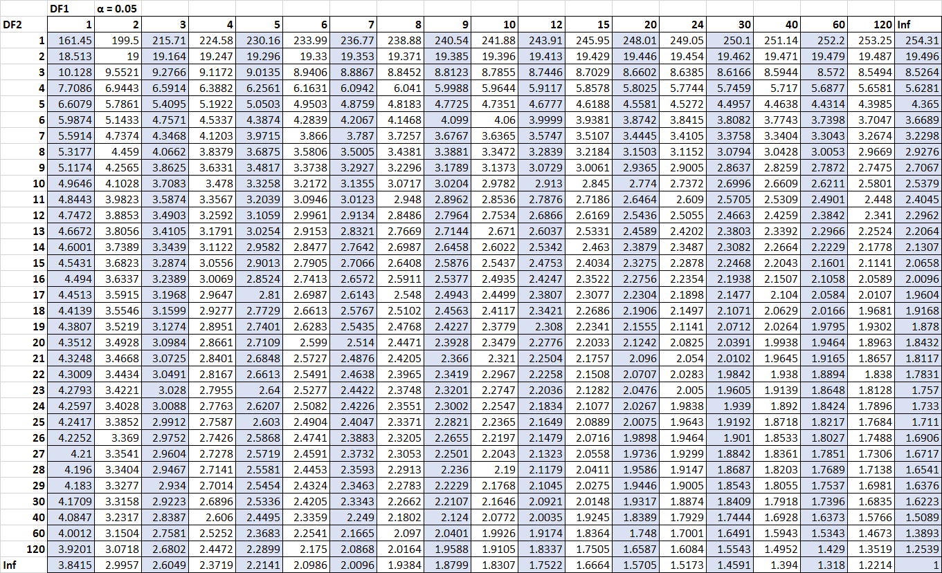
Table ‎8-33: The F-distribution table for the alpha level 0.05

