The Impact of Virtual Learning Environment

Shakera Begum Uddin
1818771
Digital Skills and Research Methods
BMSW4003
Balan Kandasamy

Table of Contents
Abstract …………………………………………………………………………………………………………
Introduction/ Aims and Objectives
Literature Review
Primary Research
Methodology
Ethical Considerations
Results and Findings………………………………………………………………………………………………………
Limitations of the Study…………………………………………………………………………………………………..
Conclusions and Recommendations…………………………………………………………………………………..
References……………………………………………………………………………………………
Appendix

The Impact of Virtual Learning Environment

Introduction to the Study
Abstract
Moodle is a learning platform for learners in institutions which provides a space for students and staff to interact online when doing coursework. This report aims to find out what impact the Virtual Learning Environment (VLE) Moodle has on students’ learning experiences. In order to reach a conclusion, I carried out a survey which was a questionnaire that asked students about their experience about learning with Moodle and how satisfied they were with the platform. The bar charts gave positive feedback, which allowed me to come to the conclusion that Moodle has had a very positive impact on learners, allowing coursework to be received online if you are absent, as well as being handed in efficiently without having to deal with the stress of losing papers or coursework material.
Introduction/ Aims and Objectives
Moodle has become widely used across the country (Moodle Partners, 2018) for learners of different institutions, for the purpose of providing a central space for learners and staff alike. It has been the main area for tutors to set up tasks for students, whilst also being the place for students to submit their work. This has evolved the way college and university institutions provide support too, as students no longer need to attend their place of education to communicate with their tutors. However, Virtual Learning Environment (VLE) may not be everyone’s choice of learning. There may be learners who may not appreciate this form of learning, this could be down to lack of experience in using computer devices, or they just generally like the older form of learning, which is face to face education.
Statement of Problem
The purpose of this study is to find out the impact of Virtual Learning Environment (VLE) Moodle has had on students’ learning experience in the University of Wales Trinity Saint David London Campus. The research will be based on the learners studying within the campus, who will take part in a survey to outline their experience in using Moodle.

Significance of Study
Moodle has turned out to be another way for courses to become a part of digital learning, using the ever-advancing technology that we have been provided with. In this digital era where we are surrounded by brand new and exciting technology that paces us towards a new reality, many will be interested in incorporating this with education, which changes the way we learn and how students engage in their classes. However, whilst this is something that many appreciate, others may have opinions that differ and prefer face to face education, the primitive form of learning. This study aims to find out what impact Moodle has on students’ learning and how satisfied they are with it.

Scope of the Study
This study was limited to being based on students’ overall experience with Moodle and how satisfied they are with it. The aim is to find out what kind of impact Moodle has on students learning, using surveys and questionnaires on what their thoughts are on Moodle and how and what they use it for.

Review of Related Literature
Moodle has become the main form of Virtual Learning Education across the country for many institutions. Moodle has various functions ranging from assignment view, forum add post, forum view, resource view user’s profile inspection, questionnaire and glossary inspection to name a few. All of which has made it somewhat evolutionary in the way students are able to learn, study and work within their place of education. Filippidi, Nikolaos & Komis (2010) looked at the impact of ICT for student’s practices and their performance. The research aimed to look at if Moodle has allowed students to perform better since the introduction of VLE’s such as Moodle. The study had in-depth look at its various functions to find out what purpose the students use Moodle for and what impact it had on their performance. From the result, one of the main uses of Moodle was to view assignments and viewing resources. This is understandable as Moodle provides access to material that are normally physically given to you in class, however those that either miss classes or want to revisit the work are able to view the documents in Moodle.

Primary Research
The research was done in the form of a survey that was taken part by 20 students within the UWTSD London campus. The aim of the research was to find out what students within this university thought of Moodle itself. Is this satisfactory? Or is this a hindrance to their study? All of which were thought of when designing the primary data? Each student was chosen at random with regards to their genders.

Methodology
The data used for this study were collected using a questionnaire developed by me at University of Wales Trinity Saint David. A stratified sampling technique was used to choose a group of 20 students, half were male, and half were female. The group was asked to take part in the questionnaire regarding their opinions on Moodle as a learning app and the impact it had on their learning. The questionnaire consisted of 10 questions, 5 of which were ‘yes or no’ questions and 5 of which were about how satisfied students were with their experience using Moodle;
- Would you recommend Moodle to others? Yes/No

- Would you say that Moodle has made it easier for you to absorb the learning materials in your course? Yes/No

- What is your experience of using Moodle?
Satisfied Very satisfied Dissatisfied Very dissatisfied

- Overall, how satisfied are you with Moodle?
Satisfied Very satisfied Dissatisfied Very dissatisfied

The results that came back implied that Moodle had a positive impact on students’ learning, and they were pleased with the experience so far.

Ethical Considerations
When choosing the 10 students to take part in the survey, a stratified sampling technique was used as I had to take into consideration the courses that each student was being selected from and whether or not they used Moodle as part of their course. The participants of the survey were asked to take part voluntarily and provide consent as it was important that they felt comfortable in being part of this research. They were also given assurances that any answer was taken anonymously, which meant that no personal details were taken apart from limited data that is important for this research. Additionally, the aim of the research was given to the participant in the clearest form in order to ensure there were no deception or exaggeration from the very point of why they’re taking part.

Results and Findings

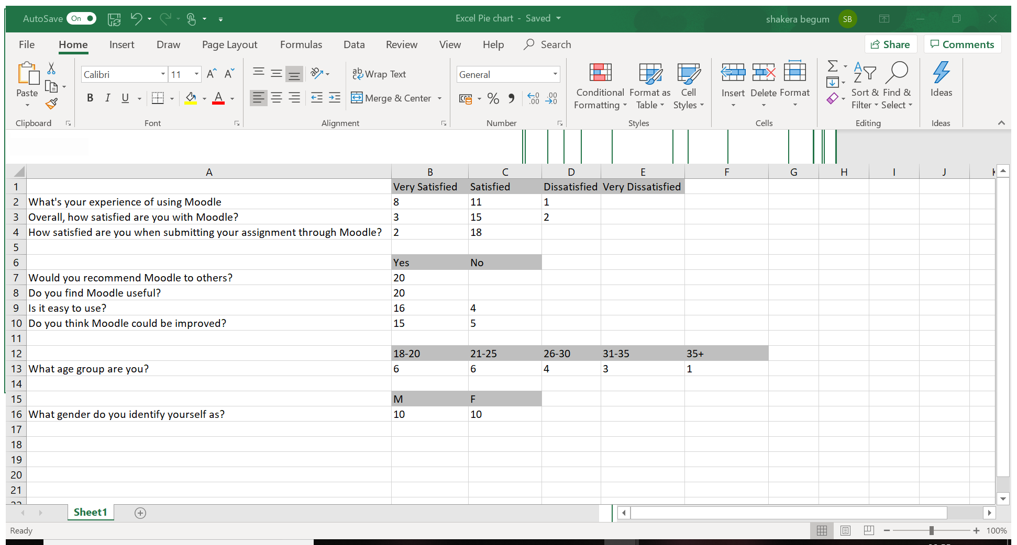
Figure 1

Figure 2

Figure 3

Figure 4
60% of the students who took part were in the ’18-20’ and ’21-25’ age groups, which makes the two groups 30% each. The age groups of the participants were varied in order to get a better conclusive result. The general opinion was that the older learners may prefer to not use Moodle, however that wasn’t the case. As the results show on Figures 1 and 2, learners of all age have an overall preference of using Moodle as opposed to not using it. As Figure 4 shows, majority of the students were actually positive about the use of Moodle. Few of the questions were simply a scale of Very Satisfied- Very Unsatisfied to avoid the questions being overly complex. Interestingly, not many thought Moodle to be unsatisfactory for its experience as it serves it purpose.
When asked what they thought about Moodle in general, majority thought that it was just satisfactory due to being convenient. Though it can be improved, as a VLE, the participants feel it has allowed them to be involved even if they were to be absent at college/ university, thanks to having access to their material online.
Lastly, a huge number of participants were wholly satisfied when asked about their thoughts on submitting work through Moodle. It’s mainly thanks to learners not needing to physically attend their university to submit work, which was the case in the past.
The survey then moved on to ‘Experience of using Moodle’, and many responded positively as they felt that Moodle does what it’s supposed to. However, it can be complex when navigating through the channel. This is why most participants thought that it could be improved, such as having a YouTube tutorial on how to do something specific. Saying that, all participants found Moodle to be useful and would definitely recommend to others as it is convenient for students.
In the ‘Experience with Moodle’ chart, we can see that very few were disappointed with it, however they also thought that there was definitely some room for improvement. From the results shown on the chart that displays students’ satisfaction with Moodle, 18 out of 20 participants were satisfied with Moodle when submitting their assignments. 8 of those participants said they were very satisfied with their experience of using Moodle, and 15 out of the 20 participants were satisfied with their overall experience with Moodle. However, there were 3 people who were dissatisfied with the learning platform but overall, the results showed very positive feedback and students seemed to have been impacted in an optimistic manner.
Limitations
In questionnaires, the participants may leave some questions unanswered, which will lead to an inaccurate result. Secondly, if some participants are biased based on what the questionnaire is about, this can lead to biased answers which can also lead to inaccuracies. Another limitation is that different people may have different interpretations of each question, which would lead to the answer being based on what they understand of the question. Furthermore, when the researcher is developing the questionnaire, they would be making their own decisions as to what is and isn’t important, so they could be missing out on something that is important. Additionally, whilst carrying out this survey, I was restricted in only using learners from the University of Wales Trinity Saint David.

Conclusion
In conclusion, overall the students at The University of Wales Trinity Saint David London Campus thought Moodle positively impacted their learning experience. Most are mature students with busy lifestyles and therefore sometimes due to unforeseen circumstances cannot make it to class, in which case Moodle proved to be very beneficial as students do not miss out on valuable teaching materials. Moodle is also a great tool to access feedback for assignments and check for resources. However, Moodle can be improved by making navigation easier and could also provide YouTube videos to demonstrate how to do specific tasks. The study shows that the primary data reflects the secondary data collected, and represents that Moodle in fact is very useful for students learning experiences.

SURVEY- IMPACT OF MOODLE ON STUDENTS

Q1. What age group are you in? 18-20 20-25 25-30 30-35 35 plus

Q2. What gender do you identify yourself as? M F

Q3. Have you used Moodle before joining Trinity Saint David university? Yes/No

Q4. Is it easy to access and use? Yes/No

Q5. Do you find Moodle useful? Yes/No

Q6. Would you recommend Moodle to others? Yes/No

Q7. Do you think Moodle could be improved? Yes/No

Q8. Would you say that Moodle has made it easier for you to absorb the learning materials in your course? Yes/No

Q9. What is your experience of using Moodle?
Satisfied Very satisfied Dissatisfied Very dissatisfied

Q10. Overall, how satisfied are you with Moodle?
Satisfied Very satisfied Dissatisfied Very dissatisfied

Q11. How satisfied are you when submitting your assignment through Moodle?
Satisfied Very satisfied Dissatisfied Very dissatisfied

REFERENCES
Flippidi, A, Nikolaos, T & Komis, V. (2010) Impact of Moodle Usage Practices on Students’ Performance in the Context of a Blended Learning Environment.
Available: Social Applications for Lifelong Learning. 0 (p4), p1-5.
K. Popper (2004). The Logic of Scientific Discovery. Vienna: Karl Popper. p31-40
Husveen Grewal. (2018). Why Should We Moodle. Available: https://moodle.com/news/why-should-we-moodle/. (Last accessed 7th Jan 2020.)
S. Ackroyd and J. A. Hughes (1981). Data Collection in Context . London: Longman. p21-22.

