AN ELECTRIC BIKE RENTAL SCHEME

MODULE NAME: Introduction to Web and Database Concept
MODULE CODE: ACCA4023
LECTURER: Fahad Ahmed
TRINITY SAINT DAVID UNIVERSITY OF WALES (LONDON CAMPUS)
Student Name: Ahmed Remache
STUDENT ID: 2334747

Table of Contents
Introduction……………………………………………………………………………………………………….
Task 1: Implementation guide:…………………………………………………………………………
Scenario Analysis……………………………………………………………………………………3
Entity-Relationship Diagram (ERD)…………………………………………………………….4
Data structure Development………………………………………………………………….5,6
Normalization Compliance………………………………………………………………………7
Sample Data Population………………………………………………………………………….8
Query Development…………………………………………………………………………. 9,10
Validation Testing…………………………………………………………………………………11
Conclusion…………………………………………………………………………………………………….12
References……………………………………………………………………………………………………..12

- Scenario Analysis
The eco_ride electric bike rental scheme involves several key entities that work together to support the daily operations of the service. Each entity holds specific information and interacts with others in a structured way. The following analysis identifies all the main entities as well as describe their attributes and explain the relationship between them.
1.Riders
Riders represent the individuals who use the eco_ride service to rent electric bikes. Eac rider has essential attributes such as their name, contact information, and a unique identification number. Riders interact with the system by renting bikes, returning them, and potentially generating usage histories that the organization may analyse. Riders form one-to-many relationship with rental transactions as a single rider may complete many rentals over time. [1]
2.Electric bikes
Electric bikes are another core entity in the system. Each bike has attributes that include its unique bike ID type condition status, location, and maintenance history. A bike can appear in many rental transactions, creating a one-to-many relationship between a bike and its associated rental records. Bikes also connect to maintenance logs, as each bike may undergo multiple maintenance activities during its lifecycle. [2]
3.Rental Transactions
Rental transactions record all information related to the hiring and returning of bikes. Attributes include the transaction ID, rental date, return date, total duration, cost and any additional notes. Each rental transaction must be linked to exactly one rider and one bike. Therefore, the rental entity serves as a bridge between the rider and bike entities. This relationship ensures that the system can track which bike was used, by whom, and for how long. [3]
4. Maintenance Logs
Maintenance logs store information about upkeep and repair activities carried out on each electric bike. Important attributes include the maintenance ID , date of service, maintenance type, description of work completed and the staff members involved. Maintenance data helps track bike condition and availability and it ensures accountability and safety.
5. Staff members
They represent employees responsible for maintaining, inspecting, or servicing electric bikes. The relationship ensures that the organisation can trace who performed service activity and maintain accurate maintenance history. [4]
Entity Relationship Diagram
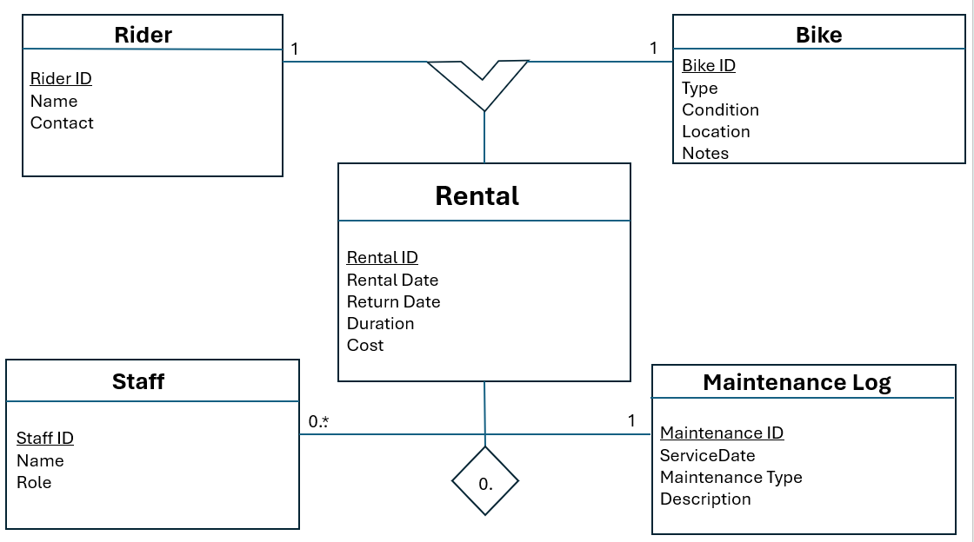

Data structure development
- Rider entity
The writer entity stores essential information about each person who uses Eco_ride service. The primary key is RiderID, which uniquely identifies every rider. Additionally attributes capture the rider’s personal details and ensure that the organisation can contact them if necessary.
Rider Table structure
- Rider ID- unique identifier for each rider; must be non-null.
- Name- The rider’s full name; cannot be left empty
- Contact- Email address or phone number; must follow a valid contact format
Constraints
- RiderID must be uniwue and automatically generated
- Contact information must not be null to allow communication
- Bike entity
The Bike entity contains all relevant details about every electric bike within the system. The primary key is BikeID, which distinguishes each bike individually. Attributes record important information such as bike condition, location, and type.
Bike table structure
- BikeID- Unique bike identifier
- Type – category of bike (e.g., city, mountain, folding).
- Condition- status such as “Available,” “In use,” “Needs Repair,” or “Under service.”
- Location – current station or storage facility where the bike is kept
- Notes- Optional comments about the bike’s status or recent issues.
Constraints
- Condition must be chosen from a predefined list of valid states.
- BikeID must be unique and not null
- Rental Entity
The rental entity records every bike rental transaction carried out by riders. The primary key is rentalID, and the entity includes two foreign keys (RiderID and BikeID) which link each rental record to the correct rider and bike.
Rental Table structure
- RentalID – unique identifier for each rental transaction.
- RentalDate – The date and time the bike was rented out
- ReturnDate- The date and time the bike was returned
- Duration- Total rental time, calculates in minutes or hours
Constraints
- RiderID and BikeID must match valid entries in their respective tables
- RentalDate cannot be null
- ReturnDate must be equal to or later than RentalDate
- Duration must be a positive value
- Maintenance Log Entity
The maintenance entity stores detailed information about any servie or inspection carried out on the electric bikes. The primary key is maintenanceID Foreign keys link each log entry to the relevant bike and the staff member who performed the work.
Maintenance Log Structures
- MaintenanceID – unique identifier for each maintenance entry
- BikeID- References Bike. BikeID
- StaffID- References staff. StaffID
- Service Date- Date the maintenance was performed
- Maintenance Type- Description of the type of service
- Description- Additional notes about what was done
Constraints
- BikeID and StaffID must reference existing records.
- ServiceDate cannot be set in the future
- MaintenanceType must not be null
- Staff Entity
The staff entity stores details for employees responsible for servicing or inspecting the bikes. The primary key is StaffID which uniquely identifies each staff member.
Staff Table Structure
- StaffID- Unique identifier for each staff member
- Name- Employee’s full name.
- Role- Job title such as “Technician” or “Inspector” or “Maintenance Officer”
Constraints
- Staff ID must be unique
- Name and Role must not be null

Normalization Compliance
The Eco_Ride database has been carefully designed to ensure that it complies fully with the principles of Third Normal Form (3NF). Normalisation is essential for reducing unnecessary duplication of data, improving data integrity, and preventing problems such as update, insertion and deletion anomalies, The following paragraphs explain how the data model satisfies the requirements of all.
To meet the requirements of First Normal Form , all attributes across all the entities in the database must contain indivisible values and each record must be uniquely identifiable. In the Eco_Ride system this condition is satisfies because each entity – Rider, Bike, Rental, Maintenance Log, and Staff – contains attributes that store only single values rather than repeated or grouped data. For example, the rider entity stores one name and one contact value per rider, while the bike entity stores a single type , condition and location for each bike. In addition , every table has a clearly defined primary key, such as RiderID or BikeID, which guarantees that each record can be uniquely identified. [5]
The database also complies with the rules of Second Normal Form (2NF). A table is in 2NF when it is already in 1NF and all non-key attributes depend fully on the whole primary key. In this Design, all primary keys consist of a single attribute which means that partial dependency cannot occur. Every non-key attribute in each table depends directly on its primary key. For instance a riders name and contact information depend only on the Rider ID and the type, condition and location of a bike depend entirely on the Bike ID. Similarly, every rental attribute such as rental date, return date, duration and price is fully dependant on the Rental ID . The same logic applies to both the Maintenance Log and Staff entities. This confirms that full functional dependency is present throughout the model.
Finally, the database satisfies the conditions of Third Normal Form (3NF), which requires that a table must already be in 2NF and that no non-key attribute depends on another non-key attribute. In the Eco_Ride design, there are no transitive dependencies within any of the tables. Each non-key attribute depends directly on its relevant primary key only. For example, in the riders table the contact information does not depend on the rider’s name but solely on the RiderID. The same is true for the Bike table where condition and location do not depend on one another and for the rental table where duration and pricing do not reply on any other non-key fields. The maintenance Log and staff tables also contain only attributes that depend directly on their primary keys, without any interdependency among non-key attributes. [6]
Overall the date structure is fully normalised to the third normal form, ensuring that the Eco_Ride database is efficient, reliable and logically organised. This level of normalization reduces redundancy and supports accurate data management.
Sample Data Population
To demonstrate how the Eco_Ride database operates in practice, sample date has been inserted into each table. This data simulates realistic situations such as riders registering for the service, bikes being added to the system, rentals being recorded and maintenance activities being logged by staff. At least five rows have been included across the different tables to satisfy the task requirements.

Sample riders
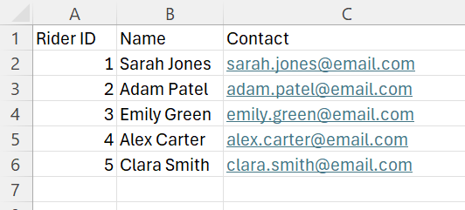
Sample Bikes
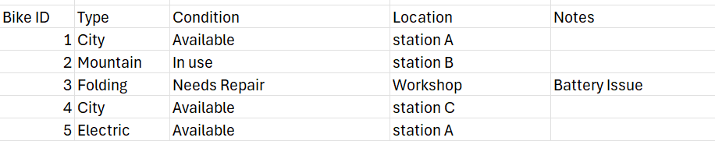
Sample Staff
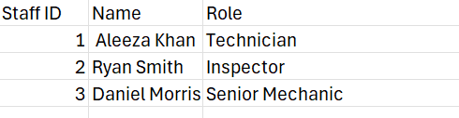
Sample Rentals
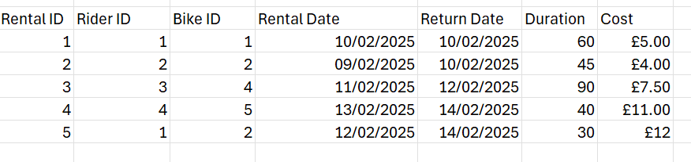
Query Development
These queries were created to reflect the everyday needs of the bike rental system, such as checking which bikes are currently rented out, identifying bikes that need maintenance, analysing rider activity, and reviewing how often certain bikes are used. Each query is written using standard SQL syntax and is based in the tables developed earlier in the database design.
The first query retrieves all bikes that are currently out on rental. This is done by selecting bikes whose condition is recorded as “In Use” which allows staff to easily monitor which bikes are unavailable. The second query focuses on rider activity by listing all rentals made by a specific rider. In this example, RiderID is used, but the query can be adjusted for any rider. This is helpful for identifying frequent users or resolving disputes about charges. [7]
A third query was developed to identify bikes that require maintenance. By selecting bikes marked as “Needs Repair” staff can quickly view which units must be taken off the road for servicing, helping to maintain safety and reliability. The fourth query identifies the most frequently rented bikes by counting how many times each bike appears in the rental table. This information supports operational planning, such as deciding which bikes types should be purchased more frequently due to high demand [8]
The final query lists all recent or upcoming maintenance activities. Sorting maintenance logs by date allows staff to track when each bike was last serviced and who carries out the work. This is essential for maintaining accurate maintenance record and ensuring that all bikes comply with safety checks.
The SQL queries used are listed below
- Retrieve all bikes currently out on rental
SELECT BikeID, Type, Condition
FROM Bike
WHERE Condition = ‘In Use’ ;
- Find all Rentals made by specific rider
SELECT RentalID, BikeID, RentalDate, ReturnDate
FROM Rental
WHERE RiderID = 1;
- List bikes that require maintenance
SELECT BikeID, Type, Condition, Location
FROM Bike
WHERE Condition = ‘Needs Repair’ ;

- Show the most frequently rented bikes
SELECT BikeID, COUNT(*) AS RentalCount
FROM Rental
GROUP BY BikeID
ORDER BY RentalCount DESC;
- List recent or upcoming maintenance activities
SELECT MaintenanceID, BikeID, StaffID, ServiceDate, MaintenanceType
FROM MaintenanceLog
ORDER BY ServiceDate DESC;

Validation and Testing
The Eco_Ride database was tested extensively to censure that it met all functional requirements. Validation focused on rider registration, rental processing, bike tracking, and maintenance logging. Sample data was inserted to test real-world behaviour, and queries were executed to verify that the database returned accurate and expected results
During testing rider information was successfully stored and retrieved, confirming that the registration system worked correctly. Rental operations were also validated bikes listed as in Use appeared in the correct queries durations were recorded accurately and returned bikes were updated within the system. Maintenance logs were checked to ensure that records linked properly to both staff members and bikes.
Integrity constraints were tested by attempting to insert invalid or incomplete data. The database correctly rejected these entries demonstrating that the defined constraints were working as intended. Overall the database performed reliably across all tests and was shown to meet the operational needs of the Eco_Ride rental scheme

Conclusion
In conclusion, the Eco_Ride database system has been successfully designed, developed, and tested to meet the requirements of the electric bike rental scheme. Through the creation of the structured tables, the use of realistic sample data, and the execution of SQL queries the database has demonstrated its ability to store organise and retrieve information effectively. The entity relationship diagram guided the structure of the system and ensured that all relationships between riders, bikes, rentals, staff and maintenance activities were accurately represented.
The SQL queries developed in task 6 showed how the database can support everyday operations such as tracking bike availability, monitoring rider activity and many more.
Overall, the Eco_Ride database is fit for purpose and provides a strong foundation for manging an electric bike rental service. It supports efficient decision-making, improves operational visibility and ensures that bikes remain well-maintained and safe for users. With further development, the system could be expanded to include route tracking, payment processing, and real-time bike availability, making it even more useful for both staff and riders.

References

[1] | L. B. M. C. D. &. K. S. Lotero Alvarez, Bike Sharing Systems and the Collaborative Economy:A, 2022.
[2] | M. J. R. V. V. &. W. E. Lmebo, “Relational event models with global covariates: an application to bike sharing,” Journal of the royal statistical society, 2025.
[3] | H. F. A. &. O. S. Billhardt, “Recommendations for renting bikes in bike sharing systems,” Applied Sciences, 2021.
[4] | “Bicycle Sharing Market Size & Share,” 2025.
[5] | T. &. B. C. Connolly, “Database Systems,” A practical Approach to design, implentation, and management. Pearson, 2015.
[6] | M. intelligence, “Bike Sharing Market-Trends, share & growth,” 2025.
[7] | R. &. N. S. Elmasri, “Fundamentals of Datebase Systems,” in Pearson, 2016.
[8] | C. J. Date, “An introduction to Database Systems,” 2004.

