Module: Problem Solving and Decision Making
Module code: BMSW4004
Assignment Title: Problem Solving and Decision Making
Student Name: Maria Magdalena Barbu
Student ID: 2011081
Table of Contents
Introduction 3
Task 1: Role Play 4
Nature and Impact of Employee Dissatisfaction 4
Cause-effect Analysis 5
PESTEL Analysis of the Contributing Factors 6
Alternative Solutions to the Problem 7
Implementation and Evaluation of the Solution 8
Task 2: Report 9
Problem defining along with its scope and impact 9
Analysing information on the problem 10
Alternative Solutions of the problem 13
Using a decision making technique to evaluate alternatives 14
Developing a plan to implement the solution 15
Communicate the plan to stakeholders and assessing monitoring techniques 17
Conclusion 19
References 20

Introduction
This unit has been written on the theme of problem-solving and decision-making. This unit is divided into two part including a role play and report. A complex workplace problem has been defined in this report. Scope and impact of that complex problem on the working environment of an organisation have been described as well. The problem which has been identified and described in this report is Gender Discrimination Problem within the working environment of Tesco PLC. Some data and information have been analysed to help the process of decision making. Some alternatives for solving the issues at Tesco have identified and described as well. A decision-making tool or technique has been utilised in this report, for selecting the most appropriate solution of the issues. A plan of identified solution implementation has been developed upon evaluation and communication with the stakeholders of Tesco PLC. Some appropriate monitoring and review methods to ensure proper implementation of the solution to resolve the issues have been assessed.

Task 1: Role Play
The role play has been done for the role of consultant to solve the complex workplace problem which is employee dissatisfaction.

Nature and Impact of Employee Dissatisfaction
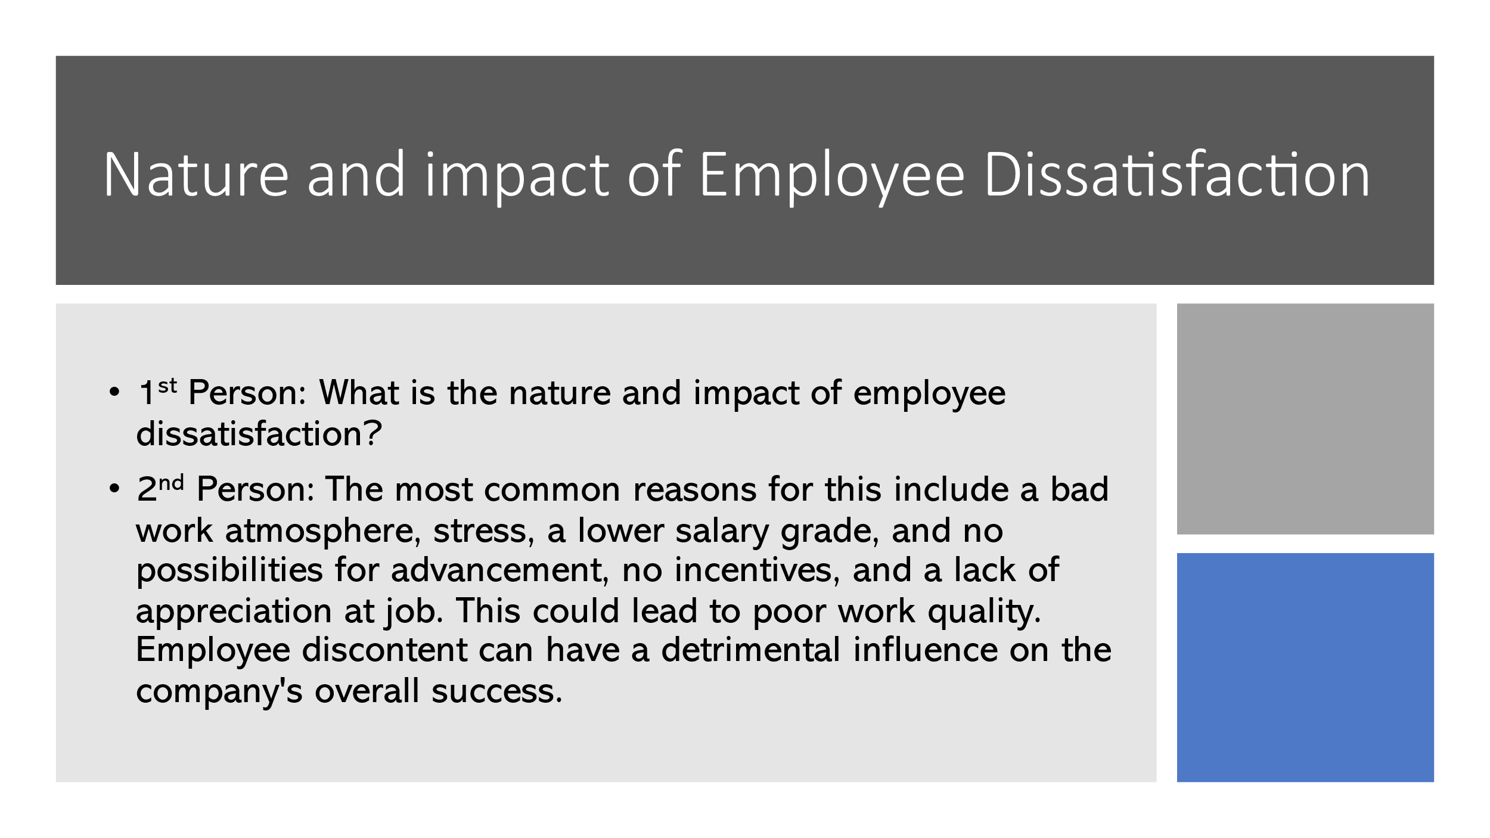
What is the nature and impact of employee dissatisfaction?
Dialogue for the Consultant
Employee discontent or job dissatisfaction is defined as being unpleasant or having bad sentiments about one's employment or work conditions. There are several elements that may be connected back to the nature or causation of workplace employee discontent. The most common reasons for this include a bad work atmosphere, stress, a lower salary grade, and no possibilities for advancement, no incentives, and a lack of appreciation at job (AlBattat et al., 2013). This could lead to poor work quality. Employee discontent can have a detrimental influence on the company's overall success. Workers that are unsatisfied with their jobs will provide bad work and practically no contribution that can contribute to disastrous and substandard work performance. As a consultant, it is advised that suitable incentives, benefits, and acknowledgment be provided to employees in order to increase their happiness and job satisfaction and to decrease the negative effects of job discontent on organisational effectiveness.

Cause-effect Analysis
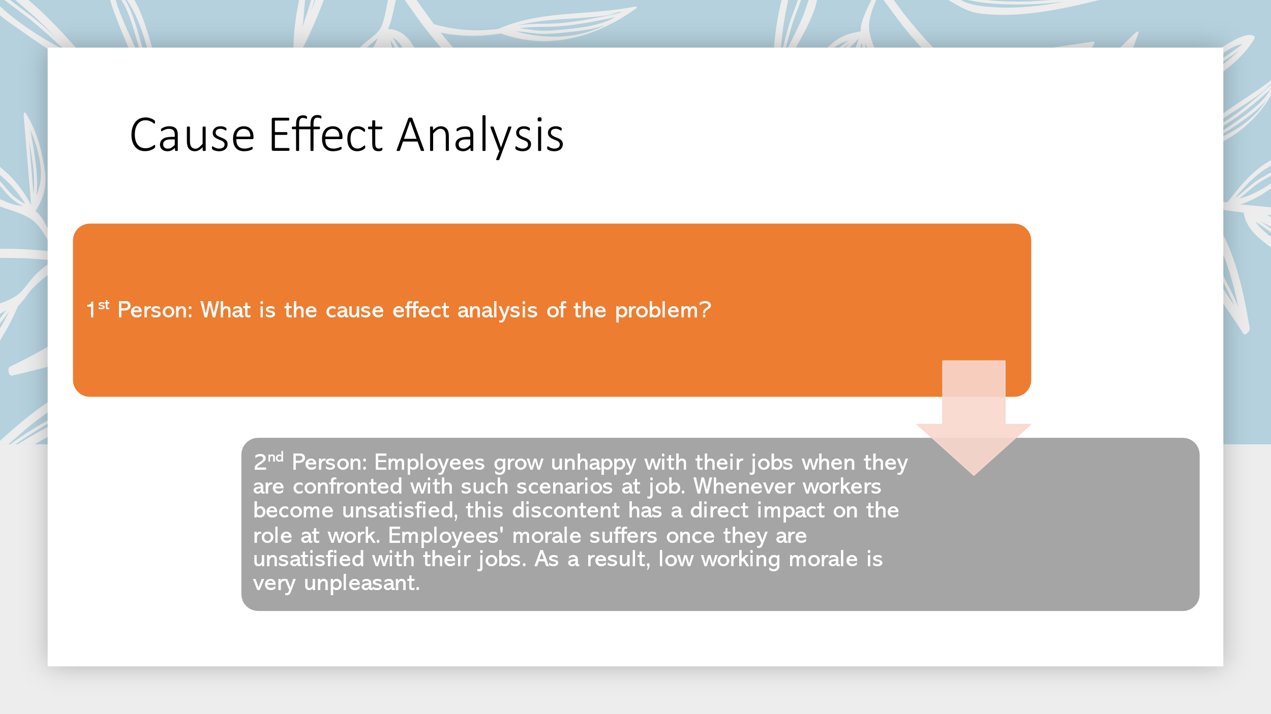
What is the cause effect analysis of the problem?
Dialogue for the Consultant
As previously stated, the primary reasons of employee discontent or job dissatisfaction include bad working conditions, a lack of recognition, a lower level of compensation, a lack of possibilities, a lack of innovation, or overburdening. Employees grow unhappy with their jobs when they are confronted with such scenarios at job. Whenever workers become unsatisfied, this discontent has a direct impact on the role at work. Employees' morale suffers once they are unsatisfied with their jobs. As a result, low working morale is very unpleasant. Workers respond negatively when they believe they are undervalued at workplace (Anand et al., 2015). As a result, there is a bad attitude and a decrease in work engagement. As a result, bad workplace conditions contribute to employee discontent, which has a detrimental influence on overall organisational performance.

PESTEL Analysis of the Contributing Factors
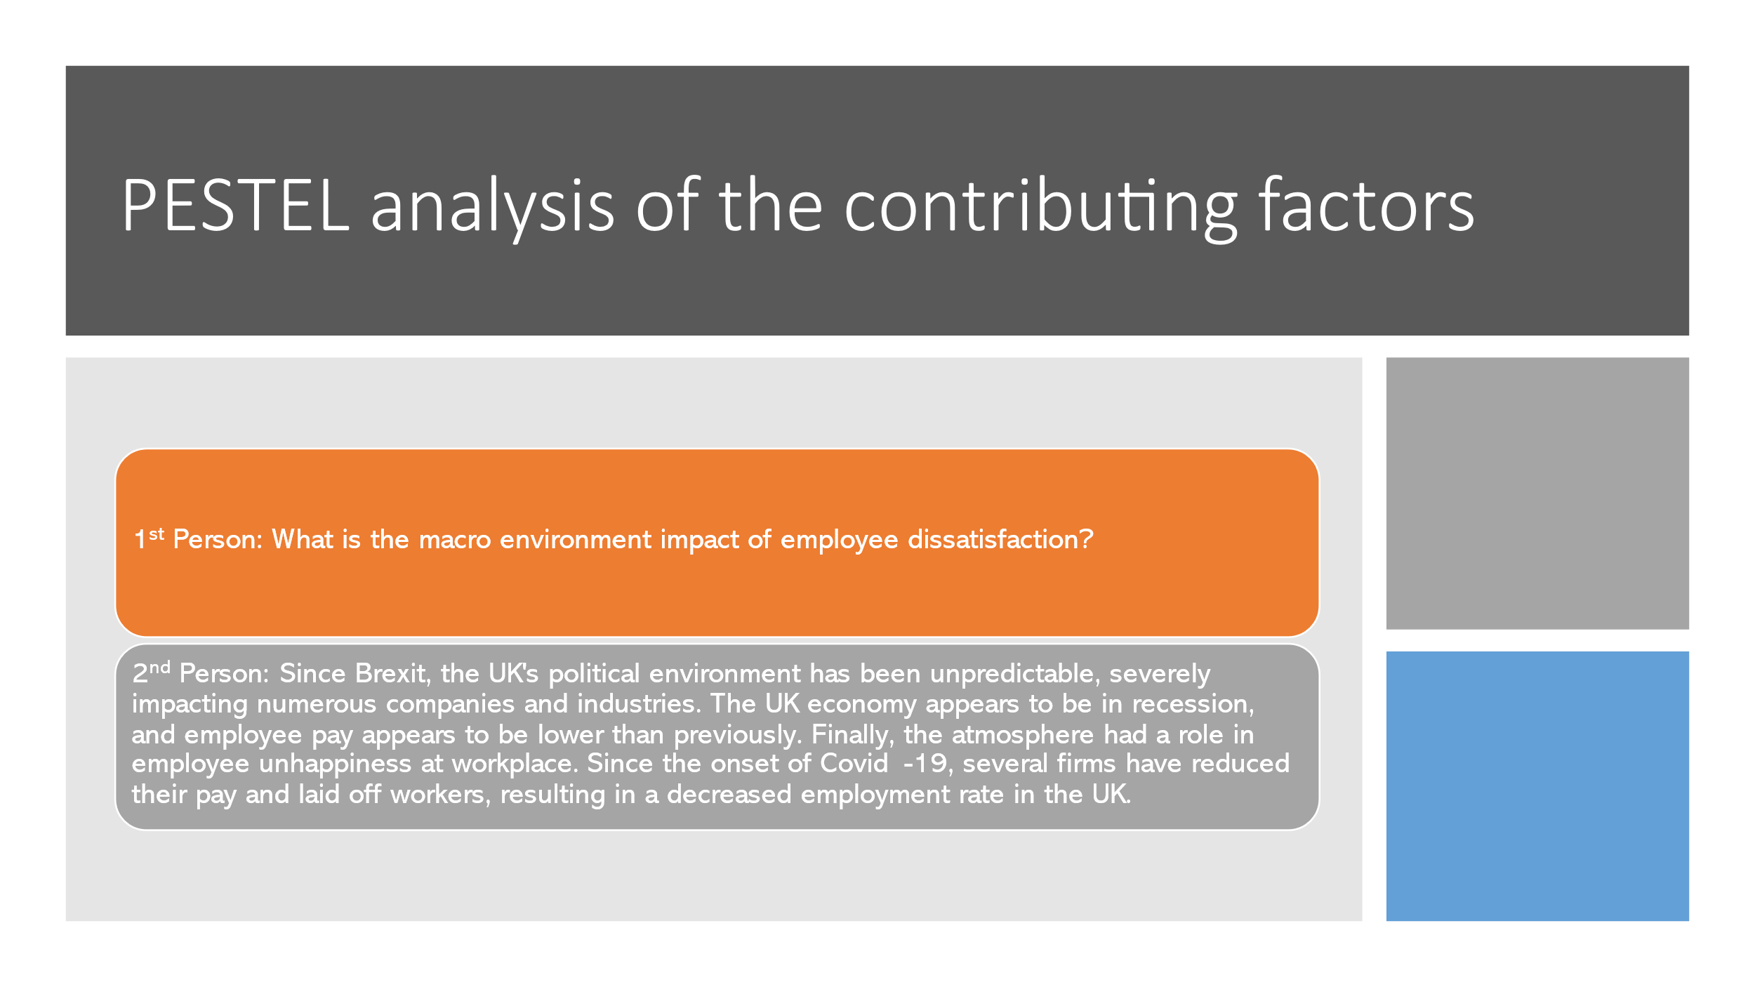
What is the macro environment impact of employee dissatisfaction?
Dialogue for the Consultant
Political, economic, and environmental issues are important contributors to employee discontent in the job. Since Brexit, the UK's political environment has been unpredictable, severely impacting numerous companies and industries. The uncertain position resulted in poor work conditions, which caused more problems (Yaseen, 2013). In addition, the UK's economic position has been uncertain since Brexit and the Pandemic. The UK economy appears to be in recession, and employee pay appears to be lower than previously. This reduced pay rate resulted from uncertain economic conditions that exacerbated the complicated situation. Finally, the atmosphere had a role in employee unhappiness at workplace. Since the onset of Covid-19, several firms have reduced their pay and laid off workers, resulting in a decreased employment rate in the UK. Employees are becoming worried as a result, which is affecting their job happiness and performance.

Alternative Solutions to the Problem
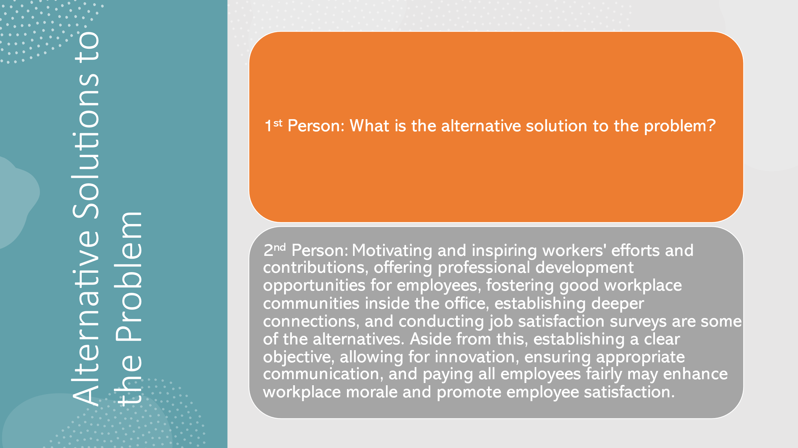
What is the alternative solution to the problem?
Dialogue for the Consultant
As a consultant, I will provide some answers to the complex issue of employee discontent at workplace. Motivating and inspiring workers' efforts and contributions, offering professional development opportunities for employees, fostering good workplace communities inside the office, establishing deeper connections, and conducting job satisfaction surveys are some of the alternatives. Aside from this, establishing a clear objective, allowing for innovation, ensuring appropriate communication, and paying all employees fairly may enhance workplace morale and promote employee satisfaction (Vangel, 2011). Among all of these options, it is advised that adequate incentives, compensation, and possibilities be provided in order to maintain morale and resolve the complicated problem of employee discontent.

Implementation and Evaluation of the Solution
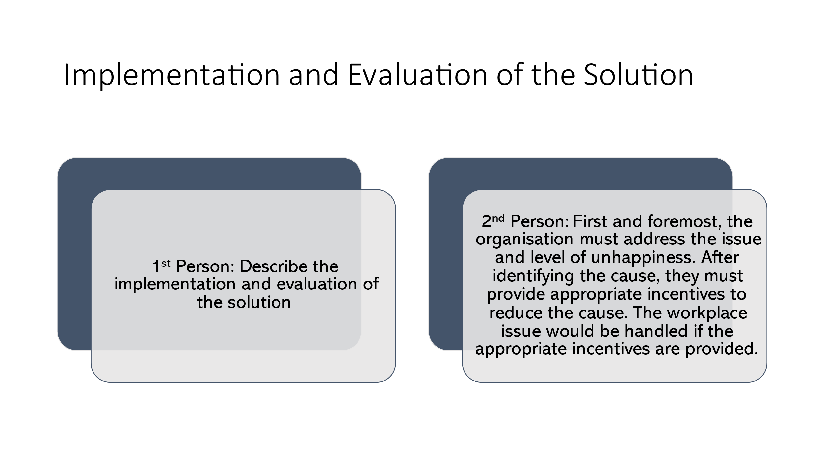
Describe the implementation and evaluation of the solution
Dialogue for the Consultant
Companies can utilize a variety of procedures to apply the selected solution to workplace challenges. The strategy must be implemented in phases. First and foremost, the organisation must address the issue and level of unhappiness (Goldberg, and Zaman, 2018). Employees may be dissatisfied for a variety of reasons. The organisation must identify the source of the discontent. After identifying the cause, they must provide appropriate incentives to reduce the cause. The workplace issue would be handled if the appropriate incentives are provided. This strategy will be well-justified since management would be recognizing occupational hardship and working to resolve it with suitable incentives. By adopting this approach, the organisation may simply satisfy its employees and maintain the organisation's morale.

Task 2: Report

Problem defining along with its scope and impact
This part of the report identifies and defines a work based problem that is influencing the operational activities of Tesco PLC. According to the scenario, I have been appointed as trainee manager at Tesco PLC. This organisation is facing a vital workplace problem which is gender discrimination and inequality.
Fisanick (2011) has defined gender discrimination at workplace as discriminating staffs based on the gender or sex. Tesco PLC is heavily impacted by this issue and facing different problems within their operational activities. This is illegal for any kinds of organisation to discriminate against any employees working for the company based on gender, sexual orientation, physical disabilities, race, religion, and culture stated in Equality Act-2010. Every organisation needs to provide equal privileges and rights to every employees working. Although, this is mandatory to follow Equality Act-2010 and give equal rights to every employees, female employees of Tesco PLC feel discriminated against male employees and there has been seen a pay gap among male and female workers working in the same position.
Scope
The issue of gender discrimination and inequality have appeared within the working environment at Tesco PLC since there can be seen a lack of bodily autonomy and employment equality. Male employees of this organisation are given more opportunities and privileges by the managers of different departments than female working creating this work based problem. Not only this, difference in pay scale among male and female employees within Tesco PLC has been observed as well. Male workers are paid £3 more than female working per hour doing the same work.

Impact
Since this is illegal to maintain inequality and gender discrimination within the working environment, some serious consequences have been faced by Tesco PLC because of this issue. Operational activities and reputation of this organisation have been severely and negatively impacted because of these issues. In 2020, Tesco was sued for gender discrimination. Equal pay claim of £4 billion for different pay range for male and female workers were faced by Tesco (Tesco faces record £4bn equal pay claim, 2020). This had a negative impact on their public image harming their overall profit and operational activities. Other than this, this organisation has lost and still losing many talented employees since they are demotivated or reluctant to work for such organisation practicing gender discrimination and inequality. Therefore, this work based problem is negatively impacting the market image, reputation, operational activities, and profit margin of Tesco PLC.

Analysing information on the problem
Research studied by Chaney (2011) showed, more than 8 million employees working for different sectors of the UK have faced discrimination in their workplace and denied proper rights or any privileges because of their gender, sexual orientation, race, or physical abilities. Although this is completely illegal and unethical to discriminate an employee in the workplace according to section 66 of Equality Act-2010, 26% of the employees working for different companies in the UK have voted being discriminated in the workplace because of their gender. Tesco PLC also practices such discrimination within their working environment which is highly demotivating for many employees. Such an example is, women having pay rate of only £8 per hour, whereas men having pay rate of as high as £11 while having the same working responsibilities at Tesco PLC (Tesco faces record £4bn equal pay claim, 2020). This is causing the company to lose many talented and competent female workers since they are losing their motivation to work for the company because of their pay discrepancies. This issue of pay discrepancies is also creating legal and ethical problems for the company harming their public image and reputation at the market. 97% of female workers at Tesco reported male employees having 12% better opportunities than female employees. Adding to this, male employees are given 16% more opportunities for promotion and evaluation than female employees. Tesco faced 4 billion euro lawsuit for maintaining pay discrepancies among employees which negatively harmed their operational activities along with their overall profit.
The above scenario about Tesco PLC creates urgency for the organisation to resolve their gender discrimination problem for saving their public image and retaining competent workers in the company. A decision making process can be proved very effective for Tesco to resolve this issue. There are some steps in a decision making process which should be followed by the managers of Tesco to efficiently resolve the problem. Those steps are:

Figure 1: Decision Making Process; Source: Chaney, (2011)
Problem Identification
Gender discrimination is the main problem which has been already identified. This would be easier for the managers of Tesco PLC to resolve the situation as they have already identified it.

Alternative Searching
In the next step, some alternative solutions would be searched by the managers of this company to resolve problem. This step would help in making efficient decision.
Alternative Evaluation
The alternative searched in the previous step would be evaluated in this step for solving the issue.
Making Decision
Upon evaluation of different alternative, they would be making a decision by selecting an alternative to solve the problem.
Decision Implementation
Managers of the company would implement their decision in this step. For this implementation, they would need to make a plan.
Result Evaluation
Results would be evaluated in this step one the decision is implemented. After implementing the decision, if the problem is resolved then they would finalise the decision. If the problem is not resolved, they would begin the process from the top.
These are stages that can be used by Tesco for making a decision to resolve their work based problem.

Alternative Solutions of the problem
Some solutions have been identified in this part of the report can help Tesco PLC to eliminate gender discrimination and any kinds of inequality from their working environment. Effectiveness of each alternative can be measured by the managers of Tesco for solving the issue. Those alternatives are as such;

Figure 2: Alternative Solutions; Source: Chegwe, (2013)
Creation of an Equal Opportunity Policy
An equal opportunity policy can be created by the authorities of Tesco. By creating this policy, workers of Tesco would be given equal opportunities and privileges. Equal rights can be enjoyed by female employees of Tesco by creating and enforcing this policy. This would solve both gender discrimination problems and pay discrepancies.
Educate Employees about Gender Discrimination
Educate every employee about gender discrimination and its impact can be proved helpful to resolve gender discrimination problem at Tesco. Seminars, training sessions, and different workshops can be arranged by the authorities of Tesco to educate every employee on this matter. By making everyone aware about the negative impact of this issue would be helpful to resolve the issue.
Take Immediate Actions to Complaints
One of the main reasons of increasing gender discrimination at Tesco is not taking any immediate actions while complained by employees. By taking immediate actions to the complaints, they can provide equal opportunities and rights to the female employees of the organisation. Taking immediate actions based on any complaints can be very much effective (Chegwe, 2013).
Be Transparent to Public
Another way Tesco can resolve this problem is by being transparent to public. When an organisation is transparent to public, they have to follow every rule diligently. By maintaining transparency, Tesco would be more aware of giving equal opportunities to everyone.
In the above, some of the alternative solutions have been mentioned that can be used by Tesco for resolving their workplace issue.

Using a decision making technique to evaluate alternatives
Conjoint analysis has been used by Tesco as their decision making technique.
Based on the research studies by Szymaniec-Mlicka (2017); conjoint analysis is a survey based technique that helps to reveal how consumers might value their attribute of a changing situation of an organisation. It is natural for an organisation to go through many changes over the course of period. In a changing situation, an organisation can use conjoint analysis to forecast the accepting rate of consumers and employees of the proposed or upcoming changing within the working environment of the company. Conjoint analysis is one of the most popular decision making technique among market researchers. By using this technique, Tesco can easily determine the brand position in the industry. Lately, brand positioning and public image of Tesco have been negatively impacted because of lawsuits and maintaining gender discrimination. Legal and ethical issues involving gender discrimination is posing threat for Tesco.
Four different alternatives have been reviewed and evaluated by using conjoint analysis to solve gender discrimination problem. Public image of this organisation had a heavy negative impact since public is aware of their pay discrepancy. In this situation, to gain the trust of the public and customers once again, Tesco should be letting their consumers know about their pay rate. This will help the organisation to maintain their brand position and image at the market. Regarding this factor, it would be efficient for Tesco PLC to choose the alternative of be transparent to the public. By choosing this alternative, their customers would be aware of their pay rate and get to know if their employees are treated equally and they are free of any discrimination. By being transparent to the public, Tesco would have to public their records which would force their managers to give equal opportunities to their workers regardless of their gender. This would force managers to evaluate every employee according to their competent. Therefore, be transparent to the public has been chosen as the best alternative among the four by using conjoint analysis.

Developing a plan to implement the solution
Tesco can follow some steps for implementing the selected alternative for solving the workplace issue. Plan for implementing the selected solution has been described below:

Figure 3: Implementing Plan; Source: Project Monitoring and Control Techniques, (2020)

Action Identification
Identification of the needed actions is the first stage of the plan. In this stage, Tesco will identify the actions which would be needed to public the pay records. Tesco will need to collect pay forms from every department to present accurate data.
Action Scheduling
Tesco can use end of every quarter for collection of pay forms. They can schedule these activities at the end of quarter. Since, size of Tesco is huge and employee number of this organisation is huge, it can be complicated for the organisation to collect pay forms. So, scheduling would be very much helpful.
Resources Identification
Resources will be identified in this stage. Resources which will be needed to implement the plan such as a structured pay form with date and employee information would be given to collect the data.
Putting Measures for Counter Consequences
Sometimes implementation of a plan creates some counter consequences (Project Monitoring and Control Techniques, 2020). Some of the counter consequences for this plan can be employees filling out wrong information on the form. To deal with such problems, counter consequences such as creating a review committee is needed.
Identify Management of the Action
Management of the action would be identified on this step. Management of action for this plan will be managers of each department would be responsible for providing and collecting the form.
Review the Plan
In the last step, they would review the plan. Every step of the plan needs to be reviewed and monitored properly to avoid any error and ineffectiveness.

Communicate the plan to stakeholders and assessing monitoring techniques
Stakeholders are one of the most significant parts of any organisation. So, this is needed for Tesco to communicate the plan with stakeholder after formulating. This plan will have major changes and impact on the operational activities of Tesco. Since, stakeholders will be impacted as well because of this plan; this is needed to communicate with them before implementation of the plan (Reeb, 2016). As Tesco has chosen to maintain transparency to the public and formulated the plan based on this alternative, they will need to publish some internal information about the company in public. A formal meeting will be held by the managers of Tesco to communicate with stakeholders. During the formal meeting, managers of this organisation would present the formulated plan and decision to resolve the issue of gender discrimination and regain their brand position in the market. Formal mail and calls would be given to those stakeholders who are unable to attend the meeting. The solution can be implemented once the plan has been presented and communicated with the stakeholders in details as well as approved by them.
Tesco can also implement some review and monitor techniques for proper implementation of the plan. Those review and monitor techniques are;
Review and Refine Action Plan
Managers of this organisation will be reviewing and refining their action plan efficiently. Every stage needed for implementing the plan within Tesco need to be properly reviewed by manager along with refining them when necessary (RAO, 2016).
Prepare the Implementation
In the next stage, managers would be preparing for implementing the action plan. Reviewed action plan would be carefully implemented by managers.
Prepare Evaluation
Evaluation is needed during implementation. So, they would prepare for evaluation. To ensure proper implementation of the action plan, they would be evaluated sincerely.
Make Mid-course Corrections based on Results
They would be needed to make any correction mid-course if necessary. Based on the results of the evaluation, they can make changes to the plan.
Develop a Plan to Communicate
In the last step, they would develop a plan for communicating with authorities of Tesco and stakeholder regarding the changes made mid-course.
To properly implement the plan within the operational activities of Tesco, these monitoring and review techniques can be used by the managers of Tesco.

Conclusion
This study has outlined a difficult workplace situation. The scope and influence of that complicated challenge on an organisation's working environment have also been described. Gender Discrimination Problem inside Tesco PLC's Working Environment has been found and detailed in this study. Some facts and information have been analysed to aid in the decision-making process. Some solutions to Tesco's problems have also been found and discussed. In this report, a decision-making method or approach was used to choose the best appropriate solution to the challenges. Following an examination and consultation with Tesco stakeholders, a strategy for implementing suggested solutions was established.

References
AlBattat, A.R.S. and Som, A.P.M., 2013. Employee dissatisfaction and turnover crises in the Malaysian hospitality industry. International Journal of Business and Management, 8(5), p.62.
Anand, S., Vidyarthi, P., Singh, S. and Ryu, S., 2015. Family interference and employee dissatisfaction: Do agreeable employees better cope with stress?. Human Relations, 68(5), pp.691-708.
BBC News. 2020. Tesco Faces Record £4Bn Equal Pay Claim. [online] Available at: <https://www.bbc.co.uk/news/business-42968342> [Accessed 17 December 2020].
Chaney, P., 2011. Equality And Public Policy. Cardiff: University of Wales Press.
Chegwe, E., 2013. A gender critique of liberal feminism and its impact on Nigerian law. International Journal of Discrimination and the Law, 14(1), pp.66-78.
Fisanick, C., 2011. Discrimination. Detroit: Greenhaven Press.
Goldberg, D. and Zaman, N., 2018. Text analytics for employee dissatisfaction in human resources management.
PMP® Blog - Project Management Professional Training. 2020. Project Monitoring And Control Techniques. [online] Available at: <https://www.projectmanagementqualification.com/blog/2019/10/21/project-monitoring-control/> [Accessed 17 December 2020].
RAO, V., 2016. APPLIED CONJOINT ANALYSIS. [Place of publication not identified]: SPRINGER.
Reeb, W., 2016. Securing The Future Vol. 2. Wiley & Sons Canada, Limited, John.
Szymaniec-Mlicka, K., 2017. The decision-making process in public healthcare entities – identification of the decision-making process type. Management, 21(1), pp.191-204.
Vangel, K., 2011. Employee responses to job dissatisfaction.
Yaseen, A., 2013. Effect of compensation factors on employee satisfaction-a study of doctor's dissatisfaction in punjab. International Journal of Human Resource Studies, 3(1), p.142.

