

Developing workplace critical thinking module

(BMSW5101)

By rares albei

Obinna Nkwocha



Table of Contents
Introduction 1
Brief background of the theory (who is the proponent, how it came about, why and for what purpose is the theory designed) 2
Discuss the main assumptions of the management theory 3
Explore other views and critiques about the theory. 4
Critically discuss how useful and relevant the theory is in today’s workplace 5
Give a practical example of how the theory is applicable or not in different workplace today 6
Critically reflect on how your critical thinking skills has developed based on your learning on the module. 7

Introduction

This article is about an American psychologist McGregor who discovered and optimised and developed two of the most important theories of current management.
He anticipated that in the coming years, changes will be made more socially than physically. and that the time will come to learn how to use society and human support in developing an efficient organisation

“It has become trite to say that the most significant developments of the next quarter century will take place not in the physical but in the social sciences, that industry—the economic organ of society—has the fundamental know-how to utilize physical science and technology for the material benefit of mankind, and that we must now learn how to utilize the social sciences to make our human organizations truly effective.
Many people agree in principle with such statements; but so far, they represent a pious hope—and little else. Consider with me, if you will, something of what may be involved when we attempt to transform the hope into reality. “

Theory x assumptions it is that people don’t like to work, they’re lazy, the people of this kind must be supervised, controlled and directed on the right path in order to achieve organisational goals, unfortunately a significant number of employees accept this situation, and they prefer to be treated like this, in order to keep away from responsibility’s

Theory Y- it is the opposite of theory x based on engagement and intrinsic motivation for the workplace, the aspiration for success, self-directed orientated and seeking for more responsibility in the organisation, also giving the employee the possibility to expand his creative capacity for the good of the company or organisation.

“Before he died, McGregor began to develop a further theory which addressed the criticisms made of theories X and Y - that they were mutually incompatible. Ideas he proposed as part of this theory included lifetime employment, concern for employees (both inside and outside the working environment), decision by consensus and commitment to quality. He tentatively called it Theory Z. Before it could be widely published, McGregor died, and the ideas faded “

Brief background of the theory (who is the proponent, how it came about, why and for what purpose is the theory designed)

Douglas Murray McGregor (1906-1964) was an American engineer and industrial psychologist
who lived in the early first years of the twentieth century? He had a seemingly simple existence, although a very deep vocation of the service determined him to make important contributions in the business world.

He went on the path of education and entered into a philosophy of productivity. Although her written work was not very large, it was so strong that it surpassed the vision of human resource management

Both of these theories were created and developed by Douglas McGregor in his book in year 1960. These two theories are suppositions that can be made about one or more employees. Douglas McGregor presents these two suppositions about people's motivation to work, suppositions that have been taken into consideration by most of the managers, assumptions about employees and human nature in advance.

Discuss the main assumptions of the management theory
‘Theory X’ ‘Theory Y’
Most people need to be closely monitored and often constrained to perform the activities necessary for the firm to achieve goals.
.
management
staff
fff
management
staff
Theory Y indicated that employees feel satisfied with their work, having the possibility and the support to develop offered by the management.
employees being important parts of the development process


Employees will need closure observation
People will avoid working whenever possible
Will avoid responsibilities
Their only desire will be money

Theory x outlines a specific type of leadership, based on authority, and methods based on authority.
This dictatorial leadership it is represented by managers or leaderships who constantly control their workers.
Based on theory x, employees they have a lack of interest, initiative in order to perform a good and quality work, they depend on they leader, they never express they satisfactions or dissatisfactions they not complaining about low wages, conditions and tasks that are impossible to achieve. In an organisation like theory x management establishes the interaction with employees based on some principles such us:

1. Employees they don’t like to be at work, they will try to avoid work as much as possible
2. Employees doesn’t have any willing to go extra mile on the contrary they try to avoid any responsibilities. Most of the subordinates proffered to be leaded and controlled by a supervisor even intimidated with punishments
3. Most of the employees desire it is a safety environment, while they have regularly small ambitions
In other words, Theory x says that an organisation’s policy must be determined by the management itself without having any consultation with other staff


Employees willing to work
Employees are motivated and engaged
Employees seek performance
Employees want to be independent at work

The concept of theory y show how the important it is for employees to feel satisfied at the workplace, and how much he appreciates the fact that they can generate ideas and be part of the decision committee
The Democrat's opinion of the workers differs from that of an autocrat and includes the following:

Besides that, the concept of theory y supports that the management can change in a democratic form in which the principles of delegation of authority, reaching a common denominator at team level, appreciation of the employee, respect for the employee, motivation of employees and improvement of working conditions are respected.
According to the y-theory in some situations employees want to work, they have nothing against it, but even more they want to perform.
- Employees should be treated with respect, not removed, with work comes the satisfaction of a job well done, success, confidence and performance by giving confidence to subordinates.
- In most cases supported by y theory employees want more responsibility at work, seek opportunities to develop themselves and even more some have the ability to use their creativity and spontaneity to solve critical situations.
- Managers often undervalue employees even if they are intelligent, committed and creative.

Explore other views and critiques about the theory.

Another view was developed by William Ouci who has completed the research that McGregor began on Theory Z. It has a system of "lifelong employment", the emphasis is on the formation of a single corporate spirit, cultivating a sense of justice in relation to the organization. The essential part of this Theory it is based on substantiation of collectivist motivation. Theory Z explain that the workers ‘should find the motivation based on the similar values as in a family, the company is perceived as a team as a big family. Those values can be developed and implemented on employees within organization
and the stimulation of relationships aimed at achieving mutual trust, solidarity and loyalty within the team.

The essence of "Z theory" is expressed in the following provisions:

1. The manager must take care of each employee as a person as a whole, he must not only provide workers with the necessary level of wages, but also take care of his quality of life.
2. An employee of a company is no less interested in his future than a manager and therefore the involvement of employees in the collective decision-making process is a direct responsibility of the manager.
3. The company demonstrates its interest in the employee by hiring for life and giving the employee the opportunity to find the most appropriate type of activity.

The analysis of the two theories shows how important it is for a manager to get to know the sense of human nature and how important it’s the work environment. Theory X stimulates employees through threats, control and disciplinary sanctions, the leader is authoritarian, conflicts are resolved through the application of sanctions, and the decision and power factor are held by the leader. Instead, theory Y motivates employees by creating optimal working conditions, the leader trusts employees, being participatory. The leader has control and authority, but at the same time accepts suggestions and opinions from employees. The emphasis is on continuous professional training and on the evaluation of individual performances.

Critically discuss how useful and relevant the theory is in today’s workplace

Both theories refer to the condition of the employee at work to the methods and principles used to obtain the desired results by the organization.
Although in some cases of theory x, managers want to take control because they do not trust their employees. They are disregarded, not paid attention, are not helped, are strung to do a job they often do not even want. Not all employees are lazy, I would say rather misunderstood. However, some of today's employees have problems at work, they are not interested in work, some have done the routine at work, they are not motivated to work just for money, and as I have often been given to hear I am there only to fool or survive 8 hrs 10, hrs, 12hrs depending on each shift.
I think the attitude of some managers is disgusting, in the 21st century I think as a human being we had the right to express ourselves freely even at work, I would like to see more consideration for employees and a closer connection between managers and workers, a closer connection human, not a connection based on social status.
Theory y shows us that it is possible and that there are serious, motivated employees who want to evolve, who take responsibility for the workplace and who actively participate in the development and benefits of the organization.
With the necessary support, these employees can find solutions in times of crisis, they can contribute with a new and different vision on the problems faced by management.
Unfortunately, the principles of the y theory are found today in a smaller number than we hoped. According to a study in the UK, 61% of employees feel disengaged while 39% feel engaged. Many feel unmotivated, uninterested which leads to lack of motivation and can affect productivity.
Only 18% of the engaged employees are willing to collaborate with their teammates in order to perform.
24% of the employment in UK are currently looking to change their jobs.
12% of the employees in UK are more interested in their next vacation than focused on work
40% of employees they have lack for any workplace flexibility
10% of them feels like they do not see the purpose of their work

Give a practical example of how the theory is applicable or not in different workplace today

In the following chapter, I am going to analyse Apple Company framework and Ford Company’s approach on theory X and theory Y. Using the available online materials, it is safe to say that Apple is using a more consistent Theory Y, engaging its employees in important decisions, whereas Ford is a more conservatory company, maintaining theory X and having a very strict framework.

“What lies behind Apple’ s success is not luck - the company has very deliberately focused its efforts on generating better ideas faster.” Gene Quinn (2010).
The result of recent studies reveal that Apple includes its people in situation where they need to be able to diagnose and treat the problems at the same time adapting to the environment changes
Steve Jobs is a high supporter of an innovative and creative organization, which shared vision is leadership and the will to innovate, key individuals, effective team working, high-involvement innovation, creative climate
Apple is making sure that its employees have the same core values as the company and that they all are committed to going in the same direction, at the same time valuing and respecting each other’s needs, such as putting in the same number of working hours, free time when they need it, weekends off, etc.
As an example, Apple believes in the power of creation and creative employees have the opportunity to express themselves and create unique products. the environment in which they works is optimised to increase his creativity and music being one of the chosen solutions

On the other hand, Ford car company leads using theory X and maintains a very rigorous structure.
Successful leadership hinges on such crucial skills as communication, collaboration, and judgment. Alan Mulally embodied these skills in an extraordinarily high-pressure environment. He transformed Ford’s culture and has fostered cooperation among divisions and regions that used to compete with each other for resources. Based on Murad Ali’s paper, Alan Mulally also modelled transparency, meeting regularly with employees and instituting a dashboard system that makes key metrics about sales and market share more visible to the organization. “Theory X is the command-and-control type of management which Ford company is following and this harm its culture.” (Ali, 2021)
As an example, Ford company members believes that their products are the best product on the market based on price and quality and the refinement it’s not necessary
Based on the “Management Approach of Ford Motor Company”, “Each employee reports to a functional manager.
” Their culture emphasizes rethinking how things are done, and sayings such as “never be satisfied” and “there’s got to be a better way” are part of their daily life.

Critically reflect on how your critical thinking skills has developed based on your learning on the module.

David Kolb is recognised in academia as an important person how create and develop inventory models of learning. He develops a model by using two elements. Those elements are known as active experience or monitoring reflection and the second elements is about conceptualisation and real or tangible experience.

Using this tow models-mentioned above he creates a new area of learning such as group exercise (brain storming), workshops, individual exercise for those ones how can focus better alone, role-plays in order to gather as much information as possible with the help of the tools provided
These models are based more on practice than theory, basically practicing them daily makes them easier to apply.
Those who participate observe much easier the connection between this two models and real life.
The Experimental learning cycle it consists of four elements:

Real or tangible experience
Observation on a real situation real experience
Creating concepts that are based on rumination and observation.
Put them in practice, test them. This procedure this technique can be repetitive for any concept.

These components are the binder for the spiral learning process that can start from any point but normally it starts with a real experience
We can say that Kolb incorporate the classic learning in this cycle: the cycle incorporate recognition, decision, and finally Practicing with innovative spiral learning process. Decision, practice together they create a completely new cycle which it’s stronger and his component are based on Practice, recognition, decision and the process of creation.

Due to the fact that those models are inspired by reality by they are easier to understand the situation and accepted in a waters and understandable way without much effort

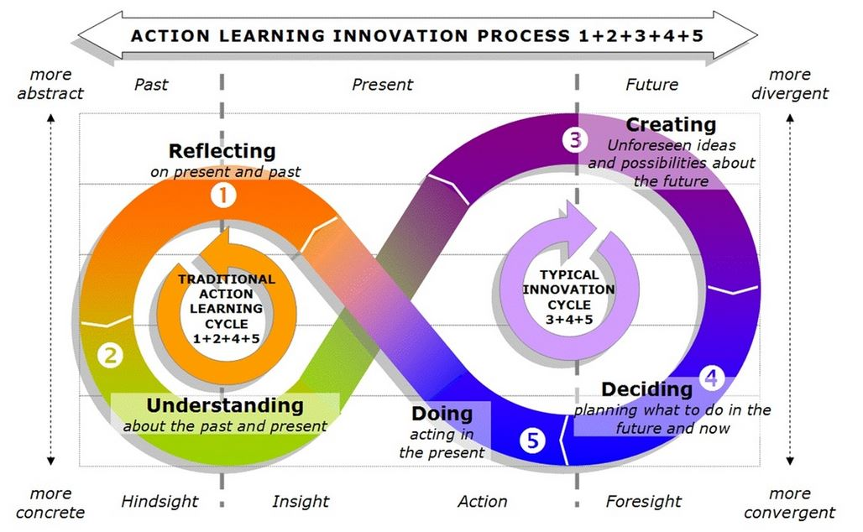

At this module we’ve learn the difference about Uncritical thinking and critical thinking “judging in a reflective way what to do or what to believe” (Facione, 2000, p. 61).
Critical thinking is regularly cited as an essential twenty-first century skill, the key to success in school and work. Given our propensity to believe fake news, draw incorrect conclusions, and make decisions based on emotion rather than reason, it might even be said that critical thinking is vital to the survival of a democratic society
Types of reasoning Inductive and Deductive reasoning, where inductive reasoning involves a probabilistic premise, that make the truth be questionable, beside deductive reasoning starts from a premise that assume to be true which leads us to a conclusion that must be true if our assumptions are true. Also, we learn and practice how to apply this tow theories in order to establish a valid reasoning or invalid reasoning and necessary or sufficient condition
Establish the connection between believes, attitude and values
“Beliefs, values, and attitudes (BVAs) have been an area of high interest for social scientists because of the insight they provide into higher-level cognitions and the influence they have on decisions and behaviour”
Also, we’ve learned what is an argument and how to develop arguments.
“An argument is a set of claims in which one or more of them-the premises-are put forward so as to offer reason for another claim, the conclusion”
After we define the argument, we’ve learned how to validate evidence and how to use critical thinking models

RED which stands for: Recognise Assumption
Evaluate Arguments
Draw Conclusions.

Casual reasoning was one of the last lessons for this term It is based on the idea that for every action, there must be reaction.
Consider these forms of causal reasoning Cause to effect and Effects to cause
The last two courses we talked about Theory of management.
“On many academic programmes change management is positioned as the integrating course because It requires students to reflect on and synthesize the various perspective on organisational function offers by other modules, such as finance, operations management, marketing, organisational behaviour and strategic management “


After this course the information and ideas I got started to take shape in my mind and to have a better understanding of certain aspects that I could not develop or could not reach them. I learned what is logic how to separate deductive reasoning of inductive reasoning, general principles and special cases. The way in which I can apply information that I have learned to realise valid reasoning or invalid reasoning.

References :

McGregor, Douglas, 2000. The Human Side of Enterprise. Reflections (Cambridge, Mass.), 2(1), pp.6–15.

MCGREGOR, Douglas. Theory X and theory Y. Organization theory, 1960, 358.1: 374.

Chapman, A. (2018). McGregor’s XY Theory of Management - BusinessBalls.com. [online] Businessballs.com. Available at: https://www.businessballs.com/improving-workplace-performance/mcgregors-xy-theory-of-management/.

Haber, J., 2020. Critical thinking,
COPY THE CITATION TO CLIPBOARD

EMMANUEL, G. and DELANEY, H., 2014. Professors' Influence on Students' Beliefs Values and Attitudes in the Classroom. Journal of College and Character, 15(4), pp. 245-258.

Mighty Optical Illusions. (2016). Variation of Devil’s Fork Illusion. [online] Available at: https://www.moillusions.com/variation-of-devils-fork-illusion/ [Accessed 24 Mar. 2021].

DUNNE, Paul E., et al. Weighted argument systems: Basic definitions, algorithms, and complexity results. Artificial Intelligence, 2011, 175.2: 457-486.

Hayes, John R, 2002. The Theory and Practice of Change Management,

Christoph M., 2010, Apple's approach towards innovation and creativity, Munich, GRIN Verlag. [online]. Available at: https://www.grin.com/document/167838 [Accessed 24 March 2021].

Ali, M., 2021. Transforming Ford into A Profitable Business. [online] Streetdirectory.com. Available at: <https://www.streetdirectory.com/etoday/-wlflcf.html> [Accessed 24 March 2021].

UKEssays. November 2018. Management behaviour in the Car Industry. [online]. Available at: https://www.ukessays.com/essays/business/management-behavior-in-the-car-industry-business-essay.php?vref=1 [Accessed 24 March 2021].

