  Bibliography
  Modern sources
  Bishop, M., 2013. Handbook to Roman Legionary Fortresses. s.l.:Pen and Sword.
  Miller, B., 2016. Faeces and lice combs show Roman toilets and baths failed to stop spread of intestinal parasites. [Online]
  Available at: https://www.culture24.org.uk/history-and-heritage/archaeology/art544212-intestine-parasite-cambridge-roman-bath-toilet
  [Accessed 17 02 2020].
  Rotherham, I. D., 2012. Roman Baths in Britain. illustrated ed. s.l.:Amberley Publishing Limited.
  Walters, H., 1930. [Online]
  Available at: https://commons.wikimedia.org/wiki/File:Roman_-_Strigil_-_Walters_541926.jpg
  [Accessed 16 02 2020].
  Wikipedia, 2019. Caerleon Roman Fortress and Baths. [Online]
  Available at: https://en.wikipedia.org/wiki/Caerleon_Roman_Fortress_and_Baths
  [Accessed 16 02 2020].
  Figure 4: Bronze Strigil (Roman, 1st century AD Source Walters, H. (2020). File: Roman - Strigil - Walters 541926.jpg - Wikimedia Commons. [online] Commons.wikimedia.org. Available at: https://commons.wikimedia.org/wiki/File:Roman_-_Strigil_-_Walters_541926.jpg [Accessed 16 Feb. 2020].
  Figure 5: Commons.wikimedia.org. (2020). File: Xylospongium.jpg - Wikimedia Commons. [online] Available at: https://commons.wikimedia.org/wiki/File:Xylospongium.jpg [Accessed 16 Feb. 2020].
  Ancient Sources
  Hippocrates, Diseases of Women 2.415.59
  Galen, Method of Medicine 2.499.106
  Caerleon Roman Baths
  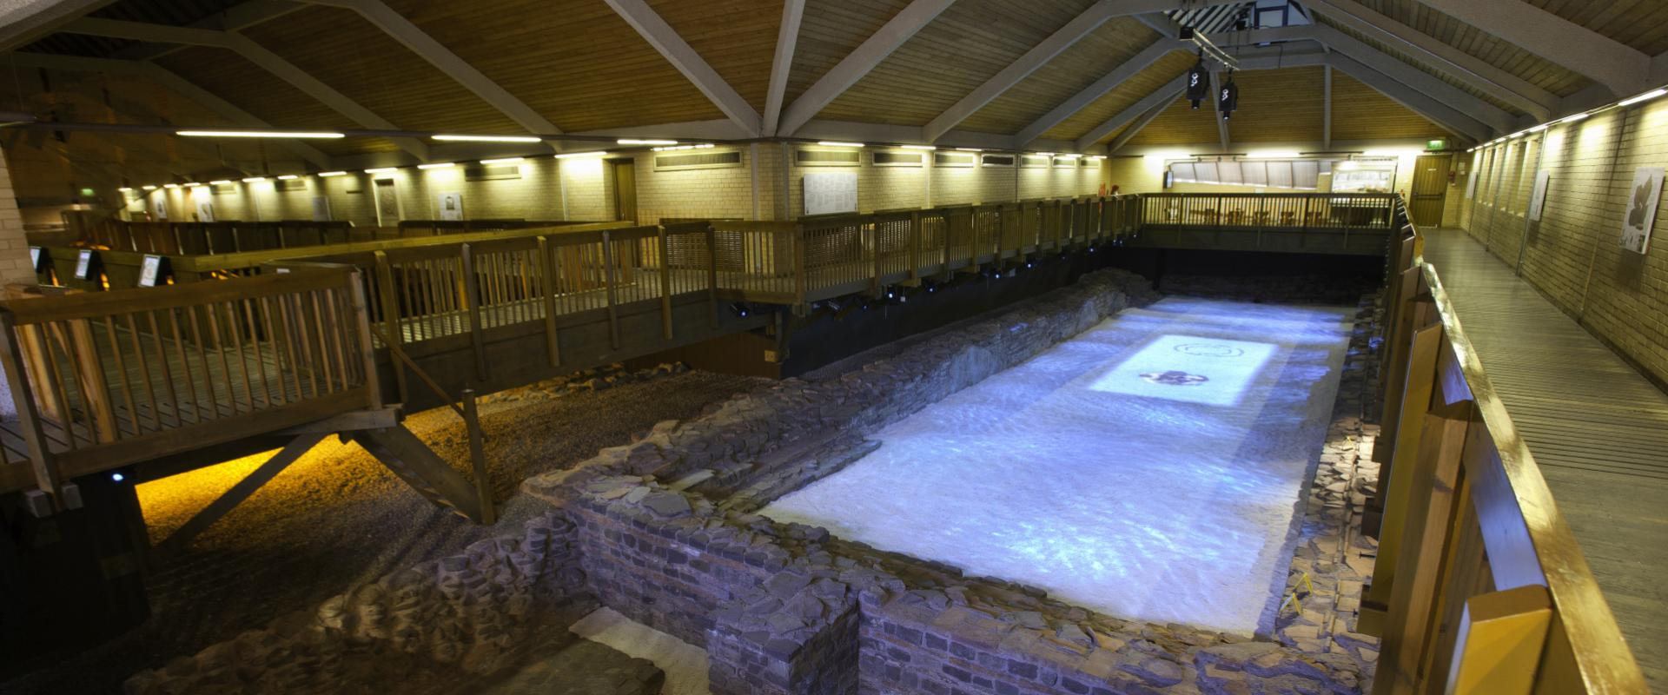
  [Figure 1: Photograph of the Caerleon Roman Fortress and Baths. Source: Cadw.gov.wales. (2020). Caerleon Roman Fortress and Baths. [online] Available at: https://cadw.gov.wales/sites/default/files/styles/banner_image/public/2019-05/SVW-C26-1011-0703.JPG?h=28deffbe&itok=jgLPz9AT [Accessed 16 Feb. 2020].

Facts
- Caerleon has extramural baths as “extramural baths were normally placed close to the fortresses defenses” (Bishop, 2013).
- “Built-in AD 75 was one of only three permanent Roman Legionary fortresses in Roman Britain” (Wikipedia, 2019).
- The open-air swimming pool or the Natatio also had a Frigidarium which was a cold bath hall.
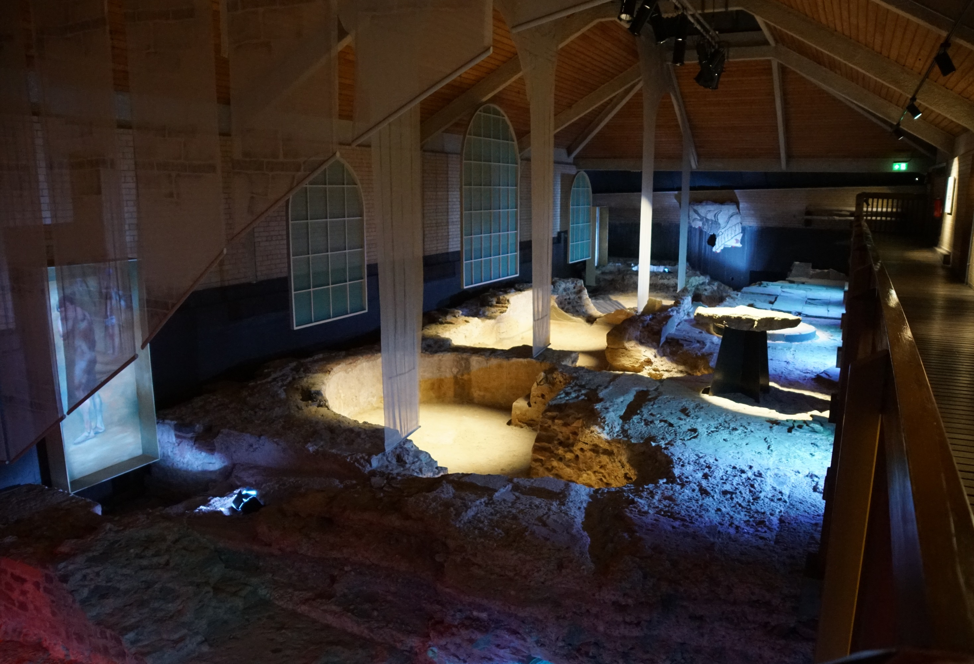
[Figure 2: Caerleon Roman Fortress Bath frigidarium Source: Commons.wikimedia.org. (2020). File: Caerleon Roman Fortress Baths 20171016 frigidarium.jpg - Wikimedia Commons. [online] Available at: https://commons.wikimedia.org/wiki/File:Caerleon_Roman_Fortress_Baths_20171016_frigidarium.jpg [Accessed 16 Feb. 2020].

Historical Context

It was typical for Roman forts to have baths and indeed in archaeological sites such as Pompeii we see more than one bath, typically though the smaller baths or Balneae could house over 500 people.
“Initially they were places for socializing, for discussing important issues, and for transacting business” (Rotherham, 2012).
However, the use of these baths despite being to help regulate hygiene actually had the opposite effect in some cases “Warm water used in the communal bathhouses could have reversed their intended effect, helping spread parasitic worms in baths where scum would build from human dirt” (Miller, 2016).
This can be shown as Galen in Method of Medicine “I kept him away from the bath for a period of many days for the sake of the betterment of the whole body”(Galen)

The Cycle  A Roman soldier would begin the apodyterium or changing rooms and then to the basilica if preferred.  Then begins the series of rooms that would progressively warmer starts in the Tepidarium which was a warm room for bathers with a small pool and a larger one for swimming.  Then the hottest room being the caldarium which was designed to make the user sweat similar to that of a sauna.  Finally, the frigidarium a very cold pool to use after the caldarium.  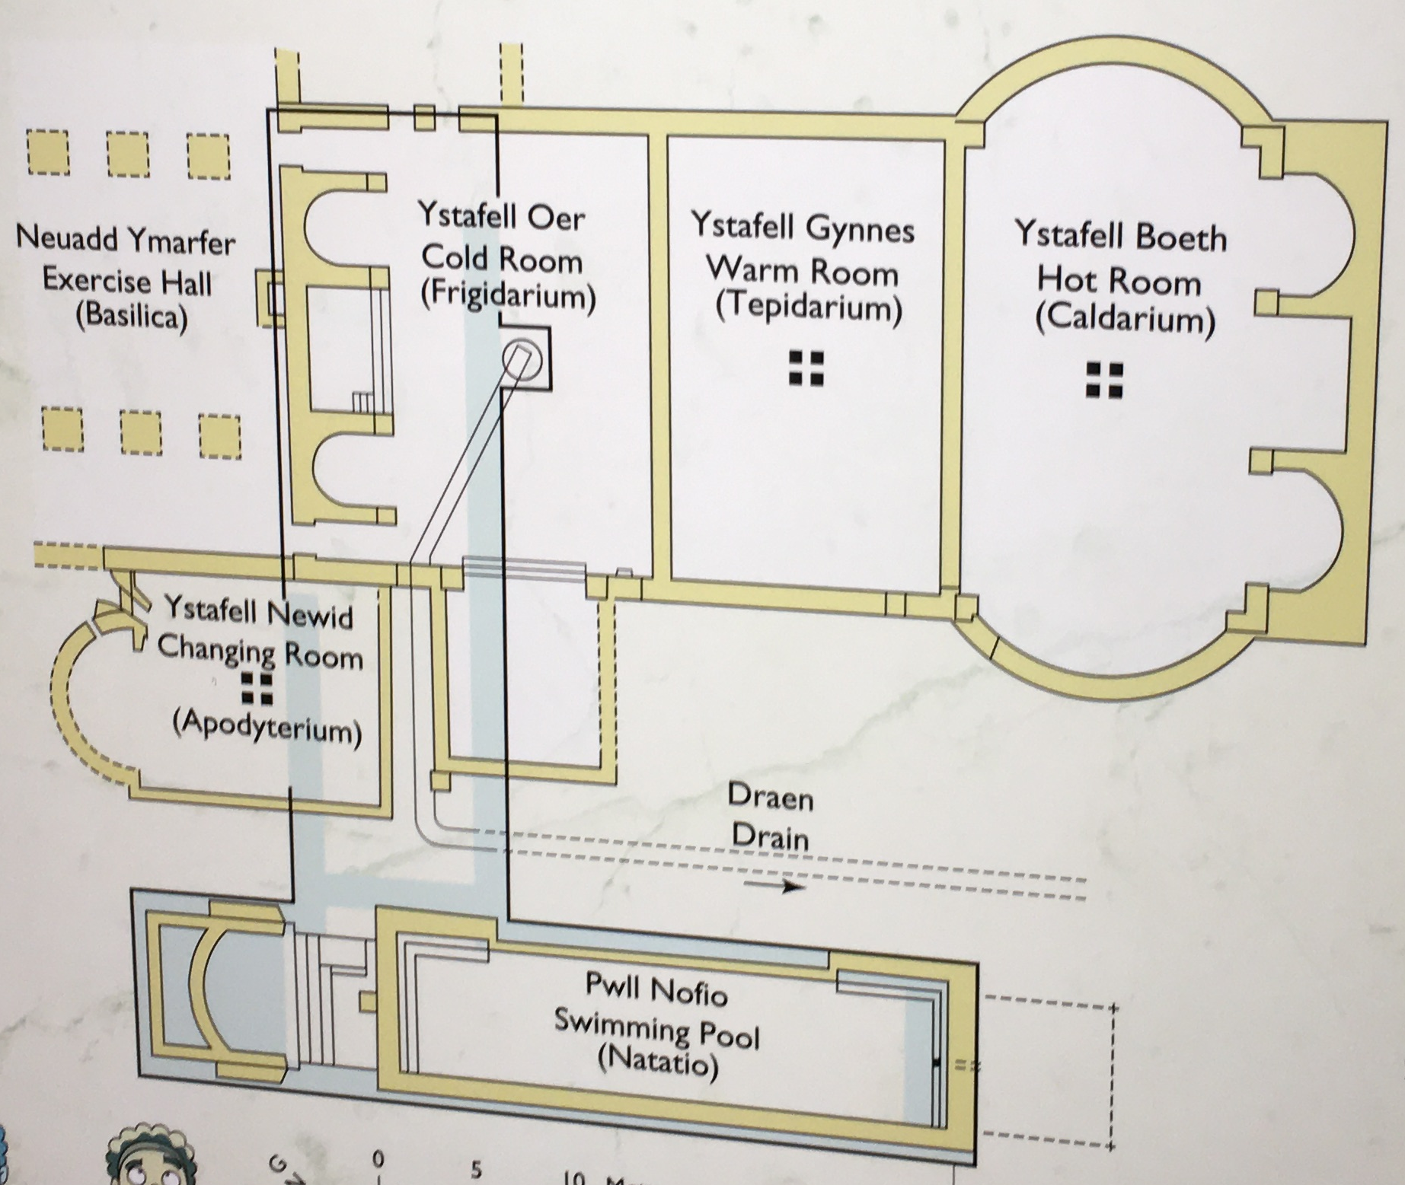  [Figure 3: Map of the bath complex located inside the Baths  Source: Photograph taken By Emily Vaughan 14/02/20] |  |  | Tools  Strigil  Xylospongium
   | “Strigils were used by Greeks and Romans to scrape layers of sand and oil from their bodies after exercising. The strigil and the "aryballos," a small oil container, were the basic equipment of all athletes in the ancient world” (Walters, 1930)
    Figure 4
    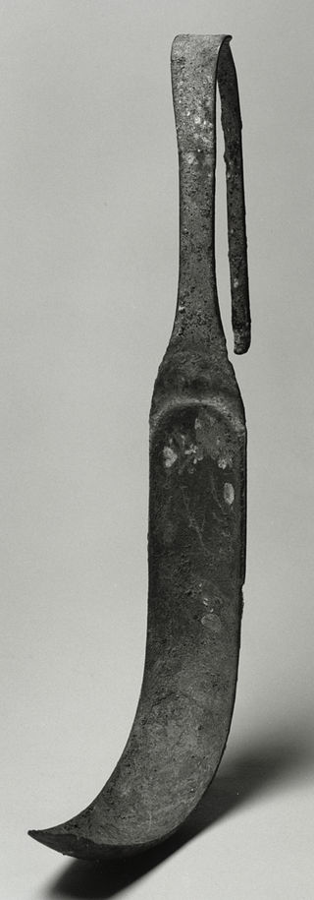
   | Although typically used in communal latrines sponges were also used in bathing practices as they were believed to have hygienic properties.  “Burned sponge is helpful: grind the sponge smooth and give it with fragrant wine” (Hippocrates)
    Figure 5
    

