10/06/2020
Application Development (ACCA5012)
Kyle Lovell (1802143)

Contents
Abstract 2
Requirements 2
Control Scheme 2
Goals 2
Design and Implementation 2
Collision Detection 3
Key Controller 3
Lifetime Keys Tracker 3
Door Controller 3
Compass Angle 3
Application Screenshots 4
Level 1 4
Level 2 4
Enemy 4
Key 5
Chest 5
Evaluation 5
Collision Detection 5
Preconditions or prerequisites 5
Test Steps 5
Expected Result 5
Actual Result 5
Status 5
Screenshots 6
Key Controller 6
Preconditions or prerequisites 6
Test Steps 6
Expected Result 7
Actual Result 7
Status 7
Screenshots 7
Compass Angle 8
Preconditions or prerequisites 8
Test Steps 8
Expected Result 8
Actual Result 8
Status 8
Screenshots 8
References 9

Abstract
In this report, the author, Kyle Lovell, will talk about the main features of his game, including the control scheme, goals, and UI components. He will also show test results for each of the main core features of the game.

Requirements

Control Scheme
The player can move in the 3-Dimensional space using WASD with W being used to walk forward, A being used to strafe left, S being used to walk backwards, and D being used to strafe right.
To turn, the player will use the mouse. The player will be unable to change the sensitivity of their mouse, however this functionality can be added in a later update.

Goals
To complete each level, the player must collect seven (7) keys scattered around the map, simply by running into them, whilst avoiding an AI-controlled enemy. If the player gets close to the AI enemy, the enemy will start to chase the player, and will continue to chase the player until either the player is caught or until the player increases the distance between the two. If the player manages to get away from the enemy, the enemy will revert to its original path, being able to find their own way back via pathfinding.
Once the player has collected 7 keys, a room containing a chest will become accessible. The player will need to run into the chest to collect it, which will show the player a victory screen, allowing them to press Y to move onto the next level, or press N to quit the game.
To make the player’s job of finding the keys / chest easier, the author has included a compass in the bottom-right corner.

Design and Implementation
In order to create their game, the author created the following methods:
- Collision Detection
- Key Controller
- Lifetime Key Tracker
- Door Controller
- Compass Controller

Collision Detection
The largest of the author’s methods, the collision detection method is responsible for telling the player character, keys, and chests what to do in the event of a collision. If the player were to collide with a key, the keyCount variable (which is displayed in the top-left hand corner) would be incremented, the lifetimeKeyCount variable (which is displayed in the top-right hand corner upon the player pausing the game using the Space key), would be incremented, and the key that the player collided with would be deactivated, and another key would be activated, except in the case that keyCount is equal to seven, in which case the door blocking the path to the chest would be deactivated using the Door Controller method.
If the player were to collide with a chest, the chest would be deactivated, and the victory screen would be shown to the player. If the player is on Level 1, they would be given the option of either proceeding to Level 2 or ending the game. If the player is on Level 2, they would only be able to end the game, as there are only two levels.
If the player were to collide with an enemy, the player will be faced with a game over screen, allowing them to choose to either restart the level or close the game.
This method works with the key controller method, as the collision detection method tells the key controller to deactivate the current key, and then activate a new key.

Key Controller
The key controller was used to randomly choose between a list of keys. This randomly chosen key would then be made active, allowing the player to find and collect it. This method works with the compass controller, as the compass will point towards whichever key is currently active.

Lifetime Keys Tracker
The lifetime keys tracker, which is included in the MiscManager script, is responsible for creating, editing, and displaying the lifetime number of keys that have been collected by the player. It does this by using Player Preferences, a function included in Unity.

Door Controller
The door controller, which is the smallest of the author’s methods, is simply used to disable the door blocking the player’s way to the chest. It does this when the player collects the seventh key.

Compass Angle
The compass angle method is used to rotate the compass located on the player’s Heads Up Display (HUD) so that it points toward the current active key (or chest if all the keys have been collected).

Application Screenshots

Level 1
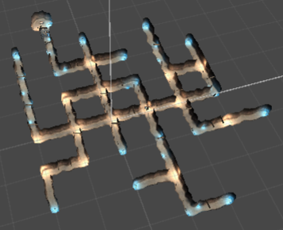

Level 2
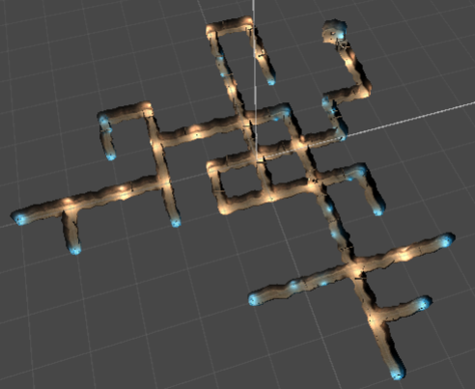

Enemy
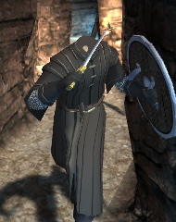

Key
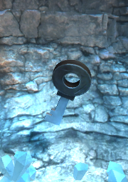

Chest
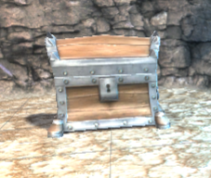

Evaluation
In order to make sure that the author’s game works correctly, the author will be testing some of the main components of his application.

Collision Detection
To test whether the author’s collision detection system works, the author will cause the player character to collide with an enemy. As the same code is used for key and chest collision, the author will not need to test these. The expected and actual results, as well as before and after images, will be shown below.

Preconditions or prerequisites
For this test, there are no prerequisites

Test Steps
For this test, the author will simply hold the W key to walk into the enemy.

Expected Result
Once the player character collides with the enemy, game over text will display, asking the user whether they wish to retry or quit the game.

Actual Result
When the player character collided with the enemy, the game over text displayed.

Status
Pass

Screenshots
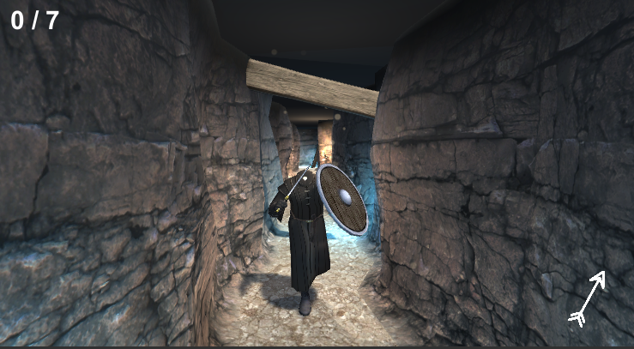
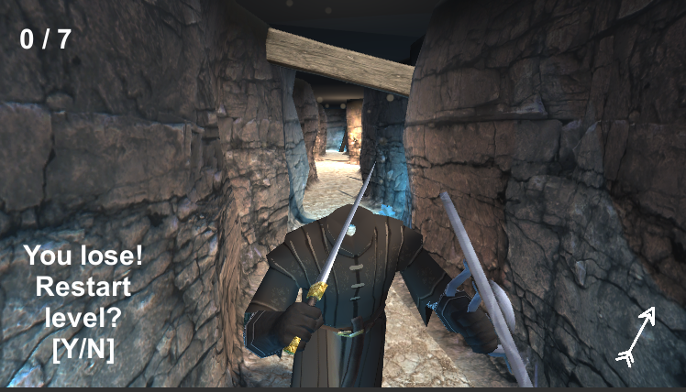

Key Controller
To test whether the author’s key controller works, the author will collect a key to test if the key controller deactivates the current key and activates a new key.

Preconditions or prerequisites
For this test, there are no prerequisites.

Test Steps
For this test, the author will find and collect the first key.

Expected Result
Once the player character collides with the key, the key should disappear, and a new key should appear somewhere else on the map. The latter will be shown by a change in the compass’ angle.

Actual Result
When the player character collided with the key, the compass’ angle changed, indicating a new key had spawned in that direction.

Status
Pass

Screenshots
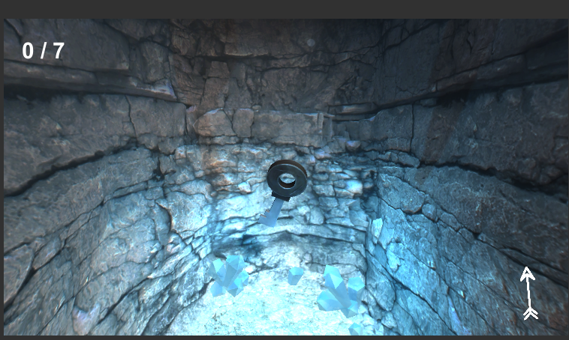
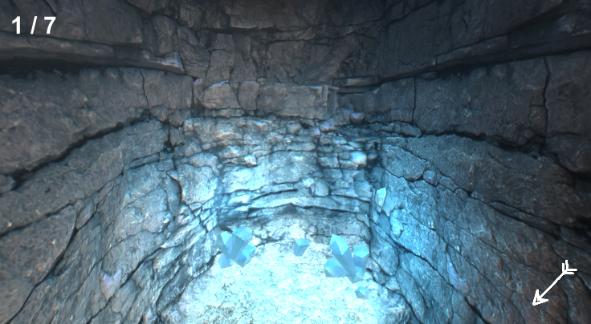

Compass Angle
To test whether the author’s compass works correctly, the author will simply rotate the character 90 degrees. The expected and actual results, as well as before and after images, will be shown below.

Preconditions or prerequisites
For this test, there are no prerequisites

Test Steps
For this test, the author will simply use the mouse to turn the character 90 degrees to the left.

Expected Result
The compass should continue pointing at the key.

Actual Result
The compass continued to point at the key.

Status
Pass

Screenshots
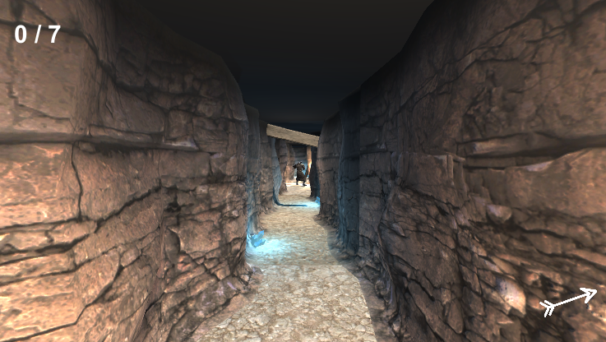
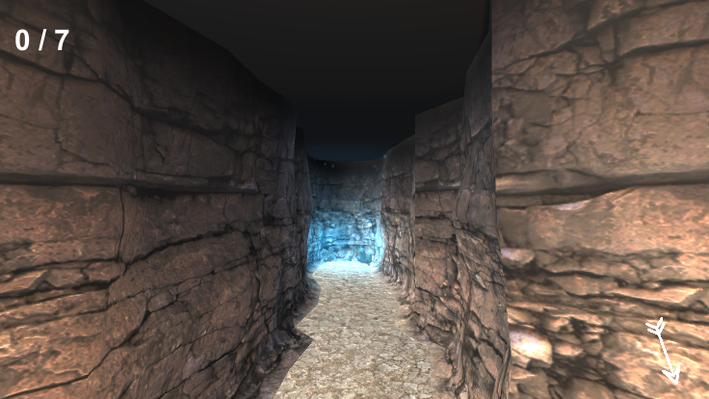

References
All of the code created by the author was either developed with the knowledge obtained through university lectures and tutorials, or using the Unity3D documentation found at https://docs.unity3d.com/Manual/index.html

