Abdul Shahid 0352098
Module code BMSW6103
Module name - Leading and Implementing Workplace Change
Assignment title - An analysis and critical review of a medium to large organisation and its change process.

Executive summery
Change is a key factor in any organisation, even though change comes with resistance eventually all change is necessary in order to have a saucerful organisation. Due to the SWOT and PESTEL factors the operational changes are strategy planned and implemented. Change is seen as the opportunity to survive and grow, and some see it as a threat both within the organisation.
Covid-19 has played havoc in the lives of many people. Changes have needed to be made in order to fight against covid-19 and the constant change of government legislations. Many organisations have needed to change their strategies to fight covid.

Table of context
1.0 terms of reference…………………………………………………4
2.1 the McDonalds story……………………………………………….5-6
2.2 reason for change……………………………………………………7-9
2.3 change models…………………………………………………………10-12
2.4 leadership-management of complex areas………………13-14
2.5 the change agents…………………………………………………….15-16
2.6 culture……………………………………………………………………..17-19
3.0 conclusion……………………………………………………………….20
4.0 recommendations………………………………………………….21
5.0 appendices…………………………………………………………..22
6.0 references……………………………………………………………..23-25

1.0
The COE or McDonalds requested this report. This was requested on 1st on February 2022. The purpose of the report is to examine change in the McDonalds industry. The manager of McDonalds compiled the report. This will be submitted on the 4th of march 2022.

2.1
McDonald’s today is one of the largest chain restaurants in the united kingdom with more than 1200 outlets. McDonalds sell fast food including burgers and fries. McDonalds was originally established by the McDonalds brothers in California in 1940 and Ray Korc expanded the business through franchising agreements in 1953
The first British branch was opened in November 1974 in the suburb of London at Woolwich.
The head office at the time was in Hampstead, north London.
In 1975 McDonalds made their first advertainment on the UK cinema.
McDonalds made a modest start in the first day takings making £98.
In 1976 the very first advertisement on tv was broadcasted and in 1978 the head office was relocated to Edgeware road, London.
In 1982 the breakfast was introduced to the menu. Again, the head office was relocated to its current site at East Finchley, north London.
In 1983 the 100th restaurant opened in Manchester, market street.
In 1984 for the benefit of the customers McDonalds became the very first restaurant in the UK in introducing nutritional information throughout the country.
In 1986 drive through restaurants opened up in Fallowfield, Manchester, Dudley, Neasden (London) and Coventry. In that year, the happy meals were also introduced.
In 1989, RMCC (Ronald McDonalds children’s charity) had been registered as an independent charity, which was later known as RMHC (Ronald McDonald house charities.
In 1994 McDonalds celebrated 20 years of serving the UK. And in 1995 the 600th restaurant had opened up at the motorway service, Woodhall area (m1). Also, that year McDonalds became the official restaurant of the football association premier league.
In 1997 the 800th restaurant had opened at the London’s former county hall. McDonalds was recognised as an investor in people and in 1995 celebrated the 25th anniversary in the UK.
In 2000 McDonalds launched the website www.mcdonalds.co.uk.
In 2012 Farm forward was launched in order to support British and Irish farmers. McDonalds had achieved 6th position for being the one of the best 25 companies to work for.
In 2014 McDonalds celebrated 40 years in the UK.
The way customers order their food and how the staff are trained to deal with these new situations which arose due to covid factors is the main change which will be looked at in this report.

The table below shows the current McDonalds current profit loss account. As it shows it is during very well, even better then normal during this covid-19 pandemic.
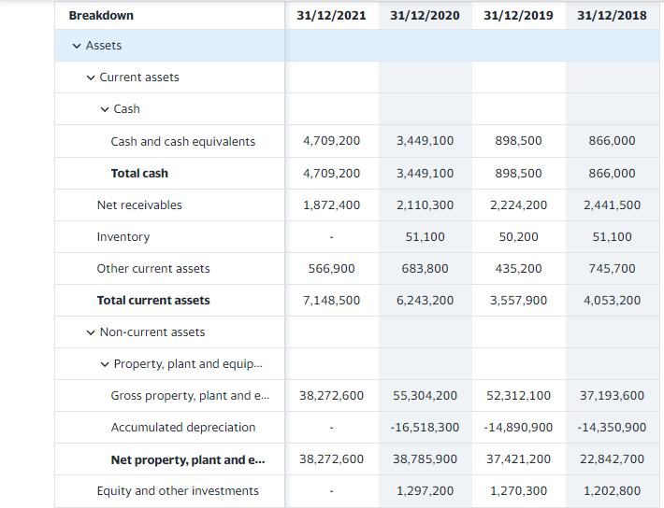

2.2
The reason for this change was forced upon not only McDonalds but the entire world itself. In order to succeed and adhere to government legislations these changes had to be made immediately.
Although McDonalds is one of the biggest fast-food chains in the world, the corona virus had such an impact that nothing could have prepared the company for it.
Going into the local McDonalds is nothing like it used to be two years ago. Where there was no plastic barrios nor social distancing markers and the menu itself had had dozens of items to choose from.
For the employees and customers alike, masks have become compulsory for ordering and eating inside. During the early days of the pandemic many fast-food chains including McDonald’s were required to be wearing masks inside and also social distancing between staff and customers where possible thus following the health and safety guidelines.
Whereas social distancing was essential during this pandemic sometimes it was hard for staff to truly maintain the distance as kitchen space was at a minimal.
Although both dining in and drive thru were available before the pandemic. During the start of covid McDonalds had closed the dining room facilities they also urged other franchises to do the same.
Only until covid 19 had been made under control would the thus allowing the restaurants to open back up. Although not all restaurants did open back up and a lot of them focused of drive through only. This had a great impact on employees as a lot of them had to be made redundant due to complete closure of the dining inside.
Plastic barriers is now the commonplace in fast food chains like McDonalds, which were not used before the pandemic. It is unclear whether these barriers will ever be removed even after the pandemic has subsided.
McDonalds decided to limit their menu as well which not only effected the customers but the staff alike as with a smaller menu lesser staff would be needed to make the food thus making employees redundant again. But McDonalds were making money as lesser items would mean less stock to purchased thus saving money and having to pay less wages. But this had a negative impact on the lives of the employees as in the beginning the furlough money was being paid to employees who were out of the job but as soon as the furlough scheme ended the payments were stopped thus meaning the employees needed to look for other jobs which was really forced upon McDonald, and it is not something the business wanted to or planned to do.
Contactless ordering systems were introduced where customers can order on a mobile device and collect the order or have the order delivered to a location of the customers choice.
McDonalds had mobilised the leaderships teams in order for making better decisions. McDonalds had developed a structured team and an agile model which supported the decision-Making integration. A leadership team for covid-19 led the changes, reported to all senior leadership, they met three times a day to address the quickly changing information thus evolving recommendations.

A lot of the change was due to micro/macro environmental on the need for change
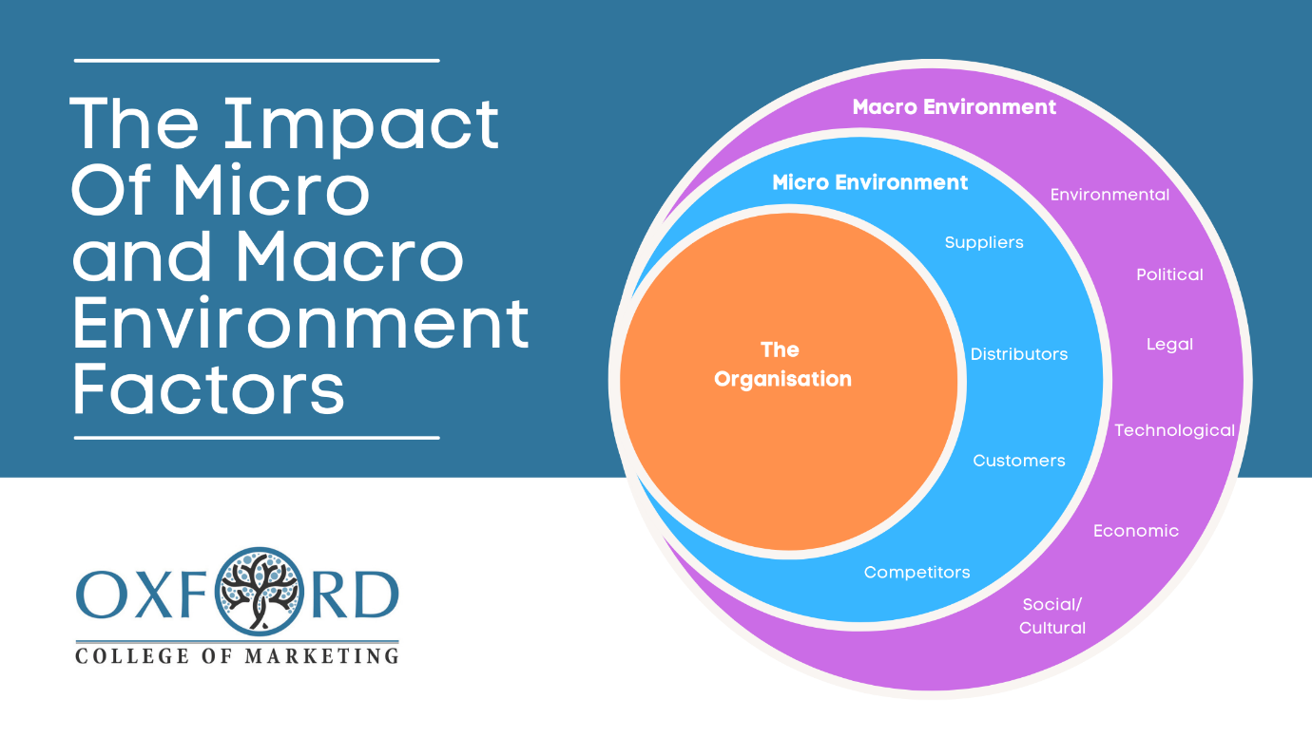
What is micro-environment
The micro-environment is the environment that has a direct impact on your business. It is related to the particular area where your company operates and can directly affect all of your business processes. In other words, it consists of all the factors that affect, particularly your business. They have the ability to influence your daily proceedings and general performance of the company. Still, the effect that they have is not a long-lasting one.
The micro-environment includes customers, suppliers, resellers, competitors, and the general public. (Understanding Of Micro And Macro Factors That Affect Your Business, 2021)
What is maco-environment
The macro-environment is more general - it is the environment in the economy itself. It has an effect on how all business groups operate, perform, make decisions, and form strategies simultaneously. It is quite dynamic, which means that a business has to constantly track its changes. It consists of external factors that the company itself does not control but is certainly affected by.
The factors that make up the macro-environment are economic factors, demographic forces, technological factors, natural and physical forces, political and legal forces, and social and cultural forces. (Understanding Of Micro And Macro Factors That Affect Your Business, 2021)

Micro factors
Suppliers played a great roll on what can be supplied or not. The success of the business is down to suppliers and due to covid supplies were short coming in.
Resellers here helped a lot during this pandemic as Deliveroo or unber eats. These are websites where customers would be odder from McDonalds and Deliveroo or uber eats would collect the order from McDonalds and deliver it to the cutometers address thus limiting contact between McDonalds and the customer as payment would have been made online.
Costumers here played a key role during this pandemic. The buying preference or patterns were analysed this creating new ways of fulfilling these demands.
The competition. McDonalds were one of the first to shut the doors on the restaurant and keep the drive through open only thus limiting the contact between customers and employers then others had followed suit by also closing the restaurant side down.
The general public. McDonalds adhered to all the government rules for example mask and social distancing rules, as it is a duty of McDonalds to look at the safety of the public. The ultimate goal of having a successful business is down to the help of the general public as this can also prevent McDonalds from archiving their goal by not ordering from McDonalds. So, McDonalds had to make the public feel safe in order for them to feel comfortable when purchasing from McDonalds.
Th macro factors.
Demographic forces played a key role as to how far customers needed to travel in order to collect the food. Also, the age or customers had impact as children had lesser guidelines to follow then the adult.
Economic factors. Greatly impacted McDonalds as covid rules meant restaurants were forced to close down as the virus was spreading greatly and to ease the spread the closing of restaurants were a necessity.
Natural/ physical forces did not play a factor in the decision making.
Technological factors were of great use during the pandemic. Where customers would walk into the restaurant and rather than order with the staff they were able to order on the screen and pay contactless thus limiting contact with employees. Click and collect was also a remarkable success as customers would order on the phone and collect at a designated parking slot thus limiting contact with employees.
Political and legal forces. Played a great roll in McDonalds being able to operate as rules such as social distancing or shutting the dinning side down had to be adhered to or sanctions would have been given if the rules were not followed.
Social and cultural forces. Did not play a key role here as lockdown would not affect the environment.

2.3
Change models.
McDonalds used the Kurt Lewin three stages model.
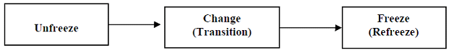
Lewin's three stage theory of change is commonly referred to as Unfreeze, Change, Freeze (or Refreeze). It is possible to take these stages to quite complicated levels, but I do not believe this is necessary to be able to work with the theory. But be aware that the theory has been criticised for being too simplistic.
The world has changed since the theory was originally presented in 1947, but the Kurt Lewin model is still extremely relevant. Many other modern change models are actually based on the 3-stage Lewin model (The Kurt Lewin Model Of Change, 2022)
McDonald’s unfreeze stage was. It was accepted and forced that a change was necessary. The braking down of the existing status quo and building up a new way of operating was essential.
They key here for McDonalds was that the existing way of doing things could not continue and covid rules had to be adhered to. This part of the change was the most stressful and difficult as McDonalds was entering the unknown yet pushed to it. Even though this would put things off balance it had to be done. The reaction of people was strongly evoked by McDonalds, and that is what is needed to be done in order to build a strong motivation seeking new equilibrium.
McDonald realised that restaurants had to be closed during lockdown and social distancing rules would have to be followed in order to keep serving the customers safely. Although McDonalds had a greater hand from their competitors as the drive thru facility were there prior to covid 19 some changes needed to be made in order for them to operate efficiently.
McDonalds ensured the staff were aware the change needed to be made thus motivationg staff to be willing to change for the better of McDonalds and the customers. Effective communication from McDonalds played a key role in effectively communication vital rolls in order to get the desired support and involvement from the people involved in the change process.
Stage 2 was the change.
This is where some of the seating sections were closed, social distancing was implemented, masks were made mandatory, plastic screens were put across tables as partition, contactless orders were being taken. Sanitisation of each and every equipment was necessary after each use. Staff here at McDonalds began to realise this change and resolving issues which arise during the change and embrace the new direction proactively participation in the change.
Although transitioning from unfreeze would not normally happen overnight in normal circumstances, this actually did happen overnight at McDonalds and time was at the essence and there was no time to think but to jump into this change.
To make the change effective, McDonalds communicated often and clearly throughout the implementation and planning stages. McDonald’s always described the benefit to this change, explaining how it would affect people and everyone id prepared for that was about to come. McDonald’s always involved employees in the decision making as it made an easier transition to the change.
Stage 3 refreezing.
McDonalds has created a sense of stability from this change. Even though change is constant in any business the refreezing state is still very important. This is where staff do not get trapped on how things need to be done. In order for McDonalds to maintain the change it needs to identify what supports the change, what are the barrios to sustaining the change and always keep everyone informed and supported.
The advantage of Lewin’s change model are.
It is easy to understand as a lot of the change models take a lot of training to get it perfect for example the Kubler Ross change curve
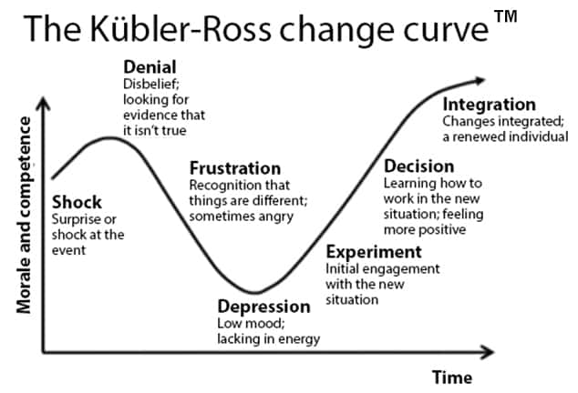
As you can see the curve has a longer and more detailed process and would take longer to undertake. McDonald’s did not have time to incorporate this model as government legislations were changing daily and this change curve would not be suitable. If a more planned change process were available then this change curve would have been more suitable then the Lewin change model.
Some disadvantages of the Lewin theory are.
The model itself is not detailed enough. Some people think the management model is too simple. The steps can be interfered in different ways and other use of models are often needed to fill the blanks in.
The model itself is too rigid which does not reflect modern times.

Benefits of using a change model to help in the change process.
The change itself is a managed process which is planned rigorously. Before the implementation is done the benefits are already known and acts as motivators and the assessment of progress.
Customer demands can be met faster. The overall impact of the change can be assessed by the organisation.
Without effecting the day to day running of the business change can be implemented. It provides a way to anticipate incoming challenges which then can be responded to effectively.

2.4
Leaders themselves are not immune to expectation and the pressure which change causes, as employees will look to the leader for clarification and also accountability particularly during the midst of a change.
In this change process the leaders helped towards this change, as I have explained before due to covid events were sprung onto McDonalds and there was not enough time to plan the change process it was forced upon so these leaders were making impulsive decisions which would help the business see out the covid-19 period.
For some leaders it is varying to the reason for not adopting the correct mindset. The allocation of time and resources towards the prospect of revenue is of great paramount versus change initiatives. Some may find it difficult in gaining the support needed in this consensus- driven culture. Some leaders are unwilling to share their expertise for the good of the change initiative. A lot may want to avoid the risk of their career if failure did occure due to the change.
During change, due to trial and error a lot of leaders learn how to effectively lead. during this pandemic trial and error would have been the best as if one method did not particularly work, another method could have been brought in to accommodate the change. As again this change was forced up to so trial and error would be best.
At McDonalds, the leaders successfully managed the change, thus did not let the change manage MacDonalds. McDonalds made sure they did not fall short of fulfilling their expectation, as the employees may have become unmotivated confused or even disillusioned, in turn McDonalds would have been the one that suffers due to bad leadership in the change process. Here at McDonalds the change was fulfilled effectively and were made efficient, thus meeting the expectations of employees and stakeholder etc.
At McDonalds, the change plan was communicated effectively. The leadership team involved in the change process managed to get all employees on board and buy into the vision of McDonald’s. Communication occurred consistently between leaders, no matter if it was for a serious change program or day to day issues. The message here was clear and always consistent.
McDonalds leaders always stayed connected to the employees as the end result will be the employees implementing these changes and serving the customers. Without this awareness it is exceedingly difficult to explain the vison and support being enlisted.
During the time of change McDonalds leaders were transparent and always accountable for what was working and what was not working. Being accountable will always yield the best result through desire and commitment. McDonalds were accountable here by letting employees see behind the doors what was taking place and how things are going. A leader who id accountable will look at all the aspects of the business in terms of process, culture, employees and management, this ensures that everyone is functioning optimally. If not then a good change leader must be willing to admit the short coming and take actions for filling the shortcomings.
Remember, perceptions of leaders are often shaped during times of transition and change. The principles outlined above help leaders conquer the change management challenge. Do not let people question your leadership and the mission of the organisation. Such questions, undermine employee commitment to the change initiatives and their allegiance to you and the company. Additionally, these leadership questions may ripple out to your customers, partners and stakeholders. (Deshler, 2021)
Do not abdicate change management to others, such as HR, or leave it to chance because you think people will “get it” the first time. You have to take full responsibility, understand the mindset of your team, enlist their support and hold them accountable.
The role of leadership in change management requires care, communication and commitment. As the leader, you are the bridge between your organisation and the envisioned change. If you understand your role and the expectations around it, clarify your vision, communicate effectively, and hold yourself and others accountable throughout the change process, you can successfully navigate even the most disruptive change. (Deshler, 2021)

2.5
A change agent, or agent of change, is someone who promotes and enables change to happen within any group or organisation. (Pratt, 2022)
In business, a change agent is an individual who promotes and supports a new way of doing something within the company, whether it's the use of a new process, the adoption of a new management structure or the transformation of an old business model to a new one. (Pratt, 2022)
A change agent is sometimes also called an agent of change or change advocate. Champion and change agent are sometimes used interchangeably, as well; however, some see differences between the roles each one plays in supporting change, with a change agent having more responsibilities and accountability than a champion for ensuring that change happens successfully. (Pratt, 2022)
McDonalds used its existing executives and managers as change agents, as to bring an external change agent will have needed time to analyse the company and input their plans. During covid there was not much time in bringing someone in and getting advice, the internal change agents will already have knowledge about McDonalds and will be fully equipped to manage the change and pass on the ides and success to the employees. Here at McDonald’s the change agent came in the form of lower level of management and employees. They have first-hand experience on how to deal with the reconstruction of the seating area along with making social distancing rules in the waiting area or the kitchen. As they work there every day they would have a greater knowledge of the layout of McDonald’s rather than an executive or director for example.

Change agents were used in promoting the value of the transformation that was being undertaken by McDonald’s. It was important in acquiring an internal change agent as employees were already familiar with these agents as guiding them will be a lot easier during this transition period. Thus, ensuring the new procedures and rolls are implemented which still delivers the expected value for McDonald’s. Internal change agents can quicky change plans if they do not work as intended, whereas external agents may take a longer period to rectify these problems.

The change agents in McDonald’s took on a number of responsibilities in terms of new ways of customers ordering food safely, preparing the food safely managing all seating area as the paramount idea here was to keep employees and customers safe from covid-19.

The advantages of having a change agent are.

As employees are working towards a goal the motivation will be increased to achieve this milestone.

They help with the alignment of the existing resources within the organisation.

Employees concerns being addressed, allowing the business in becoming more effective and efficient.

The moral is boosted overall as employees needs and wants are considered within this change process.

The organisation becomes more efficient increasing the opportunity to gain experience and be more innovative in the future.

Some disadvantages are.

The actual change may not lead to the organisation to being successful.

Changes are often time consuming and costly, but McDonalds needed to do this as they had to ader to government legislation.

There will always be resistance when it comes to change. No matter how small or big it in, colleagues sometimes find it to settle into a new routine.

2.6
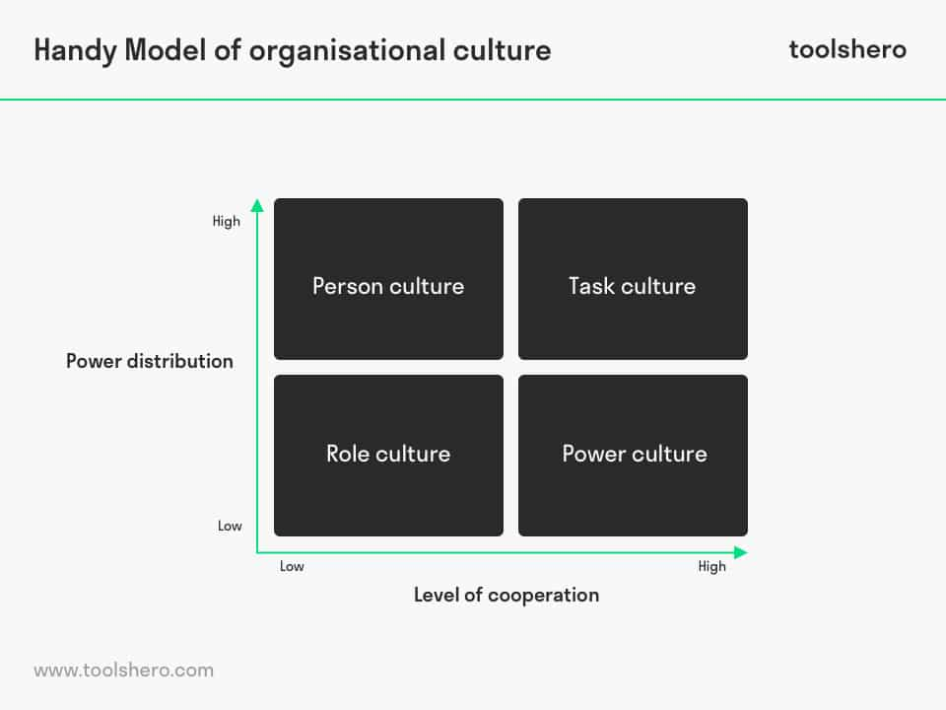
Above is Handy’s model of organisational culture.

Power distribution is all about the extent to which the top of an organisation (management or owner) is open to working with either a bottom-up or top-down approach. In case of a bottom-up approach, the power distribution is very high; employees are expected to take their own responsibility, determine their tasks and make independent decisions. (Handy Model of Organisational Culture, 2022)
In case of a complete top-down approach, there is hardly any power distribution; management or the owner is completely in control and is the only person making decisions. (Handy Model of Organisational Culture, 2022)
The cooperation level, as the name suggests, is about the degree of cooperation between the various departments and employees. A lower cooperation level means everyone works for themselves and hardly requires the help of colleagues. (Handy Model of Organisational Culture, 2022)
A high cooperation level, on the other hand, involves close, indispensable cooperation between colleagues. The combination of the two dimensions results in four organisational cultures: Role culture, Power Culture, Person Culture and Task Culture. (Handy Model of Organisational Culture, 2022)
Role culture. Has low power distribution and a low degree of cooperation. here at McDonald’s this type of power would not normally be successful but due to covid strict rules were applied in the workplace and this had to be followed by all the employees thus creating a safe environment for all customers and employee alike.
Power culture. The CEO’s of MacDonalds here, make the decision of change as they find It difficult to delegate the decision making, the employees here have helped build the company thus are very loyal to McDonald’s and each other. Due to the change having been made due to covid-19, in this culture, it is essential to have extremely good cooperation. the power lies with the CEO’s but here at McDonalds employees are loyal to the CEO’s. McDonalds here as a result is highly flexabile. As the relationship between employees and the CEO is decided by the CEO. Immense importance to power is attached.
Person culture. Due to the change being made due to covid-19, this culture was best suited to MacDonalds. This is where after the CEO’s made the new rules it was left to the employees and managers to implement these changes in the workplace. As the employees would have more knowledge of the everyday running of McDonald’s in terms or serving customers.
Task culture. This culture due to covid changes was not very effective.
The impact of culture on the change process. Executive leaders need to manage the culture of an organisation effectively as this is the most significant strategic variable.
The leading of cultural change offers a blend of practice and theory in a thorough providing and engaging way, which enables smarter actions and decision making to cultural activities of change.
Why it is important. Cultural transformation is involved to which degree the change is required. The understanding of culture change is needed within these organisations. The dynamics of the problem need to be apricated of leading cultural change, it is needed the understanding of the cultural theory and the organisational development which are drawn from the behavioural science.
Organisational culture and managers. For the managerial experience, organisational culture remains the most critical aspect. The change strategy fails if the change strategy is incompatible with the organisations culture.
Managers can find themselves trapped within their current market dynamics, unable to escape the clutches and influence of established cultural paradigms as they try to navigate serious strategic change. As a consequence, they need to have some developed conceptual and practical framework for both understanding organisational culture and for working with its dynamic processes. Culture controls expression, and how organizational members express themselves impacts the strategic potential of the organisation. (Potter, 2022)
The customer needs – the product or service would need to meet the needs of customers, as if it does not then it may be time to evolve the product to meet them needs.
Organisation culture does affect change.
Some of the aforementioned factors that affect change are very black and white. You either have the budget for change or you do not. (How Does Organizational Culture Affect Change?, 2022)
Customers either need a new feature or they do not. (How Does Organizational Culture Affect Change?, 2022)
When people become involved, though, the situation becomes more complex. (How Does Organizational Culture Affect Change?, 2022)
Employee support depends on:
- What is in it for them – that is, how they will benefit from a change
- How much extra work is involved
- How the end result will impact their jobs, their salaries, their long-term career prospects, and so forth
- Their general attitudes towards change, innovative ideas, and new things. (How Does Organizational Culture Affect Change?, 2022)
This last point is where culture comes in – because it can be viewed as the “central pillar” that strongly influences many of these other factors. (How Does Organizational Culture Affect Change?, 2022)

3.0
It can be said that this covid-19 pandemic has been an eye opener for the whole world. In terms of how it has affected people lives and the environment itself. Noting could have prepared people for this pandemic and business suffered with all the lockdowns and new legislations during this pandemic.
But McDonalds has gone from strength to strength and in theory has been performing better than pre pandemic. McDonalds have been lucky as drive thru’s have been running from before this pandemic and even though government closed the seating side of restaurants McDonalds were still able to operate through the drive thru ordering system along with delivering food to customers homes through uber eats and Deliveroo. A lot of the restaurant side of McDonalds have fully closed down the restaurant side and are only focusing on drive thru and delivering. This has made operating for McDonald better as less staff is needed to run McDonalds thus making greater profit although it is not good for the unemployment figure but for McDonalds it is about making a profit.
The Lewin three stage theory was effective during this pandemic as it was a simple theory to follow as government changed legislation every day, McDonalds had to adhere to these legislations and this theory was quick and effective where all managers, employees and CEO’s were all on board instantly.
The use of internal change agents was of great benefit to McDonalds, as again for the lack of time, to bring and external change agent would have been at a disadvantage as they would need to be trained to talk the McDonalds way and be taught how McDonalds operates, whereas the internal change agent is already equipped with the knowledge and can make instant decisions if and when needed. Also, by using an internal change agent, employees would feel more comfortable as they would be familiar with the agent and can leases with them together in making a better decision for McDonalds. Whereas an external agent may hinder the progress short term as employees would feel, they themselves have better knowledge of the MacDonalds way. this may have created a low morale for the employees which would lead to lower performance for McDonalds.
However, in order to succeed in the long run external agents will be better as they can see from the outside what is wrong with McDonalds and how to fix these problems. Whereas internal agents may become too comfortable with the current running of McDonalds and may see a change as a hinderance a benefit.

4.0
For the long run the structure of the Mckinsey 7s model will brin great success to McDonalds.
Structure – the way McDonalds is organised the relationships, accountability and chain of command is formed from the organisational chart.
Strategy – a well thought out business plan will allow McDonalds to formulate the plan of action to sustain competitive advantage, thus reinforcing the companies values and mission.
System – with the use of the technical infrastructure of McDonalds, it will allow better workflow and decision making.
Skills- employees of McDonalds will achieve its objective through capabilities and competencies due to skill factors.
Style- the establishment of code of conduct will be generated through the attitude of senior employees in terms of the way they interact and the symbolic decision making, which forms the management style of its leaders.
Staff – this would involve the management of human resources related to McDonalds, such as reward systems, recruiting and company decision making.
Shared value – the objective, values and mission will form the foundation for McDonalds, and it will play an important role which aligns all the elements in order to maintain an effective organisational design.
Below is a pdp plan to make McDonalds perform more efficiently.
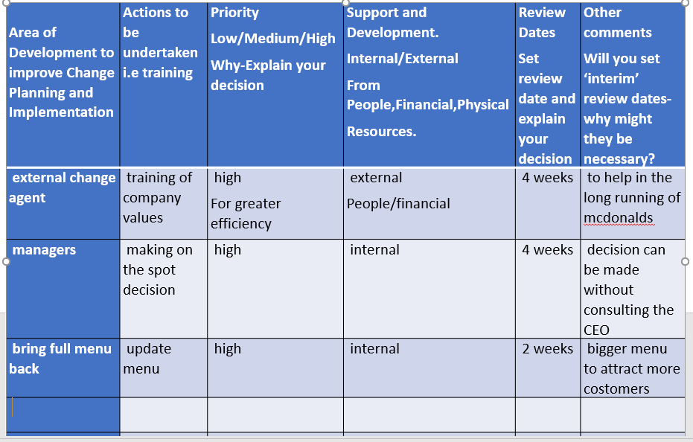
5.0
McDonalds PESTEL factors.
Political –
To increase international trade agreement (opportunity)
To follow all government guidelines for health and diet (threat and opportunity)
Public health policies need evolving (threat and opportunity)
Economic – stable but slow growth of developed countries (opportunity)
New Brexit rules (threat)
Developing countries growing rapidly (opportunity).
Social- disposable income rising. (opportunity)
Urban environments have busy lifestyles. (opportunity)
The new healthy lifestyle trend. (threat and opportunity)
Technological – increase the automation on McDonalds. (opportunity)
With the use of mobile devices thus increasing sales.(opportunity)
Economical- rising interest for corporate environmental programs.(opportunity)
The ever-increasing emphasis on a sustainable business strategy.(opportunity)
Within some regions the changing of the climate.(threat)
Legal – health regulations being increased in the workplace. (threat)
Animal welfare regulations increasing. (threat and opportunity)
Minimum wages rising. (threat)
Below is a SWOT of McDonalds.
Strengths | weakness
Highest brand value  Technology innovation  Delicious and variety of food items  Leading quick serving restaurant | High employee turnover  The franchise business model  Supply chain
opportunity | threat
Growth of the fast-food industry  Low cost  Rebuilding the brand image  Home delivery | High competition  More health-conscious consumers  Cultural preferences

6.0
Airiodion.com. 2022. Kurt Lewin Change Model | Pros & Cons | What You Need to Know – Airiodion (AGS). [online] Available at: <https://www.airiodion.com/kurt-lewin-change-model/> [Accessed 2 March 2022].
Buehring, S., 2022. Kubler Ross Change Curve | Kubler Ross Model | Kubler Ross Change Model | Kubler Ross Change Curve Model | Kubler Ross Change | Knowledge Train. [online] Knowledge Train. Available at: <https://www.knowledgetrain.co.uk/change-management/change-management-courses/change-management-models/kubler-ross-change-curve> [Accessed 2 March 2022].
Business Jargons. 2022. What is a Change Agent? definition, types and skills - Business Jargons. [online] Available at: <https://businessjargons.com/change-agent.html> [Accessed 3 March 2022].
Change Management Coach. 2022. The Kurt Lewin Model Of Change. [online] Available at: <https://www.change-management-coach.com/kurt_lewin.html> [Accessed 2 March 2022].
Change Management Coach. 2022. Benefits Of Change Management. [online] Available at: <https://www.change-management-coach.com/benefits-of-change-management.html> [Accessed 3 March 2022].
Corporate Finance Institute. 2022. McKinsey 7S Model. [online] Available at: <https://corporatefinanceinstitute.com/resources/knowledge/strategy/mckinsey-7s-model/> [Accessed 4 March 2022].
Deshler, R., 2021. The Role of Leadership in Change Management. [online] AlignOrg Solutions. Available at: <https://alignorg.com/the-role-of-leadership-in-change-management/> [Accessed 3 March 2022].
Farrell, T., 2015. A history of McDonald's UK. [online] Let's Look Again. Available at: <http://letslookagain.com/2015/05/a-history-of-mcdonalds-in-the-uk/> [Accessed 2 March 2022].
Greenspan, R., 2018. McDonald’s PESTEL/PESTLE Analysis & Recommendations - Panmore Institute. [online] Panmore Institute. Available at: <http://panmore.com/mcdonalds-pestel-pestle-analysis-recommendations> [Accessed 4 March 2022].
Indeed Career Guide. 2022. Lewin's change model: managing organisational change. [online] Available at: <https://uk.indeed.com/career-advice/career-development/lewins-change-model> [Accessed 2 March 2022].
Mageplaza. 2021. Understanding Of Micro And Macro Factors That Affect Your Business. [online] Available at: <https://www.mageplaza.com/blog/micro-and-macro-factors-affect-your-business.html> [Accessed 2 March 2022
Managementstudyguide.com. 2022. Kurt Lewin's Change Management Model: The Planned Approach to Organizational Change. [online] Available at: <https://www.managementstudyguide.com/kurt-lewins-change-management-model.htm> [Accessed 2 March 2022].
Managementstudyguide.com. 2022. Charles Handy Model of Organization Culture. [online] Available at: <https://www.managementstudyguide.com/charles-handy-model.htm> [Accessed 3 March 2022].
Marketing Tutor. 2022. PESTLE Analysis of McDonald’s – A Fast-Food Restaurant Chain. [online] Available at: <https://www.marketingtutor.net/pestle-analysis-of-mcdonalds/> [Accessed 4 March 2022].
Mcdonalds.com. 2022. COVID Safety. [online] Available at: <https://www.mcdonalds.com/gb/en-gb/latest-updates/reassurance/covid-safety.html> [Accessed 2 March 2022].
Mcdonalds.com. 2022. History | McDonald's UK. [online] Available at: <https://www.mcdonalds.com/gb/en-gb/newsroom/history.html> [Accessed 2 March 2022].
McDowell, E., 2021. THEN AND NOW: How McDonald's changed drastically between 2020 and 2021. [online] Business Insider. Available at: <https://www.businessinsider.com/how-mcdonalds-changed-during-pandemic-2021-1?r=US&IR=T> [Accessed 2 March 2022].
Mindtools.com. 2022. Lewin's Change Management Model: Understanding the Three Stages of Change. [online] Available at: <https://www.mindtools.com/pages/article/newPPM_94.htm> [Accessed 2 March 2022].
Mindtools.com. 2022. The McKinsey 7-S Framework: - Making Every Part of Your Organization Work in Harmony. [online] Available at: <https://www.mindtools.com/pages/article/newSTR_91.htm> [Accessed 4 March 2022].
Oxford College of Marketing Blog. 2022. The Impact Of Micro and Macro Environment Factors on Marketing. [online] Available at: <https://blog.oxfordcollegeofmarketing.com/2014/11/04/the-impact-of-micro-and-macro-environment-factors-on-marketing/> [Accessed 2 March 2022].
Potter, D., 2022. The Key Importance of Culture in Organizational Change. [online] Kogan Page. Available at: <https://www.koganpage.com/article/the-key-importance-of-culture-in-organizational-change> [Accessed 3 March 2022].
Pratt, M., 2022. What is change agent (agent of change)? - Definition from WhatIs.com. [online] SearchCIO. Available at: <https://www.techtarget.com/searchcio/definition/change-agent> [Accessed 3 March 2022].
Sites.google.com. 2022. Advantages and Disadvantages - Change Agents. [online] Available at: <https://sites.google.com/site/changeagentsjacqueline/why-change/advantages-and-disadvantages> [Accessed 3 March 2022].
(SWOT Analysis of Mcdonald's | Mcdonald's Strengths & Threats 2021, 2022)
Your Bibliography: Swot Analysis Template. 2022. SWOT Analysis of Mcdonald's | Mcdonald's Strengths & Threats 2021. [online] Available at: <https://www.swotanalysistemplate.com/swot-analysis-of-mcdonalds/> [Accessed 4 March 2022].

The One Brief. 2022. Case study: McDonald's responds to the COVID-19 crisis - The One Brief. [online] Available at: <https://theonebrief.com/case-study-mcdonalds-responds-to-the-covid-19-crisis-nb/> [Accessed 2 March 2022].
The Change Management Blog. 2022. How Does Organizational Culture Affect Change?. [online] Available at: <https://change.walkme.com/how-does-organizational-culture-affect-change/> [Accessed 3 March 2022].
toolshero. 2022. Handy Model of Organisational Culture. [online] Available at: <https://www.toolshero.com/management/handy-model/> [Accessed 3 March 2022].
tutor2u. 2022. Handy's Model of Organisational Culture. [online] Available at: <https://www.tutor2u.net/business/reference/models-of-organisational-culture-handy> [Accessed 3 March 2022].
Uhbristol.nhs.uk. 2022. [online] Available at: <http://www.uhbristol.nhs.uk/files/nhs-ubht/8%20How%20to%20implement%20change%20v3.pdf> [Accessed 4 March 2022]
Uk.finance.yahoo.com. 2022. Yahoo is part of the Yahoo family of brands. [online] Available at: <https://uk.finance.yahoo.com/quote/MCD/balance-sheet?p=MCD> [Accessed 4 March 2022].

Zambianguardian.com. 2022. Advantages and disadvantages of Lewin's change model. [online] Available at: <https://www.zambianguardian.com/advantages-and-disadvantages-of-lewins-change-model/> [Accessed 2 March 2022].

