

L4 – Learning in the Digital Era / Workshop Skills (ACCA4025)

L4 LDE Assignment 2
David Mathew Lewis
2219439
Electrical and Electronic Engineering

Table of Contents
1
L4 LDE Assignment 2 David Mathew Lewis 2219439 Electrical and Electronic Engineering 1
Introduction 4
Simulation 5
Schematic of the Circuit Built on Proteus 5
Table of Results 5
RMS Calculation 6
Closely Spaced Test Results 6
Graph of Gain vs Frequency 7
Breadboard 8
Table of Results 9
RMS Calculation 10
PCB 11
Easy-PC Schematic 11
12
Artwork of Built PCB 12
Table of Test Results 13
Closely Spaced Measurements 13
PCB Build 14

Introduction
The circuits consist of 3 x 10k ohm resistors, 1 x 20k ohm feedback resistor, 3 x 1 micro farad capacitors and 1 x 741 op amp, which was supplied with 9 volts. The input frequency was changed to between 100Hz to 5MHz whilst measuring the output voltage with an oscilloscope, allowing us to measure the bandwidth and calculate the gain.

Simulation

Schematic of the Circuit Built on Proteus
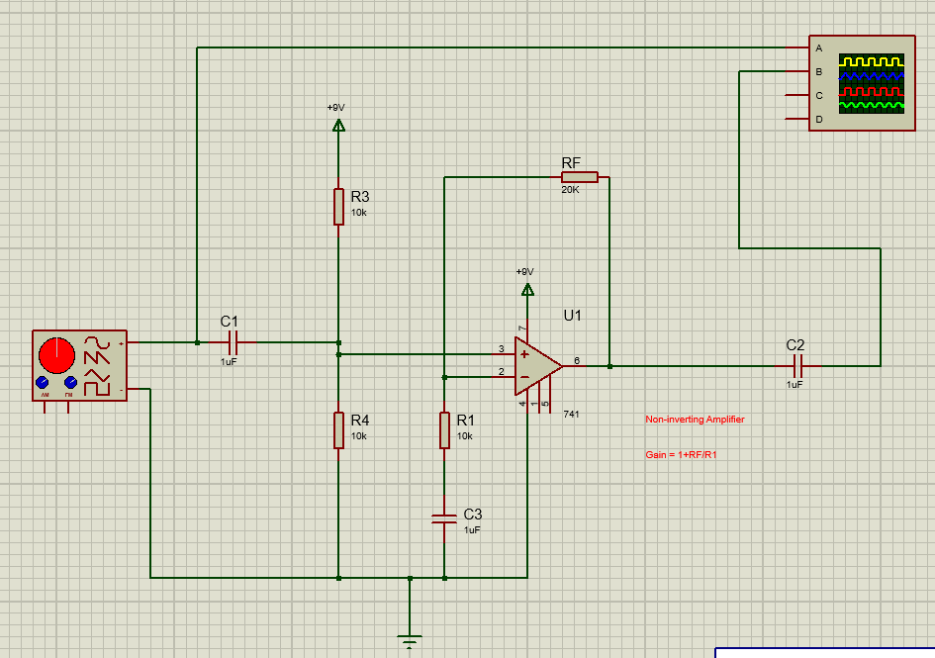
Figure 1/Proteus/Schematic
Figure 1 above is a screen grab of the circuit that was built on Proteus. This allowed us to simulate with the following results:

Table of Results

FREQ Hz | VALUE mV | FREQ Hz | VALUE mV | FREQ Hz | VALUE mV
100 | 285 | 200 | 295 | 500 | 300
1k | 300 | 2k | 300 | 5k | 300
10k | 300 | 20k | 300 | 50k | 297.5
100k | 287.5 | 200k | 255 | 500k | 157.5
1M | 87.5 | 2M | 45 | 5M | 17.5

RMS Calculation
As you can see from the table of results above, 300 was the highest and most common reading. This was multiplied by 0.707 to give us the RMS/-3db point:
RMS | 212.1 | 212 is in between 200 and 500, so pick values in between the two

Closely Spaced Test Results

250 | 237.5 | 300 | 220 | 350 | 202.5
400 | 186.25 | 450 | 171.25
310 | 215 | 320 | 212.5 | 330 | 207.5
340 | 205 |  | 960

Bandwidth = 320kHz
Gain = 3
GBP = 320*3 = 960

This can be verified by checking a 741 datasheet:
[1]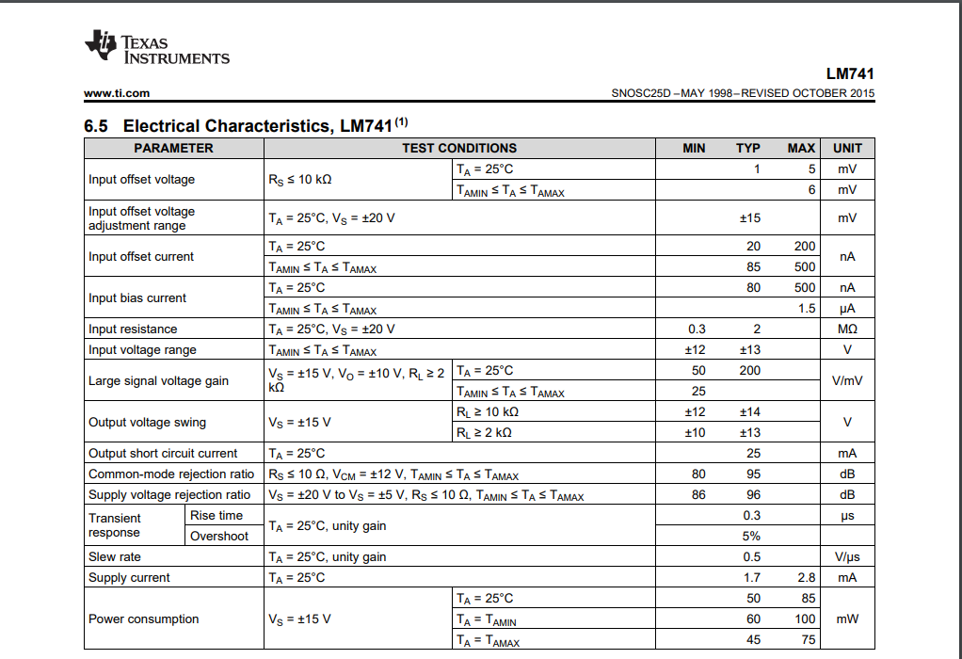
Figure 2/741/Datasheet

Graph of Gain vs Frequency

Figure 3/Simulation/Graph

Breadboard
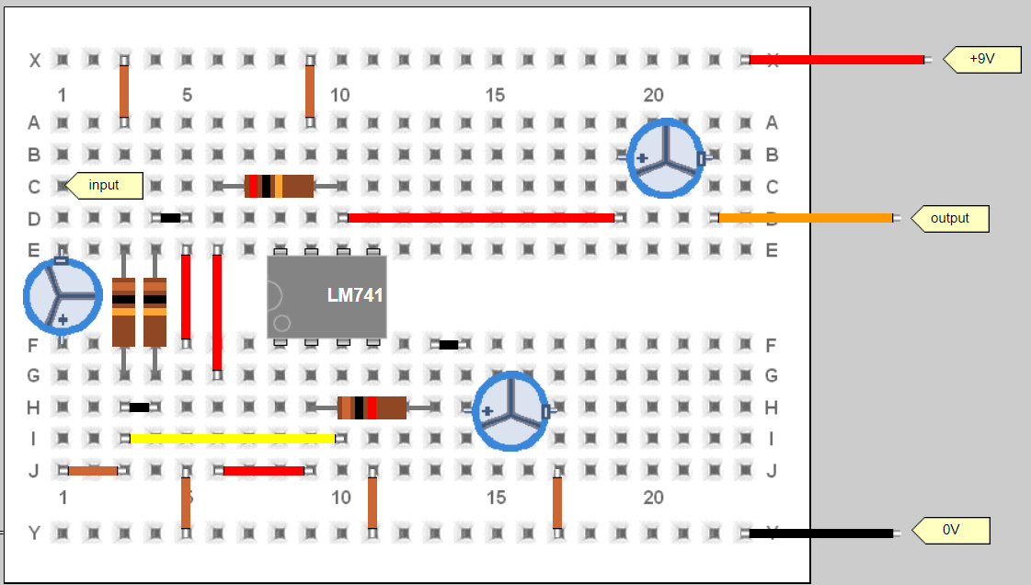
Figure 4/Breadboard/Pebble
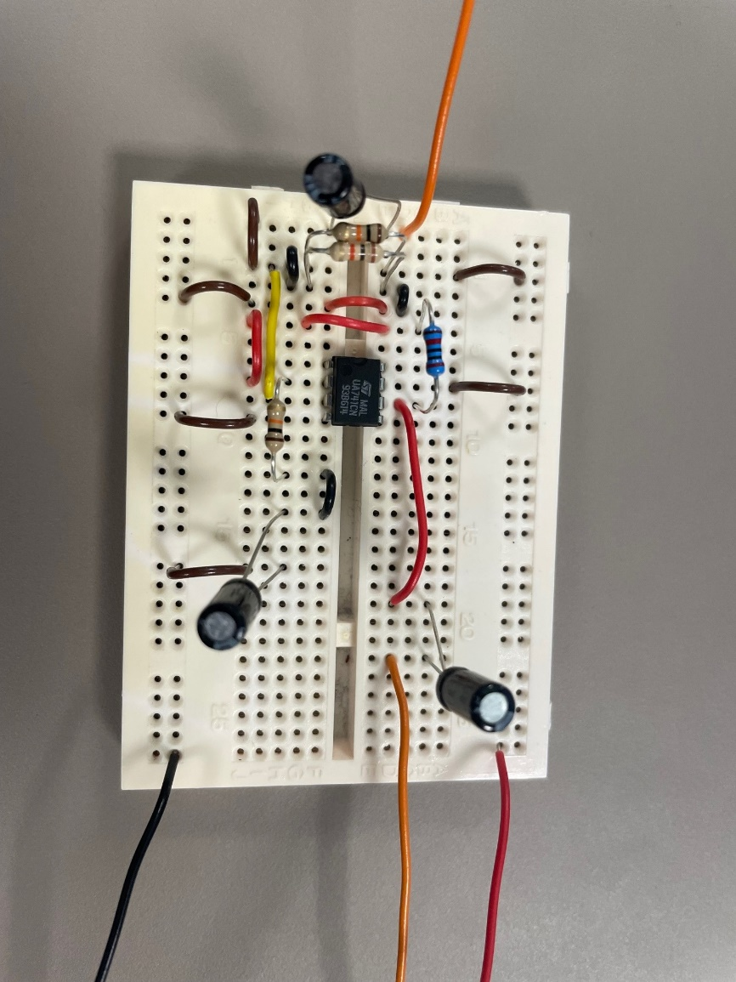
Figure 5/Breadboard/Photo
To build the circuit on the breadboard, we had to first collect the materials and equipment needed:
- Breadboard
- Cable
- Cable strippers
- 741 op-amp
- 3 x 10k ohm resistors
- 1 x 20k ohm resistor
- 3 x 1 micro-farad capacitor
- Oscilloscope
- Signal generator
- Power supply
I began by placing the components onto the breadboard as shown in the diagram above. For the jumper cables, I cut pieces to size and stripped back the ends with cable strippers and pushed them into the terminals.
To test the bread board, I firstly applied 9V 1amp to the breadboard. I also connected the output of the signal generator to the input of the breadboard as sown at C3. One of the probes of the oscilloscope connected onto the input to ensure we were having the correct frequency input, and to measure any change in the input voltage – this was on the non-inverting input of the 741. The other connected to the negative leg of the capacitor on the output side of the 741, to monitor the output voltage, to allow us to work out the gain.
[1]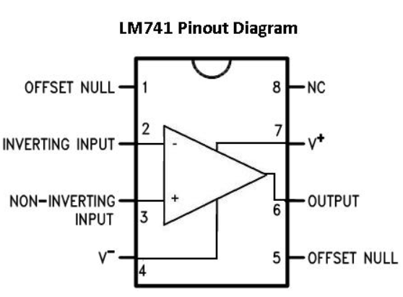
Figure 6/741/Pin-out

Table of Results

FREQ Hz | VALUE mV | FREQ Hz | VALUE mV | FREQ Hz | VALUE mV
100 | 528 | 200 | 544 | 500 | 552
1k | 560 | 2k | 552 | 5k | 552
10k | 552 | 20k | 552 | 50k | 552
100k | 552 | 200k | 456 | 500k | 200
1M | 40 | 2M | 8 | 5M | 8

RMS Calculation
As you can see from the table of results above, 560 was the highest reading. This was multiplied by 0.707 to give us the RMS/-3db point:
RMS / -3dB | 395.92 | 395.92 is in between 200k to 500k so closer readings required there

The closest I seemed I could get to was an input of 258k Hz which gave me the output of 392mV.
Bandwidth | 258 | kHz
Gain | 3.04347826
GBP | 785.217391

Figure 7/Breadboard/Graph

PCB

Easy-PC Schematic
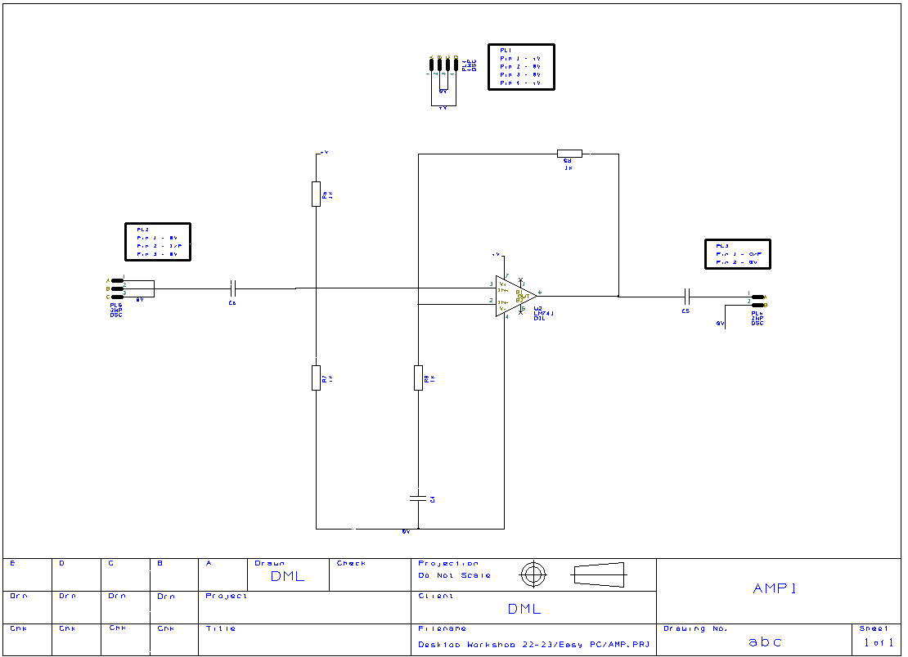
Figure 8/EasyPC/Schematic

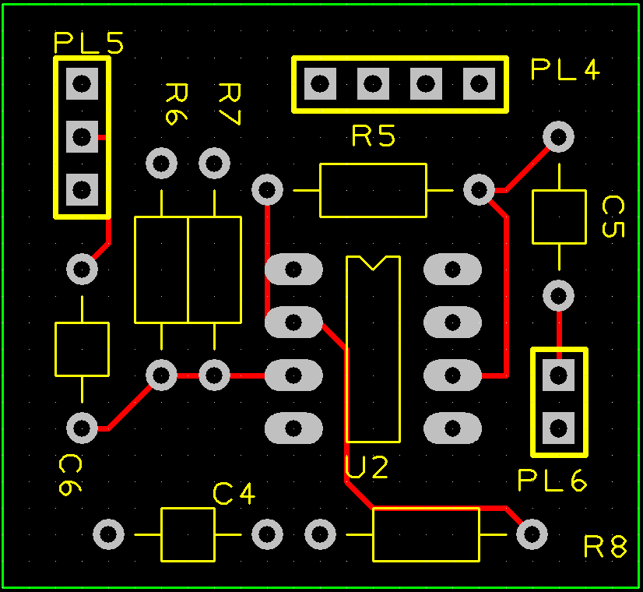
Figure 9/EasyPC/PCB

Artwork of Built PCB
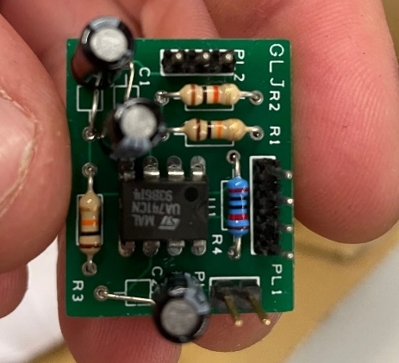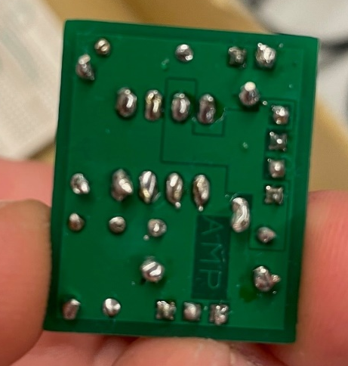
Figure 10/PCB/Components Figure 11/PCB/Soldering

Table of Test Results

FREQ Hz | VALUE mV | FREQ Hz | VALUE mV | FREQ Hz | VALUE mV
100 | 562 | 200 | 576 | 500 | 590
1k | 590 | 2k | 590 | 5k | 585
10k | 585 | 20k | 573 | 50k | 563
100k | 549 | 200k | 452 | 500k | 204
1M | 80 | 2M | 20 | 5M | 14

As you can see from the table of results above, 590 was the highest reading. This was multiplied by 0.707 to give us the RMS/-3db point:
RMS | 417.13 | 417 is in between 200 to 500kHz, so closer spacings are needed around here

Closely Spaced Measurements

250kHz | 392 | 225kHz | 416
225kHz | 424

Bandwidth | 225 | kHz
Gain = 590/190 = | 3.10526316
GBP = 3.10526316  *417.13 = | 1295.29842

Figure 12/PCB/Graph

PCB Build
To build the PCB, the schematics from Easy-PC were sent off to have the PCB’s made. Using the schematic drawing, I took the components from the breadboard and placed them into the allocated holes within the PCB. I started off with the 741 as it was the thinnest component, it would have fallen out if a capacitor was installed first. When the components were in position, I soldered them in place, making sure the extractor was on to remove any fumes. I needed to clean my iron using some flux prior to soldering as it has oxidised.

Bibliography

[1] | “Texas Instruments,” 22 May 2022. [Online]. Available: https://www.ti.com/lit/ds/symlink/lm741.pdf.
[2] | “LM741 Pinout Connections,” [Online]. Available: http://www.learningaboutelectronics.com/Articles/LM741-op-amp-pinout-connections.

