Moriyama House

A critical essay about a piece of architecture after 1945.

Moriyama house which was built in 2005 and designed by Ryue Nishizawa is a piece of architecture that was created to connect the inside and outside with a goal of creating a community for the residence of the building. Located in Ohta-ku, Moriyama house is a residential area in the center of Tokyo, single-family houses and midsize apartment blocks are most common in this area and placed in a traditional urban pattern that preserves a typically Japanese atmosphere. The client Moriyama had demolished the house where he has lived with his mother, after she passed away. He wrote to the architect telling him his need for a home to be built on the site. The architect vision for the site of the demolished house was a modern one. The houses they built have become one of the most important buildings in contemporary Japanese architecture. Nishizawa’s vision of creating a small village in a middle of a suburban area is what took shape on this small plot of land.
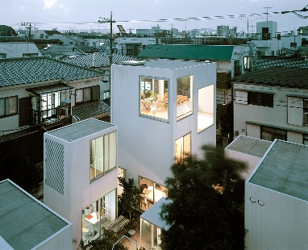
Exterior of Moriyama House
Ryue Nishizawa is a renowned contemporary architect. He had a background in art and music which helped with the creative side of his designs. He often creates a blur between art and architecture in his work. His design philosophy is to integrate architecture and nature from his designs. This is shown through the use of light, greenery and open spaces. His designs connect to the landscapes they are built in. Nishizawa has a reputation for collaborative working. He believes that this style of working allows for new ideas and perspectives on his project. The Teshima Art Museum in Japan shows this collaborative working. He worked with artist Rei Naito to push the boundaries of design of art, architecture and the natural world. Nishizawa uses concepts from his Japanese heritage and traditions in his designs such as simplicity and minimalism. This is demonstrated in Moriyama House who’s layout reflects the traditional Japanese concept of communal living. In Nishizawa’s designs he aims to create a sense of harmony by taking away the boundaries between indoor and outdoor spaces. He wants people to experience the tranquillity of nature whilst moving through his designs. Using materials that allow light to pass through in his designs helps remove the barriers that exist in many other buildings.
The building is located on 290 square meters of land and contains ten rental units that are one to three stories along with a dwelling for the owner. These units are distributed across the site to reflect the fragmented fabric of Tokyo and reinvent the traditional Japanese home. It’s believed that Nishizawa possibly took inspiration from Tokyo’s “subdivurban” phenomenon that has led to plots of land becoming smaller. This is due to properties in the area like Moriyama House resides being subdivided by incoming generations due to investment pressure. Properties have been separated into fragments that are then sold to other families as they can no longer afford to pay the inheritance tax. In Moriyama House these subdivisions have been included into the design of the building. If a section of the building was sold in the future to be demolished and rebuilt for other houses this would allow a natural link that preserves the rest of the building to the city fabric. With the design taking into consideration the areas natural tendency to property fragmentation over time I feel that the building is able to establish a long term relationship with the city it sits within. Also, the individual buildings being designed in a series of small white boxes allows for the building to feel like an independent organism that’s surrounded by ordinary buildings whilst still being connected to its surroundings.
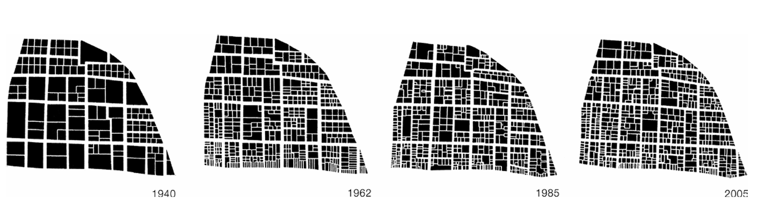The evolution of property divisions in Tokyo
Rather than being one single unit, the space has been divided into individual units separated by gardens and courtyards. The goal of the outdoor spaces was to create a sense of community for the neighbours. A lot of thought was put into the position of the units such as making sure no windows are placed opposite each other to ensure privacy. The way Nishizawa has designed the layout of the buildings creates a lack of main entrance to the houses as the orientation of the buildings is similar in both the front street and back alley. There is no correct way to move through the site, the garden spaces allowing you to move in any direction. The only sign of a front door being a small canopy above some of the doors. This allows residence to create their own experience as they move through the space. Looking at the garden space surrounding the buildings it can be difficult to tell who’s belongs to who’s. The only tell being the tenants belongs and placement of trees. Nishizawa has said that he wanted each tenant to have their own garden whilst also creating a space that encourages people to gather in groups
For each unit, space has been maximised using thin steel walls. However, the size and number of floors of each unit is different. For clients choosing their rental they can customise the layout with other units available by switching across a couple living and dining rooms or using multiple rooms at a time. Large windows placed throughout the building allow light into the interior of the space and in some areas of the building allow you to see straight through to the other side.
Nishizawa was interested in playing with the idea of what people perceive as public and private property and he did this through creating small pathways between the buildings that are open to the street whilst also connected to different parts of the building. For the different lifestyle proposed by Nishizawa, indoor and outdoor living become one and the same. A choice of design decisions support this idea along with the clients using the space. Through thinking about what the relationship between the indoor and outdoor space of Moriyama house would be like, Nishizawa was reminded of an old tradition in Japanese cities: “Tokyo was born as a village with fields, coexistence between nature and village. No boundary between inside and outside. There is a border but not like in the Western city” (Cortés et al., 2008, p. 11). In Moriyama house we can see that somehow, despite their opposite nature and their clear physical boundary, interior and exterior space in this building want to feel exchangeable. Nishizawa didn’t want the outdoor space to just be seen as a corridor to get from one building to another so he made the gardens wide enough to be considered more of a room that you can use just like rooms inside the building. To encourage people to use the spaces outside very thin walls were chosen for this building to help further this idea of continued space and create a sense of continuality along with the decision to make the windows large and ceilings higher with the idea that it would produce a similar amount of light on both the interior as the exterior to help the separation fade.

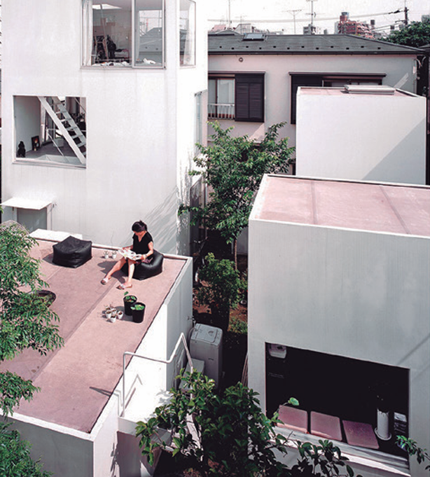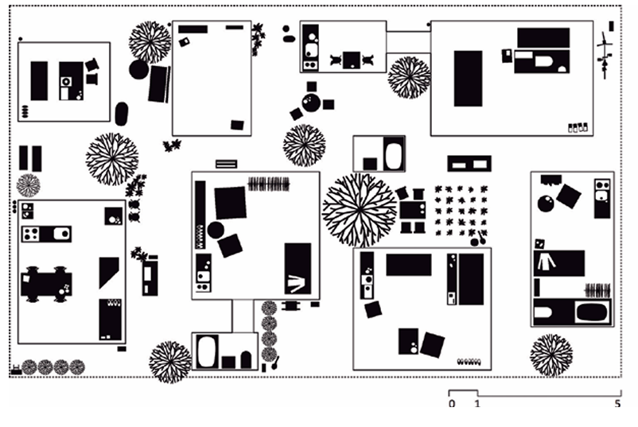
Airiel view of Moriyama House Layout of site
Experimental housing is common in Japan due to the evolution of housing in Japan in the wake of World War two and the countries population growth in the 1960s and 70s that led to architects experimenting and developing design solutions for living in a dense city. Moriyama is built in very densely populated area. The plots of land where the building is located are small so the space is scares and must be used carefully. The morphology of the surrounding area is reflected in the design on this plot. The Moriyama House has been designed to resemble a smaller version of the surrounding area. That is houses separated by narrow streets and courtyards.
In 2005 Ryue Nishizawa participated in a research project called “Urban Void Program”. The aim of the project was to explore the concept of urban porosity, looking at opposite ideals such as natural and artificial, private and public. Nishizawa would be commissioned to design Moriyama House three years before finishing this research project. Nishizawa chose a fragmented design for his building after observing the vacant interspace that surrounds buildings in the area. He also observed that neighbours were sharing and using these spaces as an expansion to their home. Nishizawa drew the alleys and narrow walkways in a series of field sketches when he first visited the site.
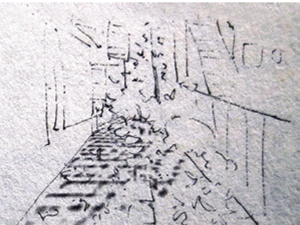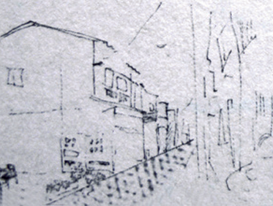
Nishizawas field sketches on site
The layout of the blocks allows people who inhabit them to use them in the kind of way they want to because the use of the blocks is flexible. The way the design is set out will allow people who live there to create a living environment that they want. This has been seen with the use of the outside areas. Some of these courtyards are meeting places for residents. So the people who live their wanted aa social community feel. However, inhabitants in the future may not want this but the space is easily adapted to the needs of the resident.
Moriyama House is an example of a piece of contemporary architecture that showcases architect Nishizawas willingness to develop his innovative ideas. The Moriyama House is successful in connecting with the outdoor space that separates the buildings through use of large windows that help balance light, thin walls that give the illusion of one continuous space and using the gardens as corridors to connect the buildings, giving the residents direction whist also giving them freedom of movement. The building is a modern representation of how Tokyo’s morphology affects residential design in the area.

References:
issuu.com. (n.d.). Case Study House - Moriyama House by Chelsea Harris - Issuu. [online] Available at: https://issuu.com/chelsharris_archiportfolio/docs/chelsea_harris_case_study_house.

Viva, A. (n.d.). Moriyama House, Tokyo - Office of Ryue Nishizawa. [online] Arquitectura Viva. Available at: https://arquitecturaviva.com/works/casa-moriyama-tokio-3.

Archweb. (n.d.). Moriyama House. [online] Available at: https://www.archweb.com/en/architettures/moriyama-house/.

architecture tokyo. (2017). 2005 – Moriyama House – Ryue Nishizawa. [online] Available at: https://architecture-tokyo.com/2017/06/28/2005-moriyama-house-ryue-nishizawa/.

Buxton, P. (2017). Step inside. [online] www.ribaj.com. Available at: https://www.ribaj.com/culture/the-japanese-house-architecture-and-life-after-1945.

Public Delivery. (2019). The extraordinary Moriyama House - By SANAA’s Ryue Nishizawa. [online] Available at: https://publicdelivery.org/moriyama-house/.

Viva, A. (n.d.). Moriyama House, Tokyo - Office of Ryue Nishizawa. [online] Arquitectura Viva. Available at: https://arquitecturaviva.com/works/casa-moriyama-tokio-3.

Kotsioris, E. (2019). The Life in Between: Ryue Nishizawa’s Moriyama House, Tokyo, 2002—2005. post: notes on modern & contemporary art around the globe. [online] Available at: https://www.academia.edu/41465082/The_Life_in_Between_Ryue_Nishizawas_Moriyama_House_Tokyo_2002_2005.

Martín Domínguez, Dra.G. and De Esteban Garbayo, Dr.J. (2018). Home-city interactions in suburban Tokyo. Revista de Arquitectura, 23(34), p.45. Available at: https://doi.org/10.5354/0719-5427.2018.47906.

