Aled Charles (P151860)

Semester 4 Progress Log.

Semester 4 Production Report.

Introduction.
This semester this group was working towards creating a fully working game. Each group member was given a tasks that they had to complete in order to make sure that the game could be completed in time. My role in creating this game mostly animation and some of the environmental assets that some of the other group members may not have time to create. The following is a detailed progress log of the game production.
Progress Log.
Friday 2nd – Thursday the 8th of February.
I have begun updating the Environmental assets as the originals were either too detailed for their in-game task or didn’t look good enough. So far I have remade a tree model which has been added to the game.
I have rigged one of the in-game characters so that it can be used in animation. There are some errors with the skinning I will have to fix this before it can be used.
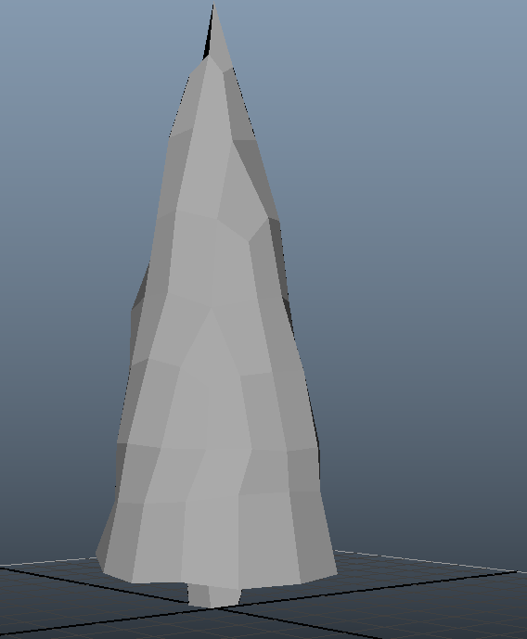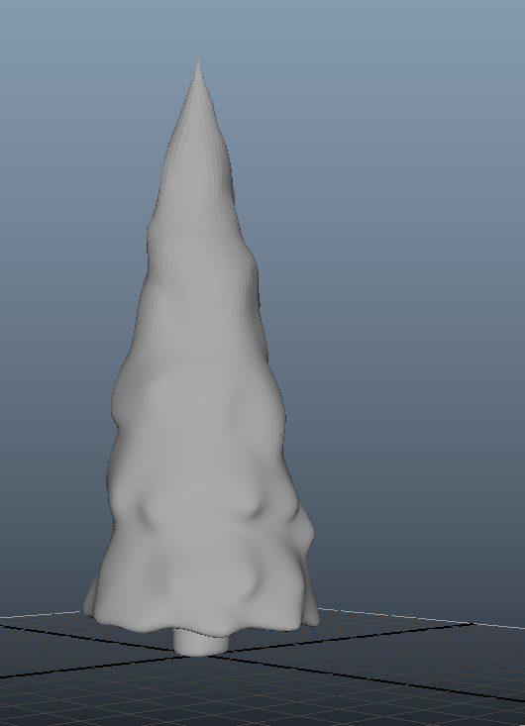
Friday 9th – Thursday the 15th of February.
The tree model for the game has been textured and is ready to be put into the game, in addition to the models that have been remade I will have to discuss with the group whether any further models will have to be made.
I have begun to act on the feedback that I have received for the soundtracks that I made last semester I have heavily edited one track and another has been trimmed down.
I have begun to rig the second chartacter for the game this model will be done by the end of Thursday and should be skinned by next week.
Unfortunately on Friday I will not be able to attend University, this will be reflected in my personal and team gantt chart.

Friday 16th – Thursday the 22nd of February.
On Friday I had to attend a funeral so unfortunately I was unable to attend Friday’s lecture, I have changed the gantt chart to show this. As I was unable to take notes during the animation lecture I will have to lend and copy them from another student. Unfortunately I was unable to receive any information on this so I have resorted to researching how to do it off the internet.
I have updated the skin weights on one of the models as it wasn’t working, this model is now ready to be animated.
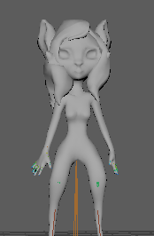
Friday 23rd of February – Thursday the 1st of March
I have created three different models to put into the game world, these models have been retopolgised (with each model having under 140 verts) and UV unwrapped.
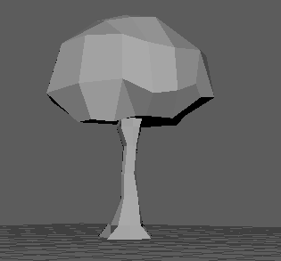
On Thursday the University was closed due to snowy weather, this will be reflected in my personal and team gantt chart.
Friday 2nd – Thursday the 8th of March.
On Friday the University was closed again due to snowy weather. This will be reflected in my personal and team gantt chart.
As the University was closed I have begun practising animating the Main Character, I succesfully created a rough idle animation and a walk cycle, these animations are very rough and will have to be improved for future use.
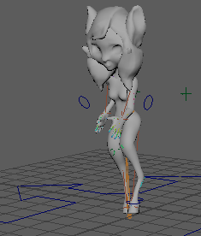
Friday 9th – Thursday the 15th of March.
On Friday it was uncovered that the Main Character’s model was incorrectly scaled at 9m tall (when it should be 1.5m), this drastically pushed back the animation production as the new model had to be Rigged and Skinned again, this was completed by Sunday.
On Tuesday Anna decided that she wanted to leave the course, this has caused the rest of the group to change their roles to ensure that the work can carry on.
On Wednesday I completed a walk cycle for the main character and I have begun an attack animation.
Friday 16th – Thursday 22nd of March.
I have continued to create animations for the main Character and in addition to the melee attack I have created an idle animation.
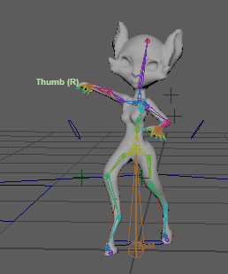
As a group we have begun planning ahead to try and estimate how the game will progress over the easter break, this includes risk assesments, as a group we think that the game should be playable and nearly complete by the 26th of April.
In addition to the above planning we have created a to do list of all the tasks that need to be done by 26th of April. For my part I have to complete all of the animations and if theres time some assets that Aday may not have time to do.
Friday 23rd – Thursday 29th of March.
I have completed half of the animations for the Main Character. I have also begun trying to give the player more character in their movements to help give the player more of an idea of the charcters personality.
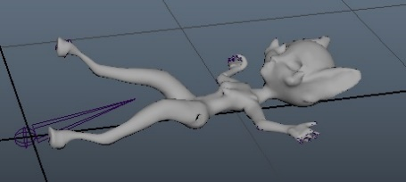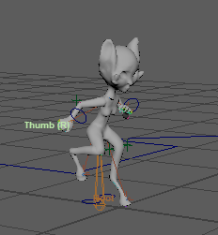
Friday 30th of March – Thursday 5th of April.
I have completed all the animations for the main character, these animations have all been exported and are ready to be added into the engine.
Friday 6th – Thursday 12th of April.
I have begun animating both the monster and the main boss character, in contrast to the main charcter these antagonists will have a much slower and bulkier look to them.
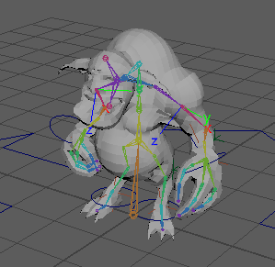
Friday 13th – Thursday 19th of April.
I have completed all of the animations on the list and hopefully they will all be used in the Unreal Engine by the end of the week.
In addition to the animations I have also created the weapon models for all the characters in the game.
I have received word from Connor saying that the animations are not working inside the engine, there are two things wrong with the imported animations, they are either not moving as they are not being exported properly or both. Although this has clearly created a bottleneck in the production it has not ground to a complete halt as Connor has begun working on some of his other tasks while I fix this.
This delay has pushed back animation progress and has been reflected in the group Gantt Chart.
Friday 20th – Thursday 26th of April.
I have managed to fix the issues with the animations, the problem was that I had incorrectly parented the control rig, this was the reason why the animations were not moving as it should.
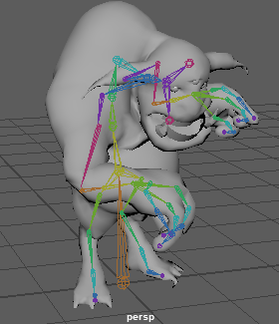
This week I have completed all of the animations for the main character, I have handed all of these animations over to Connor and he has begun putting them into the engine. After this I am now begining my final animations on the other characters which I aim to have completed by the end of this week.
On Friday the group created a list of sound effects that were required in game, as Connor was busy working on the engine I took this task and begun choosing which ones to use with Aday. I also created the characters weapons on Friday, these were later textured.
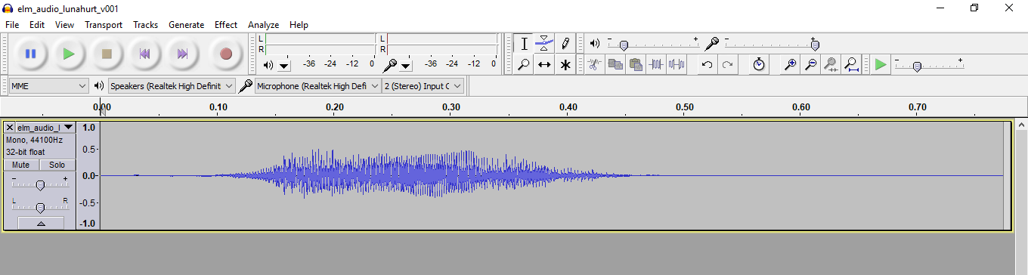
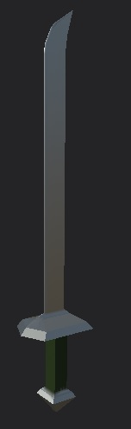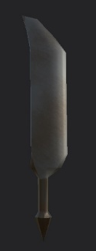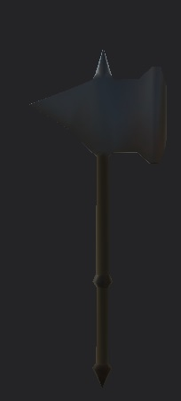

Friday 27th of March – Thursday 3rd of May
On Friday I created all of the assets that the engine would need to create the antagonists camp, all of these models have been properly scaled and are under 150 verts.
On Sunday the last of the animations were completed and are now ready to be put into the engine.
On Monday I was unfortunately unable to do much work as I had found out that I have Autism and I was required to fill forms regarding that.
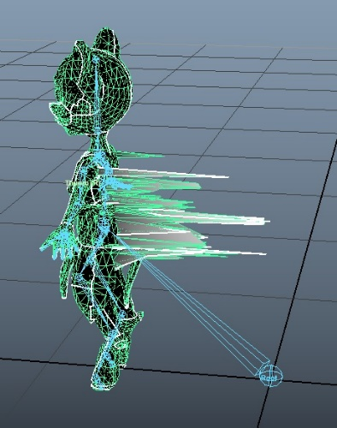
On Tuesday after Ana confirmed which model was the final version of the main character I rigged the model making sure to use the same naming conventions as the animated one and later skinned it, this model was difficult to skin but after running some movement tests on it the model should work in engine.
On Wednesday the enemy camp was fully textured and is now ready to be added into the engine. I also completed and exported all of the sound effects for the game.
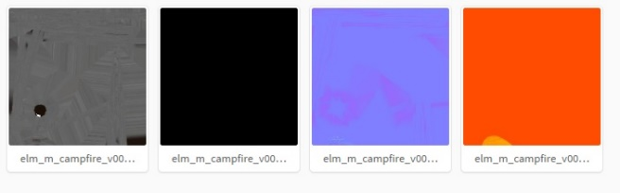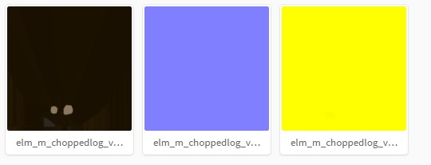

Epilogue.
In reviewing the work that has been done this semester there were many mistakes, one of the biggest examples is the problems with the animation work where a bottleneck was created because I was unable to both export them right and because I had not parented the control rig correctly, these were very obvious mistakes and I must not allow such errors to happen again.

