Student Name | Aneesah Zubair
Student Number | 1809520
Module Name | Developing skills
Module Code | Isaiah Oino
Lecture Name | BMSK5002
Submission Date | 31/03/2020

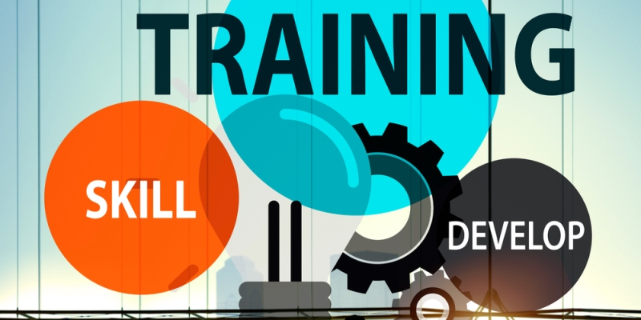
https://www.bing.com/images/

TABLE OF CONTENT……………………………………………………………………Page 1)
Inroduction……………………………………………………………………………………Page 2)
Employee Engagement and reword………………………………………………………Page 3-4
Leadeship and management………………………………………………………………Page 4-5
How the vehicles are applied within, The works. ……………………………………….Page 5-6
Bussiness plan……………………………………………………………………………….Page6-7
Conclusion…………………………………………………………………………………….Page 8.
References…………………………………………………………………………………. Page 8-9

Introduction]
I have been given a task to critically assess the potential benefits of an organisation that will be elaborating upon later on in this report. The aim of this report will be consisting upon development vehicles and how they impact upon their developing skills through the following, Employee Engagement and reward, leadership, management. This report will allow me to consist upon on how employees can develop their careers in the workplace. Moving forward, I will be explaining how to manage employees’ expectations in respect of their personal development, explained in a more simplified and detailed manor in the regards of further training and helping employees meet their career goals. After elaborating upon the above stated sectors, I will then continue to discuss upon an organisation that I currently work for, moreover I will be evaluating towards how the vehicles affects the way the management and leadership , play a major role within the business/company and how they communicate. In this report i will generate a detailed plan in regards of identifying an individual and potential management performance.

Employee engagement and reward
Employee engagement, and reward are two very critical aspect to have within an organisation, as these two topics can be combined or even dealt with in similar principles due to allowing the employees to develop an understanding whether there are achieving their goals, or just have an acknowledgment of knowing that they are being appreciated in regards of when they have met their given set targets. According to Bhattacharya and Mukherjee (2009) Employee engagement has a very high level of commitment and also involvement that an employee devotes towards the organisation.
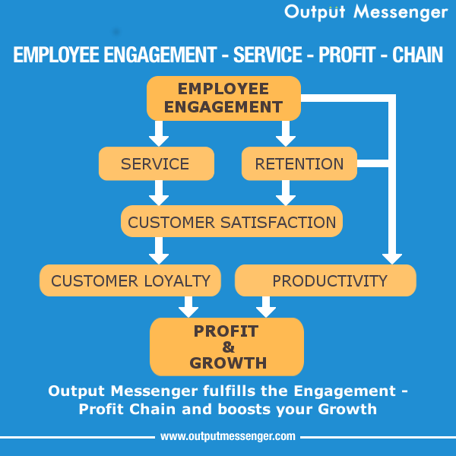
https://www.bing.com/images

Employee engagement is rather important to build relationships between employer, and the employees in any organisation so that they feel connected and motivated by enhancing workplace productivity. It is essential that a workplace meet’s an employee’s needs and in, insuring that participants of an organisation are given a pleasant experience each day, many companies devote to their employer’s values, and need to obtain this method that encourages and motivates the employees to contribute with organisational achievement, with an superior sense of their very own well-being. Employee engagement is based on accepting and with true, integrity, a two-way commitment and communication among an organisation and its participants. It is a method that increases the probabilities of commercial enterprise fulfilment, contributing to organisational and character overall performance, productivity and well-being. It can be measured. It varies from negative to positive. It can change dramatically from either perspective. According to (Fredrick Herzberg 1959.) True motivation comes from achievement. Personal development job satisfaction and recognition.]
Employee engagement, also allows and encourages an individual to feel as they have a say/ voice as it allows the employees to feel as they have an input in the business or company.
Mukherjee (2009) has stated the following, Reward strategies also hold an important role in this arena by inspiring and motivating, energising and also engaging with the employee. Reward is better described as using incentives to motivate employees in regards of benefiting the company and also managing to keep the employees satisfied in the workplace. Many a time rewards can come in different forms such as money bonuses, voucher’s or even just a day’s leave can help maintain an employee’s satisfaction within the workplace
It has been researched and documented by Shields 2009) a reward scheme may be tangible or intangible that an organisation provides to employees either intentionally or unintentionally in the exchange for the employee’s potential actual work contribution.
However, it can also have a negative impact towards the reward system due to the employees being falsely advised that, they will be rewarded upon completing their target, as some businesses can turn to differ and be very dishonest upon having to consist on their given word. As they might change the given targets given to the employees. This matter could lead to employees leaving the company due to the company’s dishonesty and being falsely given the wrong advice. It has been stated by McDuffe. (2019) In business and in life, people are rewarded and praised for success, which creates a culture where we don’t learn from failure. This deprioritize innovation in companies. Plus, you may end up repeating those mistakes. Therefore, when it comes to rewarding an employee the company should look into all aspects and always keep in consideration upon their word once promised an employee a reward or a bonus, the company must abide to their given word.
Reward digram

Leadership and management.
It has been studied and documented by Burns. (2012) leadership is a relationship that has a mutual stimulation and also an elevation that converts individuals into becoming leaders and may convert leaders into becoming moral agents. However, it is essential that the leaders have the correct and appropriate training as they direct people towards the right path if the leaders don’t communicate to the employees in a professional manor it could lead to having a barrier between the employees and the leader as, a successful leader must possess high communication skills. As this involves in communication both verbally and non-verbally towards the staff. If the leader is not fully qualified in their job role it may lead to many downfalls regarding a leader’s behaviour in the business, It has been stated by Lettis (1970.). Even if true leaders are born, there are certain skills that they will still require in order to be effective leaders right away. Those skills can be amplified by the mentors for example being coached by highly qualified mentors.

In an organisation management also play a major role, as their duties are to focus, plan. schedule, and hire and give the correct training if required.
Management is a method hired and trained by professionally trained, leaders who assist upon, setting goals and achieving them in efficient and in a successful manor, the aim of management is to manage a company whilst acknowledging the performances of the employees and guiding them in regards of the employees potentials that the employees might have not acknowledge within themselves. It has been stated by the following Bolton (2004) Management skills of the employees have been very successful and beneficial by the organisations recognitions skills.
Therefore, management help assist employees with further opportunities in order to help employees build their career path. However, some management may not want an employee to be promoted or even recognised as this can be a threat to the management in regard of the management believing that the employee’s may be wanting to take over with their job title. This can have a major impact towards the workplace due to employees lacking motivation from the management as employees try to shadow and be guided by management and if the management is not communicating with an employee it can lead to many negative assumptions. According to Walton (1988) the problem that most companies word wide have to face is not to competitors but due to self-inflicted, created right in the business, by the management. In regard of lacking initiative and communication. Down below I have a diagram that indicates the performance outcomes explained in a simplified manor.
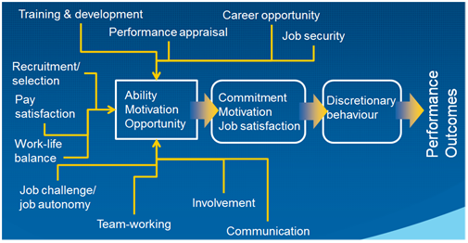
https://www.bing.com/profile

Another approach management can use to communicate with the employees is the 360-feedback, approach that has been created by Marshall goldsmith who found the following method in the year (1996) he had experienced this method throughout his coaching and consulting experience. This method elaborates upon how employees can communicate in a more confidential manor. As some employees can find face, to face meeting intimidating, or even unfair/unjust therefore this method can also benefit the works, as employees can have a say using a 360- feedback in regard of giving the management feedback as well as keeping everything they say confidential as this will avoid any unnecessary conflicts within the management and employees.

How the vehicles are applied in My chosen organisation, The works,
The company that I would like to discuss in a further in-depth manor is going to be The works as it is one of the UK’s leading art and craft retailers. I will also be elaborating upon how employee engagement is a vital vehicles to possess in The works due to the fact of how employee engagement is an asset to any organisation, such as it will help increase productivity in regards of the benefits it will atomically have, an impact upon the employees. Employee engagement allows an employee to have a say/ voice as this may help towards engaging with the management as they will feel as if they are part of the company. This method will not only bring success in the company but also the employees will feel satisfied and more content within the workplace as they will acknowledge the fact of them having an input in the business.it has been stated by Kular (2008) The consortium is moving ahead with acknowledging and is also developing in new measures regarding the nature of an employee engagement, its impact toward an organisation.
Furthermore, another vehicle that is essential in the work environment is the reward scheme this allows employees in the company to acknowledge the fact of them being praised and also appreciated in regards of an employee meeting their given targets. It has also been stated by Welch (2011) Employee engagement contributes to identifying evolutionary waves in the sense of development, it suggests a definition and engagement in a dynamic, changeable state that enhances an organisations internal communication.
The reward vehicle is also an incentive way that benefits business and also empowers workers individually or as a group. The reward schemes are not salary related. This could also be monetary. The aim of this programme is to encourage employee’s and to help improve the efficiency. According to Armstrong( 2002) Employee reward acknowledges how individuals are rewarded with their company’s value to an organisation. The reword can be financial or non-financial.
Leadership is another essential vehicle to possess in a company as it has an impact in an all-purpose point of view this also has a major role in the works as I have come to an understanding of that, leadership can be within an individual person or can be a group of leaders that influence and guide members of an organisation. Leadership includes making effective and critical decisions and also articulating a common vision setting realistic objectives by guiding members with the resources and appropriate skills required in order for the members to achieve their goals. It has been stated by Griffin( 2003) Leadership is in an individual, of leaders who are either blamed and punished when their actions don’t go according to their plans or, leaders are praised and reworded once they have accomplished their set task.
Management also a very important vehicle to possess within the works, as managers contribute majority of the company’s orders from the leaders, and also from the head offices. Management have a very important and critical role as they duties are to use variety of approaches to help employees develop individual goals that contribute in the workplace achievements, managers are to create a supportive atmosphere and understand employees expectations and, at all coast avoid workplace, negative gossip. Managers should make the effort in in understanding employees emotionally, as many occur a time when employees can be suffering from multiple stress related issues. According to Gunkel( 2015) Employee emotions receive very little attention as acquisitions are highly emotional events as the employees have a strong and affective reaction that can emerge in to resulting in positive or negative work related outcome.
A manager’s duty is to identify the strengths and weakness of the employees upon how they are functioning and working as a team and also, how the employees work individually. When the employees are not meeting the job satisfactory level, the managements duty is to identify the problem and have a reasonable solution and be prepared, as this will be beneficial for the employees as they can then identify their weakness, and enhance in further training if needed or even change the job role that, which will be more suited to the employee .This method will benefit the company and also have satisfied employees. It has been studied and documented by Burn( 2008) Employee recognition is a much more of an management issue as it only related upon the basic needs of an individual.
Overall, all these vehicles that are, Employee engagement, Reward, Leadership and management possess a major contribution in regards of, The works as the company has benefitted in many aspects throughout the business.

Business plan
In this section i will design a plan that will assist upon identifying and assist upon meeting the required needs that, the works employees, and management lack upon. The business within itself is successful upon the consumer goods but, has difficulties with inefficient employees who lack skills and knowledge regarding their job roles, leaving employees confused this has an effected the works, this is reducing productivity of conducting upon business operation efficiently and effectively therefore,

My suggested plan is for the management to invest into more staff meetings. Individual meetings this method will allow the employees to identify any weakness that the employees may posses also, certain amount of training will assist each individual employees upon which field they may be lacking upon. I have also acknowledged that majority of the employees are unaware of most of the products, therefore they should obtain more knowledge regarding more information about the products that are being sold. It has been studied by Gesme (2010) Providing staff training is essential as this will maintain a professional atmosphere and also will allow the staff to help work towards their personal career development.
As many a time, employees can have an negative impact upon the business sales productivity for example if the customer ask for an particular item that the employees may not be aware of can lead customers leaving the premises in order to purchase the product elsewhere, when the product was in the present shop therefore, it is mandatory for the staff to be fully trained in regards of fully understanding all the products the company possess. According to Truss( 2013) Employee engagement is and can be a problematic ,construct even the term within itself can subject of number of variations.
This will allow more productivity within the business and also be beneficial for the company itself. This training can be regularly observed amongst the managers and employees in a monthly staff meetings, as a team working together rather than individually, as I have acknowledged that the managers have a communication barrier in regards of being amongst the employees. The management are also lacking the training skills in regards of managing the employees appropriately. In this matter I would strongly suggest the way forward to resolve this matter is that the management should be trained professionally by trained mentors/ leaders. Once the management are professionally trained, they can then become mentors and shadow the employees as a team. This will allow the communication barrier to overcome by using this method, and together managers and employees can work as a team in order to benefit the business. According to Simon (1999) No mater how little the employees communicate with the managers. the mangers should always communicate with the employees regardless the situation.
Another approach in regards of the communication of the managers amongst the employees can be the 360-feedback method as this method is a more confidential way in communicating with the employees. Reason being face to face meetings can be intimidating and some what the employees can feel that the meeting was unfair or unjust as they might feel that they have been singled out. It has been stated by Raj (2013) 360 feedback has been a positive outcome within the interpersonal communication approach amongst the workplace.
or even recognised for potently being promoted to a higher position. I have set a goal of when the employees have met the targets I will individual speak to the staff when they have, monthly reviews and put forward the opportunity’s that will be available. For the employees who are not meeting their targets I will ask them why they haven’t and what I can do to make it easier for them. This could be to either relocate them are which ever method that they will be more suited upon employee’s needs, will go according to work around in order to have the employees satisfied within the workplace. According to Sister (1963) in order to have a successful business a managements duty is to increase employee engagement and loyalty.
In the next steps in this business plan I would like to put forward how the management will work , In the works I have noticed employees not been recognised for meeting their set goals und their rota that is based upon weekly. And also work with employees regarding a more simplified but yet appropriately managed rota as I have noticed the existing rota isn’t planned appropriately therefore if any employee is to take time off in terms of an emergence pre-existing there is no plan into place as employees from other branches may have to work their shifts. This could lead to calling employees into work even on their given day off. The way I will go according to this matter will be to be more organised and set up a standby plan by either recruiting flexible hours stand by staff. And rearrange the rota accordingly once a week as this will benefit the business and also have satisfied employees. Cording to Clark (2004) Effective crises management can depend upon having a swift decision it cannot happen unless a manger has done pre-planning in regard of supporting the given crises.
Conclusion
I have come to a conclusion of that Leadership and management, employee engagement and reward are critical vehicles to possess in any business and an organisation my chosen organisation was the works were I have focused upon how the employee engagement, vehicle and the vehicles can be applied in order to make the business prosper. therefore, I have applied them throughout my assignment as these vehicles have simplified my way of thinking in a workplace. It has also expanded my knowledge upon developing a critical plan in a business. Throughout this assignment I have explained the importance of possessing and using these vehicles in the first section I elaborated upon employee engagement. In the second section in this assignment I have critically assed upon how the vehicles can be applied in the works and in the last section, planned a detailed plan in order for the works to be successful overall as a business.

References

Armstrong, M., 2002. Employee reward. CIPD Publishing.

Burns, J.M., 2012. Leadership. Open Road Media.

Bolton, S.C., 2004. Emotion management in the workplace. Macmillan International Higher Education

Bhattacharya, S. and Mukherjee, P., 2009. Rewards as a key to employee engagement: A
comparative study on IT professionals. ASBM Journal of Management, 2(1), p.160.

cross-border acquisition outcomes: The role of management practices, employee emotions, and national culture. International Business Review, 24(3), pp.394-408

Clark, J. and Harman, M., 2004. On Crisis Managment and Rehearsing a Plan. Risk
management, 51(5), p.40.
Gunkel, M., Schlaegel, C., Rossteutscher, T. and Wolff, B., 2015. The human aspect of
Griffin, D., 2003. The emergence of leadership: Linking self-organization and ethics. Routledge.
Gesme, D.H., Towle, E.L. and Wiseman, M., 2010. Essentials of staff development and why care. Journal of Oncology Practice, 6(2), pp.104-106.

Herzberg, F., 1968. One more time: How do you motivate employees
Kular, S., Gatenby, M., Rees, C., Soane, E. and Truss, K., 2008. Employee engagement: A literature review.
Lettis, D.R. and Summers Jr, L.D., 1970. Learning is its Own Reword. Art Education, 23(1), pp.8-40.
Rai, H. and Singh, M., 2013. A study of mediating variables of the relationship between 360 feedback and employee performance. Human Resource Development International, 16(1), pp.56-73.

Simon, S.I. and Leik, M., 1999. Breaking the safety barrier: Implementing culture change. Professional Safety, 44(3), p.20.

Simon, S.I. and Leik, M., 1999. Breaking the safety barrier: Implementing culture change. Professional Safety, 44(3), p.20.

SISTER, I., 1963. EMPLOYE RECOGNITION PROGRAM. Hospital progress, 44, p.88.

Shields, J., Brown, M., Kaine, S., Dolle-Samuel, C., North-Samardzic, A., McLean, P., Johns, R., O'Leary, P., Plimmer, G. and Robinson, J., 2015. Managing employee performance & reward: Concepts, practices, strategies. Cambridge University Press.

Truss, C., Alfes, K., Delbridge, R., Shantz, A. and Soane, E. eds., 2013. Employee engagement in theory and practice. Routledge.

Walton, M., 1988. The Deming Management Method: The Bestselling Classic for Quality Management!. Penguin.
.
Welch, M., 2011. The evolution of the employee engagement concept: communication implications. Corporate Communications: An International Journal.

