
MBA-Master of Business Administration
Fadul Mikail Omar 1921914

Marking Management

Module Code: LCMB7001
Lecturer: Efua Adam
March 3, 2023
University of Wales trinity sand David

Table of contents

1. Introduction 2
2. Tesk1: Provide a critical evaluation of the elected live organization’s marketing activity. 2
2.1. background of the organization. 3
2.2. Critical evaluation of the current market activities. 3
2.3. Marketing Concepts 4
2.4. The internal macro and micro-organization environment and PESTEL Analysis. 4
2.5. Micro-environment 5
2.6. PESTEL Analytics 5
2.7. Target Market and the marketing mix. 6
2.8. Marketing Communications. 7
2.9. Measuring success: how is the effectiveness of campaigns assessed? 7
2.10. What are the contributions and the overall organization’s performance? 8
3. Task 2: Provide a managerial implication on the organization’s marketing strategy 8
4. Task 3: Based on the managerial implications draw recommendations as to how the organization’s marketing strategy could be improved. 10
5. Conclusions 11
6. References 12

Introduction
The evaluation of the Midlands Greek and Cypriot Association providing fast food, café, and attainable events has identified critical gaps in the competitive marking advantage and a lack of knowledge on how to communicate with potential customers into organizational growth and concerning building renovation could bring positive image appearance to customers and brand loyalty. The financial situation could be one of the problems looking at the Chritos’s restaurant activities poor vision and mission statements in beneficial using social media platforms such as Facebook, Twitter, and Instagram the main follow people from the community members.
The managerial implications discussions found that managers’ approaches to the business concern how to reach the organization’s goals and objective to satisfy customers’ want and need. However, managers are able to collect donations from the members of the community to run the business and aim to hire the building to others communities’ events but lack of knowledge gaps on how to communicate does not show clear information on either Facebook or Twitter.

Tesk1: Provide a critical evaluation of the elected live organization’s marketing activity.

background of the organization.
The Midlands Greek and Cypriot Association (2013) states that as a community involved in multiple sports activities since 1974, a historical journey continues as a Greek community to sustain the best connections among members. However, as members leaders were looking to improve the image of the association till 2006 the Magnet Centre building was owned by the Greek Association as its own legal entity. The Greek Cypriot community members bought the Magnet Centre building in 1984 from GEC and were supported by grant aid provided by the former West Midlands County Council and Inner-City Partnership program.

Critical evaluation of the current market activities.
The Greek association has a large number of community members in the West Midlands and won a huge building with multiple rooms that can use for business to support the charity rather than relying on members’ donations the leaders managed to build a great connection with other Greeks in the United Kingdom according to the Greek association website asking members for donations to raise money for a business to support community activities. The Greek association building centre includes a restaurant and large rooms that could hire to generate more money but instead, the community leaders mainly focus on the volunteer assistant which come from the Greeks themselves despite multiple activities running under costs such as youth and cultural events according to the Greeks’ traditional values.
The Banqueting suite restaurant offers food, drinks menus, and listing prices per order that include visits and takeaway booking available by calling Chris an experienced chief and musician over a number of years. The business students organized a visit to assess the gap between what is mentioned on the Greek Association website and the actual restaurant and building environment and how to attract more customers but a number of concerns have been raised or identified during the visit that includes the look building outside and the reception environment does not meet the standard business attraction, unclear mission and vision which can direct business to success and sustained profitability.
However, the visitors have been notified that the Banqueting Hall can be hired and is suitable for events such as weddings, other community meetings, etc. but the interior appearance does not match the exterior look very unattractive and invisible to the renters or attract their attention there is lack of signboards and other communications to reach customers despite in the website mentions that communications can be through email, phones and Facebook and Instagram which icons are not visible for customers and clear evidence or price distribution that the Hall can be hired to others. The main focus is on the food it is delivered to satisfy the Geeks community only the average price per meal is very high and the opening hours for the restaurant are not convenient for consumers and limited access for others such as Muslim communities.

Marketing Concepts
The Greek Association leaders need to understand the marketing concept of how to reach customers and identify the importance of wants and needs, which can make different approaches. Customers want to see the tangibility of the products or services which can be affordable, flexible and accessible to exchange demands within clear communication that can bring change to consumers to build brand loyalty. According to American Marking Association (AMA) (2007, as cited in Thomas, 2020, p. 4) states that marketing is defined as marketing activities, and a set of institutions that can process for creating, communicating, delivering, and exchanging offerings that have value for customers, clients, partners, and society at large. Marketing concept create a clear understanding of managers able to adopt a long-term plan on how to promote products or services to consumers and differentiate to lead marketing competitive advantages.
The Midlands Greek and Cypriot Association’s current activities rely on donations and restaurant-served food and drink for limited members and the desire to get more money to renovate the building’s exterior is a good sign to attract more visitors but has no clear business target to bring potential customers the restaurant vision to serve quality food menus is mainly Greeks which unknown to others community it is important for the managers to make decision process to run business research base on the questionnaires to attract a sale. However, “An accurate decision is vital for an organization to survive in highly competitive marketplaces. The most critical factor contributing to the accuracy of decision-making is the marketing information system” (Shkeer and Awang, 2019, p. 1).

The internal macro and micro-organization environment and PESTEL Analysis.
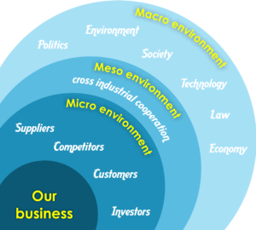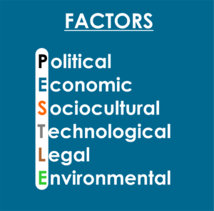
This image was adopted from (Elias, 2017)
The above is identifying the internal and external factors that can impact businesses in many ways leaders must be aware of surrounding environmental changes.

Micro-environment
suppliers are an important part of the organization to monitor them closely and build good relationships otherwise suppliers may look for sustainable companies with a long-term plan the Midland Greek Association need fresh meat and vegetable to run a restaurant, but the lack of consumers decrease the business size and difficult for suppliers to keep promises delivering time, products quality and the initial price in such business size. Customers are the most important factors in targeting customer satisfaction and creating strong relationships. The midland Greek Association getting more people into the business is the one-way solution to achieve the goals and objectives of the organization. Competitors factors can create potential risks when similar projects differentiate by quality or prices to attract customers it is important for Midland Greek Association to know what competitors doing to facilitate their services with a clear appearance to people in the chosen segments.

PESTEL Analytics
Accounting to Jones (2022) argues that PESTEL analysis identifies a wider understanding of industries that include Macro surrounding elements to help businesses’ growth and development when critically evaluating the PESTEL stages it gives a clear knowledge of the organization’s direction and earlier to predicts the future easier to minimize the risks and able to reposition potential market gains or respond to the changes.
Political factors in government can be changed at any time such as in elections new laws may introduce taxation, employee law, health and safety law, cost to tackle environmental issues inflations and salary companies need to ensure awareness of the changes. And that can impact on the midland Greek Association because of the above factors’ changes can impact individuals and donations will determine as unimportant. Economical these factors are immediately rising concerns for the Midland Greek Association because of the Russian and Ukraine war, pound deflation and other unexpected changes food, gas, and car insurance prices have doubled very quickly household struggle to pay mortgages when the initial price has significantly increased by Banks rate because of that reason the Greek members may give up.
Social factors involve cultural beliefs growing population slowly changing behaviour and attitudes and different for the Midland Greek Association to expect support from youth when everything purely traditional young people may be more modernized. Technology factors in a new digital age can businesses reach customers using social media to advertise products or services and ideal for Greek Association to be visible to others but most importantly have different things to offer that others do not have. Technology improves product design and increases productivity.
Environmental factors concerning raw materials organizations must practice ethically to sustain environmental responsibility to reduce pollution it is unavailable political agenda and may limit customers’ choices. Legal factors can impact on organization laws related to health and safety is relevant to Geek Association hygiene on food regulations, environmental issues in garbage and disposal materials consuming fatty food it is can due to health concerns in the government expenses come to legal food processing and require a legal certificate to show all this build on business costs when it comes to food ingredient customers have the legal right to challenge.

Target Market and the marketing mix.
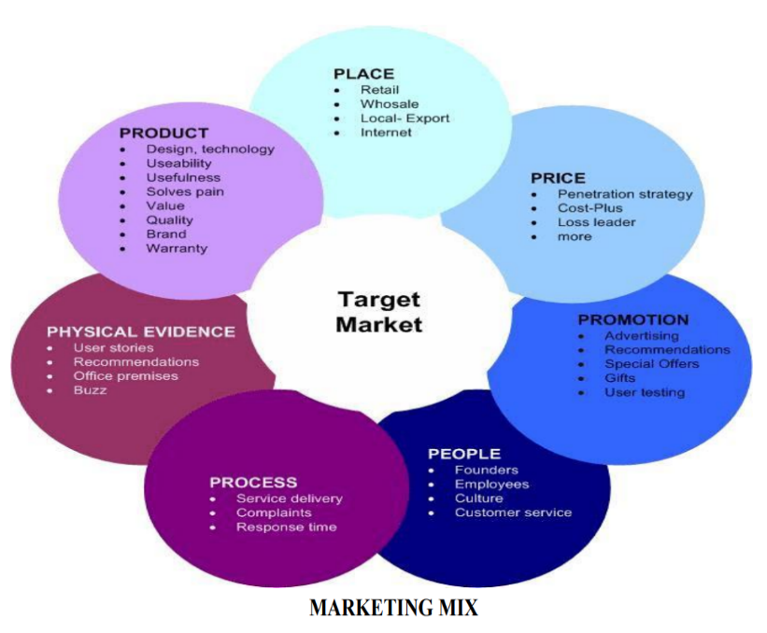
This image was adopted from (Kotler et al. 2000)
Accounting to Armstrong (2001, p. 48) defines target marketing as a process that can formulae marketing coverage guideline and segmentation of the market that can deliver the best prospects for the firm. The interchangeable target marketing and market targeting terms are the processes of target marketing and serve to control the use of the marketing mix to describe the product differentiation that how is made and available for each segment. The Midland Greek Association needs to identify segments to target audiences for marketing purposes and shows products differentiate to gain market advantage.
According to Kotler et al. (2000, p. 4) state that the 7 Ps marketing mix characterizes the combining decisions of needs and satisfaction of the customers these include the 7 Ps elements:
Products and services must be carefully planned and developed by the company for the consumers. Products’ design, quality and durability must be aligned with the brand description. The Midland Greek Association provide typically for Greeks and is not accessible to customers and has no difference from the Greeks members used to serve at homes. However, the Greek restaurant hard will make profits from the time-to-time sale. Price the products worth by exchange when the customer is willing to pay for it and it is the responsibility of the managers to decide a price that can make a profit for the business and be affordably for the customer that can much with a competitive advantage. The Greek Association restaurant listed a fixed price per meal is not aligned with a profitable business principle. And do not offer any Promotion that can attract more customers may offer discounts for short time or buy one get one free visitors could be back may be captured by place attractions or test of the food.
Place: is important for a business location’s appearance to be visible to customers and comfortable to use. The Midlands Greek and Cypriot Association operates a restaurant to serve traditional food in the building’s interior attraction suite to accommodate the demands, but furniture and equipment may rise concerns to organize or need change to meet customers the other feature of the building is a free car park space. The major issue is the outside of the building requires a roof cleaning and renovate the windows the clarity of the building image open door to bring more opportunities. People employees’ training is important to dive into the business vision to achieve long-term goals and have a clear understanding of the customers’ needs.

Marketing Communications.
According to Midlands Greek and Cypriot Association (2013) mentions that this website is newly designed and seen by many people around the world give us a call for our growing website to advertise your business. However, the Association uses media to communicate through email, phone calls and other social media such as Facebook, and Twitter but not visible to audiences the icons are very small to recognize, and it is mentioned on the website that could advertise other businesses to generate money but should do more for website development and clear exploration. however, “media advertising to potential or existing customers is about the products or services on offer to them. The aims are to impart information, to develop favourable attitudes to the product or service, and to generate sales. Media scheduling Media scheduling is the process of deciding what type of media to adopt” (Armstrong, 2001, p. 51).

Measuring success: how is the effectiveness of campaigns assessed?
How is the effectiveness of campaigns assessed?
Measuring success based on company growth and using different elements to satisfy goals and objectives to sustain value. But for the Greek Association failed to meet the botanical growth because of the lack of activities or tangible pieces of information. The marketing campaign is defined as: according to Murray (2022) argues that a campaign is measured as the process of measuring the impact of marketing to advertise efforts against your campaign goals. It includes looking at the key performance indicator (KPIs) of the campaign and assessing whether they are adequate for meeting the goals. According to Luther (2022) argues that metrics are used to chase the organization’s process to determine the performance level of the business activities and there are several metrics used in different businesses.

What are the contributions and the overall organization’s performance?
For example, activities are mainly based on events in which the Greek community members only support events through donations and part-time teaching Greeks languages to young people and other facilities such as sports and games there is an opportunity for the organization to generate more capital. For example, the restaurant could adjust the opening hours on daily bases at least 6 days a week while the cafe opens 7 days a week.
However, the use of media is good, but the information is not effective on Facebook, Twitter, and websites to attract people and does not match customer wants and needs. The lack of training staff resulted in poor management practices and affected the overall organization’s performance. However, “measures of performance show how well the operations in an organization are working. They show whether the organization is achieving its aims, or whether performance needs to be improved” (Armstrong, 2021, p. 208).

Task 2: Provide a managerial implication on the organization’s marketing strategy
Managers are responsible for the direction of the organization and employees’ behaviour by creating sustainable systems that involve research, development, training, problem-solving, decision-making, and being ready to lead and control. According to Northwest University (2018) argues that managers need to understand the organization and how impacts individuals or groups building a better relationship between management and employees. Managers are able to direct and subordinate behaviour. The managerial implication means managers are responsible for all activities of the organization’s positive or negative outcomes and engagement of customers and stakeholders’ behaviour and attitude toward business. One of the important key elements that managers need to identify the market gap is the selection of the area or segment and using such information to strategize potential market advantages
However, the Midland Greek Association managers need to run a clear business strategy and plan the organization’s future when the potential has been identified then businesses may generate huge income because the land that owns by the organization itself is a good asset but not able to maintain itself because of the gap of knowledge the managers have on how to make an effective operation on market research to understand the current position is to look for other resources to support areas that need to be developed whether intellectual such as training, hiring process or perhaps financial assistance. According to Dumbach (2014) states that managerial implications are relevant to community management are not only one position task but the accomplishment that can engage employees in different areas of hierarchical levels, and include the most important of three elements; technology innovation management, stakeholders are the most successful in the community management and it is a responsibility of the operational management of community to monitor job and the workshop facilities with the support of HR department expertise such as recruitment and training to achieve the goals and objectives of the community members desire in long term future.
The Gap Model is used to identify five gaps and offer a clear direction for managers to solve the problems that can influence customers’ evaluation in delivering a quality service and employees’ knowledge and ability to convey courtesy and trust that align with the organizations’ vision.
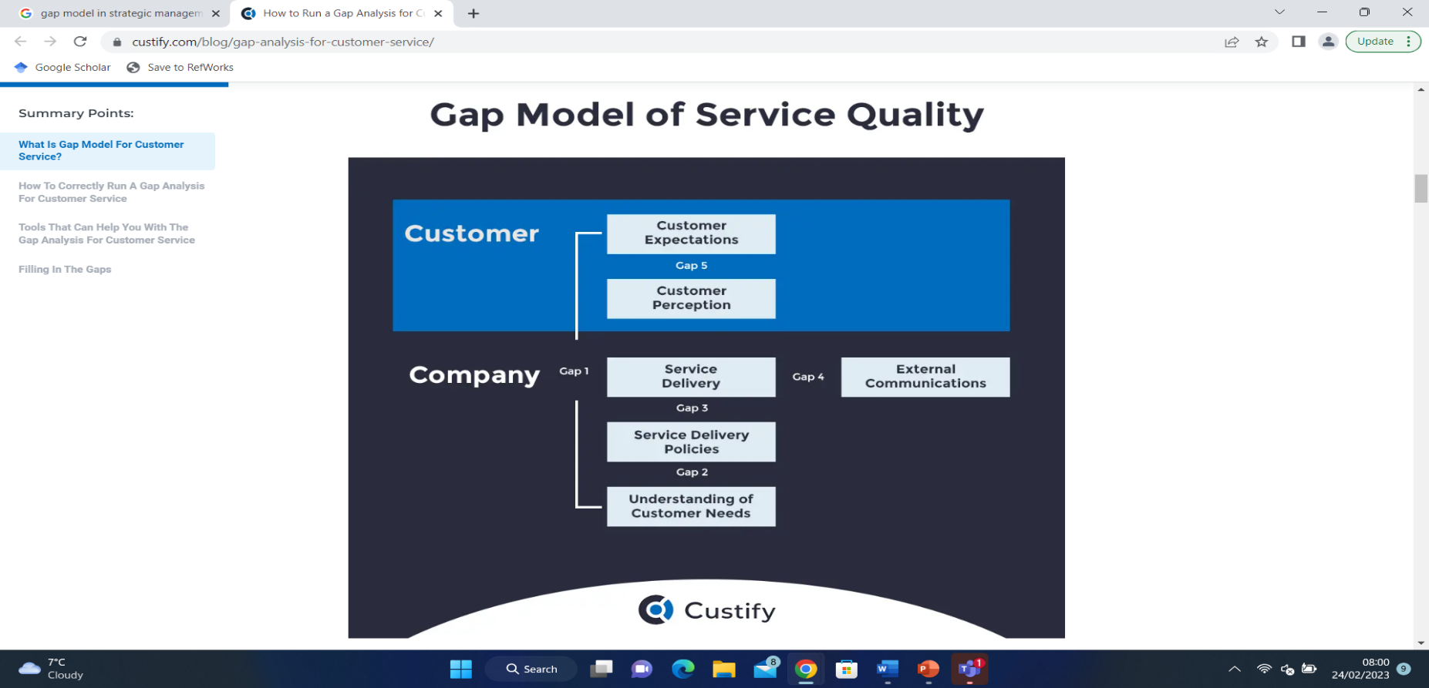
This image was adopted from (Wolf, 2022)
Gap one customers’ expectations of delivery acceptability of the services which managers’ responsibility to take action toward customers’ perception. This gap in knowledge of Christos’s Restaurant being unable to bring new customers because of a lack of knowledge of other cultures is not being presented properly by the existing customers throes are part of the community who owned the building and are treated as main consumers. Gap two for example, “the policy gap means the difference between the perception of needs by management and the actual specification of the service provided. This happens when the management understands what the customers want but it does not translate into correct specifications and orders to the rest of the company” (Wolf, 2022). Gap three identifies the delivery gaps that can specify services are being provided and make a different approach to consumers’ desires. However, Christos’s restaurant promotion does not drive to aims, new customers because lack of information that is shown in social media which includes the Greeks language and no translation into English could a problem for non-Greeks language speakers.
Gap four is a communication between the services provided by the Midland Greek Association using the website for other businesses and communication methods through email and phone calls to negotiate the price is a positive sign but, the website is more attractive to customers and website developers what make this website different from others Christos mentioned that all people from around the world visiting the website but no evidence at any single reason someone can use it. Facebook and Twitter icons are positioned on the footer page of the website on the hidden side but contain useful information about the Greeks members including the Greeks language mostly promoting Greek culture. However, “According to Managers from banks interactive social networking site applications, for example, Facebook and Twitter have altered the way bank customers gather information about services. Social networking has been appearing as a powerful customer engagement tool and a marketing channel for establishing connections between business and brand” (Tan, Hamid and Chew, 2016, p. 14).

Task 3: Based on the managerial implications draw recommendations as to how the organization’s marketing strategy could be improved.
  - Recommendations
Finding gaps in the Midland Greeks Association was not able to reach potential customers in the area to achieve competitive marking advantages managers need to do more research about the local community inquiry and introduce the services and products it suits the need or what changes can carry out for further development to support deed; using free events can help with finding and increasing customers desire for example, Christos’s restaurant can use an advertising method to invites all relevant people in such areas or postcodes for free food and cafe provided mainly Greek and during the event can the visitors at least answer the three basic questions to the provided questionnaires to help Christos to makes a change upon request to suit all necessary and comfortable environment for your next customer’s visit and getting feedback for incessant use.
Social media is one of the most important aspects to interact with customers but must importantly contain desirable information to attract more people to achieve competitive marking advantages. The information used in Christos’s restaurant does not match what it been provided in the actual restaurant environment. However, “In a competitive environment, banks need to search for their long-term competitive advantage. Improved service quality, as one of the differentiated strategies, should be adopted to achieve customer satisfaction and to maintain their profits for business success” (Tan, Hamid and Chew, 2016, p.14). The communication gap is linked to the Mainland Greeks Association website provides contacts to those who want to advertise via email and phone calls are providing, however, this is a good idea but Christos needs to add intelligence software that can show the number of visitors daily access the website that can build trust to the users and feel comfortable with services.

Conclusions
The Midland Greek Association needs to find financial support and hire experts to develop the website to be more attractive to visitors the other thing is training through the organization from the top managers to employees and it a very important to involve the HR department and such established organization able to get more money but the bank was given a loan base on activities may the organization managers unable to satisfy the borrower’s question however, the government has provided some initiative grant and funding available to support the community center or as a charity could apply for a lottery funding. The lottery funding helps the community, not businesses but in this case, the Midland Greek Association got multiple events during the year, and lottery funds rise to support events then funds come through community members could use to renovate the building and make it attractive and accessible to others.
However, advice for Midland Greek Association needs to adopt a marketing strategy and conceptual methods to improve productivity marking plan can create potential competitive advantages to promote brand loyalty and customers promotion the use of new technologies could easily identify competitors’ activities and allow a competitive marking success. For example, “traditional marketing starts from production and ends with the sale but modern marketing includes planning, product, price, promotion, place, people, after-sale service, etc” (Kotler et al, 2000, p. 2).

References
Armstrong, G. et al. (2014) Principles of marketing. 6th edn. Australia Pearson.
Armstrong, M. (2001) A handbook of Management Techniques: the best-selling guide to modern management methods. 3rd rev edn. London United Kingdom: Kogan Page Publishers.
Dumbach, M. (2014) 'Managerial implications SpringerLink', Available at: https://link.springer.com/chapter/10.1007/978-3-658-03695-9_25.
Elias, Z. (2017) 'What's around us?', Global Fashion Business, . Available at: https://blog.hamk.fi/gfb/1-whats-around-us/ (Accessed: Feb 19, 2023).
Janabi, M.Q.N. (2022) The effect of brand equity on purchase behavior: A study of fast-food brands in Iraq. Master’s thesis, Altinbas University.
Jones, S. (2022) A guide to SWOT and PESTLE analysis (with free Template). Available at: https://localiq.co.uk/blog/a-complete-guide-to-using-swot-pestle-for-marketing (Accessed: Feb 19, 2023).
Kotler, P. et al. (2000) Introduction al marketing Pearson Prentice Hall.
Luther, D. (2022) What Are Business Metrics? 35 Metrics Businesses Need to Track. Available at: https://www.netsuite.com/portal/resource/articles/business-strategy/business-metrics.shtml#:~:text=Business%20metrics%20are%20quantifiable%20measures,businesses%2C%20with%20many%20different%20processes. (Accessed: Feb 21, 2023).
Murray, E. (2022) Ways to Measure the Success of a Campaign. Available at: https://demandscience.com/resources/blog/ways-to-measure-campaign-success/ (Accessed: Feb 21, 2023).
Northwest University (2018) Why Managers Should Understand Organizational Behavior. Available at: https://online.nwmissouri.edu/articles/mba/why-managers-understand-organizational-behavior.aspx (Accessed: Feb 22, 2023).
Shkeer, A.S. and Awang, Z. (2019) 'The impact of marketing information system components on organizational decision making: A case of Jordanian five star hotels', International Review of Management and Marketing, 9(6), pp. 197.
Tan, L., Hamid, S. and Chew, B. (2016) 'Service quality audit based on conceptual gaps model of service quality: a case study of top three largest local bank in Malaysia', International Journal of Productivity and Quality Management, 18(1), pp. 99-115.
Thomas, J. (2020) Marketing concept: examining AMA definitions, evolution, influences. Indian Institute of Management Kozhikode Kerala, .
Wolf, P. (2022) 'How to Run a Gap Analysis for Customer Service & Understand Customer Satisfaction', Custify, . Available at: https://www.custify.com/blog/gap-analysis-for-customer-service/ (Accessed: Feb 24, 2023).

