By Andrew Ridgeway
Computer Games Development
P148551
Maze Game

Abstract…………………………………………………………….….2

Introduction…………………………………………………………….2

Brief Description of the Game………………………………………..2

Rules of the game……………………………………………………..2

Script……………………………………………………….……………3

Completed game……………………………………………………….9

Errors and Challenges…………………………………………………12

Evaluation……………………………………………………………….12

Future Versions…………………………………………………………12

Reference………………………………………………………………..12

Abstract
This report is about a maze game where the player controls the character to go through the maze to get to the next level. The character’s health will be decreasing over time and if the player does not get to the next level, it will be game over for them.

Introduction
The type of game that has been built using unity is a maze type game and there will be a brief description that how the game works. There will be a set of rules that explains how the player plays the game. There will be screen shots to show the completed game and there will be a scripted to show what is used to make the game run. Challenges will be explaining what problems with in the game. There will be a self-evaluation and future plans for the game.

Brief Description of the Game
The player can choose to collect coins while going through the maze to get a high score while getting chased. The player can choose to get the coins to get points or get to the next level. There are enemies in the game that push the player back to try stop and stop the player from getting to the end of the maze. There are also obstacles, such as platforms that go up and down to stop the player to going through that way or cause the player to wait. The player will have a health bar that is displayed on the top of the screen. There will be a main menu at the start of the game.

Rules of the game
- How to play the game: The game will use a keyboard and mouse support to allow the player to control their character. The mouse will be used to allow the player to look around the area. The player has a choice of using the arrow keys to move the character (left, right, back and forward) or the player can use the a, s, d and w keys in the same way.

- The gameplay: The type of challenges the player must go through in the game is to run through the Maze while there are getting chased by the enemy. The player can choose to collect the coins within the maze and the enemies can take the coins as well, so the player cannot get the coins that enemy took. The player’s health will deplete over time in the game and if the health hits zero it's game over for the player

- The goal: The main goal of the game is to get through all three levels to complete the game and the player can choose to collect the coins in the game to give them even more points. The player must go through the maze while their health is slowly depleting

Script
//////////////////////////////////////////////////////////////
// This code is used to start the game
//////////////////////////////////////////////////////////////
using System.Collections;
using UnityEngine.SceneManagement;
using UnityEngine;

public class Buttons : MonoBehaviour {
public string startGame;

// Set the buttons for the display
void OnGUI()
{
// Set the position for the button
if (GUI.Button(new Rect(400, 420, 150, 30), "Start Game"))
{
// Scenemanager is used to close the main menu to allow the player to play the game
SceneManager.LoadScene(startGame, LoadSceneMode.Single);
}

}
}
This code is use to set the GUI button on the screen to allow player to start the game and this was looked up to learn how to set the button for the game [1].

//////////////////////////////////////////////////////////////
// This code is used to give the object the capability to follow the player
//////////////////////////////////////////////////////////////
using System.Collections;
using System.Collections.Generic;
using UnityEngine;

public class EnemyMove : MonoBehaviour {
public Transform target;

// Update is called once per frame
void Update()
{
// Only moved forwards to the player
transform.LookAt(target);
// Calculate the movement speed for the enemy
transform.Translate(Vector3.forward * 1 * Time.deltaTime);
}

}

This code is used to allow the enemy to follow the player character and this will hinder player to go through area [2].

//////////////////////////////////////////////////////////////
// This code is used for the player to gain points while destroying the object
//////////////////////////////////////////////////////////////
using System.Collections;
using System.Collections.Generic;
using UnityEngine.UI;
using UnityEngine;

public class Score : MonoBehaviour {
private int count;
public Text scorePoine;

// Use this for initialization
void Start () {
count = 0;
countTheScore();
}

// Allows the player to gain points when they pick up the coins
void countTheScore()
{
scorePoine.text = "Score: " + count.ToString();
}

// The player
void OnCollisionEnter(Collision up)
{
// When the player enters the pollution the player can get 10 points while the object is destroyed
if (up.gameObject.CompareTag("GainCoin"))
{
up.gameObject.SetActive(false);
count = count + 10;
countTheScore();
}
}
}

This code is used to allow the player to gain point on the score and the coin disappears once the player touches the coin [3].

//////////////////////////////////////////////////////////////
// This code is used to move objects up and down
//////////////////////////////////////////////////////////////
using System.Collections;
using System.Collections.Generic;
using UnityEngine;

public class MoveUpAndDown : MonoBehaviour {
public float upDown;
public float length = 1;

// Use this for initialization
void Start()
{
// Only allows objects to move in the y position
upDown = transform.position.y;
}

// Update is called once per frame
void Update()
{
// The calculations updates the position of up and down for the objects
transform.position = new Vector3(transform.position.x, upDown + ((float)Mathf.Sin(Time.time) * length), transform.position.z);
}
}

This code is used to allow the obstacles to move up and down to give player some difficulty to reach the check point [4].

//////////////////////////////////////////////////////////////
// This code is used to the object to rotate in 360 degrees in the X, Y and Z Direction
//////////////////////////////////////////////////////////////
using System.Collections;
using System.Collections.Generic;
using UnityEngine;

public class Coins : MonoBehaviour {
// Update is called once per frame
void Update () {
// Object rotate
transform.Rotate(new Vector3(90, 30, 60) * Time.deltaTime);
}
}

This code is used to allow the coins to rotate in x, y and z position so this gives the coin the animation Mario look.

//////////////////////////////////////////////////////////////
/* This code is used to calculate how much
health a player has and how much damage
they would gain over time */
//////////////////////////////////////////////////////////////
using System;
using System.Collections;
using System.Collections.Generic;
using UnityEngine;
using UnityEngine.SceneManagement;

public class PlayerLife : MonoBehaviour {
public float currLife = 0;
public float maxLife = 100;
public GameObject lifeLen;

// Use this for initialization
void Start()
{
currLife = maxLife;
// InvokeRepeating is used to repeat the damage for the players health to go down
InvokeRepeating("takeDamage", 1.0f, 1.0f);
healthBar();
}

// Used for calculating the damage for the players health to go down
public void takeDamage()
{
gameOver();
currLife -= 4.0f;
healthBar();
}

// Sets the players health bar
public void healthBar()
{
float theLife = currLife / maxLife;
lifeLen.transform.localScale = new Vector3(Mathf.Clamp(theLife, 0.0f, 1.0f), lifeLen.transform.localScale.y, lifeLen.transform.localScale.z);
}

// Calls game over scene
public void gameOver()
{
if (currLife <= 0)
{
currLife = 0;
// When the players health hits 0 call game over scene[5]
SceneManager.LoadScene("GameOver");
}
}
}

This code is used to allow the character to calculate how much health the player has and to calculate the damage the character gains over time. When the player’s character health hits zero, the player character will go to the game over scene and it does this by checking if the health hit zero or lower [5] [6].

//////////////////////////////////////////////////////////////
// This code is used to that the player go to level 2
//////////////////////////////////////////////////////////////
using System.Collections;
using System.Collections.Generic;
using UnityEngine.SceneManagement;
using UnityEngine;

public class NextLevel : MonoBehaviour {
// Allows the player to go to the next level
private void OnTriggerEnter(Collider other)
{
if (other.gameObject.tag.Equals("Player"))
{
// Scenemanager is used to close level 1 to go to level 2
SceneManager.LoadScene("MazeGameLevel2");
}
}
}

This code is used to allow the player when entering the check point to finish the maze level 1 to load maze level 2 scene.

//////////////////////////////////////////////////////////////
// This code is used to that the player go to level 3
//////////////////////////////////////////////////////////////
using System.Collections;
using System.Collections.Generic;
using UnityEngine;
using UnityEngine.SceneManagement;

public class NextLevel2to3 : MonoBehaviour {
// Allows the player to go to the next level
private void OnTriggerEnter(Collider other)
{
if (other.gameObject.tag.Equals("Player"))
{
// Scenemanager is used to close level 2 to go to level 3
SceneManager.LoadScene("MazeGameLevel3");
}
}
}

This code is used to allow the player when entering the check point to finish the maze level 2 to load maze level 3 scene [7].

//////////////////////////////////////////////////////////////
// This code is used to that the player finish the game
//////////////////////////////////////////////////////////////
using System.Collections;
using System.Collections.Generic;
using UnityEngine;
using UnityEngine.SceneManagement;

public class FinishLevel : MonoBehaviour {
// Allows the player to finish the game
private void OnTriggerEnter(Collider other)
{
if (other.gameObject.tag.Equals("Player"))
{
// Scenemanager is used to close level 3 to go to the finish scene
SceneManager.LoadScene("FinishGame");
}
}
}

This code is using to allow the player when entering the check point to finish the maze level 3 to load well done scene.

//////////////////////////////////////////////////////////////
/* This code is used to allows the player to
restart again or return to main menu */
//////////////////////////////////////////////////////////////
using System.Collections;
using System.Collections.Generic;
using UnityEngine;
using UnityEngine.SceneManagement;

public class Return : MonoBehaviour {
// Set the buttons for the display
void OnGUI()
{
// Set the position for the button
if (GUI.Button(new Rect(600, 150, 150, 30), "Mainmenu"))
{
// Scenemanager is used to return to main menu
SceneManager.LoadScene("MainMenu");
}

if (GUI.Button(new Rect(600, 200, 150, 30), "Restart Game"))
{
// Scenemanager is used to restart the game again
SceneManager.LoadScene("MazeGame");
}
}
}

This code is used to set the GUI button on the screen to allow player to start the game and this was looked up to learn how to set the button for the game. The load scene is using to allow the player to enter the maze or return to the main menu when the player finishes the all level in the maze.

//////////////////////////////////////////////////////////////
// This code is used to restart the game
//////////////////////////////////////////////////////////////
using System.Collections;
using System.Collections.Generic;
using UnityEngine;
using UnityEngine.SceneManagement;

public class RestartButton : MonoBehaviour {
// Set the buttons for the display
void OnGUI()
{
// Set the position for the button
if (GUI.Button(new Rect(600, 200, 150, 30), "Restart Game"))
{
// Scenemanager is used to restart the game again
SceneManager.LoadScene("MazeGame");
}
}
}

This code is used to set the GUI button on the screen to allow player to start the game and this was looked up to learn how to set the button for the game. If the player character dies the game will allow the player to restart the game.

Completed game
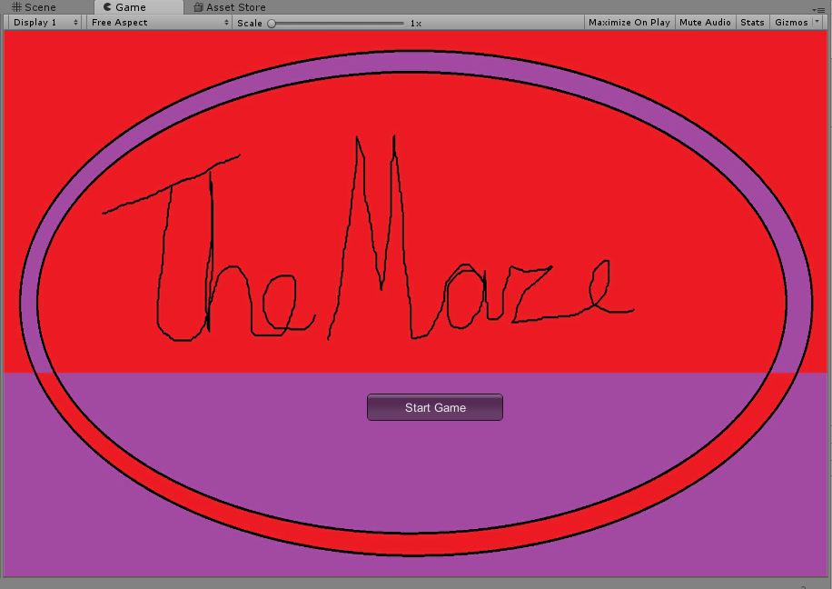
The main menu and button to start the game.
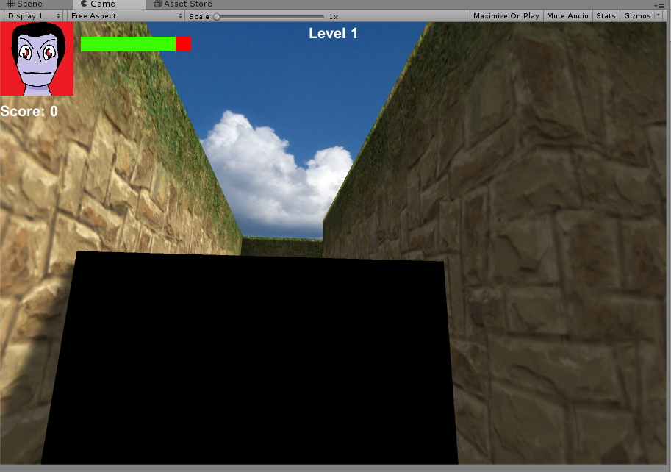
The health bar and score.
The level 1 of the maze game.
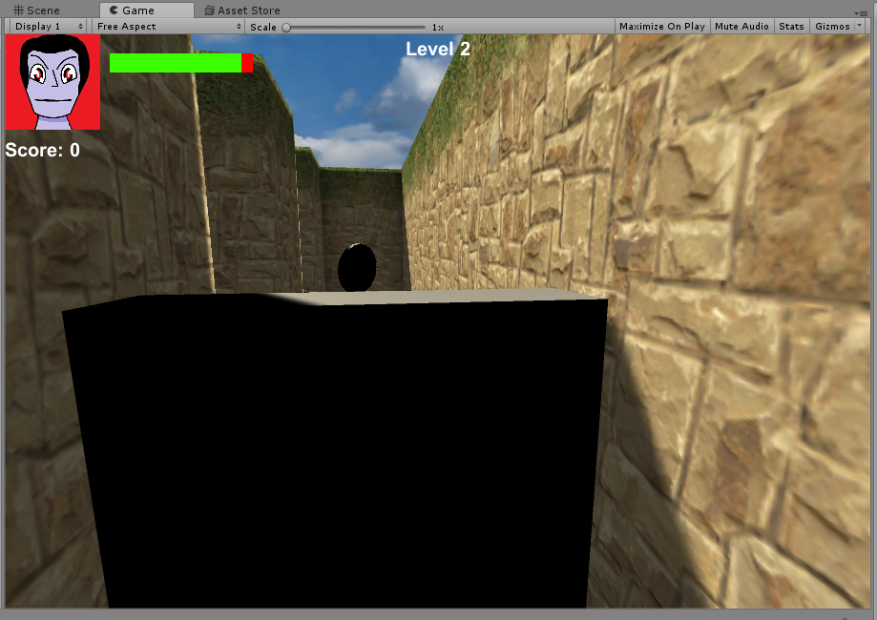
The level 2 of the maze game.
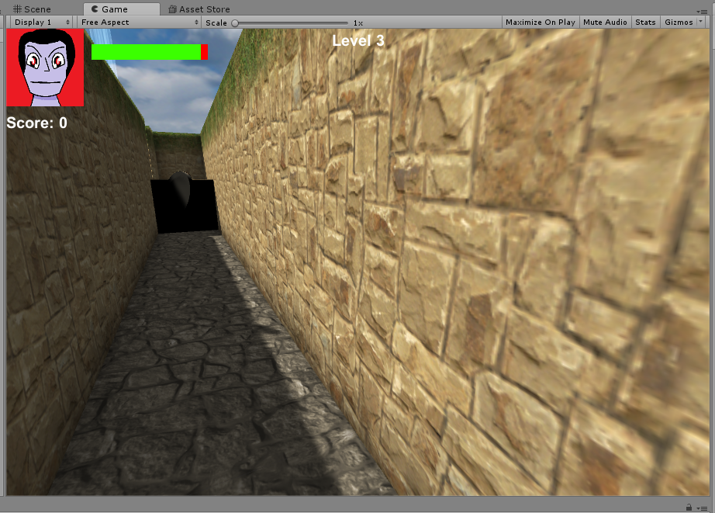
The level 3 of the maze game.
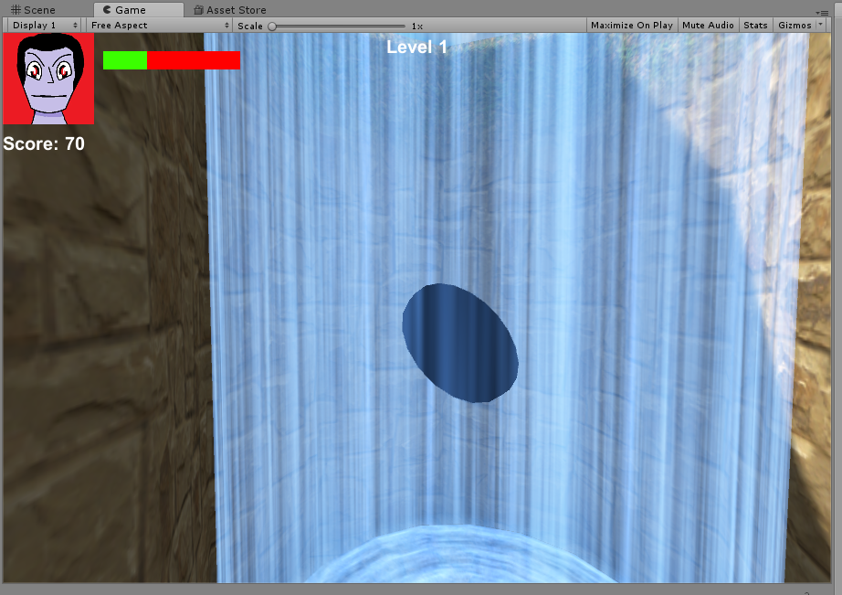
To the next level exit point.
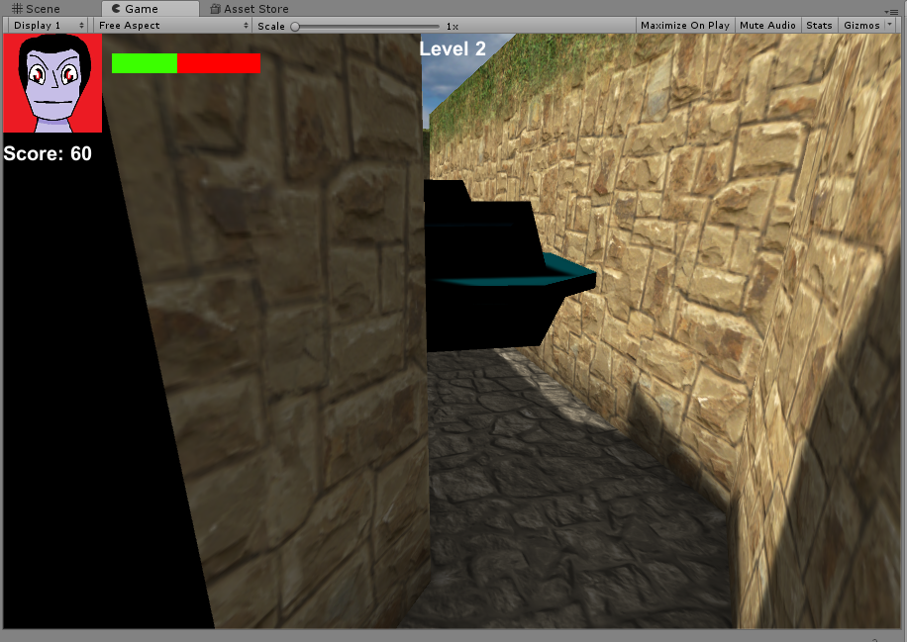
The enemy in the game.
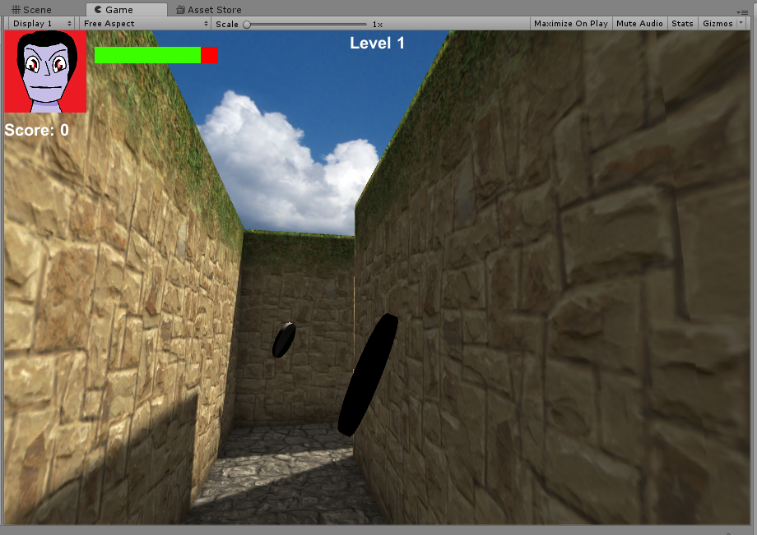
The coins for boost up the score.
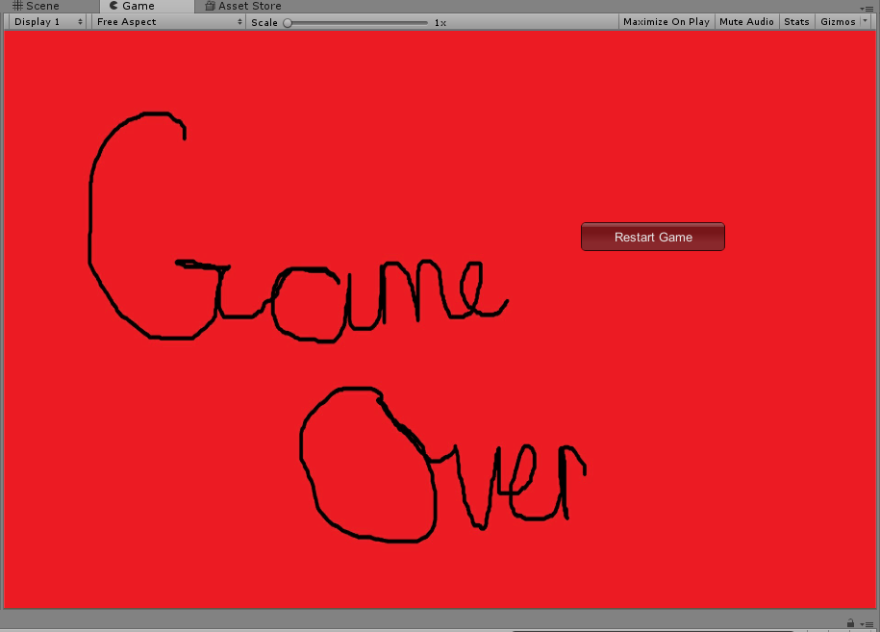
The game over and restart button.
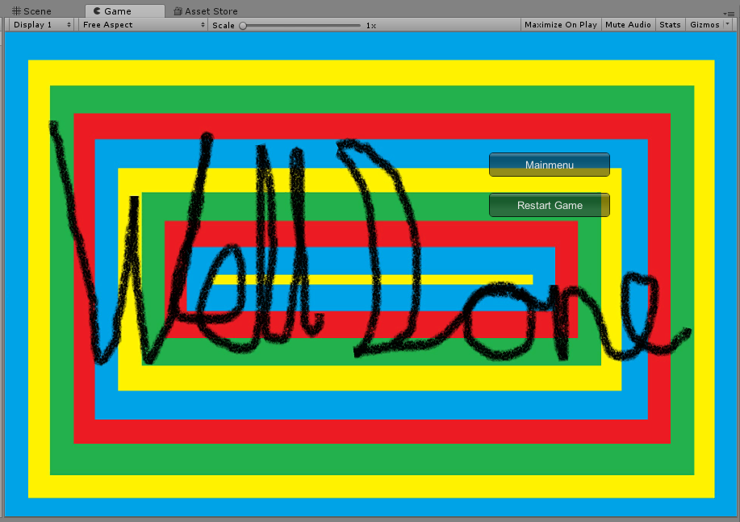
The well done, main menu button and restart button.

Errors and Challenges
There were a few challenges with creating this game and one of them was damage to the player’s health every time the player gets hurt the health goes down. But trying to figure out how to fix this code was difficult so the player loses Health over time while they are going through the maze instead.
Another challenge is when the enemies pushed the player the player would go through the wall and cause them to fall out to the map.
Another challenge was when the enemy picks up the coin sometimes the player gets double the score so this code for the enemy was scraped from the game.
Another challenge with the code of the obstacles moving sideways and this will cause the player to glitch out of map, but the code was replaced to allow the obstacle to move up and down.

Evaluation
- Gameplay: The game players very bland and some features such as jump, crouch and attack.
- Design: Very boring looking and the enemies look like Lego blocks.
- Creativity: The creativity of the game is quite bland and a bit boring.

Future Versions
The future versions of the maze game will have features such as the enemies will have the capability to damage the player instead of the player losing Health over time. The score in the game will allow the player to bring their score to the next level to give them even more of a higher score. There will be more levels than three within the maze game and have a leaderboard to allow the player to beat their own score while picking up the coin.

Reference
[1] Unity Technologies, “GUI,” 2017. [Online]. Available: https://docs.unity3d.com/ScriptReference/GUI.html. [Accessed: 20-Nov-2017].
[2] Unity Technologies, “Transform.LookAt,” 2017. [Online]. Available: https://docs.unity3d.com/ScriptReference/Transform.html. [Accessed: 08-Nov-2017].
[3] Unity Technologies, “GameObject.SetActive,” 2017. [Online]. Available: https://docs.unity3d.com/ScriptReference/GameObject.html. [Accessed: 15-Nov-2017].
[4] Unity Technologies, “Mathf,” 2017. [Online]. Available: https://docs.unity3d.com/ScriptReference/Mathf.html. [Accessed: 24-Nov-2017].
[5] Unity Technologies, “SceneManager.LoadScene,” 2017. [Online]. Available: https://docs.unity3d.com/ScriptReference/SceneManagement.SceneManager.LoadScene.html. [Accessed: 08-Dec-2017].
[6] Unity Technologies, “MonoBehaviour.InvokeRepeating,” 2017. [Online]. Available: https://docs.unity3d.com/ScriptReference/MonoBehaviour.InvokeRepeating.html. [Accessed: 03-Dec-2017].
[7] Unity Technologies, “Tags,” 2017. [Online]. Available: https://docs.unity3d.com/Manual/Tags.html. [Accessed: 15-Nov-2017].

marking criteria and Student FEEDBACK

This section details the assessment criteria. The extent to which these are demonstrated by you determines your mark. The marks available for each criterion are shown. Lecturers will use the space provided to comment on the achievement of the task(s), including those areas in which you have performed well and areas that would benefit from development/improvement.

Common Assessment Criteria Applied (Assignment 1) | Marks available | Marks  awarded
1. Research-informed Literature
Extent of research and/or own reading, selection of credible sources, application of appropriate referencing conventions.
References are okay. While it is evident from your implementation and write-up that you have done some research to implement the game, your referencing of the sources consulted is not quite accurate. See your report for additional comments. (Grade mark: 60.00%) | 5 | 3
2. Knowledge and Understanding of Subject
Extent of knowledge and understanding of concepts and underlying principles associated with the discipline.
Demonstrates good knowledge of implementing a game in Unity. There is room, however, room for improvement in your coding techniques. For example, implementation of good coding practices, such as not making class fields public but instead making use of the SerializeField attribute to expose these fields to the Inspector window and accessor property methods to expose them to other classes, as well as the use of events. Additionally, some script classes could be refactored (see example in your report) and I would like to see more evidence of your own coding ideas. (Grade mark: 62.50%) | 20 | 12.5
3. Analysis
Analysis, evaluation and synthesis; logic, argument and judgement; analytical reflection; organisation of ideas and evidence
Fair discussion of the challenges faced, but the evaluation of the game is weak. The recommendations for future improvements are relevant and practical. (Grade mark: 50.00%) | 15 | 7.5
4. Practical Application and Deployment
Deployment of methods, materials, tools and techniques; application of concepts; formulation of innovative and creative solutions to solve problems.
A very good attempt featuring a simple game that has generally been given a lot of thought. Although there are some issues and the game world is not generated dynamically, overall it implements a good range of scripting concepts. I would have liked to see a more dynamic approach to the generation of the levels. See the comment in your report about static vs. dynamic colliders or refer to Lecture 2, Slide 13. You may also want to restrict the player character's rotation on the y-axis. Overall, a very good attempt. Well done. (Grade mark: 68.18%) | 55 | 37.5
5. Skills for Professional Practice
Attributes in professional practice: individual and collaborative working; deployment of appropriate media; presentation and organisation.
The report is satisfactory, but aim to improve your writing style. See your report for additional comments. (Grade mark: 50.00%) | 5 | 2.5

Assignment Mark (Assessment marks are subject to ratification at the Exam Board. These comments and marks are to give feedback on module work and are for guidance only until they are confirmed. ) | Late Submission Penalties (tick if appropriate) |  | 63%
 | Up to one week late |  | 63%
 | 1st/2nd/3rd attempt? |  | 63%

