Alternative Power for Auxiliary systems within a Drive Cycle simulation.
  - Final Project Dissertation (M6X02206)

  - By Liam Paul Standing (P150310)
  - Supervisor Andrew Gibson

  - University of Wales Trinity Saint David
  - School of Engineering
  - Automotive Engineering BSc Year 3



21/04/2019

Abstract

This project looks into the application of Alternative energy supply for reducing parasitic losses from an automotive vehicle and its relevance to industry and current global matters. The source of these parasitic losses stem from the AC system and is resolved with the introduction of a KERS system. The approach to reach the chosen system comes from practical testing and simulation of WLTC. The overall results provided a 90% accurate simulation based on the conversion of WLTP to NEDC selected, hence overall showing that the proposed Alternative supply for the AC system increase fuel consumption by 1.6% when not in operation and decreased fuel consumption by 51%. Overall the conclusion arrived looks at the pitfalls and limitations within the simulation causing accuracy issues discusses the practicality of the real-world implication of the designed system.

Acknowledgements

I would like to thank the UWTSD lecturers and staff. In no particular order I thank Andrew Gibson for his advice and guidance since the project genesis and throughout. In addition the workshop technicians Paul, Barry and Mark for help and advice when undertaking practical testing. Furthermore, Mark Sandford for his lectures on drive cycles and understanding of hybridized systems. Also my thanks extends to UWTSD students in various stages of the automotive and motorsport degrees for ongoing support and advice during project and providing a friendly and beneficial working environment, even when the university was closed due to Covid-19.

Contents

Abstract i
Acknowledgements ii
Contents iii
Figures and Tables iv
1. Introduction 1
1.1 Aims 1
2. Background 2
3. Research 3
3.1 Tests and testing 3
3.1.1 The WLTP test 3
3.1.2 The NEDC 4
3.2 Vehicle Specification 5
3.2.1 Audi A6 5
3.2.2 Engine 6
3.2.3 The transmission 7
3.2.4 AC System 8
3.3 Alternative supply systems 10
4. Methodology 11
4.1 Practical testing 11
4.2 Simulation 11
4.2.1 Resistive forces 11
4.2.2 Enthalpy 12
5. Results 15
5.1 Simulation 15
6. Analysis 16
6.1 Low phase WLTC 16
6.2 Full WLTC 16
6.3 Comparison: low phase to Full WLTC 16
6.4 NEDC 16
6.5 Comparison: NEDC to WLTC 17
7. Discussion 18
7.1 Project planning 18
7.2 Pandemic Impact Report 18
8. Conclusion 20
9. Further Work with Recommendations 21
10. References 22
Appendix A (Results and Figures) 26
Results 26
Additional Figures 31
Appendix B (Planning and Testing) 34

Figures and Tables
Figure 1,WLTP drive cycle sourced, (Mock et al., 2014) 3
Figure 2, WLTC for class 3b vehicles, Data sourced (UNECE 2012) 3
Figure 3, NEDC, Data sourced (UNECE, 2011) 4
Figure 4, A.G Block Audi A6 V6 3.2 FSI Engine rig. Image by Standing. L, 2019 5
Figure 5, Engine specification, sourced (Audi, 2005) 6
Figure 6, Effective pressure, Power and Torque for engine speeds, sourced (Audi, 2007) 7
Figure 7, (Audi, 2008) 8
Figure 8, AC system. (Audi, 2005) 8
Figure 9, Current compressor, (Denso, 2016) 9
Figure 10, Rencool MD18 Electric AC Compressor, (Rencool , 2016) 9
Figure 11, Engine RPM and vehicle Speed for each Gear. Standing, L. 2020. 12
Figure 12, NEDC Engine Temperature increase over time period. -Black dashed line. (Eiser et al., 2011) 14
Figure 13, Standing 2020. 15
Figure 14, Low Phase WLTC Fuel usage and economy for different fuels in each variant of vehicle and AC operation from simulation. Standing, 2020. 26
Figure 15, Complete WLTC fuel usage and economy for different fuels in each vehicle variant and AC operation. Standing, 2020. 27
Figure 16, NEDC fuel usage and economy for different fuels in each vehicle variant and AC operation. Standing, 2020. 27
Figure 17, Low phase total fuel usage for each system and AC operation, Standing , 2020. 28
Figure 18, Low phase fuel requirement for each second (E5-1), Standing, 2020. 28
Figure 19, Total used fuel of each system and operation for E5-1 in low phase only. Standing, 2020 29
Figure 20, Total used fuel of each system and operation for E5-1 full WLTC. Standing, 2020. 29
Figure 21, Fuel usage Trend line (Polynomial) for given vehicle speed for low Phase, Standing 2020. 30
Figure 22, Fuel usage Trend line (Linear) for given vehicle speed for low Phase, Standing 2020. 30
Figure 23, Fuel usage Trend line (Logarithmic) for given vehicle speed full WLTC, Standing 2020. 30
Figure 24, Fuel usage Trend line (Linear) for given vehicle speed full WLTC, Standing 2020. 31
Figure 25, Published NEDC compared to simulated NEDC, Standing 2020 31
Figure 26, Published NEDC compared to simulated NEDC percentage difference, Standing 2020 31
Figure 27, Fuel economy WNQ converted from NEDC for percentage accuracy of simulation and total savings, Standing 2020. 31
Figure 28, Track specific information. (Ehsani, et al., 2010) 31
Figure 29, Atomic weight and Moles per gram of each element for Enthalpy, (Mills and Jones, 1990) 32
Figure 30, Air to Fuel ratio for each fuel used in simulation, Standing, 2020. 32
Figure 31, Boltzmann constant and combination with Avogadro number for calculation of the thermal energy, (Mills and Jones, 1990) (Sharma, 2018) 32
Figure 32 32
Figure 33, Combustion enthalpy of iso-octane for calculating energy by weight. 32
Figure 34, Combustion enthalpy of E5 for calculating energy by weight. 33
Figure 35, Combustion enthalpy of E5-2 for calculating energy by weight. 33
Figure 36, Calculated of cylinder pressure prior combustion from Boyle’s gas law, Standing, 2020. 33
Figure 37, Calculated of cylinder pressure during combustion from combined gas law and Aleiferis et al., (2017), Standing, 2020. 34

Table 1, Table of Abbreviations 6
Table 2, Audi A6 Specification, (AutoData, 2009) & (Carfolio, 2004) 13

Equation 1, $Frr$ (Ehsani, et al., 2010) 22
Equation 2, $Fw$ (Ehsani, et al., 2010) 22
Equation 3, $Fg$ (Ehsani, et al., 2010) 22
Equation 4, $Faccl$ 22
Equation 5, E5 (Eyidogan et al., 2010) 23
Equation 6, Ethanol (Eyidogan et al., 2010) 23
Equation 7, Iso-octane (Aleiferis et al., 2017) 23
Equation 8, E5~2 23
Equation 9, Stoichiometric burn of Iso-octane 24
Equation 10, Stoichiometric burn of E5 24
Equation 11, Stoichiometric burn of E5~2 24
Equation 12, kinetic theory of gases (Sharma, 2018) 24

Table 1, Table of Abbreviations
Abbreviation | Meaning
AC | Air Conditioning
ATCT | Average European Temperature Control Test
BEV | Battery Electric Vehicle
BMEP | Break Mean Effective Pressure
Cd | Coefficient of Drag
CO | Carbon monoxide
CO₂ | Carbon dioxide
ECU | Engine Control Unit
EU | European Union
HC | Hydrocarbon (THC= Total Hydrocarbon)
HEV | Hybrid electric Vehicle
ICE | Internal Combustion Engine
KERS | Kinetic energy recovery system
N₂ | Nitrogen
NEDC | New European Drive Cycle
NMHC | Non-methane hydrocarbons
NOx | Nitrogen oxides
PEMS | Portable Emissions Measurement System
PM | Particulate matter
PN | Particle number
RDE (RDET) | Real Driving Emissions (Test)
RON | Research Octane Number
UI | User Interface
UN | United Nations
WLTC | Worldwide Harmonized Light Vehicles Test cycle
WLTP | Worldwide Harmonized Light Vehicles Test procedure
WNQ | WLTC-NEDC quotient of CO2 emissions

1. Introduction

Energy efficient low carbon vehicles are becoming more popular in modern times. This is mainly due to the increase of greenhouse gases in the atmosphere predominantly CO2, which is one of the leading causes of climate change. Thus there are important environmental and ethical reasons for the government and manufacturers to make vehicles more eco-friendly, this is expressed largely in “Cradle to grave” (UCS, 2015) and “The road to Zero” (DFT, 2018). Consequently there has been considerable political pressure on the automotive industry to reduce emissions, with the restrictions to the levels of emissions that can be released by a given vehicle from production and during operational life. The WLTP is one of these procedures used to test the emissions emitted from new production vehicles.
This project envisions the possible reductions to emissions that can be achieved from an alternative electrical supply to the Auxiliary system, primarily the AC. The AC system being the largest energy consumer in the category of comfort and convenient systems (Zacharof & Fontaras, 2016) has had developments over the years to improve efficiency and reduce emissions. Zulkifli et al. (2015) and Warule and Jadhav (2017) demonstrate these some of these possible improvements in their published papers.
To using these technological improvements the project works to combine Practical engine testing, Vehicle drive cycle simulation and mathematical processes to determine the potential reduced emissions. These findings are compared with known drive cycle emission data from the NEDC and the conversion factors concerning the difference between this and the WLTP values are discussed. Ultimately the findings of the project provide a quantitative value to the possible savings that the introduction of KERS to supply power to the AC system can achieve, this being up to 51% percent.
This was achieved by improving the knowledge and understanding of different subject areas and processes. These included engine testing, simulation, fuel combustion, enthalpy, mechanical and electrical efficiencies, KERS and drive cycle analysis. This cross compatible knowledge and understanding can be repurposed in in the future to reduce parasitic losses and improve energy recovery not only in conventional ICE vehicles but also in HEVs and BEVs.

1.1 Aims
Aim one is to determine the potential fuel savings therefore emissions reduction from a 2005 Audi A6 3.2 FSI with the addition of KERS Technology suppling auxiliary power to the AC system within the WLTP drive cycle specified for the chosen vehicle. The Second aim is to construct an accurate WLTC simulation for which the Audi and alternative Audi System operates within. This requires the collection of necessary data via research, practical testing and analytical calculations. This data can be split up in to categories of drive cycles, physical vehicle data, simulation vehicle data and alternative supply systems which is required to create this simulation with a user friendly package Microsoft Excel.

2. Background

Project so far
Previously a literature review (Standing, 2019) was created investigating the government emissions limits, ICE vehicle emissions, auxiliaries’ impact on these emissions and systems to reduce these excess emissions.
Conclusion from Literature review
A trend to the Government emissions regulations was outlined as decreasing including soon to be zero emissions by 2040 for ICE and HEV vehicles (DFT, 2018), outlining future Euro 7 standards. The testing of manufactured ICE vehicles is undertaken through the WLTP and RDET which have incorporated the testing of Auxiliary systems since 2017 (EU, 2017). Prior to which the NEDC unintentionally eluded. Auxiliary emissions for comfort and convenient systems are predominantly produced by the AC system as presented by Zacharof & Fontaras (2016). These reasons show the pathway chosen to persue a investigation in AC emissions reduction. Primary practical data from a Audi A6 (Section 3.2) engine rig was collected. Reduction systems had been review for the chosen application with a KERS decided upon as a possible candidate for further review.
A better understanding of reduction systems including KERS was a requirement for completion of the project, with attention to tailoring of a system to meet the vehicle and testing requirements. In addition the simulation and mathematical methodologies required needed to be further researched to create the data essential for results.
Discussion of feedback
As per the feedback from the literature review the following has been added:
- Section 3.2.4 limitations of testing AC on an engine rig as compared to a vehicle, with regards to the closed volume of a passenger compartment and the reliability of results.
- Practical testing undertaken and the proceedures of which are express in full in section 4.1. with plans present in Appendix B.

3. Research

3.1 Tests and testing

3.1.1 The WLTP test

The WLTP is a standardized test procedure for new vehicles to determine the emissions output. This consists of a drive cycle based on a vehicles power and weight, in addition to a RDET. The cycle required for the selected vehicle is class 3b (EU, 2017), as the power to weight is greater than 34 watts/kg and has a top speed greater than 120km/h (Table 1).
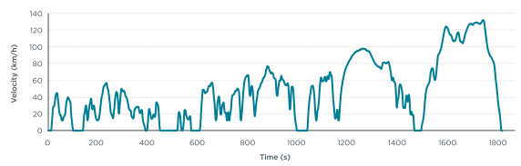
Figure 1,WLTP drive cycle sourced, (Mock et al., 2014)
For an accurate recreation of the WLTP drive cycle, data was collected from the UNECE online database (UNECE, 2012). This specific excel data is credited to Steven Heinz one of the engineers behind the development of the WLTP (Tutuianu et al., 2015). Figure 2 shows a graph of the data obtained. Comparing this to the latter published figure 1 and EU (2017) publication of WLTP regulations show these are all graphically similar in representation and have consistent key specifications (total distance, number of stops, average speed and top speed). For this reason and the accredited author the data has been used in this project.

Figure 2, WLTC for class 3b vehicles, Data sourced (UNECE 2012)
One focus in this assignment will be the first 513 seconds of vehicle operation. This is the low Phase of testing in the WLTC for class 3b. This can be compared with real data collected from the engine rig to account for warm-up phase. Additionally the whole WLTC was simulated however the greatest variance in emissions is during the warmup phase. Hence was key to compare the first phase with the live data.
The testing conditions undertaken in industry are in a sealed housing to capture the emissions and control the ambient temperature. Tests are run through varying temperatures ranging from -7 ˚c to 35 ˚c but predominantly at 23˚c known as the ATCT (EU, 2017). For this project the simulation conditions will be following the same as described in the ATCT. In the case of the live data collection the facilities used had limited range of varying ambient temperature control, for this reason the data collected is compared to secondary data seen at the temperatures described in section 5.1.
The RDET is used as a way to validate the results gathered during the testing of the WLTC on the rolling road. This consists on taking the vehicle on the open road with a PEMS attached to measure the RDE. This has been encouraged by the EU due to the recent Dieselgate scandal (EU, 2019) and works with the WLTP (EC, 2020). For this project as the analysis is simulated from an engine rig this could not be undertaken. Ideally this would have been the testing procedure if a PEMS could be accessed. For validation the results gathered from the simulation was compared to the published NEDC fuel economy results of the vehicle engine tested. In addition the NEDC was simulated in the same manner as the WLTC, to validate the simulation model to pre-published results for fuel economy.

3.1.2 The NEDC
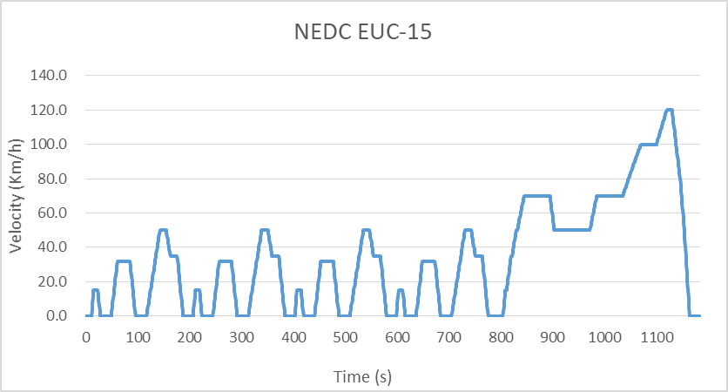
Figure 3, NEDC, Data sourced (UNECE, 2011)
The NEDC can be seen in figure 3 and this drive cycle was used to validate the results in this project. This test procedure was conducted on the specified vehicle selected which the results for the combined cycle was known from industry. Comparing this to the simulated results of the full WLTC can give bearing to the accuracy for the simulation. The comparison can be completed for the NEDC and WLTC with the use of published papers by Dimaratos et al. (2016) and Tsiakmakis et al. (2017).
The NEDC as you can see from Figure 3 is unrealistic as compared to the WLTC. The driving style is designed to mimic real world conditions however the constant velocity, linear acceleration and linear deceleration is unlike what would be seen in the real world scenario. As described by Mock (et al, 2014) the key reason put forward by the UN for developing a new test procedure was “reflecting the actual driving conditions in real-world”.

3.2 Vehicle Specification

3.2.1 Audi A6

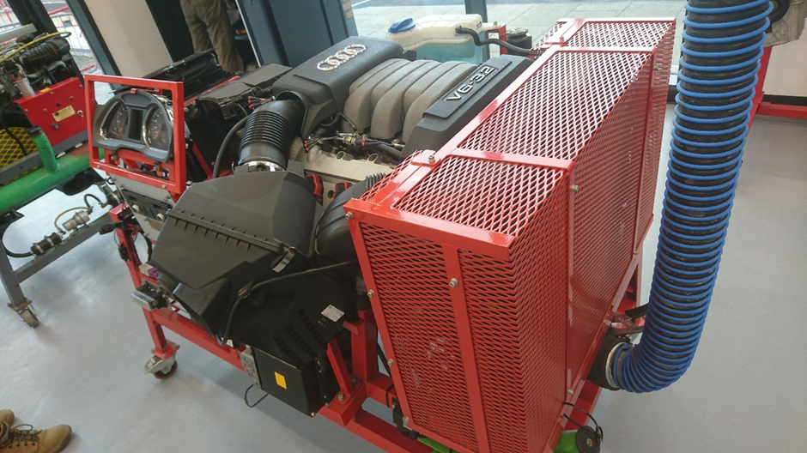
Figure 4, A.G Block Audi A6 V6 3.2 FSI Engine rig. Image by Standing. L, 2019
The vehicle chosen for the testing is the 2005 Audi A6 3.2 FSI, which throughout will be referred to as the “Audi”, “Engine” or “Vehicle”. This is in form an engine rig for practical testing, in addition to being simulated as a whole vehicle. Ideally a complete vehicle would be used on a rolling road and for a RDET with PEMS attached. The availability to each of these was limited at the time of undertaking this project. Subsequently the engine rig was used. The advantages of the engine rig was the access to sensors and components for testing while in operation due to the ease of access via probes wired in to the engine loom (figure 4). This in itself was beneficial to reduce the time of testing, preparation and improve efficiency. On the contrary, the benefit of the engine on an engine dynamometer would have greatly improved the results. However the engine installed on the accessible dynamometer didn’t have an AC system installed and the time required to install this or the engine rig chosen on to the dynamometer greatly exceeded the possible length of this project (continuation of this in section 7.2). Hence testing was carried out on the rig seen in figure 4.
There is a variety of options that can come with the Audi depending on year and specification of model. The data show in Table 2 is for the same variant Audi A6 as the engine rig. On the AutoData (2009) website there are 4 models that fit the characteristics of the engine rig, however only one with Tiptronic transmission which matches the rig. Attaining this follows on from the WLTP specification of vehicle prior to testing as not only the make and model is known but also optional extras and variations. The data seen in Table 2 isn’t from a reputable resource hence the inclusion of backing the values with a second source this being Carfolio.
Table 2, Audi A6 Specification, (AutoData, 2009) & (Carfolio, 2004)
Car information
Make and Model | Audi A6 2005 3.2l V6 FSI (4F, C6)
Weight
Kerb Weight (Kg) | 1680
Dimensions
Width (mm) | 1855
Height (mm) | 1459
Tyre size | 225/55 R16
Rolling radius (m) | 2.052
Fuel Capacity (L) | 80
Aerodynamics
Frontal area (m²) (Carfolio) | 2.26
Cd (Auto-data.net)(Carfolio) | 0.29
Other info
Top speed (km/h) | 250
Power to weight (Kw/Tonne) | 113.2
Acceleration (0-100km/h) sec | 7.1
Transmission | AWD
Gearbox | 6 speed automatic Tiptronic
Fuel Economy (NEDC)
Fuel usage –Urban (L/100km) |  | 15.7
Fuel usage -Extra Urban (L/100km) |  | 8.1
Fuel usage –Combine (L/100km) |  | 10.9
Co2 emissions (g/km) |  | 262
BMEP (Kpa) |  | 1327.9

3.2.2 Engine
The engine rig outlined is the same that is described in 3.2.1. Specific data for the engine can be seen in figures 5 and 6.
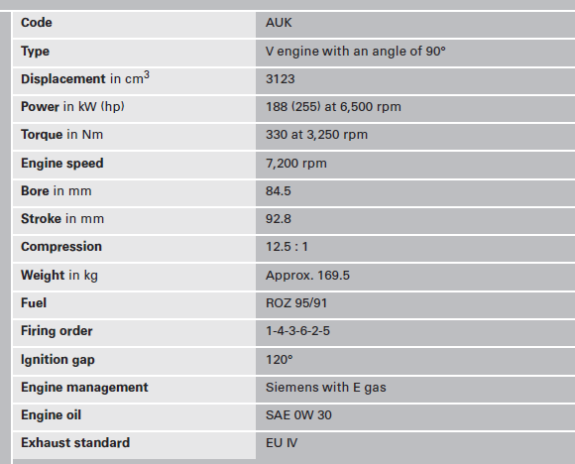
Figure 5, Engine specification, sourced (Audi, 2005)
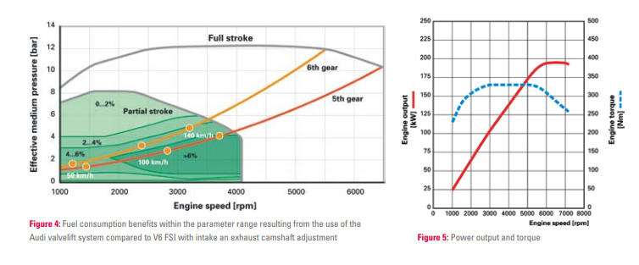
Figure 6, Effective pressure, Power and Torque for engine speeds, sourced (Audi, 2007)
The information in figures 5 and 6 are both sourced from Audi papers for the specific engine used. Even though this data is from the company that produces the engine there is a possibility that the information could adapted prior to publication. This is more likely with the infographics of figure 6. In this project the values in both figures 5 and 6 are taken at face value. There is possible slight variations in the specifications of the engine sizing due to manufacturing processes, however this could only be known for the specific engine in UWTSD by disassembly and measurement. Overall this would have taken up valuable testing time and had little to no bearing on improving the project.
The engine power and torque for each RPM graph seen in figure 6 would be considered an ideal scenario. Assuming no alterations have been made the likelihood of the engine situated in UWTSD replicating the results is sceptical. The operating conditions of the engine used in figure 6 are not known as well as the engine accessible has had testing carried out on it as part of its working life. Hence it’s not know the level of deterioration the engine has undergone and the impact this has had on its performance over the years. This is one factor that effects the difference is simulated data and live data.

3.2.3 The transmission
Tiptronic automatic transmission is situated on the vehicle. “The 09L gearbox was first used on the Audi A6 ´05 (type 4F) (C6 series)” (Audi, 2008). This 09L gearbox on the Audi is the specified in Figure 7. With this data the gearing changes, RPM to road speed and efficiencies could be found. Additionally in industry while operating in the WLTC test the operator changes gear at the given speed predetermined in the EU (2017) documentation.
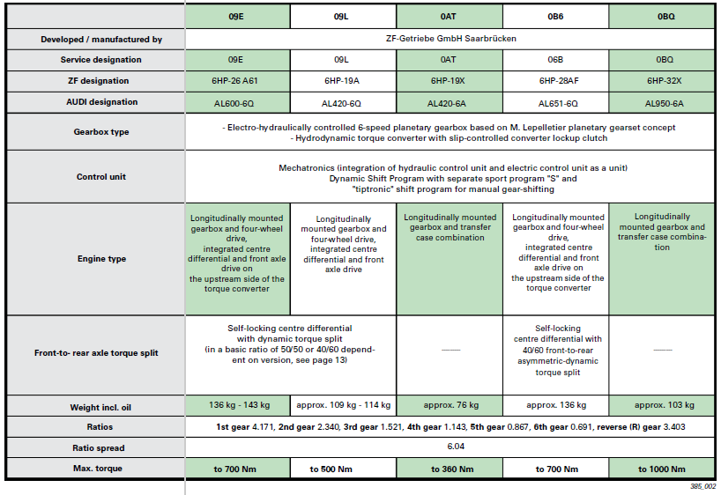
Figure 7, (Audi, 2008)

3.2.4 AC System
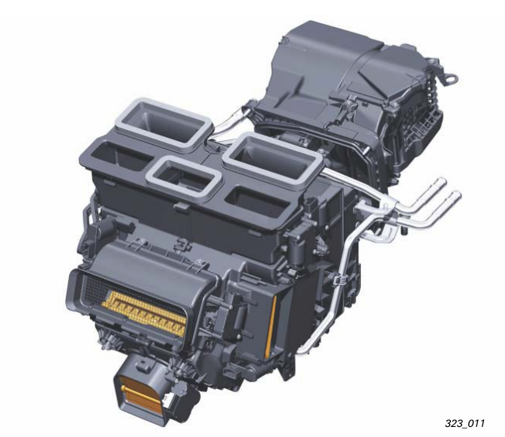
Figure 8, AC system. (Audi, 2005)
Currently the AC system is supplied electricity via the alternator and the compressor is supplied mechanically via a belt connected to the engine crankshaft. This has been theoretically changed to an electrically driven compressor with supply to this and the rest of the AC unit being supplied via an alternative electrical supply (see 3.3). With this proposed changed the rest of the AC unit and system would not require changing. The compressor is described as a “6-piston swash-plate compressor” (Audi, 2005). This same compressor is seen in figure 8, as shown in the Denso catalogue (Denso, 2016) and (OnlineCarParts, 2020).

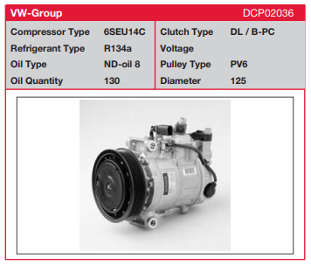
The replacement AC compressor must fulfil to same requirements as the previous compressor. This being 14cc/rev, R134a refrigerant and fit in the same area. The Rencool MD18 (Rencool , 2020) has been chosen as it uses the same R134a and is smaller in size to the original compressor (4687cmᶟ compared to 3672cmᶟ). The capacity of pumped volume per revolution of the Rencool is however larger at 18cc/rev. As this is an electrically driven compressor the rate of refrigerant pumped can be mimicked to the same rate at which the mechanical one would operate. however the larger volume causes an decrease of energy consumption around 8%-15% assuming both system were mechanically driven (Phadke et al, 2006). For the purpose of simulation this value was taken to be 11.5% (Average). Lee & Lee (2004) and Phadke (2006) discusses the energy requirements of different sized AC compressors in a similar systems. These papers focus on mechanical driven AC compressors only and there is limited publications for electrically driven compressors. Similar to this work is the paper by Zulkifli et al. (2015) which states “fuel reduction percentage by the electrically driven compressor to the belt-driven compressor about 5 to 14%.”.
Figure 9, Current compressor, (Denso, 2016)
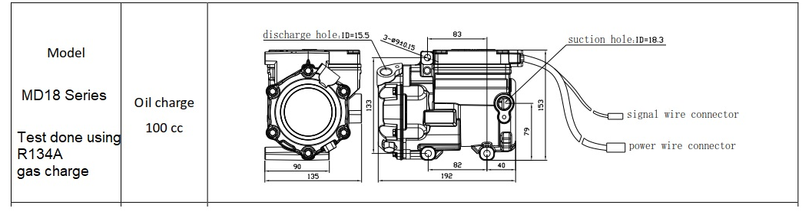
Figure 10, Rencool MD18 Electric AC Compressor, (Rencool , 2016)
The AC system is operated on the rig via the AC UI however is also controlled by the vehicles ECU. This determines the operation of the clutch of the AC compressor in relevance to the rest of the vehicle. During practical testing test #### accounted for the duration prior to which the compressor engaged in a worst case scenario (“worse case” meaning most emissions). As expressed during warmup the emissions are higher and additional load on the engine during these times is minimised. Hence the AC is request via the UI to be in use however doesn’t operate until the ECU signals the engine is to operational temperature to allow the AC compressor clutch to engage. This is all controlled via the CAN system within the vehicle with the dedicated climatronic control unit known as “J255” (Audi, 2005)

3.3 Alternative supply systems
Alternative supply methods to the new AC (3.2.4) compressor requires the electrical supply of 12v at 96A equivalent to 1152watts. From Practical testing the AC system separate from the compressor required a maximum 479 watts during peak operation. This results in a combined 1631 peak wattage required for the proposed AC system configuration and negates the mechanical loading on the engine from the previous AC compressor belt. The motor selected is the Brake Motor IE1 100L 1.8 KW sourced from (euronormportal, 2020).
Using a motor within the drivetrain will provide electricity via a clutch to incorporate itself during the act of decelerating. This allow the regeneration of electricity from the kinetic energy that would be wasted during braking. This energy is then repurposed by a motor to generate supply the AC system. Electricity recovered can be stored with either batteries or super-capacitors in this scenario. Each have their pros and cons. Prominent battery technology suggests that Lithium-ion batteries are between 88-94% efficient however the operation of discharging them beyond 10% significantly reduces the longevity of the battery and the capacity they hold (Battery University, 2020). Whereas super-capacitors can only hold between 2.5–2.7 volts at a given time they can be charge and discharged very quickly while maintaining efficiencies of 97.9% (Panda et al., 2020) (Battery University, 2020a). This reasoning lead to the selection of using super-capacitors in series to store electricity for the AC system.
67 seconds is the longest duration in the WLTC where the vehicle is stationary. Hence a storage of 109277watts is required which is equivalent to 135 units of 850 Farad Super-capacitors (AVX, 2020).

4. Methodology

4.1 Practical testing
Practical testing as previously mentioned was undertaken on an engine rig, within workshops conditions, with specific equipment. The engine rig is outlined in 3.2.2 to 3.2.4. unless otherwise specified the baseline conditions was the rig was tested from cold or at operational temperature, with changes only made via the AC UI.
The conditions in the workshop was monitored before during and after each test. These conditions include the temperature, PPM of CO, humidity and battery voltage on the rig. Reasoning for these are as each are a factor that effects the operation of the engine. When using the data for the creation of the simulation some tests were excluded as conditions were better for comparison from other tests.
Outlining testing procedures and tests carried out, intentions to find in each test and reasoning. Relate to research
Undertaking of testing with reference to limitations and reasoning for equipment. Mention issues and intentions of using equipment that access is not available to

4.2 Simulation

4.2.1 Resistive forces
The simulation was created with all the data gathered outlined in the research and practical testing.
Using the WLTC 3b drive cycle (figure 2) data in excel gave speed and acceleration against time. Incorporating this with the vehicle data in Table 1 the calculations of the vehicle resistances could be made.
$F_{rr}=\frac{f_{r}*M}{r}$
Equation 1, $F_{rr}$ (Ehsani, et al., 2010)
$F_{w}=\frac{1}{2}*ρ{*A}_{f}*C_{d}*V^{2}$
Equation 2, $F_{w}$ (Ehsani, et al., 2010)
$F_{g}=M*g*\sin{a}$
Equation 3, $F_{g}$ (Ehsani, et al., 2010)
$F_{Accl}=M*a$
Equation 4, $F_{Accl}$
These equations represent rolling resistance (equation 1), aerodynamic resistance (equation 2), gradient resistance (equation 3) and acceleration resistance (equation 4). The sum of these gives the total vehicle resistive force ($F_{t})$ for each second of the drive cycle. This could be converted in to Watts for each second giving the Power requirement for the drive cycle.
This resulting total vehicle resistive force would only apply to the wheels. For this to be show the value at the engine the efficiencies in the drivetrain and transmission are used. For this Using the gear box ratios and final drive ratio the road speed relative the engine speed could be calculated.

Figure 11, Engine RPM and vehicle Speed for each Gear. Standing, L. 2020.
By knowing the RPM relative to the power requirement from the drive cycle and using the efficiencies of the powertrain and transmission the engine output power was calculated.

4.2.2 Enthalpy
Using Enthalpy the amount of fuel used could be calculated for each second of the drive cycle. The fuel required for this would have to be there same as the practical testing, which was E5 Petrol. Through research the precise chemical equation for E5 was difficult to find, however one resource provided the equation below (equation 5). Two additional comparators were also decided upon (equation 7 & 8), due to the validity of Equation 5 being hard to distinguish. Hence using all equations 5, 7 and 8 as comparators while conducting the calculations.
${E5=C}_{6.72}H_{13.62}O_{0.05}$
Equation 5, E5 (Eyidogan et al., 2010)
$Ethanol=C_{2}H_{5}OH$
Equation 6, Ethanol (Eyidogan et al., 2010)
$Iso Octane= C_{8}H_{18}$
Equation 7, Iso-octane (Aleiferis et al., 2017)
$E5\sim 2=C_{7.7}H_{17.35}{OH}_{0.05}$
Equation 8, E5~2
Equation 8 has no reference as this was hypothetical fuel created for the purpose of testing and comparing the enthalpy values. It’s an amalgamation of 95% iso-octane with 5% ethanol. As expressed by Aleiferis (et al., 2017) E5 is akin to E10, E25, E50 and E75. These names are just representatives of the amount of ethanol within the fuel. The reason ethanol is present is for marginal benefits in emissions however with a higher RON and larger tolerance before vaporization the compression ratio for a given engine can be increased while maintaining a higher thermal efficiency and hence volumetric efficiency. Ultimately this makes ethanol desirable in fuels however levels above E5 are not yet available in the UK but are planned to be introduced in 2021 (DFT, 2020).
For the calculations of the enthalpy an assumption has been made, this being that each fuel is always operating at stoichiometric. This means that the volumetric efficiency of the air charge going into the cylinder is exactly the same as the atomised fuel required for the Air to fuel ratio of which the combustion takes place resulting no remaining air or fuel. Hence this requires the mixture to be neither lean nor rich and burn completely. In reality this would be controlled and monitored via a closed loop lambda system. However this very rarely achieves stoichiometric burn but gets close, oscillating between rich and lean burn (Rivard, 1973).
Overall the range of factors monitoring and controlling the Air to fuel ratio, burn percentage and lambda are beyond the scope of a project of this size. For these reasons stoichiometric burn has been used and discussed further in section 7.

$C_{8}H_{18 }+ 12.5 \left(O_{2} + 3.76 N_{2}\right)=8 {CO}_{2}+9 H_{2}O+47 N_{2}$
Equation 9, Stoichiometric burn of Iso-octane

$C_{6.72}H_{13.62}O_{0.05}+10.1(O_{2}+3.76 N_{2})=6.72{ CO}_{2}+6.81H_{2}O+37.976{ N}_{2}$
Equation 10, Stoichiometric burn of E5

$C_{7.7}H_{17.35}{OH}_{0.05}+12.05(O_{2}+3.76 N_{2})=7.7{ CO}_{2}+8.75H_{2}O+45.308{ N}_{2}$
Equation 11, Stoichiometric burn of E5~2
$$\frac{1}{2}{Mv_{rms}}^{2}=\frac{3}{2}K_{b}T$$
Equation 12, kinetic theory of gases (Sharma, 2018)

Equations 9-11 are used in conjunction with figures 28-37 (appendix A) for calculating the necessary values in order to achieve the j/gram released from each of the fuels. These being 44.43kj/g for iso-octane (equation 9), 42.43kj/g for E5 (equation 9) and 44.19kj/g for E5-2 (equation 11),
Having an accurate representation of the warmup of period to be simulated required Boyle’s law and combined gas laws with practical testing data. As the specification of the engine was known (figure 5) to incorporate the engine warm-up phase from the static practical testing the change is temperature was simulated as compared to work done. While idling in practical testing the temperature was recorded and using this, equation 12 and previous calculated values the engine temperature could be calculated during the WLTC simulation. Essentially the work done was calculated from practical data where engine temperature was known and this was rearranged to calculate temperature from the simulated work done of vehicle.
This was only required for the WLTC as for the NEDC engine temperate was known as seen in figure 12 which was converted to a format to be used within excel.
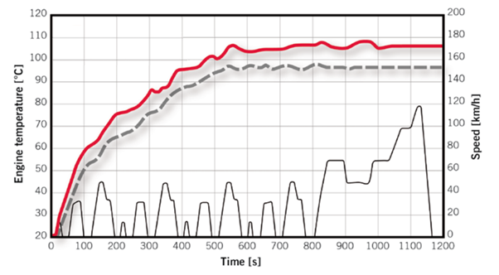
Figure 12, NEDC Engine Temperature increase over time period. -Black dashed line. (Eiser et al., 2011)

5. Results

5.1 Simulation
The results from the simulation can be seen in Appendix A. These have been imported in from excel as seen, a copy of the excel file to which the calculations were undertaken has been submitted with this paper.
The labelling of the simulation results are expressed below in figure 13.
Figure 13, Standing 2020.

6. Analysis
For the purpose of spacing in this document the figures discussed in this section are located in Appendix A.

6.1 Low phase WLTC
Figure 14. Here the data for each of the systems and AC operations are shown giving an overview of the drive cycle. Figure 17 shows graphically the same data as figure 14 in relation to total fuel usage. Notably the Standard vehicle with AC on has the highest usage, whereas the lowest is standard with AC off. Between these values the alternative system with the AC on and off can be seen. In fact a very narrow bandwidth of difference in fuel usage between alternative systems usage of the AC system can be seen as compared to the standard system. In addition the E5 fuel (Eyidogan et al., 2010) is used the most out of all the fuels followed closely by E5-2 and then iso-octane. However all these values are very similar and within the same region with none of the data showing any issues in figure 17.

6.2 Full WLTC
Figure 15. Here the resulting distance travelled is equal to that of the full WLTC. Other values in this figure changed as expected with no issues. In this figure the range of systems and AC step-ups was reduced to 4. Two for both the standard and alternative systems, one of these with AC off and the other with the AC On as max usage.

6.3 Comparison: low phase to Full WLTC
Comparing figure 15 and 14 some differences can be seen. Note that the Economy (Km per litre) of all the full WLTC values increase. The reasoning for this can be down to a number of factors, one of which being that the simulation of engine temperature. As the engine would not be at operational temperature during the initial low phase this section would be less efficient, then once at the operational temperature this is balanced out and hence lowers the economy of the cycle in full. Alternatively there is also the consideration of the gearing and the higher the gear technically less fuel required to achieve the same speed. Is relies on the torque value in the higher gear to still be maintained to achieve the reaction against the forces of motion acting upon the vehicle and acceleration forces.

6.4 NEDC
Figure 16 validates the simulation as the values for urban, extra-urban and combined as very close to the values expressed as standard in table 2. Figure 25 and 26 show this variation, with figure 26 showing the max deviation from standard being for E5 fuel as 8.6% and 24.7% difference for litres per 100km and km per litre respectively. The closest to being a match with the standard value is Iso-octane. This is a surprise as the iso-octane fuel should be the least similar to standard as the fuel properties are furthest way from E5. This information concludes that the simulation is accurate however slightly over on the values as iso-octane should be the largest deviation hence less than what it currently stands.

6.5 Comparison: NEDC to WLTC
As expressed by Mock et al. (2014) for a petrol vehicle with no stop start, automatic transmission consider a “D” category the conversion factor is 0.90 WNQ. This means that the WLTC emission are a factor of 0.9 to the NEDC counter parts. This conversion has been used in figure 27 to determine the total savings in fuel from the standard vehicle to the Alternative AC supply method. Figure 27 shows that the proposed Alternative supply for the AC system increase fuel consumption by 1.6% when not in operation and decreased fuel consumption by 51%.

7. Discussion

7.1 Project planning
The project followed a plan which was managed by a timescale dictated by key events and deadlines. The key events consisted of supervisor meetings to regularly update the supervisor on progress and to maintain a workflow with the addition of resolve any issues. These went on periodically from the start of the project until the week commencing of the pandemic lockdown. These can be seen in the Gantt chart shown.
Deadlines consisted of events which had no variation to time of delivery, this included the submission of the seminar paper, seminar presentation, project dissertation, project poster and project presentation. These can be seen in the Gantt chart shown.
One of the advantage of adopting the Gantt chart system allowed a clear display of time relative to a task and how exceeding the timeframe of the task reduced the duration of other tasks dependent upon it to meet a deadline. By using this in excel the timeframe for the next given tasks would automatically updated whereby inputting the days actually required to finish the previous task. This allowed a schedule to be maintained.
Additionally the project had individual plans for each practical test undertaken which is included in “Practical Testing Write-up” for each test.(see Appendix B)

7.2 Pandemic Impact Report
As previously mentioned the access to the engine dynamometer was available. Previously mentioned in 3.2.1 the engine dynamometer was discounted for the lack of an AC unit on the engine installed on to this equipment. However there was an alternative plan for using this engine and dynamometer setup. The mechanical loading of the AC compressor could have been a baseline force applied via the dynamometer while the engine was running with the additional force of the AC compressor engagement being applied at times appropriate of AC usage to the WLTC. This accompanied with the electrical loading of the alternator should allow a highly accurate set of live practical primary data for the WLTC with the AC on and off. This could have been a useful comparison to the simulation and would of formed a predominate part of the validation if not been the main testing of the project. For this to be undertaken a planned timescale was created and compared to the Gantt chart used maintaining the project deadline.
The plan estimated a week to write the WLTC from Excel to DaTAQ Pro V2 software used on the engine dynamometer, then a further week to run the 4 tests and resolve any issues that could have occurred. This plan would leave 3 weeks after finishing testing to complete this project. The handbook of the dynamometer was presented to research through for converting the drive cycle data to a format recognised by the DaTAQ Pro V2 software and operating the equipment. Within this short timeframe of receiving and researching the documentation required to conduct the test and operate the equipment the Covid-19 virus became established within the UK. This caused the UWTSD to restrict access to areas for a week leading up to its closure on the 20th March, primarily the workshops in which the Dynamometer was stationed.
This prevented gaining additional practical data resulting in other methods of validation being used, as expressed in the report conversion factors from papers and simulated NEDC compared to real-world NEDC. However the Covid-19 virus caused more than just the prevention of this testing. Additionally in the week leading up to the closure face to face lectures were suspended and moved online, student inventories physically and on computers had to be moved to wherever residence was for them, and daily life became difficult with the oncoming preparation for lockdown. All these factors lead to about a 5 days’ worth of productive work not getting completed, ultimately UWTSD seen this and the aftermath of the effect the virus had on students during this prior resulting in an extension to the deadline of 2 weeks. However this does not allow more time to collect the data intended with the engine dynamometer. Meaning the time extension was only beneficial to improving the quality of the research and analysis of this project, also write this pandemic impact report.
In reality other assignments were still required to be submitted in the time between UWTSD closure and the deadline of this project. In my case there were three assignments submitted in this duration. One of which required CAD software causing issues not only while installing, but when trying to use previously created and finished files via the OneDrive linked to my UWTSD account. Leading to recreating these files and using time which should have been used towards the project.

8. Conclusion

The potential fuel savings for the alternative AC supply system is 51% as seen in section 6.5. This value is on the bases of some assumptions such as the stoichiometric burn in addition to being from various research sources online in which data could have been manipulated to satisfy other needs. The 2005 Audi A6 3.2 FSI engine had many online papers and resources which aided in verifying the trustworthiness of the data within them. This was as some papers about this engine part of the VAG (Volkswagen Audi Group). Alternatively as for areas more difficult to find data such as fuel maps and lambda parameters with enough workshop time these could have been further researched. However an no extended timescale of the project would allow these tests to be undertaken during the current lockdown measures. The KERS Technology suppling auxiliary power to the AC system within the WLTC simulation can be enhanced by either more research for a more suitable, lightweight motor and controller or suitable location for the generation as the efficiency losses up to this point with the drivetrain reduces the effectiveness to generate electricity. Overall the necessary data was acquired to form an understanding of the process taking place. This is cross compatible knowledge and understanding of reducing parasitic losses and energy recovery can be used in HEVs and BEV.

9. Further Work with Recommendations

Further work that would have been like to have been undertaken includes a RDET on the road, a dynamometer run of the engine rig used in the assignment and rolling road testing of the vehicle. However these have already been discussed previously as to why they are not included (3.2.1). Additionally investigating pathways of the project simplified to maintain to the timescale would further improve the validity of the conclusion. These includes a non-stoichiometric constant burn scenario where the simulation works similarly to a vehicle whereas to maintain the lambda of 1. However these systems requires a fuel map of the closed loop system which through research couldn’t be found but could be created with extended testing on the engine.
Also one point raised during practical testing was the difference the AC made to the engine warmup period. This could not be determined for three questions; does the additional loading on the engine via the AC compressor reduce the period of warmup? &/or does the AC unit work efficiently enough during the warm-up period as a heatsink for the engine to increase the duration of the warm-up period? With these questions answer a final point of, if it’s beneficial or detrimental to economy of the vehicle and the overall effect? These points raised are valid to this project however projects in themselves.

10. References
For a complete list of literature - https://uowtsd-my.sharepoint.com/:f:/g/personal/lstanding_150310_student_uwtsd_ac_uk/EkUeWxG3ayVHoXW5q8BBB2gBUybQ7y_7Z8vZKzWyr5SSzQ?e=YM3Wfv

Audi, 2007. The New V6 3.2-litre FSI Engine, Special Edition ATZ and MTZ. [Online]
Available at: DOI: 10.1365/s40111-007-0015-0
[Accessed 2020].
Audi, 2008. 6-speed automatic gearbox 09L / 0AT / 0B6 / 0BQ / 09E, Self-Study Programme 385, Germany: AUDI AG.
AutoData, 2009. Audi A6 (4F/C6) 3.2FSI V6. [Online]
Available at: https://www.auto-data.net/en/audi-a6-4f-c6-3.2-fsi-v6-255hp-quattro-tiptronic-4661
[Accessed 19 Febuary 2020].
AVX, 2020. SCC LE Series. [Online]
Available at: https://www.mouser.co.uk/datasheet/2/40/AVX-SCC-LE-1222679.pdf
Battery University, 2020a. BU-209: How does a Supercapacitor Work?. [Online]
Available at: https://batteryuniversity.com/learn/article/whats_the_role_of_the_supercapacitor
Battery University, 2020. BU-808: How to Prolong Lithium-based Batteries. [Online]
Available at: https://batteryuniversity.com/learn/article/how_to_prolong_lithium_based_batteries
Carfolio, 2004. Audi A6 2004 3.2FSI. [Online]
Available at: https://www.carfolio.com/specifications/models/car/?car=118921
[Accessed 19 Febuary 2020].
Denso, 2016. Component Catalogue 2016-2017. [Online]
Available at: https://www.denso-am.eu/media/619718/deac160001mm.pdf
[Accessed 2020].
DFT, 2018. The Road to Zero. [Online]
Available at: https://assets.publishing.service.gov.uk/government/uploads/system/uploads/attachment_data/file/739460/road-to-zero.pdf
[Accessed 30 3 2020].
EC, 2020. Development of post-Euro 6/VI emission standards for cars, vans, lorries and. [Online]
Available at: Development of post-Euro 6/VI emission standards for cars, vans, lorries and
EEA, 2016. Explaining road transport emissions, a non technical guide, Luxembourg: Publications Office of the European Union.
Ehsani, M., Gao, Y. & Emadi, A., 2010. Modern Electric, Hybrid Electric and fuel cell vehicles. 2nd Edition ed. FL: CRC Press.
EU, 2017. (EU) 2017/1151, s.l.: Official Journal of the European Union.
EU, 2018. (EU) 2018/1832, s.l.: Official Journal of the European Communities.
euronormportal, 2020. brake-motor-ie1. [Online]
Available at: https://www.euronormportal.com/electric-motors/brake-motors/brake-motor-ie1-100l-1-8-kw-b14a-230-400v50hz/
Gillespie, T. D., 1992. Fundimentals of Vehicle Dynamics. In: s.l.:s.n.
Martyr, A. & Plint , M., 2007. Engine testing: theory and practise. 3rd ed. Amsterdam : Butterworth-Heinemann .
OnlineCarParts, n.d. Denso DCP02036. [Online]
Available at: https://www.onlinecarparts.co.uk/denso-1664591.html
[Accessed 2020].
Rencool , 2016. MD18 & MD24 series. [Online]
Available at: https://drive.google.com/file/d/1vqunuG6I0MidiB6WIb8jhpvnYzacyRp-/view
[Accessed 2020].
Rencool , 2020. MD-18 12v and 24v electric Air Conditioning Compressor.. [Online]
Available at: https://www.electricaircon.com/products/rencool-md18-12v-or-24v-electric-air-conditioning-compressor?variant=32141389332617
Sharma, A., 2018. Law of Equipartition of Energy. [Online]
Available at: https://unacademy.com/lesson/12-law-of-equipartition-of-energy/N0XWCYEQ
Silverman, D., 1993. Interpretating qualitative data: methods for analysing talk, text and interaction., London: Sage publications.
Standing, L., 2019. Alternative Power for Auxiliary systems due to increasing emissions regulations, Swansea: s.n.
UNECE, 2011. [Online]
Available at: https://www.unece.org/fileadmin/DAM/trans/main/wp29/wp29regs/r083r4e.pdf
Zacharof , N. G. & Fontaras, G., 2016. Review of in use factors affecting the fuel consumption and CO2 emissions of passenger cars, Luxembourg: EC.

(EU), (European Union) (2019) ‘2019 The EU ’ s response to the “ dieselgate ” scandal’, (February).
Aleiferis, P. G. et al. (2017) ‘Insights into stoichiometric and lean combustion phenomena of gasoline–butanol, gasoline–ethanol’, Combustion Science and Technology, 189(6), 10(0), pp. 1–53.
DFT (2020) ‘E10 Petrol and Consumer Protection : Response to 2018 Call for Evidence’, (March).
Dimaratos, A. et al. (2016) ‘Comparative Evaluation of the Effect of Various Technologies on Light-duty Vehicle CO2 Emissions over NEDC and WLTP’, Transportation Research Procedia. Elsevier B.V., 14, pp. 3169–3178. doi: 10.1016/j.trpro.2016.05.257.
Eiser, A. et al. (2011) ‘The new 1.8 l TFSI engine from Audi Part 1: Base engine and thermomanagement’, MTZ worldwide, 72(6), pp. 32–39. doi: 10.1365/s38313-011-0062-9.
Eyidogan, M. et al. (2010) ‘Impact of alcohol-gasoline fuel blends on the performance and combustion characteristics of an SI engine’, Fuel. Elsevier Ltd, 89(10), pp. 2713–2720. doi: 10.1016/j.fuel.2010.01.032.
Mills, I. and Jones, R. N. (1990) Quantities, Units and Symbols in Physical Chemistry, Vibrational Spectroscopy. doi: 10.1016/0924-2031(90)80016-w.
Mock, P. et al. (2014) ‘The WLTP: How a new test procedure for cars will affect fuel consumption values in the EU’, ICCT White Paper, 2014(9), pp. 1–20. doi: 10.1016/j.enpol.2013.12.013i.
Panda, P. K. et al. (2020) ‘Progress in supercapacitors: Roles of two dimensional nanotubular materials’, Nanoscale Advances. Royal Society of Chemistry, 2(1), pp. 70–108. doi: 10.1039/c9na00307j.
Phadke, P. and Group, C. C. (2006) ‘REDUCING AC POWER CONSUMPTION BY COMPRESSOR DOWNSIZING ON A SPORTS UTILITY VEHICLE D Srinivasan *, Prasad Phadke’, Renewable and Sustainable Energy Reviews, 80, pp. 1–7.
Preface (no date).
Rivard, J. G. (1973) ‘Closed-loop electronic fuel injection control of the internal combustion engine’, SAE Technical Papers. doi: 10.4271/730005.
Tsiakmakis, S. et al. (2017) From NEDC to WLTP: effect on the type-approval CO2 emissions of light-duty vehicles. doi: 10.2760/35344.
Tutuianu, M. et al. (2015) ‘Development of the World-wide harmonized Light duty Test Cycle (WLTC) and a possible pathway for its introduction in the European legislation’, Transportation Research Part D: Transport and Environment. Elsevier Ltd, 40, pp. 61–75. doi: 10.1016/j.trd.2015.07.011.
Warule, P. B. and Jadhav, V. V. (2017) ‘Optimization of AC Control in Hybrid Electric Vehicles during Urban Drive Conditions’, SAE Technical Papers, 2017-Janua(January). doi: 10.4271/2017-26-0087.
Zulkifli, A. A. et al. (2015) ‘Impact of the electric compressor for automotive air conditioning system on fuel consumption and performance analysis’, IOP Conference Series: Materials Science and Engineering, 100(1). doi: 10.1088/1757-899X/100/1/012028.
(UNECE, 2012) http://www.unece.org/fileadmin/DAM/trans/doc/2012/wp29grpe/WLTP-DHC-12-07e.xls
(Aleiferis et al., 2017) https://spiral.imperial.ac.uk/bitstream/10044/1/43563/10/MarkusCST_v23_Revised5_v6_Final_Deposit.pdf
EU, 2019 https://www.eca.europa.eu/lists/ecadocuments/brp_vehicle_emissions/brp_vehicle_emissions_en.pdf
Audi 2005, Audi A6, 05 service training, self-study programme 323
Rencool https://drive.google.com/file/d/11ABSvzLj4Ckg9NgibvMi_XAX0mOjOxVZ/view https://drive.google.com/file/d/1vqunuG6I0MidiB6WIb8jhpvnYzacyRp-/view
Denso https://www.onlinecarparts.co.uk/denso-1664591.html

Appendix A (Results and Figures)

Results
Figure 14, Low Phase WLTC Fuel usage and economy for different fuels in each variant of vehicle and AC operation from simulation. Standing, 2020.
Figure 15, Complete WLTC fuel usage and economy for different fuels in each vehicle variant and AC operation. Standing, 2020.
Figure 16, NEDC fuel usage and economy for different fuels in each vehicle variant and AC operation. Standing, 2020.

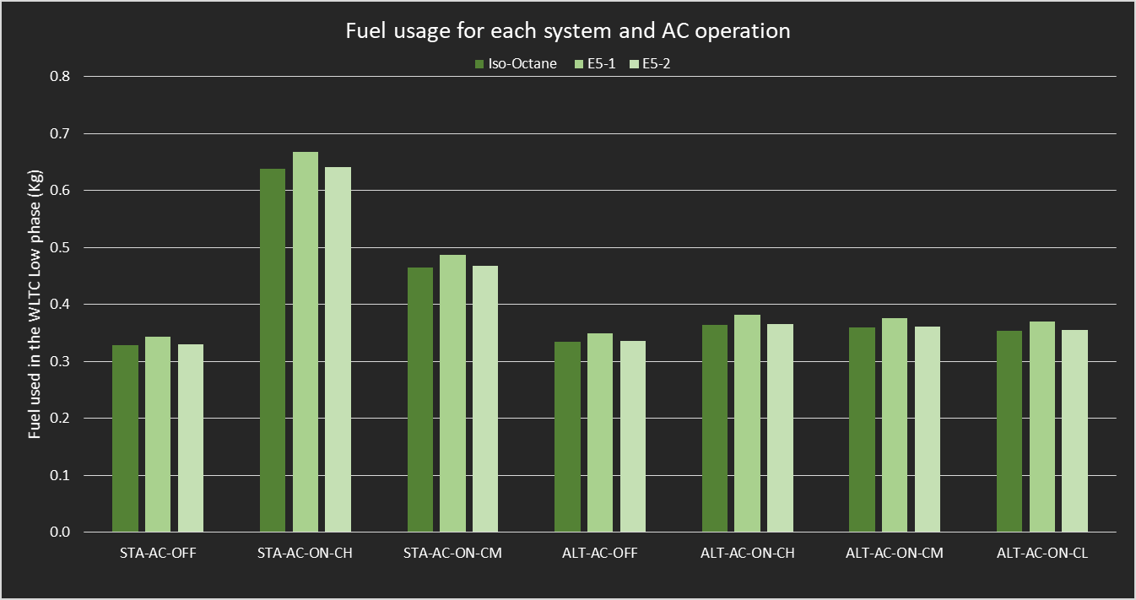
Figure 17, Low phase total fuel usage for each system and AC operation, Standing , 2020.
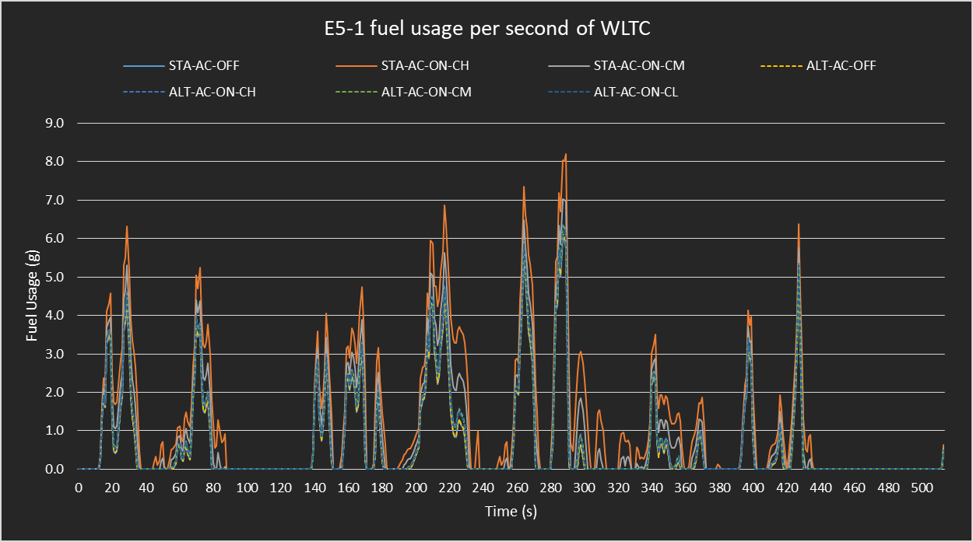
Figure 18, Low phase fuel requirement for each second (E5-1), Standing, 2020.
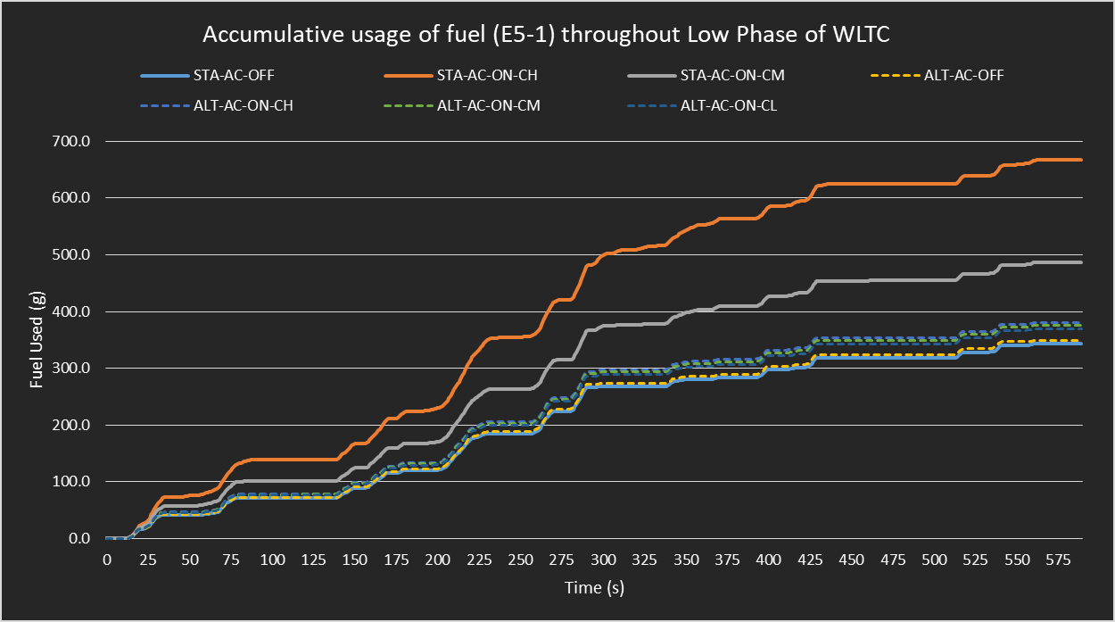
Figure 19, Total used fuel of each system and operation for E5-1 in low phase only. Standing, 2020
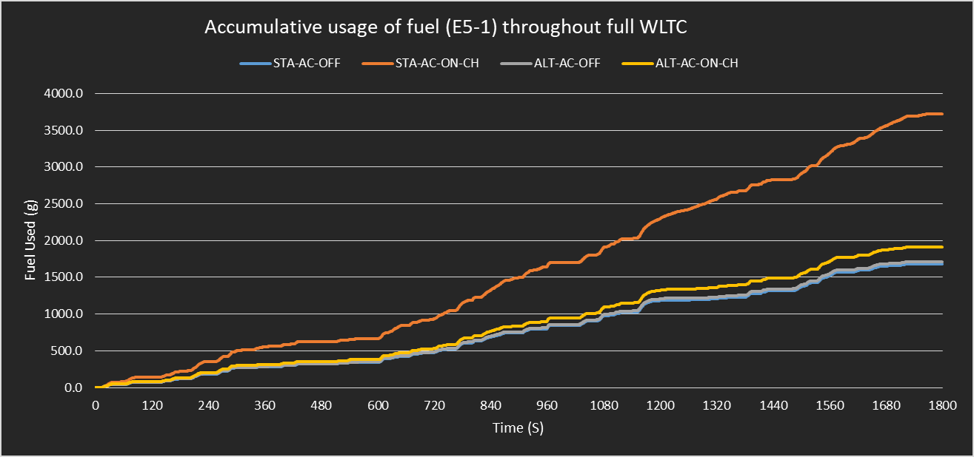
Figure 20, Total used fuel of each system and operation for E5-1 full WLTC. Standing, 2020.

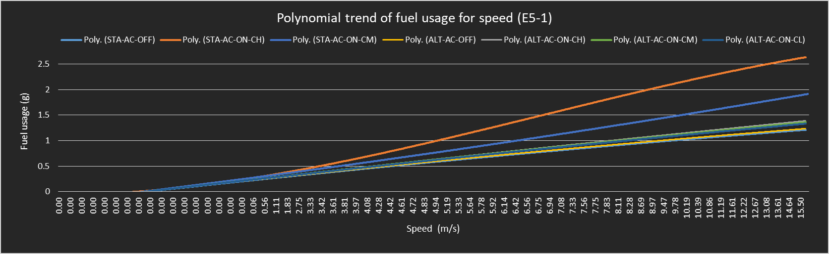
Figure 21, Fuel usage Trend line (Polynomial) for given vehicle speed for low Phase, Standing 2020.
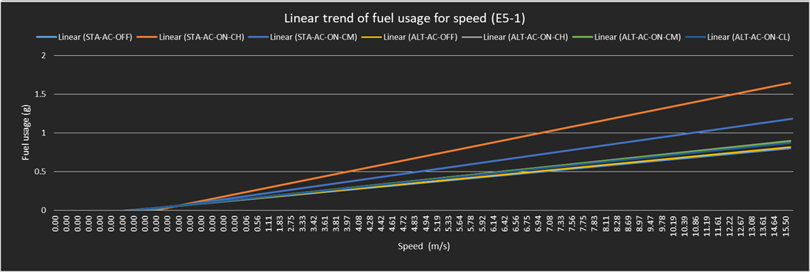
Figure 22, Fuel usage Trend line (Linear) for given vehicle speed for low Phase, Standing 2020.
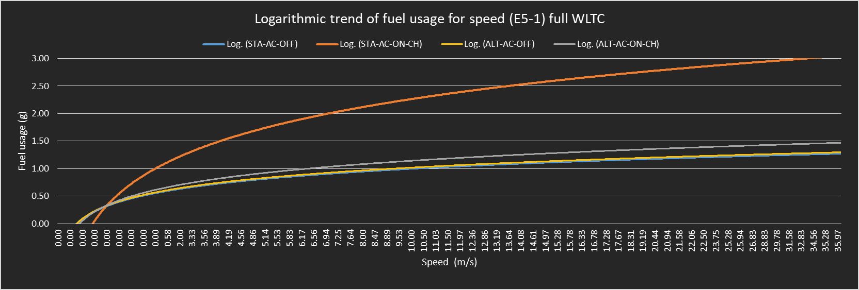
Figure 23, Fuel usage Trend line (Logarithmic) for given vehicle speed full WLTC, Standing 2020.
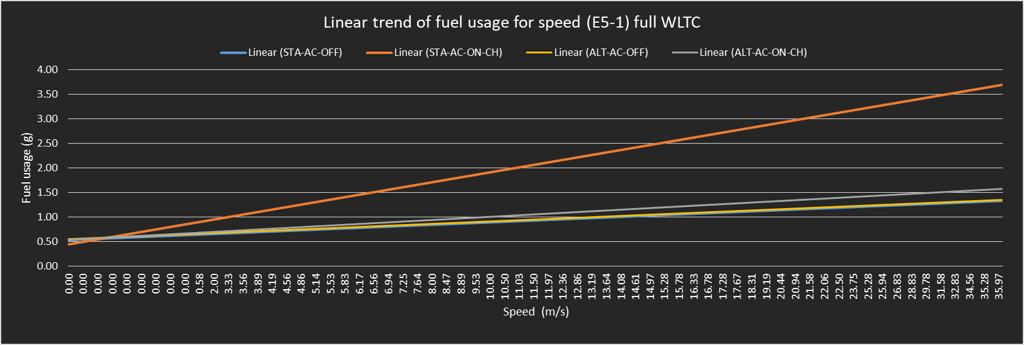
Figure 24, Fuel usage Trend line (Linear) for given vehicle speed full WLTC, Standing 2020.
Figure 25, Published NEDC compared to simulated NEDC, Standing 2020
Figure 26, Published NEDC compared to simulated NEDC percentage difference, Standing 2020
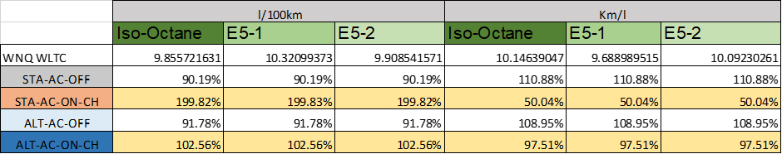
Figure 27, Fuel economy WNQ converted from NEDC for percentage accuracy of simulation and total savings, Standing 2020.

Additional Figures

Track information
Air density/ ρ | 1.2 kg/m³
Rolling resistance coefficient | 0.011
Gravity | -9.81m/s²
Figure 28, Track specific information. (Ehsani, et al., 2010)

Figure 29, Atomic weight and Moles per gram of each element for Enthalpy, (Mills and Jones, 1990)
Figure 30, Air to Fuel ratio for each fuel used in simulation, Standing, 2020.
Figure 31, Boltzmann constant and combination with Avogadro number for calculation of the thermal energy, (Mills and Jones, 1990) (Sharma, 2018)
Figure 32
Figure 33, Combustion enthalpy of iso-octane for calculating energy by weight.
Figure 34, Combustion enthalpy of E5 for calculating energy by weight.
Figure 35, Combustion enthalpy of E5-2 for calculating energy by weight.
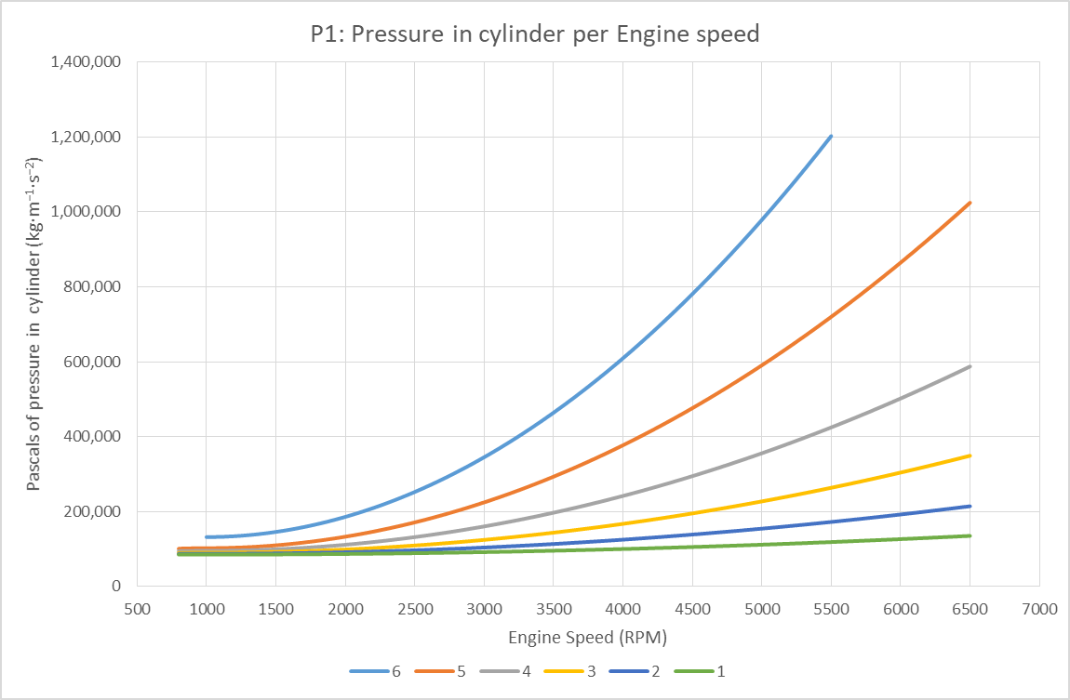
Figure 36, Calculated of cylinder pressure prior combustion from Boyle’s gas law, Standing, 2020.
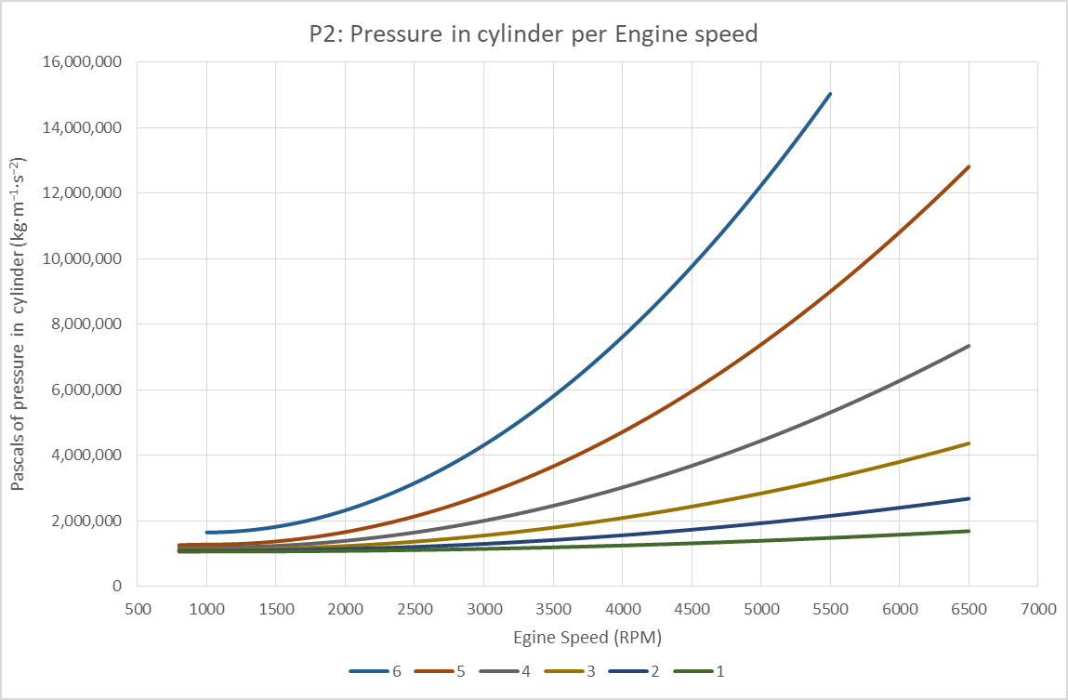
Figure 37, Calculated of cylinder pressure during combustion from combined gas law and Aleiferis et al., (2017), Standing, 2020.

Appendix B (Planning and Testing)

https://uowtsd-my.sharepoint.com/:f:/g/personal/lstanding_150310_student_uwtsd_ac_uk/Ekg4rOtQgGhOkHHLjfkOfb0BSImpqF3kyWLhvjWG9pqXSQ?e=SLHGeX

