

Principles of Health and Social Care Practice
BMHP5002_LON
Student: Anisoara Stoica
ID: 1909636
Task 2 Essay
Lecturer: Magdalena Wronska

Table of Contents

Introduction 3
Concepts of person-centered care 4
Theoretical concepts of person-centered care 4
Ethical concepts of person-centered care 6
Benefits and limitations of person-centered care 7
The application used for person-centered care 9
Recommendation for improving person-centered care 9
Conclusion 11
Reference list 12

Introduction

Health care and social care provides support to patients by contributing to them with proper medical care and protection. Likely the patients are also under the special care of an organization that provides full medical services. According to the current era, the health and social care services have been increased considering the demands and changing factors of the people. The principles of health and social care practice are to deliver effective care and support to the people who are suffering from any disease. Though these principles are being developed and nourished according to the demands of a certain group of people. Thus the key principles of support for the service users are assortment and equality, sympathy, safety, social justice, privacy, taking risks, independence, communication, beneficence and convenience by which the patients get all types of support. So by applying all these principles the people and the individuals can get the proper health care (Dearing and Cox, 2018). Additionally, the patients are expected to get proper respect from social care assistance. Even the nurse assistance provides proper care to the patients by keeping them clean and safe and preventing them from infections. Moreover, the nurse's assistance should encourage the patients so that they can gain their independence. The entire study will be done based on the concepts, benefits and limitations of person-centred care.

Concepts of person-centred care

Person-centred care providers are having an integrated form of thinking by which they take care of the people and their families with proper guidance. These persons take proper care by planning, developing and monitoring the patient's regularly which helps the patient to get cured in a short period. Person-centred care promotes key dimensions for their patients which include emotional support, respect, physical comfort, communication and information, transition and continuity, the involvement of the family and carers with the patient, approaches to care and care coordination. Even person-centred care provides such accommodations that it helps the patients to get cured with proper guidance and care. Person-centred care takes care of the patients' views and values and according to those aspects, they promote them with care. They also look after the priorities of the patients such that their thoughts and regulations of care do not hurt them.
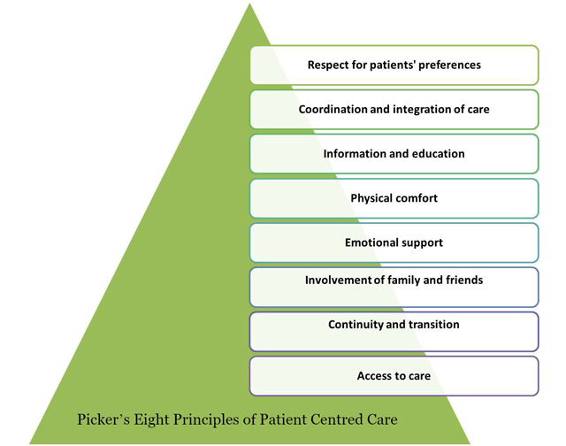
Image 1: Concepts of person-centred care
(Source: Wunder et al., 2018)
Additionally, person-centred care makes the patients get involved in personal care-related decisions (Wunder et al., 2018). However, they do this with their patients because if the patients are not providing any input to their health care then the person-centred care providers will be unable to make the cure. Person-centred care's main motive is to take care of the patients and the people surviving with any disease. Even they treat the patients in such a way that the patients can regain their autonomy and dignity when they are proceeding under challenging conditions. Rather than person-centred care does not make the patients feel to have any disability or ailment. Even the patients who have lost their independence are being regained with dignity by the person-centred care. Especially those patients are being treated with empathy and compassion. On any serious condition of the patients, person-centred care is providing coordinated care so that they can get recovered in a short interval. Moreover, personalized care of person-centred care is also being provided to patients who are suffering from severe diseases.

Theoretical concepts of person-centred care
The origins of person-centred care came from humanistic psychotherapy. In 1951, Carl Rogers suggested that if a person can be treated with love and affection he/she can get cured easily. According to Rogers, it is known to be unconditional positive regard. He added if any person performs any task certainly that the behaviors and thoughts of that individual get hidden. In this way, the unconditional positive regards guide the lack of congruence. Congruence is a term in which individuals look after the ideal self. Rogers declared that one should need to learn some new things throughout someone's life by unconditional positive regards which include open and genuine relationships and trust. Thus if these growths of conditions are being prevented then the person seems to be unhappy. While a person conducts person-centred care therapy then the therapist needs to be genuine and trustworthy with the client so that the client gets a positive vibe from the therapist. Thus the gain of self-actualization enables the client to get self-esteem and confidence towards the therapist. In nursing practice, person-centred care is the most important fundamental criteria.
Thus the service cares are being performed in partnerships rather than being performed under passive receivers of care. Additionally, the nurses allow the patients to express their fears and personal views so that they can have trust in the nurses (Surr et al., 2017). According to the perspective of the patients, several frameworks have been drawn by person-centred care. The conceptual frameworks built linkages between the conceptual and theoretical works from grey and academic literature. Though there is the involvement of organizational documents and policies. The below image depicts the implementation of the Patient-Centered Care (PCC) model. The PCC model describes the domains by which the person-centred care needs to interact with the health care providers and patients. The framework is being built in such a way that describes the entire process that is in need to provide special care to the patients.
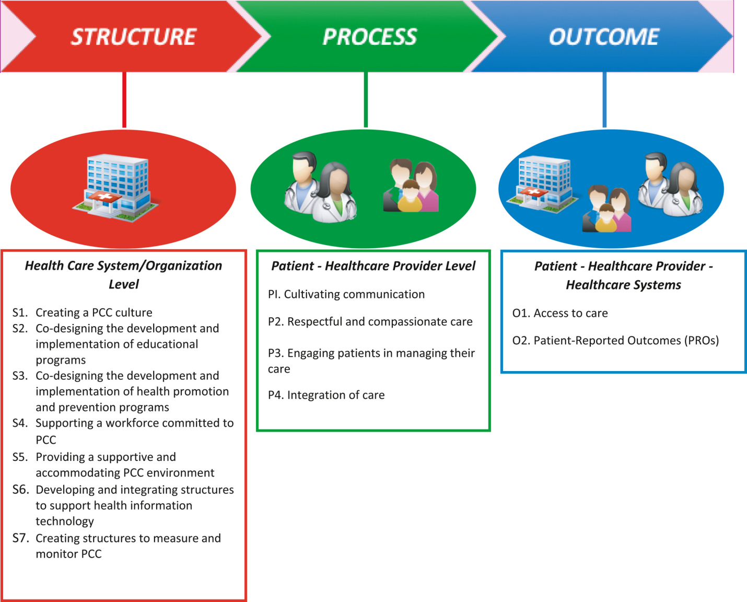
Image 2: Theoretical concepts of person-centred care
(Source: Surr et al., 2017)
From the figure, the PCC model describes the three steps domain which first describes the structure, process and the further outcome. The structure described by creating a PCC culture will enhance the care of the patients. Additionally, there is a requirement for developing and implementing educational programs for person-centred care. The development and implementation of health promotions and prevention programs also help the patient to get cured of new and advanced diseases. There is a need for implementing a PCC workforce that will provide support and accommodate the PCC environment (Cloutier, Ehlenz and Afinowich, 2019). The health information technology will also help the patients to get services in an advanced way. Though the PCC structures need to be monitored and measured regularly. The process includes communication between patients and person-centred care. Person-centred care approaches their way of communication with compassionate care and respect. After the entire process, the PCC model structured an outcome where the Patient-Reported Outcomes (PROs) will be stored by which the person-centred care will get the outcome of an individual patient.

Ethical concepts of person-centred care

Person-centred care also considers ethical principles which include patient's personal preferences, cultural dimensions, family situations, lifestyles and values. Patient-centred care is based on the respective treatment and diagnosis by proper medical treatment. The PCC treatment goes beyond the personal and physical treatment of the patients and looks after his/her needs and their family requirements, strengths, weaknesses and history. According to Aristotle's principle, the quality of health management is not the main thing but the healthcare providers required to gain emotional intelligence by which they can attain the motivation of the patients. According to Aristotle's perspective, the individual needs to be treated with proper attention and think of it as a special case (Hasegawa and Gleeson, 2018). In the United Kingdom, person-centred care has become ambiguous which looks after the quality of care provided to the patients.
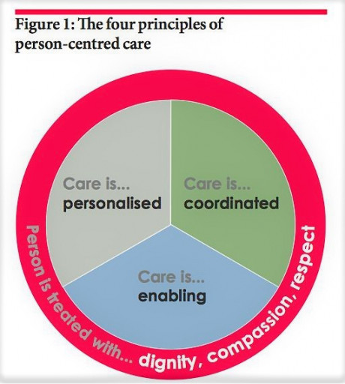
Image 3: Ethical concepts of person-centred care
(Source: Hasegawa and Gleeson, 2018)
In this policy, person-centred care involves different categories in different domains. This care is conveyed as holistic care, individualized care, autonomy, dignity and choice. However, all these categories and terms are being varied according to the wide range of health-related policies. Likely in the United Kingdom, they established a National Service Framework, especially for older people. In these health packages, the authority ensures that these people need to provide special timely and regular checkups to meet the needs of the individuals, regardless of their social services and health boundaries (Mutter et al., 2018). This policy became successful by the single assessment process, integrated services and integrated commission arrangements between social care and health. Later on, person-centred care became a multidimensional construct between several components like systematic, relational and interactional. In the policy of health care, the term dignity became the most evident for person-centred care.

Benefits and limitations of person-centred care

Person-centred care provides several benefits to their patients which are as follows:
- The patients who are cared for by person-centred care feel very confident and comfortable in their services. The patient can gain their independence and dignity so that they can have trust in person-centred care.
- The person-centred care can meet the patients' social, practical and emotional needs by which they regain their high quality of life.
- Person-centred care also provides support to those people who are unable to communicate freely with everyone and are unable to share their needs. The people who are suffering from learning disabilities, dementia are suffering from the problem as they are unable to communicate and share their problems and needs (Wright, Zeeman and Whitty, 2017). Thus the person-centred care helps them to communicate effectively and provide a quality of care.
- Person-centred care helps the people and the patients to gain their independence by which they can take decisions for themselves. Additionally, they are trained so that they can get engaged in some tasks which help them to make suitable decisions regarding their care and health.
- Person-centred care provides the patient with proper guidance from where they can take medicines. Also, they motivate their patients to embrace positive health behaviours.
Person-centred care has several limitations which are as follows:
- Person-centred care is providing treatments to several people. However, people need to be educated. Otherwise, their treatment will be not understandable to all levels of people. In such a way the person-centred care is getting a lack in their profession.
- Though some people think person-centred care is optimistic (Lockyer et al., 2017).
- The person-centred care therapists are asking the patients to have unconditional positive behaviour towards theory health. However, some of the people's maladaptive behaviour is unchangeable by person-centred care.

The application used for person-centred care

The person-centred care approach includes mobile applications from where the patients can learn about health. With the features of the application, the patients can get knowledge about health and share knowledge with other people and patients. Thus the people who are suffering from cancer or dementia are required to provide a treatment plan which will be continued for a long period. Thus the plan consists of promoting comprehension and retention in managing the anxiety of those people. Person-centred care looks after the cancer patient's physical condition such as their lips becoming dry during chemotherapy and radiation. So they are required to provide petroleum jelly which makes them relief from chapped lips (Levenson, 2017). Additionally, when the cancer patients are going through chemotherapy they are being provided with travel games and colouring books.
As chemotherapy takes hours to complete so meanwhile the patient can distract their mind by using such games and books. Person-centred care always uses framed photos of the patients' friends and family so that helps them to be sentimental. Thus in this way the patients feel that they are at home and feel to be safe. Moreover, they are also required to provide sanitiser by which they can sanitize themselves regularly. The patients who are suffering from cancer are having the problem of neuropathy. Thus the person-centred care provides them with slippers and fuzzy socks which help them to keep their feet safe and warm. Even chemotherapy and radiation affect the taste bud of cancer patients (Walji, Karimbux and Spielman, 2017). The person-centred care people provide gum and hard candy which helps them to regain their tastes. The cancer patients provide hats and wigs by person-centred care because they are having a common side effect of hair loss. These are all the applications and packages taken by the person-centred care people for cancer patients.

Recommendation for improving person-centred care

Person-centred care requires more improvement in their pathways. According to the current scenario, care needs to be improved and advanced automatically. After all the treatment and care of the patients, there is a requirement of regular feedback from the patients by which the patients can give an overview of their requirements. Additionally, there is a requirement of the Sessions Rating Scale (SRS) and Outcome Rating Scale (ORS) where a survey can be conducted with regards to the patients by which the magnitude can be understood in between the patients and the therapists. According to the answers collected after surveying the patients, the person-centred care needs to change as per the requirement (Ferrell et al., 2018). In this way, the centred care will be able to get various opportunities to make betterment for the people.
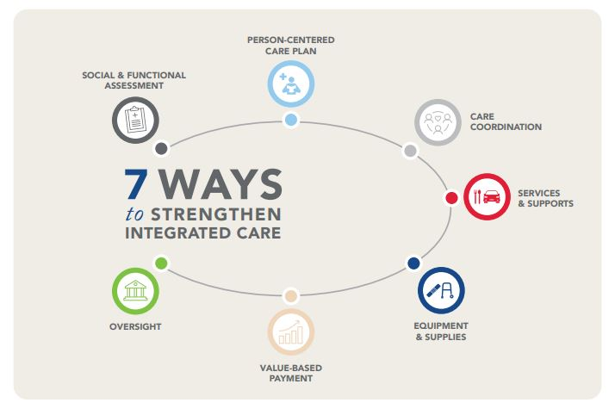
Image 4: Recommendation for improving person-centred care
(Source: Ferrell et al., 2018)
In the limitations of person-centred care, it has been declared that the uneducated people are unable to get and understand the guidance of the person-centred care. Thus the plannings are to be conducted in such a way that all levels of people can understand the regulations of the health care which are being provided by the person-centred care. Person-centred care needs to include medication that may heal the deficiency of the patients suffering from various diseases (Ravitz et al., 2019). Even the therapist needs to provide therapies to the required individuals only. If the individual is responding well after getting the therapy then they can go for discontinuation. Even person-centred care can also include counselling and interviewing the patients by which they can get motivated about their physical health and can improve their way of communication. Motivational training is the one that provides regular follow-ups after the initial training. Additionally, the motivational interview can be implemented on a diverse population by which various kinds of patients can get cured.

Conclusion

The entire study is all about the principles of health and social care practice. Person-centred care is providing benefits to several patients in a short period. It is having some of the limitations which are pulling it back from curing diseases of all the patients. Thus it can be concluded that the recommendation can help person-centred care providers to deal with the currency and upcoming situations.

Reference list

Cloutier, S., Ehlenz, M.M. and Afinowich, R., 2019. Cultivating Community Wellbeing: Guiding Principles for Research and Practice. International Journal of Community Well-Being, 2(3-4), pp.277-299. Available at: https://doi.org/10.1007/s42413-019-00033-x
Dearing, J.W. and Cox, J.G., 2018. Diffusion of innovations theory, principles, and practice. Health Affairs, 37(2), pp.183-190. Available at: https://ihpme.utoronto.ca/wp-content/uploads/2019/12/Dearing-Cox-2018.pdf
Ferrell, B.R., Twaddle, M.L., Melnick, A. and Meier, D.E., 2018. National consensus project clinical practice guidelines for quality palliative care guidelines. Journal of palliative medicine, 21(12), pp.1684-1689. DOI: 10.1089/jpm.2018.0431
Hasegawa, Y. and Gleeson, H., 2018. Three practical principles in planning and developing health care transition: our personal perspectives. Clinical Pediatric Endocrinology, 27(3), pp.109-112. Available at: https://www.jstage.jst.go.jp/article/cpe/27/3/27_2018-0002/_pdf
Levenson, J., 2017. Trauma-informed social work practice. Social Work, 62(2), pp.105-113. doi: 10.1093/sw/swx001
Lockyer, J., Carraccio, C., Chan, M.K., Hart, D., Smee, S., Touchie, C., Holmboe, E.S., Frank, J.R. and ICBME Collaborators, 2017. Core principles of assessment in competency-based medical education. Medical teacher, 39(6), pp.609-616. DOI: 10.1080/0142159X.2017.1315082
Mutter, J.B., Liaw, W., Moore, M.A., Etz, R.S., Howe, A. and Bazemore, A., 2018. Core principles to improve primary care quality management. The Journal of the American Board of Family Medicine, 31(6), pp.931-940. doi: 10.3122/jabfm.2018.06.170172
Ravitz, P., Berkhout, S., Lawson, A., Kay, T. and Meikle, S., 2019. Integrating Evidence-Supported Psychotherapy Principles in Mental Health Case Management: A Capacity-Building Pilot. The Canadian Journal of Psychiatry, 64(12), pp.855-862. DOI: 10.1177/0706743719877031
Surr, C.A., Gates, C., Irving, D., Oyebode, J., Smith, S.J., Parveen, S., Drury, M. and Dennison, A., 2017. Effective dementia education and training for the health and social care workforce: a systematic review of the literature. Review of educational research, 87(5), pp.966-1002. DOI: 10.3102/0034654317723305
Walji, M.F., Karimbux, N.Y. and Spielman, A.I., 2017. Person‐centered care: opportunities and challenges for academic dental institutions and programs. Journal of Dental Education, 81(11), pp.1265-1272. doi: 10.21815/JDE.017.084
Wright, C.J., Zeeman, H. and Whitty, J.A., 2017. Design principles in housing for people with complex physical and cognitive disability: towards an integrated framework for practice. Journal of Housing and the Built Environment, 32(2), pp.339-360. Available at: https://ueaeprints.uea.ac.uk/id/eprint/59133/1/POSTPRINT_Design_principles_in_housing_for_people_with_complex_disability.pdf
Wunder, S., Brouwer, R., Engel, S., Ezzine-de-Blas, D., Muradian, R., Pascual, U. and Pinto, R., 2018. From principles to practice in paying for nature’s services. Nature Sustainability, 1(3), pp.145-150. Available at: https://www.usf.uni-osnabrueck.de/fileadmin/DE/Startseite/Wunder_et_al._2018.pdf

