

Title: Virtual Communications
Module Code: ACCA6020
Independent project , Proposal
Student name: Simret Weldekidan Manna
Student Id: 2318869
Supervisor: Dr Abdallah Naser
Submission date: 31st July 2026

Table of Contents
Title: Virtual Communications 1
Introduction 3
Aim of the project 4
Background information 5
Methodology 6
Expected Outcomes 8
Project Timeline 9
Conclusion 10
References 11

Introduction
Communication is the basic process that links people together, and facilitates the exchange of ideas, information, feelings, and knowledge [1]. Communication was primarily face-to-face, by physical mail, and by telephone, all of which were costly, time-consuming, and distance-limited for centuries. The digital technology, internet and mobile networks have revolutionized the way we communicate, however [2]. This transition has led to virtual communication, enabling people and communities to share information instantly between cities, countries and continents without being together. Communication is now virtual, and it is a way of life now. Facilitate teleworking, distance learning, international business, healthcare and personal communications. This is highly flexible and accessible, but can also be problematic because of reliance on technology, security concerns, and the lack of nonverbal cues that may result in misinterpretation. This project is called Virtual Communication and will examine this in detail. It provides an overview of virtual communication, its various forms, the instruments used, the advantages and disadvantages, and real-life applications as well as future trends [3]. The project is designed as a fully functional web site built using HTML, CSS and some basic JavaScript, is responsive and works well on all devices and has a simple access control system [4].

Aim of the project
The primary Aim of this project is to investigate, clarify and make the idea of virtual communication comprehensible and systematic. The project will explore the emergence of digital communication, the various types of digital communication and the technologies employed, as well as the impact of digital communication on the way people communicate in contemporary society. The project also seeks to put the theory to the test by developing an interactive, easy-to-use and accessible web site that effectively communicates this information.

To achieve this aim, the project will focus on the following objectives:
- To describe the concept of virtual communication and its evolution from basic forms of digital communication to the sophisticated interactive communication systems it has become.
- To identify and describe various forms of virtual communication including the tools, technologies and appropriate applications of virtual communication within different contexts.
- To analyse the pros and cons of virtual communication and how it affects communication in the contemporary society.
- To explore the effects of digital communication in significant domains like education, business, healthcare, and everyday use.
- To discuss about what is happening now, future projections and new technologies that may influence the way people communicate in the future.
- To structure and create a fully functional, interactive and accessible web page, with HTML, CSS and minimal JavaScript, presenting the research information in a clear and professional manner.
- To develop an independent, offline-friendly platform that will be easy to navigate, secure and accessible in various devices so that users can access the content efficiently.

Background information
Communication is the key to mankind that is essential for exchanging thoughts, information and feelings. Communication once was dependent on physical interaction, writing letters, and landline telephones, each of which had its own constraints and limitations, such as distance and time [5].
Digital technology, a development that has been ongoing since the end of the 20th century, and the expansion of the internet have radicalized the way people communicate. The advent of personal computers, smart phones, high-speed Internet, and cloud-based applications has led to virtual communication: exchange of information without the need to be physically together.
This type of communication is a necessity in recent years. Its adoption is due to various factors, including globalization, the rise of remote work, online education, and the desire for real-time communication across borders. The world's transition to remote working has brought home the critical role of virtual communication in maintaining the continuity of societies, businesses and education systems.
Online communication is the norm of the day and is no longer just an option for communicating in person. It enables collaboration between people on different time zones, saves travel expenses, and offers flexibility which was unheard of in the past. But it also introduces new challenges, including the technical difficulty of reliability, privacy of data, and the potential for miscommunication and the lack of non-verbal cues.
It is a project that comes out of this background, to gain insight into the mechanisms of virtual communication, the means that facilitate it, its influence on everyday life, and its prospects.

Methodology
My project is developed in a systematic and progressive manner, allowing it to proceed from research to design and development in a step-by-step manner with a move towards accuracy, organization, and functionality [6].
1. Research & Information Gathering
Literature Review: Gathered trustworthy data from digital communication guides, education-related materials, and technology articles to identify what is meant by virtual communication, its types, its advantages, its challenges and its future [7].
AI Tools: I also employed Artificial Intelligence (AI) to assist with the research process, to structure content, to explain complex concepts and to make sure that explanations are clear, concise, and well written. AI assisted in the organization of ideas efficiently and enhanced information flow, while all the finished content was reviewed and verified by me for its accuracy and relevance [8].
Content Planning: The structure of the findings to be organized into logical sections: Overview, Types, Tools, Benefits, Challenges, Applications, and Future Outlook as per the navigation of the website [9].
2. Design & Planning
Structure Design: Designed a structured layout with a navigation bar, structured content blocks, responsive grid system and footer which is user friendly [10].
To increase the user experience, use a consistent colour scheme (dark blue, bright orange, and light background), readable fonts, hover effects, and smooth scrolling.
Security Feature: Security screen, with simple password protection, to control access to the project content [11].
3. Development & Implementation
Built the basic components and text content of the website using the Used Hypertext Markup Language [12].
CSS: Used Cascading Style Sheets for formatting the layout, colours, spacing, responsiveness and hover effects, transitions, and shadows.
Basic JavaScript: Simple script added to check the access password and to make the main content visible or not.
Responsive Design: Implemented flexible layouts and media queries for the website to ensure that it functions correctly on various devices, including desktop computers, tablets, and mobile phones.
4. Testing & Validation
Navigation Link Functionality Check: Functionality checked with navigation links, login system, buttons and form elements.
Cross‑Device Testing: Tested for layout and readability across screen sizes.
Content Review: Text: Checked all text for accuracy, clarity and formatting.
Offline Functionality: Tested that the file will function completely without an Internet connection.
After gathering the information, I compared different ideas and identified the main benefits and challenges of virtual communication. I organized the information into clear sections and explained it in simple language so it would be easy to understand [13].
Throughout the project, I used only trustworthy sources and made sure to reference them correctly. The aim was to present accurate, balanced, and up-to-date information about how virtual communication affects people's personal, educational, and professional lives.

Expected Outcomes
The results of this project are achieved by implementing the following;
1. Knowledge & Understanding
A clear and comprehensive description of what is meant by virtual communication, its development and its role today .
Specific knowledge of various types, tools and platforms for virtual communication and their uses
A balanced discussion of the pros and cons of digital communication and to educate the users on best practices.
Understanding of the use of virtual communication in various fields such as education, business, healthcare and social life, and future trends in virtual communication.
2. Technical Deliverable
A complete, independent HTML/CSS/basic-JS site that:
Has an attractive, neat, responsive format that works across all screens, computer, tablet and phone. Includes a secure password protected login screen to control access.
Offers user-friendly navigation, scrolling, and gorgeous layout.
Running completely offline no Internet connection required.
3. Learning & Skill Development
Demonstrated ability to structure and organize information logically for easy reading.
Practical application of web development skills: structuring content with HTML, styling with CSS and simple interactivity using JavaScript.
Improved understanding of user‑centred design and how to create accessible digital content.
4. Practical Value: A source that can be relied upon to provide information on virtual communication for anyone wishing to learn about virtual communication.
A well-done work that is pedagogically accurate and is clearly a presentation of the research and development process undertaken.

Project Timeline

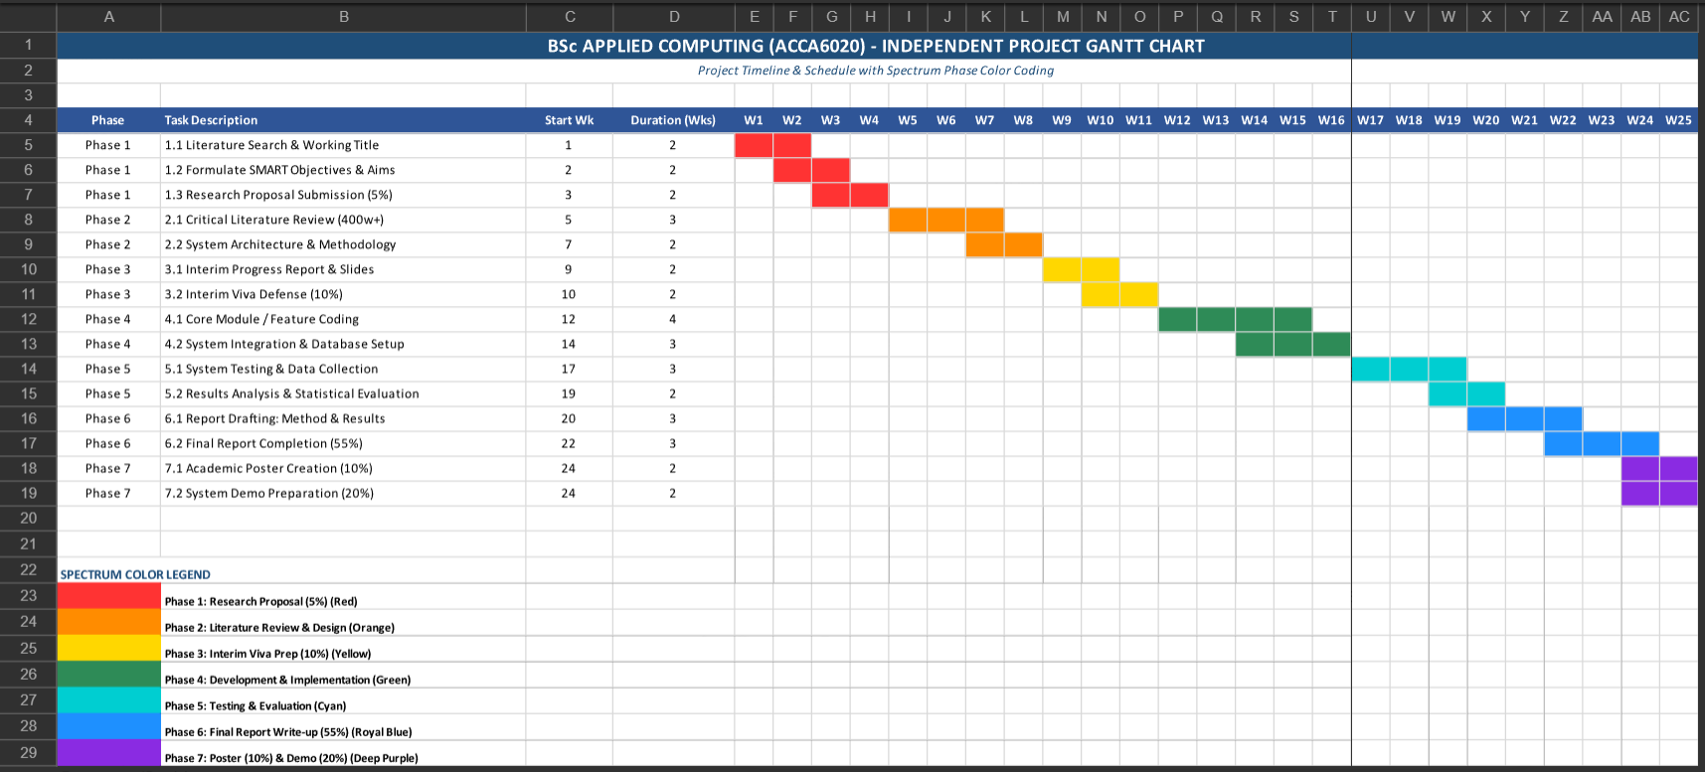

Conclusion
Finally, virtual communication has grown beyond being merely an alternative to real communication to being an essential part of infrastructure for the way people live, work and learn. It has overcome the geographical hurdles, lowered expenses and increased flexibility and has made it possible to work together and interact instantly no matter where in the world they are. During this project, we have explored its underlying principles, its various categories, tools, benefits, problems and the increasing importance of this approach in different fields like education, business and health care. There are several advantages to it, but there are also some drawbacks, such as technical problems, data safety and security concerns, and the risk of less personal connection. With the advancement of technology, innovations like virtual reality and artificial intelligence, along with faster networks, will keep enhancing the quality and security of virtual communication, making it even more immersive and secure. Overall, this project has proven to be a valuable learning experience in understanding and implementing web design and development. The final web site will be an engaging, user-friendly and accessible tool that accomplishes the project goals and objectives and demonstrates the importance of virtual communication in human interaction throughout the future.

References

[1] | S. a. H. S. {Dzamtoska-Zdravkovska, “{The theoretical basis of internal communication as an active process of information exchange},,” {Technium Soc. Sci. J.},, Vols. {43},, no. {1}, pp. {252},, {2023}.
[2] | S. {Greengard, {The internet of things},, {MIT PRESS},, {2021}.
[3] | A. V. a. A. S. H. {Shvetsov, “{When holographic communication meets metaverse: Applications, challenges, and future trends},,” {IEEE Access},, Vols. {12},, no. {IEEE}, pp. {197488--197515},, {2024},.
[4] | S. K. R. a. P. N. {Gowrigari, {Responsive Web Development},, {New Delhi, India},: {BPB Publications}, {2024},.
[5] | G. {Mantovani, {New Communications Environments: From Everyday to Virtual},, {Boca Raton, FL},: {CRC Press},, {2021},.
[6] | L. a. R. L. a. Y. Y. a. D. C. {Istanboulian, “{Adapting co-design methodology to a virtual environment: co-designing a communication intervention for adult patients in critical care},,” {Research involvement and engagement},, Vols. {9},, no. {1}, pp. {103},, {2023},.
[7] | L. a. C. J. R. A. a. Q. X. a. Y. S. a. R. J. a. W. S. Zhang, “{Academia's responses to crisis: A bibliometric analysis of literature on online learning in higher education during COVID-19},,” {British Journal of Educational Technology},, Vols. {53},, no. {3}, pp. {620--646},, {2022},.
[8] | P. a. D. V. V. a. B. S. {Kubala, “{Employee Monitoring Software, Wearable Sensor-based Devices, and Generative Artificial Intelligence and Virtual Communication and Collaboration Tools in Immersive Digital and Virtual Office Spaces},,” {Contemporary Readings in Law and Social Justice},, Vols. {15},, no. {2}, pp. {65--83},, {2023},.
[9] | P. R. {Smith, {Digital marketing excellence: planning, optimizing and integrating online marketing},, {London},: {Routledge}, {2022},.
[10] | B. D. {Miller, {Principles of web design},, {New York},: {Simon and Schuster}, {2022},.
[11] | P. {Charles P, {Security in computing},, {Boston, MA},: {springer}, {2025},.
[12] | L. a. J. D. a. K. D. a. M. M. E. {Shaw, “{Implementation of virtual communities of practice in healthcare to improve capability and capacity: a 10-year scoping review},,” {International Journal of Environmental Research and Public Health},, Vols. {19},, no. {13}, pp. {7994},, {2022},.
[13] | D. J. a. S. M. a. S. M. a. K. D. W. {Kim, “{An empirical study of community cohesiveness, community attachment, and their roles in virtual community participation},,” {European Journal of Information Systems},, Vols. {32},, no. {3}, pp. {573--600},, {2023},.

