

“The Role of Entrepreneurship in Economic Growth: Analysis of Personality Traits, Distinctions Between For-profit and Not-for-profit Organizations”

Name | Chaman
Student ID | 2214619
Program | MBA-Master of Business Administration
Module | Entrepreneurship
Module Code | LCMB7004
Assignment Title | Assessment - 1
Word Counts | 2508

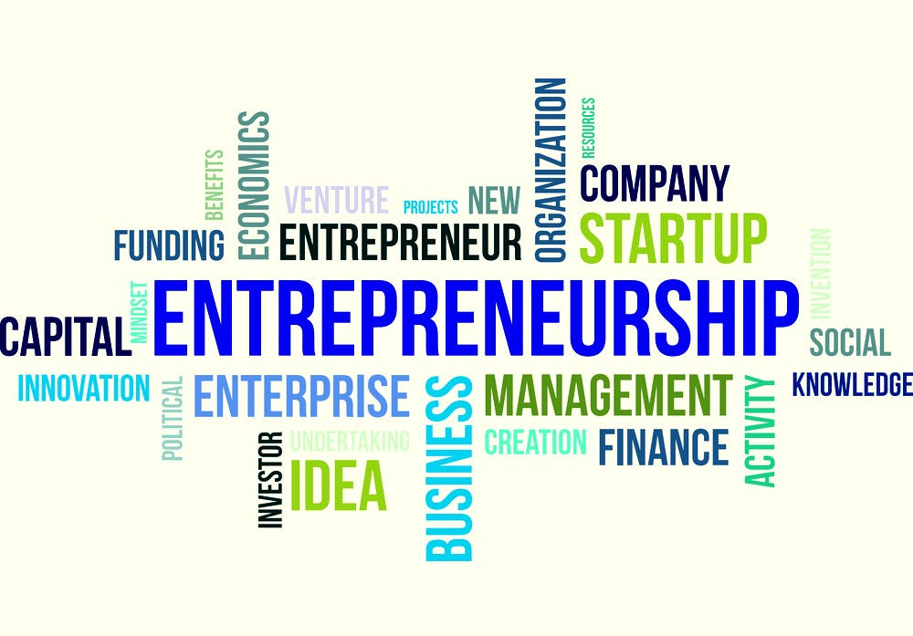

Contents
1. Introduction 3
2. Conceptual Foundation for Enterprise and Entrepreneurship 3
3. Analysis and critical evaluation of concepts of entrepreneur and 4
Entrepreneurship from the Perspective of an Entrepreneur with 4
literature backup 4
3.1 Enterprise and Entrepreneurship: An Overview 5
3.2 Innovation and Entrepreneurship 5
3.3 Risk-Taking and Entrepreneurship 5
3.4 Resilience and Adaptability in Entrepreneurship 5
3.5 Skills and Knowledge Required for Entrepreneurship 6
3.6 Factors Affecting Entrepreneurial Success 6
4. CONCEPTUAL FOUNDATION OF PERSONALITY TRAITS THEORIES WITH EXAMPLES 6
4.1. The Big Five Personality Traits Theory: 6
4.2. The Myers-Briggs Type Indicator (MBTI): 7
4.3. The Trait Theory of Leadership: 8
5. Traits, Characteristics, Attributes, and Motivations of Entrepreneurs 9
5.1. Traits 9
5.2. Characteristics 10
5.3. Attributes 10
5.4. Motivations 10
5.5. Conceptual 10
6. CONCEPTUAL FOUNDATION OF FOR-PROFIT AND NOT-FOR-PROFIT SMALL ORGANISATIONS WITH EXAMPLES 10
6.1 For-Profit Small Organizations 11
6.1.1 Principles and Values 11
6.1.2 Examples 11
6.2 Not-for-Profit Small Organizations 12
6.2.1 Principles and Values 12
6.2.2 Examples 12
7. ANALYSIS AND CRITICAL ANALYSIS OF ‘FOR PROFIT’ AND ‘NOT FOR PROFIT’ SMALL ORGANISATIONS WITH RELEVANT EXAMPLES 12
7.1 For-Profit Small Organizations 13
7.2 Not-for-Profit Small Organizations 13
7.3 Critical Analysis of For-Profit and Not-for-Profit Small Organizations 14
8. CRITICAL ANALYSIS OF ENTREPRENEUR’S VALUES AND BELIEFS IN ‘FOR PROFIT’ AND ‘NOT FOR PROFIT’ SMALL ORGANISATIONS WITH APPLICATIONS 14
9. Conclusion 15
References

Introduction

The contribution of entrepreneurship to the economic progress and development of numerous nations across the globe has been significant (Stangler, 2018). For example, small businesses and startups in the United States account for a significant portion of job creation and economic growth. As per the Small Business Administration, small enterprises that employ fewer than 500 individuals have played a significant role in the economic growth of the United States. These businesses contribute to 44% of the economic activity and have created around two-thirds of net new jobs since the 1970s (Small Business Administration, 2021).

This study analyzes the typical personality traits, characteristics, attributes, and motivational factors commonly found among successful entrepreneurs. Furthermore, this research aims to identify the distinctions between for-profit and small not-for-profit organizations. Additionally, examples of successful entrepreneurs in different industries will be provided to illustrate these concepts and demonstrate the importance of entrepreneurship in driving economic growth, job creation, and innovation.

Conceptual Foundation for Enterprise and Entrepreneurship

Entrepreneurship is the process of initiating, establishing, and directing a new enterprise with the goal of attaining both monetary gain and personal satisfaction. It involves taking calculated risks and being innovative in finding solutions to problems. Entrepreneurship is the driving force behind economic growth and job creation (Stangler, 2018).
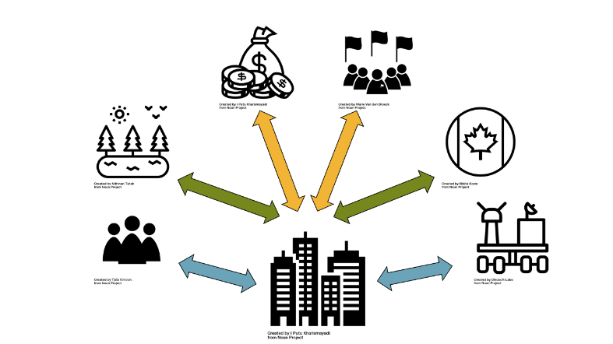
Figure 1: Putu kharismayadi, 2023

Here are some examples of successful entrepreneurs and their businesses:

Jeff Bezos - Amazon: In 1994, Jeff Bezos established the biggest internet-based vendor globally. Initially, he began with an online bookshop, which later evolved to include a wide range of goods, such as electronics, apparel, and foodstuff. Bezos is popularly recognized for his commitment to ensuring that customers are satisfied and contented. He is also known for his readiness to embrace challenges and take calculated risks to advance the enterprise's growth (Dudovskiy, 2020).

Elon Musk - Tesla, SpaceX: Elon Musk is a prolific entrepreneur who has established numerous thriving corporations, such as Tesla, SpaceX, and The Boring Company. He is renowned for his imaginative strategies and capacity to revolutionize industries with innovative technologies (Buchanan, 2021).

Sara Blakely - Spanx: Sara Blakely founded Spanx, a company that produces undergarments and shapewear for women. She started the company with just $5,000 in savings, and it has grown into a billion-dollar business. Blakely is known for her creativity and her willingness to take risks (Hesseldahl, 2021).

Mark Zuckerberg - Facebook: Facebook, the most extensive social media platform globally, was established by Mark Zuckerberg, who is one of its co-founders. He started the company in 2004 while still in college and has since grown it into a global phenomenon. Zuckerberg is known for his innovative ideas and ability to create products people love (Weinberg, 2021).

Oprah Winfrey - OWN Network: Oprah Winfrey is a prominent business magnate and entrepreneur who began her profession as a talk show presenter. However, she has expanded her business empire and established a range of media outlets, including a TV network, a magazine, and a production firm. Winfrey's extraordinary capacity to interact with her followers and concentrate on personal growth and development is widely acknowledged. (Schawbel, 2021).

3. Analysis and critical evaluation of concepts of entrepreneur and

Entrepreneurship from the Perspective of an Entrepreneur with

literature backup
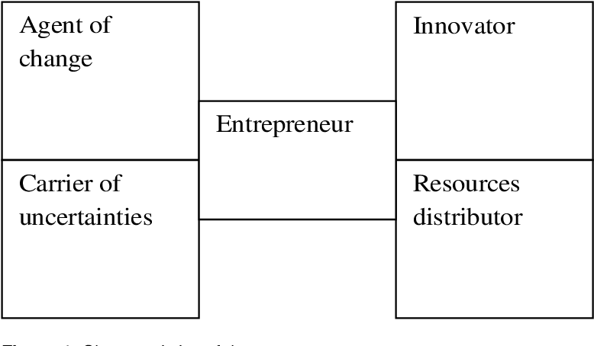
Figure 2: (Sergiu Rususup et al., 2021)

3.1 Enterprise and Entrepreneurship: An Overview
To gain insights into the process of initiating and managing a business venture, it is essential to critically examine the fundamental principles of enterprise and entrepreneurship. Enterprise involves identifying business opportunities, gathering resources, and implementing a well-designed strategy to establish a sustainable business. Conversely, entrepreneurship refers to the mindset and skills required to effectively launch and manage a business venture. This encompasses aspects such as creativity, risk-taking, perseverance, and flexibility (Klyver et al., 2021).

3.2 Innovation and Entrepreneurship
Innovation plays a crucial role in entrepreneurship, enabling entrepreneurs to differentiate themselves from competitors and provide added value to their customers. Entrepreneurs are often motivated by the desire to invent something new or creatively solve problems

3.3 Risk-Taking and Entrepreneurship
Taking calculated risks is a significant aspect of entrepreneurship, involving decision-making based on incomplete information and embracing uncertain outcomes. Successful entrepreneurs are not reckless; instead, they are willing to take calculated risks to pursue their goals. Research indicates that risk-taking positively influences entrepreneurial success (Ucbasaran et al., 2019).

3.4 Resilience and Adaptability in Entrepreneurship
Entrepreneurship is characterized by challenges and unpredictability, requiring entrepreneurs to demonstrate resilience and adaptability in order to succeed. Resilience involves the ability to overcome setbacks and failures while continuing to progress, while adaptability entails adjusting strategies and plans in response to changing circumstances. Successful entrepreneurs possess the capacity to bounce back from setbacks and adapt their approaches to achieve their objectives (Sato et al., 2019).

3.5 Skills and Knowledge Required for Entrepreneurship
Entrepreneurship demands a diverse range of skills and knowledge, including expertise in marketing, finance, and management. Successful entrepreneurs acquire and develop these competencies through experiential learning and education. They also build strong networks of mentors and advisors who provide guidance and support. According to Gielnik et al. (2019), entrepreneurs who possess a combination of technical, social, and cognitive skills are more likely to succeed.

3.6 Factors Affecting Entrepreneurial Success
Multiple factors influence the success of an entrepreneurial venture, including access to capital, market conditions, and regulatory environments. Entrepreneurs must critically analyze these factors and make informed decisions based on their assessment of the business environment. Successful entrepreneurs excel at identifying opportunities and mitigating risks to create sustainable businesses (Baker et al., 2020).

4. CONCEPTUAL FOUNDATION OF PERSONALITY TRAITS THEORIES WITH EXAMPLES
Personality traits theories are based on the idea that there are certain enduring patterns of behavior, thoughts, and emotions that distinguish one individual from another. These traits are stable over time and across different situations. Here are some examples of personality traits theories and their corresponding examples:

4.1. The Big Five Personality Traits Theory:
The theory known as the Big Five Personality Traits is a well-researched and commonly accepted understanding of personality traits. It suggests that there are five main categories that make up a person's personality: open-mindedness, responsibility, social confidence, friendliness, and emotional stability (Mayer & Salovey, 2018).
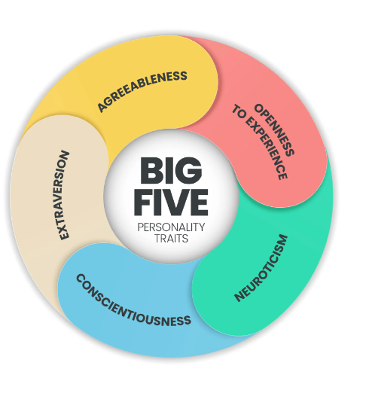
Figure 3: (Annabelle G.Y. Lim, 2023)
Examples of these traits in action include:
- Openness: a person who is open to new experiences, ideas, and perspectives and curious about the world around them.
- Conscientiousness: a person who is reliable, organized, and responsible and who takes their commitments seriously.
- Extraversion: a person who is outgoing, sociable, and energetic and who enjoys being around others.
- Agreeableness: a cooperative, friendly, and empathetic person who tends to get along well with others.
- Neuroticism: a person who is anxious, moody, and prone to negative emotions and who may experience stress and worry more easily than others.

4.2. The Myers-Briggs Type Indicator (MBTI):
The Myers-Briggs Type Indicator is a method of evaluating personality that draws upon the concepts proposed by Carl Jung. It suggests four pairs of contrasting personality traits, which include extroversion versus introversion, sensing versus intuition, thinking versus feeling, and judging versus perceiving (Briggs Myers & McCaulley, 2018).
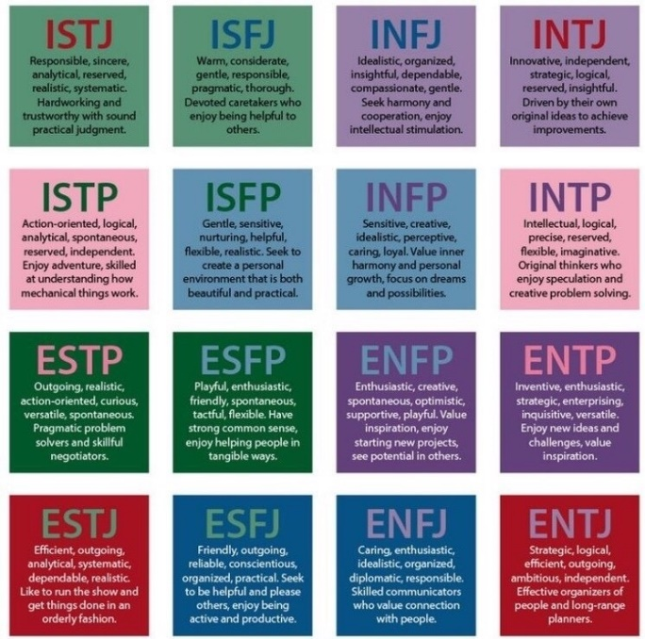
Figure 4: (EVELIINA KAMMONEN, 2017)
Examples of these traits in action include
- Extraversion vs. Introversion: a person who is energized by social interaction and enjoys being around others (extravert), or a person who is more introspective and prefers solitary activities (introvert).
- Sensing vs. Intuition: a person who relies on their senses and concrete information to make decisions (sensing) or relies on their intuition and abstract thinking to make decisions (intuition) (Soto & Tackett, 2019).
- Thinking vs. Feeling: a person who values logic and reason when making decisions (thinking) or a person who values emotions and empathy when making decisions (feeling).
- Judging vs. Perceiving: a person who prefers structure and organization in their life (judging) or a person who prefers flexibility and spontaneity (perceiving).

4.3. The Trait Theory of Leadership:
The Trait Theory of Leadership proposes that there are certain personality traits that are associated with effective leadership, such as confidence, intelligence, and decisiveness (Judge et al., 2018).
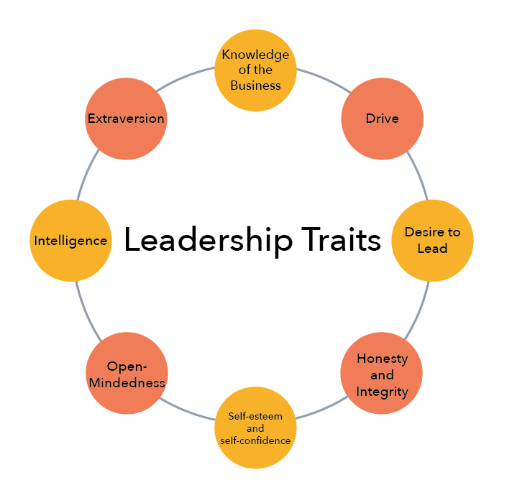
Figure 5: Trait Theory of Leadership
Examples of these traits in action include:
- Confidence: a self-assured leader with a strong conviction in their decisions and actions.
- Intelligence: a knowledgeable leader who can think critically and strategically.
- Decisiveness: a leader who can make tough decisions quickly and confidently.

Traits, Characteristics, Attributes, and Motivations of Entrepreneurs
Numerous studies have shown that successful entrepreneurs exhibit exceptional traits, characteristics, attributes, and motivations that differentiate them from others. These characteristics may include creativity, passion, resilience, adaptability, risk-taking propensity, and leadership skills (Zampetakis et al., 2018).

5.1. Traits
Trait theory suggests that certain personality traits are associated with entrepreneurship. Some of the most commonly cited traits include risk-taking propensity, proactivity, innovativeness, achievement orientation, autonomy, and self-efficacy (Stam & Elfring, 2018).

5.2. Characteristics
Entrepreneurship is often associated with characteristics such as passion, persistence, creativity, and resilience. Passion is critical because it drives entrepreneurs to pursue their goals even in the face of adversity (Ferreira et al., 2019).

5.3. Attributes
Attributes refer to the skills and knowledge that entrepreneurs need to be successful. These include marketing, finance, management, and networking skills. In addition, entrepreneurs must deeply understand their industry and the market in which they operate (Joo & Shim, 2020).

5.4. Motivations
Entrepreneurs are often motivated by a desire for autonomy and the ability to control their own destinies. They are also often motivated by a desire to create something new and positively impact the world. In addition, some entrepreneurs are motivated by financial gain, while others are motivated by the desire to solve a specific problem or to pursue a particular passion (Kautonen et al., 2018).

5.5. Conceptual
Conceptual frameworks, such as the entrepreneurial orientation (EO) framework, have been developed to help researchers better understand the motivations and behaviours of entrepreneurs. The EO framework suggests that entrepreneurs exhibit certain orientations, including a proclivity for risk-taking, a desire for autonomy, a focus on innovation, a customer orientation, and a focus on competitive aggressiveness (Lumpkin & Dess, 2018).

CONCEPTUAL FOUNDATION OF FOR-PROFIT AND NOT-FOR-PROFIT SMALL ORGANISATIONS WITH EXAMPLES
The conceptual foundation of for-profit and small not-for-profit organizations refers to the fundamental principles and values that guide their operations and decision-making processes.

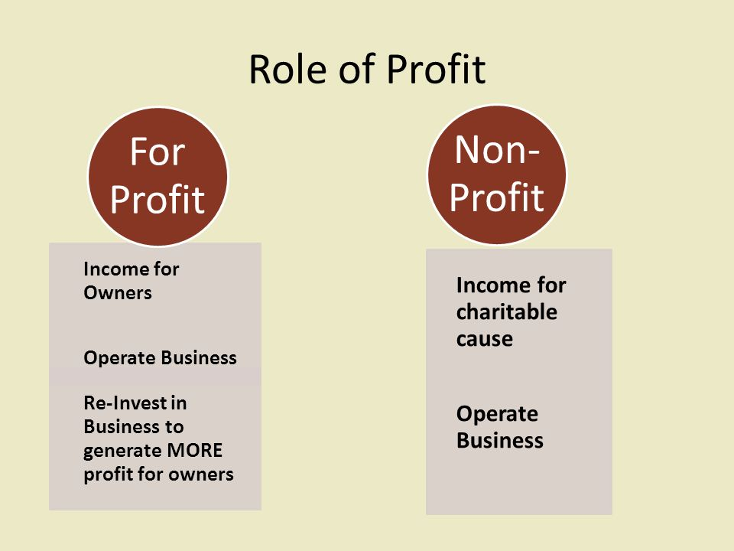
Figure 6: Understanding of For Profit And Non-Profit

6.1 For-Profit Small Organizations
Small for-profit organizations are commercial entities that function with the primary objective of earning profits for their shareholders or proprietors. They are often structured as sole proprietorships, partnerships, or corporations. The main focus of small for-profit organizations is maximizing profitability through producing and selling goods or services.

6.1.1 Principles and Values
The conceptual foundation of small for-profit organizations is based on the following principles and values:
- Profitability: Small for-profit organizations aim to generate profits for their shareholders or owners as their primary objective (Hitt et al., 2018)
- Market Success: For-profit small organizations focus on market success through effective marketing, efficient production processes, and customer satisfaction (Covin & Slevin, 2019).

6.1.2 Examples
Examples of small for-profit organizations include:
- Local restaurants: small restaurants serving their communities and generating profits by selling food and beverages.
- Retail stores: small businesses that sell products to consumers and generate profits through sales.

6.2 Not-for-Profit Small Organizations
Not-for-profit small organizations are mission-driven organizations that operate with the primary goal of serving a specific cause or group of people. They are often structured as non-profit corporations or charitable organizations.

6.2.1 Principles and Values
The conceptual foundation of small not-for-profit organizations is based on the following principles and values:
- Mission-Driven: The primary goal of small not-for-profit organizations is to achieve their mission and provide social or environmental benefits to their stakeholders (Salamon et al., 2018)
- Social Responsibility: Not-for-profit small organizations are responsible for serving their communities and improving the quality of life for their stakeholders.

6.2.2 Examples
Examples of small not-for-profit organizations include:
- Local food banks: small organizations that provide food and other essential items to people in need in their communities.
- Animal shelters: small organizations that provide shelter and care for animals in need and work to promote animal welfare.

ANALYSIS AND CRITICAL ANALYSIS OF ‘FOR PROFIT’ AND ‘NOT FOR PROFIT’ SMALL ORGANISATIONS WITH RELEVANT EXAMPLES
For-profit and small not-for-profit organizations differ in their goals, sources of funding, and legal structures. In this section, we will analyze and critically evaluate the characteristics of for-profit and small not-for-profit organizations, along with relevant examples.

https://rb.gy/ij1w2

7.1 For-Profit Small Organizations
As per Kumar's (2019) findings, small for-profit organizations refer to commercial ventures established primarily to make profits for their owners or shareholders. These organizations are typically structured as sole proprietorships, partnerships, or corporations. Their sources of funding include personal savings, bank loans, venture capital, and initial public offerings (IPOs).
Examples
Tech startups like Airbnb and Uber and small retail businesses like local coffee shops and clothing stores. These organizations are driven by the goal of generating profits for their owners or shareholders, and they often prioritize growth and expansion over social or environmental concerns (Smith, 2020).

7.2 Not-for-Profit Small Organizations
Not-for-profit small organizations, or non-profit organizations, are established to serve a specific social or environmental mission. These organizations are typically structured as non-profit corporations, and donations, grants, and government funding fund them (Jones, 2021).
Examples
Charities like the Red Cross and Save the Children, as well as community-based organizations like food banks and homeless shelters. These organizations are driven by their mission to serve their communities and often prioritize social or environmental concerns over profits.

7.3 Critical Analysis of For-Profit and Not-for-Profit Small Organizations
While for-profit and not-for-profit small organizations have distinct characteristics, both types of organizations play important roles in society. For-profit small organizations drive economic growth and create jobs, while small not-for-profit organizations address social and environmental issues that are often overlooked by the private sector (Jones, 2021).

CRITICAL ANALYSIS OF ENTREPRENEUR’S VALUES AND BELIEFS IN ‘FOR PROFIT’ AND ‘NOT FOR PROFIT’ SMALL ORGANISATIONS WITH APPLICATIONS
According to Kim (2022), Entrepreneurial values and beliefs play a significant role in shaping the goals and operations of both for-profit and not-for-profit small organizations. These values and beliefs guide entrepreneurs' decision-making processes and help create a unique organizational culture.
(a)Values and beliefs in small for-profit organizations
For-profit small organizations are often driven by the desire to generate profits for their owners or shareholders. As a result, entrepreneurs in for-profit organizations may prioritize values such as competitiveness, efficiency, and innovation (Johnson, 2021).
(b)Values and beliefs in small not-for-profit organizations
Not-for-profit small organizations are driven by their social or environmental missions, and their founders' and leaders' values and beliefs often reflect this focus. Entrepreneurs in not-for-profit organizations may prioritize values such as social justice, environmental sustainability, and community engagement.
(c)Applications of values and beliefs in for-profit and not-for-profit small organizations
The values and beliefs of entrepreneurs in for-profit and not-for-profit small organizations can significantly impact their ventures' success. For example, an entrepreneur in a for-profit organization who prioritizes efficiency and innovation may be more likely to develop streamlined processes and products that appeal to customers. On the other hand, an entrepreneur in a not-for-profit organization who prioritizes community engagement may be more successful at building partnerships and collaborations with other organizations in their community (Lee, 2019).

Conclusion
In conclusion, Entrepreneurship has driven economic growth and job creation in many countries worldwide. Entrepreneurs create new businesses that bring innovative products and services to the market, leading to increased competition and consumer choice. As a result, this stimulates economic activity and leads to the creation of new job opportunities. Furthermore, entrepreneurship promotes technological advancements and drives innovation, which can profoundly impact society's well-being. Successful entrepreneurs possess unique traits and characteristics that enable them to overcome challenges and pursue opportunities. These traits include creativity, passion, risk-taking ability, perseverance, adaptability, and leadership skills. Various motivations, such as financial rewards, personal fulfillment, social impact, and community service, drive entrepreneurs. The type of motivation often depends on the organization the entrepreneur is involved in.

References

Briggs Myers, I., & McCaulley, M. H. (2018). Manual: A guide to developing and using the Myers-Briggs Type Indicator (MBTI) (6th ed.). CPP.
Buchanan, M. (2021). Elon Musk: The entrepreneur shaking up the space race.
Covin, J. G., & Slevin, D. P. (2019). Small business management: launching and growing entrepreneurial ventures. Sage Publications.
Dudovskiy, J. (2020). Amazon.com Inc. - Company analysis. Research Methodology.
Ferreira, J. J., Ferreira, F. A., Fernandes, C. I., & Jalali, M. S. (2019). Passion as a driver of entrepreneurship: A systematic review and future research directions. Journal of Business Research, 94, 172-182.
Gielnik, M. M., Barabasch, A., Frese, M., Namatovu-Dawa, R., Scholz, F. A., Metzger, J. C., & Walter, T. (2019). A temporal perspective on entrepreneurial success: Exploring the role of (age) diversity, learning orientation, and psychological capital. Journal of Business Venturing, 34(1), 1-18.
Hesseldahl, A. (2021). The remarkable story of Spanx founder Sara Blakely.
Hitt, M. A., Ireland, R. D., & Hoskisson, R. E. (2018). Strategic management: concepts and cases: competitiveness and globalization. Cengage Learning.
Johnson, C. (2021). Entrepreneurship and the Competitiveness of Small and Medium Enterprises. In Entrepreneurship, Innovation, and Economic Growth (pp. 137-153). Springer, Cham.
Jones, T. M. (2021). Understanding the Role of Nonprofit Organizations in Society. In Advancing Nonprofit Stewardship through Self-Regulation and Transparency (pp. 1-19). IGI Global.
Joo, S. H., & Shim, E. S. (2020). Entrepreneurial skills and knowledge: An empirical study. Sustainability, 12(18), 7508.
Judge, T. A., Bono, J. E., Ilies, R., & Gerhardt, M. W. (2018). Personality and leadership: A qualitative and quantitative review. Journal of Applied Psychology, 103(3), 291–310.
Kautonen, T., Van Gelderen, M., & Fink, M. (2018). Robustness of the theory of planned behavior in predicting entrepreneurial intentions and actions. Entrepreneurship Theory and Practice, 42(3), 441-473.
Kim, J. Y. (2022). An Investigation of Entrepreneurial Values and Beliefs in Nonprofit and For-Profit Organizations. Journal of Small Business Management, 60(3), 585-600.
Klyver, K., Nielsen, T. M., & Steffensen, M. (2021). Enterprise and entrepreneurship: An overview. In Enterprise and entrepreneurship (pp. 3-20).
Mayer, J. D., & Salovey, P. (2018). What is emotional intelligence? In J. D. Mayer, P. Salovey, & D. R. Caruso (Eds.), The Wiley Blackwell Handbook of emotional intelligence (pp. 3-31). John Wiley & Sons, Ltd.
Sato, M., & Liñán, F. (2019). Entrepreneurial resilience in turbulent times: Exploring the role of routines. International Entrepreneurship and Management Journal, 15(3), 853-874.
Schawbel, D. (2021). How Oprah Winfrey became a media mogul and changed the world. Forbes.
Small Business Administration. (2021). Small business economic data. https://www.sba.gov/document/report--small-business-economic-trends
Soto, C. J., & Tackett, J. L. (2019). Personality traits in childhood and adolescence: Structure, development, and outcomes. Current Directions in Psychological Science, 28(5), 471-476.
Stam, E., & Elfring, T. (2018). Entrepreneurial orientation and new venture performance: The moderating role of intra- and extra-industry social capital. Journal of Business Venturing, 33(3), 261-279.
Zampetakis, L. A., Lerakis, M., & Kafetsios, K. (2018). Entrepreneurial potential and entrepreneurial intentions: The role of gender and entrepreneurial self-identity. International Journal of Entrepreneurial Behavior & Research, 24(1), 39-55.

