DS 1 Template

My Screenshots/Photos
- Please add 4–6 screenshots or photos of your digital life.
- You can use your phone or laptop.
- For each screenshot, write one or two sentences explaining what it shows.

Screenshot/Photo 1
[Insert Photo/Screenshot below]
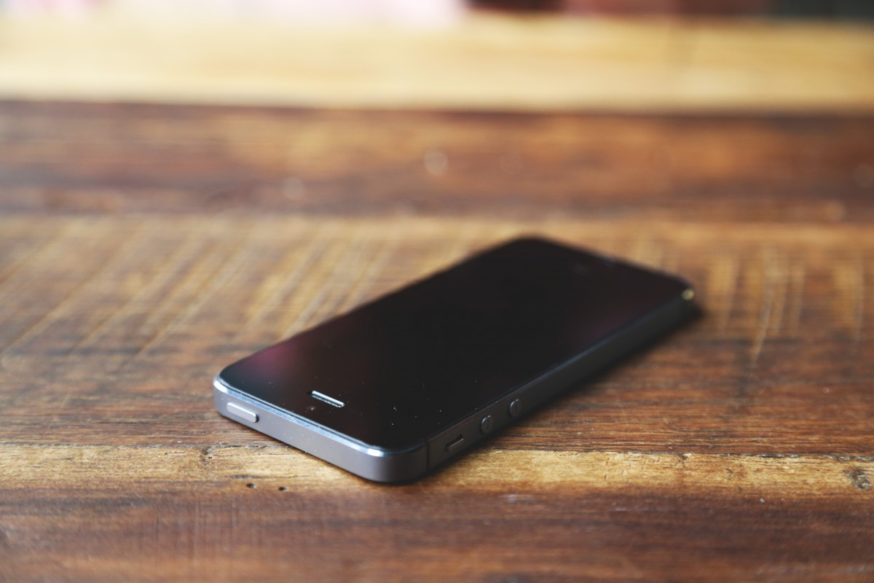
Mobile is the device I use in my daily life. Communication, entertainment, social media apps, calendar, calculator everything i get it in one device. My point of view is updated software system and big storage capacity bring more significant changes for mobile users. In our new world if you want to cop up you must need to have a huge knowledge of technology, so it can be the easy way to keep it in mind the progression of technology.

Screenshot/Photo 2
[Insert Photo/Screenshot below]
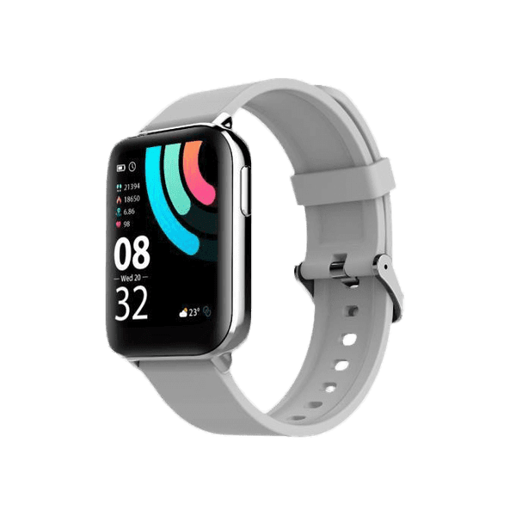
Smart watch is the device I wear every day of my life. While my phone is on my pocket i can check who’s calling me and texting through my smart watch, not only just time. Even we can pay our bills through smart watch. If the watch screen can get a bit bigger then i think i can watch YouTube and social media videos through smart watch and people will like it too. Another touch of technology you can keep it in your hand easily.

Screenshot/Photo 3
[Insert Photo/Screenshot below]
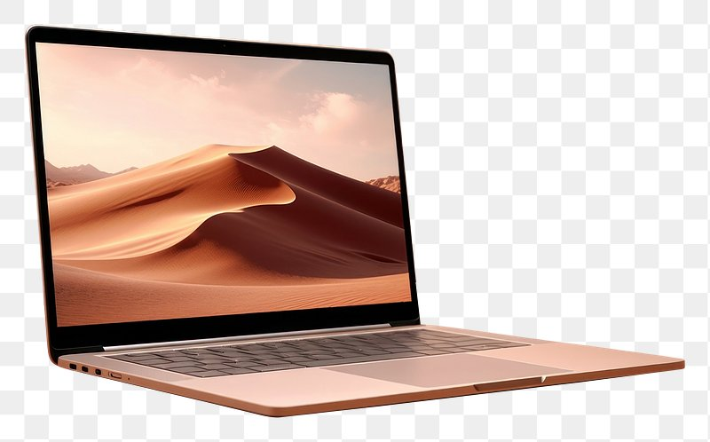
Laptop is most necessary device in my work life, so I use it every day. When I go to my work first thing is to open laptop and check the emails regarding my work. For the online meetings as well, it is so helpful. Because of its big storage its very useful to saving memories. For the online meeting’s we need to use cameras of Laptop. If the camera resolution gets improved life will be much easier. In your work life this skill is mandatory. Now a days you can’t imagine your work life without Laptop.

Screenshot/Photo 4
[Insert Photo/Screenshot below]

Electric car is the device i use daily for my transportation. The most important thing about electric car is I don't have to drive when I'm tired. I just need to put my destination, and the device will take me to the destination i asked for. It's also easy to charge and no need to buy octane or diesel for that. If they bring some changes in their operating system i think it will bring a massive demand in the market. Electric car made our life very easier cause transportation and navigation is part of our life.

Screenshot/Photo 5
[Insert Photo/Screenshot below]
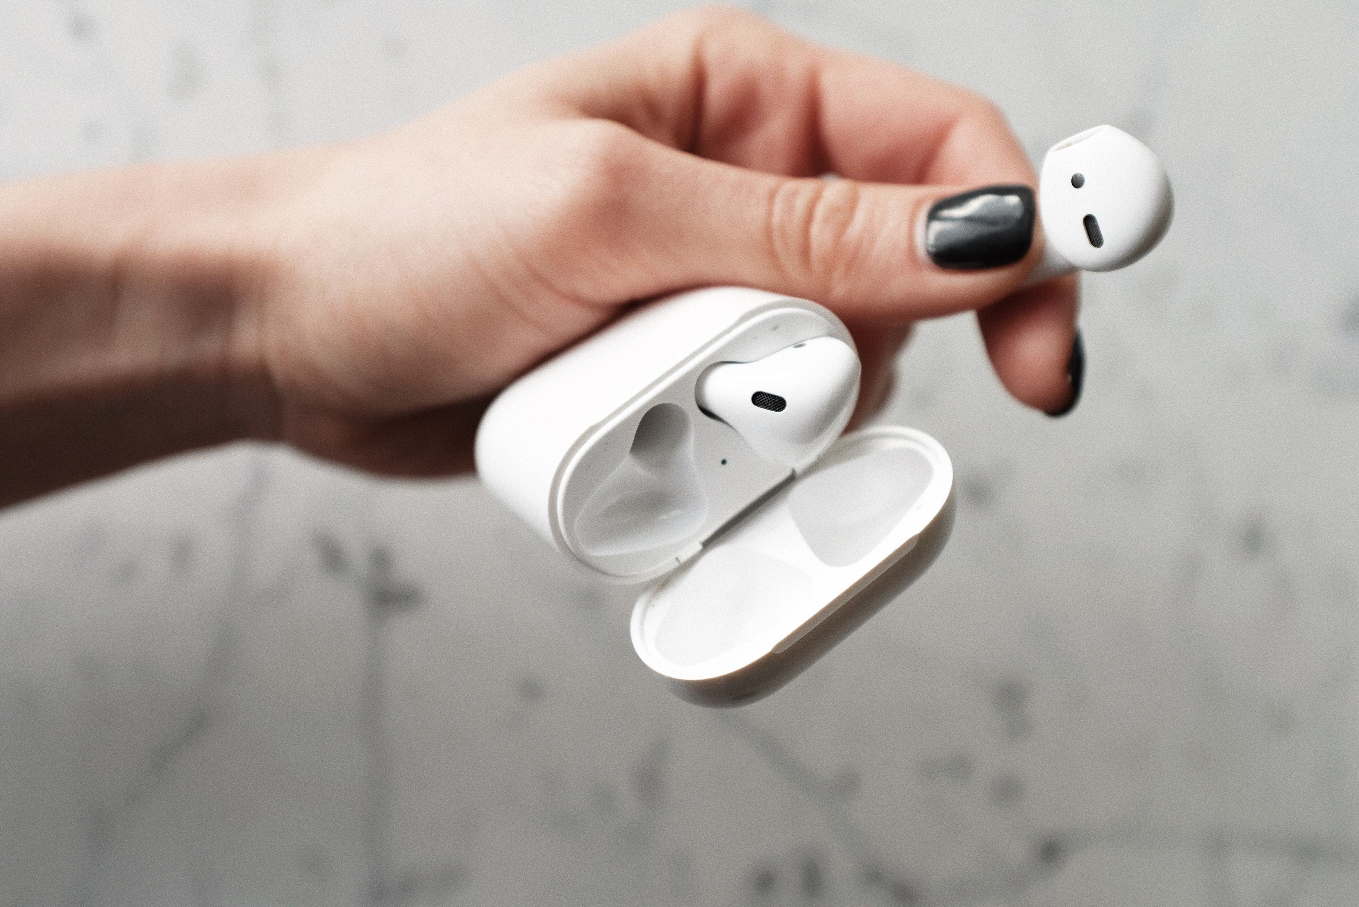
In my daily life when I'm inside or outside of my home one thing i must use and it's my air pod. I use it for calls, listening to music, watching movies and when I travel. It helps me to do my own things without bothering others that's the thing I love most . Just need to put it in charge when it requires. If the frequency of network absorbing gets more updated, it will be more helpful.

Screenshot/Photo 6
[Insert Photo/Screenshot below]
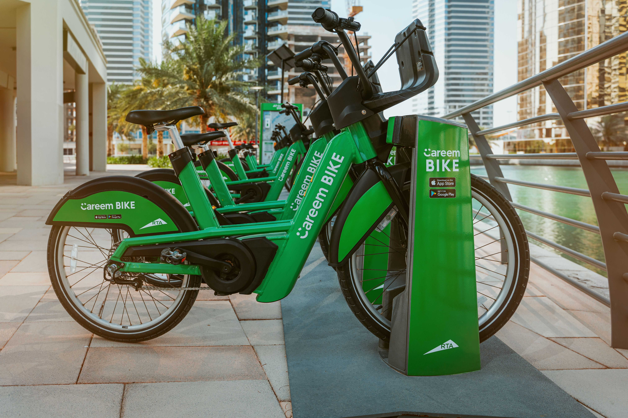
Lime bikes are very common for Londoners. Its very helpful during the train strikes or at night. Its healthy for body also. You just need to press the code to ride it. Very easy transportation device .

My Short Reflection
- Write 5–8 simple sentences about your digital life.
- You can use the sentence starters below if helpful.
My digital life is very simple. I use few digital devices. When I use it I’m confident about it. I need to improve in my laptop skill, specially for words and excel I think I need to learn more so that I can make my life easier. Other devices like mobile, smart watch, air pod, everything I know well to use it properly. Those devices made my life easier otherwise I can’t even think about it without using them .

Sentence starters
- I use digital tools to …
- I feel confident when I …
- I want to improve …
- I often use these tools: …
- I sometimes feel nervous about …
- I hope this module will help me …
- Digital skills are important for me because …
You can write more if you want.

Submission Checklist
Before you submit, please check:
​​​ ☐ I added 4–6 screenshots
☐ I wrote short sentences for each screenshot
☐ I wrote my short reflection
☐ My work is my own
☐ My file opens correctly
​​☐ My file opens correctly

