

Module Title: Research Methods for Business
Module Code: LCLM6004

Student Name: Surma Bibi
Student ID:23088945
Lecturer: Olu Adegbite

The Impact of Organisational Change and Leadership Style on Employee Engagement and Business Performance: A Case Study of John Lewis

Table of Contents
1. Identification of the Business Problem 3
2. Research Aim, Objectives and Questions 4
3. Critical Literature Review 5
3.1 Organisational Change 5
3.2 Leadership Style and Employee Engagement 6
3.3 Employee Engagement and Business Performance 7
3.4 Research Gap 8
4. Research Methodology and Design 8
4.1 Research Approach 9
4.2 Research Strategy 9
4.3 Data Collection 9
4.4 Data Analysis 10
4.5 Sampling Strategy 10
4.6 Research Ethics 10
4.7 Reliability and Validity 11
5. Business Relevance and Practical Implications 11
References 13

1. Identification of the Business Problem
John Lewis Partnership (JLP) is a leading UK-based retailer, which has had to contend with major strategic and operational problems over the last few years due to the presence of department stores and the Waitrose supermarket chain. UK retail has been under pressure due to the high competition levels, high rate of digitalisation, changing consumer purchasing patterns, increase in inflation and supply chain behaviour. In reaction, JLP has made significant organisational adjustments, such as closing stores, restructuring, cost reduction, and more strategy-intensive e-commerce and digital transformation to continue being competitive.

Figure 1: John Lewis Partnership (JLP)
Source: (Sammour et al., 2020)
These changes, though meant to enhance the financial sustainability and competitiveness in the long term, have posed internal complexities. John Lewis is an employee-owned joint venture of a distinctive type in which employees are called partners and where employees traditionally enjoy a share in profits and participative partnering frameworks (Sammour et al., 2020). Organisation restructuring, changes of leadership and financial constraints can be related to employee morale and job security as well as the level of engagement. Engagement is especially important in an employee-owned organisation since it is directly proportional to productivity, quality of customer service, and organisational commitment.
The main business issue is thus to discover the relationship between organisational change and leadership practices, which affect the engagement of the employees as well as the overall business performance. Without animals being successfully led and communicated with, the engagement of employees can decrease, which may affect the customer experience, efficiency of operations, and financial results (Woodward, 2024). Good leadership in the transformational process would enhance resilience and strategic focus.
The concern is important as the level of employee engagement is a well-known motivator of organisational performance in service-based industries like retail. Since John Lewis has been experiencing financial strains and strategic change initiatives, exploring the interrelations between organisational change and leadership approach, as well as required engagement, is crucial to further decision-making and the provision of sustainable competitive benefits.

2. Research Aim, Objectives and Questions
Research Aim
The aim of this research is to examine the impact of organisational change and leadership style on employee engagement and overall business performance at John Lewis.
Research Objectives
- To analyse the nature and extent of organisational change initiatives implemented at John Lewis in recent years.
- To evaluate how different leadership styles influence employee engagement during periods of organisational change.
- To assess the relationship between employee engagement and business performance outcomes within John Lewis.
Research Questions
- What is the nature and extent of organisational change initiatives implemented at John Lewis in recent years?
- How do different leadership styles influence employee engagement during periods of organisational change at John Lewis?
- What is the relationship between employee engagement and business performance outcomes within John Lewis?

3. Critical Literature Review

3.1 Organisational Change
Organisational change is a common definition which indicates that organisations change their structures, strategies, operations, or cultures as a result of internal and external pressures. Traditional change theories visualise change as an ordered and linear process, which is initiated by preparation, implementation and stabilization. According to Alateeg and Alhammadi, (2024) early models focus on the psychological aspect of change and propose that the new practices have to be undertaken after the employees have first unfreezed what they were doing. Although these frameworks offer background knowledge, they are criticised due to the premise that the change implementation results in stability. Change is usually constant in modern retail settings defined by digital discontinuity, economic instability and evolving consumer demands as opposed to infrequent periods of change.
Modern theories suggest that it is crucial to be flexible and form dynamic capabilities in the organisations to enable adapting to change and acknowledging the fact that culture, communication, and perceptions among the employees are as critical as the structural ones. Imran et al., (2022) mentioned that launches such as closing stores, going digital or making cuts cause confusion in the staff, and it is up to the managers to manage resistance, convey vision, and keep trust, resulting in change being a social and behavioural practice.

3.2 Leadership Style and Employee Engagement
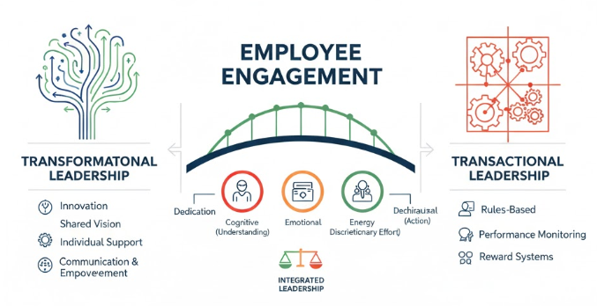
Figure 2: Identification of the Business Problem
Source: (Al-Husseini et al., 2021)
It is known that leadership is a crucial element that affects the attitude of employees in the course of organisational change. According to the theory of transformational leadership, motivating employees and increasing their engagement is possible when a shared vision is promoted by leaders who provide individual support and innovations are encouraged. Al-Husseini et al., (2021) says that transformational leaders are also likely to have an increased level of organisational commitment, especially at uncertain times. Resistance to change can be minimised with their focus on communication and empowerment, which may create a feeling of the common mission.
Transactional leadership, on the other hand, is founded on the theorised exchanges between the leader and the subordinates concerning performance monitoring and reward systems. Although such a solution can be effective to maintain short-term efficiency and compliance, it may not be effective enough to provide emotional and psychological reactions to change. According to Noor et al., (2023) other researchers would state that transformational and transactional behaviours can be integrated to create effective leaders during organisational change. Depending on the context of organisation, culture and strategic objectives, a certain leadership style may prove to be the most suitable.
Literature on employee engagement conceptualises engagement as an emotive, cognitive, and behavioural commitment an employee has towards their organisation. The involvement of employees leads to increased dedication, energy and discretionary efforts. According to research, engagement has positive relations with productivity, customer satisfaction and the performance of the organization. Koeswayo et al., (2024) explain that commitment may decrease in the restructuring process because of uncertainty, subjectivity, or lack of trust in the leadership. As a consequence, leadership behaviour plays a critical role in mediating outcomes of organisational change and engagement.

3.3 Employee Engagement and Business Performance
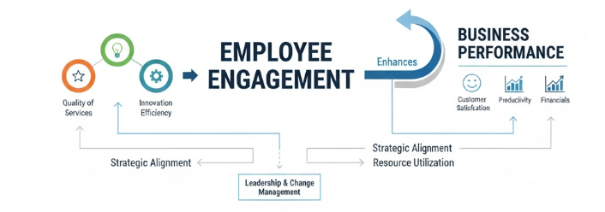
Figure 3: Employee Engagement and Business Performance
Source: (Govender and Bussin, 2020)
The connection between employee engagement and business performance is a phenomenon that is highly discussed in the management research world. It is assumed that engaged employees will help enhance the quality of services, innovation, and efficiency. Engagement is especially important in service-based companies where customer experience directly depends on the frontline personnel (retail). Govender and Bussin, (2020) argue that the relationship between engagement and financial performance is not simple and depends on the macroeconomic factors, intensity of competition in the market and external market environment.
According to some studies, engagement by itself cannot necessarily turn into better performance; a combination of strategic alignment and using resources is also required. (Koeswayo et al., 2024) Moreover, even though engagement and performance readily have positive correlations, few studies exist to identify how the relation is mediated by leadership and change management.

3.4 Research Gap
Available literature has not given much attention to the employee-owned retail organisations that are in the process of structural change; this research paper focuses on the influence of the organisational change and leadership style on employee engagement and business performance at John Lewis.

4. Research Methodology and Design
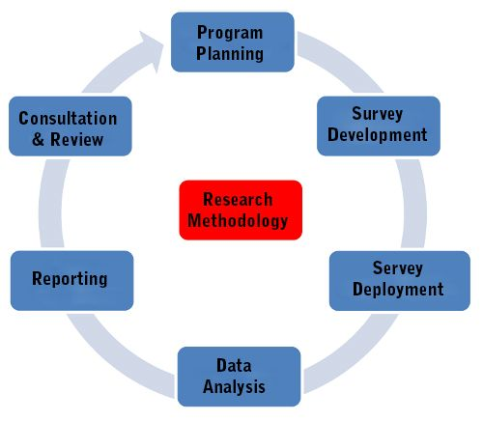
Figure 4: Research Methodology and Design
Source: (Hoang et al., 20231)

4.1 Research Approach
The proposed study will be qualitative (with the use of secondary qualitative data only). Qualitative design will suit the objectives of the research since the study aims to investigate complex organisational operations, leadership behaviours and participation in employees and not to measure the number relationships (Hoang et al., 20231). The type of the research problem is interpretive and exploratory, with the emphasis on the acquisition of meanings and organisational narratives and strategic communication in the changing context.
A quantitative survey would involve the use of primary data, whereby surveys or other structured tools would be used to statistically measure the level of engagement. This proposal, however, aims at critically revisiting the literature evidence available to realise the way organisational change and leadership practice are situated and conveyed at John Lewis (Sweeney, 2022). Hence, thematic, pattern, and strategic narrative analysis is better done in terms of qualitative analysis of existing documents.

4.2 Research Strategy
The research will be conducted through a single case study methodology, with John Lewis as the chosen organisation. A case study method provides the opportunity to take an in-depth analysis of a modern business problem in its practical background (Hutchings et al., 2021). The case study approach is also suitable as the research topic is organisational change and leadership in a particular organisational context, which gives the method contextual richness and allows studying the organisational processes in greater detail.

4.3 Data Collection
The research will rely solely on secondary qualitative data sources. These will include:
- John Lewis annual reports and financial statements
- Corporate governance and sustainability reports
- Official company press releases and leadership communications
- Strategic transformation documents
- Industry reports related to UK retail
Academic journal articles discussing leadership, change, and engagement in retail contexts
The major data collection method will be through document analysis. These sources give an insight into how changes in the organisation are communicated; the method of leadership communicated and the organisation of employee engagement as far as it is concerned with the overall performance of the organisation. (Walliman, 2004). The secondary data can be used in order to gain access to a wide pool of reliable and publicly accessible data without the ethical and logistical challenges of data collection with primary data.

4.4 Data Analysis
The thematic analysis will be used in the study to investigate patterns between the collected documents. Thematic analysis consists of a number of steps: familiarisation with data, generation of first codes, and provision of recurring themes, theme review and refinement, and interpretation of findings in accordance with the theoretical frameworks.
Potential themes may include:
- Strategic restructuring initiatives
- Leadership communication and vision
- Employee engagement references
- Performance outcomes and financial indicators
These themes will then be linked to leadership theories and organisational change models discussed in the literature review.

4.5 Sampling Strategy
The purposive strategy will be used to pick out pertinent documents. Only the documents which directly relate to organisational change, communication concerning leadership, employee engagement and business performance in John Lewis will be considered (Cooper and Schindler, 2014). The recent documents would be given priority to make them relevant to the organisational challenge at present. The academic sources will also be screened on the basis of relevance to the leadership, change management and engagement theories.

4.6 Research Ethics
The research involves the use of publicly available secondary data, and this means that there is limited risk in terms of ethics. The data will not be personal and will not be directly gathered or displayed to talk to any of the employees (Crowther and Lancaster, 2009). Nevertheless, factors such as honesty in the presentation of information and interpretation of data are ethical issues. All materials will be cited as required to avoid plagiarism.

4.7 Reliability and Validity
To increase confidence, various sources will be used to come up with credible information on the same, and information will be triangulated. The credibility of the data can be enhanced by using official corporate sources, as well as peer-reviewed academic literature. Validity will be ensured by matching the interpretation of data with the developed theories and generating transparency of the thematic analysis process.

5. Business Relevance and Practical Implications
The proposed study is very applicable to John Lewis as it will provide evidence on how organisational change and leadership style contribute to employee engagement and business performance, and can guide management to make sound strategic decisions, as well as communication and effective restructuring of the organisation to achieve better performance.
In case some of the leadership tactics increase engagement in change, the management can use a participative, transparent, and transformational style, which boosts the morale, dedication, communication and engagement of the employees, values of partners, and harmonises change programs to minimise resistance and increase efficiency (Adams, 2007).
The study can also raise concerns about adopting engagement metrics in performance management systems. The approach of redefining employee engagement as an organisational strategic resource and not a soft variable will allow John Lewis to create more effective and sustainable workforce management and customer services throughout its operations, which will, in the long run, provide greater productivity, customer satisfaction, and reinforce its presence in the retail industry environment.
The scholarly relevance of this project lies in the fact that it shows how transformational leadership, organisational change models, and employee engagement frameworks could be implemented within a practical organisational setting (Saunders et al., 2019). It builds upon analytical abilities, critical thinking, as well as the capability to relate theory to practice in business problems applicable in leadership and management positions, key competencies in leadership and management.

References
Adams, J. et al. (2007) Research Methods for Business and Social Science Students. 2nd Sage Publications, Delhi
Alateeg, S., and Alhammadi, A. (2024). The impact of organizational culture on organizational innovation with mediation role of strategic leadership in Saudi Arabia. Journal of Statistics Applications and Probability, 13(2), 843-858.
Al-Husseini, S., El Beltagi, I., and Moizer, J. (2021). Transformational leadership and innovation: the mediating role of knowledge sharing amongst higher education faculty. International Journal of Leadership in Education, 24(5), 670-693.
Cooper, D. R., and Schindler P. S. (2014). Business Research Methods. 12th ed. McGraw Hill
Crowther, D., and Lancaster, G. (2009) Research Methods: A Concise Introduction to Research in Management and Business Consultancy. 2nd Elsevier Butterworth-Heinemann, Oxford
Govender, M., and Bussin, M. H. (2020). Performance management and employee engagement: A South African perspective. SA Journal of Human Resource Management, 18(1), 1-19.
Hoang, G., Wilson-Evered, E., and Lockstone-Binney, L. (2021). Leaders influencing innovation: A qualitative study exploring the role of leadership and organizational climate in Vietnamese tourism SMEs. Employee Relations: The International Journal, 43(2), 416-437.
https://librarysearch.uwtsd.ac.uk/permalink/44WHELF_UWTSD/11c0l68/alma99100180600202421
https://librarysearch.uwtsd.ac.uk/permalink/44WHELF_UWTSD/1pbrh66/alma99100313060202421
Hutchings, M., Mous, R., Clausen, M. R., Johnson, P., Linton, K. M., Chamuleau, M. E., ... and Lugtenburg, P. J. (2021). Dose escalation of subcutaneous epcoritamab in patients with relapsed or refractory B-cell non-Hodgkin lymphoma: an open-label, phase 1/2 study. The Lancet, 398(10306), 1157-1169.
Imran, M., Ismail, F., Arshad, I., Zeb, F., and Zahid, H. (2022). The mediating role of innovation in the relationship between organizational culture and organizational performance in Pakistan's banking sector. Journal of Public Affairs, 22, e2717.
Koeswayo, P. S., Haryanto, H., and Handoyo, S. (2024). The impact of corporate governance, internal control and corporate reputation on employee engagement: a moderating role of leadership style. Cogent Business and Management, 11(1), 2296698.
Lappalainen, P., Saunila, M., Ukko, J., Rantala, T., and Rantanen, H. (2020). Managing performance through employee attributes: implications for employee engagement. International Journal of Productivity and Performance Management, 69(9), 2119-2137.
Noor, J., Tunnufus, Z., Handrian, V. Y., and Yumhi, Y. (2023). Green human resources management practices, leadership style and employee engagement: Green banking context. Heliyon, 9(12).
Sammour, A., Chen, W., Balmer, J. M., Botchie, D., and Faraday, J. (2020). Crafting the forever now: corporate heritage brand innovation at John Lewis Partnership. Strategic Change, 29(1), 115-126.
Saunders, M.N.K., Lewis, P., and Thornhill, A. (2019) Research Methods for Business Students. 8th, Pearson, Harlow
Sharafizad, J., Redmond, J., and Morris, R. (2020). Leadership/management factors impact on employee engagement and discretionary effort. International Journal of Organization Theory and Behavior, 23(1), 43-64.
Sweeney, A. (2022). Looking within: a longitudinal qualitative analysis of shared leadership behaviours in organisational teams. Team Performance Management: An International Journal, 28(7-8), 441-460.
Walliman N. (2004). Your Research Project, a step-by-step guide for the first-time researcher. Sage Publications.
Woodward, S. A. (2024). From an ‘Experiment in Industrial Democracy’to ‘Driving the Difference’: The John Lewis Partnership Co-ownership Model 1964-2014 (Doctoral dissertation, University of Essex).

