BA (Hons) Photography in the Arts
Dissertation

Colour and the Sublime

Student number: p139651

Tutor’s name: Ryan Moule

Department of Fine Art
Photography in the Arts
University of Wales Trinity Saint David

5036 words
2017

Table of Contents
page
List of Illustrations 3
Introduction 4
About Perception and Colour 4
The Psychology of Colour 10
The Sublime 15
My Art 24
Conclusion 28
Bibliography 30

List of Illustrations
Page no.
Fig 1 Reproduction of cave painting at the Lascaux 2 site. Photograph P A Green 9
Fig. 2 Samples of pigments used in the Lascaux 2 Cave paintings. Photograph P A Green 10
Fig. 3 Canto VII (1963) Barnet Newman. 17
Fig. 4 Red on Maroon, Mark Rothko (1959), part of the Seagram Murals hanging in Tate Modern 18
Fig. 5 Still from Guiness Surfer advertisement, Director John Glazer 20
Fig. 6 Martyrs (2014) Bill Viola & Kira Perov, Video exhibited in St. Pauls Cathedral, London (http://billviolaatstpauls.com/#martyrs-home) 21
Fig. 7 Nataraja 1993, oil on canvas. Bridget Riley.
Image: http://www.tate.org.uk/art/artworks/riley-nataraja-t06859 22
Fig. 8 ikb - International Klein Blue, 1957(http://uk.phaidon.com/agenda/art/articles/
2017/april/28/what-was-it-with-yves-klein-and-blue/) 23
Fig. 9 Descent into Limbo, Havana, 2016, fiberglass and pigment, diameter 3 m, unique work.
Courtesy the artist and GALLERIA CONTINUA, San Gimignano / Beijing /Les Moulins /
Habana. Photo: Paola Martinez Fiterre 24
Fig. 10 Abstract 37 photographer P A Green 26
Fig. 11 Book project, produced by P A Green 27
Fig. 12 Liminal space, exhibition piece photographer P A Green 27

Introduction:
This essay sets out to examine the nature of colour and the sublime, what they are and how they are perceived, along with the theoretical debates and philosophies which underlie our understanding and appreciation of these phenomena. It will firstly investigate how humans perceive colour physiologically and psychologically before examining the elements of colour and the implications of colour on human responses both physically and emotionally.
Considering ‘The Sublime’, which is an emotional response to an artistic experience or encounter, this essay will also investigate what has influenced sublime experiences historically and how that has altered with the passing of time. It will then ask whether the sublime can be experienced today as it was originally conceived considering the development of modern media in the digital age. Subjectively, I will examine my experiences of the sublime and the artists whose work I believe has had a powerful influence on me emotionally. Leading on from this I will discuss my own work and how it has developed through attending the Swansea School of Art and its potential progression to demonstrate how colour can elicit experience of the sublime.
About Perception and Colour:
The first known theories of colour were Aristotle’s, the ancient Greek philosopher, who thought the Gods sent colour in celestial rays of light and were based on black and white in relation to the four elements -water, air, earth and fire. His views were influential for around 2000 years until Isaac Newton’s experiments with prisms and the scientific study of light visible to the human eye. Newton’s treatise ‘Optiks’ identified the colours of a rainbow – (red, orange, yellow, green, blue, indigo and violet). These are the parts of the electromagnetic spectrum, light, that includes radio, gamma and microwaves which cannot be perceived by the eye. Goethe on the other hand argued that there was yet another dimension to Newton’s consideration of colour; he examined the human perception of colour and the physiological and psychological aspects of colour in his ‘Theory of Colours’.
By expressing the colours of the rainbow (visible spectrum of light) in a circle, Sir Isaac Newton created a method of showing the relationships between colours allowing them to be split into ‘families’ each of which have three main attributes, hue, saturation and brightness. Hue is the colour name, linked to its wavelength, such as red (700nm), green (560nm) and blue (490nm). Saturation or chroma is the intensity or purity of the hue, when a colour is fully saturated it is said to at its purest and appears washed out and grey when unsaturated. Brightness or luminescence is the shade of a colour making it appear lighter or darker and its perception is dependent on factors such as intensity of light falling on it or surrounding colours affecting its appearance. The complexity of the colour spectrum highlights the variation in perception of colour by showing the vast array of colour and the diversity in one colour’s appearance.
The discourse on colour continues and is not just academic. It issues from the arts across all genres, photography, painting, installations, poems, films and song. The perception of colour is absolutely subjective and is effected by a number of criteria ranging from age, lighting conditions, personal preference, life experiences, cultural backgrounds and many more factors which contribute to how a colour is experienced. If we take all of these factors into consideration it is understandable that communicating a colour through and across language with any accuracy has been found to be problematic.
The solution to our variation in perception and language has been met by the use of a colour meter which measures and assigns a numeric value to the colour. MacEvoy (2015) postulates that colour can be categorised into four fundamental aspects – material, radiant, visual and conceptual.
Material colour refers to the elements used to apply colour and is the physical ‘fabric’ or pigment such as paint, ink, dye and filtered light: materials that change the colour of transmitted or reflected light.
Radiant colour defines the electromagnetic wave length emitted, transmitted or reflected and is specified by the number of nanometre wave lengths in the visual spectrum which is approximately 400nm to 700nm. For example, blues are in the region of 450nm, greens in the region of 550nm and reds in the region of 650nm. Material colour is not experienced directly and is perceived as the radiance of the colour affected by the lighting conditions (in shadow) and material surface (glossy or textured) and many other factors.
Visual colour is simply what we see. It is completely subjective and does not exist outside the brain’s conscious perception. It is the human experience of the sensations and interpretations of the light reflected from the world around us. Visual colour varies enormously from person to person, lighting conditions and various other factors including surface texture, time of day and intensity of the light source. I observed the effects of changing lighting conditions on my colour perception when I was admitted to hospital in France and in a room on my own at night. The room had large windows and in the dark my surroundings were grey and colourless but as the light intensified with the dawn the walls gradually changed from a light grey to lilac and the doors from dark grey to purple. Subsequently, this experience had a profound effect on my consideration of colour realising that without reflected light there is no colour. Everything is black in the dark!
Finally, conceptual colours only exist in our minds and are what is called to mind when colour is described with language or in our imagination or memory, for example: spring green; blood red or silver moon. However, as aforementioned, colours cannot be accurately defined with language due to the variation in perception, hence a colour code system is used to identify the colour precisely such as Pantone’s CMYK or the digital RGB colour space. James Turrell when talking about colour suggests that when we are looking at the sky we assume we are receiving its blue where in fact we are creating it from the light we perceive, and therefore, we create our own realities of the world that surrounds us in which we live.
Hazel Rossotti (1983) describes human perception of colour (and sight) as a magical and mysterious illusion that enables us to interpret the world around us and to enhance our emotional responses. The human animal experiences colour through reflected light waves entering the eye through its lens, beginning a process which will result in a picture or sensation being formed. The light photons are received on the light -sensitive inner surface of the eye, the retina. There it is picked up by light sensitive cells - rods and cones - located at the ends of nerve fibres in the retina, each sensitive to different light wave lengths. These cells transfer this information through the optic nerve to the cerebral cortex, the part of the brain that processes visual information. Colour, therefore is a subjective experience of reflected light waves, a sensation separated and interpreted through the physiology of our eyes, nerve fibres and the imaginative translation of the brain.
“If one says “Red” (the name of a colour)
And there are 50 people listening,
It can be expected that there will be 50 reds in their minds.
And one can be sure that all these reds will be very different.”
Josef Albers (1963)
Phenomenology is a movement that highlights the individuality of experiences, and emphasises that perception is primarily subjective and will vary from person to person. Any person’s opinion on their experience of phenomena is regarded as legitimate and meaningful to that person as we are unable to truly explain another person’s perception or feel their emotions.
Phenomenology seeks to understand the outside world as it is interpreted by and through human consciousness. Thus, for the purpose of this essay, Phenomenology recognises and legitimises the deeply subjective experience of colour and therefore any individual’s experience of art and the sublime.
I believe that colour is an innate part of man’s need to reflect their world with art. This is evident not only from the discussion and theorising of colour from Aristotle but also from some of the earliest examples of artistic expression: Pre-historic cave art, some of which date back 40,000 years to when prehistoric artists decorated the walls of caves with paintings of hands, animals and hunters. These depictions were coloured with the natural pigments available to them at the time and were subtle and surprisingly sophisticated, thus suggesting that from the first depictions created by human kind that colour is indispensable to art and individual expression.
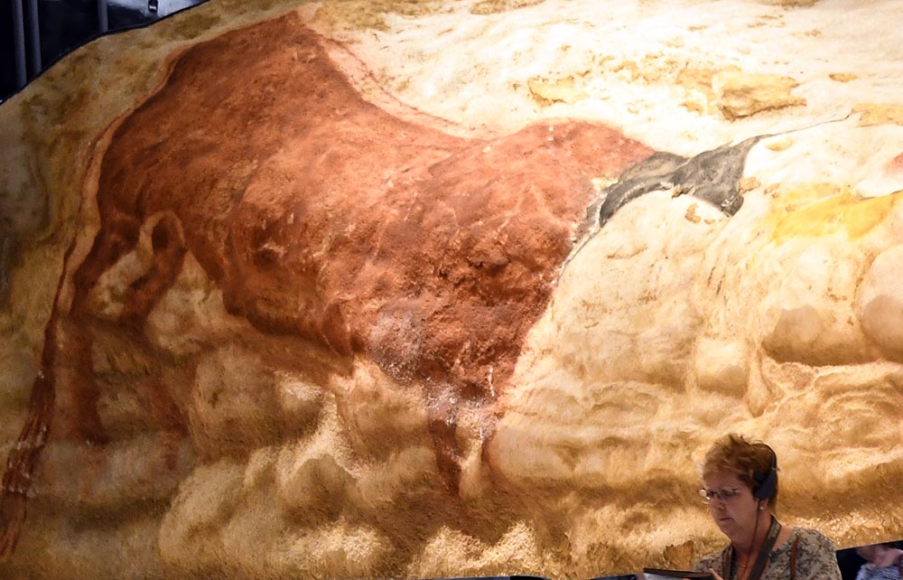
Fig. 1
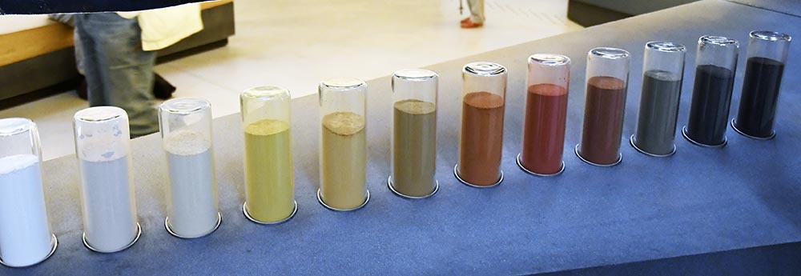
Fig. 2

Psychology of colour:
Human behaviour is affected by colour perception in often unconscious ways. Colour is not just an aesthetic sensation, it imparts valuable information about the world around us. For example, it is well documented that the colour of food can indicate if it is safe to eat or not and food which has been dyed unnatural colours will be avoided. We have also learnt to be wary of insects and animals such as yellow stinging wasps and brightly patterned, coloured poisonous snakes. Many studies have been carried out on how colour affects our mood and emotions in subtle ways that we are often not aware of.
Angela Wright (1998) writes extensively on how colour touches our daily lives and the choices we make about the colour of clothes we wear and the colours we use to decorate our homes. She confesses that her theories are not arrived at scientifically but through her life-long work with colour in personal and commercial consultancies. Interestingly, she ignores the work on colour by Rudolf Steiner, Johannes Itten and Joseph Albers whose work is more scientifically verified. However, her assumptions do seem to have some universal truths that cross the cultural divides. For instance, she suggests that the colour of your surroundings may influence your state of mind or your feelings. Warm colours such as red, orange and yellow can induce feelings varying from warmth and comfort to hostility and anger, and cool colours, green, blue and purple can induce feelings of calmness or sadness. These emotional responses are commonly used in advertising and sales to create settings and moods for customers. Theories abound on the psychological significance of colours from pure white, through the colours of the rainbow to the darkest black but it is outside the confines of this essay to list them. Interested readers only need to search the internet for abundant opinions on the meanings and associations commonly made about colour. Given the idea that colour infuses our subconscious and stimulates our responses in everyday life, it is reasonable to conjecture that when we focus on the visual presence of colour in art it effects how we perceive the work.
Faber Birren in his introduction to Ittens ‘Introduction of Colour’ (1970) cites Ittens as saying:
“He who wants to become a master of colour must see, feel, and experience each individual colour in its many endless combinations with all other colours. Colours must have a mystical capacity for spiritual expression without being tied to objects.”
In order to understand whether colour in art affects our responses to it, it is
necessary to understand how we perceive what we are looking at. The Oxford
Dictionary defines perception as “a way of regarding, understanding or interpreting
something: a mental impression.” Human perception is how we receive information
through the senses, traditionally recognised as sight, sound, touch, smell and taste,
and how this sensory information is interpreted in our brains.

In further consideration of how art is viewed Shimamura (2013) says that over the centuries the art audience has approached art from various perspectives and names them mimetic, expressionist and formalist and conceptual. With a mimetic approach the works of art are interpreted as a window on the world and assesses how successful the work is based on how well it represents the reality of the subject or event. With the expressionist approach the viewer seeks an emotional experience, for example the sublime or the beautiful. A formalist approach the objects or scenes in an artwork are unimportant but the qualities of the colours, abstract shapes and lines are considered foremost. And finally, the conceptualist’s approach is concerned with what lies behind the artwork, the artist’s concepts – what they wanted to achieve or express, rather than the image itself. Thus art is experienced in different ways depending on the view point of the observer. So a viewer’s preconceptions predisposes them to a particular response, be that emotional, rational, appreciative or analytical.

The processing of this information facilitates the identification and understanding of
the phenomena we are intentionally regarding and is dependent, not purely on the sensory information passively received, but on how we interpret it. This interpretation is dependent on our life experiences, expectations, education,
memory and attention. For example, it is common for different people to like or dislike the same work of art based on their personal ‘feelings’ which are constructed subconsciously and are based on their personal preferences and life experiences and also on their perspective on the purpose of, and the value they place on art.

Despite the complexity of variables that define how we perceive any one image, this sensual processing happens mostly outside our conscious awareness. It is the complexity and subjectivity of perception which makes it so interesting and difficult to truly define. Whilst we may have more of an understanding of the biological process of perception, philosophical curiosity has noted that perception has the potential to be shared and has many layers, linking to every aspect of human interaction.

The concept of Structuralism; a way of explaining the structure of making meaning of phenomena, came to prominence in France in the twentieth century. However, In the 1960’s Claude Levi-Strauss challenged the ideas of Jean Paul Sartre’s philosophy, further blurring the parameters which define Structuralism. As an anthropologist, Levi-Strauss used the concept of Structuralism to discuss kinship and how different cultures categorise kin to meet the needs of their societies. Levi-Strauss was followed by philosophers Jacques Lacan, Michel Foucalt and Louis Althusser in suggesting that language is essential to communicate thoughts and therefore to take part in society. Language is ‘an unconscious system’ which makes objects and ideas distinct by drawing attention to ‘differences and oppositions’ (Macey, 2000:365). For the purpose of this essay, I am going to use John Mann’s definition of Structuralism; he states in Philosophy Now (1994) that a “simple explanation of Structuralism is that it understands phenomena using the metaphor of language”. Without language we are still able to experience phenomena, but we are unable to share it. If we take the concept of Phenomenology to the extreme, it is impossible to understand another person’s perspective. However, when experiencing art in public forums, whether that be a gallery in London or a cave in France, humans share their feelings, emotions, opinions and often they are shared.

When interpreting social phenomena, including art, colour allows distinction between objects and facilitates their identification enabling labelling with language. It is my understanding that society plays a part in creating shared associations between colour and emotions or impulses. These distinctions often lead to conscious awareness of emotions or feelings when confronted by visual art, which I am going to discuss through the course of this essay. This issue is made more interesting by the fact mentioned above that due to the deeply subjective nature of experiencing colour – language may fall short in allowing us appropriate expression of what we see before us but we cannot deny that sometimes colour provokes shared responses.
The Sublime:
What is the Sublime? A reductionist consideration of The Sublime is that it is a powerful, overwhelming emotional reaction to art. The over-powering emotion and breath-taking confrontation with art depicting unbelievable figurative beauty, colourful abstracts or awe-inspiring seascapes by W. M. J. Turner can be interpreted as sublime. Yet, it must be admitted that this emotional outpouring is fundamentally subjective due to each individual’s prior experiences – as previously discussed. Using language to relate the personal inner turmoil stimulated by visual greatness, or trying to express the shock and terror of consequential emotional eruption is almost impossible. However, it is these severe emotional responses that are considered to signify The Sublime.
The world of art has moved on dramatically since 18th century philosophers, such as Edmund Burke and Immanuel Kant, expounded their theories contrasting ‘the beautiful’, which is based on form, and ‘the sublime’, which is a formless and awe-inspiring phenomenon like the enormity of the universe.
Kant (1790), in his Critique of Judgement, explains the sublime as a mixture of anxiety and pleasure. Describing The Sublime as a conflict between the mathematical and imaginative thinking; a clash between our reason, where we observe, and our imagination, which is boundless. This clash results in an inability to fully comprehend what we are experiencing. Shimamura (2013) comments that Kant (1790), in his Critique of Judgement asserted that we link sensory experience to pre-existing concepts and also held the view that we are cognitive beings. Shimamura linked this to aesthetic experiences and considered sublime feelings as sublime experiences, suggesting that there could be a divine or spiritual aspect to sublime feelings. This link with divine beings aligns with the pervading belief in God during the 18th Century and also due to the overwhelming similarities of divine and sublime encounters.
Later discussions of the sublime appear to be less intrinsically linked to divine beings – but the expression of emotions remain the same. Jean-Francois Lyotard emphasises the aesthetic of the sublime in avant-garde art in his writings about the American avant-garde artist Barnet Newman, an abstract expressionist. Canto VII, (below), an example of his work from his Canto series of 18 from 1963 a ’colour field’ an abstract painting completed during his Washington Colour School period.
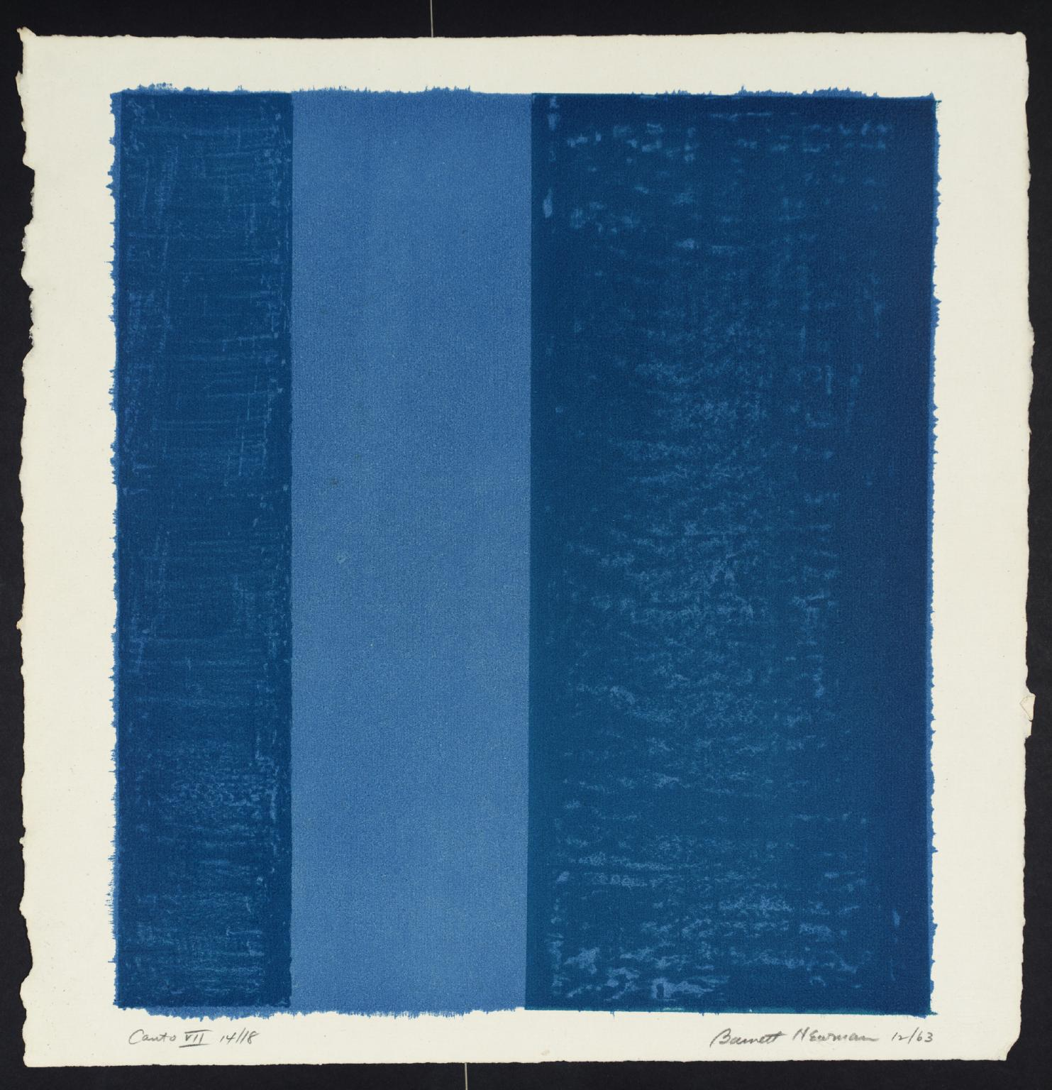
Fig. 3
Lyotard says of Newman’s work it:
‘emancipates the work from both the classical role of imitation
and the canon of the beautiful and no longer testifies to the truth
and can be conceptualized.’
Newman’s work, therefore, does not replicate nature and it’s horrors, like Turner’s work, ‘Snow Storm: Steam-Boat off a Harbour's Mouth’, (1842) yet the use of formless colour elicits a deep emotional response. Lyotard’s considerations could equally be applied to Mark Rothko’s works hanging in the Tate Gallery in London. Newman compares his Canto series to music saying, “their symphonic mass lends additional clarity to each individual canto.” David Macey (2001) suggests that ‘the sublime has always been associated with the sacred and the mystical, and there is a significant quasi-religious mysticism in the work and pronouncements of both Barnet and Rothko’.
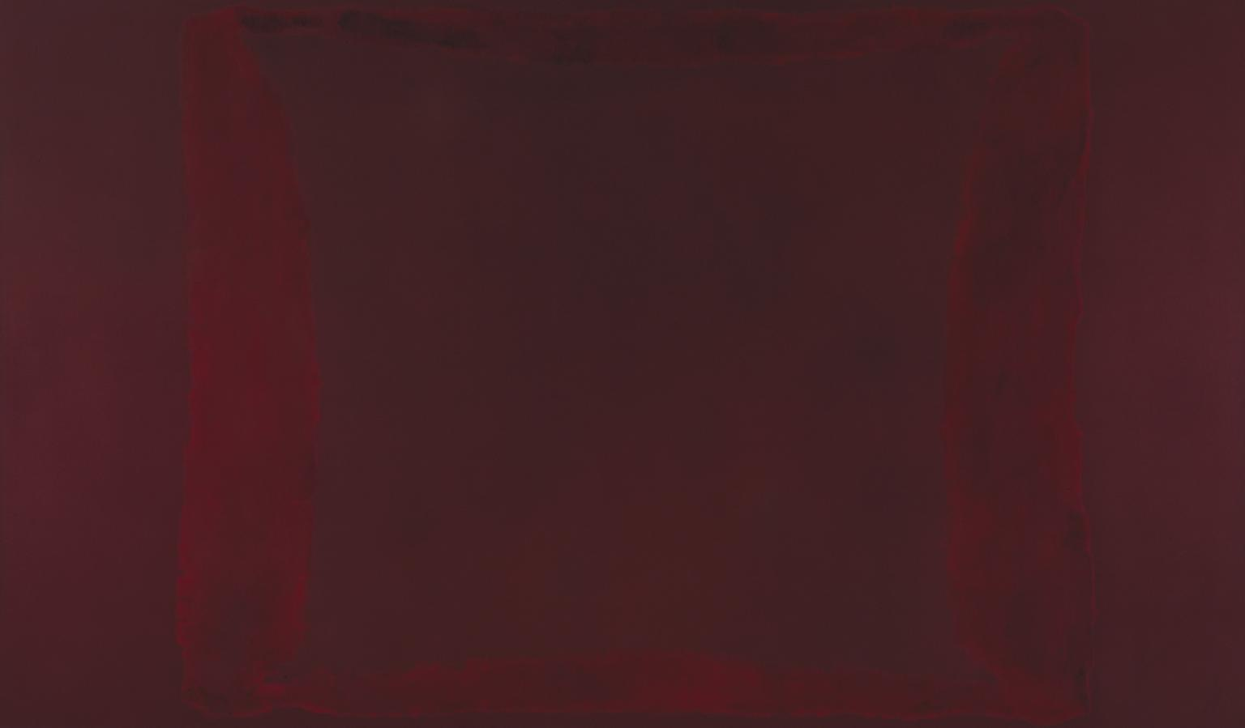
Fig. 4.
Originally conceived for the commission to decorate the Seagram restaurant, Rothko painted several series of maroon murals but rejected them and the idea of selling them privately. He was concerned that his work was becoming too decorative and subdued the colours making then more sombre before finally withdrawing from the commission completely. He donated the works to the Tate Modern in 1969 where they are hung permanently in the ‘Rothko Room’ and known as the Seagram Murals. I have sat in contemplation in the Rothko Room surrounded and absorbed by the massive dominating murals, immersed in maroon which induces a meditative mood in me. The depth of the colour somehow pervades the thoughts and is all encompassing. Arguably, it is the unseen forces of conditioning and social influence that provoke this response. As mentioned earlier, colour acts as the trigger for the deep emotional responses that are constructed from a person’s personality and their unlimited previous experiences.
In consideration of how The Sublime art experience has changed over time I suggest that the 18th century experiences are substantially different from contemporary emotional encounters as the visual media that we are constantly exposed to today would have been unimaginable then. This evolution of the sublime can be mapped into abstract art such as Rothko and Newman, as discussed above, as the deep and brooding colours used engulf the senses.
However, this evolution has, in my opinion, drastically altered with the advent of photography as it surpasses painters’ expression of nature and instead photography produces a mimetic reproduction of nature that seems to lack the ability to convey powerful emotional reactions.
I suggest that this dampened emotional response stems from the idea that we are bombarded by the ‘fantastic’. Computer generated imagery is being harnessed by science fiction movies, advertising and TV, meaning that we are constantly presented with depictions of terrifying scenes, disasters and wonderful visions of galaxies far beyond our imagining, offering viewers a surfeit of the potentially sublime – each trying to out-do the next. But surely this bombardment of the ‘fantastic’ must blunt our appetite for the aesthetic, for the beautiful and dull the sense of the sublime?
Upon my personal consideration, the sublime can only be experienced in contemporary art when images are abstracted. One example of computerised imagery evoking the sublime is an advertisement, ‘the Guinness Surfer’, directed by Johnathon Glazer. This advert shows computerised horses galloping through the waves with surfers and is dramatically surreal and awe-inspiring as it combines fantasy with nature so seamlessly.
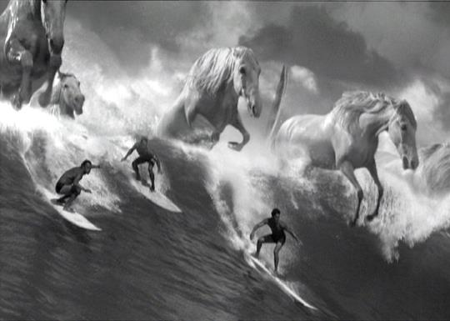 Fig. 5
For contemporary art to present the sublime it must go beyond banal visual representation of special effects and seek out the soul. Bill Viola and Kira Perov’s video work does this for me. The work is on permanent display in Saint Paul’s Cathedral in London along with its sister piece ‘Mary’. ‘Martyrs’ is a four-part video shown on vertical plasma screens representing the martyrdom of four individuals by earth, air, fire and water, the four elements depicting the transition from life to death in a dramatic and spiritual way. My experience of watching the seven minutes was soulful, both uplifting and terrifying: a sublime encounter. I have considered what it is about ‘Martyr’ that is so encapsulating and whilst, by very nature of sublime experience, it cannot be truly grasped, I feel that the historic and holy setting of St Paul’s links with my understanding of the pain and suffering martyrs experience which terrifies me, as they are rendered powerless against their accusers and only become martyrs by giving their lives in the name of their beliefs. Shimamura (2013) may suggest that it is my understanding of martyrdom that means these images resonate so deeply in my conscious experience.

Fig. 6

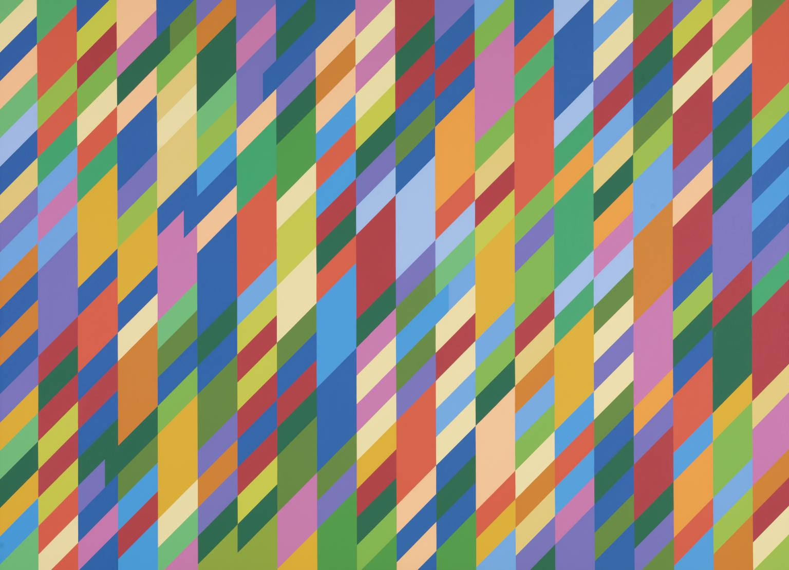
Fig. 7
There are many artists whose work touches me in some way. Visiting the Museum of Modern and Contemporary in Nice, France this summer I was brought face to face with Yves Klein’s ‘International Klein Blue’ in a bed approximately three meters square and about half a meter deep filled to the brim with his blue powdered pigment. I was mesmerized. The expanse of deep blue reverberated through my being like a physical vibration. I was captivated, held by it, it seeped into my consciousness and I felt flooded with the colour and overwhelmed by it. When I close my eyes now I can still see it!

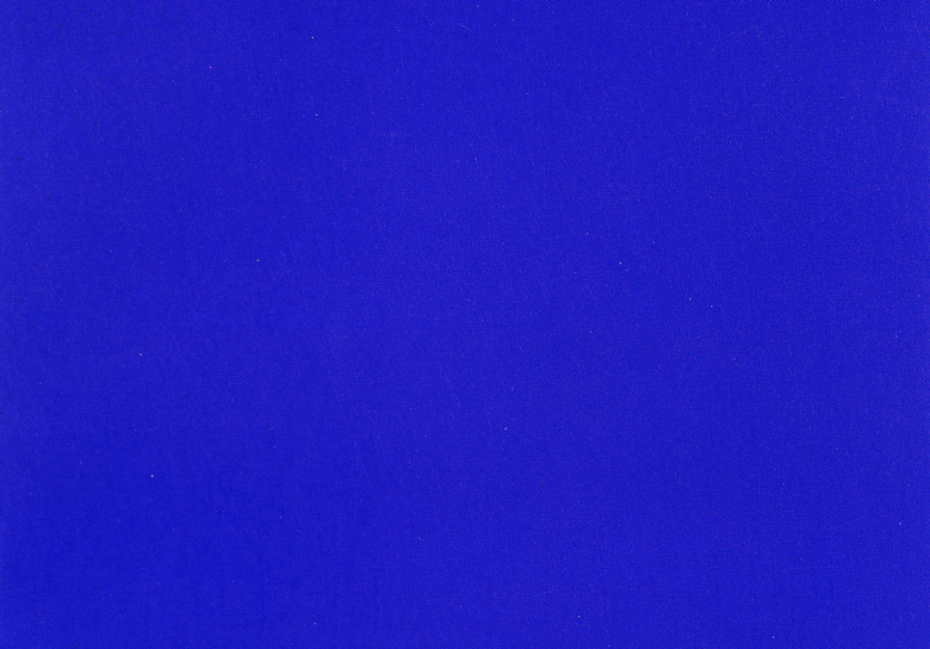
Fig. 8
Another artist to have exclusive use of a colour is Anish Kapoor with Vantablack, the blackest colour absorbing almost all light. It was developed by Surrey Nano Systems who describe Vantablack as a super black coating that holds the world record as the darkest man-made substance have given Kapoor an exclusive rights to use the colour for artistic purposes. Kapoor uses it to create illusions of depth, painting the insides of concave shapes that look flat and black circles of floors that give the impression of infinite depth and can induce a fear of falling into the abyss.
These artists all use colour with the intention of evoking an emotional reaction – none of which are mild. The size and intensity of the artworks I have discussed evoke in me some sense of awe and by extension, The Sublime. It is possible that it is the very nature of abstract art lacking a rigid form which provokes awe-inspiring phenomenon as postulated by Kant and Burke.
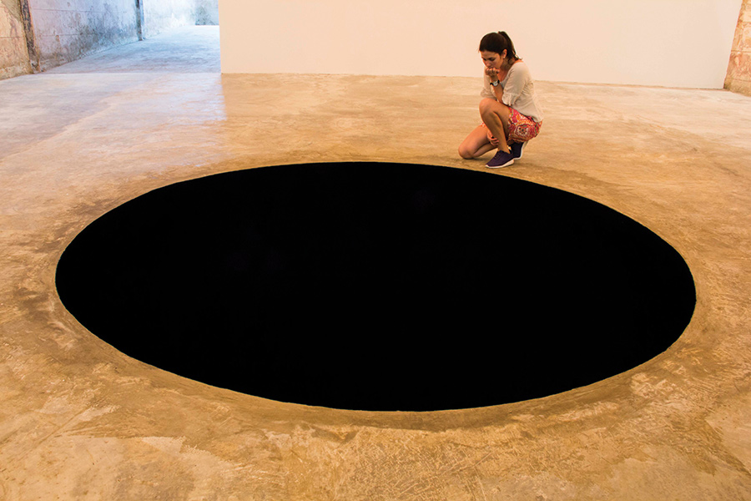
Fig. 9

My Art:
The ability to inspire conversation and to provoke emotions has become, if not an explicit aim, a joy that I experience when creating my own art work. Above all my intentions as an artist are to create objects with a combination of photography, acrylics and other materials in order to create a dialogue and relationship with the viewer. I would like my work to stir their imagination with abstract images that are fascinating enough to stimulate conjecture and for viewers to interpret the work in their own unique way. I am interested in the way that people’s life experiences, culture, education and personalities contribute to their interpretation of the abstract. This task has led me to search for a deeper understanding of how colour is perceived and when this perception is deemed to be a catalyst for The Sublime experience.
My work developed significantly through my experience of participating in a workshop focusing on glass and paint. The workshop leader pushed me outside of my comfort zone and in the process I discovered a way of making abstracts with paints, oils and acrylics sandwiched between sheets of glass. I noticed the interaction of the colours with each other and started taking abstract photographs of the area where paints combined using macro-photography. The intermingling of colours at the macro-level reminded me of images of the heavens and universe (such as one of my own abstract works; Figure 10 below). It also prompted me to think about how the interactions between colours reflected the liminal spaces between people. When people interact, many things are occurring beneath our consciousness such as pheromones and unconscious assumptions we make from people’s body language. The interacting colours expressed this abstractly and caused a chain reaction of associations that ultimately lead me to The Sublime.
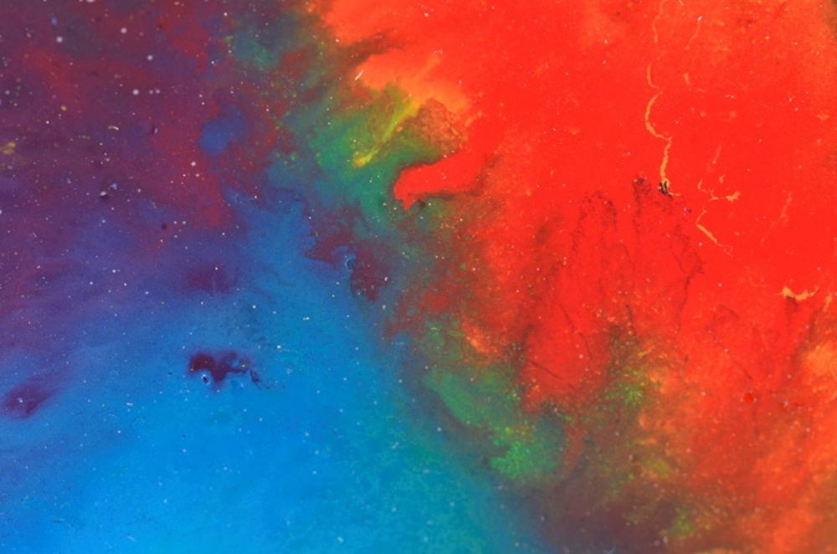
Fig. 10
Continuing in this vein I used this theme as inspiration for the book project, challenging the concepts of what constitutes a book I used acrylic triangles for the pages on a hexagonal body. I was becoming interested in the interactivity of the viewer and how people react to my work. In addition to the book form I produced an insert made from a sandwich of acrylic sheets, 3mm thick for the base and 0.5mm thick flexible for the top and filled the interior with oil based paints diluted with linseed oil and sealed so that when the surfaces were pressed together serendipitous patterns were formed.
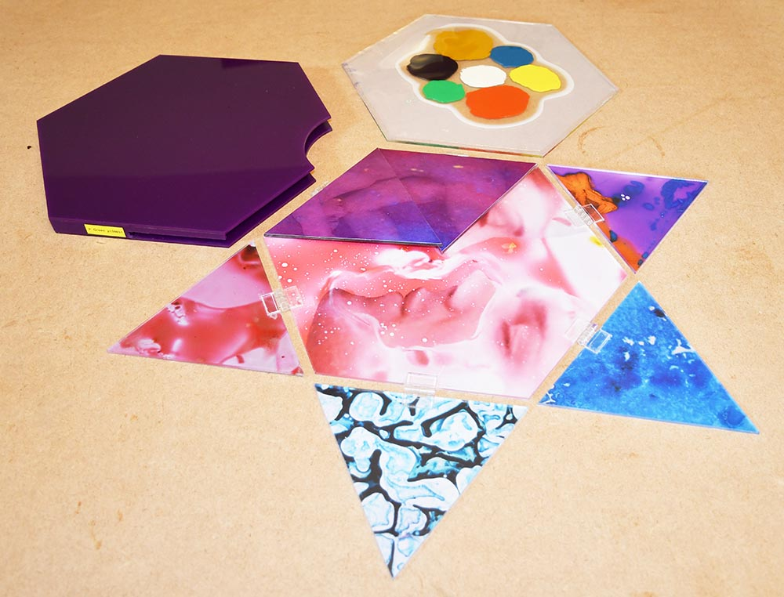
Fig. 11
Following this I continued to make abstracts using them to make my professional presentation folder and to produce work for the end of year exhibition using the hexagon shape. There was a positive reaction to my final piece (Figure 12). The intermingling of deep colours in an abstract form did evoke some strong emotions and conversations about the work. From many conversations I have had with people who have viewed my work – I feel that colour has significantly contributed to evoking emotional responses. This particular piece appears to evoke connotations of biology in some form or another – despite in reality just being paint. This goes to show that our pre-conceptions and experiences shape what we view and how we perceive.
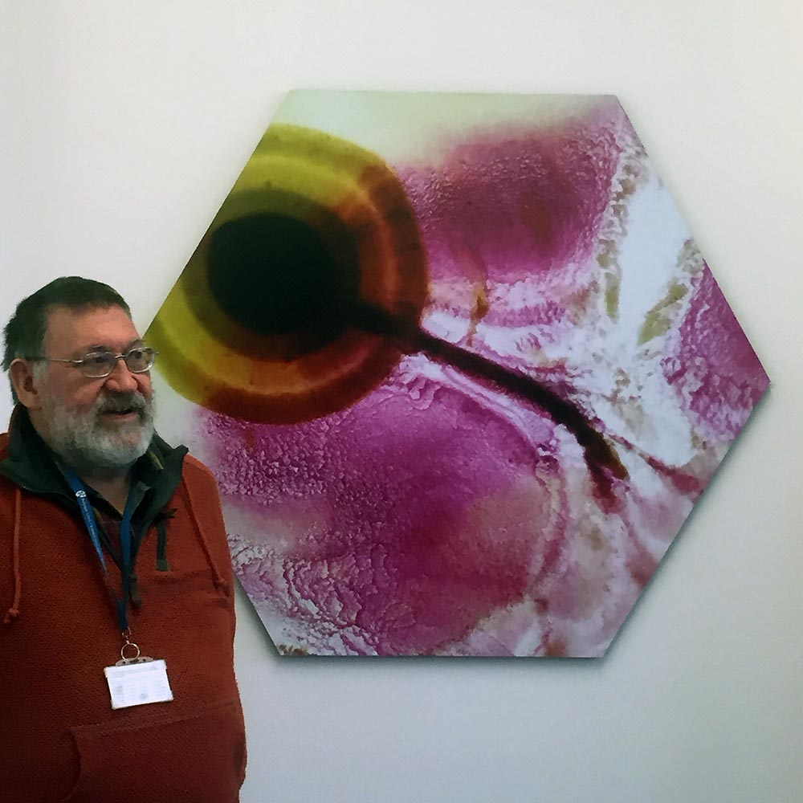
Fig. 12
Conclusion:
Throughout the course of this essay I have discussed how colour and perception are integral elements when considering our understanding and experience of The Sublime. I have also discussed how understanding the physicality and psychology behind perception is intrinsic to our understanding of how colour and The Sublime interact.
From recognising that each individual is unique in their experiences, education, personalities, age, religion, ethnicity and gender - just to name a few – I have also recognised that every individual experiences art differently. Society has enabled us to communicate using language, but due to the unique and subjective nature of perception – it can be argued that it is impossible to effectively communicate one’s ideas and experiences.
This however is not the final word on experiencing art. Shared experiences and emotions can indeed be experienced when viewing art – the most powerful and pervading of which is that of The Sublime. The Sublime as a concept manages to capture experiences of awe, fear and overwhelming amazement at what is before the viewer.
Furthermore, the use of bold colour by abstract artists such as Rothko, Riley and Kapoor connect deeply with our subconscious which brings together societal influences and personal experiences, meaning that each individual interprets the art subjectively and is more able to experience The Sublime through its observation due to the strong associations each culture makes with colour – whether it be the colour you wear to marry, or to be buried - colour means something in every culture. I therefore argue that colour is essential to our understanding, interpretation and experience of the world that we subjectively perceive and is therefore a prerequisite to our emotional responses to art, without which our responses are diminished.
Shimamura (2013) suggests art invites ‘an aesthetic and hedonistic experience’ and is different from experiencing objects from the rest of the world because someone purposefully made the art, as opposed to viewing a random object. Likewise, I further suggest that photography that merely reproduces naturally occurring phenomenon cannot evoke feelings of The Sublime because it is too prescriptive and does not allow for interpretation of emotional response.
I suggested during this essay that this subjectivity can mean that people are more or less inclined to experience The Sublime when viewing art due to viewing art in a mimetic, expressionist, formalist or conceptual way. All interpretations suggest that art is to be appreciated or to be critiqued in some way – that something is supposed to happen when you view it, even if that is just acknowledgement of the piece in terms of its physical form. I consider myself to be predominantly expressionist in how I view art due to feeling powerful emotions when viewing certain abstract works. I believe that colour is essential to The Sublime, and that unravelling the true source of sublime emotions is as complex as attempting to understand the inner workings of our subconscious.

Bibliography
Albers, J. (2013) Interaction of Colour, 50th Anniversary Edition New Haven & London, Yale University Press.
Barasch, M. (1998) Theories of Art from Impressionism to Kandinsky. New York, New York University Press
Batchelor, D. (Ed.) (2008), Colour, Documents of Contemporary Art. co-published, London, Whitechapel Gallery and Cambridge, Massachusetts, The MIT Press.
Buchanan, I. (2010) Dictionary of Critical Theory. Oxford, UK. Oxford University Press.
Cheetham, M. (1991) The Rhetoric of Purity, Essentialist Theory and the Advent of Abstract Painting. Cambridge, UK. Cambridge University Press.
Eggleston, W (2002) William Eggleston's Guide - 2nd ed New York. The Museum of Modern Art
Itten, J. (1970) The Elements of Color. New York, NY, Van Nostrand Reinhold Company, A Division of Litton Educational Publishing. Inc.
https://kimkeever.com/ (accessed 03/05/2017)
MacEvoy, B. (2015) Modern Colour Theory (Concepts)
http://handprint.com/HP/WCL/color18a.html (accessed 04/12/2017
Macey, M. (2001) Dictionary of Critical Theory. London, Penguin Group
Mackie, A. (1989) Art/Talk. Theory & Practice in Abstract Expressionism New York, Columbia University Press
Mann, J. (1994) A Gentle Introduction to Structuralism, Post Modernism, and all that. Philosophy Now Issue 10: Autumn.
Accessed: 10/12/2017 https://philosophynow.org/issues/10/A_Gentle_Introduction_to_Structuralism_Postmodernism_And_All_That
Rexer, L. (2013) The Edge of Vision - The Rise of Abstraction in Photography. New York, Aperture Foundation.
Rossotti, H. (1983) Colour, Princeton, New Jersey, Princeton University Press.
Sharp, J., Peters, J. & Howard, K. (2002) The Management of a Student Research Project - 3rd ed. Aldershot, Gower Publishing Ltd.
Shaw, P. ‘Modernism and the Sublime’, in Nigel Llewellyn and Christine Riding (eds.), The Art of the Sublime, Tate Research Publication, January 2013, https://www.tate.org.uk/art/research-publications/the-sublime/philip-shaw-modernism-and-the-sublime-r1109219, (accessed 03 May 2017)
Steiner, R. (1992) Colour, East Sussex, Rudolf Steiner Press.
Wright, A. (1995) The Beginners Guide to Colour Psychology, London, Kyle Cathie Ltd.
http://www.tate.org.uk/art/research-publications/the-sublime/what-is-the-sublime-r1109449 (accessed 09/05/2017)
http://www.tate.org.uk/art/art-terms/a/abstract-art (accessed 09/05/2017)
http://www.the-philosophy.com/edmund-burke-philosophy-summary (accessed 30/04/2017)
Zelanski, P. & Fisher M. (2006), Colour - 5th ed. New Jersey, Pearson Education Inc., USA
Surrey Nano Systems. Web site - https://www.surreynanosystems.com/vantablack (accessed 11/12/17)
https://www.xrite.com/learning/whitepapers/a-guide-to-understanding-color

