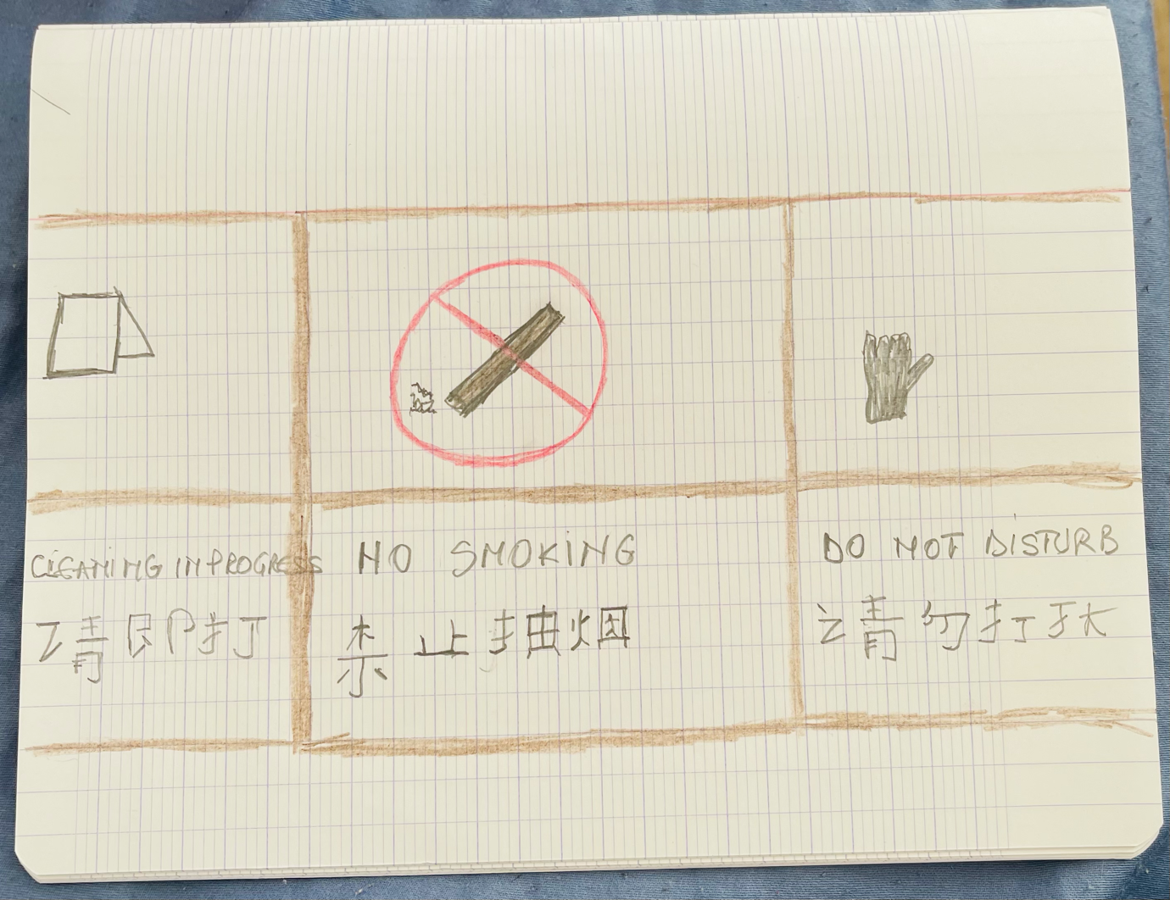

Name : Corina Iordan
Student Id:2021277
Lecturer: Jinping Li

