University of Wales Trinity saint Davis

Problem solving and decision making
BMSK 4004
Problem Solving and Decision Making
Maureen Graham/1818267

Workplace Problem
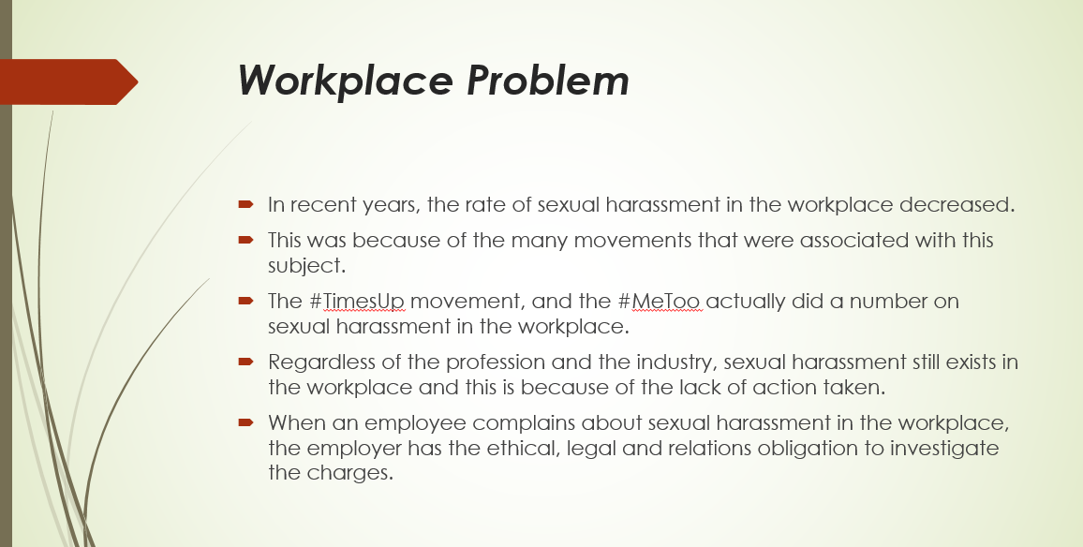

A major problem in the workplace that could arise is related to sexual harassment. Sexual harassment is a subject that does not get talked about often. It is completely undermined and not given enough attention. In recent years, the rate of sexual harassment in the workplace decreased. This was because of the many movements that were associated with this subject. The #TimesUp movement, and the #MeToo actually did a number on sexual harassment in the workplace. Regardless of the profession and the industry, sexual harassment still exists in the workplace and this is because of the lack of action taken. When an employee complains about sexual harassment in the workplace, the employer has the ethical, legal and relations obligation to investigate the charges. This is a major problem that may arise in the workplace. In fact, it is important to understand the severity of this situation.
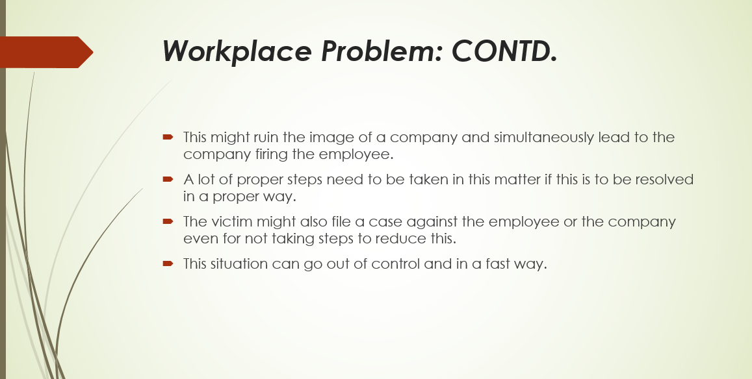

Sexual harassment may lead to a person’s life being ruined. It is a mental form of abuse which may haunt a person forever. This might ruin the image of a company and simultaneously lead to the company firing the employee. A lot of proper steps need to be taken in this matter if this is to be resolved in a proper way. The victim might also file a case against the employee or the company even for not taking steps to reduce this. This situation can go out of control and in a fast way. Thus, here the proper tools and techniques, strategies and decisions need to be used and made in order to keep a workplace decorum. The last thing that the company needs are sexual harassment allegations. The people caught with this at need to be penalized in a right manner.

Information on the Problem
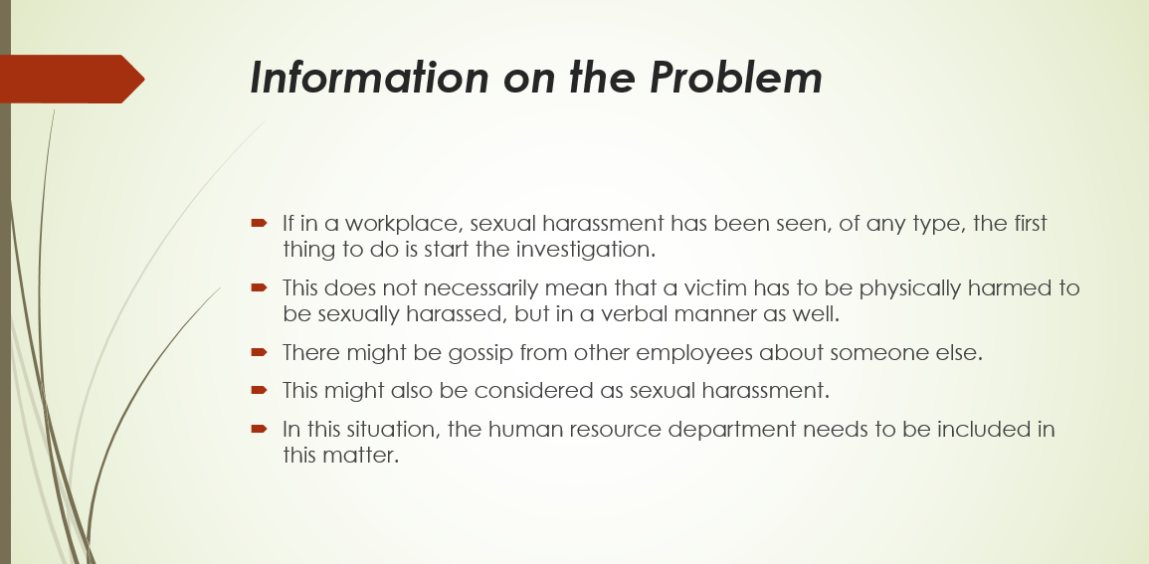

A proper decision needs to be made in this aspect. Sexual harassment is a non-negligible offence where if this is done in a severe manner, then this cannot be ignored. If in a workplace, sexual harassment has been seen, of any type, the first thing to do is start the investigation. This does not necessarily mean that a victim has to be physically harmed to be sexually harassed, but in a verbal manner as well. There might be gossip from other employees about someone else. This might also be considered as sexual harassment. In this situation, the human resource department needs to be included in this matter. In most sexual harassment cases, there are victims who feel embarrassed to come forward. This image needs to be removed from the workplace.
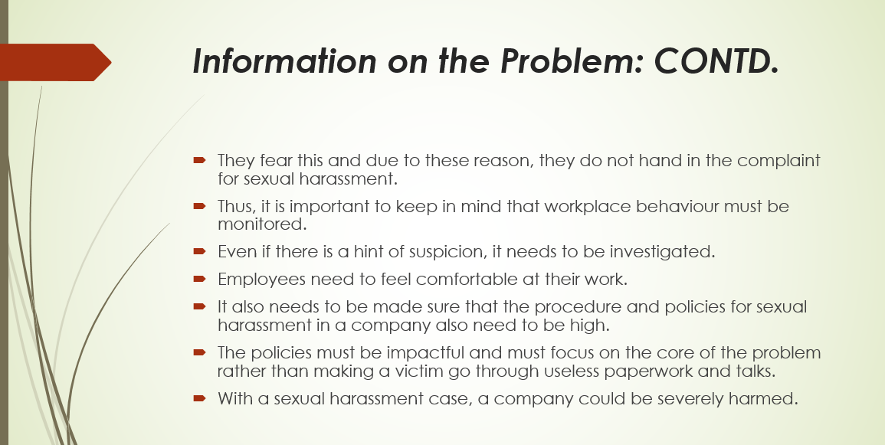

The fact of the matter is that, when a person comes forward as being sexually harassed, they are seen to be weak and lose their respect in the workplace. They fear this and due to these reason, they do not hand in the complaint for sexual harassment. Thus, it is important to keep in mind that workplace behaviour must be monitored. Even if there is a hint of suspicion, it needs to be investigated. Employees need to feel comfortable at their work. It also needs to be made sure that the procedure and policies for sexual harassment in a company also need to be high. The policies must be impactful and must focus on the core of the problem rather than making a victim go through useless paperwork and talks. With a sexual harassment case, a company could be severely harmed. Hiring workers who engage in these practices, would be a bad sign for the company. This would make clients and customers question the authenticity of the company’s workers, which could be bad for them.

Solutions to the Problem
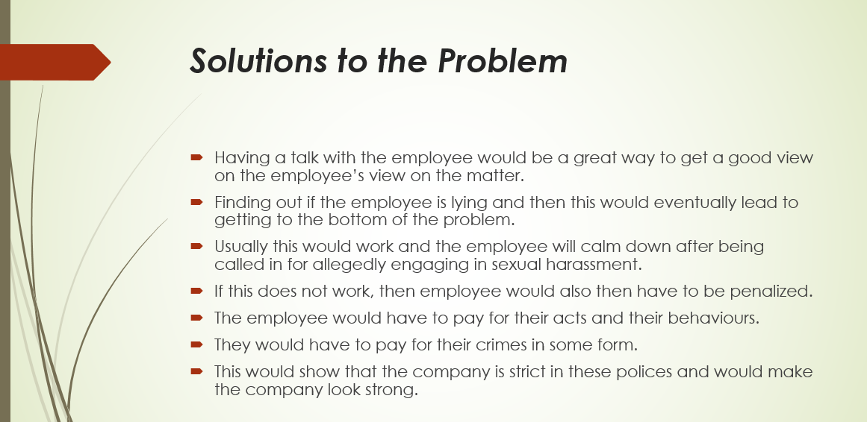

The first thing that needs to be done in this situation is to have a talk with the employee. Having a talk with the employee would be a great way to get a good view on the employee’s view on the matter. Finding out if the employee is lying and then this would eventually lead to getting to the bottom of the problem. Usually this would work and the employee will calm down after being called in for allegedly engaging in sexual harassment. If this does not work, then employee would also then have to be penalized. The employee would have to pay for their acts and their behaviours. They would have to pay for their crimes in some form. This would show that the company is strict in these polices and would make the company look strong. For instance, taking away the employee’s vacation days would be a viable option or to implement the strike system.
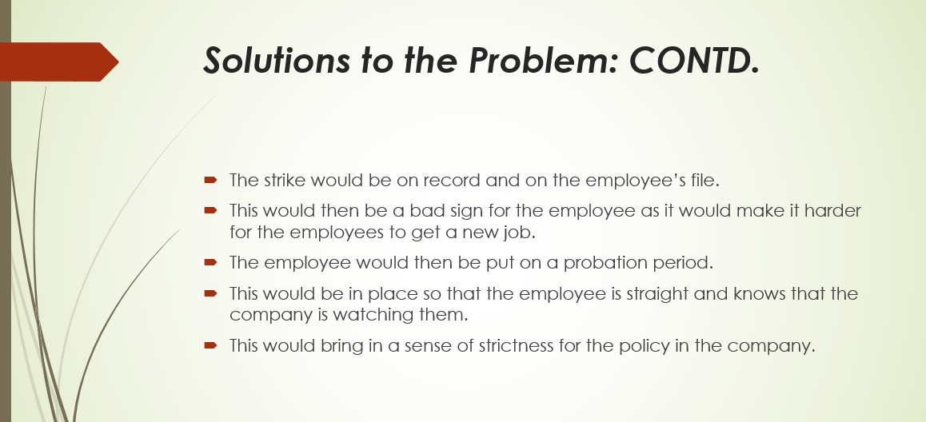

The strike would be on record and on the employee’s file. This would then be a bad sign for the employee as it would make it harder for the employees to get a new job. The employee would then be put on a probation period. This would be in place so that the employee is straight and knows that the company is watching them. This would bring in a sense of strictness for the policy in the company. An all employee meeting should be set here as well. This should be done to then work with the human resource department and give a mandatory meeting on the effects of sexual harassment. Every employee would be expected to be included in this and learn from the teachings.

Decision Making Technique
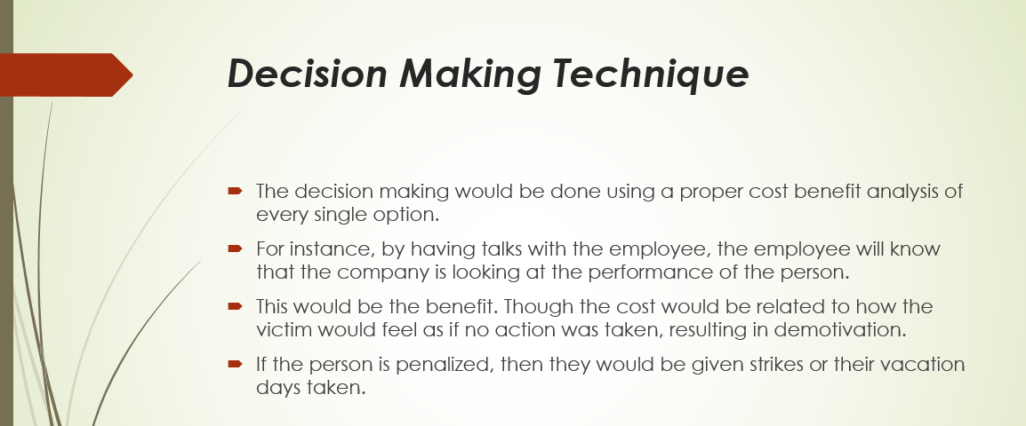

A structured decision making strategy would be implemented in this case. The process of proper structural analysis will be done. The decision making would be done using a proper cost benefit analysis of every single option. For instance, by having talks with the employee, the employee will know that the company is looking at the performance of the person. This would be the benefit. Though the cost would be related to how the victim would feel as if no action was taken, resulting in demotivation. If the person is penalized, then they would be given strikes or their vacation days taken.
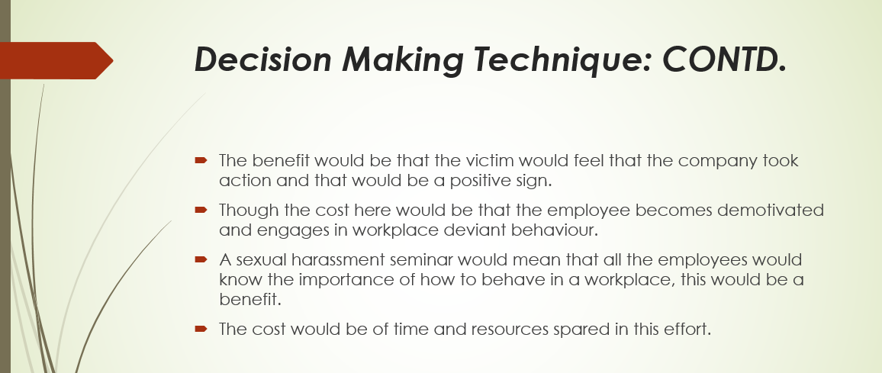

The benefit would be that the victim would feel that the company took action and that would be a positive sign. Though the cost here would be that the employee becomes demotivated and engages in workplace deviant behaviour. A sexual harassment seminar would mean that all the employees would know the importance of how to behave in a workplace, this would be a benefit. The cost would be of time and resources spared in this effort. Then, if the employee is put on probation, the benefit would be that the employee will be vigilant and do a good job, better than before. The cost would be that the victim would not feel comfortable with no action taken. Therefore, the best option here is to penalize the employee and hold sexual harassment seminar to show that the company has a strict policy.

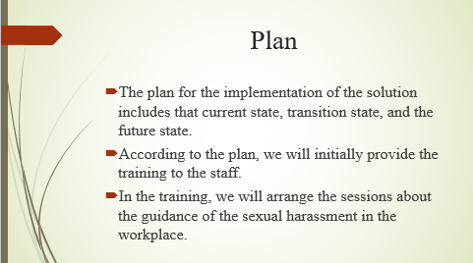

Plan for the implementation of the solution
Training of the staff
this step, we are discussing about the plan for implementation the solutions which we have recognized to overcome the issue of the sexual harassment. The first solution which we have thought is that we should train our staff members about what is the sexual harassment. So, the implementation of this solution can be done in a way if we start arranging a training session in our organization. And In those training, we should try to teach our employees about what is the sexual harassment, providing them details about to treat each other in a work place. These sessions should that how we should talk each other and other workplace manners. This session must include information about the punishment of the shameful act so that one must thing before committing it. Then the next step is the counselling of the guilty man. The manager of an organization first tries to talk him in front of the victim about the act so that he can know about the truth. Once knowing about the act manager should try to counsel an employ by talking to him and asking why he has committed this or what was his intention?
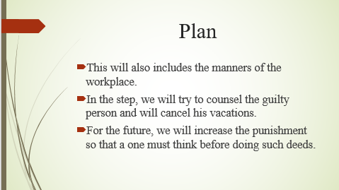
The solution which we have though is the vacation cancelling so how this solution can be implemented. It is necessary for every organization to introduce the police which must contain details about the consequences of such act. A man who has committed this act should not be allowed to have holidays or vacations; his all vacations should be cancelled and his must be provided with a lot of extra work as a punishment of his deeds. The future act against such activity will be very strict as compared to the one which are implementing. In the future, the punishment of the sexual harassment will be increased by doubled because this is not less than a crime. The manager of the firm should announce this punishment to a person who is the responsible for at least for 6 months such as a person will go into the probation or he will be executed from the firm.

Communicate plan to the stakeholder
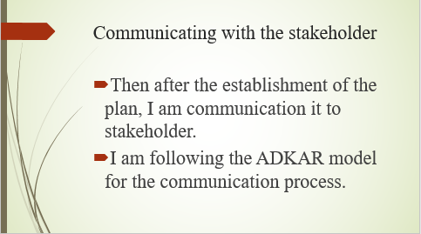

The stakeholders are the main components in every workplace. So, it is very necessary to discuss everything them. I am using the using the ADKAR model to communicate with the stakeholder. This model is the most beneficial it will help me in communicating my plan easily. There are some steps which should be taken before communication the plan to the stakeholder. Number one is that I will aware all of my staff members about the issue and the current condition of the plan.

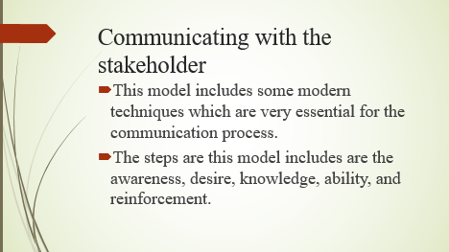
Then after analyzing the condition I will tell them we are doing this because the incident which has occurred in our firm in not small or negligible, it should be resolved. The I will analyze the stakeholder whether he wants to listen or not? The best way to communication such kind of the issue is that we will be discussed this by sitting in front. The face to face communication is very effective. In the communication I will tell the stakeholder about the current condition of the firm, that how a man has harassed a woman in our workplace. After telling this I will tell him about the plan which I have prepared, I will also tell him what this plan includes what will be punishment. Then after telling the stakeholder all this I will ask him about his opinions if he wants to add or remove anything from the plan. Then I will further ask the stakeholder about the date or the day from which he wants me to start the implementation this plan.

Techniques for the implementation of the plan

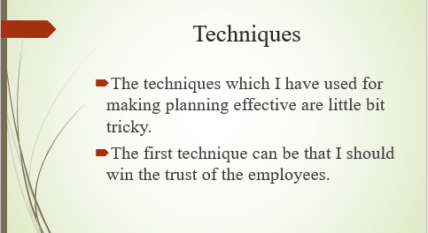

The plan which we have developed for the application of the solutions which are related to the very serious issue, sexual harassing. The implementation of the plan is difficult task, because before beginning the procedure of the implementation you have to go through a lot of the difficulties but here are some techniques which can be used for implementation of the plan. The techniques which can be utilized for the implementation of the plan are that first of all we should ensure that the plan which we have developed is effective enough or not for its implementation.
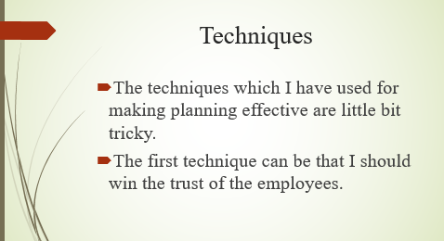
The second technique can be that you should check that the staff members are agreed with your plan and also ask them if they want to introduces any other thing in the plan. Another technique for the powerful implementation of the plan is that you can ask your stakeholders to support you in your in standing against the shameful act. The technique you can use is that you can keep the environment of the workplace strict so that every must have to obey your decisions and your plans. These were the same techniques which we can utilize in making our implementation plan successful.

References

Adair, J. (2013) Decision making and problem solving strategies. 2nd edn. London: Kogan Page.
Conte, A., 2010. Sexual Harassment in the Workplace: Sexuality, social relations, and the workplace (Vol. 1). Aspen Publishers Online.
Hersch, J., 2015. Sexual harassment in the workplace. IZA world of Labor.
Hunt, C.M., Davidson, M.J., Fielden, S.L. and Hoel, H., 2010. Reviewing sexual harassment in the workplace–an intervention model. Personnel Review.
Mainiero, L.A. and Jones, K.J., 2013. Sexual harassment versus workplace romance: Social media spillover and textual harassment in the workplace. Academy of Management Perspectives, 27(3), pp.187-203.
Maund, A. Schriek, M. and Tinkler, P. (2017). Certificate in Higher Education: Skills for the Workplace Student Yearbook. Sage Publications
McGinley, M., Richman, J.A. and Rospenda, K.M., 2011. Duration of sexual harassment and generalized harassment in the workplace over ten years: Effects on deleterious drinking outcomes. Journal of addictive diseases, 30(3), pp.229-242.
Morgan, P. (2016). The Business Student’s Guide to Study and Employability. Sage Publications
Pizlo, Z. (2012) ‘Human problem solving in 2010’, The Journal of Problem Solving, 4(1). doi: 10.7771/1932-6246.1120.
Schneider, K.T., Pryor, J.B. and Fitzgerald, L.F., 2010. Sexual harassment research in the United States. In Bullying and Harassment in the Workplace (pp. 261-282). CRC Press.
Valiente, C., 2013. Sexual harassment in the workplace: Equality policies in post-authoritarian Spain. In Politics of Sexuality (pp. 185-195). Routledge.

