BMIH50074 Financial Management for the Hotel Industry

STUDENT NAME:Adriana Alexandra Birsan
STUDENT NUMBER:2118849

Table of Contents
Introduction 3
Overview of Hilton Hotels & Resorts 3
Revenue 3
Market Position 4
Potential 4
Corporate social responsibility 6
Recommendations 7
Overview of Marriott International Hotels and Resorts 7
Revenue 8
Market Position 9
Potential 9
Corporate social responsibility of Marriott International Hotels and Resorts 10
Recommendations 10
Conclusion 11
References 12

List of figures:
Figure 1: Revenue of Hilton Hotels and Resorts 4
Figure 2: Growth and Development of Hilton Hotels & Resortsl 6
Figure 3: ESG Plan of Hilton 7
Figure 4: Revenue of Marriott Hotels and Resorts from 2001-2023 8

Introduction
The management of a company's financial resources referred to as financial management for the hotel or hospitality sector. The goal of financial management is to guarantee that a company has enough money to pay its bills and earn the highest possible profit from its investments. Making smart economic judgements necessitates efficiently allocating resources, controlling expenses without cutting into profits, and assessing relevant data. Hilton Hotels & Resorts and Marriott International Hotels & Resorts are the two hotels selected for this project. Both of these properties are part of two of the largest and best-known hotel brands in the world. Both have established themselves internationally. They both are providing a comprehensive array of amenities to their respective customer base. This analysis will examine the two hotels head-to-head, contrasting their overall revenues, market shares, expansion prospects, and suggested improvements.

Overview of Hilton Hotels & Resorts
Hilton Hotels & Resorts is one of the most recognizable names in the hospitality industry due to the chain of hotels and resorts it manages. The company, which began in 1919, has expanded to more than 5,400 locations in 118 countries and territories since its start. The personnel of Hilton Hotels & Resorts are experts in their fields and provide guests with a wide range of amenities‌ (Hilton.com, 2023). Everything from plush rooms to gourmet dining is available at The Hilton to make your stay as restful and enjoyable as possible.

Revenue
Revenue is the total amount of money received by a company from the sale of products or services and any other use of capital or assets connected to the company's principal activity before deducting any costs or expenses. According to Forbes, Hilton Hotels generated $10.39 billion in revenue in 2019, and $9.7 billion in sales in 2021 (statista.com, 2022). The Covid-19 epidemic has caused a considerable drop in income for the organization.
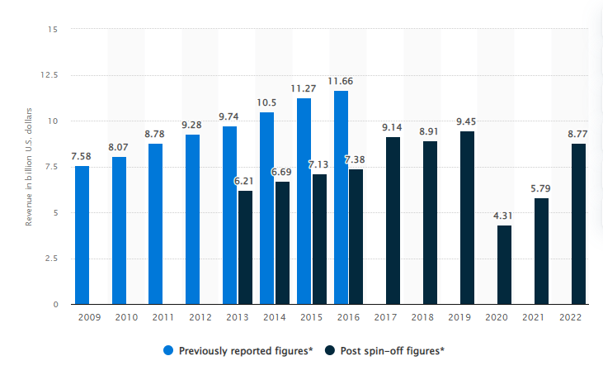
Figure 1: Revenue of Hilton Hotels and Resorts
Source: (statista.com, 2022)

Market Position
Hilton Hotels and Resorts is unquestionably a major participant in the global hotel industry. It is the second largest hotel chain in the world (after Marriott International) and the largest in the United States. In addition, thanks to their consistently high standards, Hilton Hotels & Resorts has earned a reputation as the unrivalled leader in the luxury hospitality sector. Hilton is expanding into new, fast-growing markets including those in Africa and South America to cement its market position. Hilton Hotels and Resorts estimate the global hotel industry to control by about 8%. When compared to other hotel chains, it is the largest in the United States and the second largest overall (Dudovski, 2016). Hilton Hotels & Resorts is unparalleled in the luxury hospitality industry.

Potential
One of the largest and most profitable hotel chains is Hilton Hotels and Resorts. Its widespread presence (5,500 locations in 110 countries) and loyal client base are major contributors to the company's high profile across the world (McNeill and McNamara, 2021). The business has flourished in recent years, and its rapid growth shows no signs of slowing down. The company's goal is to expand its portfolio to include over a thousand hotels by 2025. The company provides a number of services to its clientele, such as high-end lodgings, event halls, and dining establishments (finance.yahoo.com, 2018).
The company has also built a strong customer loyalty program, which rewards loyal consumers with special benefits for their continued patronage. In addition, the organization has made substantial technological advancements that enable guests to book and control their stays online. The future looks bright for the Hilton Hotel chain. When the company sets up shop in more and more places throughout the world, it will attract a larger clientele. The company's loyalty program and its investments in technology will both contribute to the company's growth. As the hospitality industry continues to develop, Hilton Hotels & Resorts positioned to take advantage of emerging possibilities (Arghandewal, 2023). Since people in the middle class are in the process of relocating, the hotel has set its prices to appeal to this demographic.
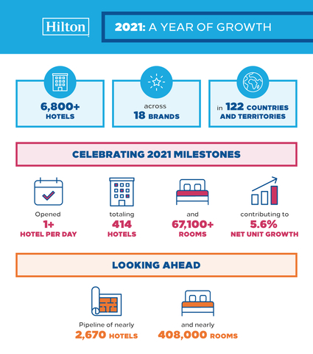
Figure 2: Growth and Development of Hilton Hotels & Resorts
Source: (Businesswire.com, 2022)

Corporate social responsibility
The Hilton brand of hotels is committed to sustainability and social justice. The company has allocated $3.75 million to Travel with Purpose initiatives that aim to address critical socioeconomic and environmental issues by 2020. The goals of these initiatives include reducing energy and water use, bolstering local communities, promoting ethical shopping, and increasing access to opportunity for individuals of all origins and viewpoints (Hgv.com, 2022). Since the Hilton Foundation's inception in 1999, the hotel business has donated more than $20 million to various charitable causes (Rw, 2018). This foundation gives grants to worthy organizations that are striving to improve the lives of children, families, and communities by reducing poverty and hunger, expanding access to quality education, and other means (Noonan and Rankin, 2022). Hilton's ESG strategy depicted in the following diagram:

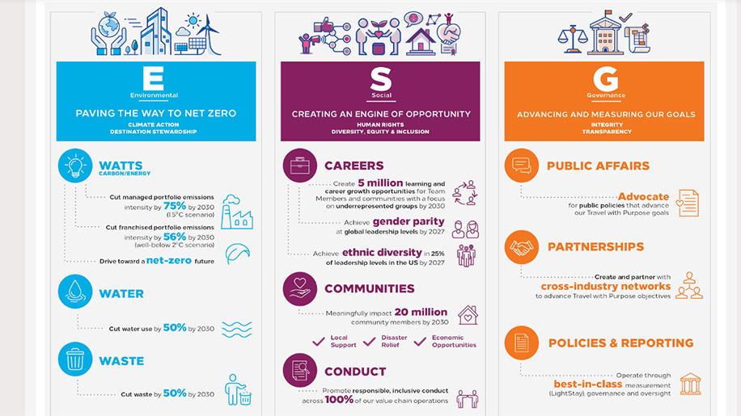
Figure 3: ESG Plan of Hilton
Source: (businesstraveller.com, 2017)

Recommendations
Considering more and more tourists are interested in visiting emerging nations, the hotel should broaden its customer base to include those continents. Businesses interested in growth pursue a strategy of "market development," in which they introduce their existing product or service to new markets. The corporation will not pursue other strategies like product innovation or diversification that might damage the hotel's reputation.

Overview of Marriott International Hotels and Resorts
Marriott International Hotels & Resorts is a global hospitality company that maintains and franchisees a broad variety of hotels and other housing facilities related to travel and tourism. It headquartered in Bethesda, Maryland (USA), and owns over 6,300 properties situated in 131 different countries and territories. Marriott has 30 different hotel brands, each aimed at a different demographic, from business travelers to vacationers (marriott.com, 2014). Its namesake Marriott Hotels & Resorts brand sits alongside the more luxury Ritz-Carlton and W Hotels, as well as the more affordable Fairfield Inn & Suites.

Revenue
Total revenues for Marriott International came in at over $17.9 billion in 2019, up slightly from 2018's total revenues of around $17.3 billion. Because of the disastrous impacts of the Covid-19 epidemic, the company's entire sales dropped in 2020 and 2021. Overall revenue for the company increased to $11.36 billion in 2021 from $9.31 billion in 2020. Hilton Hotels, on the other hand, was doing rather well. High operating expenditures and other expenses hindered the company's performance (Companiesmarketcap.com, 2023). Hilton Worldwide Holdings' operating expenses in 2021 were $4.778 billion, an increase of 1.12% over the previous year.
According to macrotrends.net (2020), Marriott spent $12.107B on operations in 2021, an increase of 15.45 percent over the previous year.

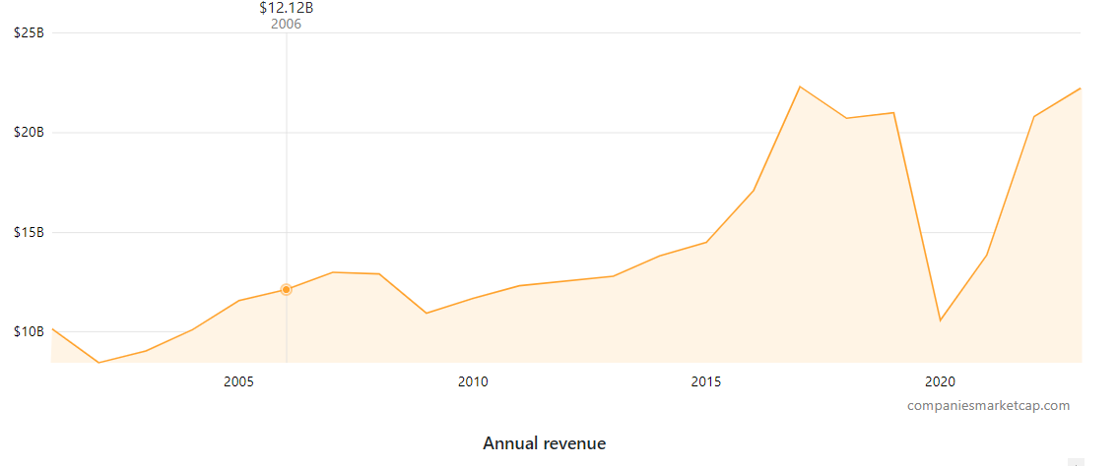
Figure 4: Revenue of Marriott Hotels and Resorts from 2001-2023
Source: (Companiesmarketcap.com, 2023)

Market Position
Marriott International belongs to one of the most prominent hotel chains in the world, operating more than 7,400 hotels and resorts in over 130 countries and territories. The company has carved itself a niche as a market leader in the luxury hotel sector and is now branching out into the midrange and budget segments (Csimarket.com, 2022). In terms of hotel rooms, Marriott International ranked fourth among the world's largest hotel companies in 2019, while in terms of hotel revenue, it ranked eighth. When it comes to the number of hotels it operates and the variety of brands it offers, no other company can compare to Marriott International.
The array of brands offered by Marriott International is unrivalled, with options for every type of traveler and every kind of budget. The company's portfolio includes such illustrious hotel names as The Ritz-Carlton, JW Marriott, Marriott Hotels, and Embassy Suites. Marriott International also manages the non-hotel Marriott Vacation Club and the extended-stay Marriott Executive Apartments. Clientele growth attributed to the Marriott Bonvoy customer reward program (Companiesmarketcap.com, 2023). The hotel industry's growing recognition of Marriott International has contributed to the company's rising market share.

Potential
Marriott International Hotels and Resorts, among of the globe's largest hotel companies, operates over five thousand hotels and resorts across over thirty different nations. Marriott International has approximately 6,700 hotels and resorts in 127 countries and territories, giving visitors a broad variety of alternatives. The company runs hotels under the Marriott, Sheraton, Renaissance, and Ritz-Carlton names, among others. There is a lot of potential for growth at Marriott International. The company has a rich history of achievement, a large and loyal client base, a global reach, and a diverse range of successful brands.
Marriott International has a number of options for future growth. Especially in emerging markets, the company's brand portfolio is expanding. To better meet the needs of its customers, the company is also making investments in cutting-edge technology and service offerings. Marriott has been highlighting the use of artificial intelligence and data analytics as part of its attempts to digitalize its operations. In 2021, Marriott anticipates spending $564.2M on information technology and other costs. The company plans to keep investing in research and development (Nicholls and Nicholls, 2023). The vast majority of this sum will spent on third-party providers of ICT services, such as computers, networks, and communication devices.
Additionally, Marriott International is investing in growing economies like China and India. Marriott International is finally making use of its global footprint to attract a wider range of customers and increase its market share.

Corporate social responsibility of Marriott International Hotels and Resorts
By investing heavily in the company's CSR initiatives, the Marriott International Hotels & Resorts brand has demonstrated its dedication to corporate social responsibility. By 2025, Marriott plans to invest more than $2 billion on these initiatives. These funds will use to advance many different goals, such as economic expansion, social cohesion, public health, and environmental responsibility. The company has also promised to get all of its energy from renewable sources by 2025, and cut its carbon output by 30% by 2030. Additionally, over the next five years, Marriott has committed to investing $50 million in local communities throughout the world, with an emphasis on addressing societal and environmental issues (Deale, 2022). To sum up, Marriott has pledged $5 million to its global education project, which aims to empower youth and expand access to education in underserved regions throughout the world.

Recommendations
If the cost of year-round staffing at the Marriott International hotel is too high, then perhaps some of the hotel's services and activities should be outsourced. In the end, this will reduce their operational costs and save them money. The hotel's running costs will go down and its revenue will go up as a result. It is possible that if Marriott International outsourced some of its non-core operations, it might better focus on its core competencies and provide better service to its customers. Artificial intelligence (AI) and big data are two technologies that might help Marriott International streamline its operations. This would help them save money and provide better service to their customers.

Conclusion
In conclusion, both Hilton Hotels & Resorts and Marriott International Hotels & Resorts enjoy widespread recognition and acclaim among travelers and the hospitality industry at large. They both attract many people from all over the world and offer a broad variety of services to those who visit. We examined the two hotels' CSR budgets, CSR initiatives, growth projections, and expert opinions. Hilton Hotels & Resorts reported $9.7 billion in sales in 2019, while Marriott International Hotels & Resorts reported $17.9 billion. Hilton Hotels & Resorts, in contrast to Marriott International Properties & Resorts' extensive portfolio of brands and ubiquitous presence across the world, is primed for expansion; the company plans to add more than a thousand hotels to its roster by 2020. These hotels have made substantial contributions to CSR program and been offered helpful feedback. As a result, both Hilton Hotels & Resorts and Marriott International Hotels & Resorts have promising prospects for expansion and continued success

References
‌Arghandewal, A. (2023). Everything you need to know about the Hilton Honors rewards program | CNN Underscored. [online] CNN Underscored. Available at: https://edition.cnn.com/cnn-underscored/travel/hilton-honors-ultimate-guide [Accessed 21 May 2023].
‌businesstraveller.com (2017). How sustainable is Hilton? – Business Traveller. [online] Business Traveller. Available at: https://www.businesstraveller.com/features/how-sustainable-is-hilton/ [Accessed 21 May 2023].
‌Businesswire.com. (2022). Hilton Celebrates Growth and Development Milestones as Company Prepares for a New, Reinvigorated Era of Travel. [online] Available at: https://www.businesswire.com/news/home/20220121005394/en/Hilton-Celebrates-Growth-and-Development-Milestones-as-Company-Prepares-for-a-New-Reinvigorated-Era-of-Travel [Accessed 21 May 2023].
‌Companiesmarketcap.com. (2023). Marriott International (MAR) - Market capitalization. [online] Available at: https://companiesmarketcap.com/marriott-international/marketcap/#:~:text=Market%20cap%3A%20%2454.12%20Billion,market%20cap%20of%20%2454.12%20Billion. [Accessed 21 May 2023].
‌Companiesmarketcap.com. (2023). Marriott International (MAR) - Revenue. [online] Available at: https://companiesmarketcap.com/marriott-international/revenue/ [Accessed 21 May 2023].
‌Companiesmarketcap.com. (2023). Marriott International (MAR) - Revenue. [online] Available at: https://companiesmarketcap.com/marriott-international/revenue/ [Accessed 21 May 2023].
‌Csimarket.com. (2022). Marriott International Inc Comparisons to its Competitors and Market Share - CSIMarket. [online] Available at: https://csimarket.com/stocks/compet_glance.php?code=MAR [Accessed 21 May 2023].
‌Deale, C. (2022). 8 Corporate Social Responsibility and the Sustainable Tourism Practices of Marriott International Synopsis and Learning Outcomes. [online] Available at: https://www.goodfellowpublishers.com/free_files/Corporate%20Social%20Responsibility%20and%20the%20Sustainable%20Tourism%20Practices%20of%20Marriott%20International%20-%20sample%20pages-6143e9b61b2e04de3cd3b89d66ed3b05.pdf.
‌Dudovski, J. (2016). Hilton Hotels Segmentation, Targeting and Positioning - Research-Methodology. [online] Research-Methodology. Available at: https://research-methodology.net/hilton-hotels-segmentation/ [Accessed 21 May 2023].
‌finance.yahoo.com (2018). Hilton’s market share in the domestic and international market. [online] Yahoo Finance. Available at: https://finance.yahoo.com/news/hilton-market-share-domestic-international-172011000.html?guccounter=1&guce_referrer=aHR0cHM6Ly93d3cuZ29vZ2xlLmNvbS8&guce_referrer_sig=AQAAAHiuj44zFtz4tr1cnGdT5XshpGKPiiG49MSMp_rnJx1CFKb0SDzvwI6lA0EhqapZtzENCjegJ-fZddOKRA6JihiiaUXSPOsYgk8aaJ-nzZRgr3JTZqVs1kqkTee12QpLp5bnJmIAw5g6_fRsJZd-P3QAC9JujDK9Ew5f54GS-yCL#:~:text=Leading%20position%20in%20the%20U.S.,share%20of%20~10%25%20each. [Accessed 21 May 2023].
‌Hgv.com. (2022). Hilton Grand Vacations - Corporate Social Responsibility - Overview. [online] Available at: https://corporate.hgv.com/corporate-social-responsibility/overview/ [Accessed 21 May 2023].
Hilton.com. (2023). Hotels by Hilton - Book the Best Rates Across All Brands. [online] Available at: https://www.hilton.com/en/ [Accessed 21 May 2023].
‌marriott.com (2014). Resorts Worldwide | Marriott Resort Hotel Destinations. [online] Marriott International. Available at: https://www.marriott.com/travel-experience/resort-hotels/ [Accessed 21 May 2023].
‌Nicholls, C. and Nicholls, C. (2023). International and luxury sites drive Marriott growth. [online] THP News. Available at: https://tophotel.news/international-and-luxury-sites-drive-marriott-growth/#:~:text=Growth%20acceleration,of%20between%204%20and%204.5%25. [Accessed 21 May 2023].
‌Noonan, A. and Rankin, C. (2022). 5 Journal of Hospitality & Tourism Cases case study. [online] Available at: https://www.chrie.org/assets/docs/JHTC-case-notes/JHTC-vol-5/JHTC_Vol5Issue4_Noonan_case.pdf.
‌Rw, U. (2018). Hilton Worldwide CSR Actions: Education – Awareness , Funds, in kind donations – Tourism for SDGs. [online] Tourism4sdgs.org. Available at: https://tourism4sdgs.org/company_csr/hilton-worldwide-csr-actions-education-awareness-funds-in-kind-donations/ [Accessed 21 May 2023].
statista.com (2022). Hilton Worldwide revenue 2022 | Statista. [online] Statista. Available at: https://www.statista.com/statistics/297760/revenue-of-hilton-worldwide-holdings-inc/#:~:text=International%20hotel%20company%20Hilton%20Worldwide,year's%20total%20of%205.79%20billion. [Accessed 21 May 2023].
‌ststista.com (2022). Marriott revenue worldwide 2022 | Statista. [online] Statista. Available at: https://www.statista.com/statistics/266279/revenue-of-the-marriott-international-inc-hotel-chain/ [Accessed 21 May 2023].

