Contents

Executive Summary 2
Introduction 3
UK Context 3
Global Context 3
Current Environmental Forces 5
Politically 5
Economically 5
Socially 9
Technologically 9
Environmentally 10
Legally 10
New Entrants to the Industry 11
Buyer Power 11
Threat of Substitute Products 11
Supplier Power 12
Industry Competition 12
SWOT Analysis 14
Conclusion 15
Recommendations 16

Executive Summary

Tata Steel UK (TSUK) is a trusted and reputable company; synonymous in Wales for the Port Talbot steelworks, especially as they now reach the end of an era. Like all UK steelmakers, the company has faced challenges over the last 20 years and are about to face their biggest yet – decarbonisation to greener steelmaking - in a climate marred by excess supply and protectionism, all as a loss-making business.
This report seeks to critically assess current environmental forces acting on TSUK and in identifying and analysing these factors, discuss the actual and potential implications.
It has found that whilst TSUK continues to hold a dominant position in the domestic steel industry due to their unique selling point (USP) of being UK based, and supplying UK automotive manufacturers with hot rolled coil products, the company’s survival is at stake. This is because of globalisation, increasing operating costs, excess supply, and a lack of demand by customers due to a downturn in purchases by end consumers.
In reflecting on the actual and potential impact for TSUK, recommendations have been proposed as to how TSUK can recover its position in the market, domestic industry and globally by:
- Focusing its efforts on supplier power as the transition to the electric arc furnace begins
- Lobby the UK government for continued state support with energy costs
- Consider future-proofing automotive customer orders
Forces currently impacting TSUK are not unique to TSUK but also impacting other domestic steelmakers and the global industry. However, as TSUK prioritises the sustainability of steelmaking in its move to an electric arc furnace, there needs to remain a focus on sustainability across all other aspects of the business also; strategically positioning in readiness for any recovery of the steel industry.

Introduction

Tata Steel UK (TSUK) is one of the biggest companies of iron and steel manufacturing in the UK (Guerrero, 2024). TSUK sites supplies almost half of UK carmakers’ flat steel requirements and has supplied the steel for nearly all copper and silver UK coins in circulation (UK Steel, 2023). However, after more than a century, TSUK is to undergo a substantial change in its operations in pursuit of survival.

UK Context
The British steel industry has been declining for nearly half a century. Deindustrialisation has seen manufacturing output decrease significantly. “Manufacturing output from the UK as a share of real GDP fell from 33% in 1970 to 17.5% in 2018 (in contrast to services, which accounted for 71%)” (Griffin and Hammond, 2021). The reduction in manufacturing output can be attributed to many factors:

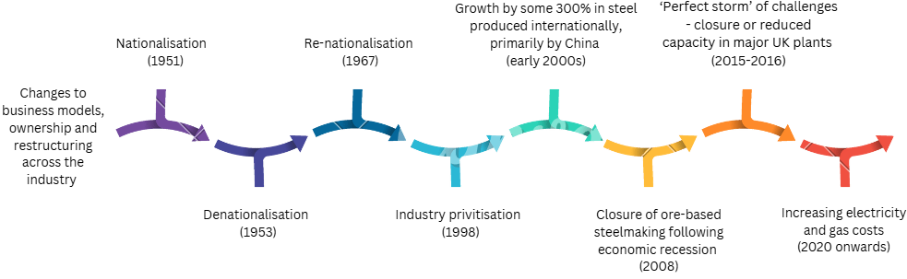
(Griffin and Hammond, 2021, presented as infographic)

Global Context
Globalisation has not only seen the growth in international trade but also the growth of powerful companies. In the early 2000s, China used export as an entry mode to internationalisation. Enabled by globalisation, they have become a large and powerful global competitor for steel; a major player in the global steelmaking arena as “the government provides subsidies to companies in sectors deemed to be strategic by the government” (Mercier and Giua, 2023). This has given them an unfair advantage and has led to them selling (and dumping) cheap steel around the rest of the world. In 2016, the European Commission launched an inquiry into the subsidies supporting Chinese steel, following a submission from the European Steel Association (Eurofer). The submission, backed by credible evidence, outlined that China was able to export at prices that were detrimental to European steel companies and as countries like the US had already clamped down on these practices, the European market would suffer as a result (Farrell, 2016). This has meant TSUK (as well as other global companies) has seen excess supply, weak profits, and longer-term instability in the industry because of China’s dominant practices.

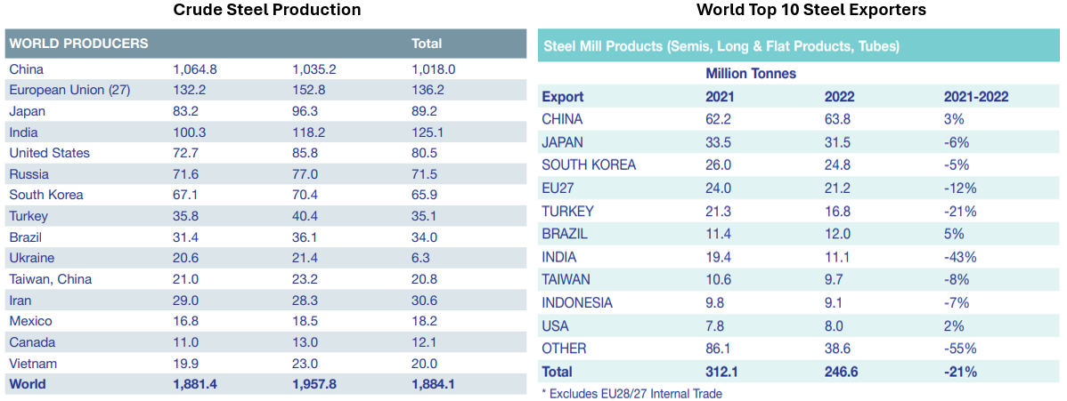
Source: UK Steel Stats Guide 2023

Current Environmental Forces

There are several external factors and influences currently challenging TSUK, as demonstrated through the PESTEL model:
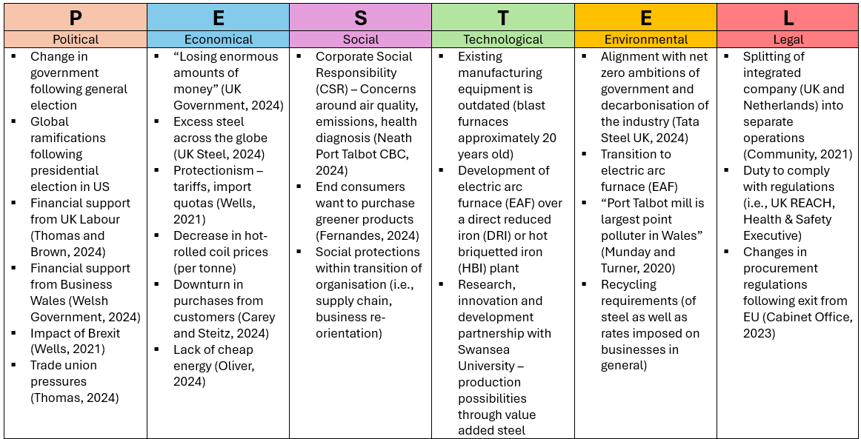
Politically, whilst the support from the UK Government (£500m) and Business Wales (£13.5m) is supporting TSUK’s transition to the EAF, the UK’s exit from the EU has continued to leave TSUK in a negative financial position. Munday and Turner (2020) acknowledged the increase in tariffs and quotas as a result of Brexit causing a concern for TSUK. Geels and Gregory (2023) also outlined that “international competitiveness and exports were hampered by the UK’s 2016 Brexit decision, which increased trade frictions with the EU, which was the steel industry's biggest export market”. In addition, with the current EU safeguards in place on imported steel, intended to protect the market from the inflow of metals diverted from the US under the 2016 Trump administration, this has led to costly tariffs for TSUK (Jozepa, 2024).
Economically, a review of international and national macroeconomic performance indicators relevant to TSUK also emphasise the challenges faced by the business.
Gross Domestic Product [GDP] - this indicator is relevant as it shows the performance of the UK economy in which TSUK is the biggest domestic steel supplier.
“Since 1990 the share of the economy attributed to services has grown from 70% to 80%, while the share attributed to manufacturing has decreased by a similar amount, from 17% to 9%” (Hutton and Zaidi, 2024). In a further analysis of the economic output by industry between 1990 and 2023, peaks and troughs can be seen in the gross value added (GVA) for basic iron and steel over the last 35 years:
(Source: ONS Data Tool)
This data tool is a useful macro metric in understanding what has been a held trend of GVA in steelmaking against the decline in the size of the secondary sector.
Data also shows that the UK annual percentage growth rate of GDP has seen a significant drop in recent years from 8.7% in 2021 to 0.1% in 2023. However, this has followed a similar trend to EU and OECD member countries:

Source: World Bank, data accessed 12 November 2024
This analysis shows that the UK economy is performing similarly to its European competitors, so in isolation is not the root cause for TSUK underperforming compared to profitability seen in the EU.
Whilst this indicator is most used to measure the health and performance of the economy, criticisms of it suggest that GDP mis-represents modern economic measuring by not considering other important factors in peoples purchasing patterns, such as social welfare status and happiness levels (Bergh, 2009). There are alternatives to GDP that can offer a different insight, such as Human Development Index or Inclusive Wealth Index, however, the economic snapshot GDP provides has yet to be displaced by a more relative measure so remains relevant to highlight TSUK’s market challenges.
Inflation - this indicator is relevant as it supports the forecasting of trends in respect of buying raw materials for steelmaking and offers an insight into the costs of steelmaking.
Since 2021, the average price for iron ore per dry metric tonne has steadily decreased from $161.7 to $110 (Statista, data accessed 12 November 2024). Whilst the cost of purchasing raw materials has deflated, the cost of making steel has increased, partly because of inflation on UK fuel prices. At the end of 2021, several factors “converged to encourage a global acceleration of prices, leading to the ongoing inflation crisis… This was followed by energy and food inflation skyrocketing after Russia's invasion of Ukraine” (Statista, 2024). For TSUK, the UK was heavily reliant on natural gas for its electricity and British companies were “paying the highest electricity prices of anywhere in the developed world” (Oliver, 2024). Although the energy intensity per tonne of crude steel production has remained relatively stable since 2016, the cost of that energy has increased substantially during this time thereby making steel more expensive to produce.

Source: Statista Tata Steel's energy intensity for per tonne crude steel production from financial year 2016 to 2023 (in gigajoules)
Ofgem Wholesale Market Indicators – Gas Prices: Day Ahead Contracts, Monthly Average (GB))
Ofgem Wholesale Market Indicators – Electricity Prices: Day Ahead Baseload Contracts, Monthly Average (GB)

As the increases in fuel prices are not solely attributed to commercial use, with increases also impacting domestic prices, the increase in cost comes an expectation by the TSUK workforce to align salaries with levels of inflation. These additional costs bear an effect on the pricing of TSUK products, and where market rates for steelmaking cannot be recovered within the product itself, TSUK soon becomes loss making – especially when supply is high, and demand is low.
Inflation indicators support TSUK in forecasting their product prices and profitability by understanding the rise and fall of goods and anticipating consumer habits. It is a helpful indicator as there are several measurements that can be used to forecast, including:
- Producer Price Inflation – the price of changes of goods bought and sold by TSUK
- Consumer Price Inflation (consumer price index [CPI]/retail price index [RPI]) - helpful for understanding end consumer likelihood of purchasing in periods of high inflation
Q3 2022/3 saw inflation pressures peak at an average of 10.77% (ONS, 2024), decreasing in 2023 for an annual inflation rate of 6.79% (Macro Trends, data accessed 10 November 2024). Although inflation continued to drop into 2024, the impact of the previous financial years led to a decline in demand by TSUK customers as end consumers opt to not buy cars or houses (automotive and construction being TSUK’s main customers) as they face financial pressures, such as the higher cost of borrowing. “Millions are finding themselves priced out of renting and buying amid high inflation and mortgage rates” (Otte, 2023) with the car industry also “warning that high inflation could stifle demand for new cars in the coming months as consumers have less money to spend and become less likely to take out the large loans usually used to buy new cars” (Jolly, 2022).
However, there are limitations to these tools in forecasting inflation. “It does not account for qualitative changes or substitutions of similar goods” with the CPI placing less emphasis on the costs for people in rural areas, focusing on urban customers instead (Maverick, 2024). Even in its criticisms of use, both CPI and producer price inflation are evidence-based metrics that can support TSUK in its forecasting, attempting to mitigate its losses.
Steel prices, although a commodity, can also contribute to macroeconomic performance insight for TSUK. TSUK continues to be financially affected by the current state of the industry. As market prices have continued to slide due to weak underlying demand, EU and UK hot rolled coil prices (HRC) are now at their weakest level since 2020 (TSUK is the UK’s only producer of HRC). MEPS International (data accessed 28 October 2024) recorded the European steel price per tonne as €678 in July 2023 with a low of €655 in April 2024. Global HRC prices continued to dwindle into Q2 of this year with Western Europe seeing a decline to €550/tonne (Kolisnichenko, 2024). A strong price for steel would reflect high demand, suggesting economic prosperity. Conversely low demand could be due to oversupply across the globe, reduction in demand or weak GDP performance.
Trade barriers and international trading are also relevant macroeconomic indicators for TSUK. Trade barriers, resulting not only from Brexit and the previous Trump administration but Chinese dumping practices, have also hindered TSUK in their profitability.
The UK currently has in a place several steel safeguards. These are “a quota on imports of certain steel products above which a 25% tariff is levied…intended to protect the UK market from cheap steel diverted from elsewhere” (Hutton and Jozepa, 2024). Whilst these measures were welcomed by UK steelmakers and support TSUK to sell domestically, TSUK’s primary customer is the UK automotive industry which is seeing a decrease in demand by consumers, thereby impacting the income and profit margins of the business. The safeguards have also attracted criticism arguing that “the framework was too heavily weighted towards the interests of importers compared to domestic industry and was too narrow in scope” (Symonds, cited in Hutton and Jozepa, 2024).
The UK’s latest free trade agreements are supporting opportunities to trade in countries where TSUK are not subject to tariffs or quotas (e.g., Norway) but whilst free trade allows good access, it also critically allows access to a potential emerging competitor (Norwegian Blastr Green Steel) to gain advantages within the UK economy.
All of this influences international trading. In 2021, 68% of UK steel exports went to the EU, with 62% of UK steel imports coming from the EU. The trade deficit in 2021 was –£2.2 billion against a -£0.8 billion deficit in 2020 (Jozepa, 2024).
These insights offer a good understanding into the implications of trade barriers on international trading to assess the current and future economical (and political) challenges for TSUK.
Socially, whilst TSUK may encounter some ‘breathing space’ in addressing the contribution to the high levels of pollution in Port Talbot following the closure of the blast furnaces, the emissions they have produced will continue to have a legacy for decades to come. Responsibility for and liability of TSUK for the pollution and other environmental damage caused by the firms’ operations is yet to be seen but will still need to be factored into its future.
TSUK’s CSR also extends to communities impacted by its business changes. Welsh Government (2024) has acknowledged that the EAF will displace the community in Port Talbot, increasing unemployment rates and disrupting local businesses in what is already a deprived area - of 91 LSOA’s in Neath Port Talbot CBC, 69.2% fall into the most deprived (Welsh Government, 2019). The Welsh Government package of support will aid TSUK in upholding its CSR.
Technologically, TSUK’s equipment is more than 20 years old and was becoming more expensive to operate and maintain. Many of the “existing ‘heavy end’ plants – such as coke ovens and blast furnaces – have reached or are reaching the end of their operational lifespans. Further investment in traditional blast furnaces is not financially or environmentally viable due to the increasing environmental and carbon costs” (Tata Steel UK, 2024). In looking at the viability and sustainability of the business, TSUK’s obvious option was an EAF because the existing blast furnaces had reached the end of their life. (Hydrogen powered steelmaking still requires fossil fuels and a blast furnace, so as well as investment in a hydrogen plant, TSUK would also need to invest in furnaces that have reached the end of their life and need reinvestment in another 20 years).
In opting for a future with an EAF, this low-carbon technology can “already make 90% of the grades of steel which blast furnaces can” with the EAF technology “tried and tested, ready to fill the gap” after existing plants reach end of life (Tata Steel UK, 2024). In addition, the research and development innovation partnership with Swansea University will support the business in differentiation of products, such as developing “new generation coatings and steel claddings for buildings which will harness, store and release solar energy - a project which has won several high-profile awards within the construction industry” (Swansea University, unknown).
Environmentally, the sector has seen moves towards sustainable and climate friendly operations at a fast pace in recent years; further emphasised by the UK’s net zero requirements. The decision to invest in the EAF follows what has seen to be successful steel production in other markets that use EAF’s, such as the US, where “emissions have been cut while guaranteeing production of complex, high-quality steel” (Tata Steel UK, 2024). Acknowledging that the installation of the EAF is going to take several years, and it has come at a cost of thousands of jobs, it will be key to the future transformation of TSUK.
Legally, TSUK will continue to be subject to the various laws and regulations, with three areas of particular focus requiring compliance and accountability in the next two years:
- Employment law - TSUK’s obligations to all those to be made redundant, redeployed or see a change in their role because of the job losses.
- UK REACH regulations (from EU regulations following Brexit) – “TSUK is affected by the implementation of the UK REACH Regulation as an importer, manufacturer, and downstream user of substances and as a manufacturer of steel products. As such we are following developments with the implementation of UK REACH with a keen interest, in particular any changes to the requirements of UK REACH registration and UK REACH authorisation” (Tata Steel, November 2022).
- Steel Safeguard Measures – the expiration of the UK steel safeguard on 30 June 2026 and the inability to extend the safeguard beyond this date (Hutton and Jozepa, 2024).
Whilst the above PESTLE analysis has helpfully identified the various external factors that TSUK are experiencing or will be facing soon, TSUK also needs to assess its competitive advantage within the industry using Porter’s Five Forces model, to evaluate its positioning for future success and profitability.

New Entrants to the Industry
The steel industry is one of the most capital expensive as a startup. It also requires significant sourcing of raw materials, licencing, regulatory agreements, and a large workforce. To be effective in its profitability, it would also need to have economies of scale (or establish these quickly). In addition, given the current excess of steel globally, products would struggle to be sold. China’s dominance in the market also makes it difficult for new entrants.
StartUs Insights (2024) identified ten key steel manufacturing companies emerging across the global industry. Of these ten, seven are focused on digital technology and software (efficiency, effectiveness, and climate impact in the steelmaking process), two are focused on iron or iron ore production, leaving one - Blastr Green Steel, founded in Norway in 2021 – a direct competitor against TSUK under the new EAF model.
It would be fair to assess the threat of new entrants to the industry is low.

Buyer Power
TSUK’s customers are predominantly automotive, construction, engineering sectors, with customers including BMW, Heinz, Jaguar Land Rover and JCB (Tata Steel UK, 2024). It could be argued that with this concentrated customer base, the bargaining power of buyers would be high, however TSUK customers can be understood as two separate groups, each with their own assessment:
- Generic HRC customers – although TSUK is the only supplier of HRC in the UK, HRC can be purchased from any steelmaker globally; therefore, price would be a factor in customer’s purchasing. With lots of supply, the price is sensitive as customers can purchase the same product cheaper elsewhere with low switching costs. This leaves TSUK’s buyer power high.
- Automotive – these customers have very specific requirements and TSUK can differentiate to meet the product requirements of the automotive industry, placing them in a position of stronger buyer power as switching costs for these customers would be high due to limited other steelmakers that could supply the specific products they look for. This leaves TSUK’s buyer power low.

Threat of Substitute Products
The obvious choice when looking at an alternative to steel is aluminium or titanium. Aluminium is lighter in weight, whilst offering similar levels of strength and can be recycled. “Aluminium is the cheapest and one of the lightest metals, which is used in manufacturing of EVs to make it light weight” (Makwana, 2022). In construction, more sustainable materials are available such as bamboo, recycled concrete and rammed earth materials. However, they do not hold the strength or ability to be used for anything produced on a large scale (high rise blocks) or are of any use beyond small scale construction (e.g., cars).
The threat of aluminium is one to be aware of, especially for TSUK’s automotive and food production customers so substitute products could be considered a medium threat.

Supplier Power
TSUK, until recently, has always had the ability to source the raw supplies it needed to make steel. Suppliers have been established for decades, providing the materials needed for steel manufacturing under strict codes of conduct, modern day slavery and corporate social responsibility governance through TSUK’s responsible sourcing policy (Tata Steel UK, unknown). With the business no longer making steel with raw materials but scrap metals, there may not be enough of a current scrap supply to provide the new business model and options being explored are challenging (Bone, 2024).
With the need to develop networks with scrap suppliers and move through supply frameworks, due diligence and procurement policies, the threat of supplier power is assessed as high as TSUK make the switch. Bone (2024) reported that TSUK were looking to acquire a scrap metal company to ensure its supply of scrap for the EAF. This would be a solid option for TSUK as vertical integration within its supply chain would be attractive in mitigating their current assessment.

Industry Competition
Following the rejection of a merger between TSUK and ThyssenKrupp in 2019 (an international expansion entry mode), ThyssenKrupp remains TSUK’s biggest competitors for flat carbon steel as “significant producers of metallic coated and laminated steel for packaging applications and of galvanised flat carbon steel for the automotive industry” (European Commission, 2019). However, ThyssenKrupp is not as much as a concern than the Chinese steel makers dumping cheap steel across the globe. “From 2000 through 2023, annual Chinese raw steel production increased by roughly 890 million metric tons (MT) – a volume over 10 times greater than the total crude steel production in the United States in 2023” (American Iron and Steel Institute, 2024).
Before increases were seen in Chinese steel production in the early 2000s, many of TSUK’s competitors were European or US steelmakers. The World Trade Organisation (WTO) and their member nations upheld the structures for “prosperous, tranquil, and responsible economic climate” with their methodology dismantling “trade barriers and other impediments between states and people. Most of the world's trading states have accepted the World Trade Organization's treaties, which form the backbone of the multilateral trade system” (Yakub et al, 2024). However, in the last two decades, like other global steelmakers, TSUK steel is not in high demand because of excess supply.
The UK has not been alone in implementing forms of protectionism (steel safeguards) to support domestic steel producers. It could be understood that because of China’s increased production, global countries have had to increase their levels and measures of protectionism for their domestic steelmakers. Globally, “in 2020, as much as 4,569 interventions were recorded as compared with 2,000–3,000 annually over the past 10 years” (GMK, 2021). These measures could also continue to increase as China subsidies and economies of scales, further giving rise to unfair competition. The American Iron and Steel Institute (2024) reported that it has been over twenty years since China acceded to the WTO, but they still do not comply with the WTO obligations. “The World Trade Organization was supposed to guarantee compliance with the rules. However, the WTO proved to be unable to perform its main functions, i.e. to resolve the major trade conflicts and ensure that the rules of the game are duly respected” (GMK, 2021). Therefore, the competitiveness of China and their levels of steelmaking, when reviewing industry competition, is not unique to TSUK.
TSUK has a USP in being the only maker of HRC in the UK so could differentiate in its quality to that of other steel manufacturers, but it lacks the investment to do so. However, industry competition or rivalry can be considered medium as TSUK’s main competitor (ThyssenKrupp) is facing the same pricing/selling challenges and the market is currently declining due to the surplus steel around the globe. When these factors change, this force could be considered high.
Porters Five Forces model also does not consider the CSR of TSUK, such as its current obligations around social protections (redundancy packages and redeployment). Whilst much of the finance for this is coming from UK Government and Business Wales, the financial cost of this is going to have an impact on other areas of the business that would support competitive positioning. If CSR was included in the forces, it could be considered that industry competition would be high; especially given how the community of Port Talbot is dependent on the steelworks financially and economically, not just for employment but also for the prosperity and survival of the supply chain and local businesses in the town.
Towards the end of the twentieth century, the industry was attractive in terms of its competitive forces. However, in the last twenty years, as globalisation and de-industrialisation has accelerated, the industry is struggling domestically and globally. TSUK would benefit from framing their business strategy now, to strategically position themselves ahead of the hopeful recovery of the steel industry and strengthen its position as it moves into 2025. Understanding TSUK’s Strengths, Weaknesses, Threats, and Opportunities will support this.

SWOT Analysis
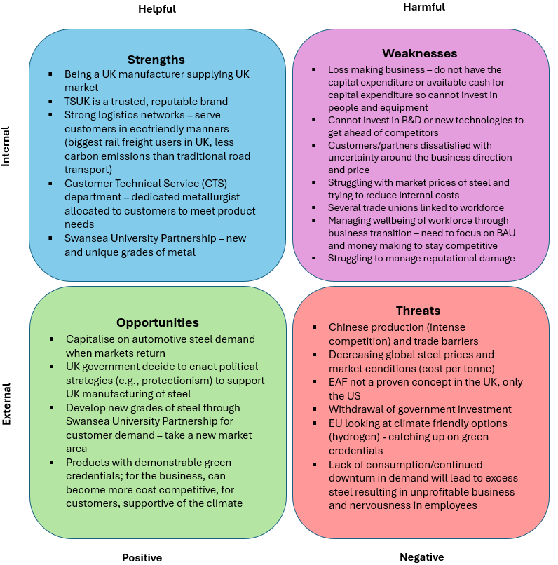

Whilst there are several threats to nullify, TSUK can turn some of their weaknesses into opportunities. Sirmon et al (2010) argue that the relationship between turning weaknesses into opportunities exists, although, it can often involve costs by the company, e.g., investment in assets that target growth markets. In TSUK removing the loss-making heavy end, they are mitigating large future financial losses as well as the huge carbon emitting element of the business. Their new operating model allows for a lower cost base to compete for when the automotive sector (a primary customer) does start to recover from the lack of demand and ensure their Buyer Power competitiveness remains low. However, they do not have a lot of money to invest in the company so TSUK may see their competitive advantage lost in the next few years through substitute products, industry competition and supplier power as they transition to their new era.

Conclusion

There is absolutely no doubt that with TSUK’s eight sites, it is the largest steelmaker in the country, but despite its size, it is a company that is failing hard and fast “with a loss of nearly £1 million a day for the year 2023/24” (Tata Steel, 2024).Market instability due to excess steel supply, challenging UK energy costs and the decarbonisation agenda are all having a significant impact on the business health and prosperity of the company.
Excess steel remains a major challenge for TSUK as it drives down profits. “Steel trade is largely determined by the comparative advantage of steel-producing countries. The stronger the relative trade performance of an economy in a particular product or sector, the greater the comparative advantage that country has in the production of that product or sector” (Kiliçarslan, 2021). China is expected to export 100Mt of steel during this year alone. This could meet the entirety of the UK’s steel demand for 13 years” (UK Steel, 2024). China’s subsidies and abundant labour has supported their growth through export-orientated manufacturing but decimated the industry for the rest of the world, including TSUK.
“Many of Tata Steel's products are uniquely designed around its customers’ needs and not available from other steelmakers” (UK Steel, 2023), but even with TSUK supplying around 1m tonnes of steel to car makers, there has been weak demand for some months now across the automotive sector (Carey and Steitz, 2024).
In addition, with the closure of both furnaces, it follows “decades of decline for Britain’s steel industry which in 1971 employed about 320,000 people (excluding the processing of steel). It now employs about 33,700” (Croft, 2024).
The sector is having to look to new business models as the pressures across the industry mounts. TSUK are not alone in this but what should be a time for great opportunity in sustainability, is one of enormous challenge and uncertainty as TSUK reshapes to be fit for the future.
Facing all these challenges, the forward outlook for TSUK remains bleak with few signs improving as the company moves into 2025. The only hope currently for future survival as a UK steel manufacturer is the £1.25 billion project to safeguard UK’s steel sovereignty and secure steel making in Port Talbot (Tata Steel, 2024). This investment on an unproven, 3-year electric arc project is going to be a critical time and likely to offer more challenge for TSUK’s survival than securing the finance for the project itself. TSUK have gone all in with a gamble for survival in the greener world.

Recommendations

Acknowledging that TSUK:
- cannot compete against the operating costs of China,
- cannot compete on basic steel price alone and
- have already explored, and failed, in merging with ThyssenKrupp,
there is a need to focus on what it can influence or control.
Therefore, the following are recommended for TSUK to strategically position itself to enable its future:
- Focusing its efforts on supplier power as the transition to the EAF begins
This will provide a crucial head start before the EAF is constructed, because without this, the EAF cannot run if supply is throttled. With a lack of suppliers, the supplier power will remain high and TSUK will lose its competitive advantage before it has even started in its green steelmaking.

- Lobby UK government for continued state support with energy costs
TSUK operations are very energy intensive. Across all sites there is an immense demand for electricity. Continuing to prioritise government lobbying and support could level the playing field with European competitors.

- Consider future-proofing automotive customer orders
As the automotive industry looks to new technology, innovation, and materials in the future of automotive production (e.g., aluminium instead of steel), TSUK could consider issuing a direction in the Swansea University research partnership to prioritise development and innovation of steel in automotive uses. This may also offer differentiation to penetrate a new market in the future but could secure the future order book from the automotive industry as the move to aluminium in new cars evolves.

Information correct as of October 2024

