Table of Contents
Introduction 1
What is CryptoWall Malware? 1
How is it spread? 2
What to do? 2
Preventions 3
What it could do to the company? 4
Conclusion 4
Reference List 5

Introduction
CryptoWall Trojan is the leading ransomware used in the united states. ‘according to the 2018 Verizon Data Breach Investigation Report, ransomware incidents now make up about 40% of all reported malware incidents!’ [1] . The malware is cheap, easy to use, and spreads fast [1]. CryptoWall mostly affects US and Canada users. However, the United Kingdom, Netherlands and Germany were hit by the attack as well.[3] Therefore research in to how to protect our company against such an attack is vital.

What is CryptoWall Malware?
CryptoWall was first release at the end of April 2014. It directly attacks all versions of windows including Windows XP, Windows Vista, and Windows 7 and 8. [2] Therefore it effects a vast array of software’s of which we potentially use in our company. The Malwares used is very similar to Crypto defence, it has identical decryption services. [2]
In October 2014 version 2.0 was released. It included upgrades to the malware such as, the malware will now scan and encrypt the files, after this has been done you will no longer be able to access your files and a notepad window will open up giving you instructions to the decryption service. Other changes to the original version include adding a unique bitcoin payment address for every separate incident. It also now provides a secure deletion of original data files. [2] The ransom money starts around $500 and can increase up to $1000 after 7 days. [2]
In January 2015, version 3.0 was released. This brought with it a new ransom note file. They advanced the development of the Web-to-TOR gateways, and also increased the ransom deadline. [2] it also uses RSA-2048 encryption to lock files [1].
In November 2015, version 4 was released. The dates show that they were possibly being more successful and the amount of targeted people was increasing as the technology is having to constantly be updated at a faster rate to keep up with demand, and to reduce the risk of getting caught. This version brought with it a more robust shadow deletion package. It also now can encrypt the file names so when you go to recover the files you do not know what information is held in which file.[2] they have once again redesigned the ransom notes, and have created a new payment gateway.
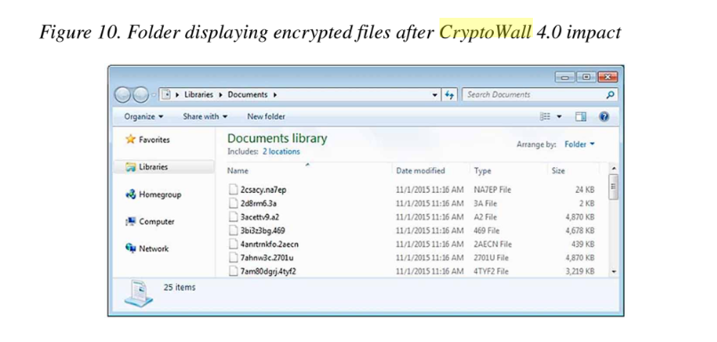[6]
The latest version is V.5.1, this malware is based on hidden tear malware. It uses AES-256 encryption. At this stage the software has changed so considerably it is possible there is none of the original software left in it. [1]

How is it spread?

This type of malware spreads mainly via emails [2]. It works by having a zip file attached to the email which will look like a PDF file. They could be labelled as an invoice, customer complaint, or bills for example. Once you click on the link to open up the file, it will start to install the malware software on to your computer in %Appdata% or %Temp% folders for example.[2] They created a TOR website that the victims can go to, to decrypt their files. Links can be found in TXT, URL, and HTML. They use this to pay the ransom money. [2] TOR, is the name given to malware which exclusively spreads through spam emails.[6]
It can scan removable drive such as USB’s, network shares, and Dropbox mapping. After it has completed the scanning process it will also delete all of the shadow volume copies to make it impossible for the victim to recover the files. [2]
Other ways in which the malware can spread is by exploit kits which use known vulnerabilities on your device which can be in the operating system. For instance, in applications you use, websites, and wordpress. Common exploit kits used include, Angler, Magnitude, and Nuclear.[5] Malicious adverts are effective and work by hacking the internet advertisements to deliver malware to you through your browser.[1]

What to do?

One of the most important bits of information to get out of this report is, what to do if it does unfortunately happen to you? Firstly, scan your computer with an anti-virus program. However usually you only realise once the encryption has been completed and you can no longer access your files. By scanning the system anyway, it will delete any malware which was installed alongside the CryptoWall such as the %Temp% or %Appdata% folders.[2]
The only method to be able to fully restore your files, is from a backup version. Such as a copy on a USB which you keep separate from your main device. You can also use file recovery tools or shadow volume copies if you are lucky. [2]
Realistically if you end up needing to pay the ransom to retrieve your files, will this actually help? Some say, yes. [2] However others say ‘It is unwise paying the money as there are few guarantees that you will retrieve the files. It’s just a malicious method used for earning illegal money.’[3] Once they have seen the payment, they will send you a decrypter file which you can download and recover your files. The only issue with this is the amount of time it takes for all of your files to get recovered.[2]
‘In 2016, Hollywood Presbyterian Medical Centre was hit with ransomware that shut down their computers for more than a week. Rather than pay the initial $3.7 million ransom, the hospital went back to paper records until they were able to negotiate the payment down to 40 bitcoins or about $17,000 (Wolff, 2016).’[7] This example shows, when a company is hit, the ransom money is very high. It also shows there is a tolerance with CryptoWall and to remember there is a human being you are talking to behind the malware.
For more information on this, there is a step by step guide on what to do here: https://www.precisesecurity.com/rogue/remove-cryptowall[4]

Preventions

The best thing to do for the company is to put in as many preventions to stop this from happening in the first place. The ways we can do this is by creating software restriction policies that block executables from running when they are located in specific pathways. You can also use a crypto prevention tool or add policies manually using a local security policy editor.[2] Here are six of the best prevention tips which if everyone in the company is made aware of it could go a long way in preventing this malware from attacking us.[1]
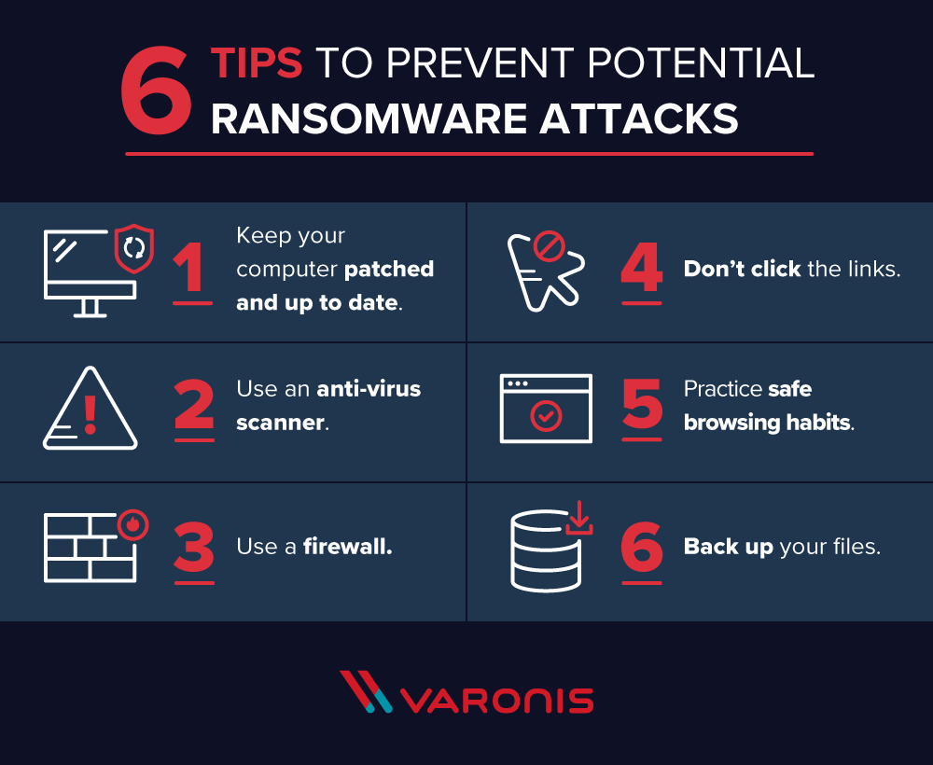
[1]

What it could do to the company?

The importance to take from this in context with the company. Is that by taking steps such as following the 6 prevention techniques. Downloading anti-virus tools and crypto prevention tools, we can stop this malware from affecting us.
Why is this so important? If they can get hold of all our data. This include spreadsheets of how much people get paid, including CEO’s, accounts for the personal business and accounts of which we hold for suppliers. They will also have access to photos and videos of which some might have very private and confidential information on which can be used for blackmail for even more money.

Conclusion

To conclude, research in to CryptoWall has brought to light, how easily accessible important information can get into the wrong hands. CryptoWall in my view, is one of the worst malwares we have seen due to the fact it encrypts the file names as well as the files, it also deletes the shadow volume copies. To go forward there are steps which I would erg we put in to place immediately such as the prevention software and awareness meetings for the employees followed by the 6 steps poster being put around the office for reminders.

Reference List

- https://www.varonis.com/blog/cryptowall/
- http://www.bleepingcomputer.com/virus-removal/cryptowall-ransomware-information
- https://www.2-spyware.com/remove-cryptowall-virus.html
- https://www.precisesecurity.com/rogue/remove-cryptowall
- Page 37, Ransomware, defending against digital extortion, by Allan Liska and Timothy Gallo. Printed USA, published by O’reilly Media Inc. editors- Courtney Allen and Virginia Willson. 18/11/2016.
- Page 203, online banking security measures and data protection, Shadi A. Aljawarneh, Jordon University of science and technology, Jordan. AISPE Book Series, Published in USA by IGI Global.
- Ransomware: Evolution, Mitigation and Prevention. Ronny Richardson Max M. North. Kennesaw State University, 1-1-2017, https://digitalcommons.kennesaw.edu/cgi/viewcontent.cgi?article=5312&context=facpubs

