Computer Architecture and Operating Systems
ACCA4022 – Operating Systems

Craig Oldham
0501251

Table of Contents
Introduction 3
1. Key Functions of General Operating Systems 3
File Management 3
Device Management 3
Process Management 3
Memory Management 4
Job Accounting 4
2. Use of Windows OS CLI Commands 5
Ipconfig 5
Ping 5
Tasklist 6
Taskkill 6
Driverquery 7
Sfc/scannow 7
Cls 8
Perfmon/rel 8
Dir 9
Powercfg -energy 9
3. Use of Linux OS CLI commands 10
Pwd 10
Clear 10
Mkdir 11
Cd 11
Touch 12
Chmod + rwx 12
Echo 13
Cat 14
History 14
And so much more … 14
4. Use of Windows OS Scripts 15
Basic Batch Function 15
Variables 15
Goto 16
User Input /p Switch & If Statements 16
Array 17
For Loop 17
Functions 18
5. Use of Linux OS Scripts 19
Variables 19
User Inputs 19
If Statements 19
Loops 20
Arrays 20
Case Statements 21
Functions 22
Conclusion 23
References 24
List of Report Figures 25
Appendix 26
Types of Operating Systems 26
Batch OS 26
Multitasking OS 26
Network OS 26
Examples of Operating Systems 26
Evidence of Engagement with an Online Certified Course 27
Appendix List of Figures 28

Introduction
In this report, we will be exploring the key functions of General Operating Systems, the use of Windows and Linux OS CLI commands and the use of Linux OS Scripts. As part of the research for this assignment, I will also show that I have engaged with online certified courses.

1. Key Functions of General Operating Systems

In an article on their website, Anshuman Singh [1] tells us that there are five main functions of an operating system. These are:

File Management
The Operating System is responsible for creating files, opening, and closing them, deleting them when prompted by the end user and the organisation of files held on the computer’s storage devices.

Device Management
This function controls connected devices, assigning programs known as input/output controllers, deciding which processes get access to devices and for how long, allocates and deallocates devices efficiently and receives requests from input/output devices.

Process Management
Here, the Operating System is responsible for starting and stopping programs, allocation of the machine’s resources and management of the amount of memory used. It will also enforce program security keeping the system safe from potential attacks.
On Windows systems, the Task Manager tool is a useful piece of software built into the Operating System that you can use to monitor what processes are running on a machine.
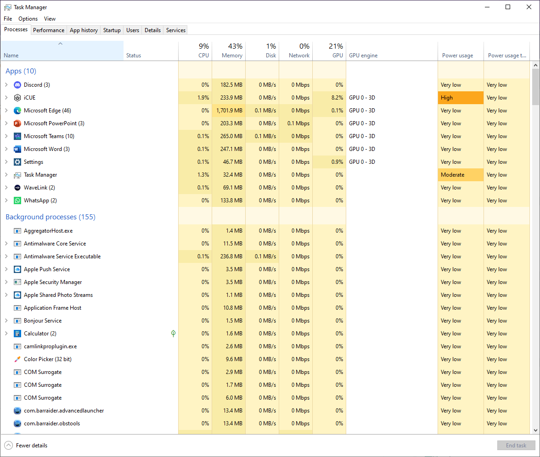
Figure 1: Screenshot of Windows Task Manager Showing Processes Running on a PC
As Figure 1 demonstrates, this lists Open Applications and Background Processes which are running at that time on your PC, along with the resources that each process is using. It can also be used, when an application is no longer running as it should, to force it to close.
Other operating systems have similar functions which allow you to do the same thing, such as Activity Monitor on Mac or a terminal window in Linux based systems.

Memory Management
The most critical function of the Operating System, this keeps track of all the different applications a system may be running and the memory resources they are using. If needed, the Operating System can move data or even delete files to make more space to allow programs to run more effectively.

Job Accounting
Used to track how computer resources are being used, this can help a user determine any performance issues on their machine and even identify software installations they did not authorise. This information can also be used locally to keep track of the system’s usage or in a wider use to bill users for resources used and even to provide information to system administrators if users or processes are causing issues.
Through the Task Manager function, we have the option to monitor the performance of the various hardware components that make up our PC, as demonstrated in Figure 2.
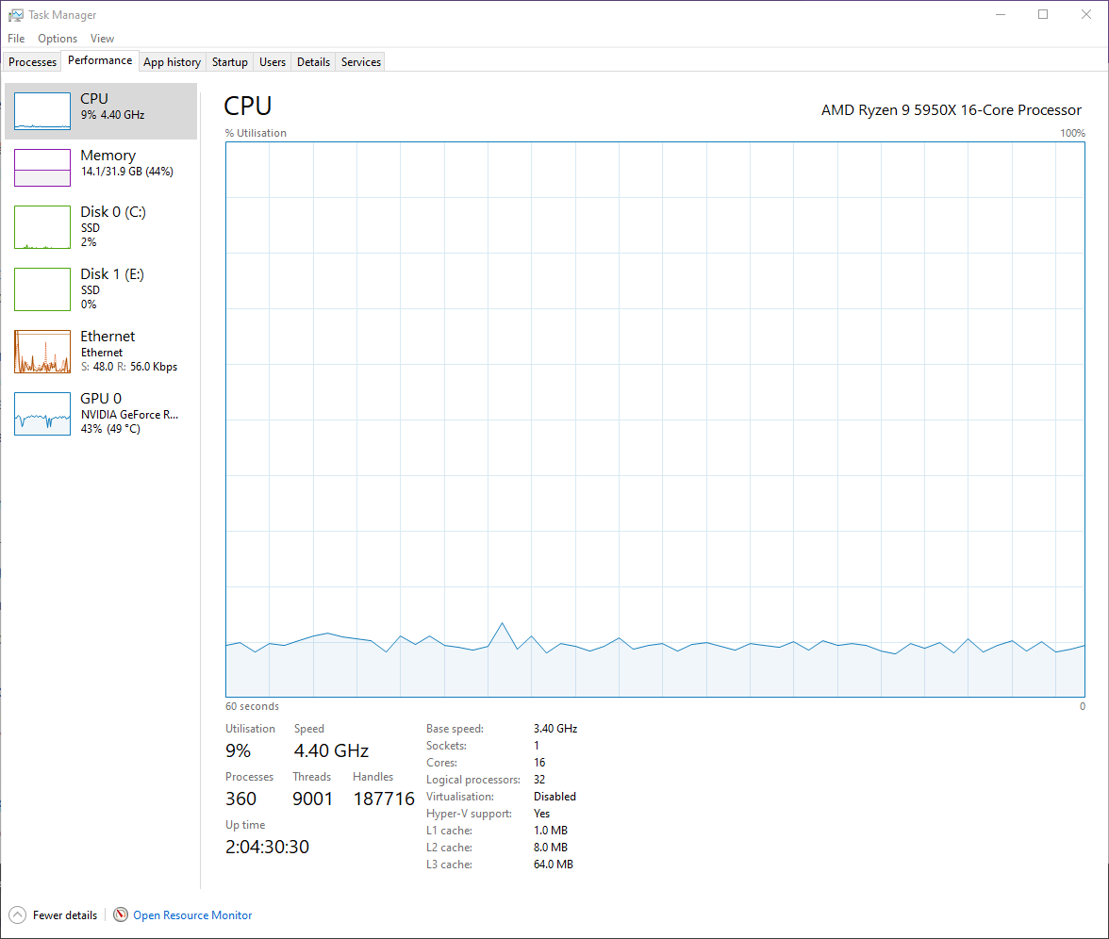
Figure 2: Task Manager - Performance Monitor
If you notice that one of your components is experiencing a high level of usage, you can click through to the Resource Monitor to see which processes are using most of the resource and, if needed, close them down (see Figure 3).
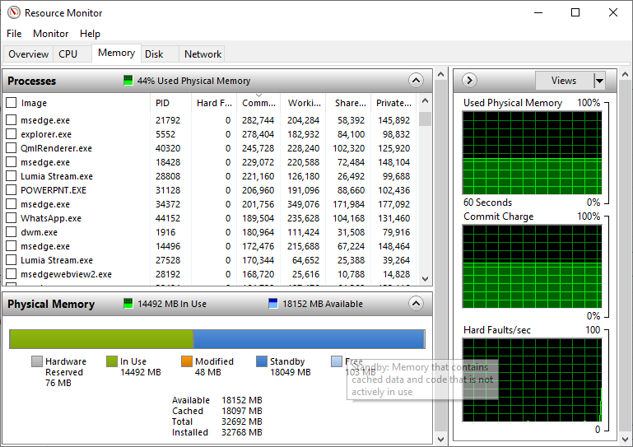
Figure 3: Resource Monitor showing processes using a PC's RAM

2. Use of Windows OS CLI Commands
Windows Command Line Interpreter can be used to view and modify directories within an Operating System or to call applications.
In an article on the TechGYD website, S Srivastava [2] lists twenty-five of the most useful Command Line prompts, some of which we are going to explore here.

Ipconfig
Ipconfig allows the user to quickly view all connections on their system rather than having to go through the Control Panel Software
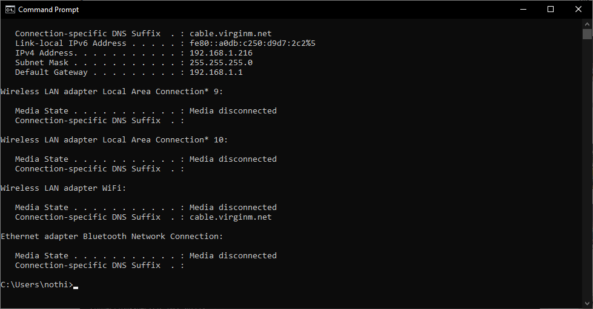
Figure 4: Screenshot of results after running ipconfig

Ping
Ping is useful if you are having issues connecting to a website and help you identify the cause.
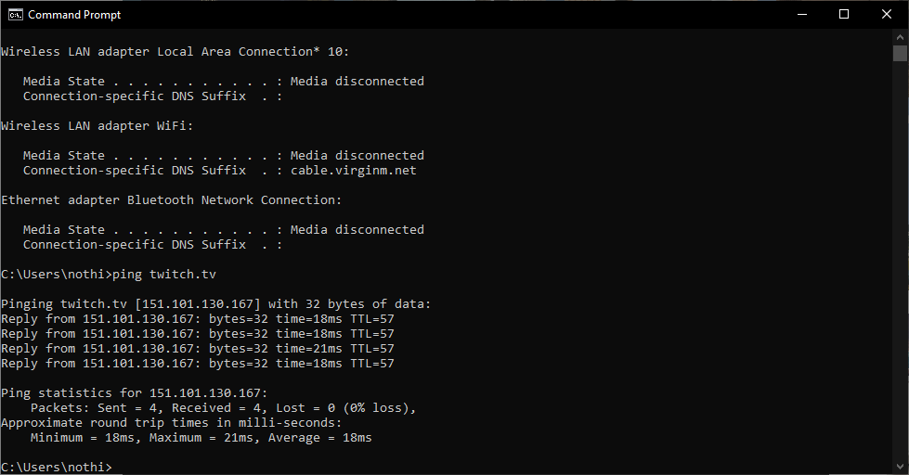
Figure 5: Screenshot of assessing the ping to the twitch.tv website

Tasklist
Like Task Manager, tasklist allows you to see all running tasks. Where it differs is it shows you hidden tasks too, useful for finding malware hidden on your computer.
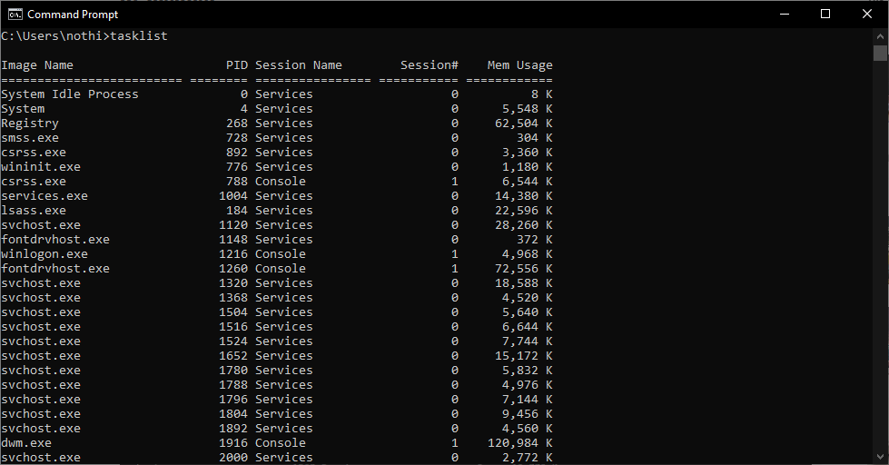
Figure 6: Screenshot of the start of the list of tasks running on the PC used to generate this report

Taskkill
As with Tasklist, this is like Task Manager, with the added benefit of being able to kill hidden tasks. Here we will kill the WhatsApp Task that is currently running on the machine.
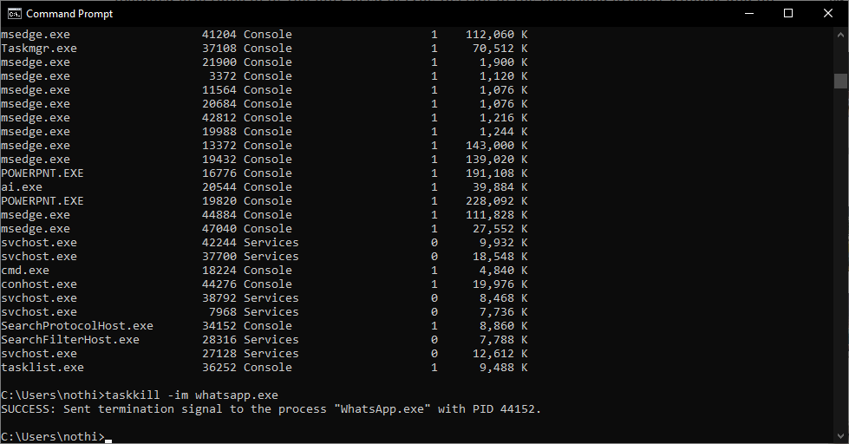
Figure 7: Screenshot showing that the taskkill command had successfully killed the WhatsApp application on the PC

Driverquery
A tool which will allow you to list every driver installed on your machine. Depending on the age of your machine and how many devices you have attached, this can be quite an extensive list.
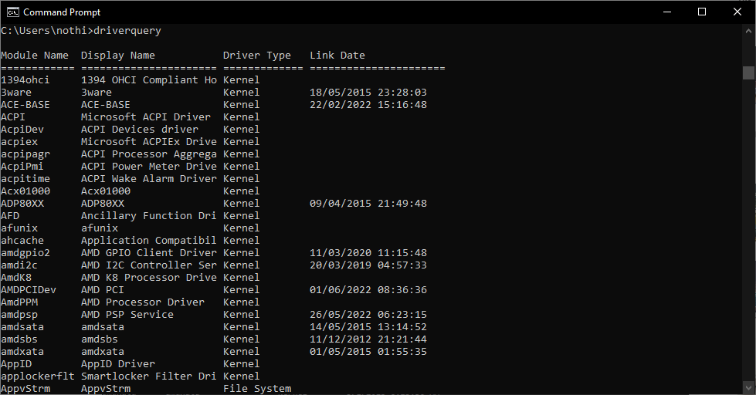
Figure 8: Screenshot of command results from running the driverquery

Sfc/scannow
This function will scan all the files on your system and, if issues are found, repair them automatically. It will then log the files it had to repair for you to review.
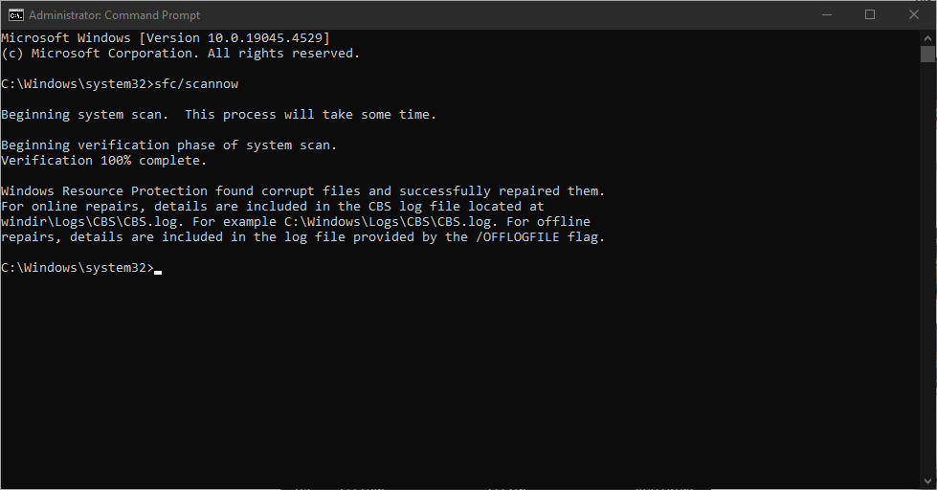
Figure 9: Screenshot of the completed sfc/scannow command's results

Cls
If you have been running many commands and you want to have a fresh start on the CLI, running this command clears the window of all previous data. This is the window after clearing the command run in the previous example.
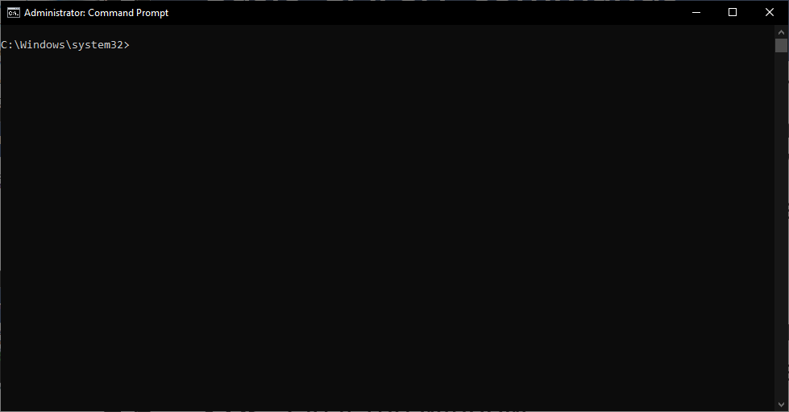
Figure 10: Screenshot showing that the CLI has been cleared by the cls command

Perfmon/rel
Running this command will open Windows Reliability Monitor, which is a useful tool for checking if you have been having multiple system issues. As you can see here, there is an app that has been crashing regularly on this machine.
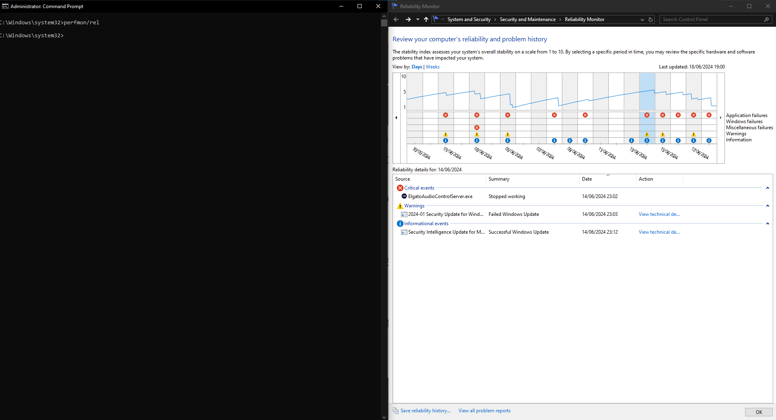
Figure 11: Screenshot showing that Windows Reliability Monitor has been successfully opened by the CLI

Dir
This command will show you all folders and files in a directory. By typing the drive letter followed by ‘:’ you can navigate to specific drives.
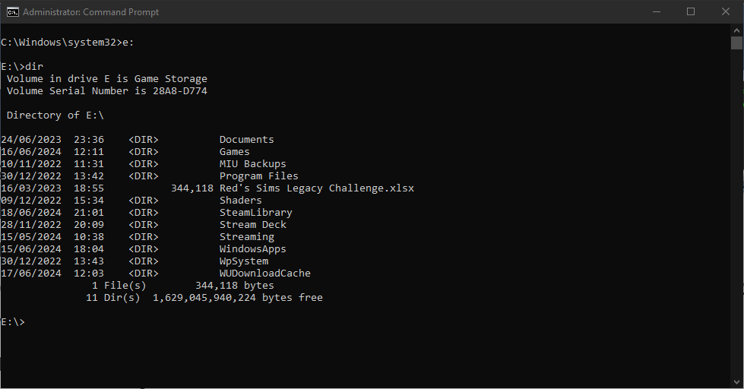
Figure 12: Screenshot showing the directories and files on the 'E' Drive on the PC used

Powercfg -energy
This will run a check on the system to see how energy efficient it is. The report it outputs can be viewed to see what are causing issues so you can address them.
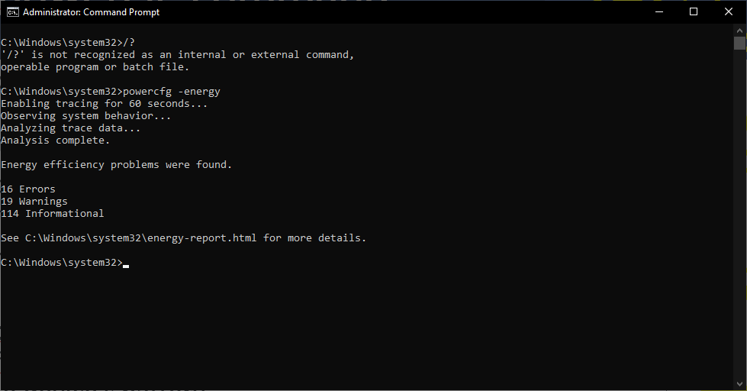
Figure 13: Screenshot of the completed powercfg-energy command

3. Use of Linux OS CLI commands

On their website, opensource.com [3] describes Linux open-source software which is behind all other software used on a computer. Here we are going to demonstrate some basic BASH commands in Linux.

Pwd
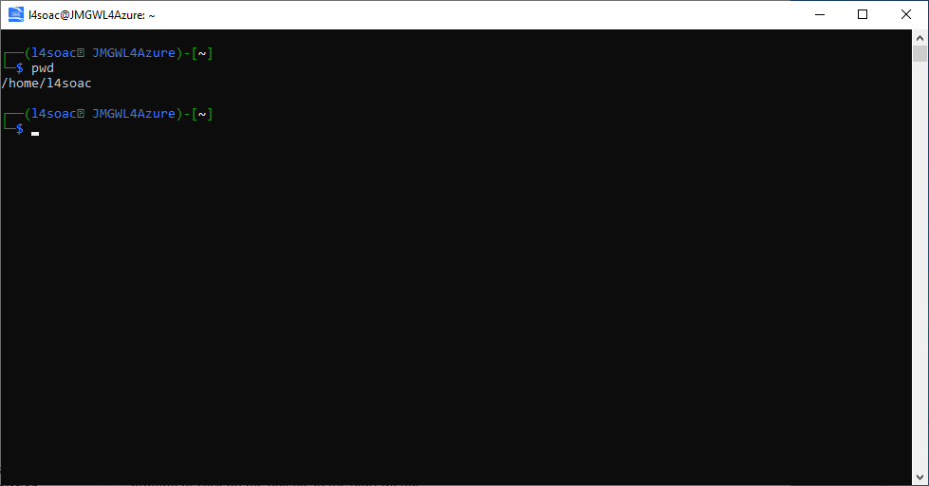
Figure 14: Screenshot showing the results from running the pwd Linux command
This command will print the current working directory the user is connected to.

Clear
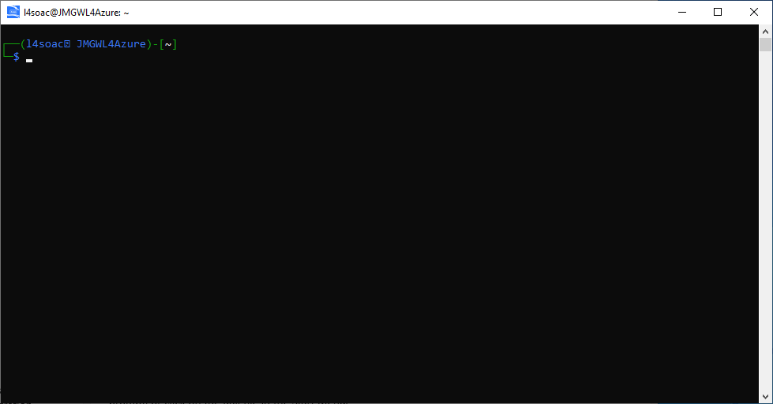
Figure 15: Screenshot showing the results after running the clear Linux command
If you have done a lot of commands and want to clear the interface, the clear command wipes everything for you.

Mkdir
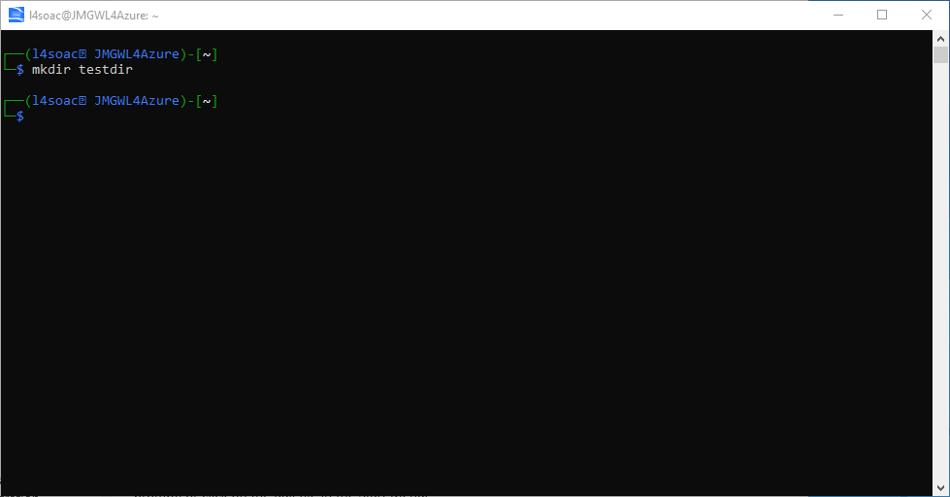
Figure 16: Screenshot showing the Linux command required to create a new directory
This command allows you to create a new directory, useful if you want to test some code without risking data in your home/root directory.

Cd
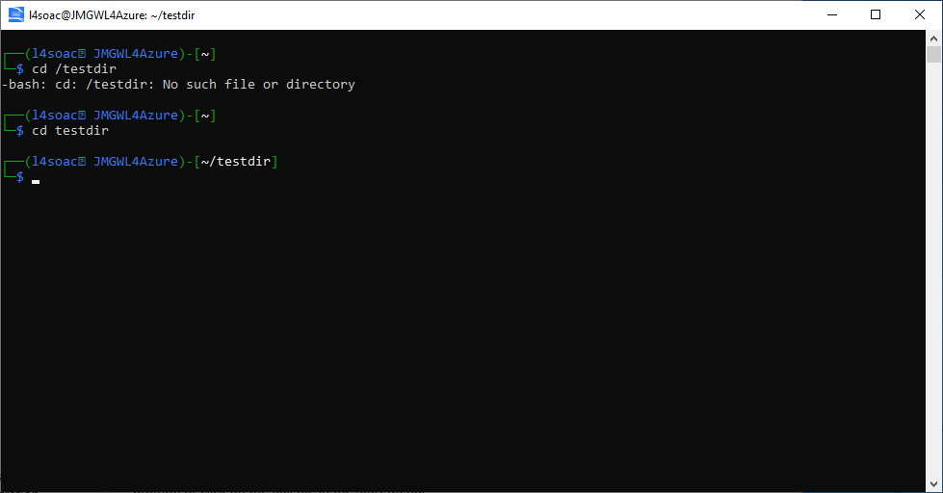
Figure 17: Screenshot showing the Linux command needed to navigate to a directory
Once you have created your new directory (here we have called it testdir) you use the cd command to navigate to it. In some interfaces you need to use cd /.

Touch
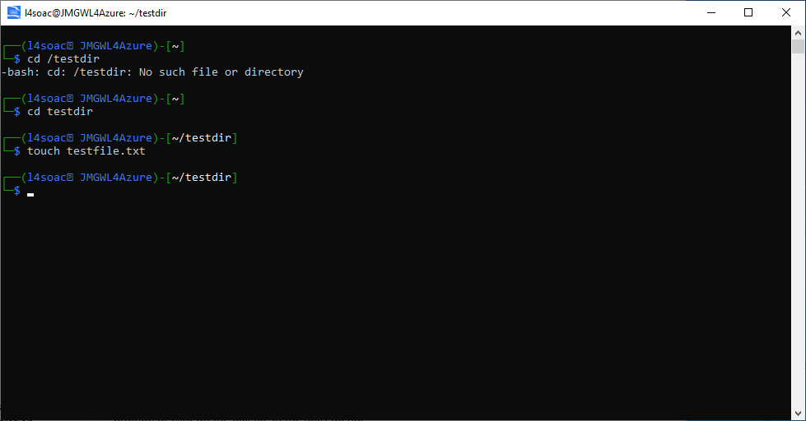
Figure 18: Screenshot showing the Linux command that creates a new file in the current directory
Touch allows you to create a file, here we have created a text file called testfile.

Chmod + rwx
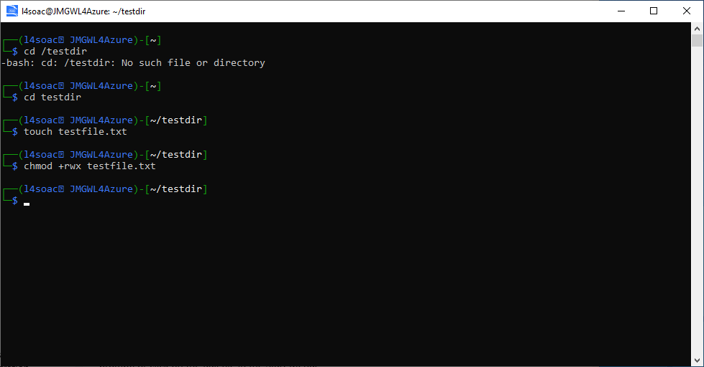
Figure 19: Screenshot showing Linux commands used to give user permissions to use a file
This command gives the user all the permissions they need to modify the file that has just been created.

Echo
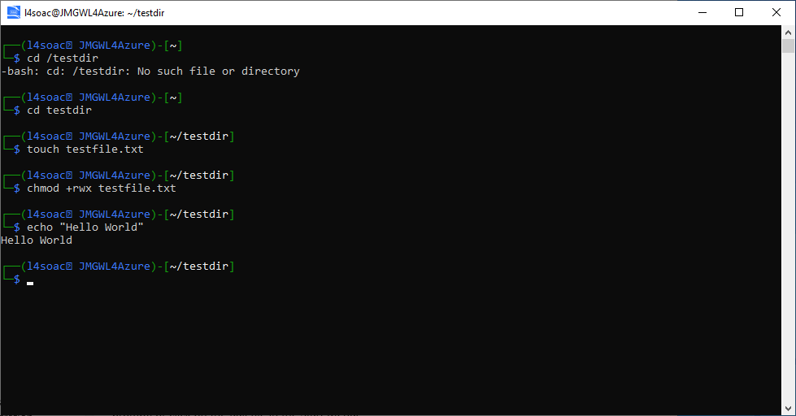
Figure 20: Screenshot showing Linux command which displays a message in the user interface
Echo will print out any text you type within “ “. Here we have asked Linux to print the phrase “Hello World”.
Combining echo with > [filename] you can write your message in to that file.
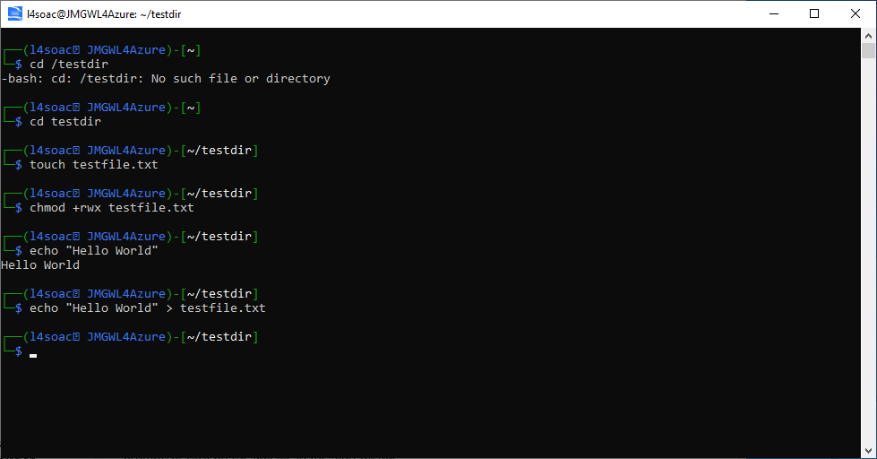
Figure 21: Screenshot showing Linux command which alters the content of a file

Cat
The cat command will read out whatever you have stored within the file you have just created. To show this better, here, after using Linux to add the initial message, I have navigated to the file in the directory and added more text for it to print.
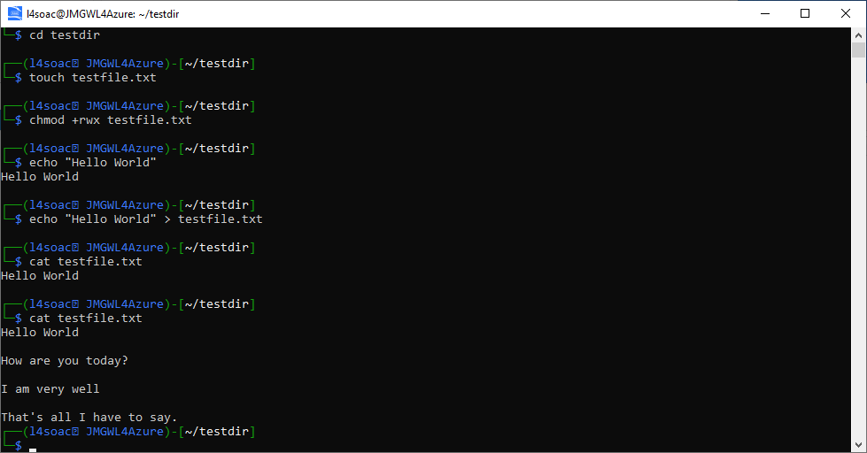
Original echo message
Manually altered message
Figure 22: Screenshot showing the Linux command which will read the contents of a file

History
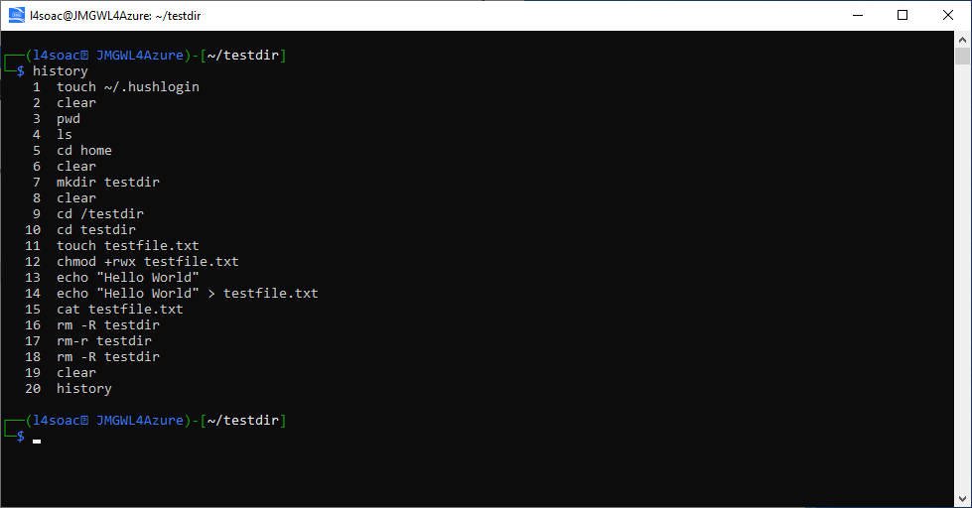
Figure 23: Screenshot showing the Linux command to view a history of all run commands
If you have accidentally cleared your interface, and want to check which commands you had run, history will show you all the previously used commands within this session, along with any commands you ran that failed.

And so much more …
This is just the tip of the iceberg, and as J Gloor [4] of makeuseof.com tells us, many people have built their own custom Operating Systems using Linux scripts and posted them online for other people to use. Like other Operating Systems there are different versions depending on the user’s needs.

4. Use of Windows OS Scripts
Windows OS scripts, better known as Batch commands, are defined by R Awati of TechTarget [5] a scripted file which can be executed to perform tasks without user input.
Here, we will explore several basic commands that can be run using Windows OS Scripts.

Basic Batch Function
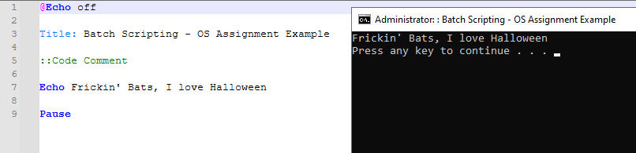
Figure 24: Screenshot showing Batch command which prints a message in the output
One of the most basic functions you can run is to print a response in the system’s Command Line Interface. Here we get it to print a message on execution (and add a title to the Interface)

Variables
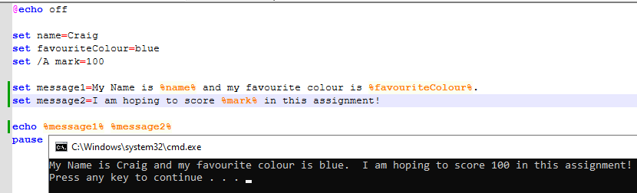
Figure 25: Screenshot showing Batch command which stores variables and calls them in a message displayed on the output
Here, we set variables that we can later call in a printed message. These are useful when you want to reference a name or a value multiple times through your script.

Goto
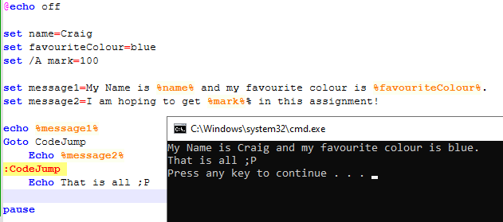
Figure 26: Screenshot showing Batch command showing a command skipping over a section
This command can be used to move to different parts of the script. Here we use it to ignore a line we changed our mind about

User Input /p Switch & If Statements
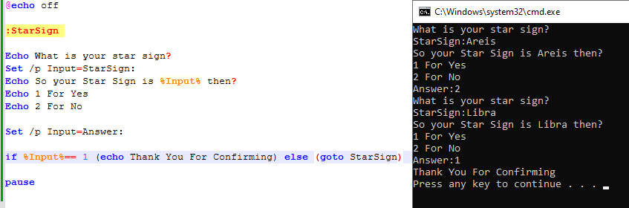
Figure 27: Screenshot showing Batch command allowing a user to input responses
Here we have combined three Batch functions. The user input combined with the /p switch asks the user for a response and allows them to enter it on the same line as the question being asked.
The if statement checks the user’s response and either prints a response or takes them back to the question to amend their response.

Array
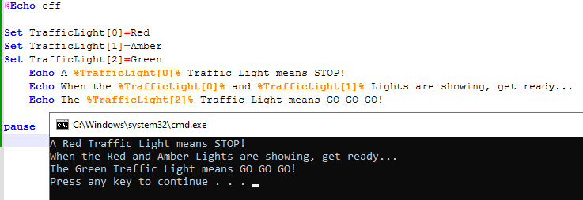
Figure 28: Screenshot showing Batch command that creates and executes and array of values
Arrays are a list, with each value assigned an index which we can later use to return the value in an output. Here we use them to list what you should do at a traffic light.

For Loop
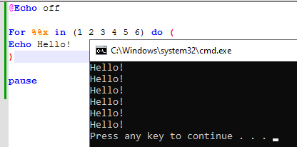
Figure 29: Screenshot showing Batch command that runs in a loop
For loops allow for tasks to be repeated a number of times, and how we determine that can be as simple as above, or like in other languages, with a start and end value and how many steps it needs to increment. Here, we have made the file say hello to the user a few times.

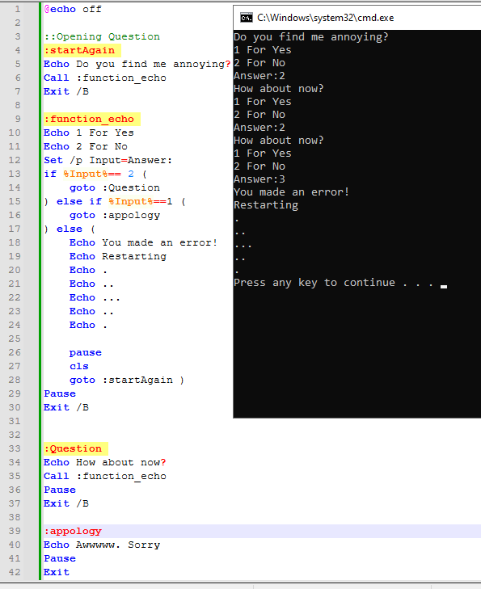
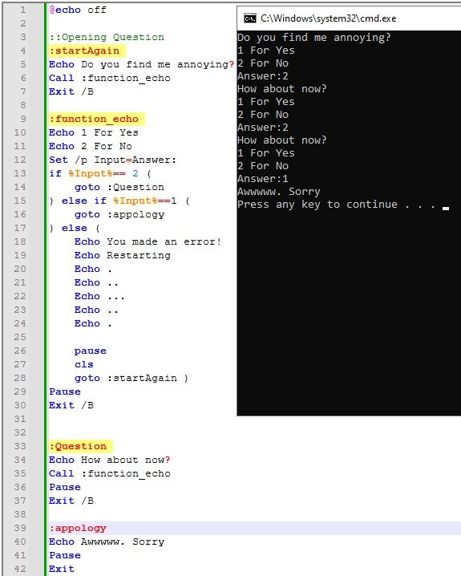
Functions
Figure 30: Screenshot showing Batch command which is set up with various functions creating an interaction with the programme

Functions are procedures that are stored outside the main script to be called when needed. Here we have included an if statement to make the functions keep repeating until the desired response is given by the end user.

5. Use of Linux OS Scripts
Linux OS scripts are referred to as BASH scripts. In the introduction to their course on freecodecamp.org, Z Hira [6] explains that, like with BAT files in Windows, BASH scripts are a series of commands which are saved in a file to be read and executed by the BASH programme.
All the below scripts were run on onlinebgdb.com [7]

Variables
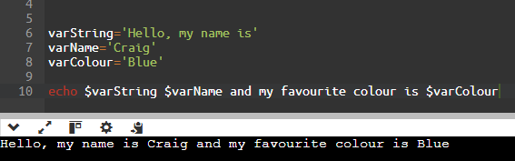
Figure 31: Screenshot showing BASH command storing and printing variables
Here we have created BASH variables which print the stored values within an output text

User Inputs
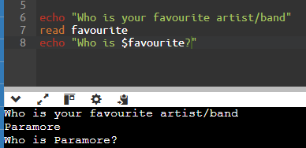
Figure 32: Screenshot showing BASH command allowing the user to input a value and printing the result
This command asks the user to input a value and the prints it out as a confirmation.

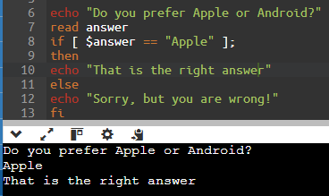
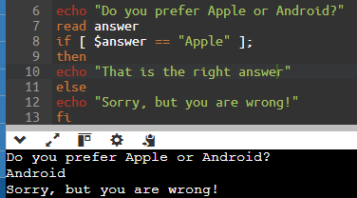
If Statements
Figure 33: Screenshot showing BASH command results to both options of an if statement

The if statement here asks the user a question, and depending on their answer will output a response. If statements can be multi-layered if needed, but too many can cause the process to slow down.

Loops
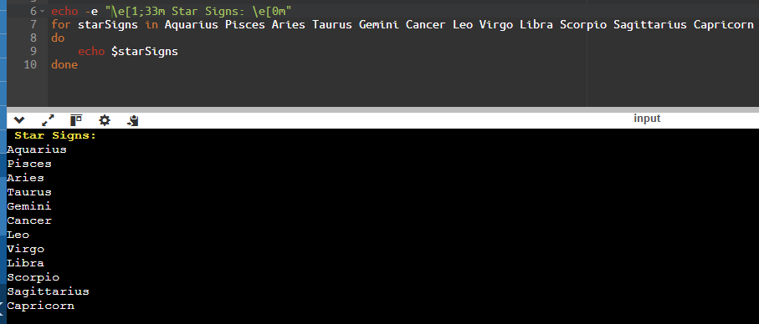
Figure 34: Screenshot showing BASH command running in a loop to list star signs
This command loops through a list of values to create a list of Star Signs. By using some text formatting, we have been able to add a header to the list which is in a distinctive style to the output list.

Arrays
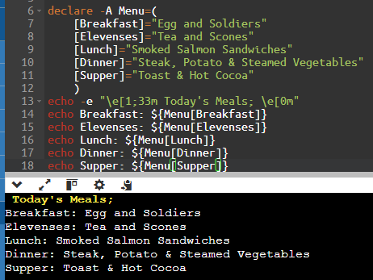
Figure 35: Screenshot showing BASH command to create an array and print out the indices as a list
An array is like a list but stores the values with unique indices. Here we have used the array to generate a list of meals available during the day.

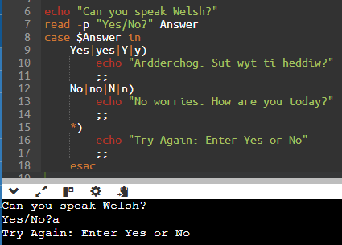
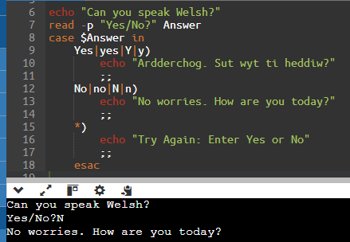
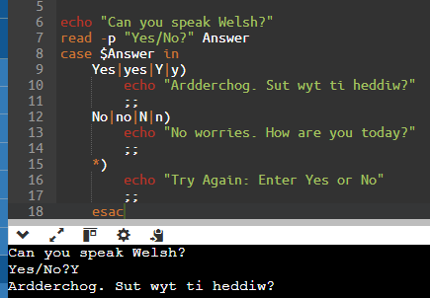
Case Statements
Figure 36: Screenshot showing BASH command showing the outputs of various different case statements

Case statements are more powerful if statements. Here we’ve listed possible outcomes to a question for each case and tested the outputs based on the user’s input.

Functions
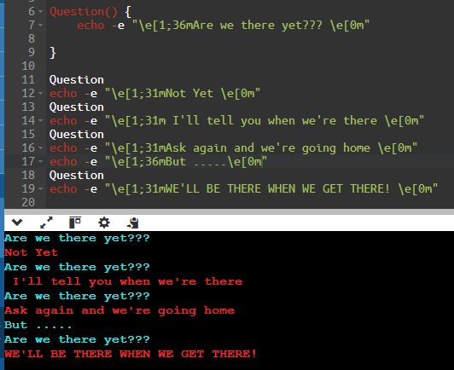
Figure 37: Screenshot showing BASH command set up as a function
Here we have created a function to ask a question each time it is called and then printed a response to that question.

Conclusion
In researching this topic, I have come to realise that there were a lot more options available for operating systems than I had known, especially when learning that Linux commands can be used to build your own custom operating system that works for exactly what you need from a computer.
It was also interesting to learn more about running applications and processes through the different Command Line Interfaces, as well as the increased productivity working through these systems can lead to. Someone who plans to work with Networks in the future would benefit from getting a good working knowledge of these systems.
While people will argue that the physical components of a computer are the most important to a well running system, without an operating system that can meet your needs, and which can control them effectively to do that, they are just useless pieces of silicone, plastic, and metal. And in some cases, expensive ones at that.

References
[1] A. Singh. (Jan 23,). Functions of Operating System - Shiksha Online. Available: https://www.shiksha.com/online-courses/articles/functions-of-operating-system/.
[2] S. Srivastava. S. Srivastava. 25 most useful commands of command prompt every windows user should know. 25 most useful commands of command prompt every windows user should know. 2017. Available: https://www.techgyd.com/command-prompt-command/27903/.
[3] Anonymous (). What is Linux? | Opensource.com. Available: https://opensource.com/resources/linux.
[4] J. Gloor. (-05-24T19:00:26Z). What Is Linux? What Can You Use Linux For?. Available: https://www.makeuseof.com/what-is-linux-used-for/.
[5] R. Awati. (). What is batch file?. Available: https://www.techtarget.com/searchwindowsserver/definition/batch-file.
[6] Z. Hira. (-03-31T19:26:38.000Z). Shell Scripting for Beginners – How to Write Bash Scripts in Linux. Available: https://www.freecodecamp.org/news/shell-scripting-crash-course-how-to-write-bash-scripts-in-linux/.
[7] Anonymous (). Online Bash Shell - online editor. Available: https://www.onlinegdb.com/online_bash_shell.
[8] Indeed Editorial Team. (April 9,). Types of Operating Systems (With OS Functions and Examples). Available: https://www.indeed.com/career-advice/career-development/types-of-operating-systems.
[9] S. Gaurav. (-11-24T00:00:00.000Z). Batch Operating System. Available: https://www.scaler.com/topics/batch-operating-system/.
[10] Prepbytes. Prepbytes. What is time-sharing operating system? What is time-sharing operating system? 2023. Available: https://www.prepbytes.com/blog/operating-system/what-is-time-sharing-operating-system/.
[11] K. Ysar and S. Lewis. (). What is a Network Operating System? | Definition from TechTarget. Available: https://www.techtarget.com/searchnetworking/definition/network-operating-system.
[12] Daisy. (-07-07T06:40:19+00:00). What Is the Network Operating System and What Are the Types of It. Available: https://www.minitool.com/lib/network-operating-system.html.
[13] R. Perian. (Jan 24,). Operating System (OS) Definition & Examples. Available: https://www.lifewire.com/operating-systems-2625912.

List of Report Figures
Figure 1: Screenshot of Windows Task Manager Showing Processes Running on a PC 3
Figure 2: Task Manager - Performance Monitor 4
Figure 3: Resource Monitor showing processes using a PC's RAM 4
Figure 4: Screenshot of results after running ipconfig 5
Figure 5: Screenshot of assessing the ping to the twitch.tv website 5
Figure 6: Screenshot of the start of the list of tasks running on the PC used to generate this report 6
Figure 7: Screenshot showing that the taskkill command had successfully killed the WhatsApp application on the PC 6
Figure 8: Screenshot of command results from running the driverquery 7
Figure 9: Screenshot of the completed sfc/scannow command's results 7
Figure 10: Screenshot showing that the CLI has been cleared by the cls command 8
Figure 11: Screenshot showing that Windows Reliability Monitor has been successfully opened by the CLI 8
Figure 12: Screenshot showing the directories and files on the 'E' Drive on the PC used 9
Figure 13: Screenshot of the completed powercfg-energy command 9
Figure 14: Screenshot showing the results from running the pwd Linux command 10
Figure 15: Screenshot showing the results after running the clear Linux command 10
Figure 16: Screenshot showing the Linux command required to create a new directory 11
Figure 17: Screenshot showing the Linux command needed to navigate to a directory 11
Figure 18: Screenshot showing the Linux command that creates a new file in the current directory 12
Figure 19: Screenshot showing Linux commands used to give user permissions to use a file 12
Figure 20: Screenshot showing Linux command which displays a message in the user interface 13
Figure 21: Screenshot showing Linux command which alters the content of a file 13
Figure 22: Screenshot showing the Linux command which will read the contents of a file 14
Figure 23: Screenshot showing the Linux command to view a history of all run commands 14
Figure 24: Screenshot showing Batch command which prints a message in the output 15
Figure 25: Screenshot showing Batch command which stores variables and calls them in a message displayed on the output 15
Figure 26: Screenshot showing Batch command showing a command skipping over a section 16
Figure 27: Screenshot showing Batch command allowing a user to input responses 16
Figure 28: Screenshot showing Batch command that creates and executes and array of values 17
Figure 29: Screenshot showing Batch command that runs in a loop 17
Figure 30: Screenshot showing Batch command which is set up with various functions creating an interaction with the programme 18
Figure 31: Screenshot showing BASH command storing and printing variables 19
Figure 32: Screenshot showing BASH command allowing the user to input a value and printing the result 19
Figure 33: Screenshot showing BASH command results to both options of an if statement 19
Figure 34: Screenshot showing BASH command running in a loop to list star signs 20
Figure 35: Screenshot showing BASH command to create an array and print out the indices as a list 20
Figure 36: Screenshot showing BASH command showing the outputs of various different case statements 21
Figure 37: Screenshot showing BASH command set up as a function 22

Appendix

Types of Operating Systems
In an article on their website, Indeed.com [8] describe six different types of Operating Systems. Here we will briefly describe some of these before listing a few examples of the most common operating systems.

Batch OS
These types of OS are not directly linked to a computer and are often used for time-consuming tasks. So that the devices are not slowed down, users prepare tasks offline then submit them to an Operator.
S Gaurav [9] explains in their Scaler Topics article that the Operator will sort out all the tasks it has been sent by the similarity of their requirements and run them in batches.
They tell us that after a job is completed, the next job will be run without user interaction as an advantage of these types of systems. However, the downside is that if a task fails, or takes a long time to run, the system might be deadlocked.

Multitasking OS
Multitasking systems will allocate time to each task and switches frequently between different tasks. This allows users to simultaneously complete tasks.
Prebytes [10] list Linux, UNIX, Windows NT Server, and Multics as some examples of a Multitasking OS, going on to list an advantage of Multitasking OS as being that multiple users can work on a system at the same time, improving teamwork and productivity.
A disadvantage they list is that these types of systems can be more susceptible to malware attacks, data breaches and unauthorised access.

Network OS
K Yasar and S Lewis of TechTarget.com [11] tell us Network Operating Systems (NOS) are designed to support PCs, workstations, and sometimes older systems on a Local Area Network. They do go on to explain that a typical NOS does not tend to exist now as many operating systems now support a client-server model.
Some of the systems they give as examples are Microsoft Windows Server, Unix OS, and Junos OS.
Daisy of MiniTool.com [12] tells us that new technology and hardware can be integrated into the system easily, but that because of this, they need to be regularly maintained and updated.

Examples of Operating Systems
There are many different types of operating systems available to suit the needs of most everyone. T Fisher of Lifewire [13] lists the main computer operating systems as Windows, Apple macOS, Chrome OS. They also tell us that there are many Unix and Linux systems that are available to use.
In addition to this, with the rise of smartphones, we now have mobile operating systems such as Google’s Android or Apple’s iOS.

Evidence of Engagement with an Online Certified Course
Here, I chose to look at Microsoft’s “Automate administrative tasks by using PowerShell” online course as this is one that may come in useful for me in future.
I completed one of the modules for the benefit of this assignment, but I will go back to look at this course in more detail in future as it looks like it is something that I could benefit from spending more time on.
Below are some screenshots from my engagement with the course.
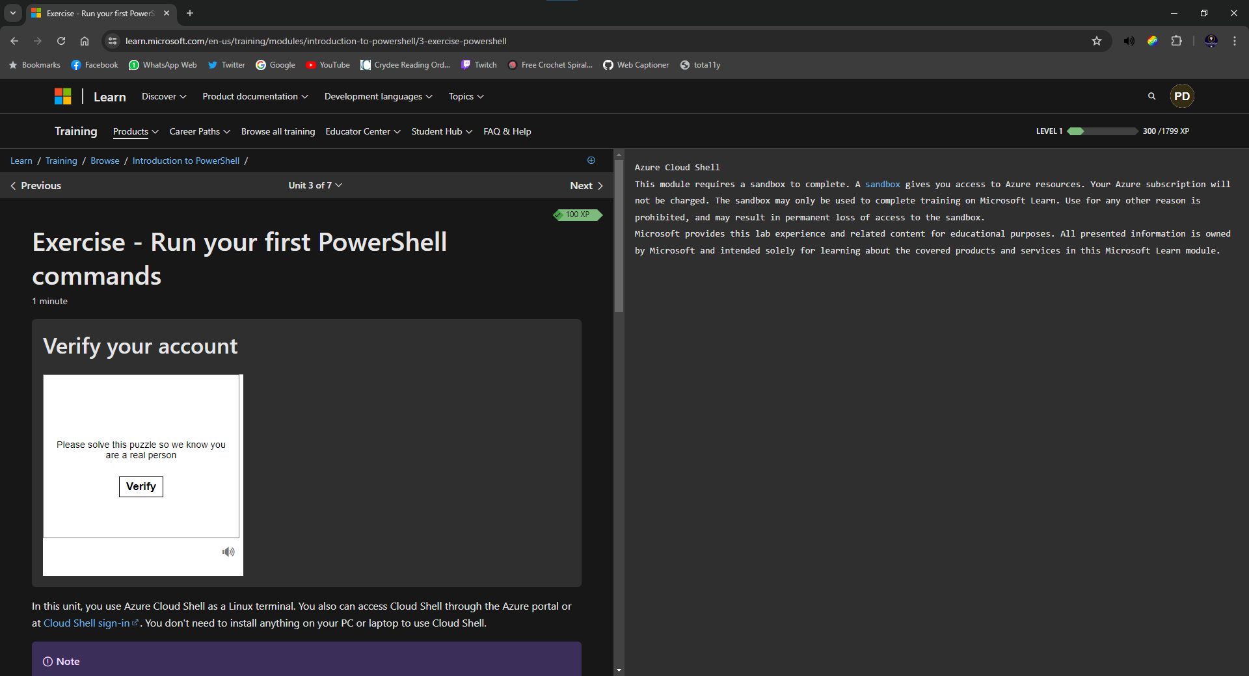
Appendix Figure 1: Screenshot of signing up to Microsoft PowerShell course

The course requires you to set up a sandbox environment to use it. Here I am just verifying my Windows account to allow me to have access to Azure Cloud Shell.

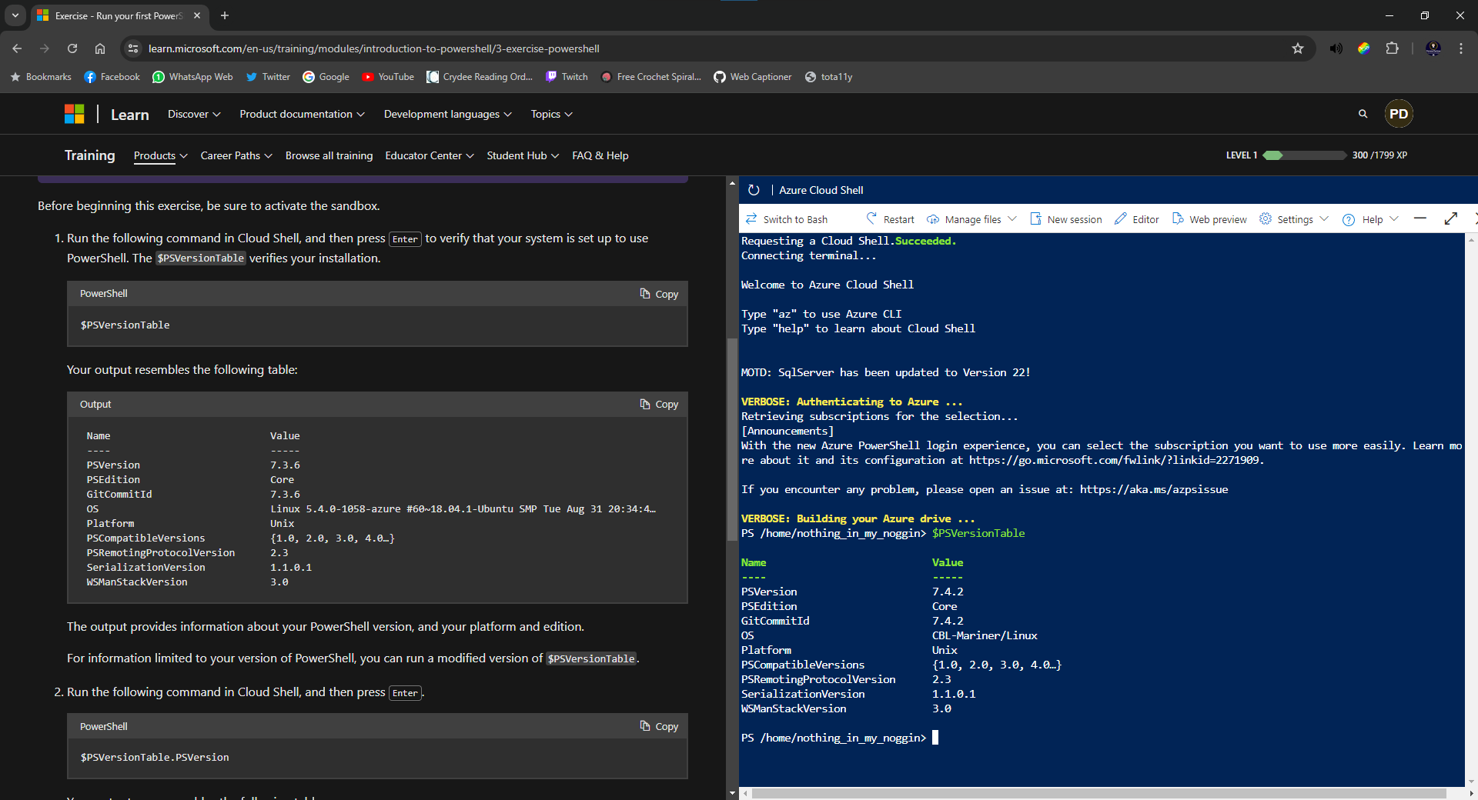
Appendix Figure 2: Screenshot of user trying out the first command suggested in the course
Here I have tried out their first command which verifies the system is set up. The next image shows me trying the next commands they suggest making sure everything works as it should.
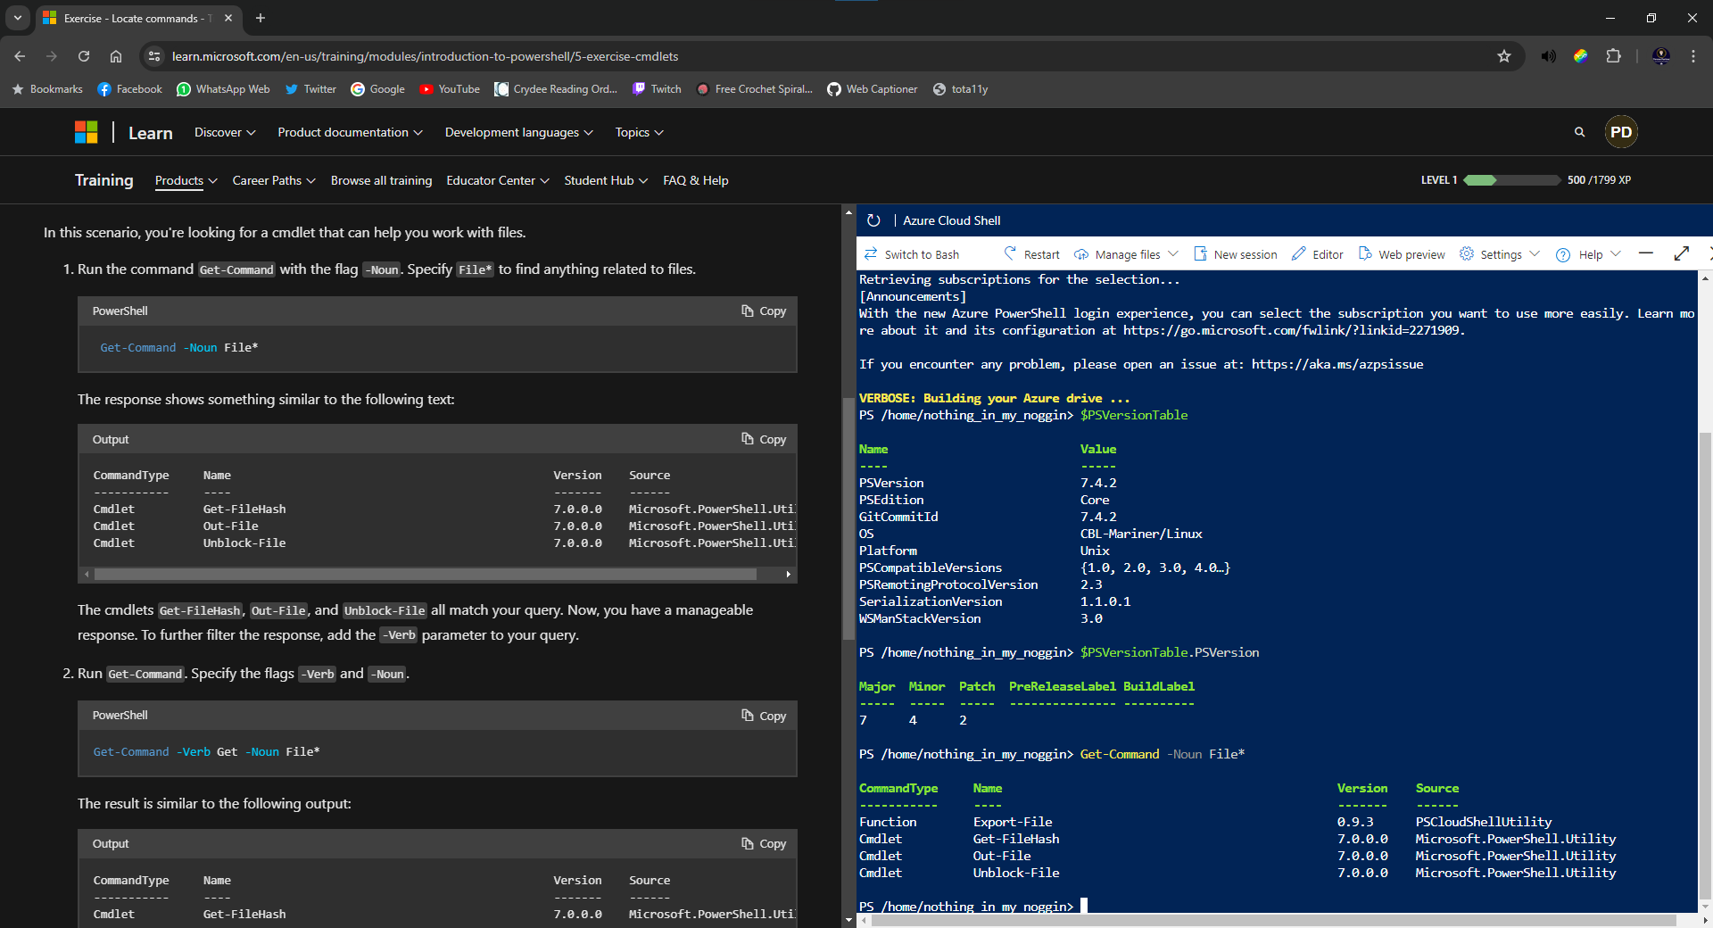
Appendix Figure 3: Screenshot of output after running all the commands in this section
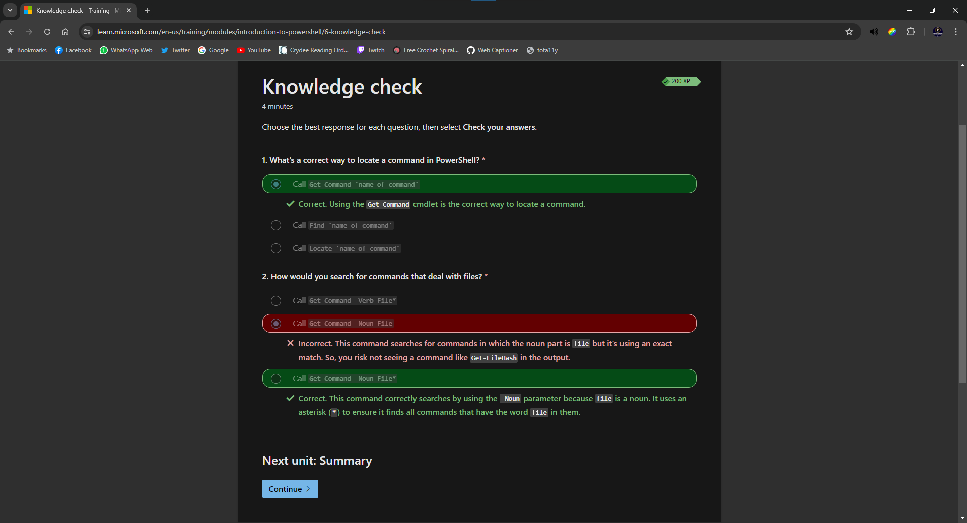
Appendix Figure 4: Screenshot showing results of a quiz at the end of the first section
At the end of each section, there is a multiple-choice quiz to check you have taken in all the content. As you can see here, not everything sunk in, and I would need to refresh my knowledge on that section.

Appendix List of Figures
Appendix Figure 1: Screenshot of signing up to Microsoft PowerShell course 27
Appendix Figure 2: Screenshot of user trying out the first command suggested in the course 27
Appendix Figure 3: Screenshot of output after running all the commands in this section 28
Appendix Figure 4: Screenshot showing results of a quiz at the end of the first section 28

