 Bay brighteners and Belbin Team roles
Written by Roxana Meader

I am currently involved in a litter picking initiative in Swansea Bay coordinated by Bay Brighteners student group from University of Wales Trinity Saint David. The project aim is to raise awareness of the negative effects of human littering on Wales shores and to set an example in community cooperation and sustainability practices.

One of the first stages of the project involved team identification and role assignment.
The methodology employed was based on Belbin team role assessment.

Belbin is an evaluation method that identifies strength and weakness of each individual and facilitates the development of cohesive and highly efficient teams (Mostert, n.d.).

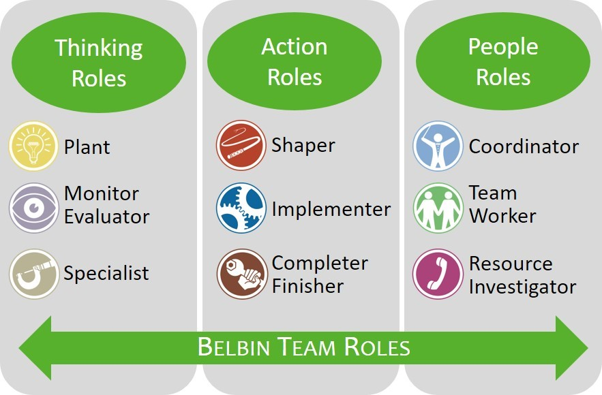
(Güven, 2023)

The roles are revealed after the completion of the questionnaire, and I have assumed the roles of Monitor Evaluator and Implementor. Both roles suited perfectly as I have been assigned the execution stage and I was coordinating the tasks and resources, while I was conducting risk assessments in real time.

Although the Belbin framework is effective in promoting self-awareness and team efficiency, it also has its limitations. It can be subjective and biased, rely on stereotypes and does not guarantee an even distribution of work (Macdonnell, 2012).
Moreover, the university project and limited time required the students to change their roles frequently to cover all the tasks and finalise the initiative.
For more information visit https://www.belbin.com/about/belbin-team-roles

 Kanban and litter picking university project.
Written by Roxana Meader

My first experience with Kanban was during a litter picking university project. The initiative seemed simple and straight forward, but on a closer look it required a multitude of tasks and subtasks, resources, and careful coordination. Kanban brought light and structure to the project and simplified the workload.
What is Kanban?
The term comes from Japanese, its meaning can be summarised as “signal card” (Anderson, 2010).
It is a visual project management tool that increases efficiency by providing a clearer image of the work and an easier approach to task monitoring process. Usually, the board is divided into three categories To do, In Progress, and Done, and it helps visualise the work, increasing efficiency, controlling the workflow, and facilitating improvement.
Our project was divided into manageable tasks, which were available for members to finalise, ensuring accountability and enhancing team cohesion. The efficiency was magnified by the visual layout that simplified the task progression, enhanced coordination, and eliminated bottlenecks.
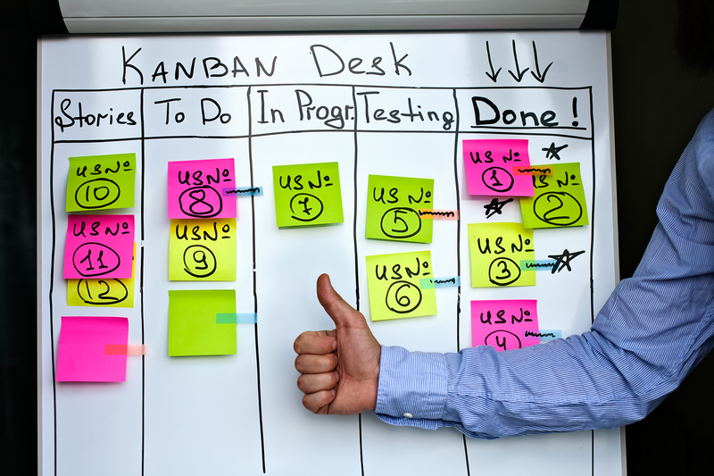
(“Kanban,” 2023)
However, the use of Kanban board did not come without challenges. The team encountered limitations in terms of time management due to the lack of build in scheduling and resource allocation as it does not address management of budget or materials. Furthermore, any delays in the tasks development can hinder the entire project progress (Alaidaros et al., 2021).
Overall Kanban facilitated tasks management, coordination and increased project efficiency but requires supplementary time and resource management tools.

For more information visit https://business.adobe.com/uk/blog/basics/what-is-kanban
 Iron triangle- still relevant or outdated?
Written by Roxana Meader

Iron triangle is one of the most recognised project management model. It is based on three fundamental criteria for achieving success : time, cost and scope (Rani et al., 2013).
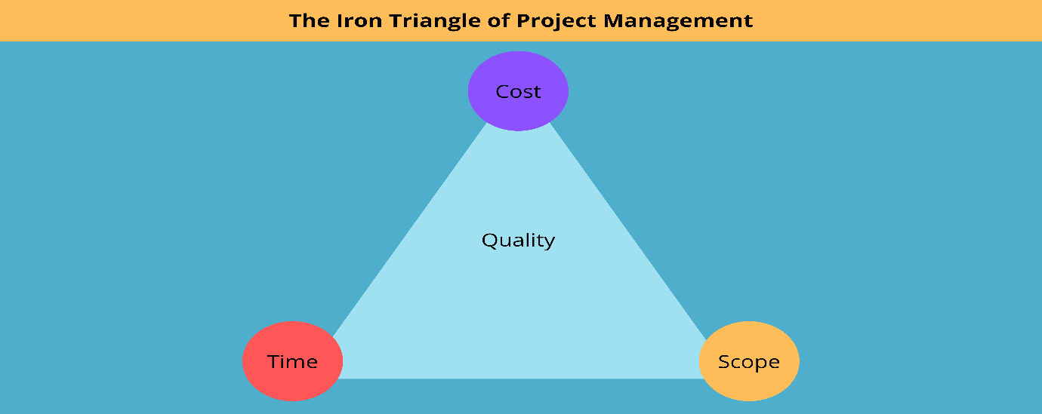
(Whyte, n.d.)
Also known as the Triple Constraint Framework, the methodology is based on the interdependence of the three variables. Closely corelated and dynamically linked, any variation or change in one of the three elements will automatically have an effect on the other two components. For instance, if the cost increases the timeline or the scope will need to modify accordingly and be proportionate with the changed variable.
If the balance of the three is not achieved the project can be compromised and fail in terms of deadline, budget, or even quality standards.
New project management theories suggest that the Iron triangle framework is highly efficient; however, it fails to adapt and address the present project management challenges.
In the present project management climate the success is also highly depended on stakeholders satisfaction, sustainability and adaptability (Atkinson, 1999).
Those variables need to be e taken into consideration and introduced into the framework, enhancing the complexity and range of the key drivers for success and efficiency.

For more information visit https://www.business.com/articles/fast-good-cheap-pick-three/


WBS- the right path in project management planning
Written by Roxana Meader

During the university project management module, my team was assigned with developing and implementing a comprehensive plan for a litter picking initiative. It was during this project that I had to research and use the WBS tool, which proved to be essential in the organisation and planning of all assignment’s tasks.
The Work Breakdown Structure (WBS) is in fact a fundamental framework in project management that facilitates the initiation, plan, execution, control and monitorisation of the entire project (Norman, Brotherton and Fried, 2008, p.11.).
The framework helped partition the project into stages, tasks, and subtasks, creating a comprehensive network of activities that have to be completed. This approach structured the workload efficiently, ensured better resource management, provided a simplified visual representation of the tasks, enabled progress tracking, accurate time, and risk management, and facilitated the completion of the project based on informed decisions.
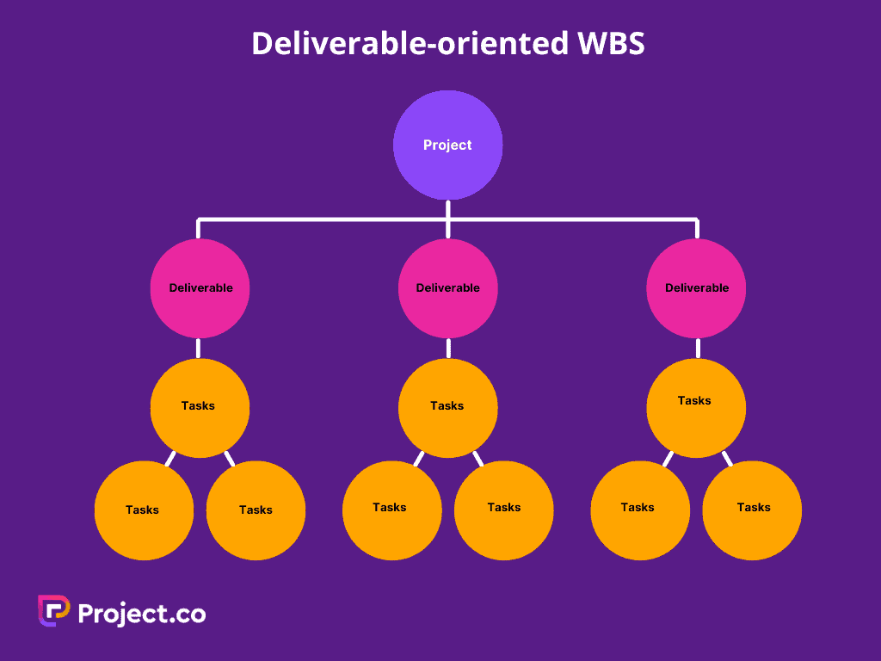
(Work Breakdown Structure (WBS): The Complete Guide, 2023)
The efficiency of the framework was partly overshadowed by the considerable amount of time necessary to structure it and the meticulous management demand for each task.
Furthermore, the tool appears to concentrate mostly on practicability and deliverables and overlooks key aspects as communication and stakeholders (Haugan, 2001).
For more information visit https://www.project.co/work-breakdown-structure/

 Bay Brighteners – a reflective journey
By Roxana Meader

The level 5 Project Management module required the application of the methodology studied into a real-life project that had to be organised, planned, and implemented. The initiative has brought together several university students, volunteers, the Swansea Council, and the community. The project provided an invaluable experience and an opportunity to apply the newly acquired knowledge into practice. Using the Gibbs reflective cycle (Gibbs, 1988), I have been able to identify the strengths and weaknesses, and provide potential recommendations based on experience and learning . 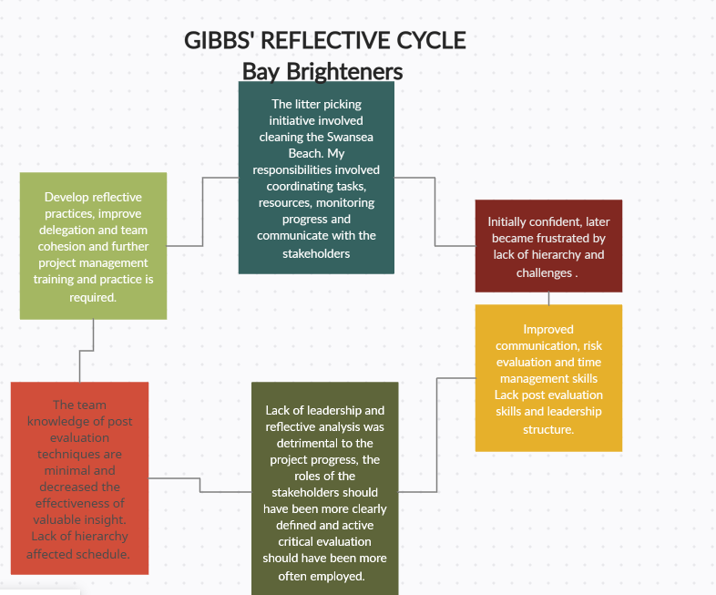

The reflective practice has been instrumental in raising awareness to the limitations and abilities I possess and how I can enrich my knowledge and experience. The final stage of the model, action planning, facilitated the creation of a professional development plan focused on further project management training, enhancement of reflective practices and also delegation and team cohesion techniques. A professional development plan is vital to identify skill gaps and structure any learning activities (Megginson and Whitaker, 2007).
To sum it up, Gibbs framework used in tandem with a professional development plan provides an effective strategy for reflective learning and continuous growth, facilitating ongoing improvement in knowledge and practice.

Reference

Alaidaros, H., Omar, M., Romli, R., 2021. The state of the art of agile kanban method: challenges and opportunities. Indep. J. Manag. Prod. 12, 2535–2550. https://doi.org/10.14807/ijmp.v12i8.1482

Anderson, D.J., 2010. Kanban: Successful Evolutionary Change for Your Technology Business. Blue Hole Press.

Atkinson, R., 1999. Project management: cost, time, and quality, two best guesses and a phenomenon, it’s time to accept other success criteria. Int. J. Proj. Manag. 17, 337–342. https://doi.org/10.1016/S0263-7863(98)00069-6

Gibbs, G., 1988. Learning by doing: A guide to teaching and learning methods. Furth. Educ. Unit.

Güven, K.M., 2023. Belbin Team Roles Model - Experianta. URL https://experianta.com/directory/concepts/belbin-team-roles-model/ (accessed 5.21.25).

Haugan, G.T. (2001) Effective Work Breakdown Structures. Berrett-Koehler Publishers.

Kanban [WWW Document], 2023. . IONOS Digit. Guide. URL https://www.ionos.co.uk/digitalguide/websites/web-development/about-kanban/ (accessed 5.21.25).

Macdonnell, J., 2012. Using the Belbin Team-Role Self Perception-Inventory to Form Groups and Assign Roles for Media Production Assessment. Media Educ. Res. J. 3, 50–62.
Mostert, N.M., n.d. Belbin – the way forward for innovation teams 1.

Megginson, D., Whitaker, V., 2007. Continuing Professional Development. Kogan Page Publishers.

Norman, E.S., Brotherton, S.A. and Fried, R.T. (2008) Work Breakdown Structures: The Foundation for Project Management Excellence. John Wiley & Sons.

Rani, H.A., Abdullah, C.S., Mohtar, S., 2013. THE IRON TRIANGLE AS THE TRIPLE CONSTRAINTS IN PROJECT MANAGEMENT. J. Tek. SIPIL 2.

Whyte, C.M., n.d. The project management triangle and how it benefits your team! [WWW Document]. URL https://blog.farmerswife.com/what-is-the-project-management-triangle (accessed 5.21.25).

Work Breakdown Structure (WBS): The Complete Guide (2023) Project.co. Available at: https://www.project.co/work-breakdown-structure/ (Accessed: 21 May 2025).

