Engineering Skills Technical Report
Engineering Skills (ACHA4022A)
Word Count: 1,983

George Campling
2503449

University of Wales Trinity Saint David
Motorsport Engineering Beng Hons

06/12/2025

Contents:

- Introduction………………………………………………………………………………………..1
- Health and Saftey with Risk Assessments…………………………………………………….2
  - Considering an Undertaken Task………………………………………………………….2
  - Relevant Health and Saftey Regulations…………………………………………………2
  - Risk Assessment……………………………………………………………………………3
- Security Risk Matrix………………………………………………………………………………6
  - Identifying Threats…………………………………………………………………………..6
  - Security Risk Matrix…………………………………………………………………………7
  - Engineering Response……………………………………………………………………..8
- Engineers Role in Society……………………………………………………………………….9
  - Code of Conduct for Engineers……………………………………………………………9
  - Engineers Responsibility to Sustainability in Motorsport……………………………….9
- Problem Solving………………………………………………………………………………...10
- Team Structuring………………………………………………………………………………..12
  - Personal Review…………………………………………………………………………..12
  - Team Structure Options…………………………………………………………………..12
- Conclusion……………………………………………………………………………………….13
- Reference List…………………………………………………………………………………..14

Figure 1, Risk assessment template and examples, sourced from HSE, 2025………………..3
Figure 2, Gantry Lift Risk Assessment……………………………………………………………..4
Figure 3, Gantry Lift Risk Assessment, Total Risk Matrix………………………………………...5
Figure 4, Security Risk Matrix……………………………………………………………………….7
Figure 5, Root Caused Analysis Flow Chart, Sourced from Vengage, 2025…………………10

Abbreviations:

Key: Abbreviation – Meaning
- UWTSD - University of Wales Trinity Saint David
- HSE – Health and Saftey Executive
- PUWER – Provision and Use of Work Equiptment Regulations
- LOLER – Lifting Operations and Lifting Equiptment Regulations
- CNWR – Control of Noise at Work Regulations
- IMechE – Institute of Mechanical Engineers
- IStructE – The Institution of Structural Engineers

Chapter 1 – Introduction:

This report aims to research and cover what skills all engineers should have in today’s society. This will cover topics such as understanding and assessing risks, both in terms of health and saftey, as well as the modern security threats posed in a modern world.
An engineer should also abide to a set of personal and professional values, and take into account the opinions of others, when working as a team. Additionally, their responsibility towards their part in society, and their obligations to work with the environment will also be assessed.
Combine all of this and an engineer should have a complete set of basic engineering skills.

1
Chapter 2 – Health and Saftey with Risk Assessments:

2.1 – Considering an Undertaken Task
As part of the first year syllabus at UWTSD all students must complete a series of three suspension workshops. The second of which involved using a gantry and lifting an electric go-kart to certain angles to find it’s centre of gravity.

2.2 – Relevant Health and Saftey Legislations

- Manual Handeling at work 1992
This states that a place of work (in this case UWTSD), “must protect the workers from the risk of injury from hazardous manual handeling” (HSE 2025). The definition of manual handeling is moving a load using bodily force, which includes pushing, pulling, and carrying loads (HSE 2025). During this task manual handling was used minimally, due to the gantry, but was used on occasion to readjust the go-karts positioning on the scales.

- PUWER 1998
PUWER places regulations over the use of work equiptment, which in this case highlights the use of the gantry. “PUWER requires that equiptment provided for use at work is… suitable for the intended use… safe for use… used by only people who have recived adiquate information, instruction and training” (HSE 2025).

- LOLER 1998
LOLER links back to PUWER, as all lifting equiptment falls under this regulation as well. Unlike PUWER however LOLER states that “all lifting operations involving lifting equiptment must be properely planned by a competent person, appropriately supervised and carried out in a safe manner” (HSE 2025).

- CNWR 2005
CNWR puts regulations over the amount of noise that a worker can be exposed to over a period of time (HSE 2025). “It also gives detailed advice on assessing risks, practical noise control, how to select and use hearing protection” (HSE 2025). When hoisting the gantry, at certain times noise levels rose to an estimated 80 decibels, this would have warranted the use of hearing protection.
2

2.3 – Risk Assessment
When creating risk assessments, referring to the HSE Managing Risks page would be advisable, and follow a pre-made template, such as the one seen below (Figure 1).

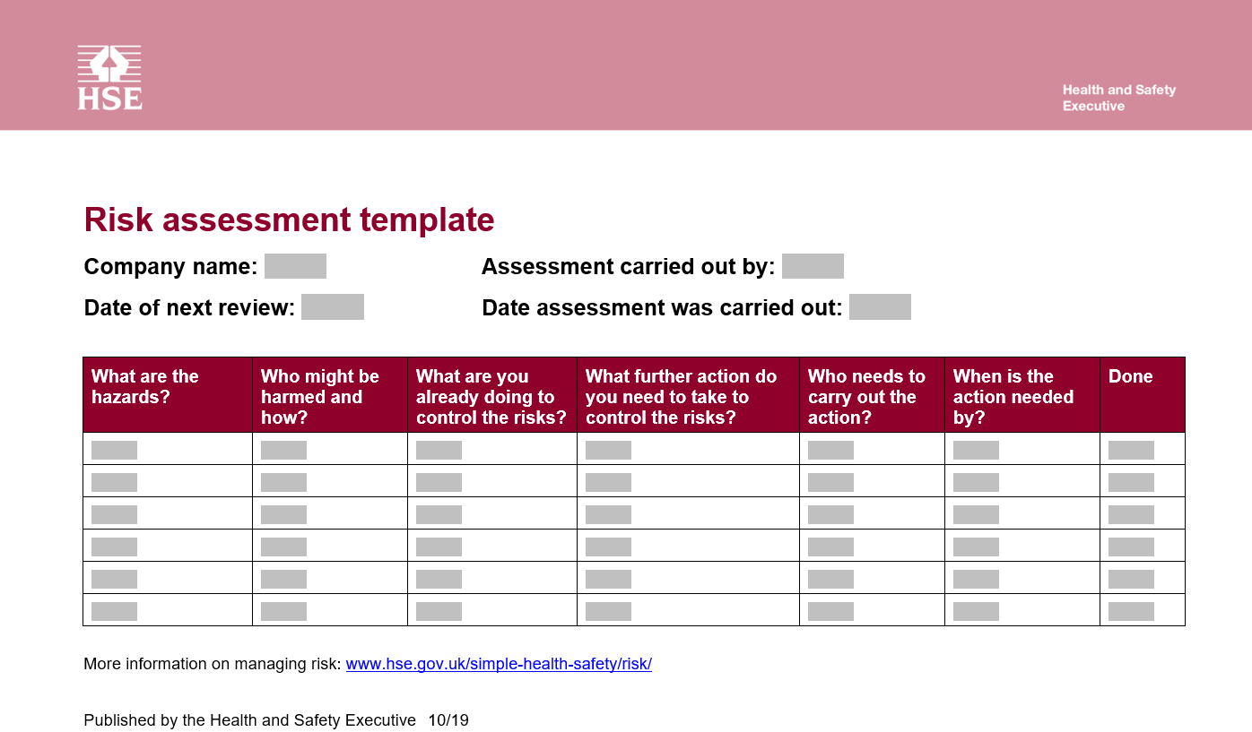
Figure 1, Risk assessment template and examples, sourced from HSE, 2025
3
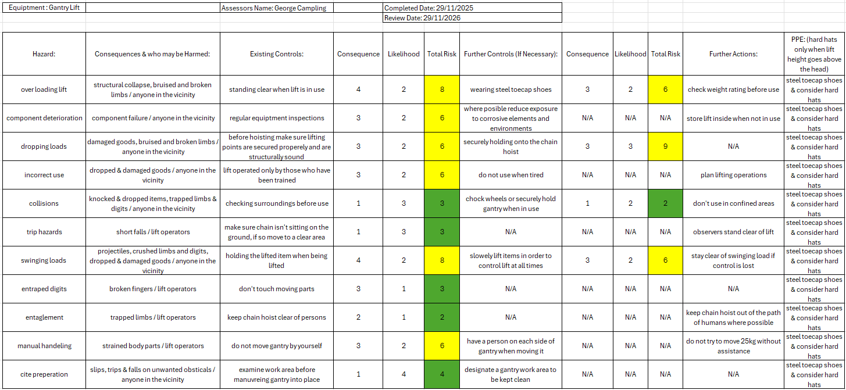
Figure 2, Gantry Lift Risk Assessment
4
“Gantry crane work has clear hazards” (Yuantai Crane 2025). Steel toecap shoes should be worn at all times when in the workshop and “Hard hats are a non-negotiable in crane areas where loads move over head” (Yuantai Crane 2025).

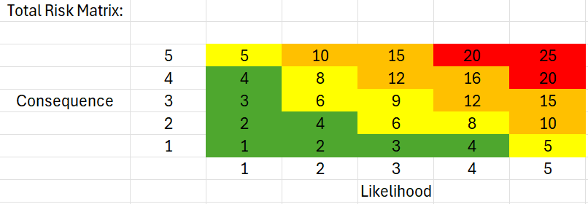
Figure 3, Gantry Lift Risk Assessment, Total Risk Matrix

5
Chapter 3 – Security Risk Matrix:

3.1 – Identifying Threats
As the world becomes more modernised and reliant on technology, and new more connected and autonomous vehicles becoming ever more prevalent, this leaves our technology and vehicles at more at risk to security threats. Identifying these risks is of the utmost importance.

- Data breaches and tampering
Cyber criminals use data breaches to access personal and sensitive customer information, such as financial details (Brokers, F.& C.I. 2025). Tampering can also lead to loss of valuable sales analytics, leading to potentual profit loss (Brokers, F.& C.I. 2025).
- Vehicle hacking
Modern vehicles are increasingly more connected, and collect the driver’s data and personal information, making them a target (Brokers, F.& C.I. 2025). Autonomous vehicles are also vulnerable to remote hacking. “Remote hacking can allow hackers to take control of critical functions such as braking, steering, and acceleration, creating severe saftey risks.” (Brokers, F.& C.I. 2025).
- Ransomware attacks
Business operations are under severe threat of ransomware attacks, where information is held captive and payment is demanded for the release. These attacks will be costly due to ransom payment, and additional information recovery efforts (Brokers, F.& C.I. 2025).

6
- Supply chain vulnerabilities
Vulnerabilities in a providers security system, may lead to compromising the entire supply chain (Brokers, F.& C.I. 2025). This can, and in most cases will lead to costly time and financial losses.

3.2 – Security Risk Matrix
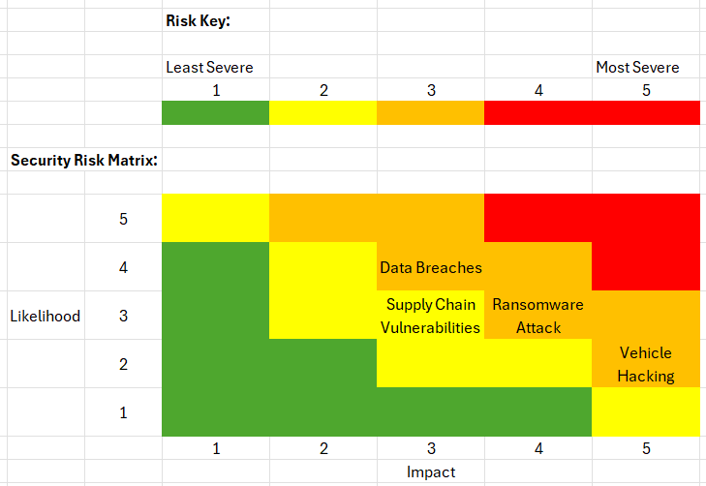
Figure 4, Security Risk Matrix
Figure 4 shows, the above security risks, put into a risk matrix that is ranked against likelihood and the severity of the impact.

7
3.3 – Engineering Response
Data breaches and ransomware attacks pose similar levels of risk towards an engineering firm so “enhancing the cyber security of physical systems, such as autonomous vehicles” is something that must be taken seriously for maximum security (Crane, Horowitz, and Lucero 2016).
Proportionate responses to prevent these risks would be to use “system-aware” security such as multi-layer authentication and using multiple save files (Crane, Horowitz, and Lucero 2016).
Multi-layer authentication is used very commonly and utilises multiple stages to a sign in process. Only those who are linked to the account and know the passwords can gain access.
In the event of holding sensitive documents (a prime target of ransomware) having multiple copies of the document in different save states or hard drives, would not prevent finacial losses, but diminish the losses, as key sales data is still held.

8
Chapter 4 – Engineers Role in Society:

4.1 – Code of Conduct for Engineer
In an industry as critical as engineering, it is important that all engineers adhere to a set of key personal and professional values, this is known as a code of conduct. Both the IMechE and IStructE publish their ideas on key engineering values.
Both Institutes state that those who take on a job must be competent for their role, demonstrate astuteness and put effort towards learning modern engineering skills (IMechE, 2025)(IStructE, 2025).

4.2 – Engineers Responsibility to Sustainability in Motorsport
The most important value to be seen in more modern codes of conduct, is an engineer’s responsibility towards sustainability and the enviroment (IMechE, 2025).
Maintaining public relations and showing that motorsport is playing its part to sustainability is now key, as the global spotlight falls on engineers to find solutions to the ever prevalent enviromental issues. To do so showing honesty, taking action and note of the public interest of all parties, is necessary (IMechE, 2025)(IStructE, 2025). King Charles III has called engineers to begin “working with the enviroment rather than directing it, and moving towards a sustainable society” (Ashley, 2012). This states that engineers can no longer just acknowledge the enviroment but must now interact and work with it at all times.
For an engineering project or process to be deemed as a success it must bring enhancements to the users lives, whist not effecting other parties in a negative manor, or to “degrade their quality of life or that of future generations” (Chacon-Hurtado et al, 2023). The authors do not solely speak of the product or result of the project, but the effect it could have on the enviroment. As an example, this means that motorsport should move away from burning fossil fuels as this pollutes the enviroment that everyone breathes.
9
Chapter 5 – Problem Solving:

Engineering as a concept and as an industry is based entirely upon problem solving, and there are multiple ways to approach solving any dilemma. It is also a key skill that any engineer must carry as well as it being something key that “engineering students must learn… to be successful in the workplace” (Jonassen, Strobel and Beng Lee, 2006).
Problem solving is never considered to be easy, but can have very simple solutions, such as brainstorming or analysing the root cause of the issue (the knowledge academy, 2025). Working as a team, being the most common way to work in engineering, offers extra perks, as one is not confined to solve an issue alone, but could receive feedback or insight from a colleague, finding a solution (the knowledge academy, 2025).
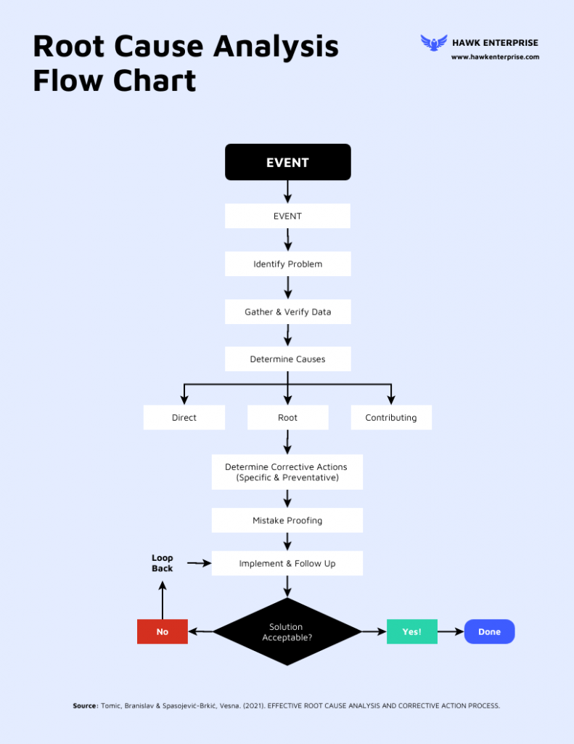
Figure 5, Root Caused Analysis Flow Chart, Sourced from Venngage, 2025
10
Figure 5 as seen above shows a simplified guide to how an engineer should approach analysing a problem, and how to fix this.
Flow charts are used commonly in engineering as they excel in simplicity and clarity. They indicate clear starting points, which can often be the hardest part of a job (Ramuthi 2025).
The first and most important step to problem solving, is to fully understand the problem, and fully articulate the details to other team members (provided one is working in a team), if not correctly done time and material will be wasted (Ramuthi, 2025).
Once a solution is drawn up, it is almost equally important to fully analyse said solution, as it is to understand the problem. Small alterations lead to small steps back in the process but can be resolved quickely if the analysis process is kept simple. (Ramuthi, 2025). Iterative design can also be implemented if further issues arise after product release.

11
Chapter 6 – Team Structuring:

6.1 – Personal Review
When I was in college, studying a mechanical engineering T-Level, from the very start of the course we were made to understand the importance of working in and as a team in engineering.
As a student, we were made to take up multiple team projects, ranging from researching and presenting on a topic, or workshop practice, most notably of which was to design a marble run on CAD software, and later make it in the workshop.
I was working in a team of four people for this task, at the time we opted for a functional team structure, where people were assigned jobs according to their expertise (Asana, 2025). In my case, and as the CAD enthusiast it was my job to design the tricky automatic marble re-loading mechanism. Others in the team were given jobs such as track design, machinist (laser cutters and mills were used in the manufacturing process) and head of assembely.
There are many positives to using a functional structure, in this case the positives that I saw are as follows:
- Everyone being suited to their part of the project
- Everyone being productive and efficient
- Valuable practice recived, in our chosen role
In terms of negative effects that I saw to using a functional structure, in a project as small as ours was very minimal:
- Over efficiency, in some cases jobs were being completed too quickely and people were left with nothing to do for a period of time
- Communication across parties wasn’t always concise

6.2 – Team Structure Options
When forming our team, we found it to be important to recognise people interests and expertise (Herro, et al, 2021). However, as part of our journey to becoming engineers, it may have been more appropriate for us to have used a hierarchical system, such as those seen in almost all large engineering firms (Asana, 2025).
12
Between the four of us, this would have meant we needed to elect someone for a leadership role, then split the remainders off into their own teams (Asana, 2025). For a small team project such as ours, a hierarchical approach most likely would not have proved as efficient or practical as the functional structure we used, but I maintain that it would have been interesting as an experiment, to have tried opting for a more professional and industry standard approach to a team project.

13
Chapter 7 – Conclusion:

This report may not have covered all of everyone’s opinions on what basic skills an engineer should have, but it does cover the fundamentals.
The most important thing the modern engineer should have from an ethical standpoint, is to have a deep understanding of working towards improved sustainability and caring for the environment.
However, the practical modern engineer should also have a deep understanding of all topics discussed, especially problem solving. An engineer can only be successful if they have the ability to problem solve.

14
Reference List:

- Asana (2025) Team structure: 10 ways to organize your team [2025] • asana, Asana. Available at: https://asana.com/resources/team-structure (Accessed: 03 December 2025).
- Ashely, R. (2012), The Role of the Civil Engineer in Society: Engineering Ethics and Major Projects, (Vol 165, Iss 3, August) p. 99, Availible at: https://www.proquest.com/docview/1081180915?accountid=130472&sourcetype=Scholarly%20Journals (Accessed: 02 December 2025).
- Brokers, F.& C.I. (2025) Top five cyber threats to the UK motor sector, Fleet Commercial Insurance Brokers. Available at: https://www.fleetandcommercial.co.uk/updates/top-five-cyber-threats-to-the-uk-motor-sector (Accessed: 30 November 2025).
- Chacon-Hurtado, D. et al, (2023), Engineering for Human Rights: The Theory and Practice of a Human Rights-Based Approach to Engineering, (Vol 49, Iss 4, 28 November) pp. 898-934, Availible at: https://journals.sagepub.com/doi/10.1177/01622439231211112 (Accessed: 02 December 2025).
- Crane, E, Horowitz, B, and Lucero, S. (2016) ‘SYSTEM-AWAIR CYBER SECURITY: A SYSTEMS ENGINEERING APPROACH FOR ENHANCING CYCBER SECURITY’, Insight, Volume 19, Issue 2, July. Availible at: https://incose-onlinelibrary-wiley-com.ezproxy.uwtsd.ac.uk/doi/epdf/10.1002/inst.12087 (Accessed: 30 November 2025).
- Herro, D. et al (2021), ‘Exploring graduate students’ collaborative problem-solving in engineering design tasks’, Journal of Engineering Design, (Vol 32, Iss 9, 07 May) pp. 496-516, Availible at: https://www-tandfonline-com.ezproxy.uwtsd.ac.uk/doi/full/10.1080/09544828.2021.1922616#d1e259 (Accessed: 03 December 2025).
- HSE (2025) Controlling noise at work, HSE. Available at: https://www.hse.gov.uk/pubns/books/l108.htm (Accessed: 29 November 2025).
- HSE (2025) Lifting operations and Lifting Equipment Regulations 1998 (LOLER), HSE. Available at: https://www.hse.gov.uk/work-equipment-machinery/loler-overview.htm (Accessed: 29 November 2025).
15
- HSE (2025) Managing risks and risk assessment at work, HSE. Available at: https://www.hse.gov.uk/simple-health-safety/risk/risk-assessment-template-and-examples.htm (Accessed: 29 November 2025).
- HSE (2025) Manual handling at work, HSE. Available at: https://www.hse.gov.uk/msd/manual-handling/index.htm (Accessed: 29 November 2025).
- HSE (2025) Provision and use of Work Equipment Regulations 1998 (PUWER) - overview, HSE. Available at: https://www.hse.gov.uk/work-equipment-machinery/puwer-overview.htm (Accessed: 29 November 2025).
- IMechE (ed.) (2025) Code of conduct explained, IMechE. Available at: https://www.imeche.org/about-us/imeche-governance/governance-and-finance-reviews/code-of-conduct-explained (Accessed: 02 December 2025).
- IStructE (ed.) (2025) Our code of conduct - the institution of structural engineers, IStructE. Available at: https://www.istructe.org/about-us/istructe-code-of-conduct/ (Accessed: 02 December 2025).
- Jonassen, D, Strobel, J, and Beng Lee, C. (2006) ‘Everyday Problem Solving in Engineering: Lessons for Engineering Educators’, Journal of Engineering Education, Vol 19, Iss 2, pp.139-151. Availible at: https://onlinelibrary-wiley-com.ezproxy.uwtsd.ac.uk/doi/epdf/10.1002/j.2168-9830.2006.tb00885.x (Accessed: 02 December 2025).
- the knowledge academy (2025) 25+ most effective problem-solving techniques explained, the knowledge academy. Available at: https://www.theknowledgeacademy.com/blog/problem-solving-techniques/ (Accessed: 03 December 2025).
- Ramuthi, D. (2025) What is a problem-solving flowchart & how to make one, Venngage. Available at: https://venngage.com/blog/problem-solving-flowcharts/ (Accessed: 03 December 2025).
- Yuantai Crane (2025) What PPE is required for Gantry Crane Operation?, What PPE is required for gantry crane operation? - Yuantai Crane. Available at: https://www.yuantaicrane.com/news/ppe-required-for-gantry-crane-operation.html (Accessed: 29 November 2025).
16

