

Assignment Title: Assignment 1
Module : Cloud Based Web Services
Module Code: ACCA6024
Student Name: Michelle Chalmers
Student Number: 1809316

Abstract
Selecting the best API type is not a straightforward process. As can be seen from this report there is no one solution that is guaranteed to out-perform others.
Deciding which is more suitable may come down to assessing all elements, rather than assuming that the latest is the best. There is a myriad of areas to consider when choosing the correct API for your needs, from your developer’s skills, bandwidth considerations, security elements, the data/systems and the transfer protocols you need to be able to use.

Table of Contents
Abstract 1
Table of Figures 2
Introduction 2
1. SOAP 2
1.1 Positives 3
1.2 Negatives 3
2. REST 4
2.1 Positives 5
2.2 Negatives 6
3. GraphQL 7
3.1 Positives 8
3.2 Negatives 8
4. How They Compare 8
5. Conclusions 9
References 11

Table of Figures
Figure 1 - Stateless versus stateful 3
Figure 2 - the layered system 6
Figure 3 - over-fetching 7
Figure 4 - each server with different data will need its own schema 8

Introduction
Wherever applications on disparate platforms need to exchange information there is a need for an application between them, acting as a bridge. These APIs (Application Programming Interfaces) are the interface for these programs. It creates the interoperability essential to most sites and apps. [1]
These days APIs are a market in themselves with the API Economy, and there are design standards for each.
‘While there were only a handful of APIs in 2005, there are now over 19.000 APIs online, with almost 2300 published in 2017’ [2]

1. SOAP
Simple Object Access Protocol was released by Microsoft in 1999 [3]. It uses a fixed XML message format and conforms to rigid standards. Because of the large message format of XML it is the most verbose of the APIs.
SOAP has a tight coupled server and client relationship, making the API more built for purpose than flexible. The front and backend both have to be changed if you are updating one. Tight coupling can be ideal where you are creating a small API that has one purpose with limited changes expected during its lifetime.
Supports both Stateful and Stateless operations. Stateful remembers information from the first message allowing the chaining of further messages without the need to resend information from the initial message (ie. a holiday website will remember your dates). Stateless isolates requests so each message is new to the server.
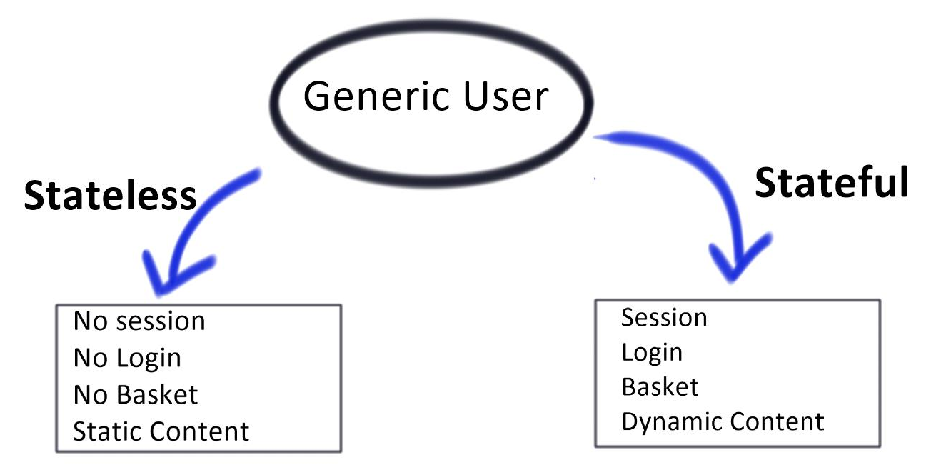 [4]
Figure 1 - Stateless versus stateful
SOAP is used by Salesforce [5] and is popular within finance and banking as it can utilise a WSS (web services security) extension. This security allows several signature formats and encryption algorithms and the ability to sign messages, encrypt, and/or attach security tokens. It is commonly used internally within a network.

1.1 Positives
Can generate useful error messages in XML, so it is easier to troubleshoot.
With the WSS extension it becomes very secure.
Supports stateful and stateless operations.
Uses a large number of transfer protocols [6], such as:
- HTTP (Hyper Text Transfer Protocol)
- SMTP (Simple Mail Transfer Protocol)
- FTP (File Transfer Protocol)
- JMS (Java Message Service)

1.2 Negatives
Uses XML only [6]. XML files contain a large amount of metadata which creates large messages/files. It requires more bandwidth than other APIs and can be server heavy.
It is tightly standardised, and protocol based and has a sharp learning curve.
The tight coupling can be inflexible as any changes need to be made on both sides.

2. REST
Representational state transfer is currently the most common API style. It was created by Roy Fielding in 2000 following his doctoral dissertation ‘Architectural Styles and
the Design of Network-based Software Architectures’ [7]. It is stateless and uses HTTP explicitly. It is not actually a standard, but an architectural style.
REST does not specify any data formats but commonly uses XML, JSON, HTML, RSS and CSV. [8]
Instead of the fixed structure of SOAP it has six guiding constraints that a REST API should have. These are not fixed requirements, and an API that complies with some of these but not all, can still be regarded as being RESTful:
- Uniform interface with one naming convention, one data format and one endpoint format.
- Caching. Although REST is stateless it can use HTTP caching to cache data that will need resubmitting.
- Code On Demand is optional. COD can send an executable, such as an encryption key, from the server at the request of the client. There are constraints in order to be able to utilise it though, and not all APIs will need it.
- Client-Server architecture. Raw data returned by the server can be processed on a PC. In theory this reduces network traffic and server load. Either the client or server can be changed without impact providing the interface remains unchanged, providing flexibility.
- Layered system - the client doesn’t know what is beyond the API. This gives good scalability with servers and allow commands to be changed with relative ease.
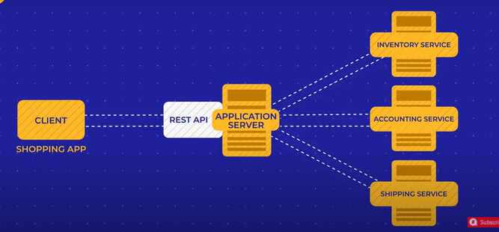 [9]
Figure 2 - the layered system
Resourced based it uses HTTP methods (HTTP verbs) to send data to a server – GET, POST, PUT and DELETE usually, but not limited to these.
It is loosely coupled so components are independent - one can be changed without it affecting the other, giving flexibility. [10]
Sometimes called REST-in-peace there is a mis assumption that companies are moving away from REST. In fact, it is still relevant and remains the most popular API type, with WordPress, Human Made, and Amazon Simple Storage Service using it.

2.1 Positives
REST is quite intuitive, and developers may find it less difficult to master than some other APIs. There is also a large community of REST developers able to provide advice and support.
Caching is available on a HTTP level, reducing the amount of data being resent and mitigating to some extent the potential inconvenience of being stateless.
Uses a wide range of data and feed data formats, such as:
- JSON (JavaScript Object Notation)
- XML (Extensible Markup Language)
- YAML (YAML Ain’t Markup Language)
- RSS (Rich Site Summary)
- SUP (Simple Update Protocol)

2.2 Negatives
With there being no fixed structure or rules there is no ideal way to build the API. This lack of structure can make development more difficult as each situation will call for a fresh approach.
Chattiness – over-fetching and under-fetching. REST relies on the server to decide what data is returned, which will often be far more than needed but in some cases can be lacking and create the need for another query to be made. In this example requests were for small pieces of information. But an excessive amount of detail has been returned:
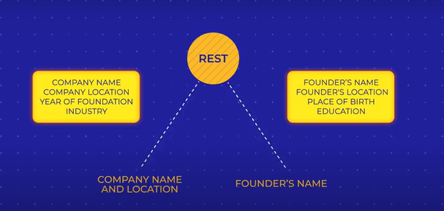 [9]
Figure 3 - over-fetching

3. GraphQL
As the demands on the Facebook app increased, the app became slow and inclined to crashing. It was using a REST API and in 2012 Facebook developed a new query language, GraphQL, to solve the problem of the REST API over-fetching. In 2015 this was released, open source, to the public.
‘When we [Facebook] built GraphQL in 2012 we had no idea how important it would become…and didn’t anticipate its value…’ [11]
GraphQL sends a precise data query, and precise data is returned. This is known as declarative data fetching. [12]
Front-end developers are able to run queries over the back-end more efficiently than with previous APIs [13], and GraphQL is sometimes described as front-end directed API technology.
Requires a schema(s) which defines what it is able to do. This schema provides the client with information about the data structure on the server – resources, relations and fields.
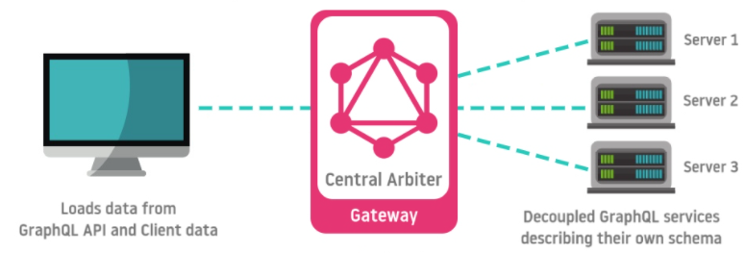 [14]
Figure 4 - each server with different data will need its own schema
The precise way it runs queries makes it ideal for mobile apps and many apps already use GraphQL, including Twitter, Pinterest, Wayfair and PayPal. [15]

3.1 Positives
Works well with queries involving linked relationships.
There are no versions to consider as it is constantly evolving.
Permissions can be set - private data will not be revealed unless permission has been granted.

3.2 Negatives
Creating the schema can be a challenging and time-consuming process.
It may require learning a new skill in order to create GraphQL APIs, as it is still relatively new. Unless you are heavily invested in using GraphQL it may be easier to use other options.
Regardless of whether the query succeeded or failed, it always returns with HTTP status 200. Without any error information it can be difficult to trouble shoot issues.
Although good for queries across linked relationships, it can perform poorly on complex queries.
Lacks built in caching support, so you have to create it yourself.

4. How They Compare
It’s impossible to provide a definitive answer to which is better as studies and papers differ in their findings. Some state that GraphQL performs better than REST:
‘… GraphQL requires less effort to implement remote service queries, when compared to REST.... These gains increase when REST queries include more complex endpoints …’ [16]
Another provides data confirming that REST performs better:
‘… GraphQL has the worst performance in all test cases regardless of the database used. REST has best performance in most of the test cases and SOAP showed more spread in the results...’ [17]

There is also evidence that it is a mix of results:
‘… no differences in performance during the operation of adding, editing and deleting data… display operation under heavy load conditions…GraphQL had a better performance …downloading large portions of data REST…exhibited a higher performance.’ [18]

5. Conclusions
It seems that at present there is not enough data or studies to absolutely define which is better. The environment, data, network, testers and quality of API will all have an impact on the final results.
There will be cases where the evidence may be the long term use of one over another. For instance GraphQL was built for a purpose – mobile app performance. Given the number of large companies that rely heavily on mobile apps and have moved to using GraphQL, there is a strong case to suggest that this is where it thrives. There is inadequate evidence that it out-performs other APIs on other platforms.
Development
SOAP and GraphQL is often regarded as more difficult to master than REST.
Caching
SOAP can be Stateful so there is no need to create an additional cache.
Although Stateless REST can utilise caching at a HTTP level.
GraphQL is Stateless and requires an additional caching module to be created if you need to cache data.
Security
SOAP is able to make use of a WS Security extension in order to provide high level encryption.
REST supports Code on Demand and is able to generate an encryption key.
GraphQL supports the setting of permissions to limit data visibility.
Flexibility for Change
With it's tight-coupled relationship SOAP is less change-friendly than REST or GraphQL, as the front and back end both need to be updated. It may not be ideal for fast evolving systems needing frequent modifications.
Performance
SOAP and REST use XML so create large files carrying an excess of data.
REST is known for over and under-fetching. It would need to make several data requests to complete a query that GraphQL will complete in one, as it leaves unnecessary data behind.
GraphQL is regarded as being more efficient as it queries precise data, and returns with just the requested data.
Schema
Only GraphQL uses a schema, which pre-defines how the data is structured on the server. It handles data as a graph and is better for queries over linked relationships than complex queries over flat data, which REST would handle better.

References

[1] | John-Paul Kamath, "computerweekly," 26 02 2008. [Online]. Available: https://www.computerweekly.com/feature/APIs-lead-the-way-to-better-interoperability. [Accessed 21 08 2021].
[2] | "freedomlab.org," 18 05 2018. [Online]. Available: https://freedomlab.org/wp-content/uploads/2018/05/Macroscope-NO146_The-API-Economy.pdf. [Accessed 21 08 2021].
[3] | "FPO," [Online]. Available: https://www.freepatentsonline.com/6782542.html. [Accessed 31 08 2021].
[4] | M. Conran, "Network, Security and Cloud," [Online]. Available: https://network-insight.net/2015/06/citrix-netscaler-application-delivery-controllers/. [Accessed 29 June 2021].
[5] | "Salesforce," [Online]. Available: https://developer.salesforce.com/docs/atlas.en-us.api.meta/api/sforce_api_quickstart_intro.htm. [Accessed 21 07 2021].
[6] | "alexsoft," 20 08 2019. [Online]. Available: https://www.altexsoft.com/blog/engineering/what-is-soap-formats-protocols-message-structure-and-how-soap-is-different-from-rest/. [Accessed 20 07 2021].
[7] | R. T. Fielding, "The Donald Bren School of Information and Computer Sciences," 2000. [Online]. Available: https://www.ics.uci.edu/~fielding/pubs/dissertation/fielding_dissertation.pdf. [Accessed 21 08 2021].
[8] | "arts management systems," [Online]. Available: https://help.theatremanager.com/theatre-manager-online-help/rest-api-output-formats. [Accessed 21 07 2021].
[9] | "altexsoft," [Online]. Available: https://www.altexsoft.com/blog/soap-vs-rest-vs-graphql-vs-rpc/. [Accessed 29 June 2021].
[10] | Kristopher Sandoval, "nordic apis," 19 08 2020. [Online]. Available: https://nordicapis.com/the-difference-between-tight-coupling-and-loose-coupling/. [Accessed 21 07 2021].
[11] | Lee Byron, "Facebook Engineering," 14 09 2015. [Online]. Available: https://engineering.fb.com/2015/09/14/core-data/graphql-a-data-query-language/. [Accessed 31 08 2021].
[12] | Nilan Marktanner, "css-tricks.com," 13 10 2016. [Online]. Available: https://css-tricks.com/declarative-data-fetching-graphql/. [Accessed 21 07 2021].
[13] | Nilkanth Patel, "dev.to," 27 09 2019. [Online]. Available: https://dev.to/nilkanthjp/why-graphql-is-the-ideal-api-language-for-frontend-engineers-4alm. [Accessed 21 07 2021].
[14] | "devathon," [Online]. Available: https://devathon.com/blog/graphql-vs-or-rest/. [Accessed 29 June 2021].
[15] | "graphql," [Online]. Available: https://graphql.org/users. [Accessed 31 08 2021].
[16] | M. T. V. Gleison Brito, "REST vs GraphQL: A Controlled Experiment," 2020.
[17] | J. R. Pontus Erlandsson, "PERFORMANCE COMPARISON Between GraphQL,REST & SOAP," 2020.
[18] | M. D. Mateusz Mikuła, "Comparison of REST and GraphQL web technology performance," Journal of Computer Sciences Institute, July 2020.

