Milton Friedman Was Wrong
The famed economist’s “shareholder theory” provides corporations with too much room to violate consumers’ rights and trust.
AUGUST 22, 2019
Eric Posner
Professor at the University of Chicago Law School
Enjoy unlimited access to The Atlantic for less than $1 per week.
Sign in
Subscribe Now
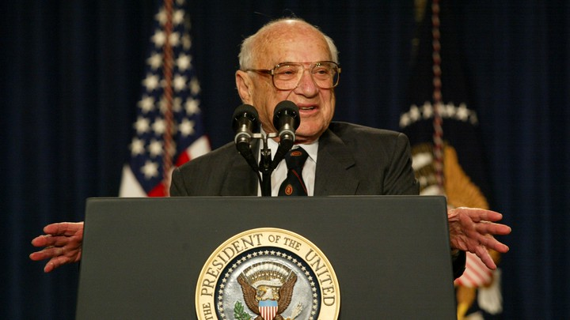ALEX WONG / GETTY IMAGES

- Link Copied

On Monday, the Business Roundtable, a group that represents CEOs of big corporations, declared that it had changed its mind about the “purpose of a corporation.” That purpose is no longer to maximize profits for shareholders, but to benefit other “stakeholders” as well, including employees, customers, and citizens.
While the statement is a welcome repudiation of a highly influential but spurious theory of corporate responsibility, this new philosophy will not likely change the way corporations behave. The only way to force corporations to act in the public interest is to subject them to legal regulation.
Get the news, without the noise.
Subscribe to The Atlantic Daily for our editors’ guide to what matters in the world.

Email Address (required)
Sign Up

Thanks for signing up!
The shareholder theory is usually credited to Milton Friedman, the University of Chicago economist and Nobel laureate. In a famous 1970 New York Times article, Friedman argued that because the CEO is an “employee” of the shareholders, he or she must act in their interest, which is to give them the highest return possible. Friedman pointed out that if a CEO acts otherwise—let’s say, donates corporate funds to an environmental cause or to an anti-poverty program—the CEO must get those funds from customers (through higher prices), workers (through lower wages), or shareholders (through lower returns). But then the CEO is just imposing a “tax” on other people, and using the funds for a social cause that he or she has no particular expertise in. It would be better to let customers, workers, or investors use that money to make their own charitable contributions if they wish to.

MORE BY THIS WRITER

The Trouble Starts If Facebook’s New Currency Succeeds
ERIC POSNER

House Democrats Have More Potent Options Than Impeachment
DANIEL HEMEL ERIC POSNER

The Anti-monopoly Backlash Reaches the Supreme Court
ERIC POSNER
Read: The inadequacy of corporate social-responsibility programs
Friedman’s theory was wildly popular because it seemed to absolve corporations of difficult moral choices and to protect them from public criticism as long as they made profits. At the same time, it took CEOs down a peg—yes, they were resented even in 1970—by denying that they were visionaries with public responsibilities. And Wall Street saw dollar signs in the single-minded devotion to corporate profits.
But Friedman’s argument contained a contradiction that should have been evident even to readers back in 1970. He complained that business executives supported wage and price controls—a policy that President Richard Nixon would later implement. Friedman believed (with some justice) that wage and price controls would harm the economy. Thus, he claimed that the business executives, although “extremely far-sighted and clear-headed in matters that are internal to their business,” evidently became “short-sighted and muddle-headed” in matters of public import.
However, there is a simpler explanation for their behavior that does not require such a dubious theory of their psychology. Many business executives realized that wage and price controls would serve their business interest (no doubt by holding down the cost of labor and other inputs) and didn’t care whether they harmed the economy at large.
Friedman should have been, and probably was, aware of this possibility. An established business will make the most profits by eliminating competition; the tried-and-true method for doing that is to persuade the government to pass a law that discourages new firms from entering its market, or that in some other way reduces its costs. And if the purpose of a business is to “increase its profits,” as Friedman argued, then it is not only “clear-headed,” but also justifiable for a business to use its political influence to dismantle the free market that Friedman cherished.
Read: What GOP economists don’t understand about Milton Friedman
Indeed, the notion that the big public corporations are tribunes for the free market is quixotic. Big corporations are islands of socialism within our market economy: Their bigness protects them from competition for customers and workers. Because investors of capital benefit when product and labor markets are monopolized, CEOs are only too happy to accommodate them.
There are other, all-too-familiar ways that Friedmanesque businesses can maximize their profits. They can (like Facebook) break promises to respect their customers’ privacy. They can (like Twitter and Google) generate ad revenue by facilitating the transmission of hate speech. They can (as Exxon used to do) propagandize against climate science. They can (like Jimmy John’s) use illegal contract terms to deter their low-skill workers from quitting low-paying jobs. They can (like the tobacco companies and now the tech companies) push addictive products onto children, or (like Purdue Pharma) create a generation of drug addicts. And they can engage in corporate lobbying. The biggest problem with Friedman’s theory is that corporations can—and, according to his theory, should—use their influence in Congress to block laws that stop corporations from causing such harms.
Nor was Friedman correct that business executives are the employees of the shareholders. Legally, business executives are employees of the corporation, which—crucially—they, not the shareholders, control. The shareholders have a contractual relationship with the corporation that entitles them to a share of its profits and a vote on certain major corporate decisions. Time and again, CEOs have used their power over the corporation to bat away shareholders when they propose that the corporation should act in a socially responsible way. When an employer says “jump” to an employee, the employee jumps. When shareholders say “jump” to the CEO, the CEO sues them.
Friedman’s strongest point was that business leaders are rarely qualified to determine the best public use for corporate funds. And that is why the switch to a “stakeholder” theory is hardly a guarantee that corporations will now act responsibly. The only proven way to stop corporations from polluting, defrauding, and monopolizing is to punish them through the law.
We want to hear what you think about this article. Submit a letter to the editor or write to letters@theatlantic.com.
ERIC POSNER is a professor at the University of Chicago Law School.

