Programme: HN/BSc Computing portfolio
Module: Changemakers: Creativity and Value Creation
Module Code: ACCA5033
Student Name:Sana Quyyam
Student ID: 2312087

Table of Contents
Introduction 3
Task 1: Project Management 3
Q1. Project Management & Planning 3
Q2. Project Design 4
Task 2: Innovation – Babylon Health 5
Q1. PEST & SWOT Analysis 5
PEST Analysis for Babylon Health 5
SWOT Analysis for Babylon Health 6
Q2. Project Implementation in a Large Organisation 7
Task 3: Project Reflection 8
Conclusion 9
References 10

Introduction
Cloud computing and artificial intelligence (AI) are transforming the educational environment with a mechanism of scalable, personalised learning which responds to the longstanding lack in attainment of STEM [1]. Study found that over 30% of 15-year-olds in the member states have not reached the minimum level of competence in mathematics, which prompts the necessity of new pedagogical approaches [2]. The existing empirical data reveal positive effects of AI-based tutoring systems on students as they provide prompt feedback, adjustable pace, and remedial actions. Cloud systems increase accessibility, in that they allow organisations to implement advanced analytics and learning applications without significant investment in local infrastructure [3]. However, a sizable portion of online learning systems is sterile, providing a limited degree of customisation and insufficient guidance to learners struggling with abstract mathematical and scientific ideas. With the combination of machine-learning models and cloud services, it will be possible to constantly improve learning paths based on learner data and behavioural patterns, thus creating more responsive and inclusive educational ecosystems [4]. The proposed project suggests that an Intelligent STEM Learning Support System should be created with the use of cloud-based AI applications to enhance the level of engagement, conceptual knowledge, and educational performance of learners. The system will strive to close learning gaps and provide practical insights to educators through the combination of adaptive tutoring, automated assessment, and real-time analytics. The strategy is compatible with the worldwide educational innovation policies that highlight the digital transformation, equity, and lifelong learning [2].

Task 1: Project Management

Q1. Project Management & Planning
The general objective of the project is to develop an Intelligent STEM Learning Support System that will tap cloud-based AI tools to improve engagement, conceptual understanding, and academic achievement in STEM education. The solution proposed includes adaptive tutoring, automatic assessment, and real-time learning analytics, thus providing students with personalised learning opportunities and educators with comprehensive information about learner progress and misconceptions [5]. The process of deployment will be supported by cloud computing infrastructure like Amazon Web Services (AWS) and Microsoft Azure to provide scalability and reduce infrastructural requirements, and the adaptive learning algorithms will be achieved with the help of AI frameworks, including Tensorflow and PyTorch [6]. Stored data, such as that of learners, grading results, and interaction history, will be held in relational or NoSQL databases, like MySQL or MongoDB; a front-end application built using ReactJS will ensure an easy user experience [3].
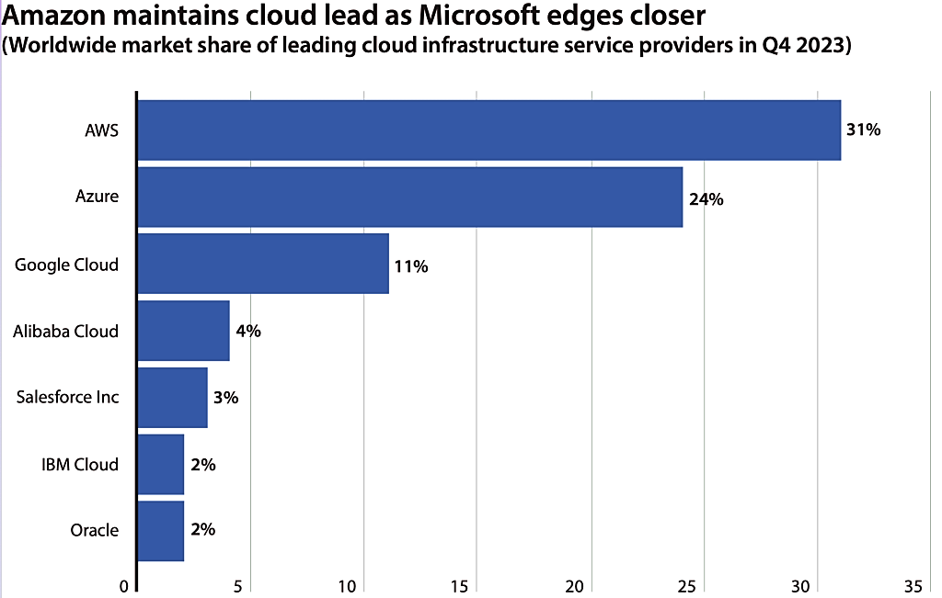

Figure 1: Cloud Computing Infrastructure [18]

The project is outlined in a 12-week time frame, with the first 2 weeks being used to analyse the requirement, after which system design will be undertaken in the 3rd and 4th weeks. Weeks 5 through 8th will be used in prototype development, weeks 9th and 10th will be pilot testing and feedback collection, and system refinement, which will culminate in the final deployment, will be done in weeks 11th and 12th. Agile approach to development has been used because of its iterative and adaptive quality that facilitates quick delivery of a module, continuous testing, and systematically incorporating feedback of the user [7]. The constraints include limited access to diverse students, adherence to the General Data Protection Regulation (GDPR) with regard to the learner data, and the possible costs of cloud services [1]. These tasks, milestones, and dependencies will be visualised in a Gantt chart that is generated using Microsoft Project, to schedule the tasks and monitor their progress appropriately.
Tasks | Timeline
 | Week 1 | Week 2 | Week 3 | Week 4 | Week 5 | Week 6 | Week 7 | Week 8 | Week 9 | Week 10 | Week 11 | Week 12
1. Requirements Analysis
2. System Design
3. Prototype Development
4. Pilot Testing & Feedback
5. System Refinement & Deployment

Q2. Project Design
The design of the project gives a high priority to structuring the system functionality and visualisation of data workflows to control further development. A Unified Modelling Language (UML) Use-Case diagram has been created to model the interaction between key participants, that is, students, educators, and system administrators [2]. The core use cases explain the submission of assessments, adaptive AI feedback, access to learning analytics, and the student progress review. This visualisation allows the stakeholders to understand how the system works and also establishes the requirements for the developers, and hence the ambiguity is reduced in the implementation process [5].

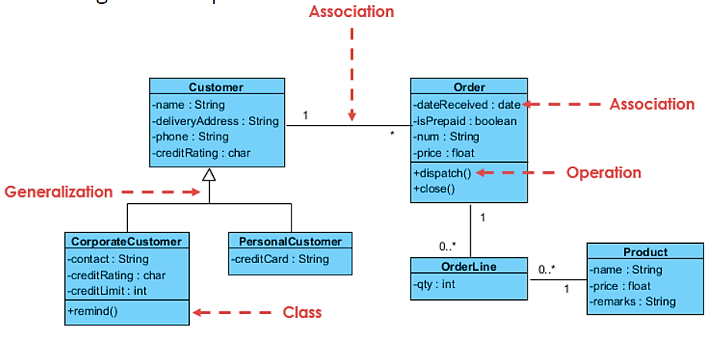

Figure 2:Unified Modelling Language [19]

Additionally, to the UML diagram, a flowchart is provided to outline the learning analytics module and present the processing of data on student performance. The flowchart begins by receiving data through the interaction logs with the students, followed by processing it through AI algorithms to identify any misconceptions, and the final stage is to provide the individualised learning recommendations [8]. The data is presented in interactive dashboards so that the students are able to receive immediate feedback, and the educators can track the trends and act in any case. These artefacts of design allow a development process to be iterative, allowing an early test of system logic and data-processing processes. Combining the UML and flowchart designs makes it clear in the system architecture, facilitates efficient coding, and keeps the development in line with the project goals [9]. The Gantt chart, UML diagram, and flowchart are examples of visual documentation that will have concrete proof of project planning and design, which will be used during evaluation, stakeholder communication, and refinement.

Task 2: Innovation – Babylon Health

Q1. PEST & SWOT Analysis
Babylon Health is a United Kingdom-based digital health technology firm that focuses on AI-powered telemedicine and teleconsultation [10]. The analysis of the main external and internal environments by applying PEST and SWOT models, respectively, can be used to design its innovation strategy and offer a systematic analysis of the political, economic, social, and technological factors and the organisational strengths, weaknesses, opportunities, and threats, respectively [11].

PEST Analysis for Babylon Health
Factor | Considerations
Political | Digital health initiatives supported by the government and collaboration with the National Health Service (NHS); policies that regulate the reimbursement of telemedicine; and regulations that relate to medical licensing in different jurisdictions [12].
Economic | The rising cost of care increases the need to implement telehealth; the inflow of investments into digital health; and the possible consequences of economic crises on patient adoption [2].
Social | Growing patient preference for remote, convenient healthcare services; ageing population that requires long-term care; levels of digital literacy influencing adoption [13].
Technological | Implementation of AI algorithms to evaluate symptoms and triage; utilisation of cloud computing to provide scalable services; cybersecurity conditions to preserve sensitive medical information [9].
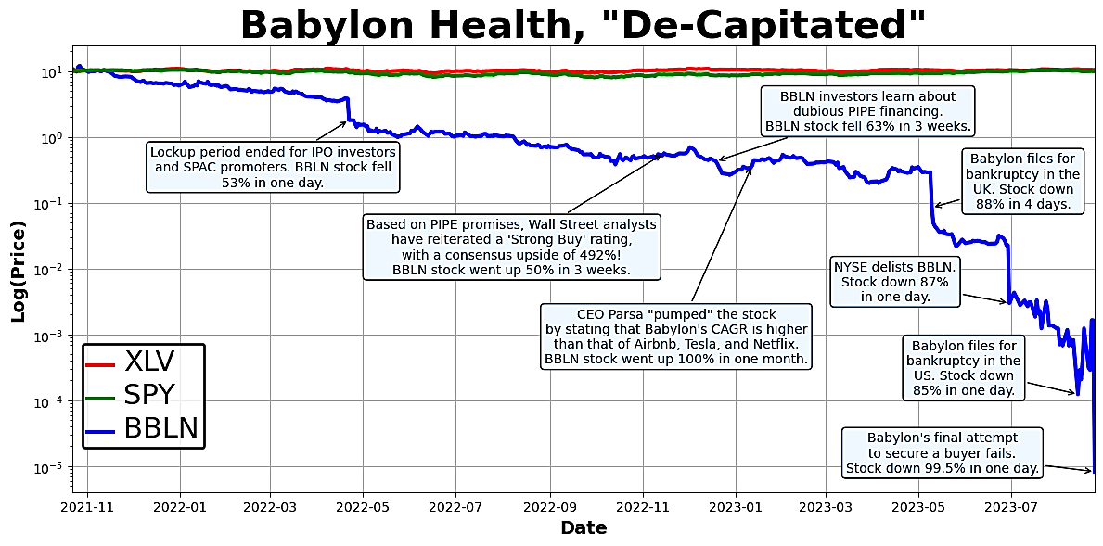
Figure 3: Babylon Health [20]

SWOT Analysis for Babylon Health
Category | Considerations
Strengths | AI-driven triage and telehealth visits; partnership with the NHS; scalable cloud computing system; strong brand identity [10].
Weaknesses | Dependency on internet connection and patient digital literacy; high costs of regulatory compliance; initial trusting barriers around AI diagnosis [6].
Opportunities | Entry into foreign markets; wearable devices integration; predictive analytics development; collaboration with insurance firms [1].
Threats | Increasing competition with telehealth start-ups and existing health providers, the threat of data breaches or cyberattacks, and alterations in government health policy, which affects reimbursement [11].

The Babylon Health industry has legal and ethical concerns that include the assurance of patient privacy, informed consent, AI transparency, and the suppression of algorithmic bias during symptom evaluation and triage [2]. The development of explainable AI systems is critical to ensure that the decision can be understood and relied upon by patients and medical workers. Adherence to health care standards and policies is indispensable to obtaining regulatory authorisation and maintaining trust in the integrity and dependability of digital health services [4].

Q2. Project Implementation in a Large Organisation
In case the proposed Intelligent STEM Learning Support System, which is based on artificial intelligence on a cloud, is introduced into the work of a large organisation, the successful implementation would require a complex set of conceptual frameworks, methodologies, and technologies [14]. In its theorisation, Agile software development provides a means of iterative design, systematic testing and staged deployment, thus providing an adaptive response to user feedback [15]. The DevOps paradigm would be concurrent, where continuous integration and delivery pipelines would be incorporated, and automated testing and monitoring performance would be introduced to ensure effective security and scalability [16]. Cloud systems like Amazon Web Services or Microsoft Azure would provide elastic storage, computing power and complex analytics, and containerisation, like Docker and Kubernetes orchestration, would provide the modular, multi-departmental deployment [1].
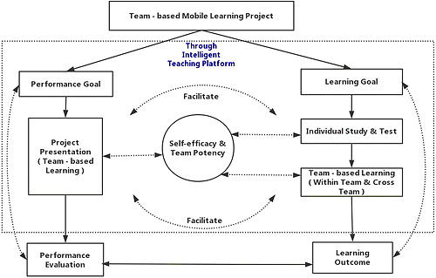

Figure 4: Intelligent STEM Learning Support System [21]

Maintenance would also involve continual checking of the fidelity of the artificial intelligence model, regular updating of teaching materials, and continuous improvement of algorithms to maintain precision and commentary. GitHub, a type of version control system, offers repository management tools and code versioning, whereas the task-management tools like Jira or Trello help keep track of the workflow and evaluate the progress [17]. Standards in healthcare must also be reflected in the ethical and regulatory compliance, which should provide a focus on the protection of the privacy of learner data, its accessibility, and inclusivity. It is essential to maintain regular audits and feedback systems, and to engage stakeholders in discussions to make the system evolve to match organisational goals and user needs [4]. Visualisation dashboards also put educators and administrators in a position to make data-driven decisions using tools of interpretation, which form the basis of continuous enhancement and sustainable implementation [7].

Task 3: Project Reflection
The opportunities to acquire a great variety of new technical, analytical, and project management skills will be offered through the proposed project, an Intelligent STEM Learning Support System based on cloud-based AI [12]. The project, technically, will enable me to have a practical experience on the implementation of AI and machine learning, training models to identify misconceptions and provide customised learning advice. My other expectations are to improve my proficiency in cloud computing infrastructure, like AWS and Microsoft Azure, to provide the ability to deploy applications and real-time data analytics on a large scale. I will also gain the necessary competence in software creation techniques, especially Agile and DevOps, which enable iterative creation, constant integration, and effective teamwork in cross-functional teams. System design will also support my skills in the requirements analysis, UML and flowchart visualisation, as well as the human-computer interaction, so that the final user experience is user-friendly and efficient [4].
These new skills can be used to make a positive impact on society. The system will be able to help promote educational equity and access, especially to students living in under-resourced communities that might not be well-equipped to use traditional classroom learning approaches [2]. Individualised AI responses can assist students in gaining confidence in complicated lessons, to think critically, solve issues, and learn throughout their lifetime [5]. Furthermore, the system has the potential to enhance data-driven decision-making by educators by offering actionable analytics, which can enhance the improvement of curriculum delivery, lessen learning gaps and increase inclusiveness of education. The creation of a digitally-competent and STEM-literate workforce in the long term would help society to become more innovative, economically developed, and create new technologies [8].
The project contains a number of threats and challenges despite the potential it holds. Technical risks involve the inaccuracy of the AI models or misdiagnosis of the misunderstanding on the part of the students, which might lower the effectiveness of the system. These risks may be avoided by means of stringent model testing, refinement, and monitoring the system performance [14]. Privacy and security risks are also highly significant, especially when working with student data; the adoption of stringent GDPR-compliant measures, encryption and safe authentication measures will minimise such risks [15].
Moreover, the problem with user adoption might occur when the students or teachers do not want to adopt the digital tools. This would be solved through training, easy user interfaces and user feedback during development. Lastly, the lack of resources, including the cost of cloud service or the unavailability of the participants to carry out testing, can hinder the progress [6]. These can be reduced by planning budgets, using free resources on the cloud and testing it with small groups of users.
Considering the presented project, it is important to note that it can be viewed as a great opportunity to develop personal skills, along with educating and influencing society in general. Through working with AI, cloud computing, and data analytics, I will be able to develop technical, analytical, and project management skills and gain practical experience in the design, deployment, and maintenance of innovative learning systems. Simultaneously, the project can lead to better outcomes of STEM education, inclusivity promotion, and data-driven teaching. This initiative is a lifelong learning, continual improvement, and significant advantage to the students, educators, and society in general through the integration of technical innovation, ethical, accessible, and inclusive strategies [7].

Conclusion
The Intelligent STEM Learning Support System suggested is an example of how modern technologies, artificial intelligence, and cloud computing can be used to address the obstacles of real-life educational issues. The system will be able to bring lasting educational value to learners by providing a practical solution that increases student engagement, understanding, and performance, and at the same time provides educational practitioners with practical learning analytics. The programme has the potential of providing sustainable benefits through careful project formulation, ethical development, and empirical practise supporting it. Also, it is a good source of development of technical, analytical, and professional skills that are imperative to the new computing careers. The combination of creativity, innovation and responsible implementation makes this endeavour congruent with the current educational needs, which promote long-term social and academic development of diverse learners in digital learning ecosystems in the world.

References
[1] F. Uche Ojika, W. Oseremen Owobu, O. Anthony Abieba, O. Janet Esan, B. Chibunna Ubamadu, and A. Ifesinachi Daraojimba, “The Role of Artificial Intelligence in Business Process Automation: A Model for Reducing Operational Costs and Enhancing Efficiency,” International Journal of Advanced Multidisciplinary Research and Studies, vol. 4, no. 6, pp. 1449–1462, Dec. 2024, doi: https://doi.org/10.62225/2583049x.2024.4.6.4046 Available: https://www.multiresearchjournal.com/admin/uploads/archives/archive-1744730118.pdf.
[2] OECD, "Review Education Policies - Education GPS - OECD," OECD.org, 2023. Available: https://gpseducation.oecd.org/revieweducationpolicies/#
[3] U. Ibrahim, “The Role of Cloud Computing in Transforming ICT Infrastructure in Educational Institutions,” International Journal of Applied and Scientific Research, vol. 2, no. 2, pp. 213–226, Feb. 2024, doi: https://doi.org/10.59890/ijasr.v2i2.1333 Available: https://journal.multitechpublisher.com/index.php/ijasr/article/view/1333.
[4] S. Qiu, “Improving Performance of Smart Education Systems by Integrating Machine Learning on Edge Devices and Cloud in Educational Institutions,” Journal of Grid Computing, vol. 22, no. 1, Mar. 2024, doi: https://doi.org/10.1007/s10723-024-09755-5
[5] L. K. Nhan, “THE ROLE OF AI IN ENHANCING PERSONALISED LEARNING, AUTOMATED ASSESSMENT, INTELLIGENT TUTORING, AND STUDENT ENGAGEMENT,” Turkish Online Journal of Distance Education, vol. 26, no. 4, pp. 55–76, Oct. 2025, doi: https://doi.org/10.17718/tojde.1612295
[6] P. D. Patel and P. J. Patel, “Scientific Substantiation of Vastu Shastra,” ITM Web of Conferences, vol. 65, Jul. 2024, doi: https://doi.org/10.1051/itmconf/20246502003. Available: https://www.researchgate.net/publication/382302764_Scientific_Substantiation_of_Vastu_Shastra
[7] A. Bhanushali, “Challenges and solutions in implementing continuous integration and continuous testing for agile quality assurance,” International journal of science and research, vol. 12, no. 10, pp. 1626–1644, Oct. 2023, doi: https://doi.org/10.21275/sr231021114758
[8] A. Bowman, “Student Learning Based Data Science Assisted Recommendation System to Enhance Educational Institution Performance,” International Journal of Intelligent Engineering and Systems, vol. 17, no. 4, pp. 172–187, Aug. 2024, doi: https://doi.org/10.22266/ijies2024.0831.14
[9] V. S. Rose and J. Wood, “Generalized Cluster Significance Analysis and Stepwise Cluster Significance Analysis with Conditional Probabilities,” Quantitative Structure-Activity Relationships, vol. 17, no. 04, pp. 348–356, Aug. 1998, doi: https://doi.org/10.1002/(sici)1521-3838(199808)17:04%3C348::aid-qsar348%3E3.0.co;2-c
[10] C. Bibi, R. Yadav, and J. Khatoon, “Revolutionizing the Healthcare Industry (Telehealth) with the Power of Artificial Intelligence,” CRC Press eBooks, pp. 51–75, May 2025, doi: https://doi.org/10.1201/9781032722092-3
[11] А. Мельник, “COMPARATIVE ANALYSIS OF STRATEGIC PLANNING FRAMEWORKS,” Економіка та суспільство, no. 73, Mar. 2025, doi: https://doi.org/10.32782/2524-0072/2025-73-122. Available: https://economyandsociety.in.ua/index.php/journal/article/view/5929
[12] J. Shinn et al., “Evolving Regulations in Telemedicine Pilot Project: Insights Into Law, Practice, and Patient Care through International Case Studies,” Journal of Korean Medical Science, vol. 40, no. 23, 2025, doi: https://doi.org/10.3346/jkms.2025.40.e181
[13] A. Bertolazzi, V. Quaglia, and R. Bongelli, “Barriers and facilitators to health technology adoption by older adults with chronic diseases: an integrative systematic review,” BMC public health, vol. 24, no. 1, p. 506, Feb. 2024, doi: https://doi.org/10.1186/s12889-024-18036-5. Available: https://pubmed.ncbi.nlm.nih.gov/38365698/
[14] Angeliki Boltsi, Konstantinos Kalovrektis, A. Xenakis, Periklis Chatzimisios, and Costas Chaikalis, “Digital Tools, Technologies and Learning Methodologies for Education 4.0 Frameworks: A STEM Oriented Survey,” IEEE Access, vol. 12, pp. 12883–12901, Jan. 2024, doi: https://doi.org/10.1109/access.2024.3355282
[15] A. S. Nwachukwu and K. E. Boatengu, “The Role of Agile Methodologies in Modern Software Development: A Comprehensive Analysis of Impact, Challenges, and Best Practices,” Business & IT, vol. XIV, no. 2, pp. 41–49, 2024, doi: https://doi.org/10.14311/bit.2024.02.05
[16] M. Moeez et al., “Comprehensive Analysis of DevOps: Integration, Automation, Collaboration, and Continuous Delivery,” Bulletin of Business and Economics (BBE), vol. 13, no. 1, Mar. 2024, doi: https://doi.org/10.61506/01.00253. Available: https://bbejournal.com/BBE/article/view/738
[17] Balu Nivrutti Ilag, A. P. Baljoshi, G. J. Sangale, and Yogesh Athave, Mastering GitHub Enterprise Management and Administration. 2024. doi: https://doi.org/10.1007/979-8-8688-0369-7
[18] False, “AWS Beats Azure to Top Global Cloud Computing Market Chart with a 31 percent Share,” Business Today, May 03, 2024. Available: https://businesstoday.lk/aws-beats-azure-to-top-global-cloud-computing-market-chart-with-a-31-percent-share/.
[19] Visual Paradigm, “What is Unified Modeling Language (UML)?,” Visual-paradigm.com, 2019. Available: https://www.visual-paradigm.com/guide/uml-unified-modeling-language/what-is-uml/
[20] Sergei Polevikov, “The Madoff of Digital Health: How Lies and the SEC’s Code of Silence Killed Babylon and Cost Investors $1.5 Billion,” Medium, Oct. 10, 2023. Available: https://medium.com/@AIHealthUncut/the-madoff-of-digital-health-how-lies-and-the-secs-code-of-silence-killed-babylon-and-cost-73f892849163
[21] Q. Zhu and M. Wang, “Team-based mobile learning supported by an intelligent system: case study of STEM students,” Interactive Learning Environments, pp. 1–17, Dec. 2019, doi: https://doi.org/10.1080/10494820.2019.1696838

