

University of Wales Trinity Saint David (UWTSD)
Programmed: MSc Cybersecurity and Digital Forensics
Module: Digital Forensics Analysis
Module code: ACCA7031
Name: Dip Patel
Student Id: 2530744

Table of Contents
No. | Content | Page No.
1 | Task 1: Research Report – Digital Forensics: Current State, Tools, Cybersecurity Convergence, Trends, Challenges, and the Job Market
1.1 | Introduction | 4
1.2 | Current State of the Field: Tools, Features and Capabilities | 5
1.3 | Intersection of Digital Forensics and Cybersecurity | 6
1.4 | Emerging Trends in Digital Forensics | 7
1.5 | Key Challenges | 8
1.6 | National and International Job Market | 9
1.7 | Conclusion | 10
2 | Task 2: Digital Forensic Investigation Report – Suspected Theft and Attempted Sale of Proprietary Patent Data
2.1 | Executive Summary | 12
2.2 | Case Background | 13
2.3 | Evidence Inventory and Chain of Custody | 14
2.4 | Methodology | 17
2.4.1 | Acquisition | 17
2.4.2 | Analysis | 19
2.4.3 | Cross-Device Correlation | 19
2.5 | Findings | 20
2.5.1 | Emma's Device (EXH-01) – Insider Source | 20
2.5.2 | Joe's Device (EXH-02) – Intermediary | 23
2.5.3 | Norman's Device (EXH-03) – Buyer Representative | 25
2.5.4 | Consolidated Timeline | 27
2.6 | Suspect Profiling | 28
2.7 | Additional Observations and Limitations | 29
2.8 | Conclusion | 30
2.9 | Recommendations | 31
3 | References | 32
4 | Appendix A: Full Screenshot Evidence Log | 33
A.1 | Acquisition Methodology (Demonstration Device) | 33
A.2 | Emma's Device (Huawei POT-LX1) – Extraction and Call Log | 36
A.3 | Emma's Device – WhatsApp Thread ("Top-up" / Joe), Full Sequence | 37

Task 1: Research Report

Digital Forensics: Current State, Tools, Cybersecurity Convergence, Trends, Challenges, and the Job Market

1.1 Introduction
Digital Forensics is the science of legally presenting electronic evidence of any kind, through the four-step process of identification, preservation, analysis and presentation. With organisations becoming more and more reliant on cloud platforms, mobile devices and inter-connecting networks, the discipline has progressed from a specialist law-enforcement tool to a fundamental part of enterprise cybersecurity and incident response (IR). This report is designed to be an overview of the state of digital forensics, some of the top tools and their capabilities, how digital forensics and cybersecurity overlap (using network forensics as an example), trends in digital forensics, challenges in the thick of digital forensics, and the national and international job market for digital forensics.

1.2 Current State of the Field: Tools, Features and Capabilities
In 2025-2026, the picture of available forensic toolkits is likely to be largely comprised of the handful of existing platforms, each of which is either commercially available or open source. Besides command line tools (dc3dd/dd) for low level imaging, FTK Imager, Guymager, Autopsy and EnCase and Cellebrite UFED are all the leading tools. Hardware and software "write filters/blockers" (Tableau, WiebeTech) are placed between evidence drive and the workstation to ensure the acquisition won't change anything on the original media [1].
EnCase is widely considered the “gold standard” in the field of law-enforcement/enterprise investigation and provides the deepest possible file-system visibility capabilities, superior handling of evidence in the courtroom and the EnScript language, which automates complex workflows during analysis [2] [3]. What sets Forensic Toolkit (FTK) apart is its database-driven, pre-indexing system to allow very fast and efficient keyword searching on large amount of evidence and a robust security package with features such as encryption, auditing and GDPR compliance [2]. The most popular open-source choice is autopsy, which is based on The Sleuth Kit, and come with support for the common filesystems (NTFS, FAT, EXT, APFS), timeline analysis, hash filtering, keyword search and recovery of deleted objects, typically used by students and small teams but falls short when dealing with very large and/or very complex disk images [2, 4]. X-Ways Forensics is popular due to its low disk space requirements, speed and fine manual control; other suites that are mobile focussed include Cellebrite UFED and suites that analyse volatile memory include MAGNET RAM Capture [4]. In aggregate, the modern platforms are using more and more data-carving, indexing and parallel processing to manage the volume of evidence sets in modern evidence. Vendor products are now starting to incorporate modules for automatic artefact classification using artificial-intelligence (AI) methods..

1.3 Intersection of Digital Forensics and Cybersecurity
Digital forensics and cybersecurity go hand-in-hand; cybersecurity is about safeguarding against intrusions, and digital forensics is about what occurred after an incident and providing evidence of the incident to be used in attribution, remediation and legal action [5]. A prime example of this convergence is network forensics, the portion of digital forensics that focuses on data in transit through computer networks (packets, flows and sessions) as opposed to static data at rest on a device [10]. A prominent example is the application of network forensics in cybersecurity (CS) incident response (IR): The proposed framework to analyse CS IR based on network forensics employs packet sniffing (using Scapy), PCAP file processing (using PyShark) and a machine-learning approach for anomaly detection (Isolation Forest algorithm), enabling real-time monitoring while providing CS analysts with protocol-distribution analysis and visualisation of the traffic volume for a given CS incident to help flag anomalies that static, rule-based intrusion detection systems (IDS) are not able to detect [9]. In the same fashion, research in Cyber security and TCP/IP network attack and forensics has revealed the use of Deep Packet Inspection (DPI) from the top layer to the bottom layer of TCP/IP protocol to identify malicious activity against a honeynet, but once the payload is encrypted DPI degrades considerably [11]. In reality, information to inform these investigations can be collected from network flow captures, firewall and host logs, and IDS/IPS alerts, which can all be combined to let investigators determine the timing and approach of an attack, including a man-in-the-middle or MAC spoofing attempt on an IEEE 802.11 wireless network [11]. This is why the skills and expertise necessary to be on the defensive by pre-configuring logging, packet capturing and evidence-preservation functions are no longer something we do to accommodate a breach, but now seen as part and parcel of mature cyber security architectures.

1.4 Emerging Trends in Digital Forensics
- Cloud-native and remote acquisition: Investors are more and more requiring to acquire evidence direct from Azure, AWS and Microsoft 365 with no physical device, and, embed remote agents to stream evidence from geographically distributed company ends [6].
- AI and machine learning for analysis: AI/ML is becoming a part and parcel of the forensic process, where images can be automatically classified, and some suspicious communication patterns can be singled out by AI filtering, exempting the examiner from the task of long manual search and allowing him to concentrate on reviewing and verifying the classified material [6, 5].
- Use beyond the traditional computing area: Digital forensics is no longer limited to computers and the Internet of Things (IoT), embedded systems, mobile devices and drones/satellites are all now targeted by the field [7]; blockchain and cryptocurrency forensics is another trend, with tools like Chainalysis, Maltego and SpiderFoot being able to trace the criminal uses of cryptocurrencies often associated with money laundering and ransomware payments.
- Linked career progression to certification: The tools are getting increasingly sophisticated and specialised so working with commercial suites (e.g. EnCE for EnCase, ACE for FTK) is an increasingly essential aspect for career progression [6].

1.5 Key Challenges
Though this progress is made, the field still keeps up having obstacles. Trace evidence can be almost eliminated when anti-forensic technologies of encryption, steganography and data obfuscation are intentionally employed to make the evidence difficult to find and/or interpret [8] [5]. This is exacerbated by the fact that the evidence is scattered on multi-tenant environments, across borders and under the control of the investigator's out of control environment, creating jurisdictional, chain-of-custody and evidence-access obstacles which are not provided for by traditional models of evidence analysis [8], [5]. The enormous volume of data generated by today's networks and clouded applications also presents a storage and processing issue as it becomes more difficult to locate real IoC's in the ocean of data generated by an ever-expanding source of information, forcing analysts to sift through large amounts of noisy data sets to find patterns [11], [5]. Other obstacles are legal and regulatory requirements (such as GDPR-style data-protection requirements), the fast pace of technological change driving tools that examiners can't keep up, and a lack of examiners, who must integrate a range of skills in law, procedures and technical matters [5], [12].

1.6 National and International Job Market
There is a great demand for Digital Forensics professionals around the globe. The global digital forensics market is also anticipated to see a growth of around USD 14.85 billion in the year 2025, reaching USD 31.74 billion by year 2030, while in the United States, the U.S. Bureau of Labor Statistics has predicted 13% employment growth in the field of forensic science technicians from the year 2024 to 2034 [12]. More generally, 514,359 U.S. cybersecurity jobs went unfilled as of 2025, with positions in cybersecurity forensics being some of the hardest to fill, as they rely on a combination of legal expertise and highly technical skills, which are not acquired during generalist cybersecurity roles [12]. The need for these skills is backed up by salary data, as the average salary of a digital forensics analyst in the United States was roughly USD 124,578 per year—as per the industry benchmarking data [12] and the average salary of a digital forensics examiner as per Glassdoor is approximately USD 123,667 per year, with some earning as high as USD 200,000 per year as senior examiners. The associated computer-forensics-analyst occupation is projected to grow 32% through 2032 and has a median pay of over USD 100,000, based on recent industry analysis [13] and other information-security-analyst occupations are projected to grow about 33% [14] through 2032, with many forensic investigators moving on to become information security analysts. Employers range from government sectors (law enforcement, defence and homeland-security), private cybersecurity/consulting companies, financial institutions, healthcare organisations and technology companies, and locations with high demand like Washington D.C., New York and San Francisco pay more than the average [14]. Cloud Forensics and Mobile Investigations & AI-Assisted Analyses are deemed as not being niche skills, but as baseline skills, and these are the skills which relate to the highest salary premium – both on the national market (U.S.) as well as on the international market, U.S. data shows that there is a stronger demand for hybrid skills, i.e., combinations of baseline Cybersecurity and Forensic skills that focus on a specific technology, compared to narrowly defined technology-specific skills sets, [12].

1.7 Conclusion
Digital forensics is a well-developed discipline now and a key component of cybersecurity; it has a now well-established commercial and open-source toolset, including EnCase, FTK, Autopsy and X-Ways. It has crossed over the most with cyber security, for instance, network forensics, a space that has shifted from packet-level analysis to AI-backed anomaly detection in both prevention and post-incident situations. While obstacles like cloud computing, encryption and anti-forensic techniques and growing volumes of data remain, the job growth—both nationally in the United States and internationally—is proof that digital forensics is a strong and growing career trail for people with a combination of technical, legal and analytical abilities.

Task 2: DIGITAL FORENSIC INVESTIGATION REPORT
Suspected Theft and Attempted Sale of Proprietary Patent Data
Case Reference: QT-AI-2025
Client / Reporting Party: Quantum Tech

2.1 Executive Summary
The report provides an account of a digital forensics analysis used to uncover suspicions of unauthorized access to Quantum Tech's QT-AI-2025 patent data and the subsequent sale of it to NexGen Circuits. Cellebrite UFED and Physical Analyzer were used to perform a forensically exam into 3 smartphones belonging to Emma, Joe and Norman. Confidential information is mentioned in recovered communications, as is a 'blueprint' and payments of 5,000,000 accessed via an offshore facility, and a handover timeframe of 48 hours. Location and media evidence independently validate movements and interactions across the devices. In general, these suggest profiteering (possibly trade-secret theft) or corporate espionage, which was initiated by Emma and mediated by Joe, the buyer-side rep being Norman.

2.2 Case Background
It was noticed that the proprietary file with the patent information of Quantum Tech named QT-AI-2025 was accessed via unauthorised means, with Emma, a recently hired senior engineer, as the top suspect. There was speculation that through an intermediary, Joe, she was trying to sell the patent to NexGen Circuits. Emma, Joe and Norman's three Android smartphones under the custody of the police were subjected to a digital forensic investigation after being handed to the cops. WhatsApp/Messenger communications, calls and location/media artefacts were analysed. This investigation only reviewed digital evidence provided to them; no physical or testimonial evidence was reviewed.

2.3 Evidence Inventory and Chain of Custody
Proper continuity-of-evidence protocols were followed in receiving and examining the following exhibits: Each device was logged and data was only accessed through a forensically sound process (write protected acquisition through Cellebrite UFED) to ensure that the source data could not be modified. Case details, examiner name/exhibit numbers have been documented on UFED at time of acquisition and the acquisition logs are kept with this report.
Exhibit | Device | Custodian / Role | Notes
EXH-01 | Huawei P Smart (POT-LX1), Android 10 | Emma – Senior Engineer, Quantum Tech (insider / suspect) | Extraction via Android ADB; contains WhatsApp and Facebook Messenger threads plus call log
EXH-02 | Samsung Galaxy A13 (SM-A137F), Android 14 | Joe – Intermediary / Broker | Android Backup extraction; 1,465 location records used to corroborate travel referenced in chat
EXH-03 | Nokia C2 2nd Edition, Android 11 | Norman Smith – Buyer representative (NexGen Circuits) | Android Backup extraction; 29 location records and one identifying photograph geotagged near Swansea

Each of the three extractions has been verified against its own acquisition hash value within Cellebrite Physical Analyzer and each extraction summary reads “Extraction images are verified” meaning no difference was detected between the acquired image and the hash recorded at the time of the extraction when it was verified. No evidence of exploration/manipulation was seen on any of the three exhibits.
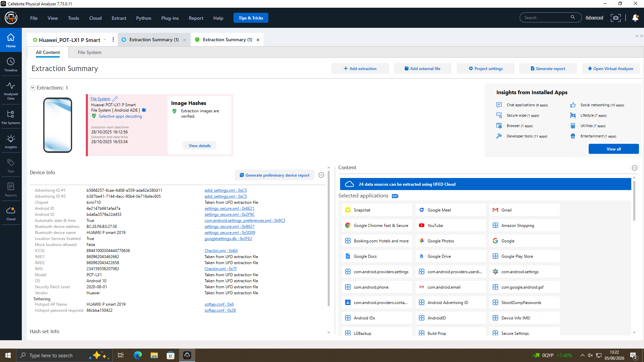
Figure 1 — Extraction Summary confirming Emma's Huawei POT-LX1 P Smart (EXH-01), Android 10, verified hashes.
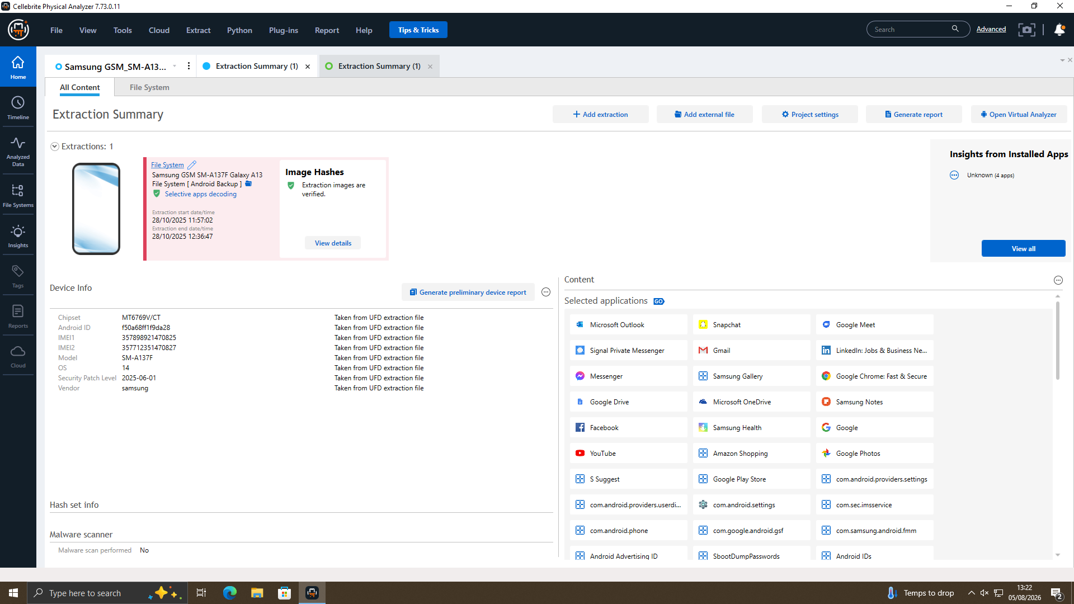
Figure 2 — Extraction Summary confirming Joe's Samsung Galaxy A13 (EXH-02), Android 14, verified hashes.
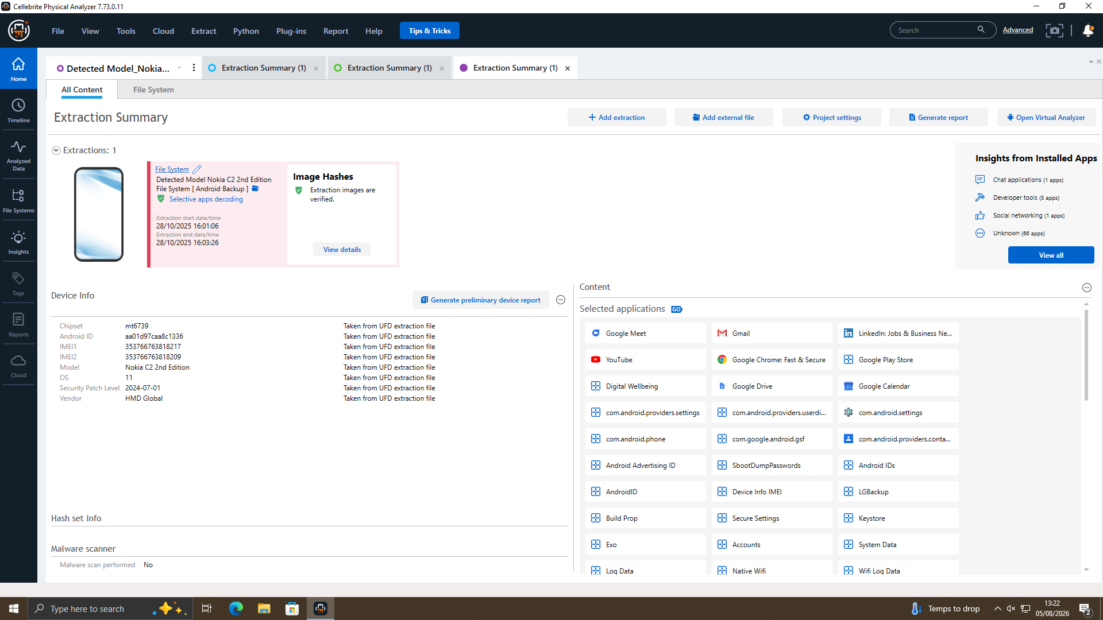
Figure 3 — Extraction Summary confirming Norman's Nokia C2 2nd Edition (EXH-03), Android 11, verified hashes.

2.4. Methodology

2.4.1 Acquisition
Cellebrite UFED (v7.76.0.24) was used to acquire each of the smartphones. For each of the devices a new case was created, with the following information captured: the examiner, evidence/device identifier, offence type and department/location, following good forensic practice in establishing the chain of evidence. They were made available through UFED's Auto Detect function which correctly detected each of the handsets prior to application of an extraction profile and content-type selection (Device data and SIM/Memory Card if applicable). To maximise the recovery of relevant artefacts, full data types were chosen to be extracted such as call logs, contacts, SMS/MMS, calendar, pictures, ringtones, documents, archives, locations, advertising ID and general files. The workflow for the acquisition was demonstrated on the Training/Reference Handset (Samsung SM-A145P), and used the same standard procedure for the three case exhibits.
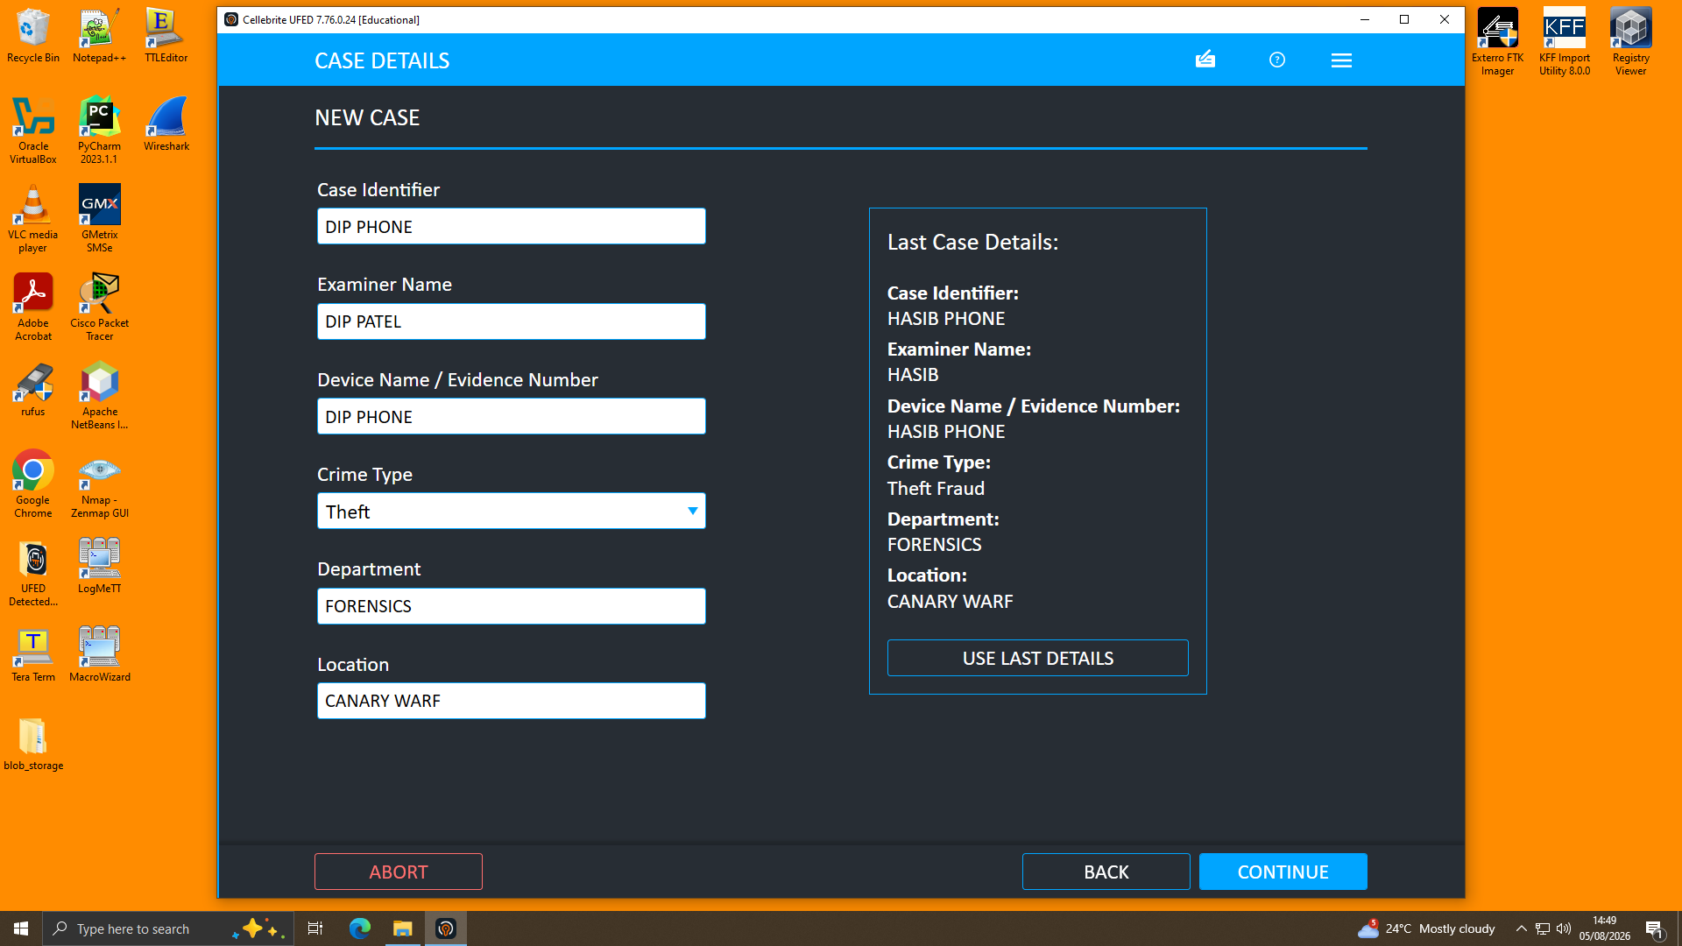
Figure 4 — UFED new case creation, recording examiner and case details prior to acquisition.
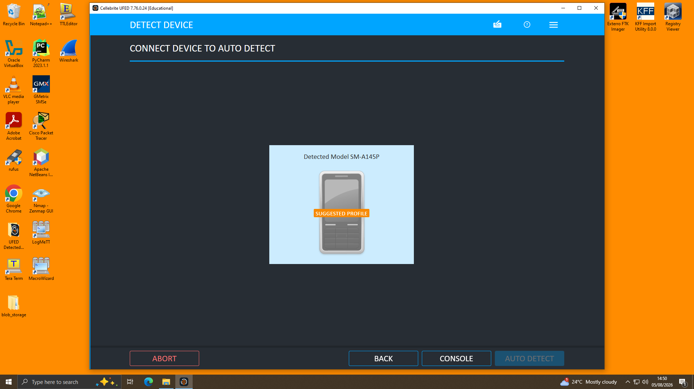
Figure 5 — UFED Auto Detect identifying the connected handset and suggesting an extraction profile.
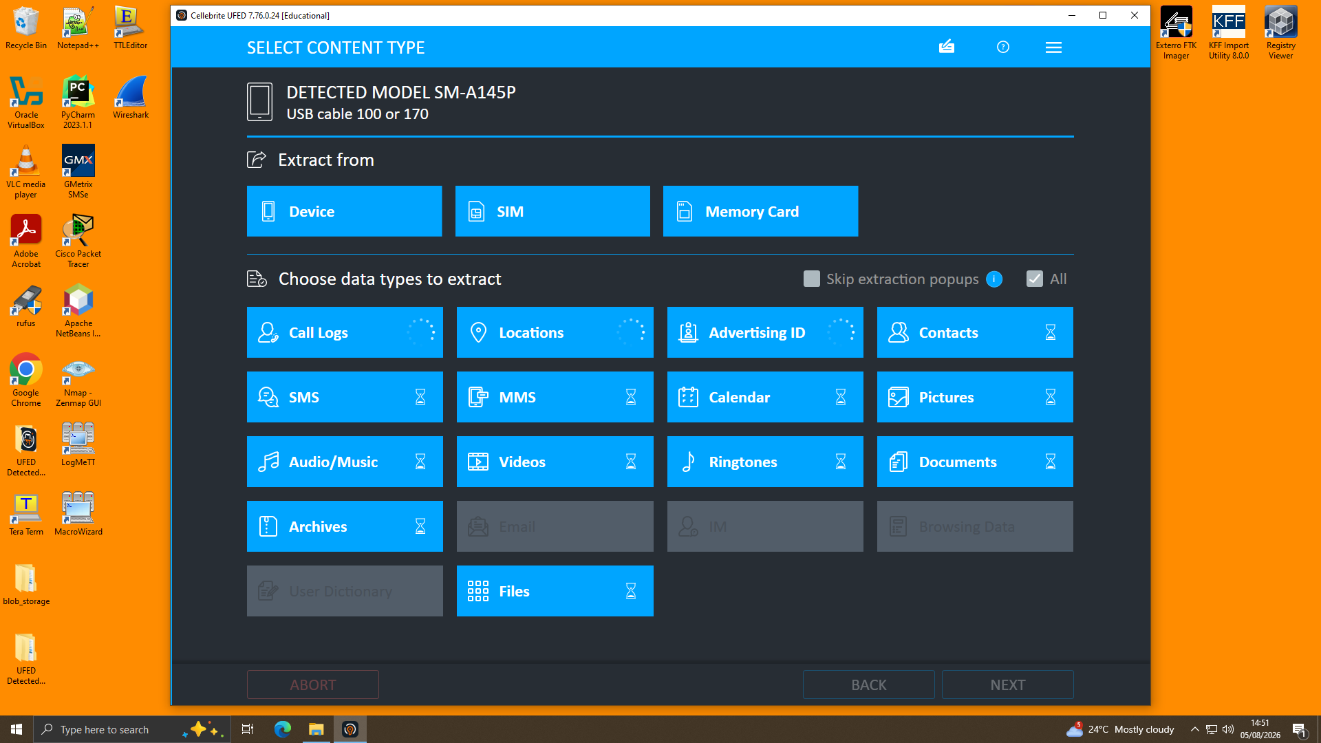
Figure 6 — UFED Select Content Type screen: all relevant data categories selected prior to extraction.
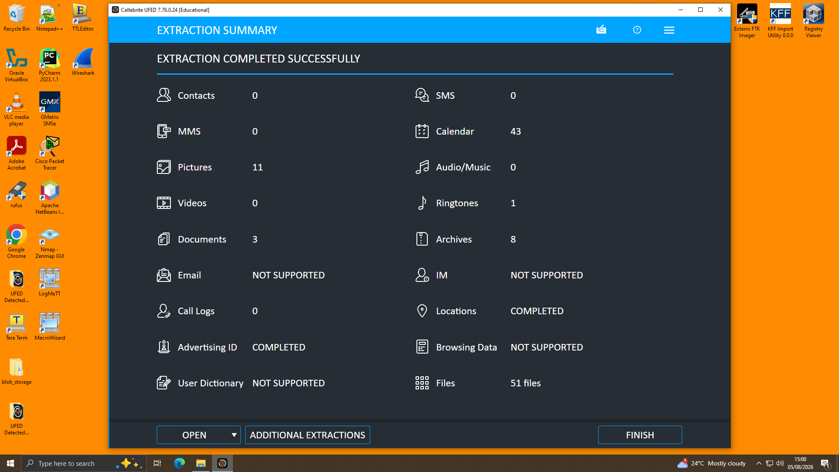
Figure 7 — UFED Extraction Summary confirming successful completion of the acquisition.

2.4.2 Analysis
Cellebrite Physical Analyzer (v7.73.0.11) was used to open all the extraction images. Parsed artefacts, such as Application data, Calls, Contacts, Manual Data Collection (chat reconstructions in table/thread mode for WhatsApp and Facebook Messenger), Location Related data and Media, were navigated in the "Analyzed Data" pane. In the Conversation view, chat threads were read in chronological order and the source of each chat message and time of occurrence was checked in the Details/Sources panel, to ensure it came from where it claimed. Location Related records were analysed on the built-in mapping view with regard to the time and location of occurrence; as the Facebook chats were written at different times, place names from the chats (e.g Glasgow, Paris, Manchester) were compared against the devices' location information. All photos (Media Items) were analyzed with complete EXIF data - capture time, GPS position and camera make & model information was used to determine the location and time the image was captured.

2.4.3 Cross-Device Correlation
Each device finding was checked against the other two exhibits to determine a common timeline and to verify the findings against that timeline with consistency checks between chat log statements and location and media metadata. If a date or city or person referred to in the retrieved Emma chat was also contained within a geotagged picture or recognizable photograph (e.g., a courthouse, a park) on Joe's or Norman's possession, then it was used as corroborating evidence that connected the exhibits and the person or persons involved.

2.5 Findings

2.5.1 Emma's Device (EXH-01) — Insider Source
An on-camera perspective from the 5.1 channel/surround-reach, called the Emma's Device (EXH-01), is also available. Emma's device is P Smart (POT-LX1) that has Android 10 preloaded. Extraction was carried out as per Android ADB and inspected on ‘Manual Data Collection' in Physical Analyzer. The extracted data includes a WhatsApp thread with a contact named "Top-up" (273 messages dated between August 21, 2024, and Jan. 31, 2025) and another thread on Facebook Messenger dated 31st January 2025, as well as a call log with 15 entries. It all starts with the owner of the device saying to the recipient (Joe) she has information for him as a buyer from ABC Technologies, which is “highly valuable”, and that they will have to keep the information “under wraps,” that is, confidential."
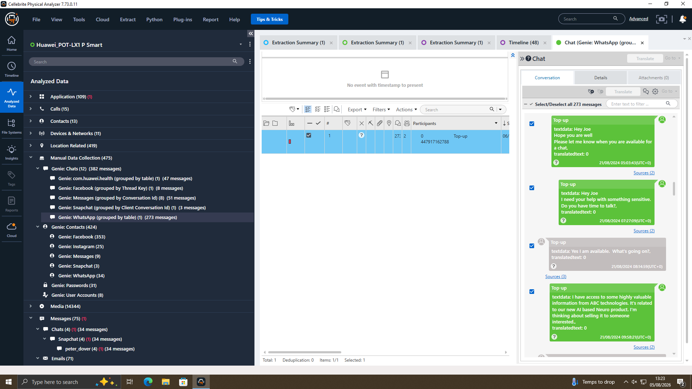
Figure 8 — Opening WhatsApp exchange: Emma raises possession of confidential company data (21/08/2024).
Joe's reported progress goes from there over the subsequent months as the same thread states he was travelling to Glasgow, Paris and Manchester to meet with prospective buyers and then escalates to a concrete negotiation by a buyer in January 2025, with him requesting a demo sample, stating “5M” was now one of “secured” and introducing an “offshore arrangement.”
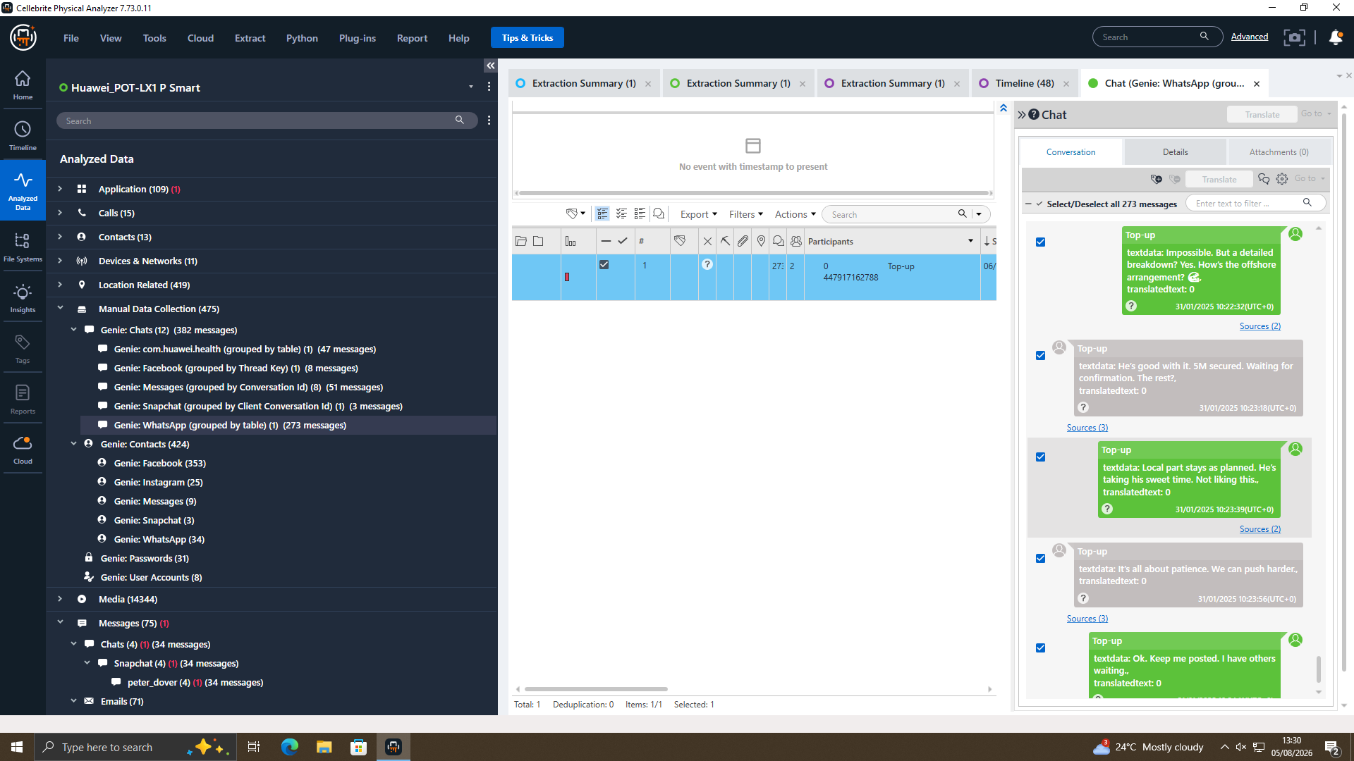
Figure 9 — WhatsApp negotiation: "Impossible. But a detailed breakdown? … How's the offshore arrangement?" / "He's good with it. 5M secured" (31/01/2025).
This Facebook Messenger conversation, also extracted 31 January 2025, is between the accounts "Peter Dover (owner)" and "Norman Smith": Norman, Joe told me u r ready to proceed. Let's keep this clean and quick — this one thread directly connects to the one above between Joe & Emma, also on 31 January 2025, on the same platform.
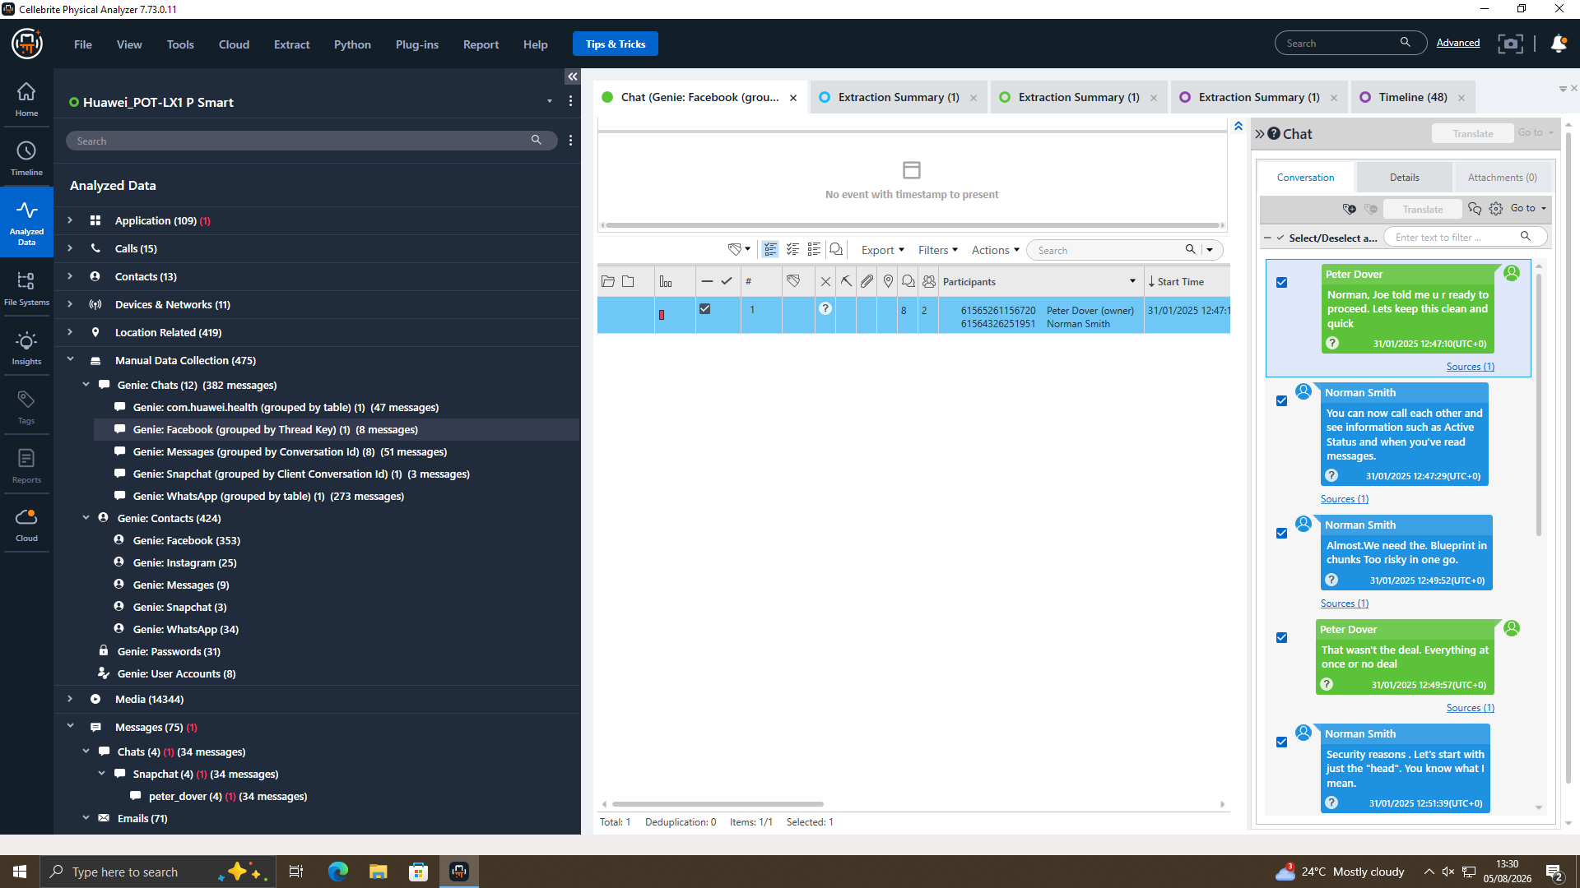
Figure 10 — Facebook Messenger thread opening: reference to Joe as the connecting party, and negotiation over delivery of the "blueprint" (31/01/2025).
The parties engage in what turns out to be protracted negotiations over how they are to be delivered — Norman asking for the "blueprint in chunks" on security grounds and Dover demanding an "all-or-nothing" basis — before finally deciding to start with just the "head", a payment scheme of "5M offshore" and a 48-hour window for handover after which "we are ghosts".
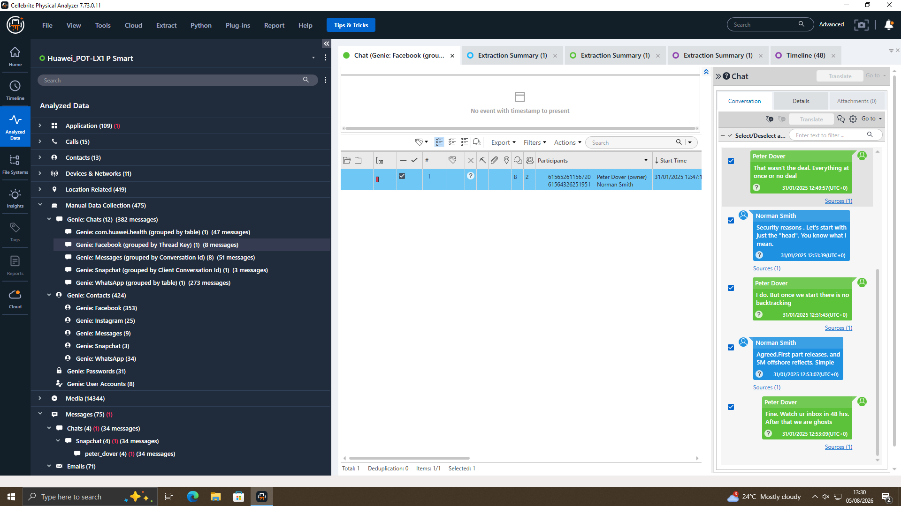
Figure 11 — Facebook Messenger thread continued: payment and handover terms agreed, including the 48-hour window (31/01/2025).
The call log from this device shows 15 calls made 2 August 2024 to 19 August 2024, most of which were "Not answered," and were in the UK format to and from a limited range of numbers. None of these calls lasted long enough to create content but the fact that they were repeated over the days before the WhatsApp discussion suggests that there were previous voice communication efforts to get in touch, between the same participants in those posts.
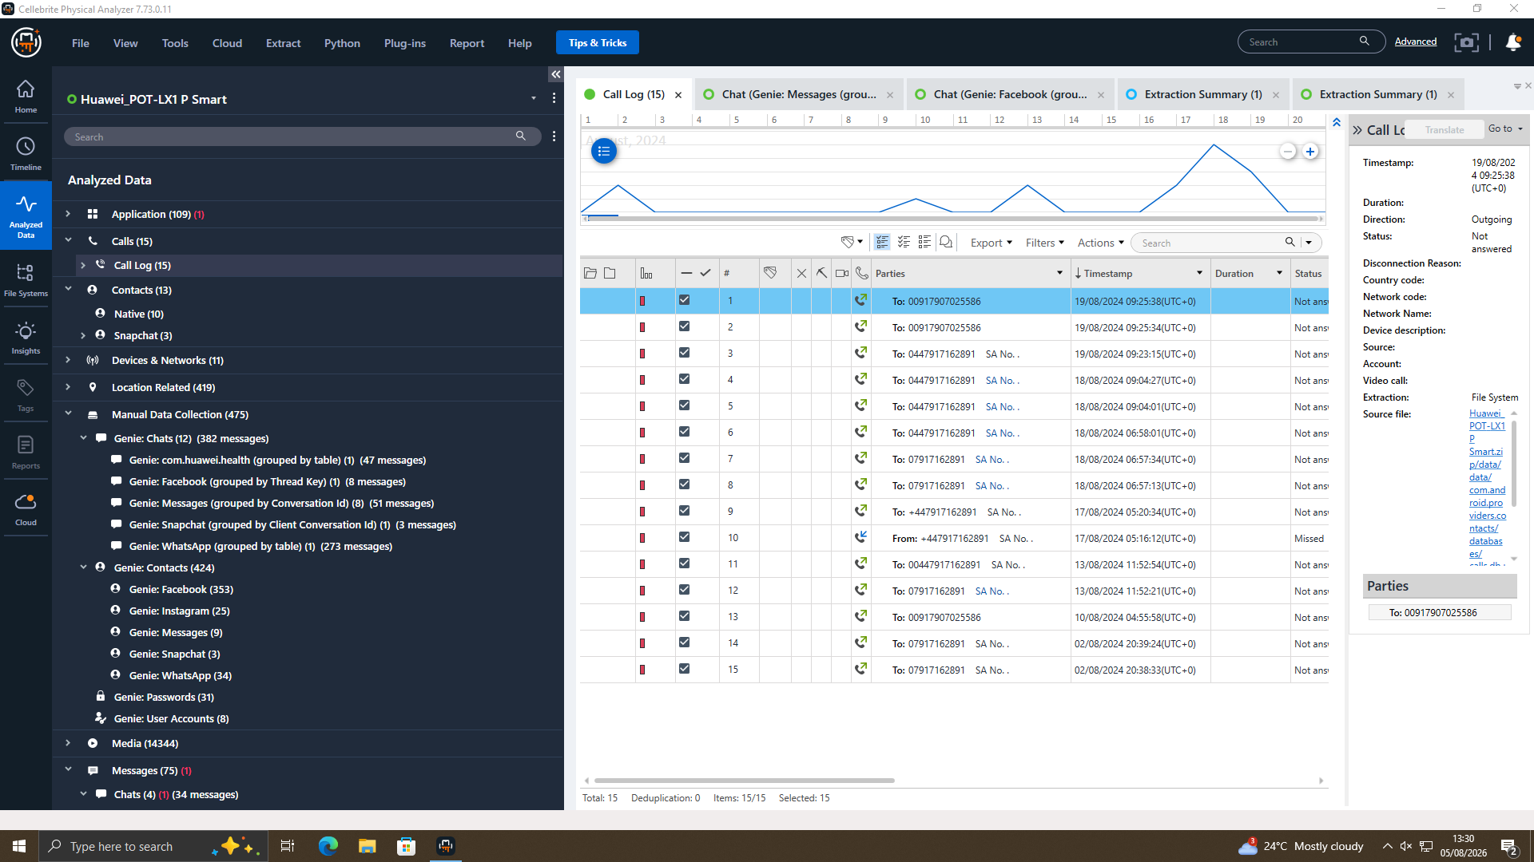
Figure 12 — Call log recovered from Emma's device: 15 entries, predominantly unanswered outgoing calls (Aug 2024).

2.5.2 Joe's Device (EXH-02) — Intermediary
Samsung Galaxy A13 (SM-A137F) on Android 14, has 1,465 Location records in Joe's device. This place name filtering of the location data provided clusters of photographs which corroborate the travel as reported in the WhatsApp location data thread recovered from Emma's device.
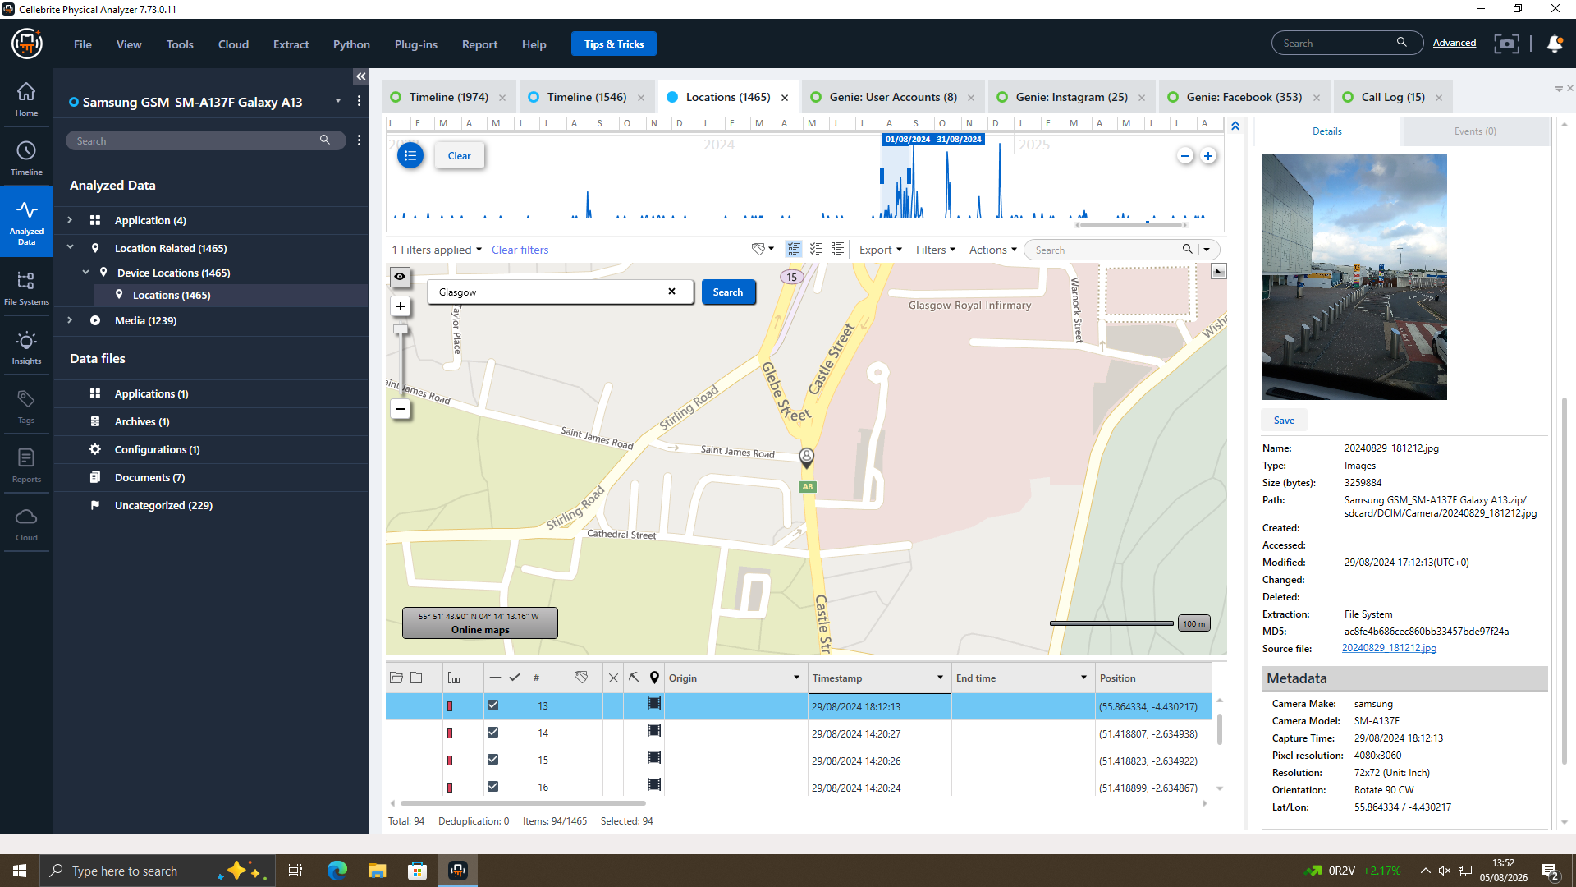
Figure 13 — Location search "Glasgow": geotagged photograph dated 29/08/2024, matching Joe's WhatsApp message reporting travel to Glasgow that day.
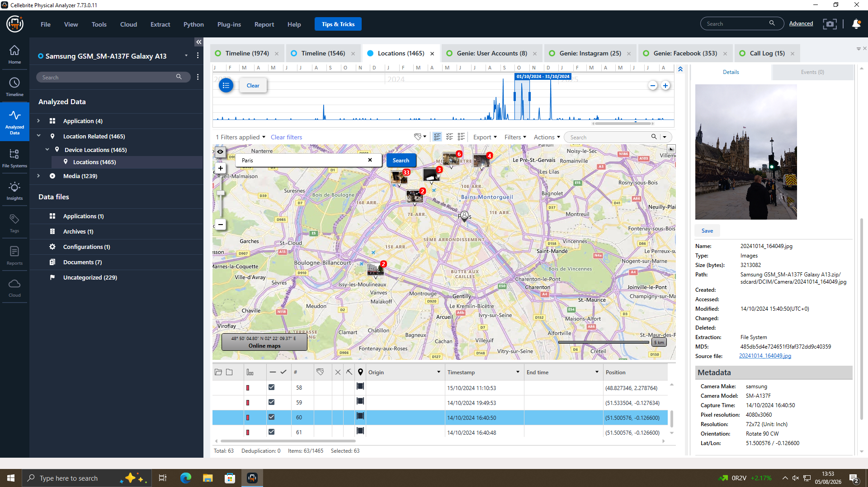
Figure 14 — Location search "Paris": geotagged photograph dated 14/10/2024, matching Joe's WhatsApp message reporting travel to Paris that day.
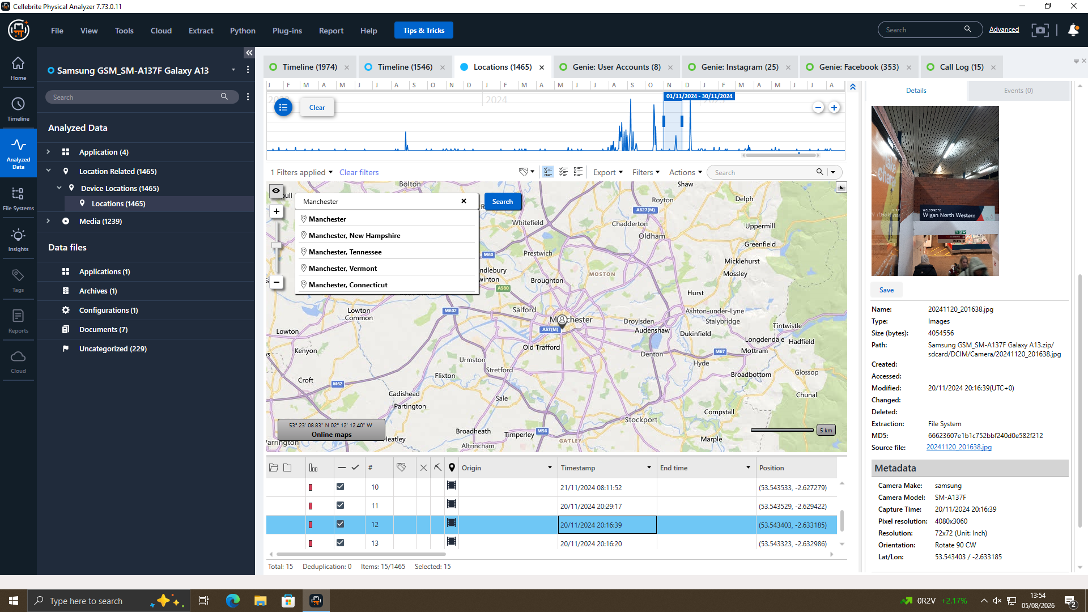
Figure 15 — Location search "Manchester": geotagged photograph dated 20/11/2024, matching Joe's WhatsApp message reporting a client meeting in Manchester that week.
Another photo found in this device is dated 04 September 2024 of a hotel key-card/ticket ("YOU GOT THE KEY"). This date corresponds with the finding of the identifying photo on Norman's device (section 5.3) and this is considered as “same-date” corroboration; this does not necessarily indicate a shared location between the two devices on this date because the exact coordinates of the devices during that time were not the same, but rather is supporting evidence for a shared location because Joe wanted to meet Norman in-person around this date.
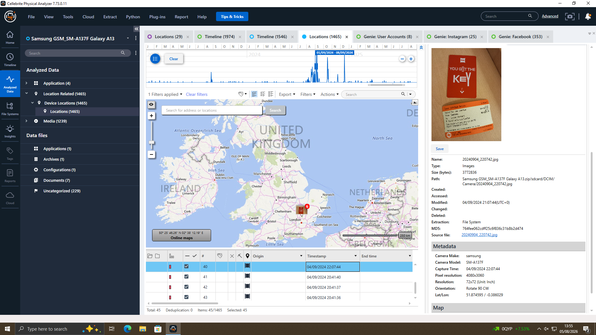
Figure 16 — Hotel key-card / ticket photograph recovered from Joe's device, dated 04/09/2024 — the same date as the identifying photograph recovered from Norman's device.

2.5.3 Norman's Device (EXH-03) — Buyer Representative
Norman's Device (EXH-03) price $5.30 buys the largest balloon volume / seesaw.
Norman's device is a Nokia C2 2nd Edition (Android 11, HMD Global), which had a total of 29 location records, 117 images and 72 applications installed on it. One of recovered images shows an identifiable individual (IMG_20240904_123804_430.jpg) which shows a person near Swansea, south Wales and was taken on 04 September 2024.
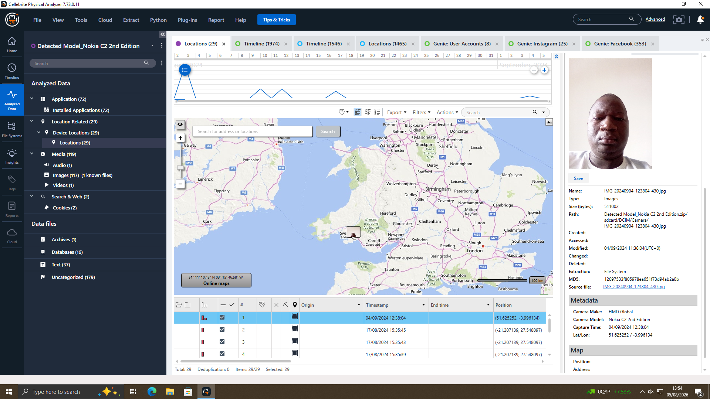
Figure 17 — Identifying photograph recovered from Norman's device, geotagged near Swansea and dated 04/09/2024.
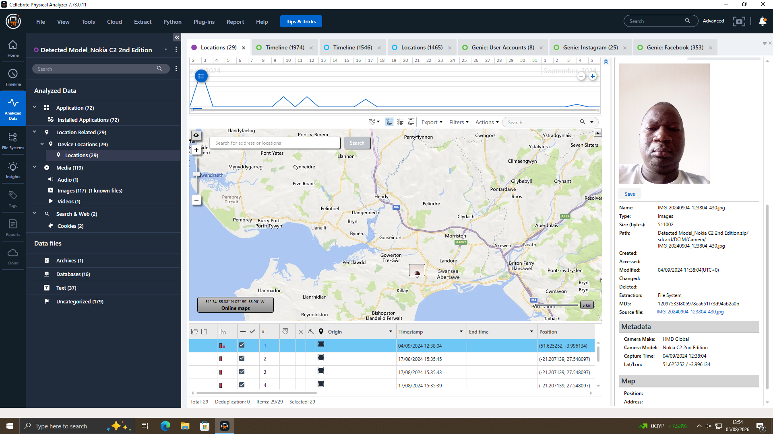
Figure 18 — Zoomed map view confirming the photograph's location directly over the Swansea area.
This date and location were checked against material obtained from Joe's travel/tickets, which points to an in-person meeting between Joe and Norman approximately in early September 2024 (Figure 16 – same date) but is not conclusive evidence. This is rated as additional evidence, other than the pure textual negotiation that got picked up from the WhatsApp and Facebook Messenger threads on Emma's digital device.

2.5.4 Consolidated Timeline
Key events reconstructed from all three exhibits have been grouped together in chronological order.
Date | Actor | Event
21/08/2024 | Emma → Joe (WhatsApp) | Emma opens contact, then states she has "highly valuable information from ABC Technologies" related to "our new AI-based Neuro product" and asks Joe to find a buyer.
21/08/2024 | Joe → Emma | Agrees to help; states he is meeting clients that day at a hotel meeting room to raise the offer; both agree to "keep this under wraps."
26/08/2024 | Joe → Emma | Reports the first meeting was unsuccessful but new contacts have been secured.
29/08/2024 | Joe → Emma | States he is "flying to Glasgow to meet a contact" — corroborated by a geotagged photograph on Joe's Samsung Galaxy A13 dated the same day.
14/10/2024 | Joe → Emma | States he is "travelling back to France, this time Paris, to get some good deals" — corroborated by a geotagged photograph on Joe's device dated the same day.
20/11/2024 | Emma → Joe | Applies pressure — "no response from you… I may go with someone if you are not interested" — indicating an alternate buyer is being considered.
20/11/2024 | Joe → Emma | States he is in "final talks," meeting the client that week in Manchester — corroborated by a geotagged photograph dated the same week.
31/01/2025 10:15–10:24 | Emma ↔ Joe (WhatsApp) | Urgent negotiation: buyer wants a demo sample; Emma refuses but offers a "detailed breakdown"; Joe confirms "5M secured, waiting on confirmation"; discussion of an "offshore arrangement" and local-part arrangements.
31/01/2025 12:47–12:53 | Peter Dover ↔ Norman Smith (Facebook Messenger) | "Joe told me u r ready to proceed… keep this clean and quick." Norman requests the "blueprint in chunks"; Dover insists on all-or-nothing; both agree to release the "head" first, a 5M offshore payment, and a 48-hour handover window after which "we are ghosts."

6. Suspect Profiling
Taking the sum of the communications and the location and media evidence gathered, the roles of the three are estimated in the following way.
Individual | Role | Supporting Evidence
Emma | Insider / Source (perpetrator) | WhatsApp messages sent from the account owner on Emma's own device (EXH-01) explicitly reference stolen company information and solicit a buyer through Joe.
Joe | Intermediary / Broker | The negotiation thread recovered from Emma's device (EXH-01) shows Joe actively soliciting buyers; geotagged photographs recovered from Joe's own device (EXH-02) independently confirm his presence in Glasgow, Paris and Manchester on the dates he reported meeting buyers in that same thread.
Norman Smith / Peter Dover alias | Buyer representative (NexGen Circuits) | A Facebook Messenger thread (also recovered from EXH-01) between "Peter Dover (owner)" and "Norman Smith" negotiates delivery of a "blueprint," a 5M payment, and a 48-hour handover. A photograph on Norman's own device (EXH-03) places an identifiable individual near Swansea on 04/09/2024; a photograph recovered from Joe's device (EXH-02), dated the same day, is consistent with Joe travelling to meet him around that date.

The WhatsApp discussion was recovered from her own device and contains evidence which makes Emma the main source of awaytaken information, with her actually stating she owns information on the 'confidential points' of the company and instigating the search for a buyer. Utilizing each device, it is determined that Joe is the intermediary/broker as his device is seen to have him actively canvassing buyers for a five month period and that his travel is separately confirmed by geotagged photographs retrieved from his device. Norman is evaluated as the buyer side - representative, and the detailed negotiations for the final terms of the deal (modification of price, payment account, delivery format and timing) are made with a different Facebook Messenger identity, while the presence of the buyers' representative in the vicinity of Swansea is confirmed by photographic and location evidence on his smartphone, as set out in the travel note of Joe's smartphone, from the same date.

7. Additional Observations and Limitations
- Those who did not have any relationship were filtered out as they were irrelevant WhatsApp messages, like sports news, or general commentary.
- Three of the extraction summaries showed no evidence of e-mail. This is a gap in evidence and doesn't mean that there was no email communication.
- The connection between Joe's and Norman's photographs of 4 September 2024 is solely based on the same date, and is therefore not conclusive evidence.
- A limitation of this study is that no malware scan was run on the three exhibits, this is considered a follow-up study.

8. Conclusion
There is consistency and corroboration within the evidence from all three devices. Emma is seen communicating with others of her attempts to enlist Joe's help in selling information about Quantum Tech, then reaching out to some other people; this culminates in agreement over a certain payment amount, out-of-country arrangements and a delivery of a “blueprint.” These communications are backed up with Facebook Messenger logs and separate location and image data from the device of both Joe and Norman. The results are all consistent with the notion that Emma was attempting to sell QT-AI-2025 to Joe, who was also using the identity “Peter Dover” as Norman. An alternate non-criminal cause of death was not found in the evidence that was reviewed.

9. Recommendations
- Immediately review and revoke, if needed, Emma's access to the systems of QT-AI-2025 while retaining appropriate servers logs.
- Apply for lawful production orders for WhatsApp and Facebook Messenger server-side information.
- Confirm identification of “Peter Dover” and “Norman Smith” and their connection(s) to NexGen Circuits.
- Have travel or hotel records to support the 4 September 2024 relationship between Joe and Norman.
- Malware and Integrity Scans: Run a Malware and Integrity scan on all three devices.
- Access and retrieve the file system and metadata of Emma's thumb drive for the files noted in the conflaki's QR-TEST-2025 folder.
- Take the results as possible circumstantial evidence against alleged business spies and theft of trade secrets.

References
[1] InfoSec4TC, "Digital Forensics Tools: Your 2025 Guide," InfoSec4TC Blog, Dec. 2025. [Online]. Available: https://www.infosec4tc.com/digital-forensics-tools-your-2025-guide/
[2] DevOpsSchool, "Top 10 Digital Forensics Tools: Features, Pros, Cons & Comparison," DevOpsSchool Blog, Dec. 2025. [Online]. Available: https://www.devopsschool.com/blog/top-10-digital-forensics-tools-features-pros-cons-comparison/
[3] Cyber Forensics Academy, "FTK vs EnCase vs X-Ways: Which Forensic Tool Is Best in 2025?," Cyber Forensics Academy Blog, Dec. 2025. [Online]. Available: https://www.cyberforensicacademy.com/blog/ftk-vs-encase-vs-x-ways:-which-forensic-tool-is-best
[4] ForensicsColleges.com, "A Guide to Digital Forensics and Cybersecurity Tools (2026)," Mar. 2026. [Online]. Available: https://www.forensicscolleges.com/blog/resources/guide-digital-forensics-tools
[5] A. S. S. Hamed and O. Dewangan, "Digital Forensic: Techniques, Challenges, and Future Direction," Int. J. Res. Appl. Sci. Eng. Technol. (IJRASET), 2025, doi: 10.22214/ijraset.2025.71562.
[6] Cyber Forensics Academy, "FTK vs EnCase vs X-Ways: Which Forensic Tool Is Best in 2025?," Cyber Forensics Academy Blog, Dec. 2025. [Online]. Available: https://www.cyberforensicacademy.com/blog/ftk-vs-encase-vs-x-ways:-which-forensic-tool-is-best
[7] "Emerging Trends in Digital Forensics: Computer, Mobile, Network, Cloud, IoT, and Blockchain Forensics," Int. J. Comput. Sci. Eng. Inf. Technol. (CSEIT), Feb. 2025. [Online]. Available: https://www.scribd.com/document/877532789/CSEIT251451-2025
[8] Author(s), "Analysis on Digital Forensics Challenges and Anti-forensics Techniques in Cloud Computing," in Proc. 11th Int. Conf. Syst. Model. Advancement Res. Trends (SMART), Moradabad, India, Dec. 2022, IEEE Conf. ID 55829. [Online]. Available: https://ieeexplore.ieee.org/document/10047629/
[9] "PCAP-Forensics: An Automated Network Traffic Analysis Framework," in Proc. [Conf. Name], Springer Nature, 2025, doi: 10.1007/978-3-031-98036-7_26.
[10] Forensic Focus, "Network Forensics: A Short Guide to Digital Evidence Recovery from Computer Networks," Forensic Focus, Mar. 2025. [Online]. Available: https://www.forensicfocus.com/guides/network-forensics-a-short-guide-to-digital-evidence-recovery-from-computer-networks/
[11] "Cybersecurity and Network Forensics: Analysis of Malicious Traffic towards a Honeynet with Deep Packet Inspection," Appl. Sci., vol. 7, no. 10, p. 1082, 2017, doi: 10.3390/app7101082.
[12] EC-Council University, "Why Digital Forensics Is One of the Fastest-Growing Careers in Cybersecurity," ECCU Blog, Jul. 2026. [Online]. Available: https://www.eccu.edu/blog/digital-forensics-career-guide/
[13] Research.com, "2026 Computer Forensics Analyst Careers: Skills, Education, Salary & Job Outlook," Apr. 2026. [Online]. Available: https://research.com/advice/computer-forensics-analyst-careers-skills-education-salary-job-outlook
[14] Research.com, "2026 How to Become a Digital Forensic Investigator: Salary & Career Paths," Jun. 2026. [Online]. Available: https://research.com/careers/how-to-become-a-digital-forensic-investigator-salary-and-career-paths
[15] Glassdoor, "Digital Forensics Analyst: Average Salary & Pay Trends 2026." [Online]. Available: https://www.glassdoor.com/Salaries/digital-forensics-analyst-salary-SRCH_KO0,25.htm

Appendix A: Full Screenshot Evidence Log
The below screenshots were taken during acquisition and analysis, in Cellebrite UFED and Cellebrite Physical Analyzer (PA). Exhibit and topic specific supporting screenshots are offered below; all of the figures already presented in-line within Section 5 (Findings) are not repeated here in full-size for the sake of completeness of the evidential record.

A.1 Acquisition Methodology (Demonstration Device)
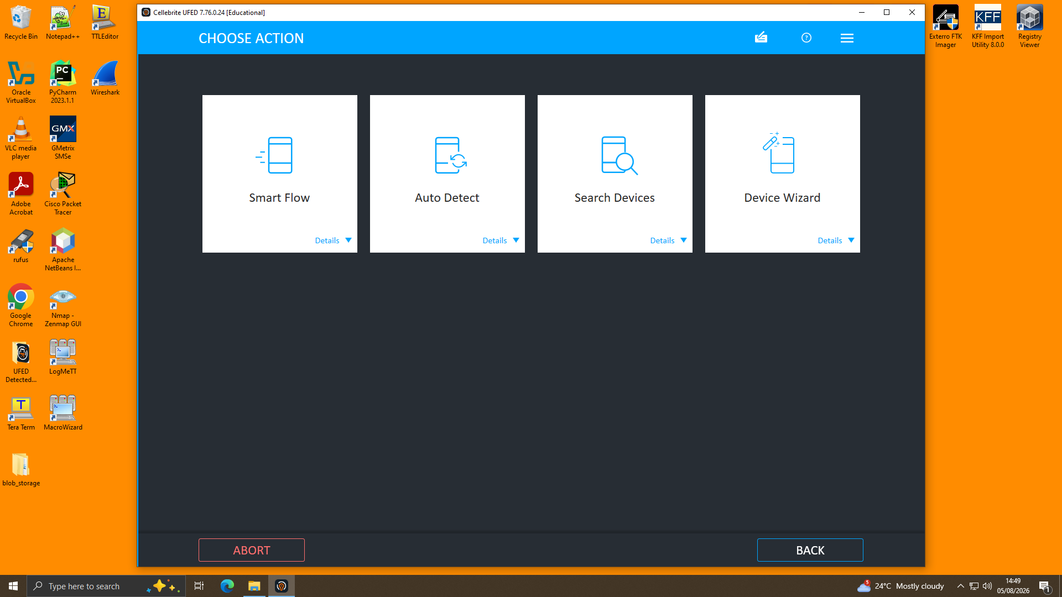
Figure A.1 — UFED Choose Action screen: Auto Detect selected for device identification.
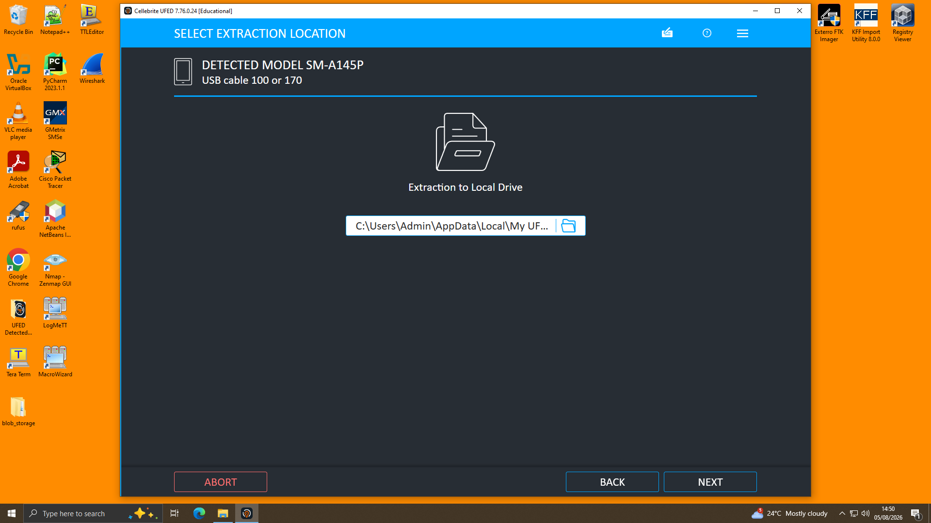
Figure A.2 — UFED Select Extraction Location: local drive path for the acquired image.
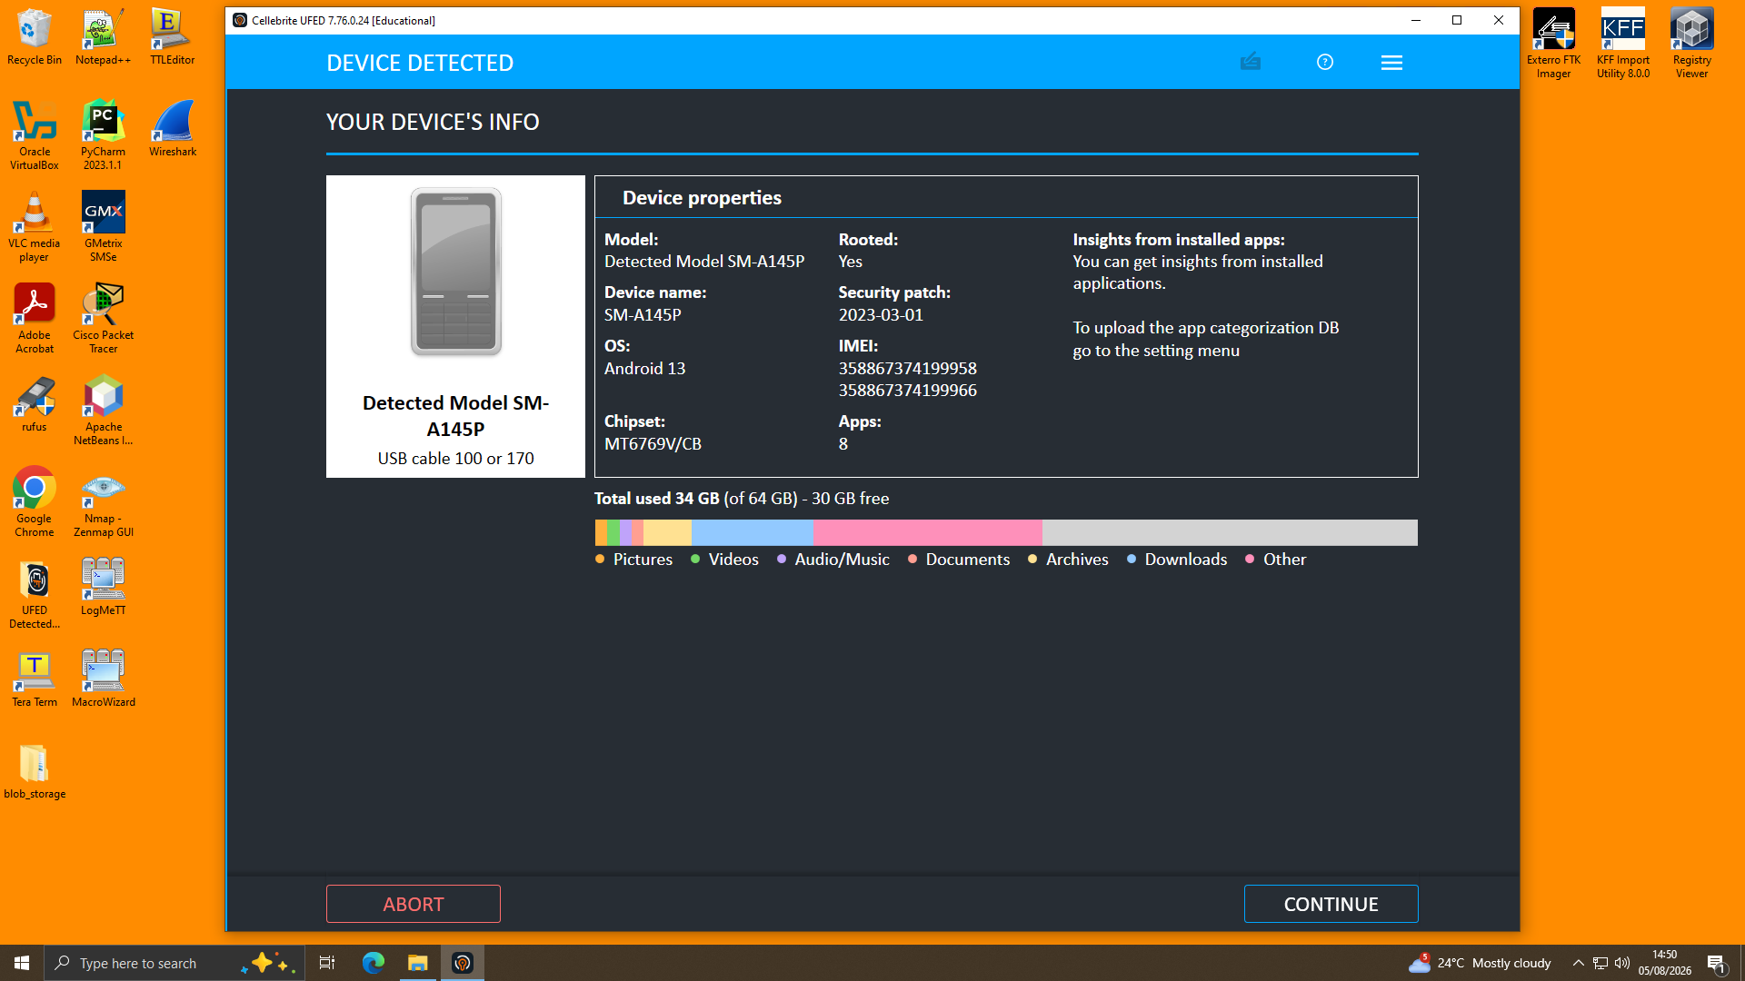
Figure A.3 — UFED Device Detected summary showing model, OS, IMEI and storage usage.
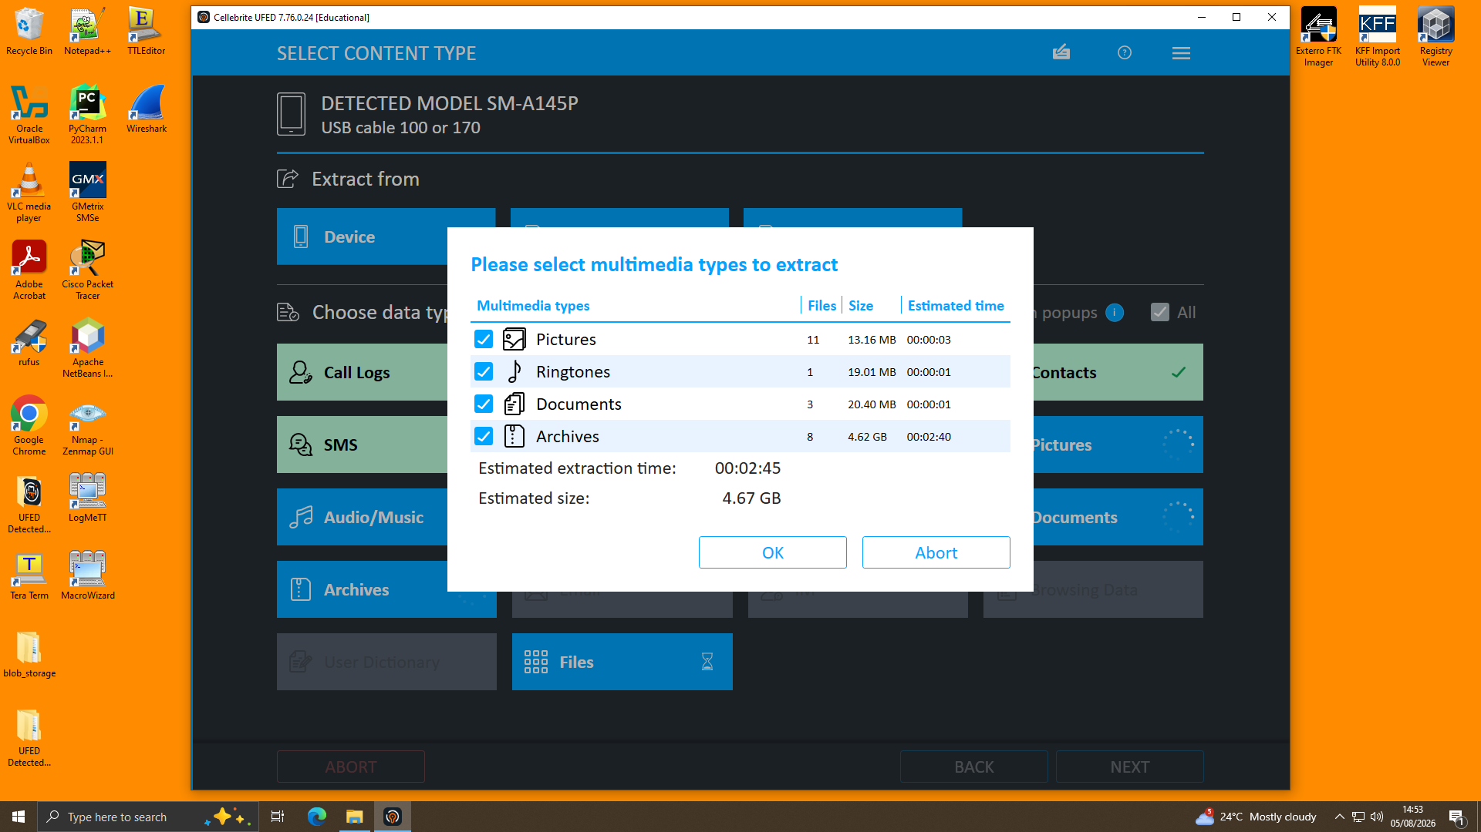
Figure A.4 — Multimedia extraction confirmation dialog: file counts and estimated size/time prior to extraction.
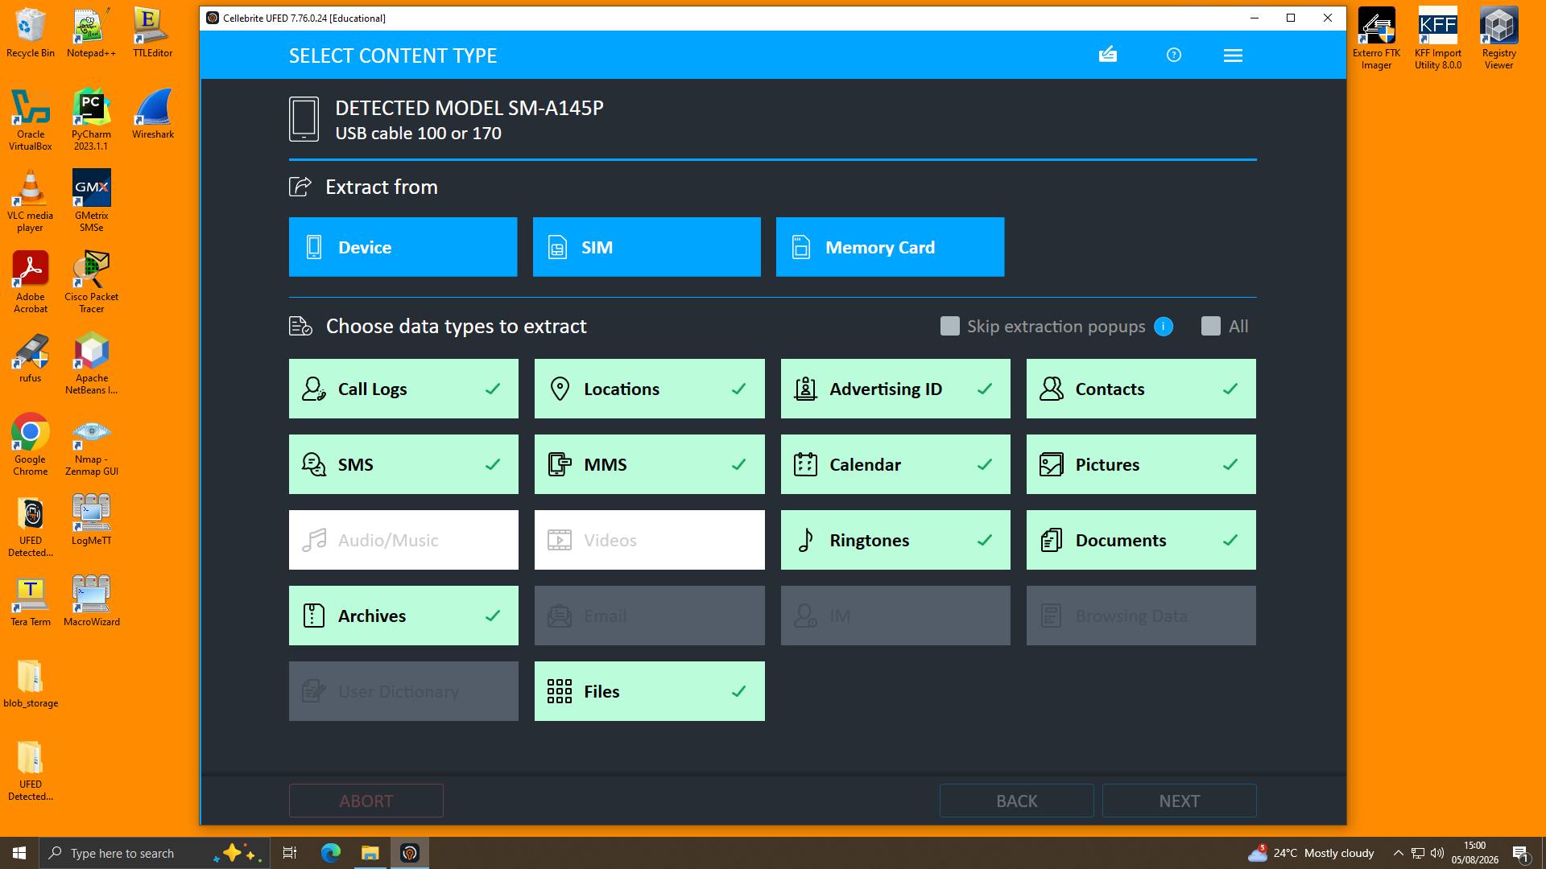
Figure A.5 — Content types confirmed selected (green) prior to running the extraction.
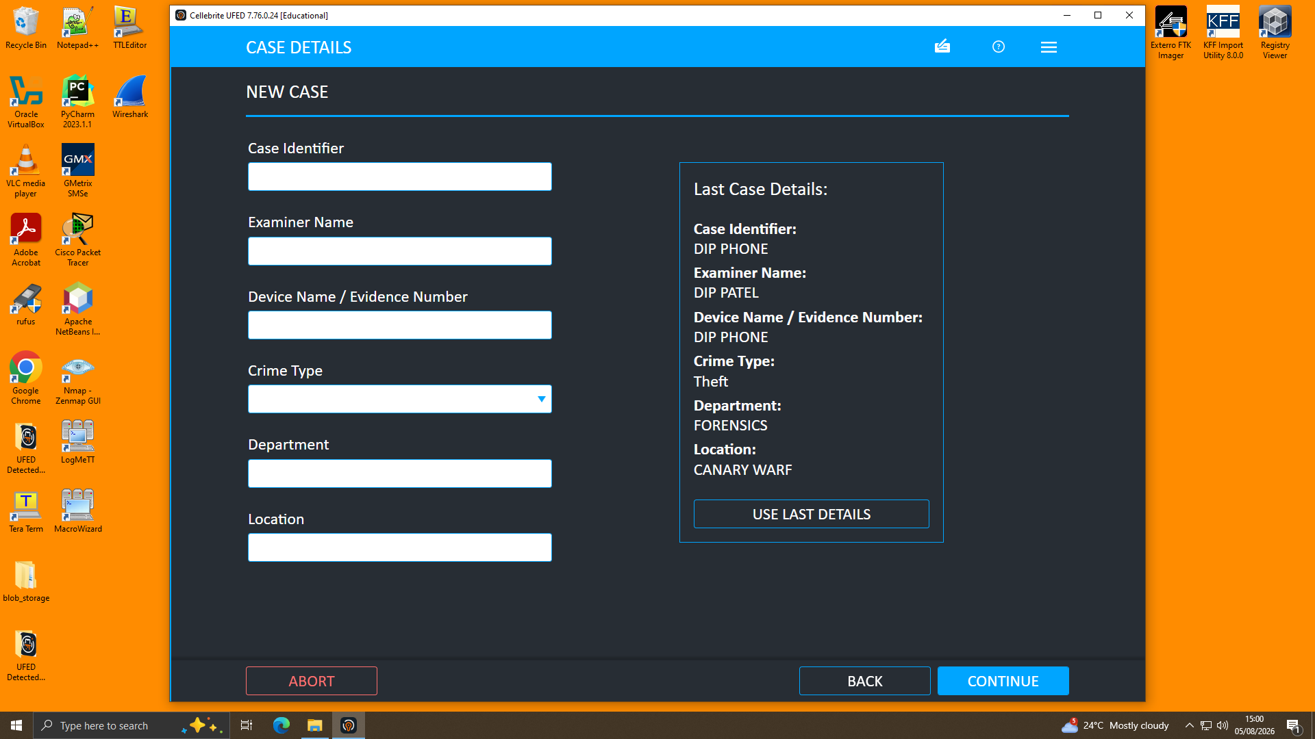
Figure A.6 — Blank New Case screen shown prior to starting a subsequent device acquisition, confirming a fresh case was opened per exhibit.
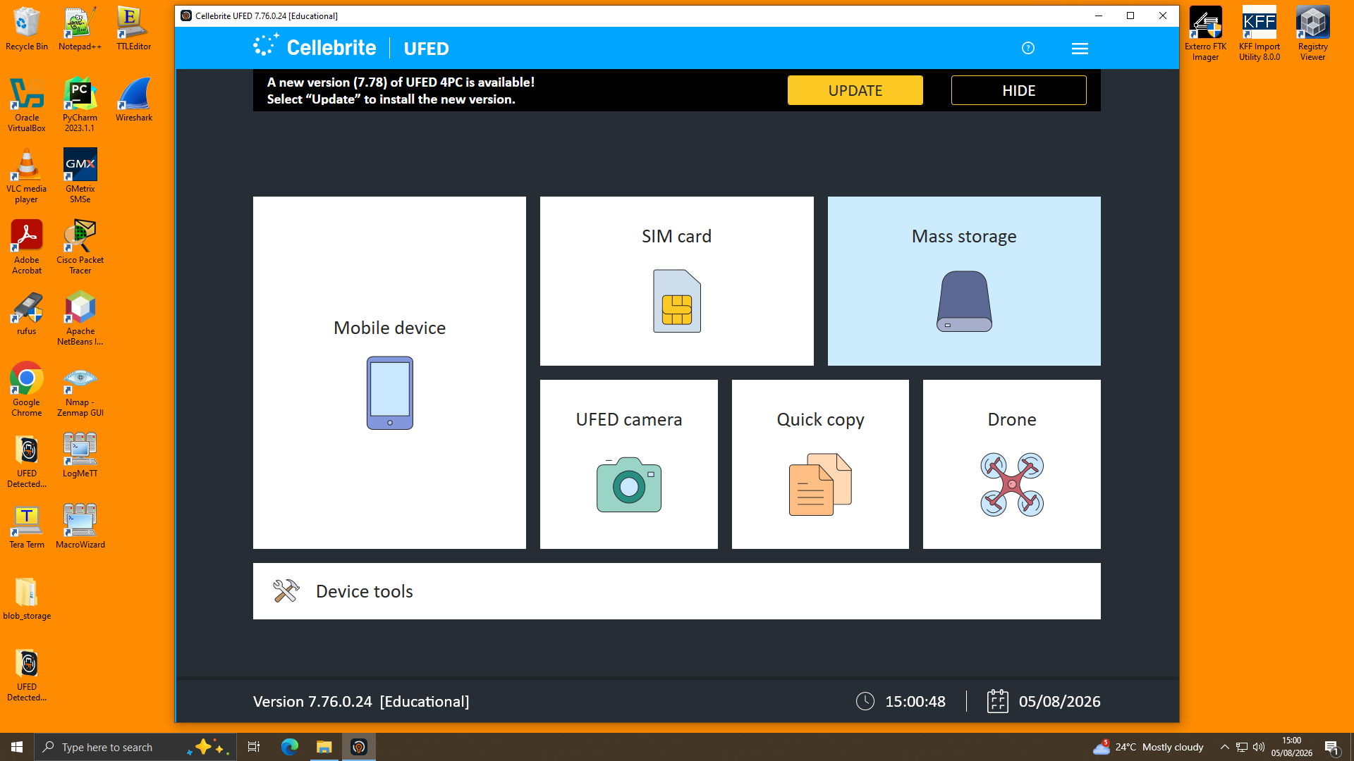
Figure A.7 — Cellebrite UFED main hub, confirming the acquisition module used across exhibits.

A.2 Emma's Device (Huawei POT-LX1) — Extraction and Call Log
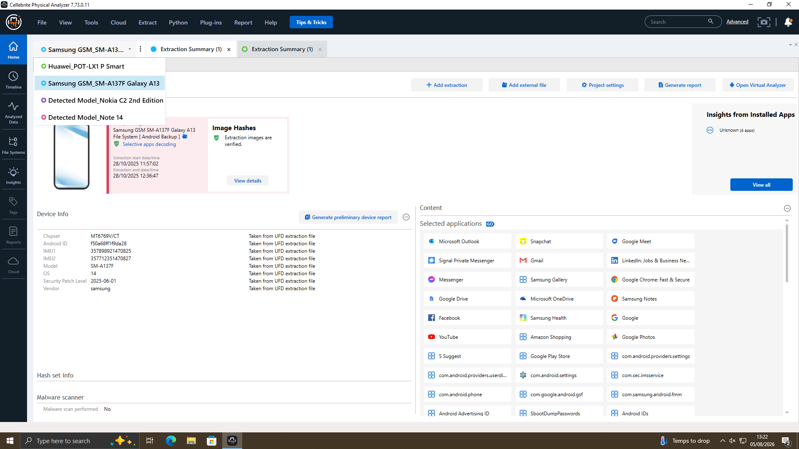
Figure A.8 — Device switcher confirming all case exhibits loaded within the same Physical Analyzer project.
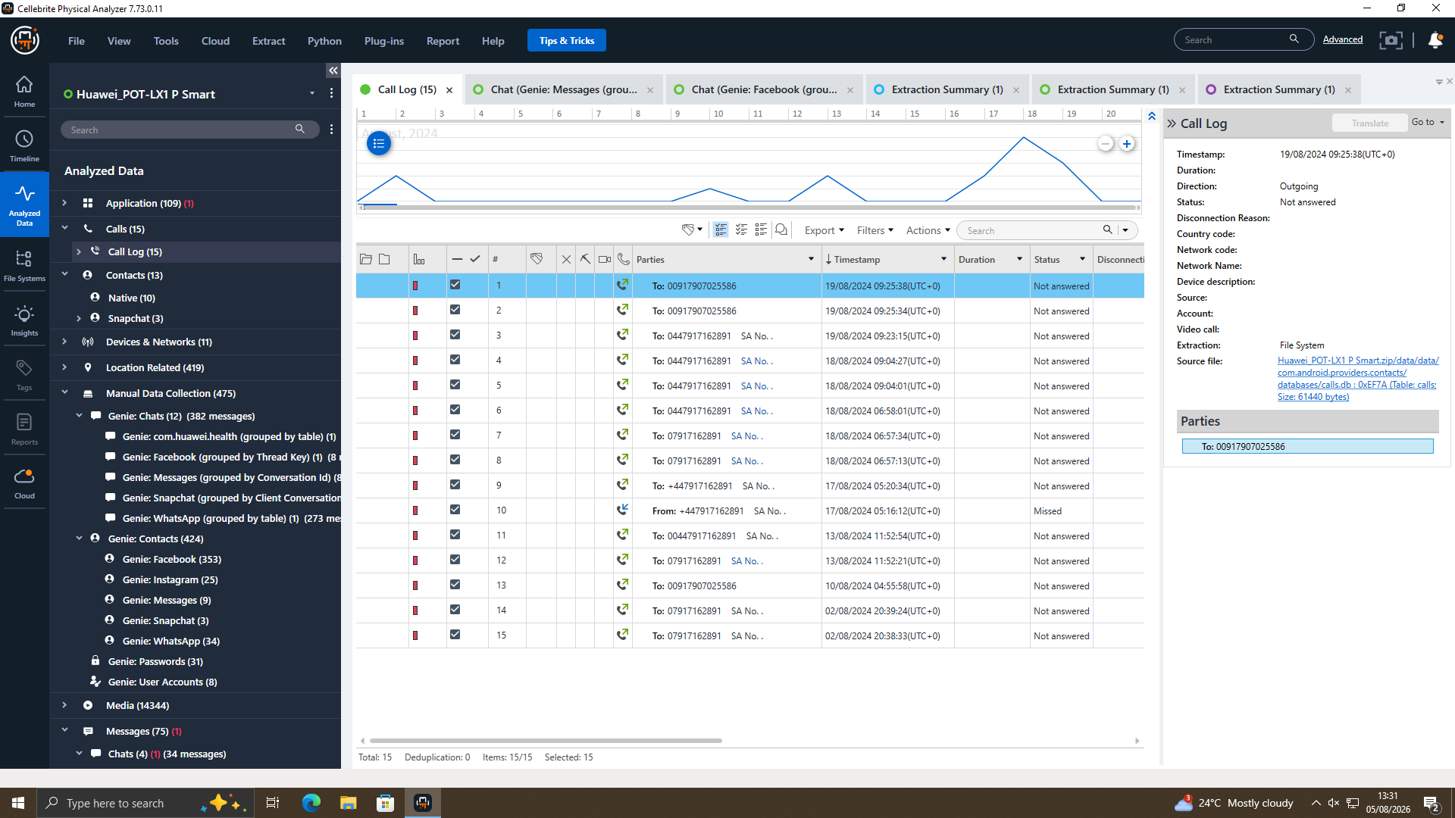
Figure A.9 — Call log detail panel showing the full source file path (com.android.providers.contacts/databases/calls.db), confirming provenance.

A.3 Emma's Device — WhatsApp Thread ("Top-up" / Joe), Full Sequence
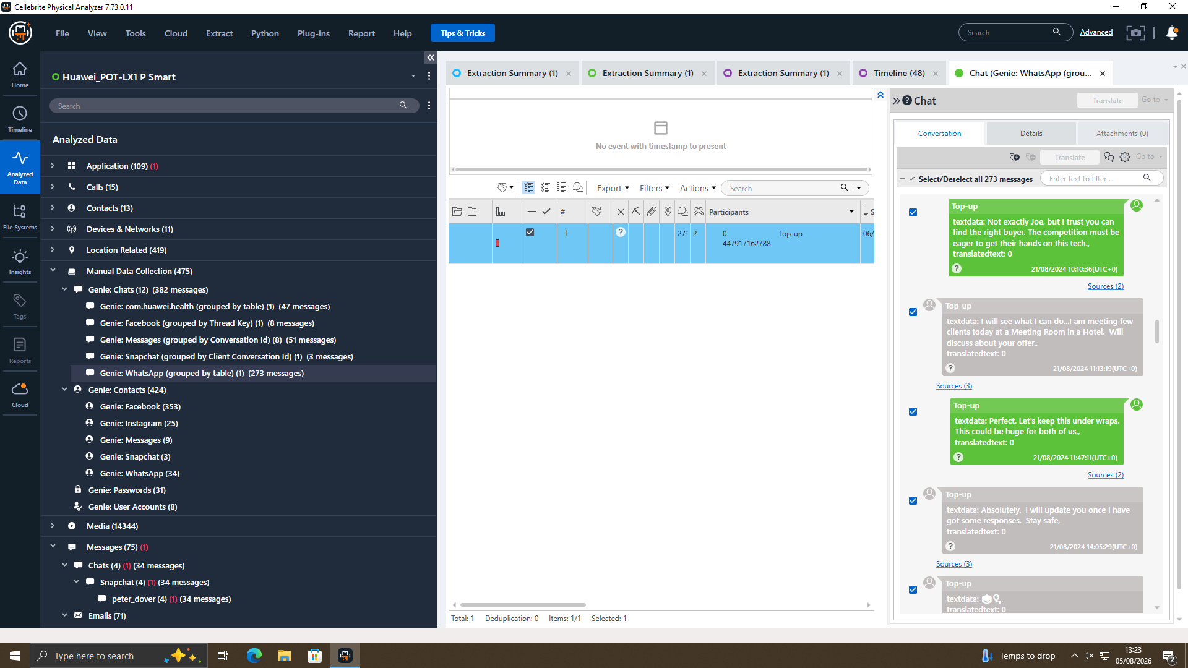
Figure A.10 — WhatsApp continued: Joe agrees to raise the offer with clients; both agree to secrecy (21/08/2024).
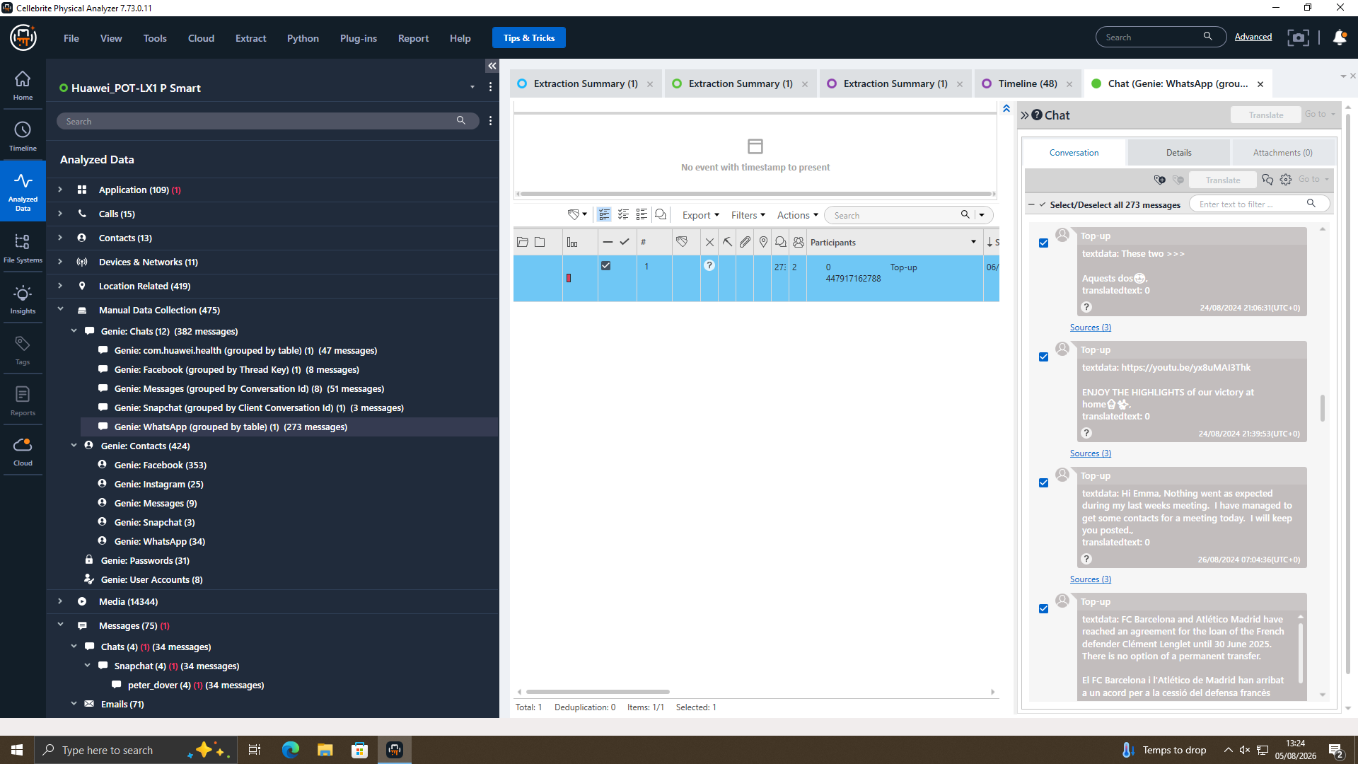
Figure A.11 — WhatsApp continued: "Hi Emma, nothing went as expected during my last week's meeting" (26/08/2024); an unrelated football-related message also appears in the same thread.
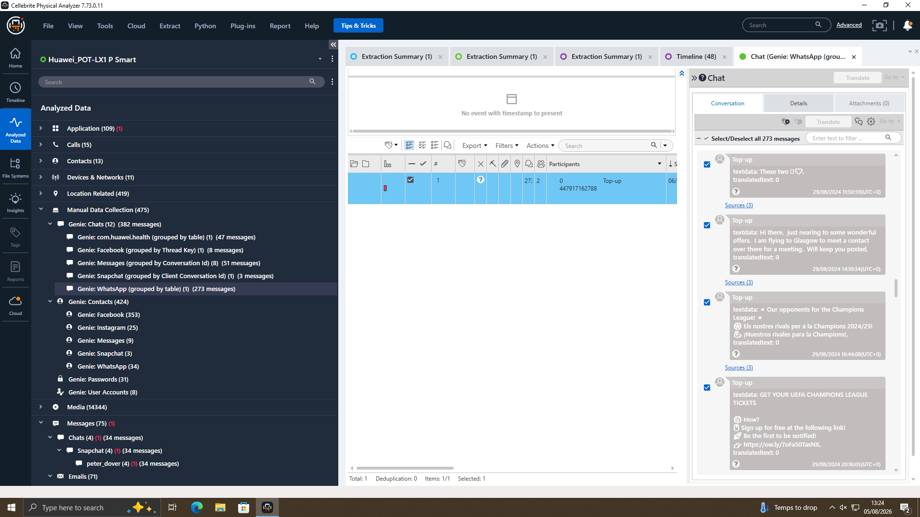
Figure A.12 — WhatsApp: "I am flying to Glasgow to meet a contact" (29/08/2024) — referenced inline as Figure 13's corroborating chat message.
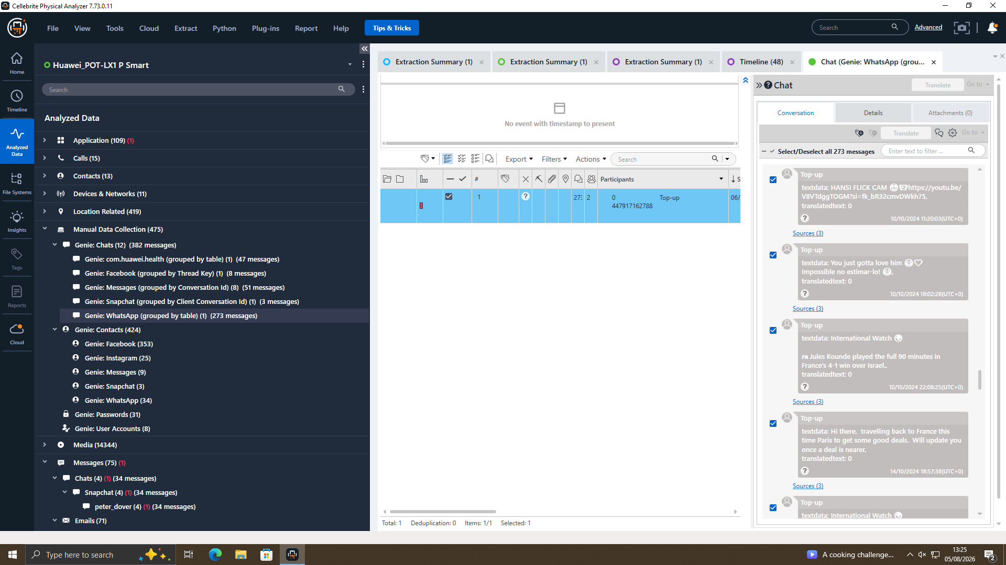
Figure A.13 — WhatsApp: "travelling back to France, this time Paris, to get some good deals" (14/10/2024) — referenced inline as Figure 14's corroborating chat message.
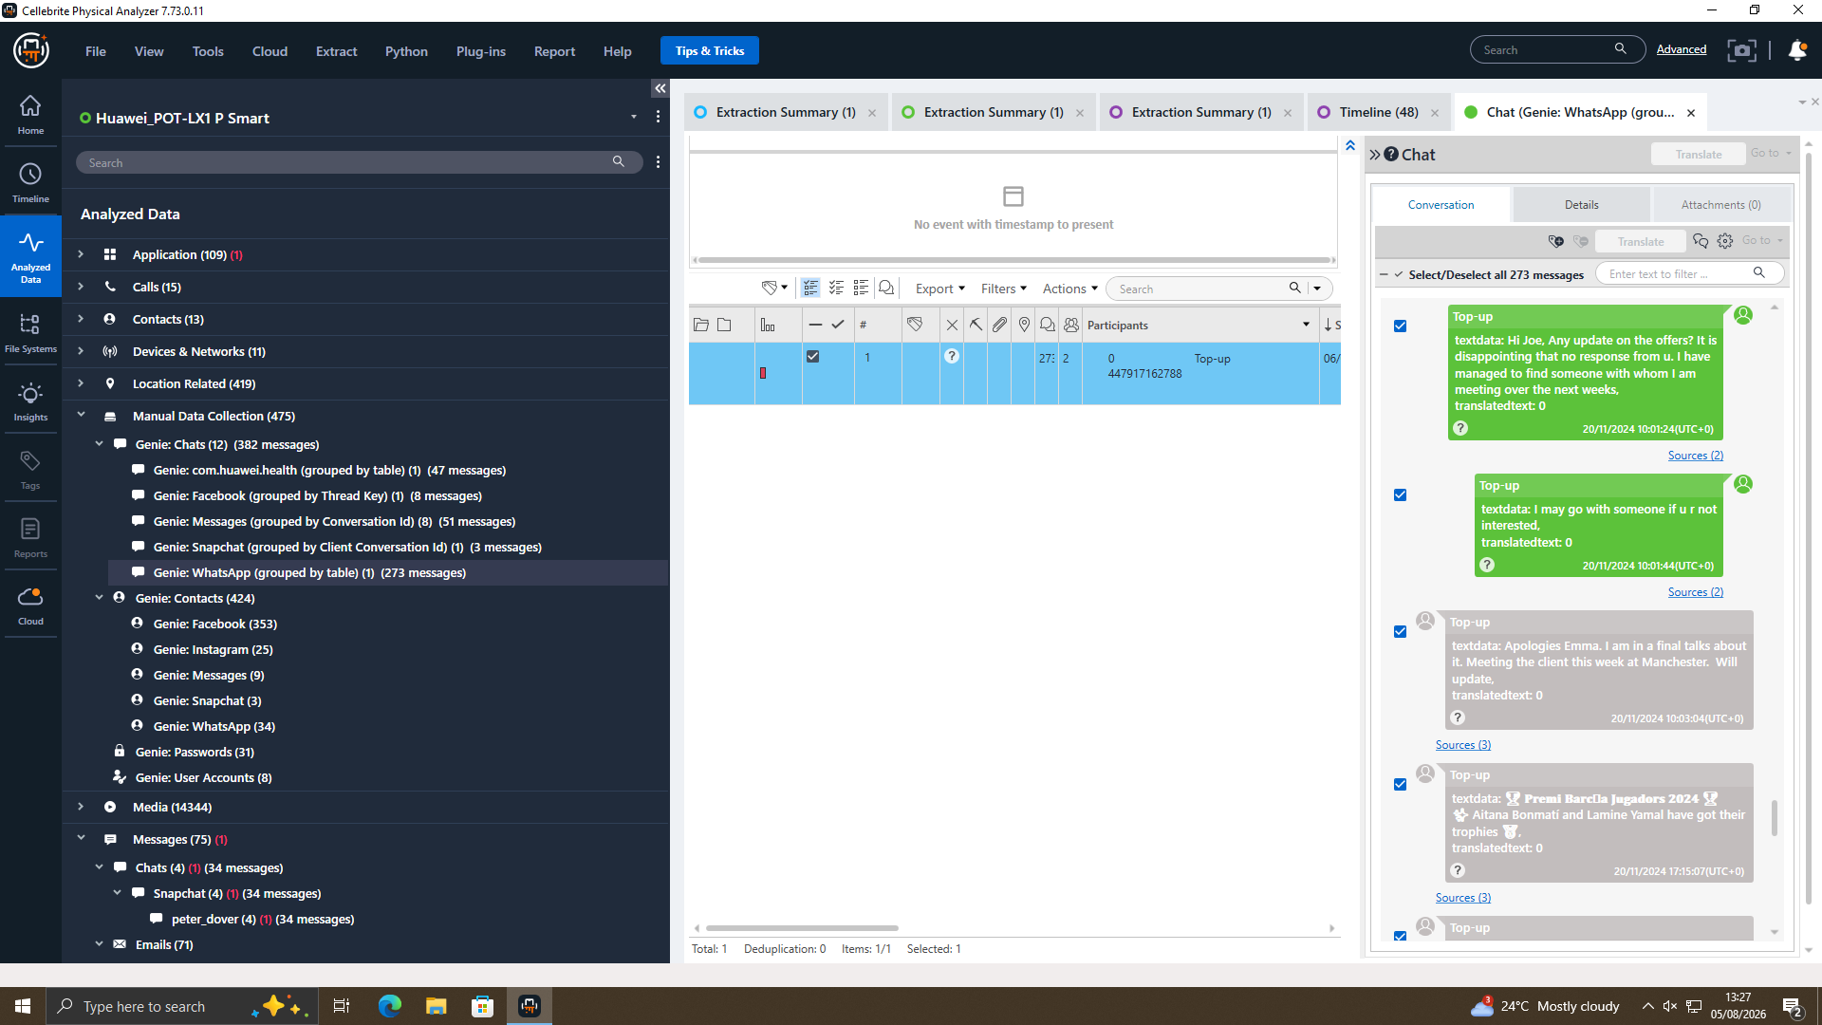
Figure A.14 — WhatsApp: "I am in final talks about it. Meeting the client this week at Manchester" (20/11/2024) — referenced inline as Figure 15's corroborating chat message.
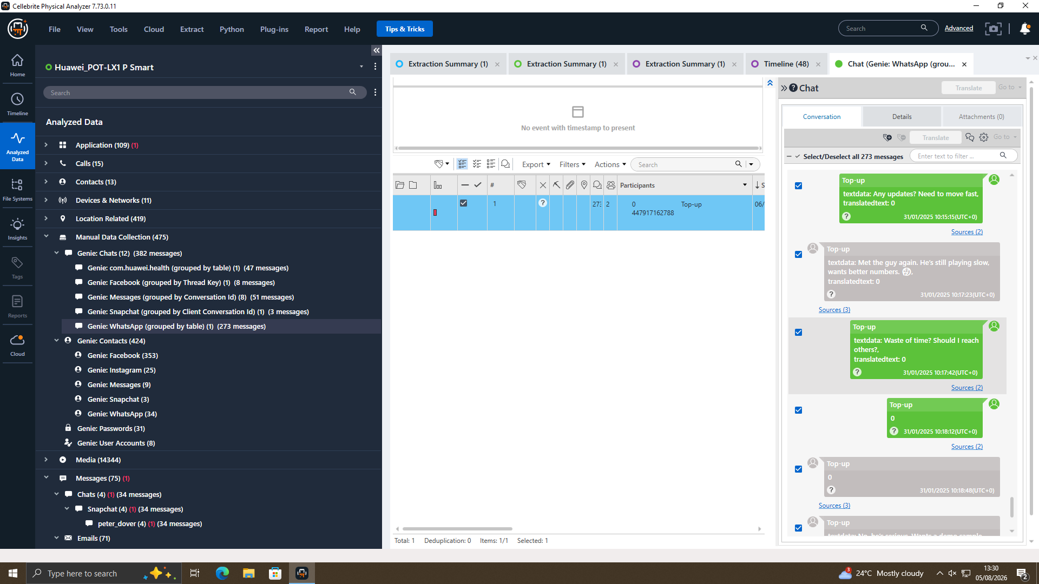
Figure A.15 — WhatsApp: "Any updates? Need to move fast" / "Met the guy again. He's still playing slow, wants better numbers" (31/01/2025).

